Case report: dual diagnosis of Mulibrey nanism and Jacobs syndrome in an Indian boy

**Abstract**

**Background** Mulibrey-Nanism (Muscle-liver-brain-eye Nanism = dwarfism; MUL) is a rare genetic syndrome caused by *TRIM37* gene variants characterized by growth failure, dysmorphic features and congestive heart failure. We report a 6-year-old boy with Mulibrey nanism and Jacobs syndrome who was referred to us on suspicion of some genetic syndrome.

**Case description** A 6-year-old boy was referred for genetic evaluation with a suspected diagnosis of Silver-Russell syndrome. Comprehensive genetic analysis of the proband was conducted using both classical and modern tech- niques, including karyotyping, chromosomal microarray (CMA), and whole exome sequencing (WES). G-banding chromosomal analysis revealed a mosaic pattern of 47,XYY[25]/46,XY[25], indicative of Jacobs syndrome. Further anal- ysis with CMA identified a pathogenic mosaic gain of Y chromosome consistent with the karyotype results; no other pathogenic copy number variants were observed. Finally, WES revealed a nonsense homozygous variant c.586C >T

in the *TRIM37* gene which is causative of Mulibrey nanism.

**Conclusion** This case marks the first documented instance in India of the co-occurrence of Mulibrey nanism

and Jacobs syndrome, adding significant insights into the genetic diversity and clinical presentation of these condi- tions. The study highlights the importance of various genetic tests to diagnose rare genetic syndromes with overlap- ping phenotype.

**Keywords** Mulibrey, Jacobs syndrome, Whole exome sequencing, Karyotype

# Introduction

Mulibrey nanism (MUL), also known as muscle-liver- brain-eye nanism, is an exceedingly rare autosomal reces- sive disorder that affects multiple organs and systems

within the body. It is characterized by significant growth failure, distinctive facial dysmorphism, and various sys- temic complications, including cardiac anomalies. The term “Mulibrey” is derived from the primary organs affected: muscle, liver, brain, and eye, while “nanism”

indicates dwarfism. Major signs of this condition include

prenatal onset growth failure, constrictive pericarditis, and hepatomegaly, among others [1]. The condition has a particularly high prevalence in Finland, with over 100 diagnosed cases, but it has also been reported sporadi- cally in other populations around the world [2].

The genetic basis of Mulibrey nanism involves muta- tions in the TRIM37 gene located on chromosome 17q22–q23, which encodes a peroxisomal protein involved in cellular regulation [3]. It is expressed in sev- eral tissues. Thus, it is no surprise that MUL shares

features with other peroxisomal disorders. These include growth failure, facial dysmorphism with midface hypo- plasia, retinal pigmentary changes, skeletal dysplasia, skin changes, cardiac involvement, muscular hypotonic- ity, and hepatomegaly [4].

Jacobs syndrome, also known as 47,XYY syndrome, occurs in approximately 1 in 1,000 male births and is characterized by the presence of an additional Y chro- mosome. This extra chromosome can lead to a variety of physical, developmental, and behavioral issues, although many individuals remain undiagnosed due to the sub- tlety of symptoms [5]. In the mosaic form, 46,XY/47,XYY, which develops during early embryonic stages, the clini- cal presentation can be even more variable.

Consanguineous marriages, which are more com- mon in certain cultures, significantly increase the risk of autosomal recessive disorders such as Mulibrey nanism. Studies have shown that the offspring of consanguine- ous unions have a higher likelihood of inheriting genetic disorders due to the increased probability of both parents carrying the same deleterious allele [6]. This is particu- larly relevant in populations where such marriages are prevalent, underscoring the need for genetic counseling and awareness.

Early and accurate diagnosis of these rare genetic conditions is crucial for effective management and intervention. Genetic testing, including karyotyping, chromosomal microarray (CMA), and whole exome sequencing (WES), plays a vital role in identifying the underlying genetic mutations and providing a definitive diagnosis. This enables healthcare providers to tailor treatment plans and offer appropriate genetic counseling to affected families.

This case report discusses a unique instance of co- occurrence of MUL and Jacobs syndrome in a single indi- vidual, highlighting the importance of comprehensive genetic diagnostics in identifying and managing these overlapping phenotypes.

# Case description

A 6-year-old male child presented referred for genetic testing with a preliminary diagnosis of Silver-Russell syndrome having features such as bilateral undescended testes, short stature, facial dysmorphism, and a congeni- tal heart anomaly. His familial history was unremarkable and he was the only member in his family suffering from severe progressive growth failure.

He was the first child of consanguineous Indian par- ents (Fig. 1). He was born full-term via vaginal delivery, with a birth weight of 2.5 kg. His parents noticed his growth began to falter after five months. His short height became quite evident, but aside from weakness in his legs and short stature, he had no other major issues, so

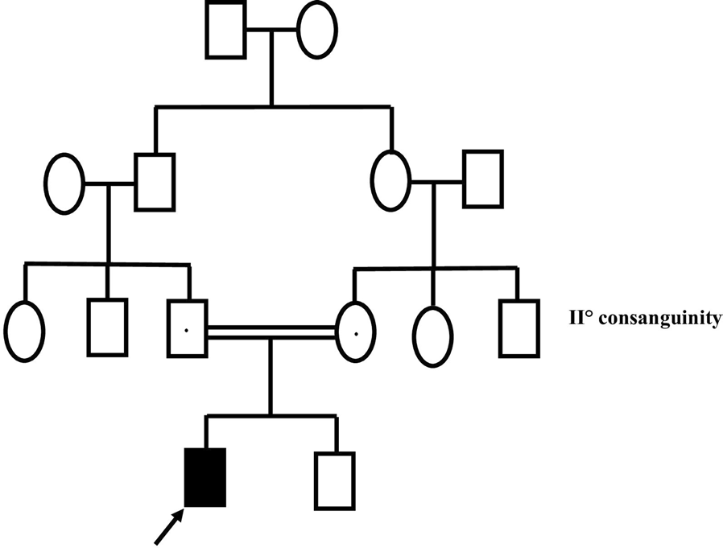

**Fig. 1** Pedigree analysis of a proband born to 2° consanguineous parents

his parents did not consult a doctor. As he grew older, his weakness worsened, impacting his daily activities and his short height became more noticeable. At the age of five, his parents decided to consult a physician regarding his restricted growth and weakness. On evaluation, he was diagnosed with heart anomaly; 2D echocardiography showed anterior mitral leaflet and posterior mitral leaflet prolapse, myxomatous mitral valve, severe mitral regur- gitation, and fair ventricular function for which he was advised for mitral valve repair by the cardiologist.

On physical examination, the child displayed notable facial dysmorphism, including hypertelorism, a broad nasal bridge, frontal bossing, and a triangular face. He also had dental crowding, leg weakness, and mild hypo- tonia, although his intellectual development was within normal limits (Fig. 2A, B). His voice was high pitched. His growth parameters were significantly below the 5th percentile: weight at 8.2 kg (z-score −12.96), height at 84 cm (z-score −6.76), and BMI at 11.6 kg/m2 (z-score

−5.37).

Ophthalmologic examination revealed no squint, but ultrasonography of the left eye showed choroidal hypoplasia and yellowish deposits in the retinal fundi (Fig. 2C). Laboratory tests indicated elevated levels of serum protein (9.20 g/dl), serum albumin (5.10 mg/dl), serum globulin (4.10 mg/dl), and total bilirubin (2.09 mg/ dl). On abdominal ultrasound the liver appeared normal in size and shape. No other significant abnormality was observed.

Standard karyotyping, performed using the 400–450 G banding technique, revealed a mosaic pattern of 47,XYY[25]/46,XY[25], consistent with a diagnosis of Jacobs syndrome. Chromosomal microarray (CMA) analysis confirmed the presence of mosaic gain of the Y chromosome, matching the karyotype results, with

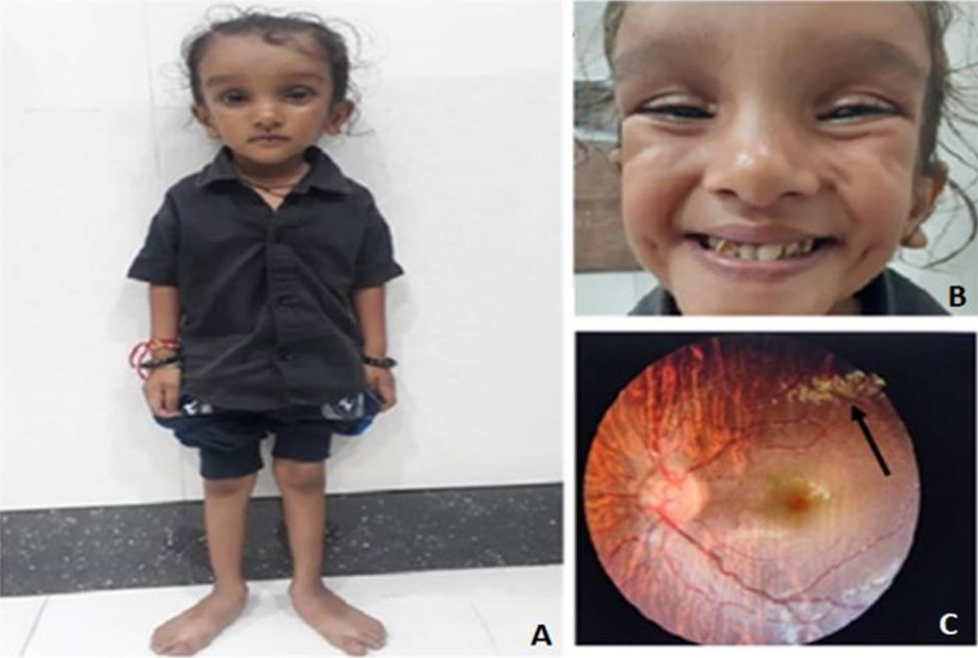

**Fig. 2** Clinical presentation of proband (**A**). Proband with low nasal bridge, high broad forehead, frontal bossing and triangular face (**B**). Crowding of teeth (**C**). Yellow deposits and choroidal hypoplasia in retinal fundi of left eye

pathogenic copy number variations (CNVs) of 5.58 MB gain at p11.31–p11.2, a 14.63 MB gain at q11.21–q11.23, and a 15.66 MB gain mosaic at q11.1–q11.23 on the Y chromosome (Fig. 3A, B).

Whole exome sequencing (WES) identified a homozy- gous variant (NM_001005207.5: c.586C > T) in the TRIM37 gene (chr17:57,157,145; Depth: 63x) causative of Mulibrey nanism (Fig. 4). This variant results in a pre- mature stop codon, producing a truncated protein at the glutamine residue at position 196. This variant has not been found in the 1000 Genomes and TOPMed data- bases but has a minor allele frequency in the gnomAD database and is reported as likely pathogenic in the Clin- Var database. In silico analysis using tools such as SIFT, PolyPhen2, CADD, REVEL, and MVP suggested that this variant is deleterious.

# Discussion

Mulibrey nanism is an exceptionally rare hereditary con- dition characterized by distinct clinical traits with auto- somal recessive inheritance. Consanguineous marriages

are always a risk factor for manifestation of such rare autosomal recessive diseases. [7]

According to Karlberg and colleagues, the diagnosis of MUL is based on the presence of both major and minor clinical criteria [1]. MUL shares some features with other peroxisomal disorders as well as other developmental disorders. Due to overlapping symptoms with Silver- Russell syndrome (such as triangular facies, crowded teeth, low-set prominent ears, broad forehead, phalanges, clinodactyly, and lower extremities), it was challenging to diagnose the patient just on clinical basis. This is where genetic testing plays a crucial role in confirming the diag- nosis. Karyotyping and CMA analysis were advised, but the results did not align with the phenotype.

Consequently, whole exome sequencing (WES) was performed, which confirmed the molecular diagnosis by revealing a nonsense variant (c.586C > T) in the TRIM37 gene. To the best of our knowledge, India is the first nation to report this variant. Nonsense-mediated mRNA decay (NMD) can occur when a premature termination codon is inserted into the open reading frame (ORF) of a protein-coding gene, preventing the translation of

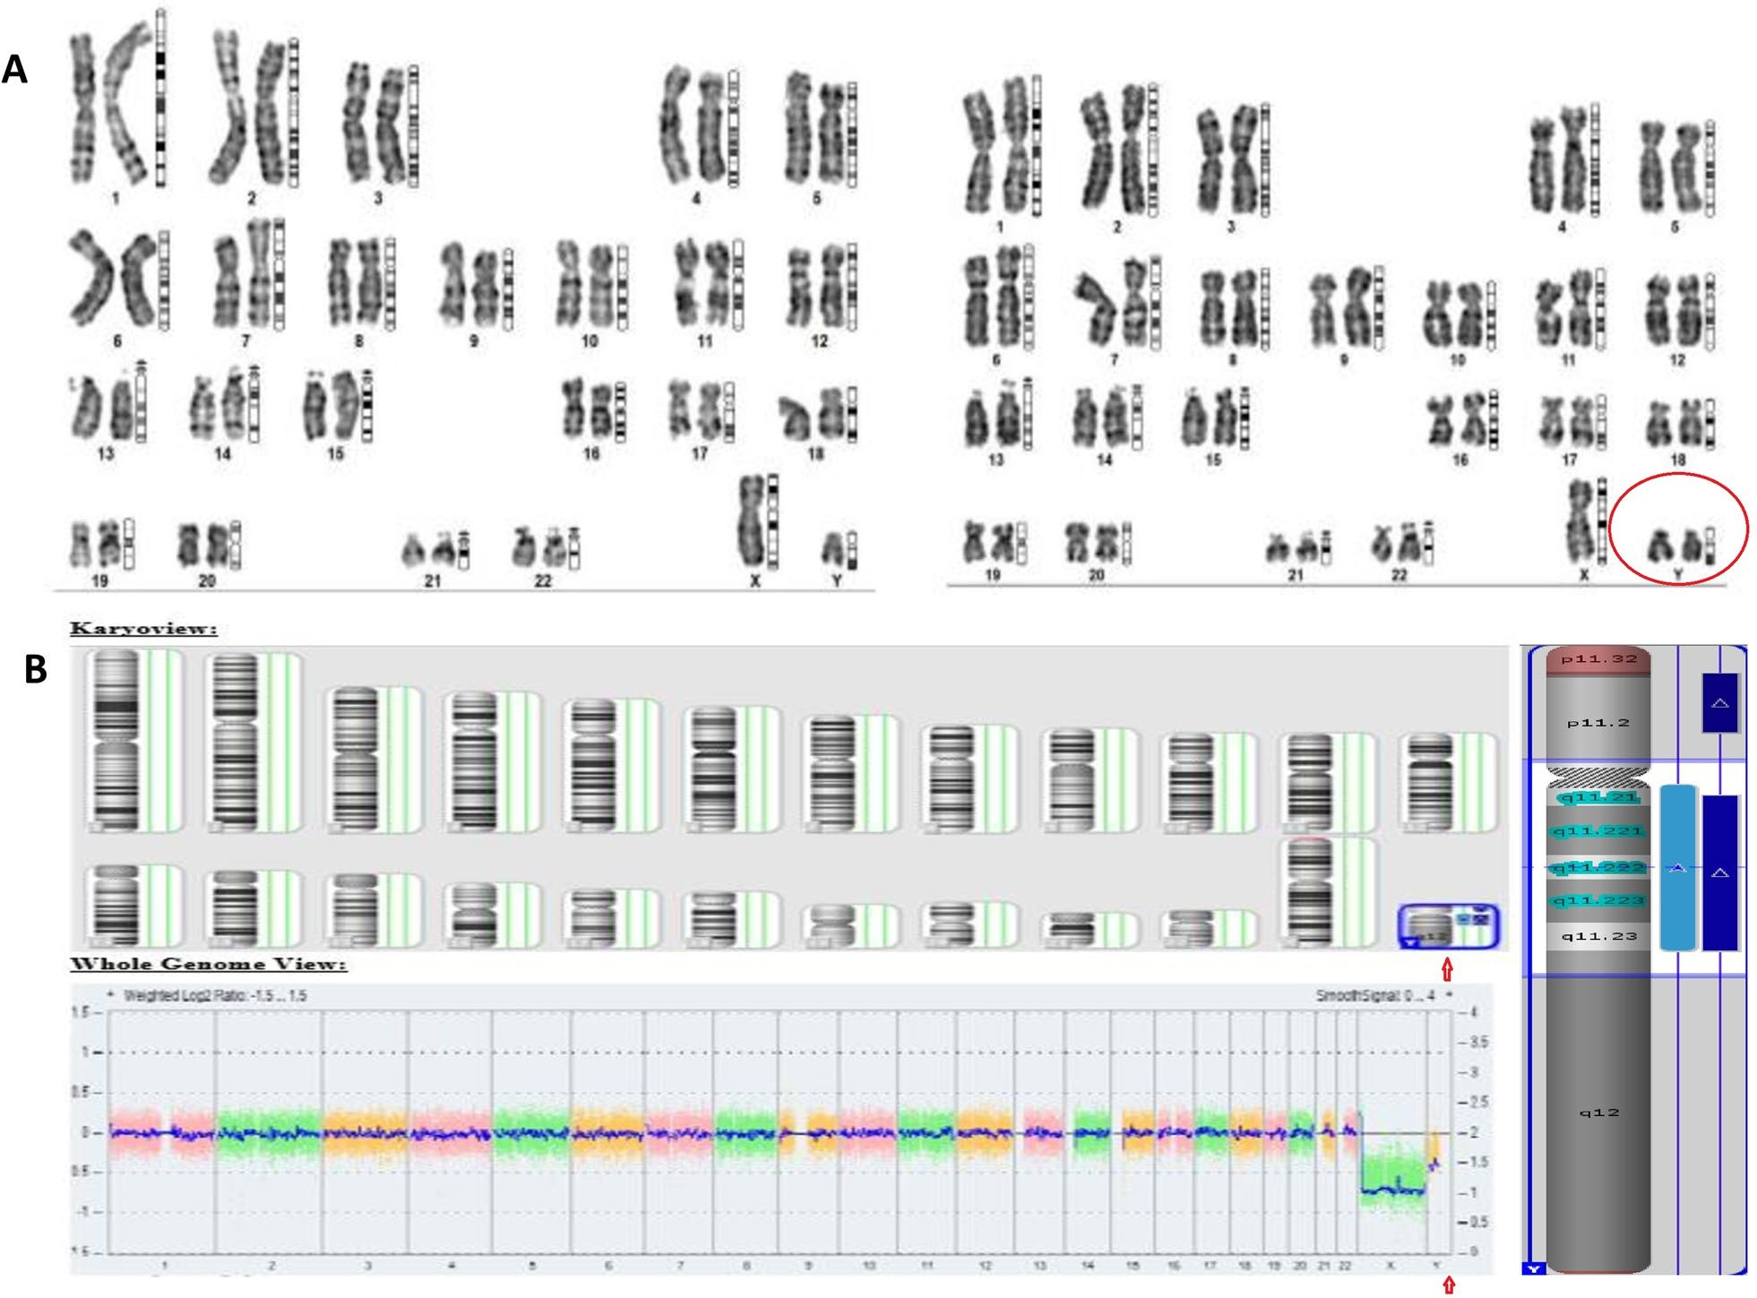

**Fig. 3** Cytogenetic analysis of proband **A** Karyotype showing presence of mosaic cell line 47,XYY in addition to normal 46,XY. **B** CMA profile of the proband showing a 5.58 MB gain at p11.31, 14.63 MB gain at q11.21 and 15.66 MB mosaic gain at q11.1

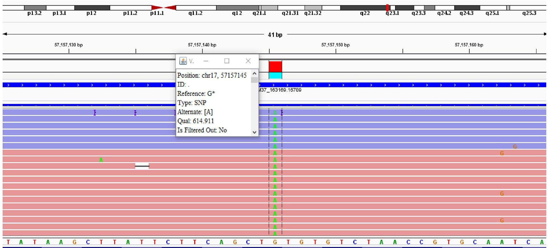

**Fig. 4** Proband’s IGV showing homozygous nonsense variant c.568C >T (NM_001005207.5:chr17:57,157,145) in *TRIM37* gene detected by WES

shortened, malfunctioning proteins [8]. As yet, there seems to be no genotype–phenotype correlation [9]. Whether a tissue-specific peroxisomal defect is involved in pathogenesis of MUL remains to be investigated. Moreover, the peroxisomal function in patients with MUL needs to be characterized in more detail to deter- mine which subset of metabolic functions are affected in this disorder.

The results of previous reports of this syndrome con- firm that MUL is a distinct but variable entity [10, 11]. The most consistent findings were severe growth failure and characteristic craniofacial features. Organ manifes- tations varied considerably over the patient’s lifetime. In our case, the patient did not develop hepatomegaly ini- tially, but it could arise in the future. Therefore, surveil- lance is crucial to detect it early for timely management. Constrictive pericarditis [12] with congestive heart fail- ure dominates the clinical state as well as the prognosis [13]. However, only 12% of Finnish patients in Karlberg et al. review had CHF at the time of diagnosis and half of the adult patients were free of major heart problems [1, 14–16]. In contrast, almost all sporadic cases reported from other parts of the world were notably characterized by a heart disease [17, 18]. In this case, patient had myxo- matous mitral valve instead of constrictive pericarditis and has been advised for mitral valve repair.

Timely identification and management of feeding, res- piratory, or cardiac issues are crucial. Treatment focuses on addressing organ-related problems, including the heart, through medication or surgery. Additionally, assessment of growth and puberty and hormone replace- ment therapy is provided. Abdominal ultrasound screen- ing is recommended for all patients to detect Wilms’ tumor and ovarian tumors in females.

Mulibrey nanism has been documented in vari- ous case reports, highlighting its clinical features and genetic basis. For instance, a comprehensive case report by Andrea Gazzin et al. described a patient with Muli- brey nanism who presented with progressive lympho- penia and required intravenous immunoglobulin (IVIG) replacement therapy [19]. This aligns with our patient’s need for consistent monitoring and management of potential immunological complications. A male toddler with MUL presented with recurrent episodes of hypoxia, feeding intolerance, and generalized swelling in the set- ting of subtle echocardiographic findings [20]. Similarly, a report by Tareq Al Saadi et al. documented two Syrian siblings with MUL, emphasizing the importance of rec- ognizing this condition in diverse populations. The sib- lings exhibited growth failure and dysmorphic features, similar to our patient [21].

Patients with Jacobs syndrome have been noted to have genitourinary abnormalities such as microphallus,

hypoplastic scrotum, cryptorchidism, and hypospadias. These patients are also at an increased risk for learn- ing disabilities, attention deficit/hyperactivity disorder (ADHD), autism spectrum disorder, and speech difficul- ties [22]. In case of mosaics, the phenotype depends on the proportion of abnormal cell lines. Given that symp- toms in Jacobs syndrome are often absent or subtle, it is highly likely that mosaics individual having normal cell line in majority would exhibit a normal phenotype. In our case it is possible that undescended testis could be the effect of extra Y chromosome but otherwise patient had no other behavioral problems. For undescended testis, timely orchiopexy can reduce, but not eliminate, the risk of decreased fertility and testicular malignancy [23].

In the context of Jacobs syndrome, a case report by Suleman Elahi Malik et al. described a patient with 45X/47XXY mosaicism presenting with ambiguous genitalia and hypospadias. This case underscores the variability in phenotypic expression and the need for comprehensive genetic evaluation and multidisciplinary approach in diagnosing and managing such patient [24]. A 38-year-old male with infertility issues, tall stature, and neurodevelopmental symptoms was diagnosed with a 47, XYY karyotype during a hospital visit prompted by his spouse’s adverse obstetric history [25]. Another case report described a male with Jacobs syndrome present- ing with developmental delay, speech and behavioural issues, and tall stature [26]. These cases highlight the importance of early diagnosis and intervention to address cognitive and behavioural deficits associated with Jacobs syndrome. These comparisons with literature and case reports highlight the importance of a thorough diagnos- tic workup and the need for ongoing research to better understand these rare genetic conditions.

The possibility of being affected by two relatively com- mon or rare inherited genetic conditions would be sus- pected when signs and symptoms are incoherent with the primary diagnosis. In this case, the patient was diag- nosed with two different genetic conditions: one related to a copy number variant or chromosomal aneuploidy, and another due to biallelic sequence variants in a gene associated with an autosomal recessive disorder. This increases the clinical complexity of the patient’s condi- tion, necessitating a more intricate clinical management plan with a multidisciplinary approach involving cardi- ologists, immunologists, endocrinologists, geneticists, and other experts [27]. This approach includes long-term follow-ups and future surveillance.

# Conclusion

This study highlights the importance of early genetic screening and a multidisciplinary approach in diag- nosing and managing rare syndromes. By combining

conventional tests with advanced genetic diagnostics, clinicians can achieve accurate and comprehensive diag- noses. The co-occurrence of Mulibrey nanism and Jacobs syndrome in this case adds valuable knowledge to the existing literature by documenting the first reported instance in India, providing insights into the genetic diversity and presentation of these conditions, and can guide clinicians in treating similarly complex cases.

**Abbreviations**

MUL Mulibrey nanism

CNVs Copy number variations CMA Chromosomal microarray WES Whole exome sequencing

NMD Nonsense-mediated mRNA decay ORF Open reading frame

ADHD Attention deficit/hyperactivity disorder

**Availability of data and materials**

The contributions of this study are thoroughly explained in the article. For additional details, please reach out to the corresponding author.

**Declarations**

**Ethics approval and consent to participate**

Ethical clearance for this study was obtained by the local ethical committee of Institute of Kidney Diseases and Research Centre.

**Consent for publication**

Written informed consent was obtained from the parents of the patient for this publication.

**References**

1. Karlberg N, Jalanko H, Perheentupa J (2004) Mulibrey nanism: clinical features and diagnostic criteria. J Med Genet 41(2):92–98
2. Lipponen M, Wartiovaara K, Lönnqvist T, Kääriäinen H, Kristo P, Waris T (2001) Mutations in the TRIM37 gene are the major cause of Mulibrey nanism. Am J Hum Genet 69(5):1147–1153
3. Hatakeyama S (2011) TRIM proteins and cancer. Nat Rev Cancer 11(11):792–804
4. Ozato K, Shin DM, Chang TH, Morse HC (2008) TRIM family proteins and their emerging roles in innate immunity. Nat Rev Immunol 8(11):849–860
5. Stochholm K, Juul S, Gravholt CH, Jensen AS (2012) 47, XYY syndrome: a clinical update. J Clin Endocrinol Metab 97(7):E1477–E1483
6. Bittles AH (2001) Consanguinity and its relevance to clinical genetics. Clin Genet 60(2):89–98
7. Khayat AM, Alshareef BG, Alharbi SF, AlZahrani MM, Alshangity BA, Tashkandi NF (2024) Consanguineous marriage and its association with genetic disorders in Saudi Arabia: a review. Cureus 16(2):e53888. [https://](https://doi.org/10.7759/cureus.53888) [doi.org/10.7759/cureus.53888](https://doi.org/10.7759/cureus.53888)
8. Fatscher T, Boehm V, Gehring NH (2015) Mechanism, factors, and physiological role of nonsense-mediated mRNA decay. Cell Mol Life Sci 72(23):4523–4544
9. Avela K, Lipsanen-Nyman M, Idanheimo N, Seemanova E, Rosengren S, Makela TP, Perheentupa J, de la Chapelle A, Lehesjoki A-E (2000) Gene encoding a new RING-B-box coiled-coil protein is mutated in Mulibrey nanism. Nat Genet 25:298–301
10. Perheentupa J, Autio S, Leisti S, Raitta C, Tuuteri L (1975) Mulibrey nanism: review of 23 cases of a new autosomal recessive syndrome. Birth Defects Orig Artic Ser 11(2):3–17
11. Kallijärvi J, Lehesjoki AE, Lipsanen-Nyman M (2003) Mulibrey nanism–a novel peroxisomal disorder. Adv Exp Med Biol 544:31–37. [https://doi.org/](https://doi.org/10.1007/978-1-4419-9072-3_3) [10.1007/978-1-4419-9072-3_3](https://doi.org/10.1007/978-1-4419-9072-3_3)
12. Tuuteri L, Perheentupa J, Rapola J (1974) The cardiopathy of mulibrey nanism, a new inherited syndrome. Chest 65(6):628–631. [https://doi.org/](https://doi.org/10.1378/chest.65.6.628) [10.1378/chest.65.6.628](https://doi.org/10.1378/chest.65.6.628)
13. Lipsanen-Nyman M, Perheentupa J, Rapola J, Sovijärvi A, Kupari M (2003) Mulibrey heart disease: clinical manifestations, long-term course, and results of pericardiectomy in a series of 49 patients born before 1985. Cir- culation 107(22):2810–2815. [https://doi.org/10.1161/01.CIR.0000070949.](https://doi.org/10.1161/01.CIR.0000070949.76608)

[76608](https://doi.org/10.1161/01.CIR.0000070949.76608)

1. Mozzillo E, Cozzolino C, Genesio R, Melis D, Frisso G, Orrico A, Lombardo B, Fattorusso V, Discepolo V, Della Casa R, Simonelli F, Nitsch L, Salvatore F, Franzese A (2016) Mulibrey nanism: two novel mutations in a child identi- fied by Array CGH and DNA sequencing. Am J Med Genet A 170(8):2196– 2199. <https://doi.org/10.1002/ajmg.a.37770>
2. Karlberg N, Jalanko H, Lipsanen-Nyman M (2007) Growth and growth hormone therapy in subjects with mulibrey nanism. Pediatrics 120(1):e102–e111. <https://doi.org/10.1542/peds.2006-2686>
3. Karlberg S, Tiitinen A, Lipsanen-Nyman M (2004) Failure of sexual matura- tion in Mulibrey nanism. N Engl J Med 351(24):2559–2560. [https://doi.](https://doi.org/10.1056/NEJM200412093512423) [org/10.1056/NEJM200412093512423](https://doi.org/10.1056/NEJM200412093512423)
4. Doğanc T, Yüksel Konuk BE, Alpan N, Konuk O, Hämäläinen RH, Lehesjoki AE, Tekin M (2007) A novel mutation in TRIM37 is associated with muli- brey nanism in a Turkish boy. Clin Dysmorphol 16(3):173–176. [https://doi.](https://doi.org/10.1097/MCD.0b013e3280f6d00b) [org/10.1097/MCD.0b013e3280f6d00b](https://doi.org/10.1097/MCD.0b013e3280f6d00b)
5. Lapunzina P, Rodríguez JI, de Matteo E, Gracia R, Moreno F (1995) Muli- brey nanism: three additional patients and a review of 39 patients. Am J Med Genet 55(3):349–355. <https://doi.org/10.1002/ajmg.1320550320>
6. Gazzin A, Pala F, Bosticardo M, Niemela J, Stoddard J, Biasin E et al (2023) Mulibrey nanism and immunological complications: a comprehensive case report and literature review. Front Immunol 14:1303251. [https://doi.](https://doi.org/10.3389/fimmu.2023.1303251) [org/10.3389/fimmu.2023.1303251](https://doi.org/10.3389/fimmu.2023.1303251)
7. Kreinbrook JA, Izzo L, Atkins C, Das S (2024) Subtle echocardiogram findings requiring further investigation: restrictive cardiomyopathy in a rare genetic condition. BMJ Case Rep 17(10):e261443. [https://doi.org/10.](https://doi.org/10.1136/bcr-2024-261443) [1136/bcr-2024-261443](https://doi.org/10.1136/bcr-2024-261443)
8. Saadi TA, Alkhatib M, Turk T, Turkmani K, Abbas F, Khouri L (2015) Report of two Syrian siblings with Mulibrey nanism. Oxf Med Case Rep 12:367–370. <https://doi.org/10.1093/omcr/omv065>
9. Bardsley MZ, Kowal K, Levy C, Gosek A, Ayari N, Tartaglia N, Lahlou N, Winder B, Grimes S, Ross JL (2013) 47, XYY syndrome: clinical phenotype and timing of ascertainment. J Pediatr 163(4):1085–1094. [https://doi.org/](https://doi.org/10.1016/j.jpeds.2013.05.037) [10.1016/j.jpeds.2013.05.037](https://doi.org/10.1016/j.jpeds.2013.05.037)
10. Kurz D (2016) Current management of undescended testes. Curr Treat Options Pediatr 2(1):43–51. <https://doi.org/10.1007/s40746-016-0039-7>
11. Malik SE, Munib N, Javed J, Jehandad Z, Haider I (2023) A case report - Jacob syndrome (45X/47XXY mosaicism). J Med Sci 31(02):157–159
12. Joshi G, Thapa S, Khanal S, Bista P, Khadka A, Dhakal N, Kunwar AJ, Thakur N (2024) Cytogenetic profiling unveils Jacobs syndrome (47, XYY) - a

unique chromosomal abnormality case from Nepal. J Clin Images Med Case Rep 5:2862. <https://doi.org/10.52768/2766-7820/2862>

1. Subhash RLP, Anupama D, Bindurani MK, Harshal KL, Kadandale JS, Shetty S, Bhat M (2020) Jacob’s syndrome - a rare case report. SSAE J Interdiscip Res 1(1):1–4
2. Reuner U, Stremmel W, Weiskirchen R (2019) The interesting case-orphan diseases-double trouble. Ann Transl Med 7:S74. [https://doi.org/10.21037/](https://doi.org/10.21037/atm.2019.04.31) [atm.2019.04.31](https://doi.org/10.21037/atm.2019.04.31)