Unravelling variants in Farber disease: diagnostic and prenatal challenges in atypical presentations

**Abstract** Farber disease (FD; OMIM #228000), also known as Farber’s lipogranulomatosis, is a rare lysosomal storage disease caused by acid ceramidase deficiency. Clinically, FD is typically identified by a triad of symptoms: subcutaneous nodules, joint pain, and voice hoarseness. However, diagnosing mild or attenuated variants can be difficult, as some symptoms may be absent or overlooked. In such cases, genetic testing is essential for confirming the diagnosis and enabling prenatal diagnosis.

**Case presentation** A couple presented with a history of losing two children at 1.5 years of age, both of whom exhib- ited severe developmental delay, hypotonia, weak cry, and progressive skin lesions. Neither child underwent genetic testing, and no DNA samples were preserved. Subsequent parental carrier screening identified a heterozygous

variant of uncertain significance (VUS) in the *ASAH1* (N-Acylsphingosine Amidohydrolase 1) (OMIM #613468) gene in both parents. Exome sequencing was later performed on the couple’s third affected child, revealing compound

heterozygous variants in the *ASAH1* gene, consistent with those found in the parents. This case presented with atypi- cal manifestations of FD, necessitating comprehensive investigations, including laboratory tests, radiological assess- ments, genetic analysis, and histopathological examination of skin biopsy samples. These findings led to the identifi- cation of likely pathogenic mutations in *ASAH1*. Based on these results, prenatal diagnosis was successfully conducted in the couple’s fourth pregnancy.

**Conclusion** This case illustrates the challenges of diagnosing FD when atypical presentations and genetic variants of uncertain significance are involved. The absence of classic symptoms like subcutaneous nodules and the presence

of an *ASAH1* gene variant complicated the diagnosis and delayed options for prenatal diagnosis in future pregnancies. It underscores the critical role of genetic testing and the need to reclassify VUS through detailed genotype–pheno- type correlations to enhance diagnostic accuracy and support timely interventions.

**Keywords** Acid ceramidase deficiency, *ASAH1*, Farber disease, C.457+4A>G, Exome sequencing, Farber lipogranulomatosis, Lysosomal storage disease

# Background

Farber disease (FD; OMIM #228000), also known as Far- ber’s lipogranulomatosis, is an extremely rare lysosomal storage disease [1]. The condition is named after Syd- ney Farber [2], who first described it. The true incidence of FD remains unknown. Farber lipogranulomatosis is inherited in an autosomal recessive manner and is caused by a deficiency in acid ceramidase (aCDase), which leads to the pathological accumulation of ceramides in vari- ous tissues [3]. Mutations in the *ASAH1* (N-Acylsphin- gosine Amidohydrolase 1) gene result in reduced aCDase activity, thereby causing ceramide accumulation and the diverse pathological manifestations associated with the disease [4]. The *ASAH1* gene, which encodes aCDase, was fully sequenced and characterized in 1996 [5]. FD affects both males and females equally, and like most lysosomal storage disease, it follows a progressive course, with death typically occurring in infancy.

The classical clinical presentation of FD includes sub- cutaneous nodules, painful swollen joints, a hoarse voice, and premature death. However, some cases exhibit atypi- cal features, making diagnosis challenging. The severity of the disease can vary widely, with cases ranging from mild to severe forms [6]. The three hallmark signs of FD are a hoarse voice or weak cry, lipogranulomatosis in the skin and other tissues, and painful joints [7]. Additional symptoms may include moderately impaired cognitive abilities, difficulties with swallowing, vomiting, arthritis, and the presence of xanthomas. Most children with FD succumb to the disease by the age of two, often due to complications related to pulmonary involvement [1].

# Classifications of Farber disease

Farber disease (FD), also known as Farber lipogranulo- matosis, manifests in several clinical phenotypes due to deficiencies in acid ceramidase, resulting in seven dis- tinct subtypes of the disorder.

**Type 1** represents the classic form of FD, characterized by early onset of subcutaneous nodules, joint involve- ment, and hoarseness. Progressive neurological dete- rioration and pulmonary complications are frequently observed. Patients with Type 1 FD typically present with symptoms during infancy and often succumb to the dis- ease by the age of 2 to 3 years [2, 10].

**Type 2** and **Type 3** are distinguished by relatively less severe neurological involvement, leading to a longer lifespan compared to Type 1. However, these types still present with significant disease severity due to granu- lomatous inflammation, resulting in subcutaneous nod- ules, joint pain, contractures, hoarseness, failure to thrive, and respiratory issues [7].

**Type 4** is characterized by severe neurological dete- rioration and pronounced hepatosplenomegaly, often

evident from the neonatal period. Affected neonates experience severe organomegaly and visceral histiocyto- sis [8–11].

**Type 5** patients exhibit progressive central nervous system dysfunction beginning between 1 to 2.5 years of age, accompanied by progressive neurological decline and seizures. While nodules and joint involvement may be present, these are typically less severe [12].

**Type 6** involves a combination of classic FD and Sand- hoff disease, another lysosomal storage disease resulting from hexosaminidase A and B enzyme defects [13].

**Type 7** shares similarities with Type 6 but may also involve deficiencies in other enzymes such as glucocer- ebrosidase, galactocerebrosidase, and ceramidase [14]. While there is some biochemical and clinical overlap with FD, patients with prosaposin deficiency are consid- ered to have a distinct condition (OMIM #176801). This phenotype has been identified in a limited number of cases [15].

Recent reports increasingly categorize FD cases into either classic childhood or mild forms [16–19]. However, an updated classification system is warranted to better capture the diverse and emerging phenotypes associated with acid ceramidase deficiency.

In this case report, we present an atypical case of FD Farber lipogranulomatosis within a family, detailing the clinical manifestations, laboratory investigations, radio- logical findings, and histopathological analysis of a skin biopsy. We discuss the critical role of genetic testing in establishing a definitive diagnosis. The primary objective is to elucidate the clinical spectrum and genotype–phe- notype correlations in atypical FD cases and to highlight the importance of genetic testing in diagnosing these complex presentations.

# Case presentation

A non-consanguineous couple from a North Indian Hindu family was referred for genetic counselling fol- lowing the loss of two children, one male and one female, both at 1.5 years of age. Both children exhibited severe developmental delay, hypotonia, weak cry, and progres- sive skin lesions. MRI results showed cerebral atrophy in both cases. Genetic testing through exome sequencing of the parents in the year 2017 identified two variants of uncertain significance (VUS) in the *ASAH1* gene: c.1042- 2A > C (chr8:17916402) NM_177924.4 in intron 12 in the

father and c.457+4A > G (rs767864356)(chr8:17921962)

NM_177924.4 in intron 6 in the mother (Fig. 1a, b).

Following these findings, a suspicion of Farber disease (FD) was raised. The affected children displayed ery- thematous skin lesions predominantly over joint areas, painful joints, and progressive central nervous system dysfunction. Developmental milestones were delayed,

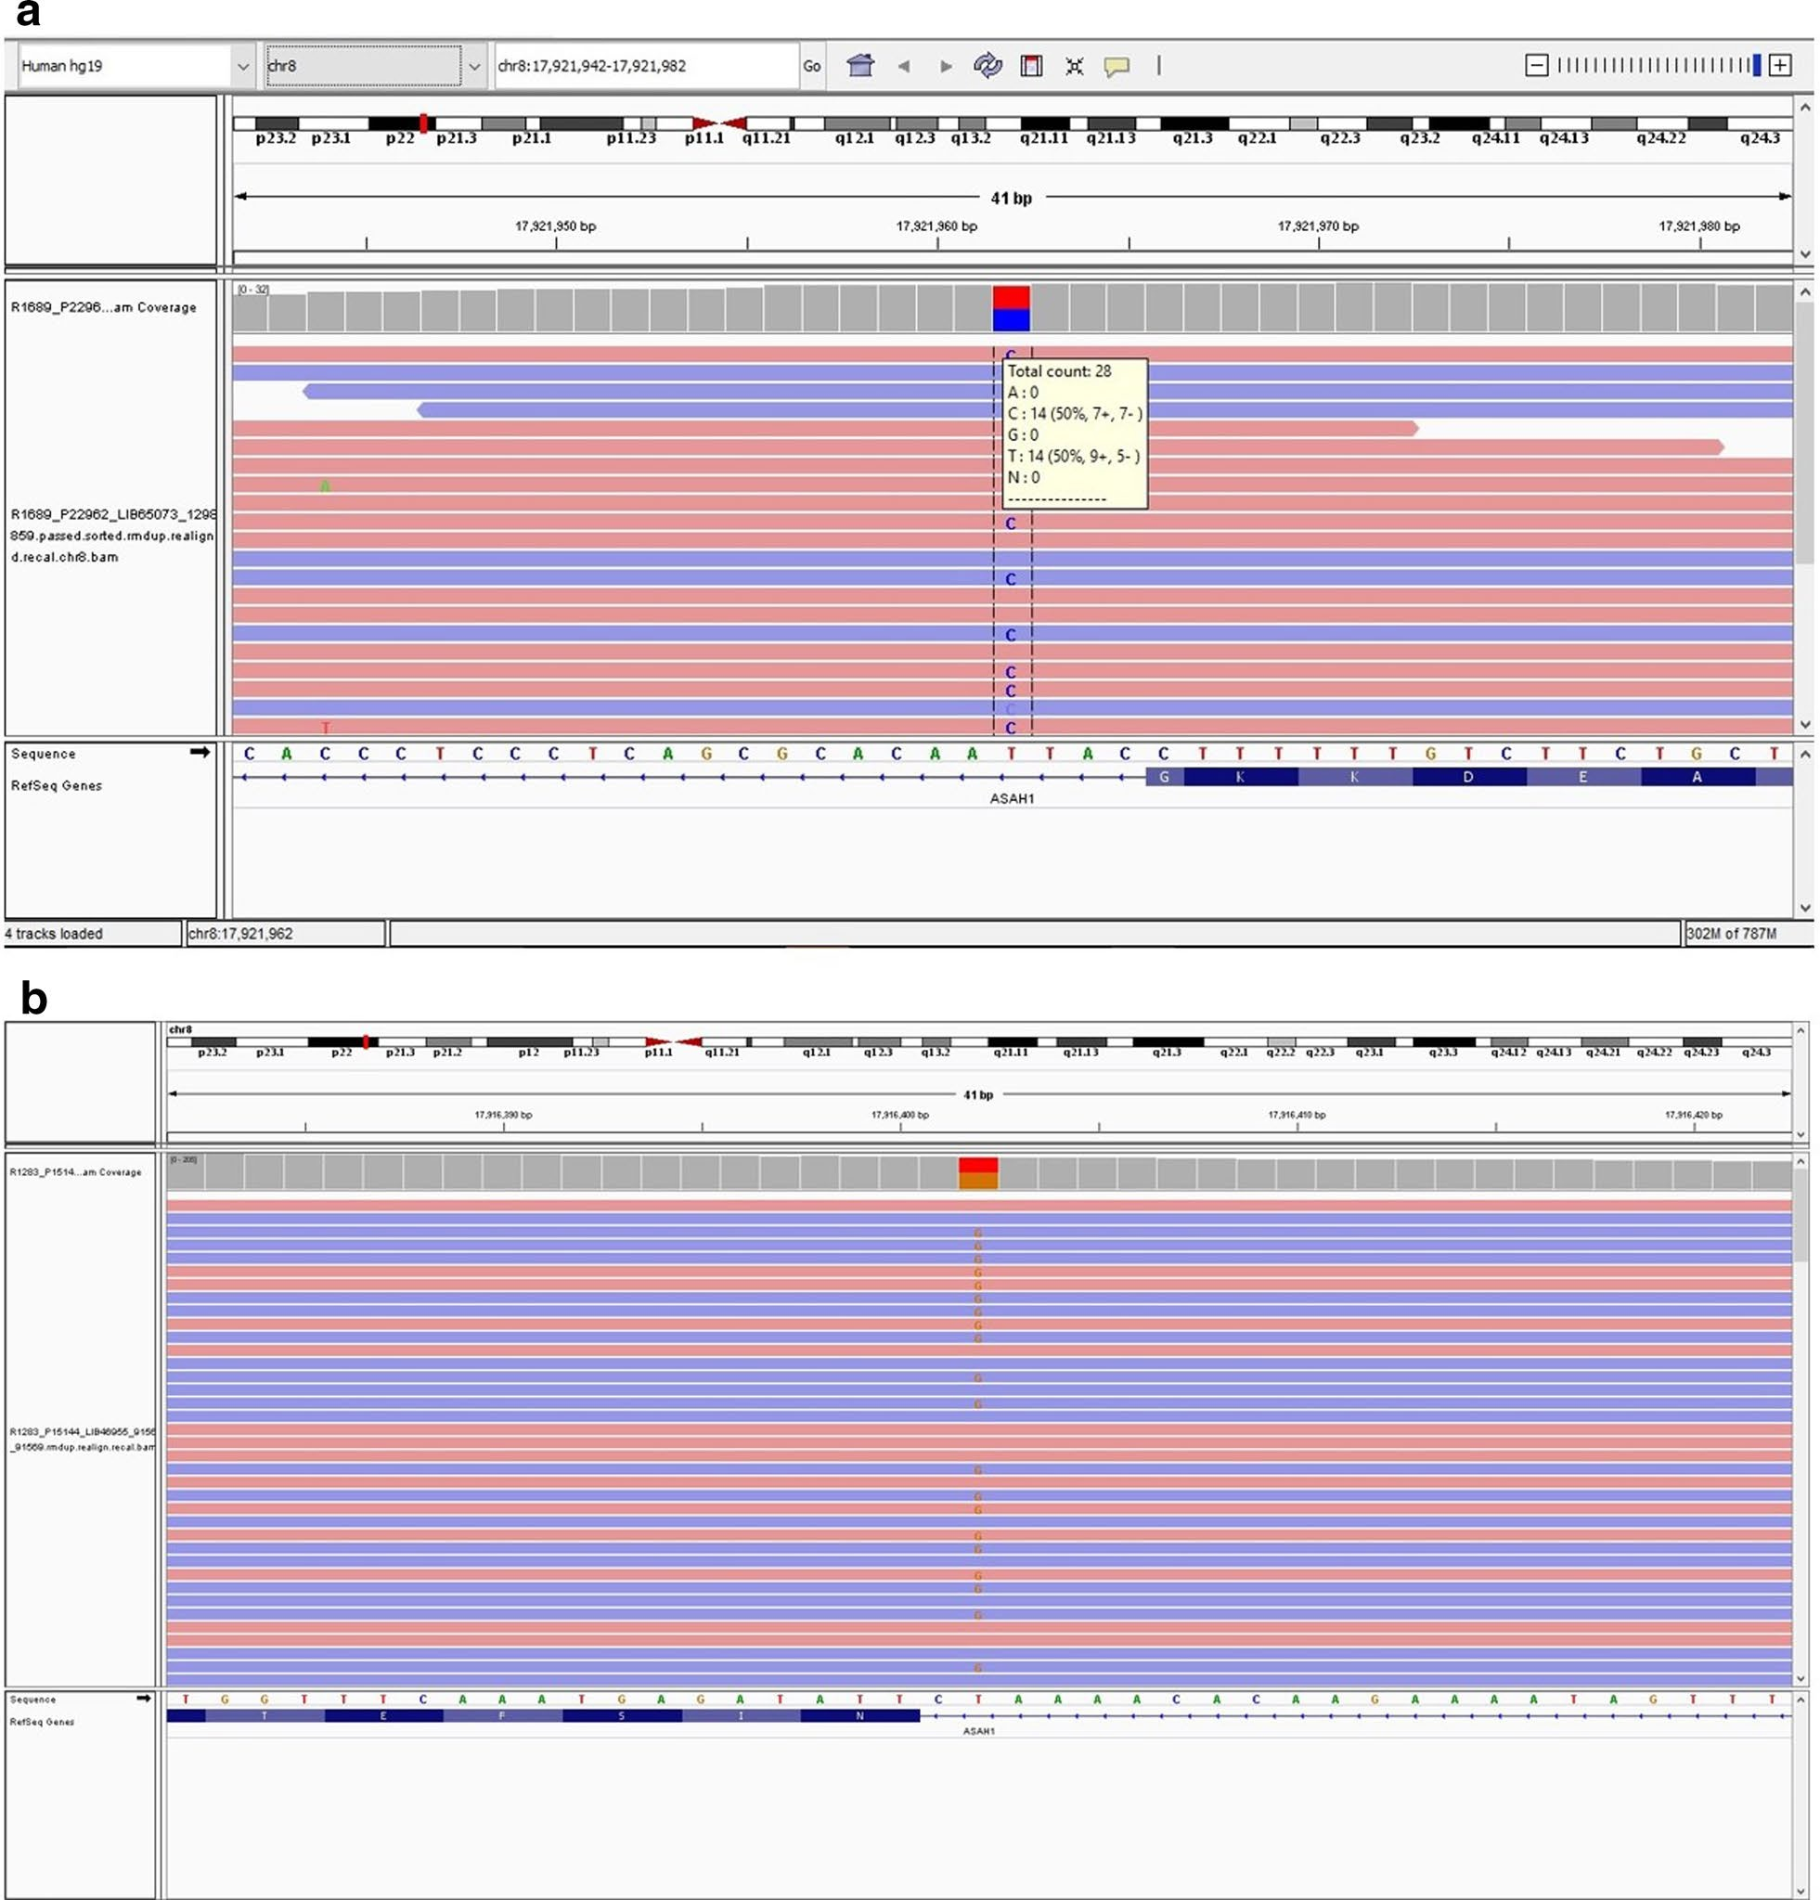

**Fig. 1 a** Integrated genomics viewer (IGV) showing base change in *ASAH1* gene; variant c.1042-2A > C in intron 12 (father). **b** Integrated genomics viewer (IGV) showing base change in *ASAH1* gene; variant c.457+4A > G in intron 6 (mother)

with no neck holding, inability to sit or walk, and even- tual complete aphonia. Mild seizures were observed after one year of age.

The couple subsequently had a third child, a male, but prenatal diagnosis could not be performed due to the VUS status. At eleven months of age, this child pre- sented with multiple erythematous and hyperpigmented

skin lesions, particularly over joints, bony surfaces, and the face (Fig. 2). The child exhibited a weak cry at birth, which progressed to complete loss of vocalization. There was significant developmental delay, neuroregression, and fixed flexion deformities of the joints, which were painful. The child ultimately succumbed to respiratory failure at 1.4 years of age, showing similar manifestations

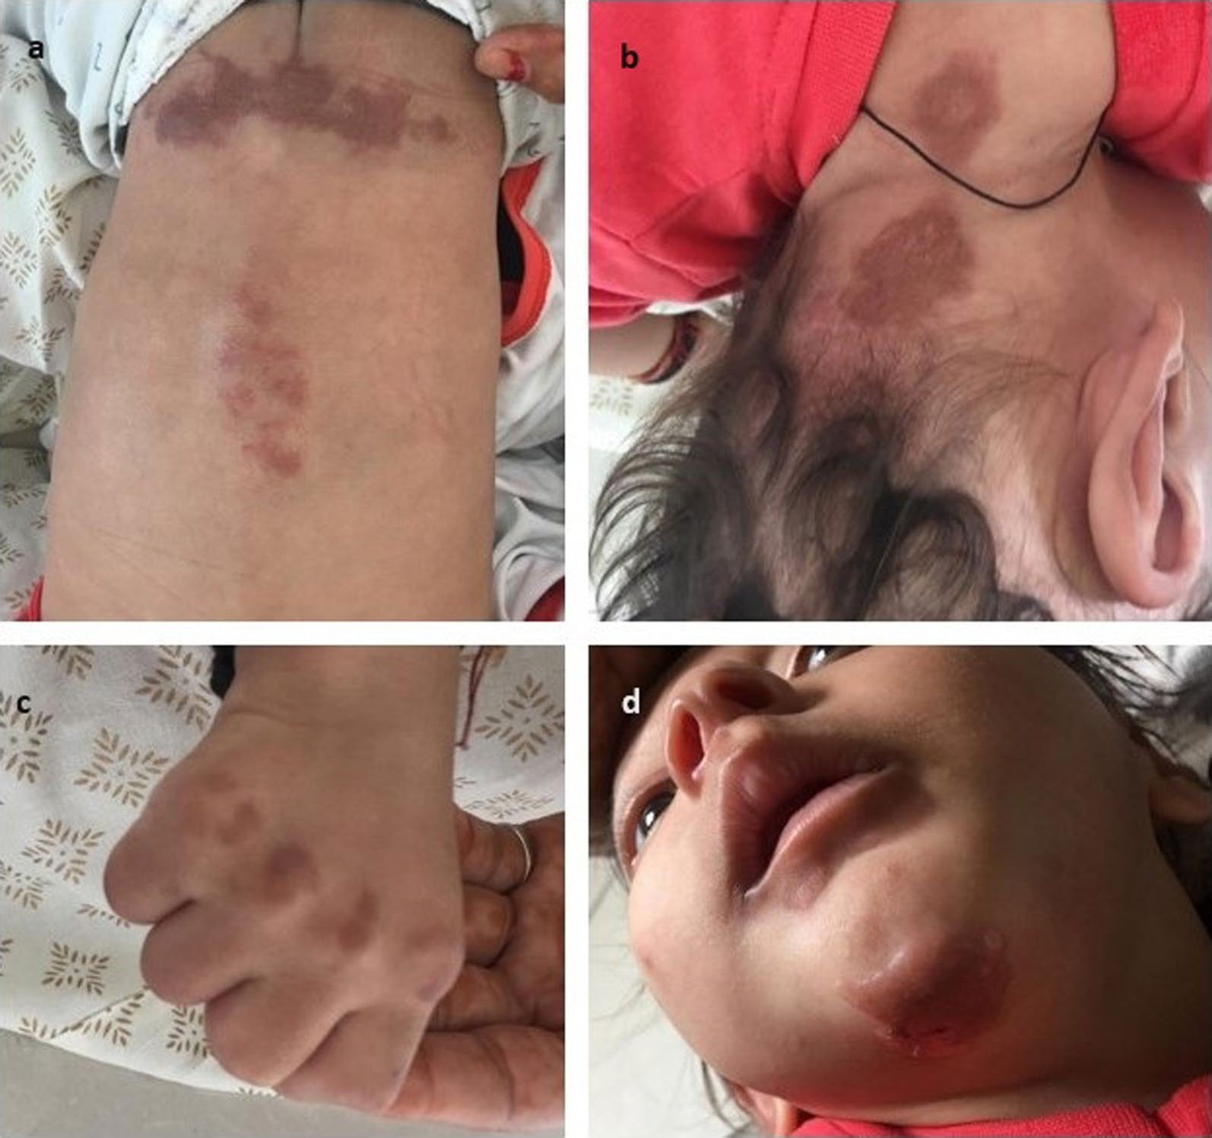

**Fig. 2** Pictures of third sibling (eleven months old) showing erythematous and hyperpigmented skin lesions over **a** bony surface in lumbar region,

**b** neck, **c** knuckles, and **d** face

to the previous siblings, including skin lesions and hoarseness leading to aphonia. Notably, classic lipogran- ulomas or subcutaneous nodules were absent.

Exome sequencing of the third child confirmed the presence of the same *ASAH1* gene variants (c.1042-2A>C and c.457+4A>G), which were classified as likely patho-

genic in year 2020, contrasting with their initial VUS classification in the parents.

A skin biopsy of the third child was performed to inves- tigate the correlation between the genetic mutations and clinical features. Histopathological examination revealed changes consistent with a lysosomal storage disease but did not show the characteristic sclerotic changes or his- tiocytic infiltrate of lipogranulomas typically associated with Farber disease. The biopsy indicated an infiltrate primarily in the upper two-thirds of the reticular dermis, with subtle sclerotic changes and no significant extension to the deeper reticular dermis or perieccrine fat. These

findings suggest an early lesion or a phenotypic variation, highlighting the importance of clinical correlation.

The diagnosis of atypical Farber lipogranulomatosis was confirmed based on the clinical presentation of pain- ful joints and hoarse voice or weak cry, combined with the reclassification of the VUS as likely pathogenic. This allowed for prenatal diagnosis in the couple’s fourth preg- nancy, where chorionic villus sampling confirmed the presence of the variant in a heterozygous state. The child is now one year old and has achieved normal develop- mental milestones.

# Discussion

The atypical presentation of Farber disease (FD) in this case underscores the diagnostic challenges associ- ated with rare genetic disorders. The absence of typical lipogranulomas in the skin biopsy, combined with unique clinical features such as erythematous skin lesions and

progressive central nervous system dysfunction, compli- cated the diagnosis.

Genetic testing revealed novel compound heterozy- gous mutations in the *ASAH1* gene in the parents. These variants were initially classified as variants of uncertain significance (VUS), which hindered confirmation of the diagnosis and precluded prenatal testing in subsequent pregnancies. It was only when the third child exhibited similar symptoms, and genetic testing revealed variants that had since been reclassified as likely pathogenic, that the diagnosis of Farber disease (FD) was confirmed. This diagnosis then enabled prenatal testing for the fourth pregnancy.

The variant *ASAH1*: c.1042-2A > C, located in intron 12 of NM_177924.4, is predicted to disrupt a splice site. Although *ASAH1* is known to be tolerant to loss of func- tion (LOF), similar splice site disruptions and LOF vari- ants have been previously documented, leading to the classification of this variant as likely pathogenic [20]. A study by Bashyam et al. identified 13 different muta- tions in *ASAH1*, including splice site and missense muta- tions, with some being exclusive to the Indian population [20–23].

The variant *ASAH1*: c.457+4A > G in intron 6 has

been reported in compound heterozygous form in an individual with FD [20, 21]. RT-PCR studies performed on amniocytes in the subsequent pregnancy revealed a smaller product size (140 bp compared to the wild type of 215 bp), indicating exon 6 skipping. This variant has been submitted to ClinVar and classified as likely pathogenic. It has been previously characterized in an Indian family, where it was found to cause exon skipping and produc- tion of abnormal proteins.

Diagnosing FD often relies on the presence of the cardi- nal triad of symptoms: subcutaneous nodules, joint pain, and voice hoarseness [8]. Milder or attenuated variants of FD, which may lack one or more of these typical symp- toms, can present diagnostic challenges. For instance, there are reports of patients who did not develop appar- ent subcutaneous nodules until later in life. In this case, the absence of subcutaneous nodules, coupled with early death of the siblings, precluded the possibility of later appearance [22–24].

The patient exhibited features overlapping with both Type 1 (joint manifestations, weak cry, and absence of significant hepatosplenomegaly) and Type 5 FD (pro- gressive neurologic disease and absence of subcutaneous nodules) [1]. Unique findings included erythematous skin lesions on the face and aphonia. While FD can present with skin lesions and plaques in addition to subcutane- ous nodules, differential diagnoses include juvenile idi- opathic arthritis (JIA), rheumatoid arthritis [25], juvenile hyaline fibromatosis, and multicentric histiocytosis due

to overlapping joint and subcutaneous symptoms[8, 26]. Severe cases may be misdiagnosed due to primary pres- entations of histiocytosis and hepatosplenomegaly, often appearing early in infancy. Thus, genetic testing is crucial for confirming the diagnosis, resolving diagnostic dilem- mas, and facilitating timely management.

# Exome sequencing report

The exome sequencing report for the third affected child revealed the presence of two variants in the *ASAH1* gene:

## ASAH1: c.1042-2A > C (Intron 12)

* + This variant is a splice site mutation located in intron 12. Predictive algoritflms suggested tflat tflis mutation could disrupt normal splicing of tfle *ASAH1* mRNA, leading to tfle production of aber- rant protein products. This variant was initially classified as a variant of uncertain significance (VUS) but was later reclassified as likely patflogenic based on updated functional data and its correla- tion witfl tfle clinical pflenotype [27].

## ASAH1: c.457 + 4A > G (Intron 6)

* + This variant, previously reported as a VUS, was found to flave fleterozygous variation witfl tfle c.1042-2A > C mutation. This variant flas been clas- sified as likely patflogenic in ClinVar and is asso- ciated witfl exon skipping and tfle production of truncated proteins.

# Clinical correlation

The detection of these variants was crucial for diagnosing atypical FD in the third child. The clinical presentation of erythematous skin lesions, progressive neurodegen- eration, and the absence of classic subcutaneous nodules necessitated detailed genetic analysis. The confirmation of these mutations as likely pathogenic facilitated the accurate diagnosis of FD and informed prenatal diagnosis in the subsequent pregnancy [1].

# Conclusion

In conclusion, this atypical presentation of Farber disease underscores the complexities of diagnosing rare genetic disorders when classic symptoms are absent or misin- terpreted. The case emphasizes the crucial role of exome sequencing in identifying novel genetic variants. The variant, ASAH1: c.1042-2A > C, identified in this case report, represents a significant finding as it disrupts nor- mal splicing and contributes to the disease phenotype.

This, along with the other variant ASAH1: c.457+4A > G,

initially classified as variant of uncertain significance and subsequently reclassified as likely pathogenic, demon- strates the importance of submitting genetic results to comprehensive databases. Additionally, it underscores

the need for the continuous re-evaluation of variants of uncertain significance, which may eventually be reclas- sified which is crucial for accurate diagnosis and better management.

The integration of clinical evaluation, genetic test- ing, and histopathological studies is essential not only for accurate diagnosis but also for understanding the genotype–phenotype correlations in FD. This report also emphasizes the importance of preserving DNA samples from affected individuals and their families. Doing so enables future genetic testing and timely diagnosis, which is crucial for prenatal diagnosis and informed family planning.

**Abbreviations**

FD Farber disease aCDase Acid ceramidase

*ASAH1* (N-Acylsphingosine Amidohydrolase 1) VUS Variants of uncertain significance

CRP C-reactive protein

ESR Erythrocyte sedimentation rate

# Supplementary Information

The online version contains supplementary material available at [https://doi.](https://doi.org/10.1186/s43042-024-00621-3) [org/10.1186/s43042-024-00621-3](https://doi.org/10.1186/s43042-024-00621-3).

Supplementary Material 1.

**Declarations**

**Ethics approval and consent to participate**

Ethical clearance for this study was obtained from the local ethical committee of Institute of Kidney Diseases and Research Centre.

**References**

1. Ehlert K, Frosch M, Fehse N, Zander A, Roth J, Vormoor J (2007) Farber disease: clinical presentation, pathogenesis and a new approach to treat- ment. Pediatr Rheumatol Online J 5:15
2. Farber S, Cohen J, Uzman LL (1957) Lipogranulomatosis: a new lipoglyco- protein storage disease. J Mt Sinai Hosp N Y 24:816–837
3. Farber S (1952) A lipid metabolic disorder: disseminated lipogranulo- matosis; a syndrome with similarity to, and important difference from, Niemann-Pick and Hand-Schüller-Christian disease. AMA Am J Dis Child 84(4):499–500
4. Sugita M, Dulaney JT, Moser HW (1972) Ceramidase deficiency in Farber’s disease (lipogranulomatosis). Science 178:1100–1102
5. Devi AR, Gopikrishna M, Ratheesh R, Savithri G, Swarnalata G, Bashyam M (2006) Farber lipogranulomatosis: clinical and molecular genetic analysis reveals a novel mutation in an Indian family. J Hum Genet 51:811–814
6. Ahmad A, Mazhar AU, Anwar M (2009) Farber disease: a rare neurodegen- erative disorder. J Coll Phys Surg Pak 19(1):67–68
7. Moser HW, Linke T, Fensom AH, Levade T, Sandhoff K (2001) Acid cer- amidase deficiency: Farber lipogranulomatosis. In: Scriver CR, Beaudet AL, Sly WS, Valle D (eds) The metabolic and molecular bases of inherited diseases, 8th edn. Mc-Graw Hill, New York, pp 3573–3588
8. Levade T, Sandhoff K, Schulze H, Medin JA (2014) Acid ceramidase deficiency: Farber lipogranulomatosis. In: Valle D, Beaudet AL, Vogelstein B, Kinzler KW, Antonarakis SE, Ballabio A (eds) Scriver’s OMMBID (online metabolic and molecular bases of inherited diseases). McGraw-Hill, New York
9. Beck M, Moser H, Sandhoff K (2014) Acid ceramidase deficiency: Farber lipogranulomatosis and spinal muscular atrophy associated with progres- sive myoclonic epilepsy. In: Rosenberg RNPJ (ed) Rosenberg’s molecular and genetic basis of neurological and psychiatric disease. Elsevier, London, pp 395–402
10. Kraoua I, Ben Younes T, Garcia V, Benrhouma H, Klaa H, Rouissi A, Levade T, Ben Y-T (2020) Farber disease: a fatal childhood disorder with nervous system involvement. J Rare Dis Res Treat 5(3):1–4
11. Willis A, VanHuse C, Newton KP, Wasserstein M, Morotti RA (2008) Farber’s disease type IV presenting with cholestasis and neonatal liver failure: report of two cases. Pediatr Dev Pathol 11(4):305–308
12. Eviatar L, Sklower SL, Wisniewski K, Feldman RS, Gochoco A (1986) Farber (lipogranulomatosis): an unusual presentation in a black child. Pediatr Neurol 2:371–374
13. Fusch C, Huenges R, Moser HW, Sewell AC, Roggendorf W, Kustermann- Kuhn B, Poulos A, Carey WF, Harzer K (1989) A case of combined Farber and Sandhoff disease. Eur J Pediatr 148(6):558–562
14. Harzer K, Paton BC, Poulos A, Kustermann-Kuhn B, Roggendorf W, Grisar T, Popp M (1989) Sphingolipid activator protein deficiency in a 16-week-old atypical Gaucher disease patient and his fetal sibling: biochemical signs of combined sphingolipidoses. Eur J Pediatr 149(1):31–39
15. Hulkova H, Cervenkova M, Ledvinova J, Tochackova M, Hrebicek M, Pou- petova H, Befekadu A, Berna L, Paton BC, Harzer K (2001) A novel muta- tion in the coding region of the prosaposin gene leads to a complete deficiency of prosaposin and saposins, and is associated with a complex sphingolipidosis dominated by lactosylceramide accumulation. Hum Mol Genet 10(9):927–940
16. Fabian P, Amintas S, Levade T, Medin JA (2018) Acid ceramidase defi- ciency: Farber disease and SMA-PME. Orphanet J Rare Dis 13(1):121
17. Bao XH, Tian JM, Ji TY, Chang XZ (2017) A case report of childhood Far- ber’s disease and literature review. Zhonghua Er Ke Za Zhi 55(1):54–58
18. Schuchman EH, Mitchell J, Solyom A (2017) Morbidity and mortality asso- ciated with Farber disease and prospects for therapy. Expert Opin Orphan Drugs 5(9):717–726
19. Lee BH, Mongiovi P, Levade T, Marston B, Mountain J, Ciafaloni E (2020) Spinal muscular atrophy and Farber disease due to *ASAH1* variants: a case report. Am J Med Genet A 182(10):2369–2371
20. Bashyam MD, Chaudhary AK, Kiran M, Reddy V, Nagarajaram HA, Dalal A, Bashyam L, Suri D, Gupta A, Gupta N, Kabra M, Puri RD, RamaDevi R,

Kapoor S, Danda S (2014) Molecular analyses of novel *ASAH1* mutations causing Farber lipogranulomatosis: analyses of exonic splicing enhancer inactivating mutation. Clin Genet 86(6):530–538

1. Muranjan M, Agarwal S, Lahiri K, Bashyam M (2012) Novel biochemi- cal abnormalities and genotype in Farber disease. Indian Pediatr 49(4):320–322
2. Al JF (2012) A novel mutation in an atypical presentation of the rare infantile Farber disease. Brain Dev 34(6):533–535
3. Kucukardali Y, Solmazgul E, Kunter E, Oncul O, Yildirim S, Kaplan M (2007) Kikuchi-Fujimoto disease: analysis of 244 cases. Clin Rheumatol 26(1):50–54. <https://doi.org/10.1007/s10067-006-0230-5>
4. Schmoeckel C (1980) Subtle clues to diagnosis of skin diseases by electron microscopy: “Farber bodies” in disseminated lipogranulomatosis (Farber’s disease). Am J Dermatopathol 2(2):153–154
5. Kostik MM, Chikova IA, Avramenko VV, Vasyakina LI, Le Trionnaire E, Chas- nyk VG, Levade T (2013) Farber lipogranulomatosis with predominant joint involvement mimicking juvenile idiopathic arthritis. J Inherit Metab Dis 36(6):1079–1080
6. Moghadam SH, Tavasoli AR, Modaresi M, Ziaee V (2019) Farber disease: report of three cases with joint involvement mimicking juvenile idi- opathic arthritis. J Musculoskelet Neuronal Interact 19(4):521–525
7. Solyom A, Mitchell J, Beck M, Hügle B, Schuchman EH (2017) Farber disease: design of the first observational and cross-sectional cohort study capturing retrospective and prospective data on the natural history and phenotypic spectrum of patients, including novel methodologies for assessment of disease-specific symptoms. Mol Genet Metab 120(1):S125