**Anticancer Efficacy of Garlic Bioactive Constituents: Allicin and Z‑Ajoene**

## ABSTRACT

Garlic (*Allium sativum*) owes much of its anticancer activity to sulfur‑containing metabolites produced when cloves are crushed, chiefly **allicin** and its more stable rearrangement product **Z‑ajoene**. Even though it breaks down quickly, allicin causes mitochondrial-driven apoptosis, modifies the Nrf2 pathway to change the cellular redox balance, and inhibits drug efflux proteins (such P glycoprotein) to make resistant cancer cells more sensitive to chemotherapy. Z‑ajoene exerts complementary effects: it triggers endoplasmic reticulum stress—upregulating BiP/GRP78 and activating the PERK/ATF4/CHOP axis—to drive caspase‑mediated cell death; it blocks Wnt/β‑catenin signaling through CK1α‑mediated β‑catenin phosphorylation, reducing oncogenic drivers like c‑Myc; it disrupts vimentin filaments to impair invasion; and it selectively targets cancer stem cells by influencing AKT, TGF‑β, Notch, and ERK/p38 pathways. Recent translational efforts include nanoformulation of allicin for enhanced stability and delivery, as well as combination regimens pairing these compounds with standard chemotherapeutics (e.g., 5‑FU, paclitaxel) that demonstrate synergistic tumor inhibition and reduced systemic toxicity.

***Keywords:***allicin, ajoene, garlic, anticancer, apoptosis, chemoresistance.

**1. INTRODUCTION**

Since ancient times, people have utilized garlic (Allium sativum) as a food ingredient and for its many health benefits, which include cancer prevention. [Catherine H. Kaschula 2019]. It is also regarded as one of the most potent anti-cancer and chemopreventive meals. [Hyejin Lee 2019]. Sulfur compounds found in garlic continue to exhibit a variety of anticancer properties that go beyond redox regulation and apoptosis. Allicin's stability, circulation time, and tumor uptake have been significantly increased by recent nanoformulation techniques, such as liposomal encapsulation and polymeric nanoparticles, which has improved the drug's in vivo effectiveness in lung and breast cancer xenografts [Jan Borlinghaus 2024]. It is generally assumed that the health-promoting attributes, including the anticancer activity and the characteristic smell of garlic, are mainly due to garlic organosulfur com pounds(OSCs), among them allicin, allyl sulfide (AS), diallyl sulfide (DAS), diallyl disulfide (DADS), diallyl trisulfide (DATS), diallyl tetrasulfide (DATeS), dipropyl disulfide (DPDS), ajoene, allyl methyl thiosulfonate, 1-propenyl allyl thiosulfonate, L-glutamyl-S-alkyl-L cysteine, S-allylcysteine (SAC), and S-allylmercaptocysteine (SAMC) [Paulina Furdak 2024].

These delivery methods allow for regulated release at the tumor location while shielding allicin from quick breakdown. In the meantime, z-ajoene has become a powerful chemosensitizer: when coupled with paclitaxel and 5-FU, it overcomes multidrug resistance in ovarian and colorectal cancer models by downregulating ATP-binding cassette transporters (e.g., p-gp, MRP1) [Mohamed T. El-Saadony 2024]. At the signaling level, Z-ajoene suppresses the synthesis of inflammatory cytokines mediated by NF-κB and inhibits the PI3k/AKT and STAT3 pathways, which lowers proliferation and survival signals [Wamidh H. Talib 2024, Yuchae Jung, 2014]. Additionally, its capacity to trigger ER stress (BiP, CHOP) complements the blockage of the Wnt/β-catenin pathway—through CK1α-dependent β-catenin phosphorylation—to reduce stemness markers (c-Myc, cyclin-D1) and hinder the self-renewal of cancer stem cells [Catanzaro E 2022]. Numerous investigations have documented the anticancer, antioxidant, anti-inflammatory, and antibacterial properties of allicin (AC), an organosulfur component present in garlic. [ Faris J. Alyasiri 2023].

These developments collectively highlight a synergistic paradigm: Z-ajoene addresses resistance mechanisms and oncogenic networks, providing a strong, multi-targeted approach against resistant cancers, while stable allicin formulations provide long-lasting pro-apoptotic and antioxidant effects.

## 2. Chemistry & Biosynthesis

**2.1 Allicin:**

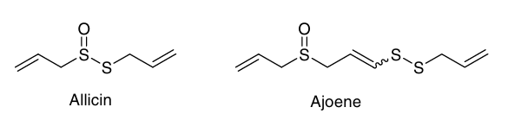Stoll and Seebeck identified the structure of allicin, a thiosulfinate, in 1948. In nature, an enzymatic reaction that damages plant tissue results in the production of allicin. The non-proteinogenic amino acid alliin (S-allyl-l-cysteine sulfoxide) is the precursor of allicin. The enzyme alliinase hydrolyzes alliin and other S-alkyl-l-cysteine sulfoxides, producing allyl sulfenic acid and dehydroalanine in the case of alliin. One allicin molecule is produced when two allyl sulfenic acid molecules spontaneously condense. Alliin can be found in ramsons (Allium ursinum) and garlic (Allium sativum). It's interesting to note that onions (Allium cepa) produce isoalliin (trans-(+)) rather than alliin. The sulfoxide of S-(1-propenyl)-l-cysteine. It is still unclear how alliin is biosynthesized. Granroth's groundbreaking research, which identified two potential biosynthetic routes based on radioactive labeling tests, hasn't been improved upon as of yet. Scheme 1 presents his findings. [Jan Borlinghaus 2014]

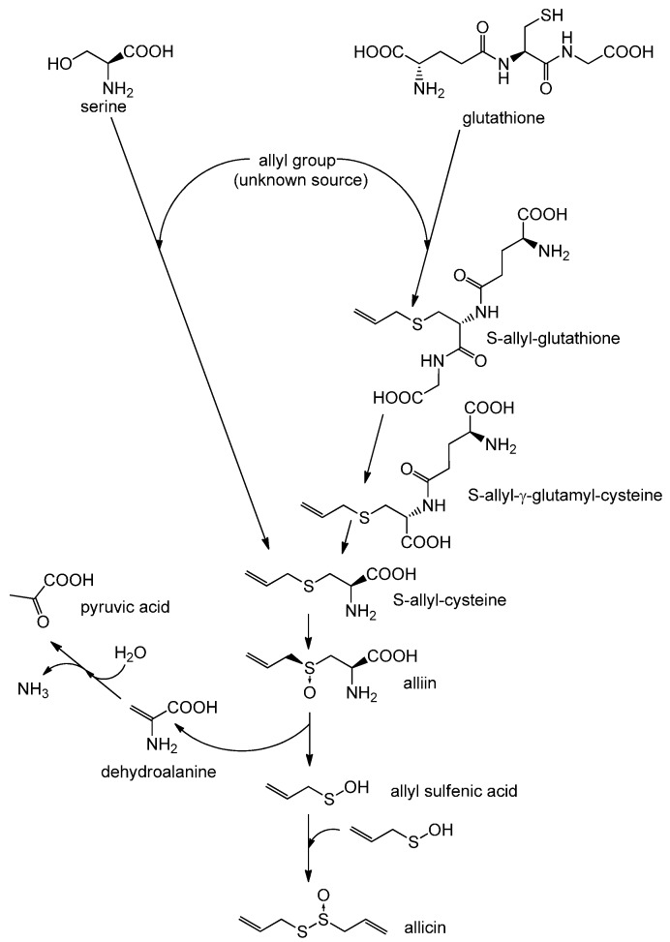

Fig No:1 Biosynthesis of allicin

**2.2 Z‑Ajoene**

Structure of Ajoene [Roger Hunter 2009]

Extracts of garlic (Allium sativum) include an organosulfur component called ajoene. It is a colorless liquid with functional groups of disulfide and sulfoxide. Garlic is called "ajo" in Spanish, which is where the name (and pronunciation) originate. It contains up to four stereoisomers, which differ in the stereochemistry of the core alkene (E- vs. Z-) and the chirality of the sulfoxide sulfur (R- vs. S-). [Catherine H. Kaschula 2010] The first isolation of Z-ajoene was made from processed garlic in an E/Z combination. [Yuchae Jung 2014]. Ajoene consists of Two isomers are combined to form ajoene [(E, Z)-4,5,9-trithiadodeca-1,6,11-triene-9-oxide]. [Min Li 2002].

Allicin is released when a garlic clove is crushed or finely minced, and when the substance dissolves in different solvents, such as edible oils, ajoene is formed. Garlic extract also contains ajoene. The most plentiful and stable form of ajoene is found in garlic macerate, which is made from chopped garlic in edible oil.   
  
Two allicin molecules are involved in the chemical sequence that creates ajoene (2 in the diagram). First, 2-propenesulfenic acid and thioacrolein are formed when one allicin molecule (1 in the picture) breaks apart. These two react with another allicin molecule in distinct phases using a conjugated thiocationic intermediate. It has an interesting allyl vinyl disul de functional grouping that probably explains its variety of biological actions by functioning as a sulfenylating agent against sulfhydryl groups in proteins. [Roger Hunter 2008].

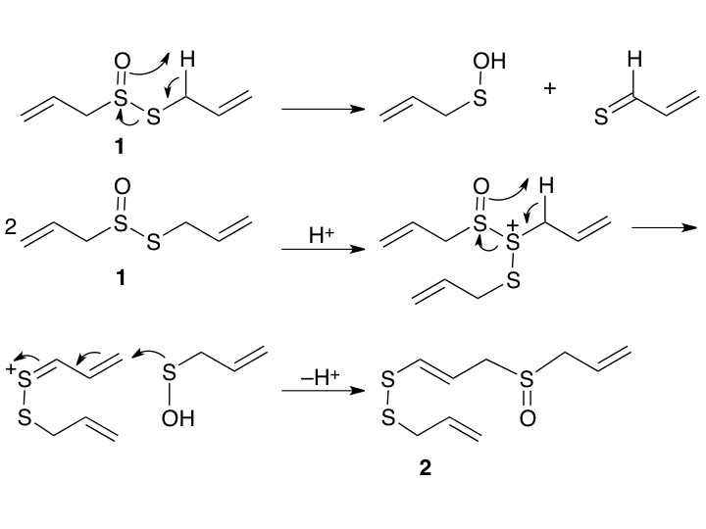

Fig No:2 Biosynthesis of a Z‑Ajoene

## 3. Mechanisms of Anticancer Action

**3.1 Allicin**

**3.1.1 Apoptosis & Cell-Cycle Arrest**

**3.1.1.1 *Promotion of Apoptosis****:* Allicin inhibits the PI3K/Akt signaling pathway, which is essential for cell viability, while downregulating anti-apoptotic proteins such as Nrf2 and heme oxygenase 1. This facilitates planned cell death by triggering pro-apoptotic pathways and upregulating the production of molecules such as caspases and Bax.

**3.1.1.2 *Cell-Cycle Arrest****:* Allicin inhibits the growth of cancer cells by influencing cell cycle regulators, which results in arrest in particular phases. Modification of signaling pathways including p53 and NF-κB that are important in cell cycle progression mediates this inhibition. [Wamidh H. Talib 2024].

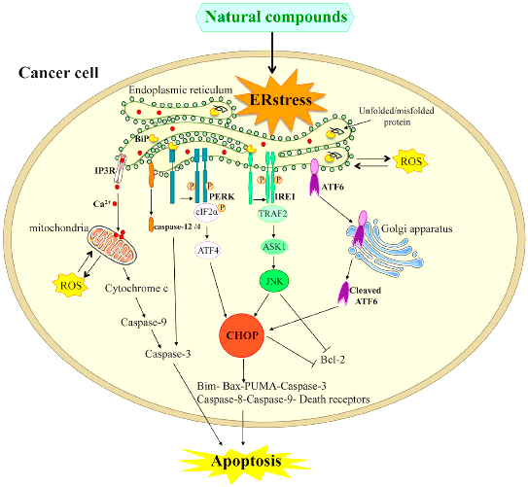

Fig No.3 Mechanism of Apoptosis

**3.1.2 Oxidative Stress & Nrf2**

An imbalance between the body's capacity to use antioxidants to counteract dangerous chemicals known as free radicals results in oxidative stress. Cell damage from this can lead to illnesses like cancer.   
A protein called Nrf2 aids in shielding cells from oxidative damage. It helps cells fight off harm by triggering the synthesis of antioxidants and other defense-related enzymes.

**3.1.3 Protein Thiolation**

The chemical process by which sulfur-containing groups, known as thiols, bind to proteins is known as protein thiolation. Protein function may be altered by this alteration, which frequently has an impact on cell growth, survival, or death. Targets proteins like NF‑κB, STAT3, HIF‑1α via thiol modification to inhibit proliferation and metastasis.

**3.1.4 Chemoresistance Reversal**

When cancer cells cease reacting to chemotherapy medications, it is known as chemoresistance, which reduces the effectiveness of treatment.   
Reversing chemoresistance increases the likelihood of a successful course of treatment by figuring out how to make cancer cells susceptible to these medications once more. [Yang Zhou 2022]

**3.1.5 In Silico Targeting**

This is the process of predicting how allicin would interact with various disease-related proteins, including those implicated in bacterial infections, inflammation, cancer, and viruses like COVID-19, using computer simulations.   
In order to create successful medicines without requiring preliminary laboratory testing, scientists can better understand which allicin forms bind to certain targets with the aid of these computer models. Modeling studies confirm high-affinity interactions with HER-2, PI3K, and AKT, guiding analog design.

**3.1.6 Nano‑Formulation Advances**

To better carry allicin into the body, researchers are creating nanotechnology-based carriers known as nanocages. Allicin can be encapsulated by these microscopic carriers (such as Al₁₂N₁₂, B₁₂N₁₂, and C₂₄), which improves its stability, prevents degradation, and facilitates its delivery to particular sick cells or tissues.   
The use of these nanocages increases the therapeutic potential of allicin by improving its stability and absorption as well as its capacity to interact with disease targets. [E. S. Mozafari 2025].

**3.2 Z‑Ajoene**

**3.2.1 ER Stress-Related Apoptosis**

The endoplasmic reticulum (ER), a cell structure involved in protein folding, is stressed in this way. Cancer cells can die as a result of apoptosis, a process that is triggered by excessive ER stress. Induces ER stress markers (BiP, PERK, ATF4, CHOP), increases Bax and caspases, while suppressing Bcl-2 in NSCLC; 4‑PBA reverses effects.

**3.2.2 DLG1/YAP Axis Inhibition**

DLG1 and YAP are proteins involved in cell growth and survival. Blocking the interaction or pathway (called the DLG1/YAP axis) that promotes cancer cell proliferation can inhibit tumor growth.

**3.2.3 Apoptosis in Leukemia**

Promoting apoptosis, or programmed cell death, in leukemia cells aids in the reduction or eradication of the cancer. ROS-driven, caspase-3-dependent apoptosis in HL‑60 cells; counteracted by antioxidants and caspase inhibitors.

**3.2.4 G₂/M Arrest & hTERT Inhibition**

Cell division can be stopped by stopping the cell cycle at the G₂/M phase. Furthermore, cancer cells' capacity to preserve their telomeres is restricted when hTERT (the telomerase enzyme) is blocked, which results in cell aging and death. Arrests cycle via cyclin B1/Cdc2 and suppresses telomerase activity in leukemia models.

**3.2.5 Wnt/β‑catenin Pathway Suppression**

The signaling system of Wnt/β-catenin promotes cell division and proliferation. Cancer cell proliferation can be decreased by inhibiting this mechanism. Enhances CK1α-mediated β‑catenin phosphorylation, promoting degradation and reducing c-Myc and cyclin D1 in colon cancer.

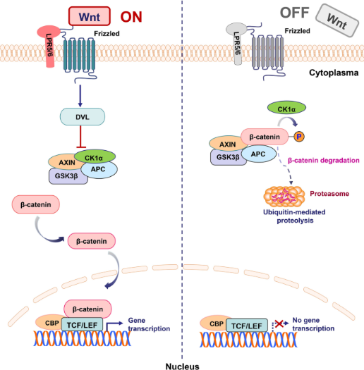  
Fig.no:4 Wnt/β‑Catenin Inhibition by Z‑Ajoene

**3.2.6 Cytoskeletal Disruption**

Cell mobility and shape are preserved by the cytoskeleton. By interfering with its migration and invasion, cancer cells can be prevented from spreading. Modifies vimentin to hinder motility and metastasis in breast/esophageal cancers.

**3.2.7 CSC Targeting**

A tiny subset of tumor cells called cancer stem cells has the ability to regenerate the malignancy. The goal of targeting these cells is to enhance therapy results and stop tumor recurrence. Affects glioblastoma CSCs (CD133+/ALDH+) by inhibiting AKT, TGF-β, Notch, Hedgehog, while activating ERK/p38.

**3.2.8 Antioxidant/Cytotoxic Duality**

Certain substances have the capacity to kill cancer cells (cytotoxic effect) as well as neutralize dangerous reactive oxygen species (antioxidant effect). This dual function can attack cancer cells while defending healthy cells. ERK–Nrf2–NQO1 activation at low doses vs ROS-mediated apoptosis at higher exposures [ Wamidh H. Talib 2024]

## 4. Comparative Analysis

|  |  |  |
| --- | --- | --- |
| Characteristic | Allicin | Z‑Ajoene |
| Stability | Unstable; rapidly degraded | Stable; suitable for oral formulations |
| Mechanism Breadth | Broad thiol reactivity, apoptosis | ER stress, Wnt inhibition, cytoskeletal and CSC targeting |
| Chemoresistance Effect | Reverses NSCLC drug resistance | Synergizes with chemotherapy; CSC elimination possible |
| Bioavailability | Enhanced via nanocarriers | Drinkable/oil formulations viable |

## 5. Translational & Clinical Perspectives

**5.1 Advanced Formulations**

* **Allicin**: Computational analyses show that, in comparison to free allicin, the development of nanocomplexes such as Allicin/C₂₄, Allicin/B₁₂N₁₂, and Allicin/Al₁₂N₁₂ has increased stability and stronger interactions with biological targets. sophisticated formulations that include allicin, especially when it comes to its inclusion in nanocages like C₂₄, B₁₂N₁₂, and Al₁₂N₁₂. These nanocages are promising drug delivery vehicles that improve allicin's stability, bioavailability, and targeted delivery. [E. S. Mozafari 2025]
* **Z‑Ajoene**: Ideal for nutraceutical formulations; oil-based delivery standardization in progress.

**5.2 Safety & Pharmacokinetics**

* Allicin is degraded before systemic uptake—necessitating novel delivery forms
* Z‑ajoene shows targeted CSC toxicity with minimal normal cell impact, substantiating clinical trials.

**5.3 Clinical Trial Pipeline**

* No major allicin trials in oncology; topical/adjunct studies underway.
* Meta-analyses show promise in GI and prostate cancer risk reduction, though RCT data is mixed.

**5.4 Combinatorial Therapy**

Compounds from garlic are used in combination therapy to target several cancer hallmarks at once, increasing anticancer efficacy. Among the examples are:  
 **5.4.1 Garlic with 5-Fluorouracil (5-FU):** Research has shown that allicin and 5-FU together enhance the generation of reactive oxygen species (ROS), cause mitochondrial malfunction, activate caspase-3 and PARP, and decrease the expression of Bcl-2. This multimodal strategy enhances therapeutic results and encourages apoptosis.

**5.4.2 Garlic Components with Other drugs:** Garlic components can enhance anticancer activities such apoptosis induction, proliferation inhibition, and angiogenesis suppression when combined with targeted drugs or traditional chemotherapeutics. Studies demonstrate synergy with 5‑FU, oxaliplatin, gemcitabine, paclitaxel; Z‑ajoene may complement via CSC targeting. [ Wamidh H. Talib 2024]

**5.5 Development Roadmap**

1. Design and characterize nano formulations.
2. Conduct PK/PD and safety in animal models.
3. Use biomarkers (ER stress, β‑catenin) for translation.
4. Initiate Phase I trials in chemoresistant cancers.
5. Combine phytochemical and standard chemotherapy regimens.

## 6. Conclusions and Future Directions

Allicin and Z‑ajoene offer complementary anticancer strategies: allicin reverses chemoresistance via thiol reactivity; Z‑ajoene induces ER stress, suppresses Wnt signaling, disrupts CSCs and metastasis.

**Future priorities** include:

* Nano-carrier formulations.
* Biomarker-driven preclinical and clinical validation,
* CSC-focused combination studies.
* And initiation of phase I clinical trials.

These compounds meet key translational criteria: multi-pathway efficacy, target selectivity, manageable toxicity, and formulation adaptability.

**References**

1. Catherine H. Kaschula, Rosanna Tuveri, Ellen Ngarande, Kevin Dzobo, Christopher Barnett, Daniel A. Kusza, et al. (2019). The garlic compound ajoene covalently binds vimentin, disrupts the vimentin network and exerts anti-metastatic activity in cancer cells, BMC . <https://doi.org/10.1186/s12885-019-5388-8>.
2. Hyejin Lee, Ji-Won Heo, A-Reum Kim, Minson Kweon, Sorim Nam, Jong-Seok Lim, et al. (2019). Z-ajoene from Crushed Garlic Alleviates Cancer-Induced Skeletal Muscle Atrophy, MDPI, Nutrients. 11, 2724; doi:10.3390/nu11112724
3. Jan Borlinghaus, Frank Albrecht, Martin C. H. Gruhlke, Ifeanyi D. Nwachukwu and Alan J. Slusarenko (2014). Allicin: Chemistry and Biological Properties, MDPI journal. 12591-12618; doi:10.3390/molecules190812591
4. Paulina Furdak, Grzegorz Bartosz and Izabela Sadowska-Bartosz (2024). Which Constituents Determine the Antioxidant Activity and Cytotoxicity of Garlic? Role of Organosulfur Compounds and Phenolics, MDPI, International Journal of Molecular Science. https://doi.org/10.3390/ijms25158391
5. Mohamed T. El-Saadony, Ahmed M. Saad, Sameh A. Korma, Heba M. Salem, Taia A. Abd El-Mageed, Samar Sami Alkafaas et al. (2024). Garlic bioactive substances and their therapeutic applications for improving human health: a comprehensive review, Frontiers in immunology, Sec. Nutritional Immunology <https://doi.org/10.3389/fimmu.2024.1277074>
6. Yuchae Jung, Heejoo Park, Hui-Yuan Zhao, Raok Jeon, Jae-Ha Ryu, and Woo-Young Kim (2014). Systemic Approaches Identify a Garlic-Derived Chemical, Z-ajoene, as a Glioblastoma Multiforme Cancer Stem Cell-Specific Targeting Agent, Molecules and cells. <http://dx.doi.org/10.14348/molcells.2014.0158>
7. Faris J. Alyasiri, Maryam Ghobeh, Masoud Homayouni Tabrizi(2023). Preparation and Characterization of Allicin-Loaded Solid Lipid Nanoparticles Surface-Functionalized with Folic Acid-Bonded Chitosan: In Vitro Anticancer and Antioxidant Activities, Frontiers in Bioscience, Landmark. https://doi.org/10.31083/j.fbl2807135
8. Wamidh H. Talib, Media Mohammed Baban, Sana Allala and Lina T. AL Kury, Aya O. Azzam, et al. (2024). Allicin and Cancer Hallmarks, MDPI, Molecule. https:// doi.org/10.3390/molecules29061320
9. Elena Catanzaro, Donatella Canistro, Valentina Pellicioni, Fabio Vivarelli, Carmela Fimognari (2022). Anticancer potential of allicin: A review, DOI: <http://doi.org/10.1016/j.phrs.2022.106118>.
10. Catherine H. Kaschula, Roger Hunter and M. Iqbal Parker(2010). Garlic-derived anticancer agents: Structure and biological activity of ajoene, DOI: 10.1002/biof.76
11. Yuchae Jung, Heejoo Park, Hui-Yuan Zhao, Raok Jeon, Jae-Ha Ryu, and Woo-Young Kim(2014). Systemic Approaches Identify a Garlic-Derived Chemical, Z-ajoene, as a Glioblastoma Multiforme Cancer Stem Cell-Specific Targeting Agent, Molecules and cells, <http://dx.doi.org/10.14348/molcells.2014.0158>
12. Min Li, jing -Rong Ciu, Ying Ye, Ji-Mei Min, Li-he Zhang, Kui Wang, et al. (2002). Antitumor activity of Z-ajoene, a natural compound purified from garlic: antimitotic and microtubule-interactoin properties. Carninogenesis vol.23.
13. Wamidh H. Talib, Sally Atawneh, Areen Nabil Shakhatreh, Ghyda’a Nabil Shakhatreh, Islam Subhi Rasheed aljarrah, Reem Ali Hamed, et al.(2024). Anticancer potential of garlic bioactive constituents: Allicin, Z-ajoene, and organosulfur compounds. Pharmacia. <https://doi.org/10.3897/pharmacia.71.e114556>
14. Yang Zhou1,2, Xingxuan Li2, Wenyu Luo2, Junfeng Zhu3, Jingwen Zhao4, Mengyao Wang(2022). Allicin in Digestive System Cancer: From Biological Effects to Clinical Treatment. Frontiers, Frontiers in Pharmacology. <https://doi.org/10.3389/fphar.2022.903259>
15. E. S. Mozafari, Mohammad T. Baei & E. Tazikeh Lemeski(2025). Computational study of the therapeutic properties of allicin and its nanocomplexes using DFT and molecular docking techniques. Scientific reports. <https://doi.org/10.1038/s41598-025-03293-0>
16. Roger Huntera, Catherine H. Kaschula, Iqbal M. Parkerb, Mino R. Caira, Philip Richards, Susan Travis, et al.(2008). Substituted ajoenes as novel anti-cancer agents. Elesevier, Bioorganic and Medicinal Chemistry Letters. doi:10.1016/j.bmcl.2008.08.056