**Anticancer Efficacy of Garlic (*Allium sativum*) bioactive constituents: Allicin and Z‑Ajoene**

## ABSTRACT

Garlic (*Allium sativum*) derives much of its anticancer properties from sulfur-containing metabolites generated when cloves are crushed, including Allicin and its more stable rearrangement product Z Ajoene. Despite its rapid degradation, Allicin induces mitochondrial-driven apoptosis, changes the Nrf2 pathway to alter cellular redox balance, and inhibits drug efflux proteins (such as P glycoprotein) to render chemotherapy-resistant cancer cells more susceptible. Z Ajoene has multiple effects, including triggering endoplasmic reticulum stress (upregulating BiP/GRP78 and activating the PERK/ATF4/CHOP axis), blocking Wnt/β catenin signaling through CK1α mediated β catenin phosphorylation, reducing oncogenic drivers like c Myc, disrupting vimentin filaments to impair invasion, and selectively targeting cancer stem cells through AKT, TGF β, Notch, and ERK/p38 pathways. Recent translational efforts include nanoformulation of Allicin for better stability and delivery, as well as combination regimens matching these drugs with traditional chemotherapeutics (e.g., 5FU, paclitaxel), which demonstrate synergistic tumor suppression and lower systemic toxicity..

**Keywords:** Allicin, Ajoene, Garlic, Anticancer, Apoptosis, Chemoresistance.

**1. INTRODUCTION**

Garlic (*Allium sativum*) has been used as a dietary ingredient since ancient times, and it has numerous health advantages, including cancer prevention. (Catherine H. Kaschula 2019). It is also considered one of the most effective anti-cancer and chemopreventive foods. (Hyejin Lee 2019). Garlic sulfur compounds continue to display anticancer effects that extend beyond redox modulation and apoptosis. Recent nanoformulation techniques, such as liposomal encapsulation and polymeric nanoparticles, have significantly increased Allicin's stability, circulation time, and tumor uptake, increasing the drug's in vivo effectiveness in lung and breast cancer xenografts (Jan Borlinghaus 2024). It is generally assumed that the health-promoting attributes, including the anticancer activity and the characteristic smell of garlic, are mainly due to garlic organosulfur compounds (OSCs), among which Allicin, allyl sulfide (AS), diallyl sulfide (DAS), diallyl disulfide (DADS), diallyl trisulfide (DATS), diallyl tetrasulfide (DATeS), dipropyl disulfide (DPDS), Ajoene, 1-propenyl allyl.

These delivery systems provide regulated release at the tumor site while protecting Allicin from rapid degradation. Meanwhile, z-Ajoene has emerged as a potent chemosensitizer: when combined with paclitaxel and 5-FU, it overcomes multidrug resistance in ovarian and colorectal cancer models by inhibiting ATP-binding cassette transporters (e.g., p-gp, MRP1) (Mohamed T. El-Saadony 2024). Z-Ajoene inhibits inflammatory cytokine synthesis through NF-κB and the PI3k/AKT and STAT3 pathways, reducing proliferation and survival signals (WamidhH.Talib 2024, Yuchae Jung, 2014).

In addition, its ability to cause ER stress (BiP, CHOP) enhances the inhibition of the Wnt/β-catenin pathway, which reduces stemness markers (c-Myc, cyclin-D1) and prevents cancer stem cells from self-renewing through CK1α-dependent β-catenin phosphorylation (Catanzaro E 2022). Garlic contains an organosulfur called Allicin (AC), which has been shown in numerous studies to have antibacterial, anti-inflammatory, antioxidant, and anticancer effects. (Faris J. Alyasiri 2023). These developments together highlight a synergistic paradigm: Z-Ajoene targets resistance mechanisms and oncogenic networks, giving a potent, multi-targeted therapy to resistant malignancies, whereas stable Allicin formulations have long-lasting pro-apoptotic and antioxidant benefits.

## 2. Chemistry & Biosynthesis

**2.1 Allicin:**

Allicin's structure as a thiosulfinate was determined by Stoll and Seebeck in 1948. Allicin is produced naturally when an enzymatic reaction destroys plant tissue. Alliin (S-allyl-l-cysteine sulfoxide), a non-proteinogenic amino acid, is the precursor of Allicin. Other S-alkyl-l-cysteine sulfoxides, including alliin, are hydrolyzed by the enzyme alliinase, which yields dehydroalanine and allyl sulfenic acid in the case of alliin. When two allyl sulfenic acid molecules spontaneously condense, one Allicin molecule is created. Alliin is present in garlic (*Allium sativum*) and ramsons (*Allium ursinum*). Interestingly, onions (Allium cepa) do not create alliin; instead, they make isoalliin (trans-(+)). S-(1-propenyl)-l-cysteine can be sulfoxided. How alliin is biosynthesised is currently unknown. To date, no improvements have been made to Granroth's pioneering work, which used radioactive labeling studies to identify two possible biosynthetic pathways. Scheme 1 displays his results. (Jan Borlinghaus. 2014)

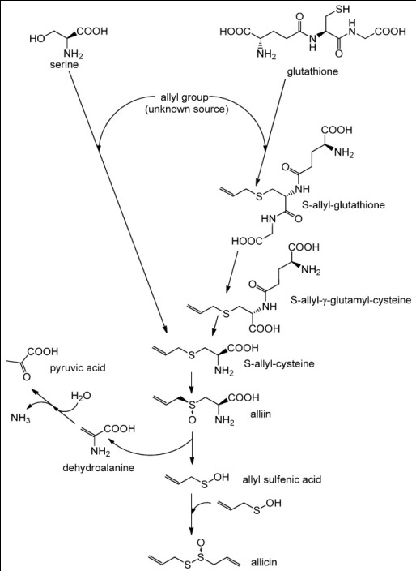

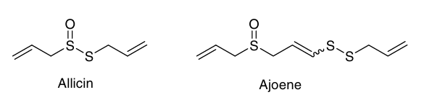



Fig No:1 Biosynthesis of Allicin -

Structure of Ajoene (Roger Hunter 2009)

Garlic extracts (*Allium sativum*) contain an organosulfur component known as Ajoene. It is a colorless liquid that contains disulfide and sulfoxide functional groups. Garlic is known as "ajo" in Spanish, which is where the word (and pronunciation) originates. It contains up to four stereoisomers with different stereochemistry of the core alkene (E- vs. Z-) and chirality of the sulfoxide sulfur (R- vs. S-). (Catherine H. Kaschula 2010.) The first isolation of Z-Ajoene came from processed garlic in an E/Z combination. (Yuchae Jung2014). Ajoene comprises of Two isomers are combined to form Ajoene ((E, Z)-4,5,9-trithiadodeca-1,6,11-triene-9-oxide). (Min Li. 2002).

When a garlic clove is crushed or finely diced, Allicin is released, and Ajoene is produced when the material dissolves in various solvents, such as edible oils. Garlic extract contains Ajoene. The most abundant and stable form of Ajoene is found in garlic macerate, a mixture of chopped garlic and edible oil. The chemical process that produces Ajoene involves two Allicin molecules (figure 2). When one Allicin molecule (1 in the illustration) breaks apart, it produces 2-propenesulfenic acid and thioacrolein. These two react with another Allicin molecule in separate phases via a conjugated thiocationic intermediate. It contains an unusual allyl vinyl disulfide functional grouping, which possibly explains its wide range of biological effects by acting as a sulfenylating agent against sulfhydryl groups in proteins. (Roger Hunter 2008).

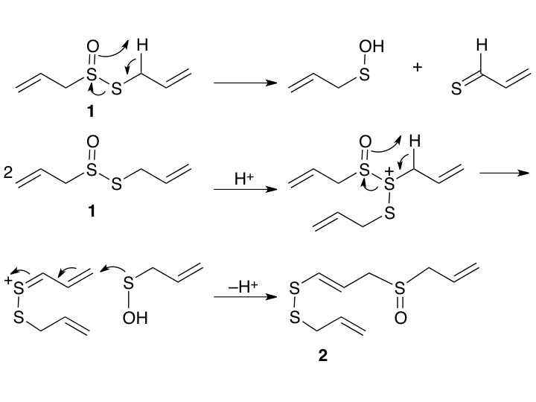

Fig No:2 Biosynthesis of a Z‑Ajoene

## 3. Mechanism of Anticancer Action

**3.1 Allicin**

**3.1.1 Apoptosis & Cell-Cycle Arrest**

**3.1.1.1 Promotion of Apoptosis**: Anti-apoptotic proteins including Nrf2 and heme oxygenase 1 are downregulated by Allicin, which also inhibits the PI3K/Akt signaling pathway, which is necessary for cell existence. This promotes the synthesis of molecules like caspases and Bax and initiates pro-apoptotic pathways, which enable planned cell death.

**3.1.1.2 Cell-Cycle Arrest**: By altering cell cycle regulators, Allicin prevents the growth of cancer cells and causes them to stop in specific stages. This suppression is mediated by changes to signaling pathways, such as p53 and NF-κB, which are crucial for the progression of the cell cycle. (Talib, Wamidh H. 2024).

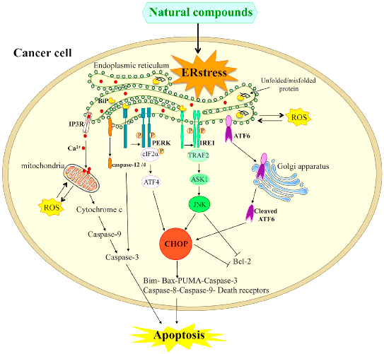

Fig No.3 Mechanism of Apoptosis

**3.1.2 Oxidative Stress & Nrf2**

Oxidative stress is caused by an imbalance in the body's ability to use antioxidants to combat harmful molecules called free radicals. This can cause cell damage, which can result in diseases like cancer. Nrf2 is a protein that helps protect cells from oxidative damage. By inducing the production of antioxidants and other defense-related enzymes, it aids cells in fending off damage.

**3.1.3 Protein Thiolation**

The chemical process known as protein thiolation is how sulfur-containing groups, or thiols, attach to proteins. Often, this change affects cell growth, survival, or death via changing the function of proteins. Thiol modification targets proteins such NF-κB, STAT3, and HIF-1α, preventing metastasis and proliferation.

**3.1.4 Chemoresistance Reversal**

Chemoresistance is a condition that decreases the efficiency of chemotherapy when cancer cells stop responding to the drugs used to treat it. Finding a way to make cancer cells sensitive to these drugs again raises the chance of a successful treatment by reversing chemoresistance. (Yang Zhou 2022)

**3.1.5 In Silico Targeting**

This is the technique of using computer simulations to anticipate how Allicin would interact with various disease-related proteins, such as those involved in bacterial infections, inflammation, cancer, and viruses like COVID-19. Scientists can use computer models to better understand which Allicin forms bind to certain targets, allowing them to build viable treatments without the need for preliminary laboratory research. Modeling investigations validate the high-affinity interactions with HER-2, PI3K, and AKT, driving analog design.

.**3.1.6 Nano‑Formulation Advances**

Researchers are developing nanotechnology-based carriers known as nanocages to improve Allicin absorption in the body. Microscopic carriers, such as Al₁₂N₁₂, B₁₂N₁₂, and C₂₄, can encapsulate Allicin, improving its stability, preventing breakdown, and facilitating delivery to specific diseased cells or tissues.   
The usage of these nanocages improves Allicin's therapeutic potential by increasing its stability, absorption, and ability to interact with disease targets. (E. S. Mozafari, 2025).

**3.2 Z‑Ajoene**

**3.2.1 ER Stress-Related Apoptosis**

This stress is directed at the endoplasmic reticulum (ER), a cell component that is important in protein folding. Cancer cells can die as a result of apoptosis, a process that is initiated by high ER stress. In NSCLC, it elevates ER stress indicators (BiP, PERK, ATF4, CHOP), increases Bax and caspases, and suppresses Bcl-2; however, 4 PBA reverses these effects.

**3.2.2 DLG1/YAP Axis Inhibition**

Two proteins that are essential for cell development and survival are DLG1 and YAP. It is possible to stop tumor growth by blocking the DLG1/YAP axis, a mechanism or interaction that encourages the growth of cancer cells.

**3.2.3 Apoptosis in Leukemia**

Leukemia cells can be made to undergo apoptosis, or programmed cell death, which helps to lessen or completely eradicate the cancer. Caspases and antioxidants counteract ROS-driven, caspase-3-dependent apoptosis in HL 60 cells.

**3.2.4 G₂/M Arrest & hTERT Inhibition**

The cell cycle can be interrupted at the G₂/M phase to prevent cell division. Furthermore, blocking the telomerase enzyme hTERT limits the ability of cancer cells to maintain their telomeres, leading to cell aging and death. stops the cycle through cyclin B1/Cdc2 and inhibits the activity of telomerase in leukemia models.

**3.2.5 Wnt/β‑catenin Pathway Suppression**

The Wnt/β-catenin signaling pathway encourages cell division and growth. By blocking this pathway, cancer cell proliferation can be reduced. promotes degradation and lowers c-Myc and cyclin D1 in colon cancer by increasing CK1α-mediated β catenin phosphorylation.

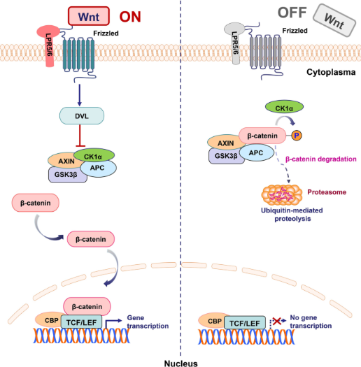  
Fig.no:4 Wnt/β‑Catenin Inhibition by Z‑Ajoene

**3.2.6 Cytoskeletal Disruption**

The cytoskeleton maintains the form and mobility of cells. It is possible to stop cancer cells from spreading by interfering with their invasion and migration. Alters vimentin to prevent breast and esophageal cancers from moving and spreading.

**3.2.7 CSC Targeting**

The malignancy can be regenerated by cancer stem cells, a very small subset of tumor cells. Targeting these cells aims to improve treatment outcomes and prevent tumor recurrence. impacts glioblastoma CSCs (CD133+/ALDH+) by activating ERK/p38 and inhibiting AKT, TGF-β, Notch, and Hedgehog.

**3.2.8 Antioxidant/Cytotoxic Duality**

In addition to their antioxidant action, some chemicals have the ability to neutralize harmful reactive oxygen species and kill cancer cells (cytotoxic effect). Both cancer and healthy cells can be attacked by this dual function. ROS-mediated apoptosis at higher exposures versus ERK–Nrf2-NQO1 activation at low concentrations in 2024, by Wamidh H. Talib.

## 4. Comparative Analysis

|  |  |  |
| --- | --- | --- |
| Characteristic | Allicin | Z‑Ajoene |
| Stability | Unstable; rapidly degraded | Stable; suitable for oral formulations |
| Mechanism Breadth | Broad thiol reactivity, apoptosis | ER stress, Wnt inhibition, cytoskeletal and CSC targeting |
| Chemoresistance Effect | Reverses NSCLC drug resistance | Synergizes with chemotherapy; CSC elimination possible |
| Bioavailability | Enhanced via nanocarriers | Drinkable/oil formulations viable |

## 5. Translational & Clinical Perspectives

**5.1 Advanced Formulations**

* **Allicin:** According to computational investigations, the creation of nanocomplexes like Allicin/C₂₄, Allicin/B₁₂N₁₂, and Allicin/Al₁₂N₁₂ has greater interactions with biological targets and is more stable than free Allicin. complex formulations that contain Allicin, particularly when it comes to its incorporation in nanocages such as Al₁₂N₁₂, B₁₂N₁₂, and C₂₄. These nanocages enhance the stability, bioavailability, and targeted administration of Allicin, making them attractive drug delivery vehicles. (Mozafari, E. S. 2025)
* **Z‑Ajoene**: Standardization of oil-based delivery is being worked on; ideal for nutraceutical compositions.

**5.2 Safety & Pharmacokinetics**

* Allicin is degraded before systemic uptake—necessitating novel delivery forms
* Z‑Ajoene shows targeted CSC toxicity with minimal normal cell impact, substantiating clinical trials.

**5.3 Clinical Trial Pipeline**

* No major Allicin trials in oncology; topical/adjunct studies underway.
* Meta-analyses show promise in GI and prostate cancer risk reduction, though RCT data is mixed.

**5.4 Combinatorial Therapy**

Compounds from garlic are used in combination therapy to target several cancer hallmarks at once, increasing anticancer efficacy. Among the examples are:

**5.4.1 Garlic with 5-Fluorouracil (5-FU):** According to research, 5-FU and Allicin combined increase the production of reactive oxygen species (ROS), disrupt mitochondria, activate PARP and caspase-3, and reduce Bcl-2 expression. In addition to promoting apoptosis, this multimodal approach improves therapeutic outcomes.

**5.4.2 Garlic Components with Other drugs:** Components of garlic can improve anticancer effects such angiogenesis suppression, proliferation inhibition, and apoptosis induction when paired with specific medications or conventional chemotherapeutics. Z Ajoene may complement through CSC targeting; studies show synergy with 5 FU, oxaliplatin, gemcitabine, and paclitaxel. In 2024, Wamidh H. Talib

**5.5 Development Roadmap**

1. Design and characterize nano formulations.
2. Conduct PK/PD and safety in animal models.
3. Use biomarkers (ER stress, β‑catenin) for translation.
4. Initiate Phase I trials in chemoresistant cancers.
5. Combine phytochemical and standard chemotherapy regimens.

## Conclusions and Future Directions

The anticancer strategies of Z Ajoene and Allicin are complementary: Z Ajoene causes ER stress, inhibits Wnt signaling, disrupts CSCs, and causes metastases, while Allicin reverses chemoresistance through thiol reactivity.

**Future priorities** include:

* Nano-carrier formulations.
* Biomarker-driven preclinical and clinical validation,
* CSC-focused combination studies.
* And initiation of phase I clinical trials.

These substances satisfy the following important translational requirements: formulation adaptability, target selectivity, controllable toxicity, and multi-pathway efficacy.

**References**

1. Catherine H. Kaschula, Rosanna Tuveri, Ellen Ngarande, Kevin Dzobo, Christopher Barnett, Daniel A. Kusza, et al. (2019). The garlic compound Ajoene covalently binds vimentin, disrupts the vimentin network and exerts anti-metastatic activity in cancer cells, BMC .<https://doi.org/10.1186/s12885-019-5388-8>.
2. Hyejin Lee, Ji-Won Heo, A-Reum Kim, Minson Kweon, Sorim Nam, Jong-Seok Lim, et al. (2019). Z-Ajoene from Crushed Garlic Alleviates Cancer-Induced Skeletal Muscle Atrophy, MDPI, Nutrients. 11, 2724; Doi:10.3390/nu11112724
3. Jan Borlinghaus, Frank Albrecht, Martin C. H. Gruhlke, Ifeanyi D. Nwachukwu and Alan J. Slusarenko (2014). Allicin: Chemistry and Biological Properties, MDPI journal. 12591-12618; Doi:10.3390/molecules190812591
4. Paulina Furdak, Grzegorz Bartosz and Izabela Sadowska-Bartosz (2024). Which Constituents Determine the Antioxidant Activity and Cytotoxicity of Garlic? Role of Organosulfur Compounds and Phenolics, MDPI, International Journal of Molecular Science. https://doi.org/10.3390/ijms25158391
5. Mohamed T. El-Saadony, Ahmed M. Saad, Sameh A. Korma, Heba M. Salem, Taia A. Abd El-Mageed, Samar Sami Alkafaas et al. (2024). Garlic bioactive substances and their therapeutic applications for improving human health: a comprehensive review, Frontiers in immunology, Sec. Nutritional Immunology. https:// doi.org/10.3389/fimmu.2024.1277074
6. Yuchae Jung, Heejoo Park, Hui-Yuan Zhao, Raok Jeon, Jae-Ha Ryu, and Woo-Young Kim (2014). Systemic Approaches Identify a Garlic-Derived Chemical, Z-Ajoene, as a Glioblastoma Multiforme Cancer Stem Cell-Specific Targeting Agent, Molecules and cells. http:// dx.doi.org/10.14348/molcells.2014.0158
7. Faris J. Alyasiri, Maryam Ghobeh, Masoud Homayouni Tabrizi(2023). Preparation and Characterization of Allicin-Loaded Solid Lipid Nanoparticles Surface-Functionalized with Folic Acid-Bonded Chitosan: In Vitro Anticancer and Antioxidant Activities, Frontiers in Bioscience, Landmark. https://doi.org/10.31083/j.fbl2807135
8. Wamidh H. Talib, Media Mohammed Baban, Sana Allala and Lina T. AL Kury, Aya O. Azzam, et al. (2024). Allicin and Cancer Hallmarks, MDPI, Molecule. https:// doi.org/10.3390/molecules29061320
9. Elena Catanzaro, Donatella Canistro, Valentina Pellicioni, Fabio Vivarelli, Carmela Fimognari (2022). Anticancer potential of Allicin: A review, DOI: <http://doi.org/10.1016/j.phrs.2022.106118>.
10. Catherine H. Kaschula, Roger Hunter and M. Iqbal Parker(2010). Garlic-derived anticancer agents: Structure and biological activity of Ajoene, DOI: 10.1002/biof.76
11. Yuchae Jung, Heejoo Park, Hui-Yuan Zhao, Raok Jeon, Jae-Ha Ryu, and Woo-Young Kim(2014). Systemic Approaches Identify a Garlic-Derived Chemical, Z-Ajoene, as a Glioblastoma Multiforme Cancer Stem Cell-Specific Targeting Agent, Molecules and cells, <http://dx.doi.org/10.14348/molcells.2014.0158>
12. Min Li, jing -Rong Ciu, Ying Ye, Ji-Mei Min, Li-he Zhang, Kui Wang, et al. (2002). Antitumor activity of Z-Ajoene, a natural compound purified from garlic: antimitotic and microtubule-interactoin properties. Carninogenesis vol.23.
13. Wamidh H. Talib, Sally Atawneh, Areen Nabil Shakhatreh, Ghyda’a Nabil Shakhatreh, Islam Subhi Rasheed aljarrah, Reem Ali Hamed, et al.(2024). Anticancer potential of garlic bioactive constituents: Allicin, Z-Ajoene, and organosulfur compounds. Pharmacia. <https://doi.org/10.3897/pharmacia.71.e114556>
14. Yang Zhou1,2, Xingxuan Li2, Wenyu Luo2, Junfeng Zhu3, Jingwen Zhao4, Mengyao Wang(2022). Allicin in Digestive System Cancer: From Biological Effects to Clinical Treatment. Frontiers, Frontiers in Pharmacology.<https://doi.org/10.3389/fphar.2022.903259>
15. Mozafari E. S., Mohammad T. Baei & E. Tazikeh Lemeski (2025). Computational study of the therapeutic properties of Allicin and its nanocomplexes using DFT and molecular docking techniques. Scientific reports. <https://doi.org/10.1038/s41598-025-03293-0>
16. Roger Hunter, Catherine H. Kaschula, Iqbal M. Parkerb, Mino R. Caira, Philip Richards, Susan Travis (2008). Substituted Ajoenes as novel anti-cancer agents. Elesevier, Bioorganic and Medicinal Chemistry Letters. Doi:10.1016/j.bmcl.2008.08.056