Book Name: | Medical Science: Recent Advances and Applications
Manuscript Number: | Ms_BPR_6130
Title of the Manuscript: | Medical Ultrasound Imaging: Ultrafast Beamforming Algorithms for Real-Time and High-Quality Imaging
Type of the Article | Book Chapter

Special note:

A research paper already published in a journal can be published as a Book Chapter in an expanded form with proper copyright approval.
Source Article:

This chapter is an extended version of the article published by the same author(s) in the following journal.

Medical Research Archives, 12(12): 1-11, 2025.
DOI: https://doi.org/10.18103/mra.v12i12.6177

PART 1: Comments

 | Reviewer’s comment  Artificial Intelligence (AI) generated or assisted review comments are strictly prohibited during peer review. | Author’s Feedback (Please correct the manuscript and highlight that part in the manuscript. It is mandatory that authors should write his/her feedback here)
Please write a few sentences regarding the importance of this manuscript for the scientific community. A minimum of 3-4 sentences may be required for this part.

Is the title of the article suitable?
(If not please suggest an alternative title)

Is the abstract of the article comprehensive? Do you suggest the addition (or deletion) of some points in this section? Please write your suggestions here.

Is the manuscript scientifically, correct? Please write here.
Are the references sufficient and recent? If you have suggestions of additional references, please mention them in the review form.
-

Is the language/English quality of the article suitable for scholarly communications?

Optional/General comments | Medical Ultrasound Imaging: Ultrafast Beamforming Algorithms for RealTime and High-Quality Imaging  This paper focuses on Medical ultrasound imaging, beamforming algorithms with the support of parallel computing architectures to work in minimum time and present their efficiency. parallel processing or GPU acceleration architectures can be designed by Field Programmable Gate Array (integrated circuit) and a set of transducer elements receives ultrasound signals and merged to create a beam focused in a particular direction. The work discusses the advantages of this process and highlights it does not apply ionizing radiation and provide several models for clinical applications and to improve their analysis quality.  Contribution:  Merits and demerits  Several bf architectures- schemes and design  - Delay and Sum beamforming  - Minimum Variance beamforming  - Synthetic Aperture Beamforming  - Adaptive Beamforming.  My comments and suggestions:  Under fig1. Add expansion for AFE, LNA, TGC, ADC  In equation 2, mention what is 𝑃𝑖,𝑘 and 𝜏𝑖,𝑘  Please mention what do you mean by this line - the architecture's implementation is simple5, 9-10.  W(MVB) – what is it?  In eq 5, what is 𝛿 ? 𝒂 is the steering vector in text  A.1D – section last paragraph, instead of saying in recent paper 16, write the statements in passive voice and add reference for it. (suggestion)  Same for A.1E second paragraph too. As a book chapter you can present the contect and add reference, this is good for readability.  The paragraphs are not arranged in proper order. 3. ultra-fast beamforming algorithms comes between A1E and A1F. These 2 paragraphs looks like introduction.  Organization of content is very poor. Please check flow.  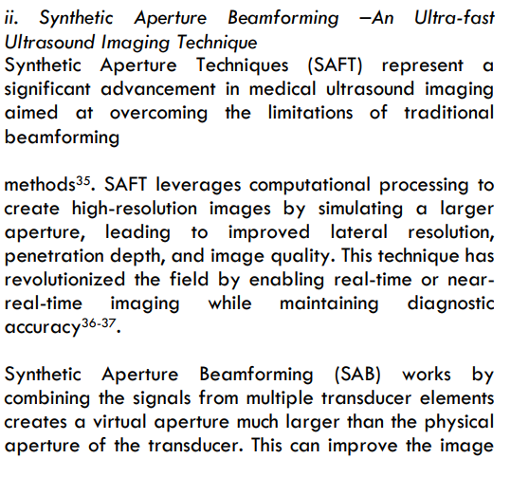  SAB is discussed in section A1D. it comes it between A1G.  In section iv, deep learning – give some nueral network models for Data-driven beamforming, Model-based beamforming- Add enough references, since in conclusion DL models are on the high impact level.  “Multi-Line Transmission (MLT) based beamforming has emerged as a promising approach to overcoming the limitations of traditional beamforming methods in medical ultrasound imaging. “ this line looks like introduction line at iii of A1G  Insead of 4.Discussion, it could be performance analysis

PART 2:

 | Reviewer’s comment | Author’s comment (if agreed with reviewer, correct the manuscript and highlight that part in the manuscript. It is mandatory that authors should write his/her feedback here)
Are there ethical issues in this manuscript? | (If yes, Kindly please write down the ethical issues here in details)

Reviewer details:
Buvaneswari Natarajan, USA

