**Performance Analysis of Sweet Pepper (*Capsicum annum* L.) Under Varied Farming Managements in Marginal Uplands**

## ABSTRACT

This study investigates the performance of sweet pepper (*Capsicum annum* L.) under different farming management practices in marginal uplands . The results revealed that microbial-enriched organic fertilizer does not match the efficacy of inorganic fertilizers in enhancing sweet pepper yield and yield components. Specifically, Treatment 2 (inorganic fertilizer) significantly improved sweet pepper yield at 6,880.74 kg ha-1 (*P<0.01*). Additionally, cost and return analysis revealed that Treatment 3 (Goat manure) yielded the highest Return on Investment (ROI) at 860.79, followed closely by Treatment 4 (Goat manure + IMO 3) with an ROI of 774.18. These findings provide valuable insights for optimizing farming practices to enhance sweet pepper production in marginal uplands while considering economic viability.

*Keywords: Inorganic; Growth; Microbial fertilizer; Organic; Sweet pepper; Yield*

**1. INTRODUCTION**

Agricultural productivity is a cornerstone of global food security, and optimizing crop performance is essential to meet the increasing demands of a growing population. Among the diverse array of crops, sweet pepper (*Capsicum annuum*) plays a vital role in culinary and nutritional contexts [1]. However, enhancing sweet pepper yield sustainably presents significant challenges, particularly given the ecological concerns associated with conventional farming practices [2]. This research addresses these challenges by investigating the performance of sweet peppers treated with microbial-enriched organic fertilizers.

Conventional agriculture heavily relies on synthetic fertilizers, often resulting in adverse environmental effects, soil degradation, and a decline in overall soil health [3]. The excessive use of chemical inputs raises concerns about long-term sustainability and poses potential threats to ecosystem integrity. Sweet pepper, a nutrient-demanding crop, frequently faces yield limitations due to nutrient imbalances and soil deterioration [4]. This research seeks to confront these issues by exploring alternative approaches reinforcing crop yield while promoting ecological harmony and economic viability.

Various strategies have been employed to enhance sweet pepper yield, including applying different fertilizers and soil amendments [5]. However, many of these solutions are rooted in conventional farming practices that may exacerbate environmental concerns. While organic farming has emerged as a more sustainable alternative, challenges persist in achieving optimal yields without compromising ecological integrity [6]. Microbial-enriched organic fertilizers are promising, as they have demonstrated efficacy in improving nutrient availability, soil structure, and overall plant health across various crop stages [6]. Nevertheless, their specific impact on sweet pepper cultivation still needs to be explored.

Despite the potential benefits of microbial-enriched organic fertilizers, a clear gap exists in the literature regarding their application to sweet pepper crops. Existing research predominantly focuses on general soil health and crop yield in broader terms, often neglecting the delicate requirements of specific crops like sweet pepper [7]. Understanding the symbiotic relationships between microbes, soil, and sweet pepper plants is crucial for tailoring agricultural practices to the unique needs of this crop. This research seeks to fill this void by investigating microbial-enriched organic fertilizers' positive contributions to sweet pepper plants.

This study aims to comprehensively investigate the impact of microbial-enriched organic fertilizers on sweet pepper performance. Through controlled experiments, we assessed vital indicators such as growth, yield components, and return on investment. By elucidating the complex dynamics between microbial communities in the soil and sweet pepper plants, we aspire to explore how these fertilizers can be optimized for sweet pepper production. The findings of this research have the potential to revolutionize sweet pepper farming practices and contribute to the broader discourse on sustainable agriculture by providing insights into the role of microbial interactions in crop productivity.

**2. material and methods**

A Randomized Complete Block Design (RCBD) was employed in this study, with four treatments replicated four times, as follows: Treatment 1 (Control, no fertilizer); Treatment 2 (Inorganic fertilizer at 100-90-60 kg ha⁻¹ N-P₂O₅-K₂O); Treatment 3 (Goat manure at 5 t ha⁻¹); and Treatment 4 (Goat manure + IMO 3 at 5 t ha⁻¹). The study was conducted at the Crop Science Experimental Area of JHCSC-Dumingag Campus, School of Agriculture, Dapiwak, Dumingag, Zamboanga del Sur (8º11'17.52" N, 123º17'32.38" E, elevation 359.35 meters) from November 1, 2022, to February 9, 2023. The materials used in this study included sweet pepper seeds, inorganic fertilizers, goat manure, microbial-enriched goat manure, a shovel, seedling tray, grub hoe, hand sprayer, sharp bolo, weighing scale, signboard, field notebook, camera, measuring tape, and water container.

Seedlings were raised in a seedling tray filled with growing media composed of compost and garden soil in a 1:1 ratio. Goat manure was collected from the goatery project at the JHCSC School of Agriculture, dried for two weeks before application, and used as Treatment 3. For the microbial-enriched goat manure (Treatment 4), the manure was mixed with Indigenous Microorganism 2 (IMO 2) at a dilution ratio of 20:1000 (20 ml per liter). Anaerobic fermentation was conducted for three weeks, followed by aerobic fermentation for one week before application.

The preparation of IMO 1 involved using ½ kg of rice, a kettle, knife, spade, Manila paper, twine, basin, and tablespoon. The rice was cooked for 30 minutes and cooled for 1 hour before being placed inside a bamboo tube. It was not disturbed to promote the growth of indigenous microorganisms. The bamboo tube was covered with cellophane, tied with twine, and buried in an agro-forest for five days. Upon harvest, whitish mold on the rice indicated the presence of beneficial microorganisms.

To prepare IMO 2, 1 kg of IMO 1 was mixed with 1 liter of molasses in a basin and fermented in a bamboo tube for seven days. After seven days, the mixture was strained and stored in a clean container. IMO 3 was prepared by mixing 1 liter of IMO 2 with 10 liters of water and gradually adding this solution to 2 sacks of corn bran. The mixture was thoroughly stirred, covered with canvas, and fermented anaerobically for three days. The whitish mold on the corn bran confirmed the successful preparation of IMO 3.

Sweet pepper seeds were sown in the seedling tray and protected from ants and other pests. One week after germination, seedlings were pricked and hardened by gradual exposure to sunlight before transplanting. The experimental area, covering 285 square meters, was plowed twice and harrowed between plowing sessions. Weeds were removed to prevent nutrient competition, and the soil was pulverized to ensure optimal plant growth.

Each experimental plot measured 3 m x 5 m. Inorganic fertilizer was applied in three split doses: the first during transplanting, the second at 15 days after transplanting, and the third at 30 days. Goat manure and microbial-enriched goat manure were applied basally two weeks before transplanting at a rate of 5 t ha⁻¹. Sweet pepper seedlings were transplanted with one seedling per hill, spaced at 50 cm x 50 cm. The replanting of missing hills occurred one week after the transplant.

Ten representative plants were selected from each plot as test plants, identified with numbered sticks to ensure accurate data collection. Proper care and management, including regular watering, weeding, and drainage canal construction, were carried out throughout the vegetative and reproductive period to prevent flooding during heavy rains.

Sweet peppers were harvested at maturity, indicated by the reddish color of the fruits, and sorted by size. Data collected included plant height, leaf area index, number of days from transplanting to flowering, yield per plot (kg), fruit weight (g), and return on investment (ROI). Meteorological data such as rainfall, relative humidity, and temperature were recorded during the study. Soil samples were submitted to the Bureau of Soils and Water Management (BSWM) before and after the experiment.

Data analysis was conducted using the Statistical Tool for Agricultural Research (STAR) software, and mean comparison was done using Least Significant Difference (LSD) tests. Principal component analysis was used to determine the relationship of different parameters.

**3. results and discussion**

**3.1 Agrometeorological data**

Figure 1 presents the average weekly temperature (°C), relative humidity (%), and rainfall recorded during the study period. At 10:00 AM, the average weekly temperature was 26.79°C, rising to 38.4°C at noon and dropping to 23.14°C by 2:00 PM. The overall average weekly temperature throughout the study was 29.71°C.

For relative humidity, readings were 62.46% at 10:00 AM, 66.41% at 12:00 noon, and 55.83% at 2:00 PM.

The highest rainfall was recorded during the 9th and 11th weeks, with a peak measurement of 295.7 mm.

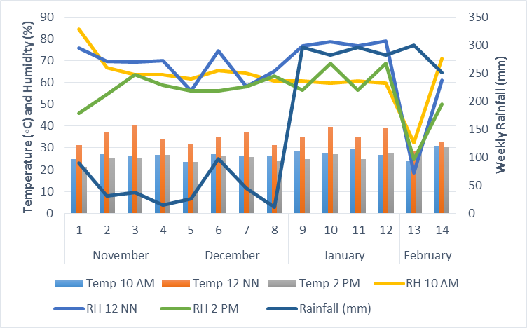

**Figure 1. Rainfall and relative humidity data from November 1, 2022, to February 9, 2023 at School of Agriculture, JHCSC-Dumingag Campus, Dapiwak, Dumingag, Zamboanga del Sur.**

**3.2 Soil analysis**

The experimental area underwent a soil analysis before and after the experiment, evaluating key parameters, including pH, organic carbon, organic matter, nitrogen, available phosphorus, and exchangeable potassium, as detailed in Table 1. Before the sweet pepper cultivation, the initial soil composition indicated a pH of 6.13, organic carbon content of 1.20%, organic matter at 2.07%, nitrogen level of 0.10%, phosphorus concentration of 13.79 ppm, and potassium availability of 147.68 ppm.

The initial soil analysis underscored the need for adequate fertilization to optimize sweet pepper production. After the experiment, a slight reduction in soil pH from 6.13 to 5.99 was observed, along with a marginal decrease in phosphorus levels from 13.79 to 12.85 ppm. Conversely, there was a slight increase in organic carbon content from 1.20% to 1.41%, an increase in organic matter from 2.07% to 2.43%, a rise in nitrogen levels from 0.10% to 0.12%, and an augmentation in potassium availability from 147.68 ppm to 203.76 ppm. These findings indicate that not all nutrients provided by the basal fertilizer were fully utilized by the plants; a portion persisted in the soil as residues, contributing to the observed increases in specific parameters.

**Table 1. Soil pH, organic carbon, organic matter, nitrogen, phosphorus, and potassium before and after the experiment conducted**

|  |  |  |  |
| --- | --- | --- | --- |
| **Parameters** | **Test Method** | **Before Planting** | **After Planting** |
| Soil pH | Potentiometric | 6.13 | 5.99 |
| Organic carbon, % | Walkley-Black | 1.20 | 1.41 |
| Organic matter, % | By computation | 2.07 | 2.43 |
| Nitrogen, % | By computation | 0.10 | 0.12 |
| Available phosphorus, ppm | Olsen | 13.79 | 12.85 |
| Exchangeable potassium, ppm | Ammonium acetate | 147.68 | 203.76 |

*(Source: Integrated Laboratories Division DA RFU-9)*

**3.3 Plant height and LAI**

Table 2 shows the plant heights at 15, 30, and 45 days after transplanting, measured in centimeters using a measuring tape.

At 15 days after transplanting (DAT), Treatment 4 (Goat manure + IMO 3) recorded the tallest plants at 13.21 cm, followed closely by Treatment 3 (Goat manure) with 13.23 cm, Treatment 2 (Inorganic fertilizer) with 12.69 cm, and Treatment 1 (Control) with 6.7 cm.

At 30 DAT, Treatment 2 (Inorganic fertilizer) resulted in the tallest plants at 49.02 cm, followed by Treatment 4 (Goat manure + IMO 3) at 48.77 cm. Treatment 1 (Control) had the shortest plants at 20.05 cm.

At 45 DAT, Treatment 2 (Inorganic fertilizer) maintained the tallest plants at 57.64 cm, followed by Treatment 3 (Goat manure) at 48.85 cm and Treatment 1 (Control) at 33.05 cm.

The leaf area index ranged from 0.92 to 0.99 in Treatments 2, 3, and 4, higher than Treatment 1 with 0.35.

The analysis of variance revealed significant differences in plant height and LAI across all measurement periods, indicating that the different farming practices had a distinguished impact on sweet pepper growth.

Table 2 shows Treatment 2 (Inorganic fertilizer) exhibited the tallest plants at all growth stages (15, 30, and 45 DAT), with an impressive height measurement of 57.64 cm at 45 days. The results align with previous study that underscore the importance of nutrient availability from inorganic fertilizers in promoting vegetative growth in crops [7]. In contrast, the organic treatments (Goat manure and Goat manure + IMO 3) demonstrated slower growth, reflecting the gradual nutrient release associated with organic amendments, which may not meet the immediate demands of nutrient-demanding crops like sweet pepper [8].

**Table 2. Height (cm) of the plants at 15, 30, and 45 days after transplanting as influenced by the different farming management**

|  |  |  |  |  |
| --- | --- | --- | --- | --- |
| **Treatments** | **Plant Height (DAT)** | | | **LAI** |
| **15** | **30** | **45** |
| Treatment 1 – Control | 6.70b | 20.15b | 33.95c | 0.35b |
| Treatment 2 – 100-90-60 kg ha⁻¹ N-P₂O₅-K₂O) | 12.69a | 49.02a | 57.62a | 0.99a |
| Treatment 3 – Goat manure at 5 t ha-1 | 13.23a | 45.40a | 48.85a | 0.99a |
| Treatment 4 – Goat manure + IMO3 at 5 t ha-1 | 13.21a | 48.77a | 48.52b | 0.92a |
| Test of Significance | ** | ** | ** | * |
| C.V. % | 5.46 | 9.87 | 3.25 | 21.26 |

* - significant at 5%level

** - significant at 1% level

**3.4 Yield and yield components**

Table 3 presents sweet pepper's yield and yield components as influenced by different farming practices. For the first harvest, Treatment 2 (Inorganic fertilizer) produced the highest average fruit weight at 39.27 grams, followed by Treatment 4 (Goat manure + IMO 3) with 28.28 grams, and Treatment 1 (Control) with 19.31 grams.

In the second harvest, Treatment 2 again recorded the highest average fruit weight at 36.81 grams, followed by Treatment 1 (Control) with 26.86 grams, Treatment 4 (Goat manure + IMO 3) with 24.89 grams, and Treatment 3 (Goat manure) with 24.66 grams.

Treatment 2 maintained the highest average fruit weight for the third harvest at 31.43 grams, followed by Treatment 4 with 28.13 grams, Treatment 3 with 23.13 grams, and Treatment 1 with 19.70 grams.

In the fourth harvest, Treatment 4 (Goat manure + IMO 3) achieved the highest average fruit weight at 32.64 grams, followed by Treatment 2 (Inorganic) with 26.40 grams, Treatment 3 (Goat manure) with 23.87 grams, and Treatment 1 (Control) with 23.43 grams.

For the average yield per plot at the first harvest, Treatment 2 (Inorganic) recorded the highest at 2.3 kg, followed by Treatment 4 (Goat manure + IMO 3) at 1.55 kg, Treatment 3 (Goat manure) at 1.28 kg, and Treatment 1 (Control) at 0.52 kg. Treatment 2 consistently had the highest average yield per plot in the second, third, and fourth harvests, with 3.17 kg, 2.75 kg, and 1.06 kg, respectively.

For the total yield per plot, Treatment 2 (Inorganic) achieved the highest yield of 8.26 kg, followed by Treatment 3 (Goat manure) with 5.47 kg, Treatment 4 (Goat manure + IMO 3) with 4.98 kg, and Treatment 1 (Control) with 2.38 kg.

The projected yield per hectare was highest for Treatment 2 at 6,880.84 kg ha⁻¹, followed by Treatment 3 (Goat manure) with 4,562.50 kg ha⁻¹, Treatment 4 (Goat manure + IMO 3) with 4,151.25 kg ha⁻¹, and Treatment 1 (Control) with 1,979.17 kg ha⁻¹.

Table 3 reveals that Treatment 2 (Inorganic) resulted in the highest average fruit weights across all harvests and achieved the highest total yield of 8.26 kg per plot. This is consistent with findings by [8], who reported that inorganic fertilizers significantly enhanced fruit quality and yield in pepper cultivation.

**Table 3. Yield and yield components of sweet pepper as affected by the different farming managements**

|  |  |  |  |  |  |  |
| --- | --- | --- | --- | --- | --- | --- |
| **Treatment** | **Weight per harvest (g)** | | | | **Total yield/plot (kg)** | **Projected yield (kg ha-1)** |
| 1st | 2nd | 3rd | 4th |
| T1 | 0.52c | 0.78c | 0.40c | 0.38c | 2.38c | 1979.17c |
| T2 | 2.30a | 3.17a | 2.75a | 1.06a | 8.26a | 6880.74a |
| T3 | 1.28b | 1.57b | 2.00ab | 0.63bc | 5.47b | 4562.50b |
| T4 | 1.55b | 1.48bc | 1.80b | 0.94ab | 4.98b | 4151.25b |
| F-Test | **\*\*** | **\*\*** | **\*\*** | **\*\*** | **\*\*** | **\*\*** |
| C.V. % | 13.40 | 26.90 | 27.51 | 27.22 | 17.18 | 17.18 |

ns – non-significant, * - significant at 5% level

** - significant at 1% level

Table 4 shows the number of fruits per plot for the first, second, third, and fourth harvests. Treatment 2 (Inorganic) produced the highest number of fruits, with 87.75, followed by Treatment 3 (Goat manure) with 64.75, Treatment 4 (Goat manure + IMO 3) with 63.5, and Treatment 1 (Control) with 28.75.

These results indicate that the different farming management practices significantly influenced fruit production across all four harvest operations. The substantial difference in fruit number between Treatment 2 and the organic treatments underscores the immediate benefits of inorganic fertilizers in enhancing fruit set and development [9].

**Table 4. Number of fruits of sweet pepper at 1st, 2nd, 3rd, and 4th harvest**

|  |  |  |  |  |  |
| --- | --- | --- | --- | --- | --- |
| **Treatment** | **Number of Fruits per Harvest** | | | | |
| **1st** | **2nd** | **3rd** | **4th** | **Total Harvest** |
| T1 – Control | 27.25c | 28.75c | 36.00c | 16.75c | 108.75c |
| T2 – 100-90-60 kg ha⁻¹ N-P₂O₅-K₂O) | 60.00a | 87.75a | 87.00a | 41.75a | 276.50a |
| T3 – Goat manure at 5 t ha-1 | 46.00b | 64.75b | 55.50b | 26.00b | 192.25b |
| T4 – Goat manure + IMO3 at 5 t ha-1 | 54.50ab | 62.00b | 63.50b | 29.75b | 209.75b |
| F-test | ** | * | * | * | ** |
| C.V.% | 13.01 | 16.01 | 16.11 | 19.00 | 18 |

* - significant at 5%level

** - significant at 1% level

**3.5 Scree plot and principal component analysis**

Figure 2 shows the scree plot illustrating the relationships among various parameters of sweet pepper. As indicated, the first principal component accounts for the majority of the total variability in the data, as evidenced by the eigenvalues.

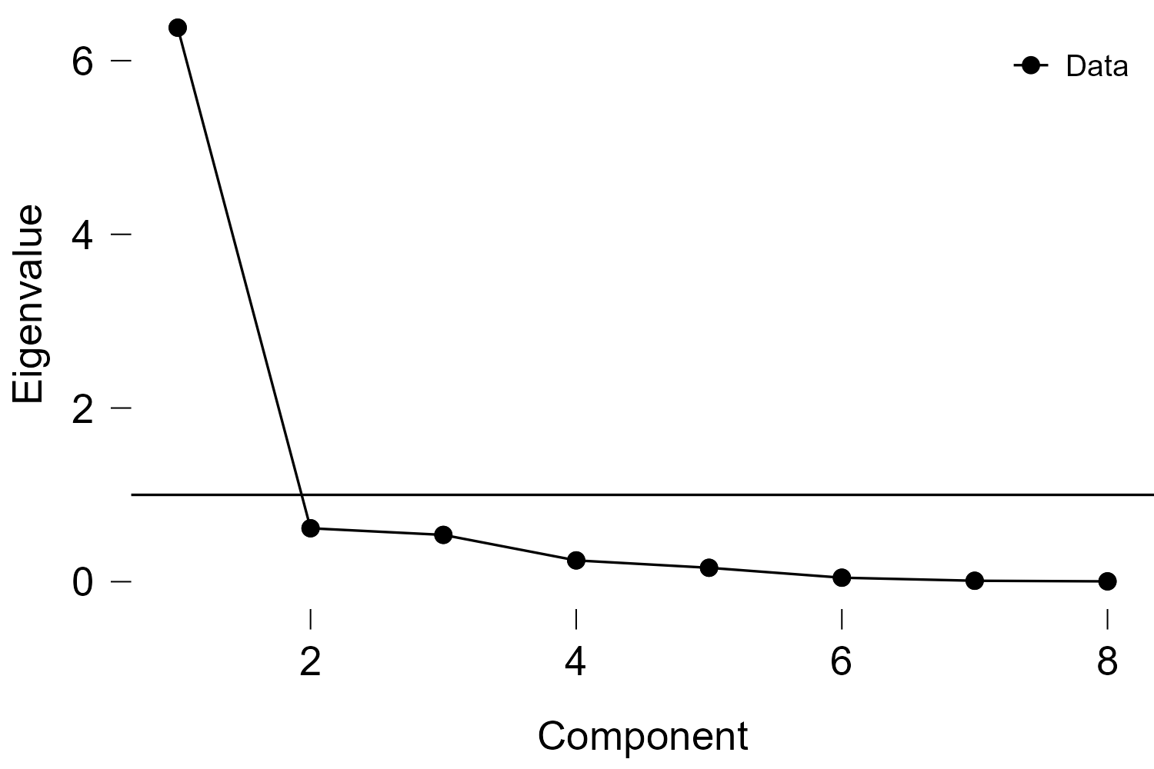

**Figure 2. Scree plot of different growth and yield parameters of sweet pepper as influenced by different farming management practices**

Table 5 presents the principal component analysis of selected sweet pepper parameters. The data show that plant height at 15 DAP (0.895), plant height at 30 DAP (0.921), plant height at 45 DAP (0.974), weight per fruit (0.705), LAI (0.880), number of fruits harvested per plot (0.946), and actual yield per plot (0.944) had the highest positive loadings. In contrast, the number of days from planting to flowering (-0.851) had the highest negative loading under component 1. The results suggest that sweet pepper plants flowered earlier as growth and LAI increased. Furthermore, it indicates that plants that flowered earlier produced more fruits, higher yields, and heavier fruit weight.

The highest positive loadings were observed for plant height at different stages of development (15 DAP, 30 DAP, and 45 DAP), weight per fruit, leaf area index (LAI), number of fruits harvested, and actual yield per plot. These findings suggest that vegetative growth, particularly plant height, and LAI, plays a critical role in enhancing fruit yield and size in sweet peppers, which is consistent with previous studies that emphasize the importance of plant architecture in optimizing crop yield [10].

Interestingly, the negative loading for the number of days from planting to flowering implies that early flowering is inversely related to plant growth stages such as height. According to component 1, early flowering of plants was associated with higher fruit numbers, yield, and weight. This result supports previous research, which suggests that the timing of flowering is a critical determinant of fruit yield, with early-flowering plants typically exhibiting higher reproductive success and yield potential [11]. The influence of early flowering on yield can be attributed to an extended reproductive phase, allowing for better fruit set and development, leading to heavier fruits and increased overall production [12].

As demonstrated by its favorable solid loading, the correlation between LAI and yield aligns with earlier findings that LAI is an essential indicator of canopy efficiency and light interception, which are crucial for photosynthesis and subsequent fruit production [13]. Therefore, maximizing LAI during crucial growth periods can enhance sweet pepper productivity by improving the plant's ability to capture light and convert it into biomass and reproductive organs.

**Table 5. Principal component analysis of selected parameters of sweet pepper as influenced by different farming management practices**

| **Component Loadings** | | **RC1** | | **Uniqueness** | |
| --- | --- | --- | --- | --- | --- |
| Plant height 45 DAP |  | 0.974 |  | 0.052 |  |
| Total fruits harvested/plot |  | 0.946 |  | 0.105 |  |
| Actual yield/plot (kg) |  | 0.944 |  | 0.109 |  |
| Plant height 35 DAP |  | 0.921 |  | 0.151 |  |
| plant height 15 DAP |  | 0.895 |  | 0.199 |  |
| LAI |  | 0.880 |  | 0.225 |  |
| No. of days from transplanting to 50% flowering |  | -0.851 |  | 0.275 |  |
| Weight per fruit (g) |  | 0.705 |  | 0.503 |  |
|  | | | | | |
| *Note.* *The applied rotation method is promax*. | | | | | |

**3.6 Cost and return analysis**

Table 6 presents sweet pepper's cost and return analysis under different farming systems, including gross income, total expenses, net income, and return on investment (ROI).

Treatment 2 (Inorganic fertilizer) had the highest projected yield of 6,880.84 kg/ha, resulting in the highest gross income of ₱688,033.00 and the highest production cost of ₱99,287.00. This led to a net income of ₱588,746.00 but a relatively low ROI of 592.97%.

Treatment 3 (Goat manure) had a projected yield of 4,562.50 kg/ha, generating a gross income of ₱456,250.00, with a production cost of ₱47,487.00. The net income was ₱408,763.00, and the ROI was the highest at 860.79%.

Treatment 4 (Goat manure + IMO 3) produced a projected yield of 4,151.25 kg/ha, with a gross income of ₱415,125.00 and a production cost of ₱47,487.00. This resulted in a net income of ₱367,638.00 and an ROI of 774.18%.

Treatment 1 (Control) had the lowest projected yield of 1,979.17 kg/ha, with a gross income of ₱197,917.00 and a production cost of ₱37,487.00. The net income was ₱160,430.00, and the ROI was 427.96%.

The economic evaluation of the different treatments highlights the return on investment (ROI) associated with each farming practice. While Treatment 2 (Inorganic) yielded an ROI of 592.97%, Treatments 3 (Goat manure) and 4 (Goat manure + IMO 3) showed favorable returns of 860.79% and 774.18%, respectively. These findings suggest that while inorganic fertilizers may enhance productivity and gross income, organic practices can also provide high ROI, reflecting lower input costs [14]. This is particularly relevant for smallholder farmers who may seek cost-effective strategies while maintaining soil health and sustainability

**Table 6. Cost and return analysis of sweet pepper production as affected by the different farming management**

|  |  |  |  |  |  |
| --- | --- | --- | --- | --- | --- |
| **Treatments** | **Projected yield(kg/ha)** | **Gross income (₱)** | **Production**  **cost (₱)** | **Net income**  **(₱)** | **ROI %** |
| T1 – Control | 1979.17 | 197,917.00 | 37,487.00 | 160,430.00 | 427.96 |
| T2 – 100-90-60 kg ha⁻¹ N-P₂O₅-K₂O) | 6880.84 | 688,033.00 | 99,287.00 | 588,746.00 | 592.97 |
| T3 – Goat manure at 5 t ha-1 | 4562.50 | 456,250.00 | 47,487.00 | 408,763.00 | 860.79 |
| T4 – Goat manure + IMO3 at 5 t ha-1 | 4151.25 | 415,125.00 | 47,487.00 | 367,638.00 | 774.18 |

**4. Conclusion**

The findings of this study demonstrate that while inorganic fertilizers offer immediate and significant improvements in the growth and yield of sweet pepper, the use of organic amendments—such as goat manure—plays a crucial role in promoting long-term soil health and sustainability. Integrating both approaches may offer a balanced strategy that enhances crop productivity while preserving the ecological integrity of agricultural systems.

**References**

[1] C. Brezeanu *et al.*, “Nutritional value of new sweet pepper genotypes grown in organic system,” *Agriculture*, vol. 12, no. 11, p. 1863, 2022.

[2] E. Chatzisymeon, S. Foteinis, and A. G. L. Borthwick, “Life cycle assessment of the environmental performance of conventional and organic methods of open field pepper cultivation system,” *Int. J. Life Cycle Assess.*, vol. 22, no. 6, pp. 896–908, June 2017, doi: 10.1007/s11367-016-1204-8.

[3] S. Tripathi, P. Srivastava, R. S. Devi, and R. Bhadouria, “Influence of synthetic fertilizers and pesticides on soil health and soil microbiology,” in *Agrochemicals detection, treatment and remediation*, Elsevier, 2020, pp. 25–54. Accessed: Aug. 03, 2025. [Online]. Available: https://www.sciencedirect.com/science/article/pii/B9780081030172000027

[4] A. Hartono, B. Barus, and D. M. P. Simanihuruk, “Fertilizer recommendation for pepper based on soil properties and nutrient uptake,” in *IOP Conference Series: Earth and Environmental Science*, IOP Publishing, 2022, p. 012047. Accessed: Aug. 03, 2025. [Online]. Available: https://iopscience.iop.org/article/10.1088/1755-1315/974/1/012047/meta

[5] A. R. Al-Harbi, A. Obadi, A. M. Al-Omran, and H. Abdel-Razzak, “Sweet peppers yield and quality as affected by biochar and compost as soil amendments under partial root irrigation,” *J. Saudi Soc. Agric. Sci.*, vol. 19, no. 7, pp. 452–460, 2020.

[6] J. P. Reganold and J. M. Wachter, “Organic agriculture in the twenty-first century,” *Nat. Plants*, vol. 2, no. 2, pp. 1–8, 2016.

[7] A. A. Shahane and Y. S. Shivay, “Soil health and its improvement through novel agronomic and innovative approaches,” *Front. Agron.*, vol. 3, p. 680456, 2021.

[8] E. M. El-Said, “Effect of organic fertilizers; irrigation regimes and biological amendments on growth and production of sweet pepper,” *Egypt J Hort*, vol. 42, no. 1, pp. 691–706, 2015.

[9] M. M. Islam, M. K. Islam, R. Proshad, M. S. Islam, T. K. M. Kormoker, and M. M. Billah, “Effect of inorganic and organic fertilizers on soil properties with vegetative growth and yield quality of sweet pepper (Capsicum annuum L.) in Bangladesh,” *Int. J. Agron. Agric. Res.*, vol. 11, no. 5, pp. 37–46, 2017.

[10] S. Ahmed, A. G. Roro, H. M. Beshir, and A. Haile, “Physiological, growth, yield, and quality responses of hot pepper due to shade level,” *Int. J. Veg. Sci.*, vol. 29, no. 5, pp. 375–402, Sept. 2023, doi: 10.1080/19315260.2023.2233955.

[11] A. R. Bentley *et al.*, “Flowering Time,” in *Genomics and Breeding for Climate-Resilient Crops*, C. Kole, Ed., Berlin, Heidelberg: Springer Berlin Heidelberg, 2013, pp. 1–66. doi: 10.1007/978-3-642-37048-9_1.

[12] M. Agustí and E. Primo-Millo, “Flowering and fruit set,” in *The genus citrus*, Elsevier, 2020, pp. 219–244. Accessed: Aug. 03, 2025. [Online]. Available: https://www.sciencedirect.com/science/article/pii/B9780128121634000115

[13] P. Patil, P. Biradar, A. U. Bhagawathi, and I. S. Hejjegar, “A review on leaf area index of horticulture crops and its importance,” *Int J Curr Microbiol App Sci*, vol. 7, no. 4, pp. 505–513, 2018.

[14] M. A. Islam, N. A. Khan, and R. Bashar, “A comparative study on the costs and returns of organic vs. inorganic farming practices at selected areas near Dhaka, Bangladesh,” *Res. Agric. Livest. Fish.*, vol. 6, no. 2, pp. 289–299, 2019.