Mapping Stakeholder Perceptions of Service Quality: Development and Validation of an e-Tool in HEIs

# ABSTRACT

In pursuit of quality and excellence in educational institutions, it is increasingly important to identify demands and needs of stakeholders. Service quality has been identified as one such demand. The purpose of the current study was to develop and validate a quality service assessment tool based on SERVQUAL Model to describe the service quality in Higher Education Institution. The sources of data were the head and personnel of the different clusters of CBSUA. The data were treated statistically using weighted mean and rank. The weighted-mean scores for the five SERVQUAL dimensions across the offices of the University President, Research and Innovation, Administration and Finance, Business and External Affairs, and Academic Cluster demonstrates that respondents find all five dimensions to be appropriate for assessing the service quality of each office. The relatively high scores across all dimensions highlight the importance of Tangibility, Assurance, Reliability, Reliability, Responsiveness, and Empathy in shaping stakeholders' perceptions and expectations of service quality within an educational institution. While some dimensions hold greater importance for specific offices due to their unique roles and responsibilities, all dimensions are nonetheless essential for evaluating the overall service quality in each context. The findings align with previous research on the applicability of the SERVQUAL model across various contexts, including higher education institutions. Ultimately, the results underline the significance of maintaining a high level of service quality across all dimensions in each office, as this is crucial for ensuring stakeholder satisfaction and fostering a positive reputation for the university.

*Keywords: e-Qual; development; validation; online quality service; assessment tool; higher education institution; quality service.*

# INTRODUCTION

In today's globalized and highly competitive environment, education has become both a strategic investment and a cornerstone of national development. The quality of education, especially at the higher education level, is pivotal in shaping employable, globally competitive graduates (Al-Ibrahim, 2014). Students and families increasingly prioritize institutions recognized for quality education, viewing them as gateways to successful and fulfilling careers (Setyawan, 2003; Wadjdi & Djamin, 2021).

Ensuring and improving educational quality has thus emerged as a core responsibility for Higher Education Institutions (HEIs). This is particularly urgent in dynamic socio-economic environments, where institutions must adapt quickly and efficiently (Datta & Vardhan, 2017). Şavga (2013) characterizes universities as service providers whose output—knowledge and competencies—must meet the expectations of students and stakeholders to be considered of value.

In the Philippine context, this commitment to quality is institutionalized through CHED Memorandum Order No. 46, series of 2012, which outlines standards for QA mechanisms including performance evaluations and financial audits. These are designed to elevate the overall performance of HEIs and ensure they meet global benchmarks. State Universities and Colleges (SUCs) are thus challenged not only to deliver but to sustain degree programs that align with international standards while producing graduates who exhibit both competence and lifelong learning skills.

Quality service delivery to stakeholders, particularly students, plays a key role in educational effectiveness (Janjua & Aftab, 2016). It influences student satisfaction, motivation, and loyalty, which in turn affect institutional reputation and student outcomes (Abdullah, 2006; Siming et al., 2015). This connection underscores the importance of robust tools and methodologies for measuring and managing service quality (Singh & Kumar, 2014; Yarimoglu, 2014).

At the Central Bicol State University of Agriculture (CBSUA), various mechanisms such as customer satisfaction surveys, ISO certification, and ISA evaluations are in place to monitor service quality. However, these existing approaches offer only a partial view. Traditional metrics often emphasize institutional prestige rather than capturing the lived experiences and expectations of students (Raphael, 2014). This gap calls for a more targeted, scientifically grounded approach.

This study, titled “Mapping Stakeholder Perceptions of Service Quality: Development and Validation of an e-Tool in HEIs," seeks to address that gap. The e-Qual tool, grounded in the SERVQUAL model by Parasuraman, Zeithaml, and Berry, integrates functional and relational dimensions of service delivery. Its primary aim is to provide an accessible, context-sensitive instrument that HEIs can use to continuously evaluate and improve their services (Afridi, Khattak, & Akhan, 2016; Kanakana, 2014; Vazirova, 2016).

By embedding this tool in institutional processes, CBSUA aims to enhance its e-governance system while supporting broader goals related to stakeholder satisfaction, educational relevance, and organizational credibility. Ultimately, this study contributes not just to

institutional quality assurance but to the long-term vision of education as a service-oriented and inclusive endeavor.

The research addresses the need for a reliable mechanism to assess and enhance the quality of services in HEIs. It specifically aims to (1) develop an assessment tool based on SERVQUAL tailored to the university's stakeholder needs, and (2) validate its effectiveness in accurately capturing perceptions of service quality. The study also aligns with CBSUA's institutional thrust on digital transformation, reinforcing the idea that quality assurance in education must evolve alongside technology and stakeholder expectations.

# METHODOLOGY

This study utilized a development and descriptive-evaluative research design to create and validate a Quality Service Assessment Tool grounded in the SERVQUAL model. The dual approach allowed for the systematic creation of a tool customized to the university context while also enabling the analysis of stakeholder feedback on the appropriateness of each service quality dimension.

The development phase began with a comprehensive literature review of existing models on service quality assessment, leading to the adaptation of the SERVQUAL model's five core dimensions—Tangibility, Assurance, Reliability, Responsiveness, and Empathy—into a higher education setting. Each dimension was represented by four indicators, resulting in a 20-item tool designed to be applicable across various clusters within the university.

Initial validation of the tool was conducted through pre-testing with a small and diverse group composed of students, faculty, non-teaching staff, and alumni. Feedback from this phase guided revisions to ensure clarity, relevance, and contextual fit. After revisions, the refined tool was disseminated using Google Forms to a larger sample drawn purposively from different university clusters, including key personnel and office heads.

To ensure the tool's validity, expert review was also conducted. This step affirmed the alignment of the items with the SERVQUAL framework and the educational setting. A 4-point Likert scale was used in the final version, ranging from "Not Appropriate" to "Very Appropriate," which enabled respondents to express nuanced assessments of each indicator.

The assessment tool was subsequently administered to a total of 105 respondents, comprising students, faculty, non-teaching staff, and external stakeholders. Its distribution via Google Forms enabled broad reach and convenient data collection. Clear instructions were provided to ensure that respondents completed the tool accurately and consistently. The collected data were then analyzed using weighted mean and ranking methods. This analysis offered a detailed view of how appropriate each service quality indicator was perceived within the SERVQUAL dimensions. By ranking the indicators, the study was able to identify specific areas of strength as well as aspects that may require further improvement in the university’s service delivery. The study’s end-to-end approach—from the development of the tool to the interpretation of the data—illustrates a sound and systematic framework for evaluating service quality in a higher education context.

# RESULTS AND DISCUSSION

## Quality Service Assessment tool Developed Based on the SERVQUAL Model

In assessing the quality of services provided by an office, a comprehensive tool was developed to evaluate five key dimensions of service quality: Tangibility, Assurance, Reliability, Responsiveness, and Empathy. Each dimension was assessed through four specific indicators, which together provide a detailed understanding of the office's service performance.

The **Tangibility** dimension refers to the physical aspects of service such as facilities, equipment, and appearance of personnel. In an academic institution, this includes the layout and accessibility of online platforms, the visual presentation of forms, and clarity of digital communication.

The **Reliability** dimension relates to the ability to perform the promised service dependably and accurately. It captures how consistently offices deliver requested services such as records, clearances, and certifications.

The **Responsiveness** dimension indicates the willingness to help and provide prompt service to clients. It includes timely replies to queries, updates, and the general speed of service transactions.

The **Assurance** dimension reflects the knowledge, courtesy, and ability of staff to inspire trust and confidence. This encompasses professionalism, effective communication, and confidence in addressing stakeholder concerns.

Finally, the **Empathy** dimension pertains to the level of care and individualized attention provided to clients. It assesses how staff accommodate specific needs, listen to feedback, and express understanding in their service approach.

The indicators for each dimension were adapted from Parasuraman’s SERVQUAL model to better align with the specific context of educational quality services provided by the university. These indicators were carefully tailored by the researcher to reflect the unique needs and expectations within a higher education setting. Each indicator under the respective dimensions is accompanied by a detailed explanation to clarify its relevance and applicability in this context.

Table 1 presents the indicators under the Tangibility dimension along with corresponding explanations. Table 2 outlines the Assurance dimension, followed by descriptions of each indicator. Table 3 details the Reliability dimension with its respective explanations. Table 4 presents the Responsiveness dimension and provides clarifications for each indicator. Finally, Table 5 highlights the Empathy dimension, with explanations illustrating its suitability for the educational environment.

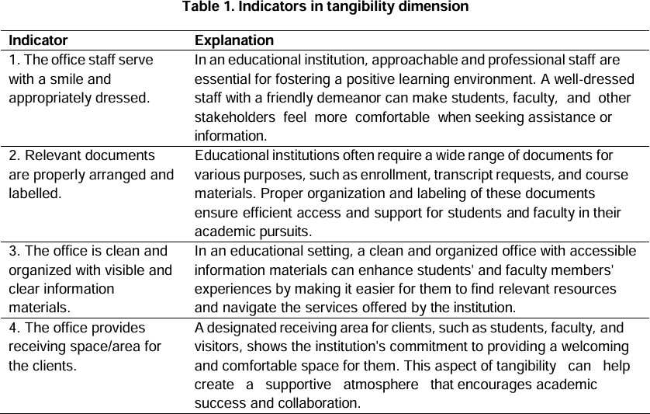

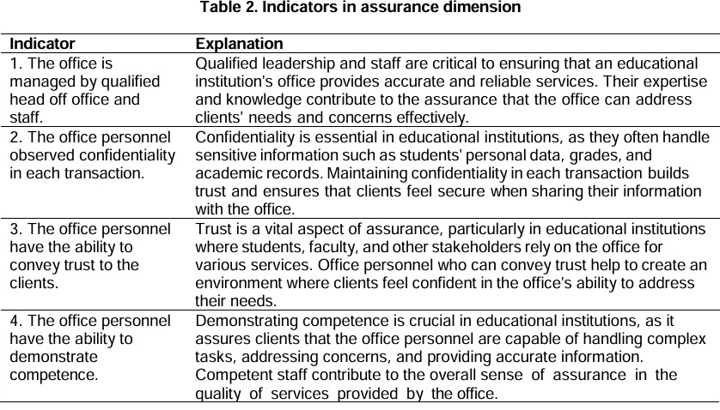

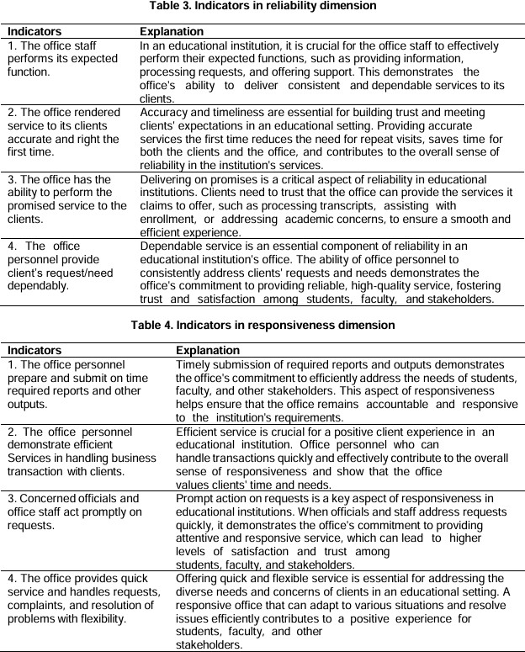

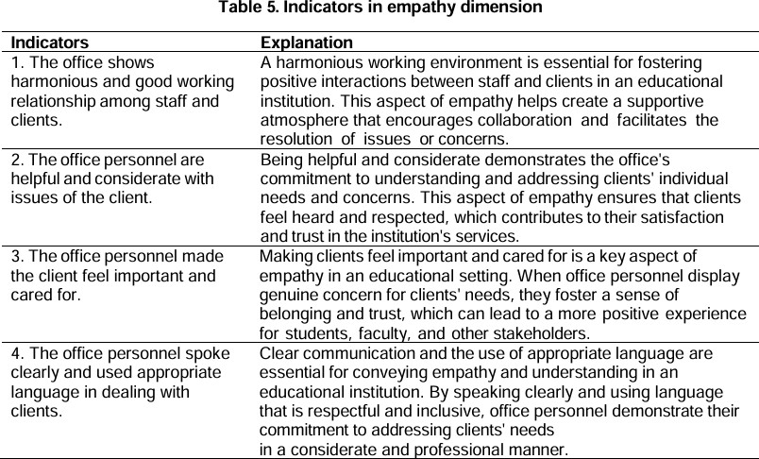

## Validation Phase

Quality service is an evaluation of how well a provided service meets or exceeds a client’s expectations. Today, service quality has become a prominent and emerging construct, gaining increased attention among higher education stakeholders. As key participants in the academic community, stakeholders deserve quality service and consistently expect good—if not the best—experiences, as they are vital resources of the university.

The figures below illustrate the graphical results on the appropriateness of the indicators across each SERVQUAL dimension, as validated by every cluster within the university. Fig.

1 reveals that Empathy obtained the highest mean score of 3.89, interpreted as very appropriate. This result aligns with the administration’s core principle of care. It indicates that the Office of the University President is consistent in upholding this value, as reflected by the high rating for the indicators under the empathy dimension. This supports Green’s (2016) statement that empathy refers to the care and individualized attention an organization provides to its clients.

Furthermore, indicators across the other dimensions—Assurance, Reliability, Responsiveness, and Tangibility—were all rated very appropriate, reinforcing the relevance of these dimensions in evaluating service quality.

Given the context of the Office of the University President and its role in overseeing institutional processes, the weighted mean scores for each dimension demonstrate that respondents find all five SERVQUAL dimensions suitable for assessing this office’s service performance.

Tangibility (3.72): The slightly lower score in this dimension suggests that while physical aspects—such as a professional appearance and an organized environment—are still

considered important, they may not be as central to the President’s Office compared to other dimensions. As noted by Zeithaml, Parasuraman, and Berry (1990), tangibles do contribute to positive perceptions, but in this setting, operational oversight and strategic leadership are the office’s primary focus.

Assurance (3.86): In the context of leadership, assurance is essential as it reflects the office’s knowledge, credibility, and authority in guiding the institution. The ability to inspire trust and confidence is fundamental to ensuring stakeholder confidence and the smooth operation of the university. This affirms Kuo, Wu, and Deng’s (2009) findings on the role of assurance in building organizational trust.

Reliability (3.88): This high score emphasizes the critical role of the President’s Office in consistently delivering on commitments and managing institutional processes effectively. As Zeithaml, Parasuraman, and Berry (1990) emphasized, reliability is a cornerstone of service quality—particularly in leadership—where consistent execution strengthens trust and institutional performance.

Responsiveness (3.88): Responsiveness signifies the office’s ability to act promptly on requests and concerns from various university sectors. A high score in this dimension suggests that the office is viewed as accessible and accountable, addressing issues in a timely manner. This supports the view of Parasuraman, Zeithaml, and Berry (1988), who underscored responsiveness as a key determinant of perceived service quality.

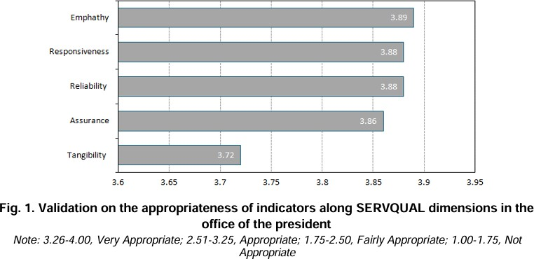

Empathy (3.89): The high score for empathy suggests that respondents value the office's ability to provide individualized attention and understanding. The Office of the University President must remain attuned to the needs and concerns of various stakeholders, fostering strong relationships and building trust within the institution. Research by Zeithaml, Parasuraman, and Berry (1990), as well as Kuo, Wu, and Deng (2009), supports empathy as a key driver of service quality.

In summary, the results indicate that all five SERVQUAL dimensions are deemed appropriate for assessing the Office of the University President. These findings are

consistent with previous research on the significance of these dimensions in shaping service quality perceptions and customer satisfaction across various contexts, including educational institutions (Parasuraman, Zeithaml, & Berry, 1988; Kuo, Wu, & Deng, 2009).

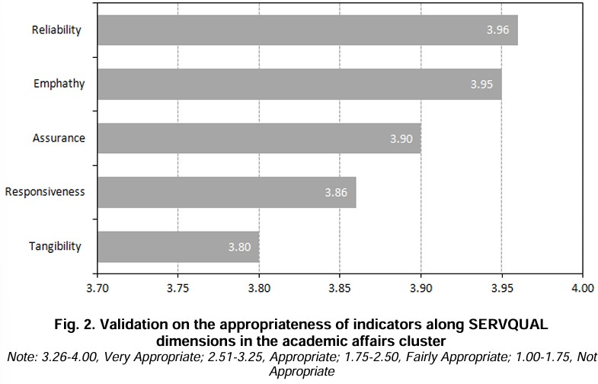

Figure 2 reveals that indicators under Reliability received the highest mean of 3.96, interpreted as very appropriate. This was followed by Empathy with a mean of 3.95, Assurance at 3.90, and Responsiveness at 3.86—all of which are also interpreted as very appropriate. The lowest mean was for Tangibility at 3.80, yet still categorized as very appropriate. Therefore, all indicators under the five SERVQUAL dimensions validated by personnel in the Academic Cluster are considered very appropriate.

Based on the weighted mean scores, it appears that respondents found all five dimensions suitable for assessing the Academic Cluster, which includes the various colleges within the university. The scores range from 3.80 to 3.96.

Tangibility (3.80): While Tangibility received the lowest score, it still falls within the very appropriate range. This may be because it addresses the physical aspects of service quality, which may be perceived as less critical compared to other dimensions in an academic context. Nonetheless, Zeithaml, Parasuraman, and Berry (1990) emphasized that a professional appearance and well-organized environment contribute positively to service quality perceptions.

Assurance (3.90): Assurance is especially important in an academic setting, as it relates to the knowledge, credibility, and trustworthiness of office personnel. In the case of the Academic Cluster, the competence of deans, chairpersons, and office staff is vital in maintaining the quality of academic services. This aligns with Kuo, Wu, and Deng (2009), who highlighted assurance as a major contributor to trust in institutional environments.

Reliability (3.96): The high score for reliability indicates that the Academic Cluster is perceived as dependable in fulfilling its responsibilities. In educational settings, reliability is essential to ensure that students receive consistent and quality instruction and support services. This is in line with the findings of Zeithaml, Parasuraman, and Berry (1990), who identified reliability as a fundamental aspect of service quality.

Responsiveness (3.86): The high rating for responsiveness shows that the Academic Cluster is viewed as prompt and efficient in addressing stakeholder concerns. According to Parasuraman, Zeithaml, and Berry (1988), responsiveness is critical in shaping clients’ overall service perceptions. In the academic context, this contributes to more positive experiences among students, faculty, and other constituents.

Empathy (3.95): The high score for empathy highlights the value placed on personalized attention and care within the Academic Cluster. This suggests that the colleges are appreciated for providing individualized support that fosters strong relationships and trust—core elements supported by Zeithaml, Parasuraman, and Berry (1990), and Kuo, Wu, and Deng (2009).

Figure 3 reveals that items under Responsiveness and Empathy both received the highest mean score of 3.83, interpreted as very appropriate. These are followed by Reliability and Assurance, both with a mean of 3.81. Tangibility received the lowest score at 3.71, though still categorized as very appropriate. Therefore, all indicators under the five SERVQUAL dimensions validated by personnel in the Administration and Finance Cluster are likewise considered very appropriate.

Given the responsibilities of the Administration and Finance Office—including budgeting, financial management, and resource allocation—the weighted mean scores reflect the perceived appropriateness of all five dimensions in evaluating this cluster.

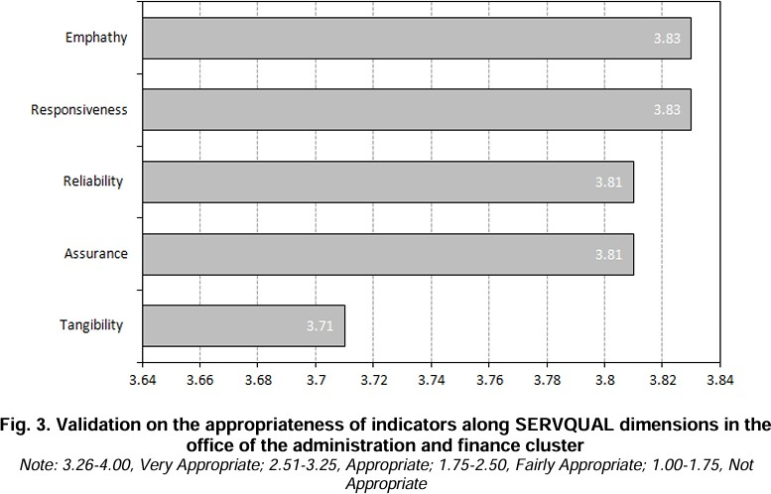

Tangibility (3.71): This score indicates that the visual and physical aspects of the office remain important. Since this office manages sensitive financial transactions, an organized and professional environment helps build stakeholder trust (Zeithaml, Parasuraman, & Berry, 1990).Assurance (3.81): Assurance is critical here, as it reflects the office’s competence in managing the university’s financial matters. Stakeholders must feel confident in the office’s ability to handle budgets, disbursements, and reports accurately and professionally (Kuo, Wu, & Deng, 2009).

Reliability (3.81): The high rating in reliability underscores the importance of dependable service delivery, particularly in financial documentation and support. A reliable Administration and Finance Office contributes to institutional stability and operational continuity (Zeithaml, Parasuraman, & Berry, 1990).

Responsiveness (3.83): The slightly higher score for responsiveness shows that stakeholders view the office as timely and helpful in addressing financial inquiries and concerns. This responsiveness supports accountability and smooth operations (Parasuraman, Zeithaml, & Berry, 1988).

Empathy (3.83): A strong score in empathy suggests that stakeholders value how the office accommodates specific needs, listens to concerns, and demonstrates a personalized approach—especially in financial interactions. This aligns with previous research affirming empathy’s role in service relationships (Zeithaml, Parasuraman, & Berry, 1990; Kuo, Wu, & Deng, 2009).

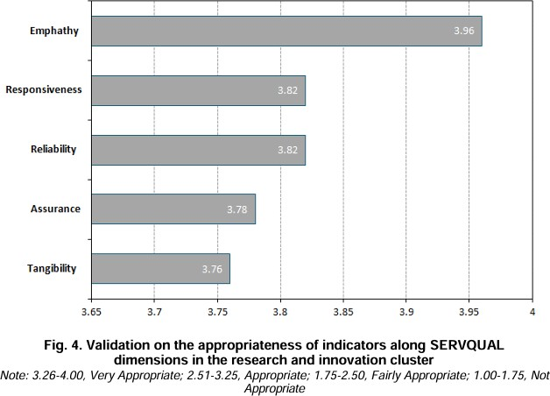

In summary, the results indicate that all five SERVQUAL dimensions are appropriate for evaluating the Administration and Finance Office. These results are consistent with prior research highlighting the dimensions’ applicability in both financial and educational service contexts (Parasuraman, Zeithaml, & Berry, 1988; Kuo, Wu, & Deng, 2009).

Figure 4 shows that items under Empathy achieved the highest mean of 3.96, followed by Reliability and Responsiveness, both at 3.82. Assurance followed with a mean of 3.78, while Tangibility had the lowest score at 3.76. Nevertheless, all scores are within the very appropriate range. Thus, all indicators under the five SERVQUAL dimensions were validated as appropriate by personnel in the Research and Innovation Cluster.

Given the role of the Research and Innovation Office—with its three divisions focused on research, production, and community extension—the results demonstrate that all five dimensions are fitting for service quality assessment in this context.

Tangibility (3.76): A relatively high score in tangibility shows that organized and professional environments remain important in this office. Given its engagement with researchers, funders, and external partners, a positive physical setting enhances credibility and collaboration (Zeithaml, Parasuraman, & Berry, 1990).

Assurance (3.78): This reflects the need for demonstrated competence in managing complex research and outreach programs. Assurance is critical in building trust with internal and external stakeholders (Kuo, Wu, & Deng, 2009).

Reliability (3.82): The score reflects consistent service delivery and adherence to commitments, vital in maintaining trust in collaborative research and extension work (Zeithaml, Parasuraman, & Berry, 1990).

Responsiveness (3.82): Timely communication and prompt resolution of issues are essential in research operations. The score shows the office is perceived as proactive and accountable (Parasuraman, Zeithaml, & Berry, 1988).

Empathy (3.96): The highest score in this cluster highlights the importance of personalized attention and relationship-building. Empathy fosters collaboration and trust among diverse stakeholders, which is key to successful research engagement (Zeithaml, Parasuraman, & Berry, 1990; Kuo, Wu, & Deng, 2009).

Figure 5 shows that indicators under Reliability and Responsiveness received the highest mean score of 3.83, interpreted as excellently provided. This is followed by Empathy, which received a mean of 3.79, also interpreted as excellently provided. The lowest score was under Tangibility, with a mean of 3.75, yet still categorized as excellently provided. These results indicate that all items or indicators under the five SERVQUAL dimensions are perceived as excellently provided by personnel in the Business and External Affairs Cluster.

Given the scope of the Business and External Affairs Office—which is tasked with managing the university’s external relationships, including international partnerships, sister-school agreements, and collaborations with government agencies—the weighted mean scores for each dimension suggest that all five are appropriate for evaluating this office’s service quality.

Tangibility (3.75): The strong score in this dimension underscores the value of maintaining a professional appearance and a well-organized environment. As the front-facing office that represents the university in external engagements, a polished and efficient workspace contributes positively to the perception of credibility and professionalism among external partners (Zeithaml, Parasuraman, & Berry, 1990).

Assurance (3.75): Assurance plays a critical role in the Business and External Affairs Office, as it reflects the staff’s competence in navigating institutional partnerships and official agreements. A high level of assurance is essential for building confidence among both internal stakeholders and external collaborators regarding the office’s ability to manage complex negotiations and relationships (Kuo, Wu, & Deng, 2009).

Reliability (3.83): The top score for reliability suggests that the office is seen as dependable and consistent in delivering on its commitments. In the context of external affairs, reliability is key to maintaining effective partnerships and strengthening the institution’s reputation across different sectors (Zeithaml, Parasuraman, & Berry, 1990).

Responsiveness (3.83): Responsiveness is especially important for this office, as it manages inquiries, proposals, and time-sensitive matters involving external institutions. The high score implies that stakeholders view the office as prompt and effective in its communications, which fosters trust and ensures efficient collaboration (Parasuraman, Zeithaml, & Berry, 1988).

Empathy (3.79): The high score for empathy indicates that respondents appreciate the office’s ability to extend individualized attention and understanding to external partners. This suggests that the office excels in nurturing relationships and demonstrating care in its interactions—an essential aspect of successful long-term partnerships (Zeithaml, Parasuraman, & Berry, 1990; Kuo, Wu, & Deng, 2009).

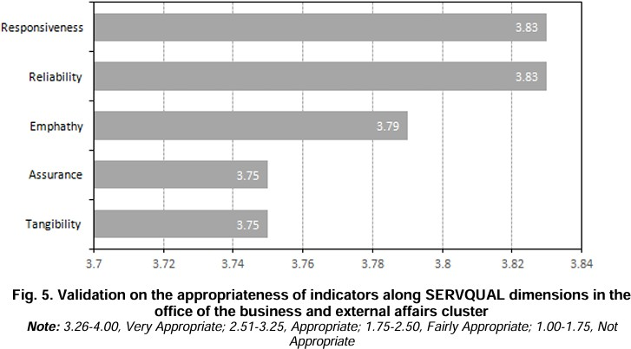

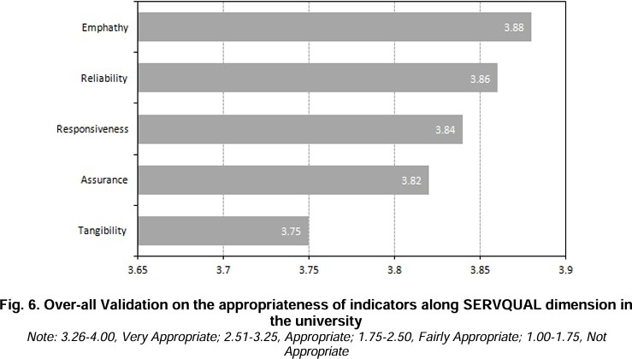

In summary, the results indicate that all five SERVQUAL dimensions are considered appropriate for assessing the Business and External Affairs Office. These findings are consistent with previous research emphasizing the relevance of these dimensions in shaping service quality perceptions and stakeholder satisfaction across a variety of settings, including partnership management and higher education institutions (Parasuraman, Zeithaml, & Berry, 1988; Kuo, Wu, & Deng, 2009).

The figure above presents the overall validation of the indicators under each SERVQUAL dimension in terms of their appropriateness for the developed Quality Service Assessment Tool. The Empathy dimension received the highest overall mean of 3.88, followed by Reliability with 3.86, Responsiveness with 3.84, and Assurance with 3.82. Tangibility received the lowest mean at 3.75, though still rated as very appropriate. Overall, all items under the five SERVQUAL dimensions were validated as very appropriate for assessing quality service in the university context.

The detailed analysis for each office highlights that while certain dimensions may carry more weight depending on an office’s specific functions, all five SERVQUAL dimensions remain essential for comprehensively evaluating service quality across the institution. These results reinforce the applicability of the SERVQUAL model in diverse organizational contexts, including higher education institutions (Parasuraman, Zeithaml, & Berry, 1988; Kuo, Wu, & Deng, 2009).

## Conclusions and Recommendations

In conclusion, the weighted mean scores across the five SERVQUAL dimensions—for the Office of the University President, Research and Innovation, Administration and Finance, Business and External Affairs, and the Academic Affairs Cluster—demonstrate that stakeholders consider the indicators appropriate for assessing service quality. The consistently high scores across all dimensions emphasize the continued relevance of

Tangibility, Assurance, Reliability, Responsiveness, and Empathy in shaping stakeholder perceptions of service delivery within the university.

These findings underscore the importance of maintaining strong performance across all five dimensions to ensure stakeholder satisfaction and to uphold a positive institutional reputation.

The researcher recommends conducting a more extensive study to evaluate the overall state of service quality and stakeholder satisfaction across the university using the developed Quality Service Assessment Tool. In addition, it is suggested that similar research be undertaken across all State Universities and Colleges (SUCs) in the Bicol Region to broaden the scope of validation and applicability.

It is also recommended that the university formally adopt the developed and validated indicators for assessing service quality. The implementation of a web-based e-Quality Service Assessment Tool is encouraged to enhance the efficiency and accessibility of service quality monitoring processes. The results generated from this system can provide essential evidence for ISO Certification, program accreditations, and PRIME-HR initiatives, ultimately supporting the university’s ongoing pursuit of excellence and future-readiness.

# DISCLAIMER (ARTIFICIAL INTELLIGENCE)

Author(s) hereby declare that generative AI technologies such as Large Language Models, etc have been used during writing or editing of this manuscript. This explanation will include the name, version, model, and source of the generative AI technology and as well as all input prompts provided to the generative AI technology.

## Details of the AI usage are given below:

1. ChatGPT trial version used in editing some parts of the paper.

# COMPETING INTERESTS

Author has declared that no competing interests exist.

# REFERENCES

Afridi, S. A., Khattak, A. A., & Khan, A. (2016). Measurement of service quality gap in the selected private universities/institutes of Peshawar using SERVQUAL model. City University Research Journal, 6(1). Retrieved from <http://www.cityuniversity.edu.pk/curj/Journal> s/Journal/Jan%202016/artcile%2005a.pdf

Al-Ibrahim, A. (2014). Quality management and its role in improving service quality in public sector. Journal of Business and Management Sciences, 2(6). Retrieved from <http://pubs.sciepub.com/jbms/2/6/1>

Atiyah, A. (2017). Impact of service quality on customer satisfaction. Australian Journal of Basic and Applied Sciences, 11(5), 20–28. Retrieved from <http://ajbasweb.com/old/ajbas/2017/April/20> -28.pdf

Cayanan, C. (2017). Service quality of private tertiary education institutions in the Province of Pampanga: A gap analysis. DLSU Research Congress 2017, De La Salle University, Manila, 20-22 Philippines. Retrieved from https://[www.researchgate.net/publication/32](http://www.researchgate.net/publication/32) 4834437_Service_Quality_of_Private_Tertiary_Education_Institutions_in_the_Provin ce_ of_Pampanga_A_Gap_Analysis

Datta, K. S., & Vardhan, J. (2017). A SERVQUAL-based framework for assessing quality of international branch campuses in UAE. SAGE Open, 7(1). https://doi.org/10.1177/2158244016676294

Green, P. (2014). Measuring service quality in higher education: A South African case study. Journal of International Education Research, 10(2). Durban University of Technology, South Africa. Retrieved from https://ir.dut.ac.za/handle/10321/1332

Janjua, Q. R., & Aftab, F. (2016). Service qualitycustomer loyalty chain in business schools: A multivariate analysis. Global Management Journal for Academic & Corporate Studies, 6(2). Retrieved from https://searchproquest.com.library.capella.edu/docview/1 925719280?pqorigsite=summon&<http://library.capella.edu/l> ogin?url=accountid=27965

Kanakana, M. (2014). Assessing service quality in higher education using the SERVQUAL tool. Retrieved from <http://iieom.org/ieom2014/pdfs/24.pdf>

Krsmanovic, M., Horvat, D., & Ruso, J. (2014). Application of SERVQUAL model in high education: Belgrade University in Serbia. In Proceedings of the 11th International Conference on Standardization, Prototypes and Quality: A Means of Balkan Countries' Collaboration. Retrieved from <http://www.academia.edu/8902577/Applicati> on_of_SERVQUAL_Model_in_High_Education

Kuo, Y. F., Wu, C. M., & Deng, W. J. (2009). The relationships among service quality, perceived value, customer satisfaction, and post-purchase intention in mobile value-added services. Computers in Human Behavior, 25(4), 887-896. https://doi.org/10.1016/j.chb.2009.03.003

Mwiya, B., Siachinji, B., Chanda, M., Mbewe, S., & Sibalwa, I. (2017). Higher education quality and student satisfaction nexus: Evidence from Zambia. Open Access Library Journal, 4(5), 1-19. https://doi.org/10.4236/oalib.1103913

Nenadal, J. (2015). Comprehensive quality assessment of Czech higher education institutions. International Journal of Quality and Service Sciences, 7(2/3), 138-151. https://doi.org/10.1108/IJQSS-03-2015- 0034

Nyenya, T., & Bukaliya, R. (2015). Comparing students’ expectations with the students’ perceptions of service quality provided in open and distance learning institutions in Zimbabwe’s Mashonaland East Region. International Journal of Research in Humanities and Social Studies, 2(4), 34- 45. Retrieved from <http://www.ijrhss.org/pdf/v2-> i4/7.pdf

Parasuraman, A., Zeithaml, V. A., & Berry, L. L. (1988). SERVQUAL: A multiple- item scale for measuring consumer perceptions of service quality. Journal of Retailing, 64(1), 12-40.

Raphael, M. M. (2014). An analysis of service quality measurements in tertiary colleges in Kenya: A case study of Zetech College. Retrieved from <http://irlibrary.ku.ac.ke/bitstream/handle/123> 456789/10071/An%20analysis%20of%20se r vice%20quality%E2%80%A6.pdf?sequence =1&isAllowed=y

Setyawan, Abhiyoga Alan. (2023). The Effect of E-Service Quality and Convenience of Online Services on E-Customer Loyalty through E-Customer Satisfaction on Livin By Mandiri Users. South Asian Journal of Social Studies and Economics 18 (3):50- 58. https://doi.org/10.9734/sajsse/2023/v18i36 60.

Singh, G., & Kumar, M. (2014). Exploratory factor analysis of service quality dimensions for higher educational institutes: A students perspective. Global Journal of Management and Business Research: Administration and Management, 14(8), 32-42. Retrieved from https://globaljournals.org/GJMBR_Volume 14/6-Exploratory-Factor- Analysis.pdf

Vazirova, N. (2016). Measuring service quality in higher education: A study of postgraduate students in Northern Cyprus (Master's thesis). Eastern Mediterranean University, Gazimağusa, North Cyprus. Retrieved from <http://irep.emu.edu.tr:8080/jspui/handle/11129/30> 13

Wadjdi, Farid, & Zulkifli. (2021). The Relationship Between E-Service Quality and Ease of Use on Electronic Customer Relationship Management (E-CRM) Performance Mediating by Brand Image. Asian Journal of Economics, Business and Accounting 21

(4):9-19. https://doi.org/10.9734/ajeba/2021/v21i430 367.

Yarimoglu, E. K. (2014). A review on dimensions of service quality models. Journal of Marketing Management, 2(2), 79-93. Retrieved from <http://jmmnet.com/journals/jmm/Vol_2_No_> 2_June_2014/5.pdf

Zeithaml, V. A., Parasuraman, A., & Berry, L. L. (1990). Delivering quality service: Balancing customer perceptions and expectations. New York, NY: The Free Press.