**Meiofaunal Distribution on Coral Reefs of Pangkajene Islands, South Sulawesi, Indonesia**

## ABSTRACT

This study investigated the distribution patterns of meiofauna associated with coral reefs in the waters of the Pangkajene Islands, South Sulawesi, Indonesia. Surveys were conducted at depths between 6 and 8 meters, with live coral cover ranging from 10.27% to 78.47%. Sediment samples were collected using a 3 cm diameter core to a depth of 10 cm at nineteen permanent reef transect sites. Thirteen meiofaunal taxa were identified, with nematodes, harpacticoid copepods, polychaetes, turbellarians, and foraminifers consistently present at all sites. Nematodes dominated the meiofaunal communities, with the highest abundance observed at Site 9 (3,764 individuals/10 cm²). Total meiofaunal density varied widely, from 123 to 5,235 individuals/10 cm². Cluster analysis based on Bray–Curtis similarity revealed three main groups at a 50% similarity threshold, confirmed by non-metric multidimensional scaling (nMDS) ordination. Overlaying live coral cover percentages onto the meiofaunal distribution pattern showed no clear relationship between meiofaunal abundance and coral cover. These findings suggest that other environmental factors likely influence meiofaunal community structures on coral reefs.

*Keywords: Distribution; hard coral; coral reef; Raja Ampat Regency.*

# 1. INTRODUCTION

Indonesia's coral reef system is among the largest in the world, serving as a vital hub of marine biodiversity. Situated in the heart of the Coral Triangle, this area supports a wide variety of coral species and marine life, establishing itself as a key biodiversity hotspot [1][2]. Coral reefs serve as crucial habitats for many macro-organisms, creating complex microenvironments that support small invertebrates, including meiofauna. Despite their essential role in maintaining benthic ecosystem stability, research on meiofauna communities in this region remains limited compared to studies on reef fish, scleractinian corals, and macrobenthos [3][4].

The Pangkajene Islands (Pangkep) Regency, located in South Sulawesi Province, has a coastal area of strategic importance characterized by a group of small islands stretching from north to south [5]. This geographic layout presents considerable opportunities for developing sectors such as marine activities, fisheries, marine tourism, and the utilization of other coastal resources. However, increased human activities in this coastal region, including urbanization, fisheries, and maritime transportation, have heightened environmental pressures, endangering habitat health and worsening water pollution [6].

The coral reef ecosystem in Pangkep includes a wide range of ecological functions, acting as an essential buffer for the survival of various marine organisms, including meiofauna communities that live in the sediments between coral structures. Meiofauna are defined as small invertebrates that can pass through a sieve of 500–1000 µm but are retained by a 32 µm sieve [7][8]. These organisms typically inhabit the spaces between sediment particles from the littoral zone to the deep sea, including groups such as Nematoda, Copepoda, Turbellaria, and Tardigrada. Meiofauna are vital to the benthic ecosystem cycle through their roles in organic matter decomposition, nutrient recycling, and microbial population control, while also providing an energy source for higher-level consumers [3]. Their short life cycles and limited mobility also make them sensitive indicators of environmental change [9].

Despite their ecological importance, research on meiofauna communities within Indonesia's coral reef ecosystems remains limited. Studies conducted between 2007 and 2012 in the Pangkajene Islands mainly focused on parameters such as coral cover, reef fish communities, and macrobenthos. Investigations specifically targeting meiofauna communities only began after 2012, leading to limited information about their community structure, spatial distribution, and ecological roles within coral reef systems. Coral reefs in this region develop on complex geological structures and include various types, such as fringing and patch reefs, characterized by high hard coral diversity, with at least 98 species identified, mainly *Porites cylindrica* [10][11]. The spaces between corals often contain unconsolidated carbonate sediments caused by bioerosion and physical damage to the skeletons of calcareous organisms [12][13][14], which can serve as potential habitats for meiofauna communities.

Investigating meiofauna communities in coral reef sediments is crucial for various ecological and practical reasons. First, the distribution and composition of meiofauna reflect the physicochemical conditions of sediments and can serve as early indicators of environmental disturbances, including eutrophication, sedimentation, and anthropogenic pollution [15][16][17]. Second, meiofauna's role within trophic networks and biogeochemical processes—such as bioturbation and the remineralization of organic matter—plays a key role in maintaining the dynamics and functionality of marine sediment ecosystems [18]. Third, these communities show sensitive responses to changes in environmental factors, such as chlorophyll a content, sediment texture, and substrate stability, potentially serving as biological indicators for assessing benthic ecosystem health [19]. The diverse range of meiofauna, including over 20 phyla, highlights their importance in evaluating the biodiversity and stability of marine ecological systems [20].

This study provides the first baseline assessment of meiofaunal community structure in the coral reef sediments of the Pangkajene Islands. The main objective is to examine the spatial patterns of meiobenthic communities in relation to variations in live coral cover. Hopefully, this research can contribute valuable information and serve as fundamental data for future studies.

**2. MATERIALS AND METHODS**

**2.1 Date and Location**

A study on meiofauna distribution patterns in coral reefs was conducted in the waters of the Pangkajene Archipelago, South Sulawesi. Meiofauna were sampled from 19 stations in April 2012 along the coastal area of Pangkajene waters (Figure 1).

SCUBA divers sampled the sediment around corals using three syringe barrels, each 3 cm in diameter, inserted into the sediment at a depth of 10 cm. After removing the syringe from the sediment, the open end was immediately capped with a rubber sheet to prevent any loss of the sample when returning to the boat. The samples were preserved in 4% formaldehyde and rose Bengal stain for further sorting and identification. In the laboratory, the samples were washed through a set of two sieves, the upper one with a mesh size of 1000 μm and the lower one with a mesh size of 32 μm. Animals retained on the lower sieve were counted as meiofauna. Extraction of meiofauna from the sediment was carried out using strong swirl decantation [3], followed by microscopic sorting. All meiofauna collected from each sampling site were counted into major taxa, which is adequate for ecological studies [16][21]. Abundance values of meiofauna are expressed as the average number of individuals per 10 cm² per station.

Data analysis followed methods described by Clarke & Warwick [22], using the PRIMER 5 (Plymouth Routines in Multivariate Ecological Research) software package [23]. Multivariate data analysis was performed using non-metric multidimensional scaling (MDS) with the Bray-Curtis similarity measure. The examination of relationships between sites with animals was conducted using classification and ordination techniques [24]. The data with the fourth root transformation reduced the influence of abundant taxa but emphasized the less abundant taxa in the analysis. All abundance data were double-square-root transformed (Yij = √√Vij) before creating similarity matrices. These matrices were then subjected to clustering analyses. A hierarchical, agglomerative approach using group-average linkage was visualized with a dendrogram. The ordination method employed was non-metric multidimensional scaling (MDS), aiming to create a ‘map’ of the sites based on sample similarity. Finally, the correlation between meiofaunal abundance and environmental factors was assessed by superimposing these factors on the two-dimensional configurations of site positions derived from the multivariate faunal analysis [25].

**Figure 1.** **Map showing the sampling sites along the coastal line of Pangkajene waters.**

**3. RESULTS AND DISCUSSION**

**3.1. Environmental Characteristics of the Study Area**

The environmental parameters recorded at the sampling stations in the Pangkajene Islands indicate that the study area is a typical shallow tropical coral reef ecosystem with stable oceanographic conditions. The depths of the sampling sites ranged from 6 to 8 meters, with an average depth of 6.92 ± 0.57 meters. Salinity levels remained consistent, averaging 31.1 ± 0.56 ppt, while seawater temperature stayed elevated, with an average of 30.7 ± 0.49°C. The water pH was slightly alkaline, ranging from 8.05 to 8.21, with a mean of 8.13 ± 0.06 (Table 1). Live coral cover showed notable spatial variation, ranging from 10.27% to 78.47%, with an average of 42.36 ± 24.33% (Figure 2).

The sediment composition at all sites was mainly carbonate, made up of fine to coarse sands. These sediments came from the bioerosion and breakdown of coral skeletons and other calcareous creatures. Such substrate conditions create a varied microhabitat that supports diverse meiobenthic communities.

The stability of salinity, temperature, and pH indicates that the study area is not currently under severe environmental stress. However, oceanographic parameters in coral reef ecosystems are known to fluctuate seasonally due to changes in precipitation, runoff, wind-driven mixing, and tidal cycles [26]. In this setting, the meiofaunal community is likely resilient to moderate environmental changes, as these organisms are adapted to the naturally dynamic conditions of reef-associated sediments [3].

The physical and chemical environment described here offers a useful reference for future monitoring. It sets a baseline for examining the link between abiotic factors and meiofaunal community structure in reef ecosystems.

**Table 1. Physical environmental parameters at stations in the Pangkajene Islands.**

|  |  |  |
| --- | --- | --- |
| Parameters | Range | Mean ± SD |
| Depth (m) | 6 - 8 | 6.92±0.57 |
| Salinity (ppt) | 30 - 32 | 31.1±0.56 |
| Temperature (˚C) | 30 - 32 | 30.7±0.49 |
| pH | 8.05 – 8.21 | 8.13±0.06 |

**Figure 2. Percentage of live coral cover at each location**.

**3.2. Diversity and Density of Meiobenthic Fauna**

A total of 13 major meiofaunal taxa were identified from sediment samples collected at coral reef sites in the Pangkajene Islands. Among these, six groups of meiobenthic metazoans—Nematoda, Harpacticoida, Polychaeta, Turbellaria, Foraminifera, and Nauplii—were consistently present at all sampling stations. These taxa are essential components of meiobenthic communities associated with coral reefs and are frequently documented as dominant groups in tropical marine sediments **[27]**. Conversely, other taxa such as Amphipoda, Isopoda, Tanaidacea, Ostracoda, Kinorhynchia, Nemertini, and Cumacea were observed sporadically and were absent at certain stations. The distribution of these less abundant taxa may reflect microhabitat specificity, seasonal reproductive cycles, or competitive exclusion under specific environmental conditions **[15][28]**.

Meiofaunal densities showed significant spatial variation, ranging from a low of 123 individuals per 10 cm² at Station 18 to a high of 5,235 individuals per 10 cm² at Station 9 (Table 2). The overall average density was 1,037 ± 1,145 individuals per 10 cm², reflecting a patchy distribution across stations. The large differences in meiofaunal abundance likely stem from variations in sediment texture, organic matter levels, and microhabitat complexity, especially those influenced by live coral cover and reef structural diversity [15][27].

The dominant meiofaunal groups at most stations were Nematoda, Harpacticoida, and Turbellaria. Nematodes usually make up the most significant part of the community, consistent with previous studies highlighting their ability to adapt to different sediment environments and their high tolerance to environmental gradients. Harpacticoids, which rely on microalgal biofilms and detritus, were also common at all stations, showing higher benthic productivity. Their ability to adapt to various sediment types and form symbiotic relationships with other marine organisms, including macroalgae and invertebrates, helps ensure their survival and reproduction by providing nutritional benefits and protection from predators [29][30].

High live coral cover, observed at sites 4, 9, and 13, is linked to significantly higher meiofauna densities. This relationship indicates that structurally complex habitats enhance habitat diversity and resource availability for meiobenthic organisms [27][3]. Live coral structures are crucial in trapping organic particles and supporting microalgal growth, thus enriching resources for sedimentary meiofauna. Coral mucus effectively captures particles, boosts particulate organic carbon and nitrogen levels, and promotes nutrient recycling in reef ecosystems [31][32][33]. These processes highlight the close connection between coral structure, organic matter dynamics, and the enrichment of meiofaunal communities in reef ecosystems.

**Table 2.** **Meiofaunal densities (individuals/10 cm²) at each station.**

|  |  |  |  |  |  |  |  |  |  |  |  |  |  |  |
| --- | --- | --- | --- | --- | --- | --- | --- | --- | --- | --- | --- | --- | --- | --- |
| Site No. | Nem | Har | Nau | Pol | Amp | Iso | Tan | Ost | Kin | For | Tur | Nrt | Cum | Total |
| 1 | 231 | 221 | 75 | 18 | 1 | 0 | 0 | 0 | 0 | 16 | 18 | 0 | 0 | 580 |
| 2 | 127 | 95 | 10 | 11 | 0 | 0 | 0 | 0 | 0 | 6 | 17 | 3 | 0 | 269 |
| 3 | 134 | 32 | 6 | 4 | 0 | 0 | 0 | 0 | 1 | 3 | 4 | 3 | 0 | 187 |
| 4 | 831 | 953 | 578 | 80 | 0 | 0 | 1 | 4 | 0 | 30 | 24 | 0 | 0 | 2501 |
| 5 | 673 | 341 | 23 | 17 | 4 | 0 | 0 | 4 | 3 | 15 | 183 | 0 | 0 | 1263 |
| 6 | 511 | 170 | 35 | 25 | 1 | 0 | 1 | 1 | 0 | 70 | 105 | 2 | 0 | 921 |
| 7 | 715 | 424 | 57 | 21 | 1 | 0 | 0 | 11 | 3 | 11 | 23 | 0 | 3 | 1269 |
| 8 | 520 | 157 | 11 | 13 | 2 | 0 | 0 | 0 | 2 | 3 | 93 | 2 | 0 | 803 |
| 9 | 3764 | 989 | 142 | 91 | 5 | 2 | 16 | 2 | 12 | 12 | 198 | 2 | 0 | 5235 |
| 10 | 117 | 51 | 7 | 3 | 0 | 0 | 0 | 0 | 6 | 7 | 11 | 0 | 0 | 202 |
| 11 | 651 | 279 | 27 | 11 | 0 | 0 | 0 | 3 | 20 | 21 | 95 | 0 | 0 | 1107 |
| 12 | 463 | 311 | 18 | 7 | 0 | 0 | 0 | 7 | 0 | 3 | 8 | 0 | 0 | 817 |
| 13 | 1358 | 731 | 103 | 33 | 6 | 0 | 0 | 0 | 0 | 11 | 101 | 3 | 3 | 2349 |
| 14 | 113 | 17 | 6 | 3 | 0 | 0 | 0 | 0 | 0 | 2 | 5 | 0 | 0 | 146 |
| 15 | 93 | 24 | 3 | 7 | 0 | 0 | 4 | 3 | 0 | 6 | 11 | 1 | 0 | 152 |
| 16 | 116 | 23 | 9 | 5 | 1 | 0 | 0 | 3 | 1 | 6 | 8 | 0 | 1 | 173 |
| 17 | 97 | 31 | 8 | 8 | 0 | 0 | 1 | 4 | 6 | 6 | 7 | 3 | 1 | 172 |
| 18 | 85 | 24 | 4 | 4 | 0 | 0 | 0 | 0 | 0 | 3 | 3 | 0 | 0 | 123 |
| 19 | 106 | 37 | 8 | 21 | 24 | 1 | 0 | 3 | 1 | 7 | 15 | 0 | 0 | 223 |

**Remarks:** **Nem = Nematoda, Har = Harpacticoida, Nau = Nauplii, Pol = Polychaeta, Amp= Amphipoda, Iso = Isopoda, Tan = Tanaidacea, Ost = Ostracoda, Kin = Kinorhynchia, For = Foraminifera, Tur = Turbellaria, Nrt = Nemertini, Cum = Cumacea.**

Benthic organisms, including amphipods, isopods, cumaceans, foraminifera, tanaidaceans, and kinorhynchs, perform interconnected roles within marine ecosystem dynamics. In terms of nutrient cycling, amphipods and isopods act as detritivores, aiding in the breakdown of organic matter and recycling essential nutrients back into the aquatic system, which in turn supports primary productivity and maintains ecosystem function [34][35]. These organisms also play a vital role in trophic interactions, acting as prey for larger predators such as demersal fish and carnivorous crustaceans, thus influencing population structure through energy transfer within the food web. Bioturbation by species like amphipods and cumaceans disturbs sediment structures through burrowing and movement, increasing oxygen diffusion and nutrient availability, and thereby creating supportive microhabitats for other benthic organisms [35].

Certain organisms, such as foraminifera, contribute to sediment formation and stabilization by excreting calcium carbonate. Tanaidaceans and kinorhynchs are adapted to specific microhabitats, which influence the diversity and structure of the benthic community [36]. Therefore, the presence and activities of these organisms indicate the quality of the benthic environment and play vital roles in essential ecological functions within coastal and marine ecosystems. Although less frequently studied, foraminifera, Turbellaria, and Nemertini serve as valuable indicators for assessing environmental conditions; foraminifera are effective bioindicators of changes in chemical parameters such as pH and salinity, while Turbellaria and Nemertini, as mid-level predators, help regulate meiofauna populations and increase trophic complexity within benthic ecosystems [3][37].

These findings highlight the importance of habitat complexity in shaping meiofaunal communities and emphasize the potential of these organisms as bioindicators of reef ecosystem health. The increased sensitivity of meiofauna to subtle environmental changes further supports their use in long-term ecological monitoring of coral reef habitats.

**3.3. Spatial Patterns of Meiofauna**

Multivariate analyses revealed distinct spatial patterns in meiofaunal communities across the coral reef sites in the Pangkajene Islands. Cluster analysis using Bray-Curtis similarity (after root-root transformation of abundance data) identified three main station groups at a 50% similarity threshold (Figure 3). These groups reflect ecological differences, especially in habitat features like live coral cover and substrate diversity. Stations marked by high live coral cover tended to cluster together, showing a strong link between coral structural complexity and meiofaunal community makeup. The presence of microhabitats, crevices, and sediment pockets within coral frameworks likely encourages meiofaunal diversity by providing refuge from predators and improving access to organic detritus and microbial food sources [3][15].

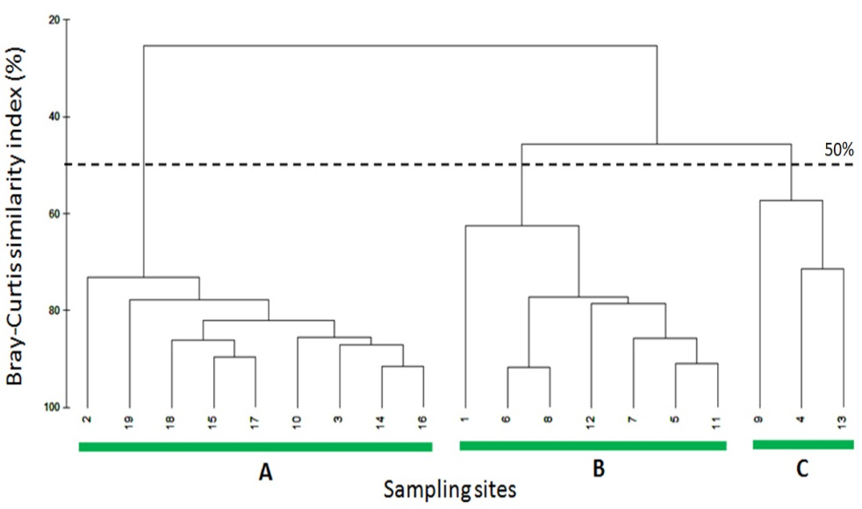

**Figure 3.** **Dendrogram for group-average clustering based on Bray-Curtis similarity and root-root transformation of abundance data at 50% similarity**

To clarify the spatial variation in community structure, a non-metric multidimensional scaling (nMDS) ordination was used on the same dataset (Figure 4). The nMDS plot showed distinct spatial separation among stations, aligning with the cluster analysis, and had a low stress value of 0.01, indicating an excellent two-dimensional representation of the underlying multivariate relationships [37]. Incorporating live coral cover into the nMDS configuration using proportional symbol sizes (Figure 5) provided additional ecological insight. Stations with larger circles (i.e., higher coral cover) appeared more tightly clustered, reaffirming the influence of habitat complexity on meiofaunal assemblages. Conversely, stations with lower coral cover, often located at reef edges or within sediment-dominated zones, showed greater dispersion in ordination space, reflecting more heterogeneous and potentially stressed community structures.

These findings emphasize the ecological importance of biogenic habitat complexity in influencing the distribution and diversity of meiobenthic organisms in coral reef ecosystems. They also demonstrate the potential of meiofaunal communities as sensitive indicators of benthic habitat health, especially in structurally intricate tropical reef environments.

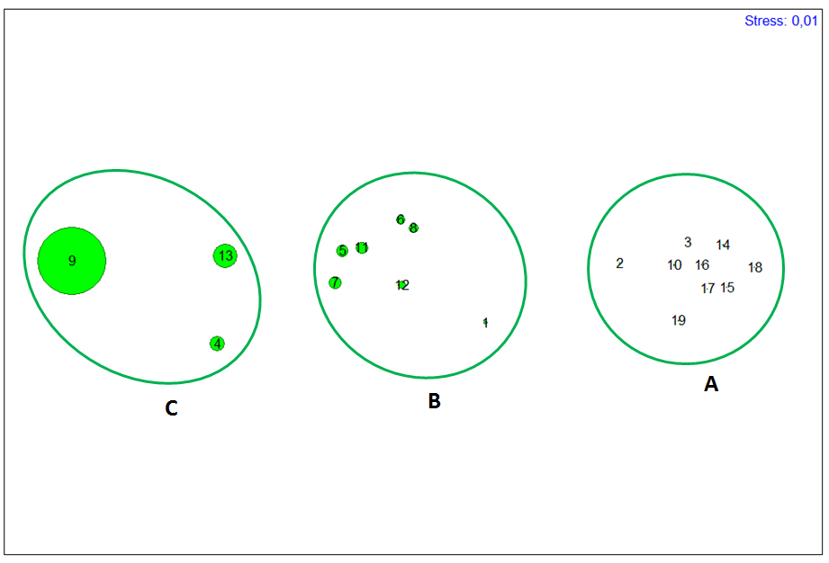

**Figure4. Two-dimensional configuration (multidimensional scaling ordination) based on meiofaunal abundance data. Stress value = 0.01.**

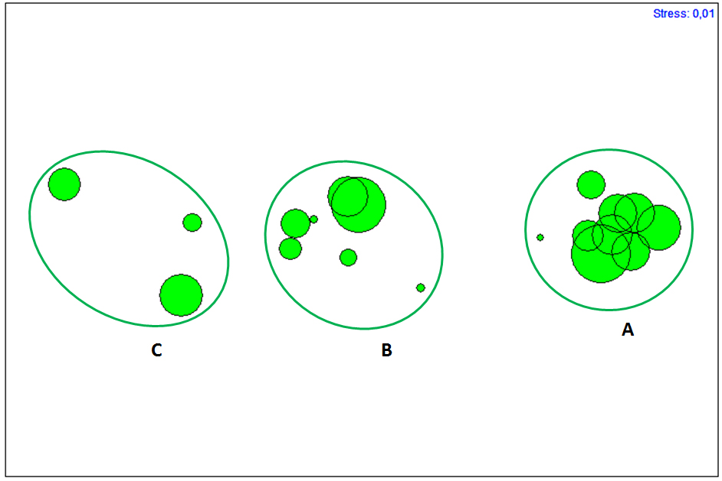

**Figure 5. nMDS configuration of the sites with symbols scaled to represent live coral cover (largest circle = 78.47% and smallest circle = 10.27%).**

**3.4. Comparison with Other Coral Reef Regions**

Analyses of meiofaunal density across tropical coral reef ecosystems reveal significant spatial variation, primarily driven by environmental factors, sediment type, and habitat complexity. In this study, meiofaunal counts ranged from 123 to 5,235 individuals per 10 cm² (Table 3), similar to values observed in reef sediments from Rocas Atoll, Brazil. However, overall densities were generally lower than those in the Pangkajene Archipelago, where meiofaunal counts often exceeded 2,000 individuals per 10 cm², reaching over 5,000 individuals at some stations.

This disparity indicates that meiofaunal communities in the Pangkajene region are more diverse and productive, likely due to more favorable environmental conditions. A key factor leading to lower densities at some stations in this study is the nature of the sediments, especially their high calcium carbonate content. Carbonate-rich sediments generally have low organic matter adsorption capacity, limiting the availability of essential nutrients and decreasing habitat stability [38][39][40]. Conversely, in regions like Pangkajene, where fine sediments from biogenic erosion are typical, the substrate acts both as a nutrient source and a protective barrier against hydrodynamic stress and predation [41]. Additionally, some reef areas experience relatively low levels of human disturbance, helping to maintain ideal conditions for benthic communities to thrive.

Meiofauna, as interstitial organisms with short life cycles and limited pelagic larval dispersal, are highly sensitive to environmental changes [42]. Their distribution is strongly influenced by abiotic factors, including temperature, salinity, current patterns, sedimentation processes, grain size, dissolved oxygen levels, and organic matter availability [43][44]. The interaction among these factors, especially the combination of live coral structures with sediment characteristics, plays a crucial role in enhancing habitat stability and supporting meiofaunal productivity. Comparing this study area with other tropical reef systems emphasizes the key role of reef geomorphology and benthic microhabitat conditions in shaping meiofaunal community structure. These findings highlight the importance of standardized sampling and reporting protocols to enable accurate and comprehensive cross-site ecological evaluations, thereby guiding conservation and management strategies for tropical coral reef ecosystems.

**Table 3. Meiofaunal densities in various coral reef ecosystems.**

|  |  |  |
| --- | --- | --- |
| **Location** | **Meiofaunal Density**  **(individuals/10 cm²)** | **Source** |
| Madagascar | 500–1,200 | [45] |
| French Polynesia | 800–1,500 | [46] |
| Costa Rica | 300–1,800 | [47] |
| Brazil | 700–1,400 | [48] |
| Losari Coast, Makassar | 20–20,010 | [49] |
| Pangkajene Islands | 123–5,235 | This study |

**3.5. Environmental Influence on Meiofaunal Communities**

Environmental factors—especially live coral cover and sediment properties—are vital in shaping meiofaunal community structure in coral reef ecosystems. This study reveals a complex interaction between benthic microhabitat conditions and meiofaunal abundance, showing that structural complexity from live coral frameworks acts as a key ecological driver. Complex reef matrices offer diverse microhabitats, greater surface area, and better organic detritus retention, which support more abundant and diverse meiofaunal communities [26][50]. Reefs with high live coral cover support the development of three-dimensional habitats that encourage spatial niche differentiation and resource partitioning among meiobenthic taxa. These intricate habitats also provide refuges from predation and hydrodynamic stress while promoting trophic interactions at multiple levels [10][11]. In contrast, degraded reef areas with fragmented substrates, coral rubble, and sediment compaction generally show lower meiofaunal density and diversity. Coral rubble-dominated substrates often lack the structural stability needed to maintain diverse meiofaunal microhabitats and are often linked to unstable sediment conditions and reduced organic input.

Sediment granulometry and composition further influence meiofaunal distribution. Stations with fine to medium carbonate sands—primarily resulting from coral bioerosion—supported higher meiofaunal abundance compared to those with coarser, less stable substrates. This finding aligns with previous research indicating that sediment grain size and organic content are critical factors in shaping meiofaunal community structure, affecting burrowing behavior, oxygen penetration, and food availability [3]. Meiofauna act as sensitive bioindicators of benthic habitat quality, responding quickly to changes in environmental conditions and substrate health. As a result, meiofaunal assessments offer valuable insights into the ecological effects of coral reef degradation and serve as a reliable method for monitoring habitat health in tropical reef systems [51].

In this study, the lack of seagrass at all sampling sites likely limited the accumulation of organic matter from plant debris. Additionally, the absence of human pollution—evidenced by healthy coral growth—suggests relatively pristine environmental conditions. This may help explain the high meiofaunal densities observed in the reef sediments of the Pangkajene waters. These results contrast with previous reports of low meiofaunal abundance in carbonate-rich reef sediments, which have been linked to reduced organic matter retention due to the high calcium carbonate content of the sediment [3][52]. However, contrary to expectations, the current results did not show a strong link between meiofaunal abundance and live coral cover (Figures 4 and 5). This suggests that sediment-related factors might have a greater impact on meiofaunal populations than coral cover itself. The breakdown of organic matter within the sediment probably plays a more direct role in supporting meiofaunal communities by providing a primary food source [53]. Additionally, the physical features of the sampled reef substrates resemble those of sandy-bottom habitats. As a result, the meiofaunal communities observed are similar in composition and function to those typically found in sandy coastal environments.

In such sedimentary habitats, meiofauna act as essential connectors between primary producers and higher trophic levels, including juvenile stages of nektonic and benthic macrofauna [54]. They also play a crucial role in key ecological processes like organic matter mineralization and nutrient cycling [55], highlighting their functional importance within coral reef ecosystems.

**4. CONCLUSION**

This study shows that meiofaunal communities in the coral reefs of the Pangkajene Islands are highly diverse and abundant, with their distribution closely tied to live coral cover and sediment structure. High coral complexity promotes richer and more stable meiobenthic groups, highlighting the ecological importance of healthy reef habitats. These results emphasize the key role of meiofauna in reef ecosystem functioning and stress the importance of including meiofaunal assessments in coral reef conservation strategies in Indonesia.

**DISCLAIMER (ARTIFICIAL INTELLIGENCE)**

The author (s) hereby declare that no generative AI technologies such as Large Language Models (ChatGPT, COPILOT, etc.) and text-to-image generators have

been used during the writing or editing of this manuscript.

**COMPETING INTEREST**

The authors have declared that no competing interests exist.

**REFERENCES**

1. Laitupa, S., Noor, S. M., Manuputty, A. & Hendrapati, M. The Protection of Biological Diversity in Convention on Biological Diversity Framework. *Research on Humanities and Social Sciences*, *9*(13)2019, 64-73. Available:<https://www.iiste.org/Journals/index.php/RHSS/article/view/48967>
2. Marwayana, Onny N., et al. “Environmental DNA in a Global Biodiversity Hotspot: Lessons from Coral Reef Fish Diversity across the Indonesian Archipelago.” Environmental DNA, vol. 4, no. 1, Oct. 2021, pp. 222–38, Available: doi:10.1002/edn3.257.
3. Schratzberger, Michaela, and Jeroen Ingels. “Meiofauna Matters: The Roles of Meiofauna in Benthic Ecosystems.” Journal of Experimental Marine Biology and Ecology, vol. 502, Feb. 2017, pp. 12–25.

Available: Available: doi:10.1016/j.jembe.2017.01.007.

1. García‐Gómez, Guillermo, et al. “Meiofauna Is an Important, yet Often Overlooked, Component of Biodiversity in the Ecosystem Formed by Posidonia Oceanica.” Invertebrate Biology, vol. 141, no. 2, June 2022. Available: doi:10.1111/ivb.12377.
2. Faizal, Ahmad, et al. “Analysis of Coral Reef Benthic Cover Changes around Kapoposang Island, Pangkep Regency, South Sulawesi Using Multi-Temporal Remote Sensing Imagery.” IOP Conference Series Earth and Environmental Science, vol. 370, no. 1, 2019, pp. 012021–012021. Available: doi:10.1088/1755-1315/370/1/012021.
3. Ahmed, Rashed, and Md. Tanzimur Rahman Tamim. “Marine and Coastal Environments: Challenges, Impacts, and Strategies for a Sustainable Future.” International Journal of Science Education and Science, vol. 2, no. 1, Mar. 2025, pp. 53–60.

Available: doi:10.56566/ijses.v2i1.325.

1. Gielings, Romy, et al. “DNA Metabarcoding Methods for the Study of Marine Benthic Meiofauna: A Review.” Frontiers in Marine Science, vol. 8, Sept. 2021.

Available: doi:10.3389/fmars.2021.730063.

1. Ptatscheck, Christoph, et al. “Should We Redefine Meiofaunal Organisms? The Impact of Mesh Size on Collection of Meiofauna with Special Regard to Nematodes.” Aquatic Ecology, vol. 54, no. 4, Sept. 2020, pp. 1135–43.

Available: doi:10.1007/s10452-020-09798-2.

1. Bouchet, V. M. P., Zeppilli, D., & Frontalini, F. The Ecological Quality Status Assessment of Marine and Transitional Ecosystems: New Methods and Perspectives for the Future. *Water*, *15*(16), 2023, 2864.

Available: <https://doi.org/10.3390/w15162864>

1. Risjani, Yenny, et al. “Indonesian Coral Reef Habitats Reveal Exceptionally High Species Richness and Biodiversity of Diatom Assemblages.” Estuarine Coastal and Shelf Science, vol. 261, Aug. 2021, pp. 107551–107551, Available: doi:10.1016/j.ecss.2021.107551.
2. Karisa, Juliet, et al. “Spatial Heterogeneity of Coral Reef Benthic Communities in Kenya.” PLoS ONE, vol. 15, no. 8, Aug. 2020, pp. e0237397–e0237397.

Available: doi:10.1371/journal.pone.0237397.

1. Brown, Kristen T., et al. “Habitat‐specific Biogenic Production and Erosion Influences Net Framework and Sediment Coral Reef Carbonate Budgets.” Limnology and Oceanography, vol. 66, no. 2, Sept. 2020, pp. 349–65, Available: doi:10.1002/lno.11609.
2. Schlaefer, Jodie A., et al. “A Snapshot of Sediment Dynamics on an Inshore Coral Reef.” Marine Environmental Research, vol. 181, Sept. 2022, pp. 105763–105763, doi:10.1016/j.marenvres.2022.105763.
3. Ainési, Baptiste Victor, et al. “Meta‐Study of Carbonate Sediment Delivery Rates to Indo‐Pacific Coral Reef Islands.” Geophysical Research Letters, vol. 51, no. 4, Feb. 2024.

Available: doi:10.1029/2023gl105610.

1. Wang, Xiaoxiao, et al. “Distribution Patterns of Meiofauna Assemblages and Their Relationship With Environmental Factors of Deep Sea Adjacent to the Yap Trench, Western Pacific Ocean.” Frontiers in Marine Science, vol. 6, Dec. 2019.

Available: doi:10.3389/fmars.2019.00735.

1. Gheller, Paula Foltran, and Thaïs Navajas Corbisier. “Monitoring the Anthropogenic Impacts in Admiralty Bay Using Meiofauna Community as Indicators (King George Island, Antarctica).” Anais Da Academia Brasileira de Ciências, vol. 94, no. suppl 1, Jan. 2022.

Available: doi:10.1590/0001-3765202220210616.

1. Michelet, Claire, et al. “First Assessment of the Benthic Meiofauna Sensitivity to Low Human-Impacted Mangroves in French Guiana.” Forests, vol. 12, no. 3, Mar. 2021, pp. 338–338.

Available: doi:10.3390/f12030338.

1. Maciute, Adele, et al. “Reconciling the Importance of Meiofauna Respiration for Oxygen Demand in Muddy Coastal Sediments.” Limnology and Oceanography, vol. 68, no. 8, June 2023, pp. 1895–905.

Available: doi:10.1002/lno.12393.

1. Cui, C., Zhang, Z., & Hua, E. Meiofaunal Community Spatial Distribution and Diversity as Indicators of Ecological Quality in the Bohai Sea, China. *Journal of Ocean University of China*, *20*(2) 2021, 409–420.

Available: <https://doi.org/10.1007/S11802-021-4550-5>

1. Leasi, F., Sevigny, J. L., Laflamme, E. M., Artois, T., Curini-Galletti, M., Navarrete, A. de J., Di Domenico, M., Goetz, F. E., Hall, J. A., Hochberg, R., Jörger, K. M., Jondelius, U., Todaro, M. A., Wirshing, H. H., Norenburg, J. L., & Thomas, W. K. Biodiversity estimates and ecological interpretations of meiofaunal communities are biased by the taxonomic approach. *Commun Biol* **1**, 112 (2018).

Available: <https://doi.org/10.1038/s42003-018-0119-2>

1. Gallucci, Fabiane, et al. “Predicting Large-Scale Spatial Patterns of Marine Meiofauna: Implications for Environmental Monitoring.” Ocean and Coastal Research, vol. 71, no. suppl 3, Jan. 2023.

Available: doi:10.1590/2675-2824071.22070fg.

1. Clarke, K. R., & Warwick, R. M. (1994). Change in marine communities: an approach to statistical analysis and interpretation. Plymouth Marine Laboratory. *Plymouth, UK*, *144*.

Available:<https://www.scirp.org/reference/referencespapers?referenceid=1530126>

1. Iacobucci, Dawn. “Multivariate Statistical Analyses: Cluster Analysis, Factor Analysis, and Multidimensional Scaling.” SSRN Electronic Journal, Jan. 2018.

Available: doi:10.2139/ssrn.3425995.

1. Tachibana, Kazuki, et al. “Meiofauna in the Southeastern Bering Sea: Community Composition and Structuring Environmental Factors.” Frontiers in Marine Science, vol. 10, Apr. 2023.

Available: doi:10.3389/fmars.2023.996380.

1. Glasl, Bettina, et al. “Microbial Indicators of Environmental Perturbations in Coral Reef Ecosystems.” Microbiome, vol. 7, no. 1, June 2019.

Available: doi:10.1186/s40168-019-0705-7.

1. Mohammad, Deyaaedin A. “Meiobenthic Assemblages in Some Coral Reef Sites in Marsa Alam (Red Sea, Egypt) with Emphasis on Free Living Nematodes.” Egyptian Journal of Aquatic Biology and Fisheries, vol. 26, no. 6, Nov. 2022, pp. 495–510.

Available: doi:10.21608/ejabf.2022.273376.

1. Huang, Min, et al. “Spatiotemporal Dynamics and Functional Characteristics of the Composition of the Main Fungal Taxa in the Root Microhabitat of Calanthe Sieboldii (Orchidaceae).” BMC Plant Biology, vol. 22, no. 1, Dec. 2022.

Available: doi:10.1186/s12870-022-03940-y.

1. Huys, R. (2016). Harpacticoid copepods—their symbiotic associations and biogenic substrata: a review. *Zootaxa*, *4174*(1), 448–729.

Available: <https://doi.org/10.11646/ZOOTAXA.4174.1.28>

1. Apprill, Amy. “The Role of Symbioses in the Adaptation and Stress Responses of Marine Organisms.” Annual Review of Marine Science, vol. 12, no. 1, July 2019, pp. 291–314.

Available: doi:10.1146/annurev-marine-010419-010641.

1. Mayer, Florian, and Christian Wild. “Coral Mucus Release and Following Particle Trapping Contribute to Rapid Nutrient Recycling in a Northern Red Sea Fringing Reef.” Marine and Freshwater Research, vol. 61, no. 9, Jan. 2010, pp. 1006–1006.

Available: doi:10.1071/mf09250.

1. Zhang, Xiaoyu, et al. “Coral Mucus Promotes the Carbon Metabolic Potency of Microorganisms in the Coral Reef Ecosystem.” Limnology and Oceanography, Aug. 2024.

Available: doi:10.1002/lno.12673.

1. Nelson, C. E., Kelly, L. W., & Haas, A. F. (2022). Microbial Interactions with Dissolved Organic Matter Are Central to Coral Reef Ecosystem Function and Resilience. *Annual Review of Marine Science*, *15*(1), 431–460.

Available: <https://doi.org/10.1146/annurev-marine-042121-080917>

1. Giari, Luisa, et al. “The Ecological Importance of Amphipod–Parasite Associations for Aquatic Ecosystems.” Water, vol. 12, no. 9, Aug. 2020, pp. 2429–2429.

Available: doi:10.3390/w12092429.

1. Ritter, C. J., & Bourne, D. G. (2024). Marine amphipods as integral members of global ocean ecosystems. *Journal of Experimental Marine Biology and Ecology*.

Available: <https://doi.org/10.1016/j.jembe.2023.151985>

1. Deldicq, Noémie, et al. “Assessing Behavioural Traits of Benthic Foraminifera: Implications for Sediment Mixing.” Marine Ecology Progress Series, vol. 643, Apr. 2020, pp. 21–31.

Available: doi:10.3354/meps13334.

1. O’Brien, P. A. J., Asteman, I. P., & Bouchet, V. M. P. (2021). Benthic foraminiferal indices and environmental quality assessment of transitional waters: A review of current challenges and future research perspectives. *Water, 13*(14), 1898.

Available: <https://doi.org/10.3390/w13141898>

1. Clarke, K. R., & Warwick, R. M. (2001). Change in marine communities. *An approach to statistical analysis and interpretation*, *2*, 1-168.

Available:<https://scholar.google.com/scholar?q=related:ao4Jf0yIGc4J:scholar.google.com/&scioq=&hl=en&as_sdt=0,5>

1. Drylie, Tarn P., et al. “Calcium Carbonate Alters the Functional Response of Coastal Sediments to Eutrophication-Induced Acidification.” Scientific Reports, vol. 9, no. 1, Aug. 2019.

Available: doi:10.1038/s41598-019-48549-8.

1. Castro‐Sanguino, Carolina, et al. “Dynamics of Carbonate Sediment Production by Halimeda: Implications for Reef Carbonate Budgets.” Marine Ecology Progress Series, vol. 639, Feb. 2020, pp. 91–106.

Available: doi:10.3354/meps13265.

1. Biçe, Kadir, et al. “The Effect of Carbonate Mineral Additions on Biogeochemical Conditions in Surface Sediments and Benthic–Pelagic Exchange Fluxes.” Biogeosciences, vol. 22, no. 3, Feb. 2025, pp. 641–57.

Available: doi:10.5194/bg-22-641-2025.

1. La Ode Muhammad Yasir Haya, and Masahiko Fujii. “Assessment of Coral Reef Ecosystem Status in the Pangkajene and Kepulauan Regency, Spermonde Archipelago, Indonesia, Using the Rapid Appraisal for Fisheries and the Analytic Hierarchy Process.” Marine Policy, vol. 118, May 2020, pp. 104028–104028.

Available: doi:10.1016/j.marpol.2020.104028.

1. Spedicato, Adriana, et al. “Deciphering Environmental Forcings in the Distribution of Meiofauna and Nematodes in Mangroves of the Atlantic-Caribbean-East Pacific and Indo-West Pacific Regions.” The Science of The Total Environment, vol. 930, Apr. 2024, pp. 172612–172612.

Available: doi:10.1016/j.scitotenv.2024.172612.

1. Ballentine, Will M., and Kelly M. Dorgan. “The Meioflume: A New System for Observing the Interstitial Behavior of Meiofauna.” Integrative Organismal Biology, vol. 6, no. 1, Jan. 2024.

Available: doi:10.1093/iob/obae016.

1. Monnissen, Jill, et al. “Where Meiofauna? An Assessment of Interstitial Fauna at a Belgian Beach.” Diversity, vol. 17, no. 4, Apr. 2025, pp. 287–287.

Available: doi:10.3390/d17040287.

1. Thomassin, B. A., Vivier M–H & Vitiello, P. (1976) Distribution de la meiofaune et de la macrofaune des sables coralliens de la retenue d’eau epirecifale du Grand Recife de Tulear (Madagascar) *J. Exp. Mar. Biol. Ecol.* **22** 31-53.
2. Dinet, A., & Vivier, M. H. (1979). Meiofauna of an atoll lagoon in French Polynesia. *Micronesica*, 15(1–2), 113–120.
3. Guzman, Hector M., et al. “Meiofauna Associated with a Pacific Coral Reef in Costa Rica.” Coral Reefs, vol. 6, no. 2, Oct. 1987, pp. 107–12.

Available: doi:10.1007/bf00301379.

1. Netto, S. A., & Gallucci, F. (2003). Meiofauna and macrofauna communities in a polluted shallow-water bay in southern Brazil. *Estuarine, Coastal and Shelf Science*, 57(1–2), 267–276.

Available: <https://doi.org/10.1016/S0272-7714(02)00356-4>

1. Yusal, Muhammad Sri, et al. “Water quality study based on meiofauna abundance and pollution index in the coastal zone of losari beach, Makassar.” Jurnal Ilmu Lingkungan, vol. 17, no. 1, May 2019, pp. 172–172.

Available: doi:10.14710/jil.17.1.172-180.

1. Barroso, Marina Siqueira, et al. “Microscale Vertical Distribution of Meiofauna in a Coral Reef Protection Area in Northeastern Brazil.” Bulletin of Marine Science, vol. 101, no. 2, Feb. 2025, pp. 1021–42.

Available: doi:10.5343/bms.2024.0069.

1. Leasi, Francesca, et al. “Meiofauna as a Valuable Bioindicator of Climate Change in the Polar Regions.” Ecological Indicators, vol. 121, Nov. 2020, pp. 107133–107133.

Available: doi:10.1016/j.ecolind.2020.107133.

1. Stoltenberg, Laura, et al. “Seasonal Variability of Calcium Carbonate Precipitation and Dissolution in Shallow Coral Reef Sediments.” Limnology and Oceanography, vol. 65, no. 4, Nov. 2019, pp. 876–91.

Available: doi:10.1002/lno.11357.

1. Fegley, Stephen R., et al. “Nourished, Exposed Beaches Exhibit Altered Sediment Structure and Meiofaunal Communities.” Diversity, vol. 12, no. 6, June 2020, pp. 245–245.

Available: doi:10.3390/d12060245.

1. Lindquist D G, Cahoon L B, Clavijo I E, Posey M H, Bolden S K, Pike L A, Burk S W & Cardullo P. A. (1994). Reef fish stomach contents and prey abundance on reef and sand substrata associated with adjacent artificial and natural reefs in Onslow Bay, North Carolina *Bull. Mar. Sci*. **55** 308-318
2. Goddek, Simon, et al. “Nutrient Mineralization and Organic Matter Reduction Performance of RAS-Based Sludge in Sequential UASB-EGSB Reactors.” Aquacultural Engineering, vol. 83, Aug. 2018, pp. 10–19.

Available: doi:10.1016/j.aquaeng.2018.07.003