# Development Potential of the Areca Nut (*Areca catechu* L.) In Indonesia

## ABSTRACT

The area of Indonesia's AAreca nut plantations cover 143,202 hectares and are found across most of the country. The largest concentration is on the island of Sumatra, which accounts for approximately 95,532 hectares or 66.71 % of the total area. Areca nuts have a wide range of uses, from traditional ceremonies and and the textiles to the pharmaceutical industry, making them an important export commodity. Despite their widespread growth and economic importance, research and development into the plant has not kept significant pace. Exploration efforts to find new, superior varieties that could enrich Indonesia’s genetic diversity and create better seeds have been greatly limited. While 33 provinces in Indonesia thave ArecaAreca nut populations, only seven have conducted exploration activities with ex-situ collections of 41 Arecaaccessions and 9 High Producing Blocks (BPT). To date, y the Ministry of Agriculture has officially released only three areca nut varieties as national superior varieties..

*Keywords: Conservation, Exploration, Germplasm, , , Seed production*

**1. INTRODUCTION**

Areca nut(Areca catechu L.), often called betel nut, is a plant with immense cultural and commercial significance throughout Asia. Indonesia, an archipelago of 17,000 islands located between two continents and two oceans, Indonesia has a vast germplasm diversity. Germplasm refers to the the genetic material within a plant, animal, or microorganism organ that can be inherited. It’s a critical resource for developing new, superior plant varieties that are more productive or resistant to diseases and environmental stresses. According to Pathirana and Carimi (2022), germplasm is a material that has enormous benefits, especially for improving plant productivity, quality, and adaptability to biotic and abiotic stresses. Efforts to improve plant varieties typically use genetic material existing collections to create these improved varieties, which hold a strong promise for genetic advancement.

The ArecaAreca nut (*Areca catechu* L.) is believed to be native to South Asia. Its distribution is found across South, and Southeast Asia, as well as on various islands in the Pacific Ocean. The greatest diversity of this species is located in the Malay Peninsula (Malay-Archipelago), the Philippines, and the East Indian Islands. Specifically, the presence of 24 distinct Areca species in Malaya, Kalimantan and Sulawesi highlights that the East Indies serves as a significant center of diversity of Areca nuts (Bavappa *et al*., 1988). According to Ahuja and Ahuja., (2011), Areca nut plants had been planted and grown in Malacca before 1593. According to Bharath *et al*. (2015), ; Areca nut is commercially cultivated in India, Bangladesh, and Sri Lanka and grown in China, Malaysia, Indonesia, Vietnam, the Philippines, Thailand, Nepal, Myanmar, and Bhutan.. Athukorala *et al*. (2021) stated that about 600 million people worldwide use Areca nuts, primarily for betel chewing, a practice that is most prevalent in Asian countries(Athukorala *et al*., 2021; Warnakulasuriya and Chen, 2022).

Areca nut is a monocotyledonous plant belongs to the Nutaceae family. The genus Areca is monoecious; the female and male flowers are in one bunch and it is cross-pollinated. The plant is grown for its seeds (kernels), which are typically chewed either young, ripe, or in a processed form. It is often associated with social or cultural rituals, to the population's customs in Papua, East Nusa Tenggara, and Maluku. According to Gupta *et al*. (2020), Areca nut is a widely chewed natural product with an estimated 600 million users worldwide. Areca nut is chewed with betel leaf and lime betel, which relates to social and cultural ceremonies of welcoming of guests in Aceh (,..

Commercial Areca cultivation is only practiced in India, Bangladesh, and Sri Lanka (Anonymous, 1985). In Indonesia, it grows wild or planted as a garden fence, except in several areas in Sumatra. Some farmers have started cultivating it, although not in a large scale. According to Miftahorrachman *et al*. (2018), Areca nut is a potential and promising commodity in Sumatra, and it has become a potentially an export commodity.

**2. Benefits of Areca nut**

The Areca nut is a versatile plant with diverse applications beyond its traditional use as a stimulant, mixed with betel, lime, and tobacco. Apart from being used for betel nut ingredients, dry betel nut is an industrial and pharmaceutical raw material. The seeds are used in leather tanning and as a dye for fabrics and cotton in the industrial field. The nut also has applications in the furniture, cosmetics, traditional medicine, food, and textile industries(Chavan and Singhal,2013).

In a study by Zhou Wen-hua *et al*. (2011), a combination of Areca nut oil and arecoline was found to work synergistically to enhance hypolipidemia in rats. Humaryanto *et al.* (2023) discovered that while the ethanol extract of both young and old Areca nuts is ineffective against **MRSA**, the extract from old Areca nuts has potent antibacterial activity against **MSSA**.

Beyond its medicinal properties, Areca nut is a significant psychoactive substance, ranking fourth in use after caffeine, nicotine, and alcohol (Anjana *et al*., 2015). It has been associated with several positive effects, including its ability to inhibit microbial growth, and its anti-schizophrenia, anti-inflammatory, and memory-enhancing properties.

The antibacterial effects of Areca nut seed extract against both Gram-positive and Gram-negative bacteria also show promise for the food industry. According to Neda Jam *et al*. (2021), this could be used to develop new food safety policies. Looking ahead, Ziyuan Guo *et al*. (2024) suggest that Areca nut extracts have a broad range of future applications in the fields of food, medicine, industry, and construction.

According to Cahyani *et al*. (2020) ,Areca nut peel extract is a potent natural antioxidant due to its extreme activity. Wida Ningsih (2018) found that Areca nut extract’s strong antioxidant and antibacterial properties make it suitable for use in an edible film. Furthermore, Ave Olivia *et al*. (2020) state that Areca nut acts as an aphrodisiac by increasing libido. Nilasari *et al*. (2020) discovered that a toothpaste containing ethanol extracts of betel leaf, Areca nut, and gambier can inhibition the growth of Pseudomonas aeruginosa.

**3. Area and Spreads Of Areca nut Plants in Indonesia**

The area of the Areca nutplantations is approximately 143,202 hectares and is spread across all regions of Indonesia, which is a massive opportunity for the development of the Indonesian Areca nutnut plantations (Table 1).

**Table 1. The distribution and area of Indonesian Areca nut plantations**

|  |  |  |  |  |  |  |  |  |
| --- | --- | --- | --- | --- | --- | --- | --- | --- |
| **No** | **Province** | **Area (ha)** | | | | **Dried kernel production (ton)** | **Productivity (kg/ha)** | **Number of farmers involved**  **(family)** |
| **Immature Plants** | **Produtive Plants** | **Damaged/ old plants** | **Total** |
| 1. | Aceh | 9.770 | 32.120 | 3.154 | 45.044 | 17.677 | 550 | 83.514 |
| 2. | Sumatera Utara | 1.364 | 4.570 | 381 | 6.315 | 4.613 | 1.009 | 14.586 |
| 3. | Sumatera Barat | 2.792 | 12.276 | 322 | 15.390 | 7.460 | 608 | 41.031 |
| 4. | Riau | 3.790 | 14.258 | 4.473 | 22.521 | 12.295 | 862 | 34.503 |
| 5. | Kepulauan Riau | 67 | 50 | 13 | 130 | 53 | 1.052 | 541 |
| 6. | Jambi | 5.592 | 15.925 | 870 | 22.387 | 28.480 | 1.788 | 28.753 |
| 7. | Sumatera Selatan | 464 | 1.002 | 160 | 1.625 | 690 | 689 | 11.378 |
| 8. | Kep. Bangka Belitung | 109 | 25 | 4 | 138 | 7 | 303 | 181 |
| 9. | Bengkulu | 644 | 2.051 | 125 | 2.819 | 1.272 | 620 | 14.261 |
| 10. | Lampung | 246 | 646 | 103 | 994 | 292 | 451 | 2.933 |
| SUMATERA | | **24.838** | **82.922** | **9.604** | **117.364** | **72.839** | **878** | **231.681** |
| 11. | DKI Jaya | - | - | - | - | - | - | - |
| 12. | Jawa Barat | 79 | 307 | 125 | 511 | 112 | 366 | 5.699 |
| 13 | Banten | - | - | - | - | - | - | - |
| 14 | Jawa Tengah | 1 | 11 | 7 | 19 | 3 | 316 | 382 |
| 15 | DI Yogyakarta | - | - | - | - | - | - | - |
| 16. | Jawa Timur | 307 | 1.258 | 436 | 2.000 | 596 | 474 | 733 |
| JAWA | | **387** | **1.575** | **568** | **2.530** | **712** | **1.156** |  |
| 17. | Bali | 8 | 90 | 8 | 105 | 3 | 31 | 1.285 |
| 18. | Nusa Tenggara Barat | 100 | 531 | 126 | 756 | 188 | 354 | 2.913 |
| 19. | Nusa Tenggara Timur | 8.977 | 13.902 | 3.087 | 25.966 | 5.533 | 398 | 44.676 |
| Bali + NTB + NTT | | **9.085** | **14.523** | **3.220** | **26.828** | **5.724** | **394** | **48.874** |
| 20. | Kalimantan Barat | 762 | 2.106 | 273 | 3.141 | 2.564 | 1.217 | 9.140 |
| 21. | Kalimantan Tengah | 70 | 107 | 2 | 180 | 50 | 467 | 1.686 |
| 22. | Kalimantan Selatan | 69 | 211 | 44 | 324 | 65 | 308 | 1.446 |
| 23. | Kalimantan Timur | - | 3 | - | 3 | 0 | 87 | 2 |
| KALIMANTAN | | **902** | **2.427** | **319** | **3.648** | **2.679** | **1.104** | **12.274** |
| 24. | Sulawesi Utara | - | - | - | - | - | - | - |
| 25. | Gorontalo | - | - | - | - | - | - | - |
| 26. | Sulawesi Tengah | - | - | - | - | - | - | - |
| 27. | Sulawesi Selatan | 81 | 443 | 409 | 993 | 154 | 348 | 3.996 |
| 28. | Sulawesi Barat | - | - | - | - | - | - | - |
| 29. | Sulawesi Tenggara | 161 | 422 | 39 | 622 | 189 | 448 | 3.590 |
| SULAWESI | | **242** | **865** | **447** | **1.555** | **344** | **397** | **7.586** |
| 30. | Maluku | 2 | 3 | 0 | 5 | 1 | 500 | 127 |
| 31. | Maluku Utara | - | - | - | - | - | - | - |
| 32. | Papua | 1.769 | 2.092 | 493 | 4.354 | 1.478 | 706 | 4.989 |
| 33. | Papua Barat | 244 | 729 | 123 | 1.096 | 135 | 185 | 5.321 |
| MALUKU + PAPUA | | **2.015** | **2.824** | **617** | **5.455** | **1.614** | **571** | **10.437** |
| INDONESIA | | **37.469** | **105.137** | **14.774** | **157.380** | **83.911** | **798** | **311.585** |

Source: Directorate General of Estate Plantations, 2022.

Sumatra Island is the primary hub for t Areca plantation in Indonesia, with 95,532 hectares dedicated to its plantation. The area and production of Areca nut is stable and even tends to increase. The Directorate General of Plantations (2022) noted that the area of Areca nut plantations and production from 2019 to 2022 continued to increase. The area of Areca nut plantations in 2019 was 142.192 hectares with a production of 61,785,000 tons of seed which continued to increase significantly until 2022, to 157.369 hectares with a production of 82.234 tons (Figure 1). Despite this growth, Indonesia is not meeting the international demand for Areca nut seeds. The Ministry of Trade (2017) reports that the demand for Areca nuts in the South Asian market reaches 9,000 tons per month which is equivalent to about 500 containers, supplying 200 to 250 containers monthly.

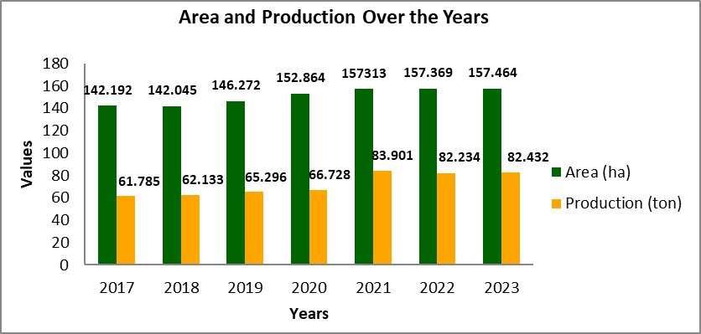

**Figure 1. Area and production of Indonesian Areca nuts over 6 years (Source: Directorate General of Estate Crops, 2022**)

Expanding the cultivation area using superior seeds is essential for increasing Areca nut productivityHowever, there is a major challende,has been the lack of availabile high quality seeds. According to the data from the Directorate General of Estate Crops (2022) (Figure 2) average Areca nuts production at the time was only 689.0 kg of dry seeds per tree, while the highest productivity in 2021 was around 798.0 kg per tree. The production potential of Betara Areca nut released in 2012 can reach 2280 kg of dry seeds/ha (estimated from 400 trees per hectare). Opportunities for the Areca plant as a mainstay commodity in several regions such as Aceh, North Sumatra, West Sumatra, Bengkulu, Riau, Jambi, East Nusa Tenggara, and Papua require considerable attention for its development. Extensification and plant rehabilitation must be prioritized in several production center areas.

**Figure 2. Areca nut production for 6 years**

**(Source Directorate General of Estate Crops, 2022)**

**4. THE POTENTIAL OF ARECA NUT GERMPLASM IN INDONESIA**

**4.1. Diversity and Spread of Areca nut Germplasm**

The results of explorations conducted by the Nuta Plant Research Institute from 1994 to 2007 on the islands of Sumatra, North Sulawesi, Gorontalo, Kalimantan, and Papua found several Areca accessions with high genetic diversity and productivity. This genetic diversity is a valuable asset for future the development of Areca nut plants. The Nut Plant Research Institute (BALITNUTA) has conserved ex-situ collections of 25 Areca accessions from Aceh, North Sumatra, West Sumatra, Bengkulu, North Sulawesi, and Papua. The more detailed characteristics of these 25 Areca germplasm accessions, see Table 2.

Table 2. Characteristics of the ex situ collection of Areca nut germplasm

|  |  |  |  |  |  |  |  |
| --- | --- | --- | --- | --- | --- | --- | --- |
| No. | Accessions | Characters | | | | | |
| Height of plants  (m) | Girth of stem  (cm) | Number of leafscars | Number of leaf | Number of bunch | Number of fruits |
| 1. | Bengkulu-1 | 8.10 | 50.66 | 8.00 | 8.38 | 3.00 | 119 |
| 2. | Bengkulu-2 | 8.00 | 50.65 | 7.62 | 8.32 | 3.00 | 61.92 |
| 3. | Sumbar-1 | 7.82 | 53.00 | 6.83 | 8.50 | 3.27 | 41.00 |
| 4. | Sumbar-2 | 6.70 | 50.28 | 8.94 | 8.31 | 4.0 | 81.0 |
| 5. | Sumbar-3 | 7.86 | 53.35 | 6.85 | 7.50 | 3.00 | 65.36 |
| 6. | Sumbar | 8.36 | 56.38 | 5.85 | 7.57 | 3.00 | 100 |
| 7. | Sumut-1 | 7.30 | 50.13 | 8.27 | 7.93 | 3.43 | 75.38 |
| 8. | Sumut-2 | 8.15 | 54.50 | 6.00 | 7.50 | 4.13 | 79.0 |
| 9. | Mongkonai | 4.18 | 47.71 | 12.71 | 5.35 | 4.0 | 59 |
| 10. | Molinow-1 | 6.32 | 53.79 | 17.07 | 7.15 | 3.0 | 35 |
| 11. | Pinang Emas | 4.41 | 47.71 | 13.50 | 5.93 | 4.0 | 67 |
| 12. | Galangsuka | 7.68 | 54.28 | 19.18 | 7.95 | 3.41 | 60 |
| 13. | Jaharun | 6.30 | 57.0 | 9.60 | 6.20 | 4.0 | 79 |
| 14. | Nifasi-1 | 6.16 | 62.76 | 11.76 | 7.62 | 4.3 | 91 |
| 15. | Nifasi-2 | 5.97 | 62.63 | 9.74 | 7.85 | 5.1 | 43 |
| 16. | Tarean | 6.57 | 54.10 | 18.27 | 7.10 | 3.0 | 27 |
| 17. | Kampung Harapan | 5.95 | 65.71 | 9.21 | 7.51 | 4.0 | 65 |
| 18. | Kalisusu | 5.86 | 60.62 | 9.77 | 7.08 | 3.4 | 71 |
| 19. | Oyehe | 6.47 | 66.09 | 10.36 | 7.45 | 3.7 | 83 |
| 20. | Kaliharapan | 6.16 | 64.48 | 9.81 | 7.19 | 4.2 | 63 |
| 21. | Betara-1 | 7.75 | 44.18 | 4.73 | 9.33 | 7.73 | 127.80 |
| 22. | Betara-2 | 6.20 | 42.27 | 4.93 | 9.93 | 7.17 | 137.13 |
| 23. | Muara Sabak Timur-1 | 7.64 | 36.25 | 4.36 | 9.57 | 4.57 | 47.21 |
| 24. | Muara Sabak Timur-2 | 7.23 | 43.36 | 4.40 | 9.73 | 4.67 | 53.17 |
| 25. | Muara Sabak Timur-3 | 7.50 | 43.73 | 4.27 | 9.73 | 4.53 | 73.07 |

The 25 Areca nut germplasm accessions exhibit significant diversity, providing breeders with ample genetic material to develop new high yielding varieties. The more diverse characteristics are the number of leaf scars, bunches, and fruits. Based on the criteria for mother nuts; a minimum of 4 bunches and 50 fruit per tree per year, 10 of the 25 accessions collected by the Nuta Research Institute can be used as sources for superior seeds, as detailed in Table 3.

Table 3. Passport data and seed production of ten accessions of Areca nut

|  |  |  |  |
| --- | --- | --- | --- |
| No. | Accessions | Origin | Seed production potential (seeds) |
| 1. | Sumbar-2 | Guci Village, District 2 X 11.6 Lingkung, Padang Pariaman Regency, West Sumatra Province | 438,400 |
| 2. | Sumut-2 | Situmba Village, Siais District, South Tapanuli Regency, North Sumatra Province | 446,990 |
| 3. | Pinang Emas | Molinow Village, Kotamobagu District, Kotamobagu City, North Sulawesi Province | 367,160 |
| 4. | Jaharun | Jaharun B Village, Galang District, Deli Serdang Regency, North Sumatra Province | 432,920 |
| 5. | Nifasi-1 |  | 535,670 |
| 6 | Kampung Harapan | Kampung Harapan Village, Nabire District, Nabire District, Papua Province | 356,200 |
| 7. | Kali Harapan | Kali Harapan Village, Nabire District, Nabire Regency, Papua Province | 363,050 |
| 8. | Betara | Makmur Jaya Village, Betara District, West Tanjung Jabung Regency, Jambi Province. | 897,350 |
| 9. | Muara Sabak Timur-2 | Muara Sabak Timur District, Tanjung Jabung Timur Regency, Jambi Province | 363,050 |
| 10. | Muara Sabak Timur-3 | Siau Village, Muara Sabak Timur District, Tanjung Jabung Timur Regency, Jambi Province | 500,050 |

Observations on fruit components reveal that the Betara Areca nut population is the most superior variety in Indonesia, yielding 30.91 kg of ripe fruit per tree per year. Other high producing Areca nut accessions include; Muara Sabak Timur-3 (18.27 kg), Nifasi-1 (18.20 kg), West Sumatra-2 (16.20 kg), Sumut-2 (15.80 kg), Jaharun (15.80 kg), Molinow-2 (13.40 kg), Muara Sabak Timur-2 (13.25 kg), Kampung Harapan (13 kg), Kaliharapan (12.60 kg), and Mongkonai (11.80 kg).

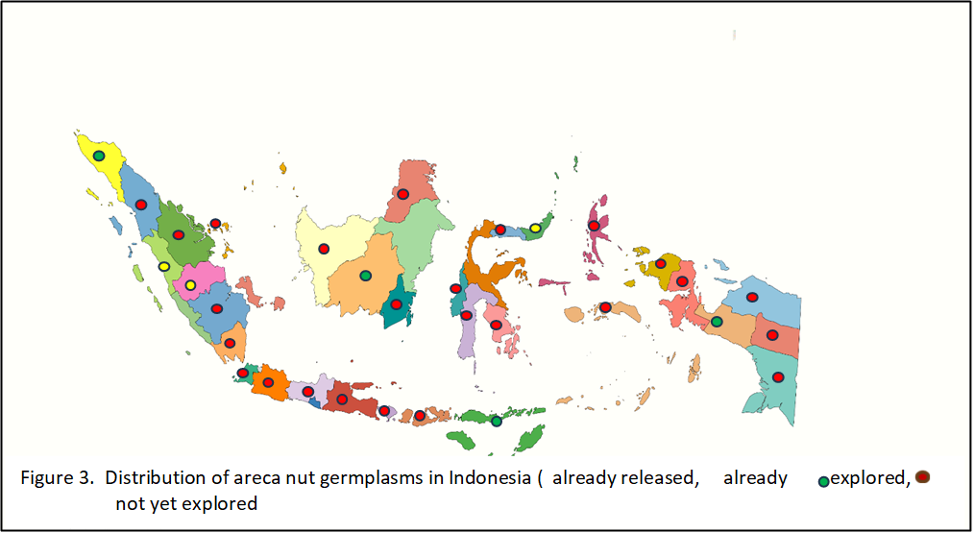

Table 1 and Figure 3 show the distribution of Areca nutin Indonesia’s 38 provinces. The exploration activities have never occurred in 16 of these provinces (indicated by red marks on the map). Meanwhile, eight provinces have been explored (indicated by green, yellow, and blue). Of the 24 provinces where Areca nut germplasm is distributed, only three; Jambi Province, North Sulawesi Province, and West Sumatera (marked in yellow), officially have local superior varieties. These varieties, released by the Minister of Agriculture in 2012, 2019, and 2023, are suitable for use as a source of superior seeds. This data highlights the vast opportunity for further exploration of Areca nut germplasm. It suggests the possibility of discovering new superior germplasm beyond the existing Betara, Emas, and Pinang Wangi varieties.

**Table 4. Seed production of superior and local Areca nut of Indonesia**

|  |  |  |  |  |  |  |  |
| --- | --- | --- | --- | --- | --- | --- | --- |
| No | Variety | Characters | | | | Number of mother nuts (tree) | Number of seeds/ha  /year (nut) |
| Number of Bunch | Number of fruits/  bunch | Colore of young nut | Color of mature nut |
| 1. | Betara Arecanut/ West Tanjung Jabung, Jambi Provice | 5 | 131.35 | Darked green | Oranye | 2000 | 1,313,500 |
| 2. | Pinang Emas (Golden Arecanut/ Manado, North Sulawesi Province | 4,68 | 75,30 | Yellowish green | Yellow | 250 | 113,320 |
| 3. | Pinang Wangi Arecanut (aromatic Arecanut)/ Padang Pariaman, West Sumatera Province | 4.88 | 69.16 | Yelowish green | Yellow | 200 | 369,407 |
| 4. | Local Arecanut/ Padang Pariaman, West Sumatera | 5.04 | 106.8 | Dark green | Oranye | 250 | 137,750 |
| 5 | Gampong Gunci Arecanut/ North Aceh Regency, Aceh Province | 5.87 | 154.93 | Dark green | Oranye | 1,680 | 1.529,640 |
| 6 | Alue Arecanut / Bireun Regency, Aceh Province | 4.60 | 190.10 | Dark green | Oranye | 450 | 393,300 |
| 7 | Rantau Panjang Arecanut/ Bireun Regency, Aceh Province | 5.53 | 222.63 | Dark green | Oranye | 600 | 729,000 |
| 8 | Krueng Simpo Arecanut/ Bireun Regency, Aceh Province | 4.40 | 222.57 | Dark green | Oranye | 1,600 | 1.548.800 |
| 9 | Batee Arecanut/ West Aceh Regency, Aceh Province | 5.0 | 187 | Dark green | Oranye | 464 | 433,840 |

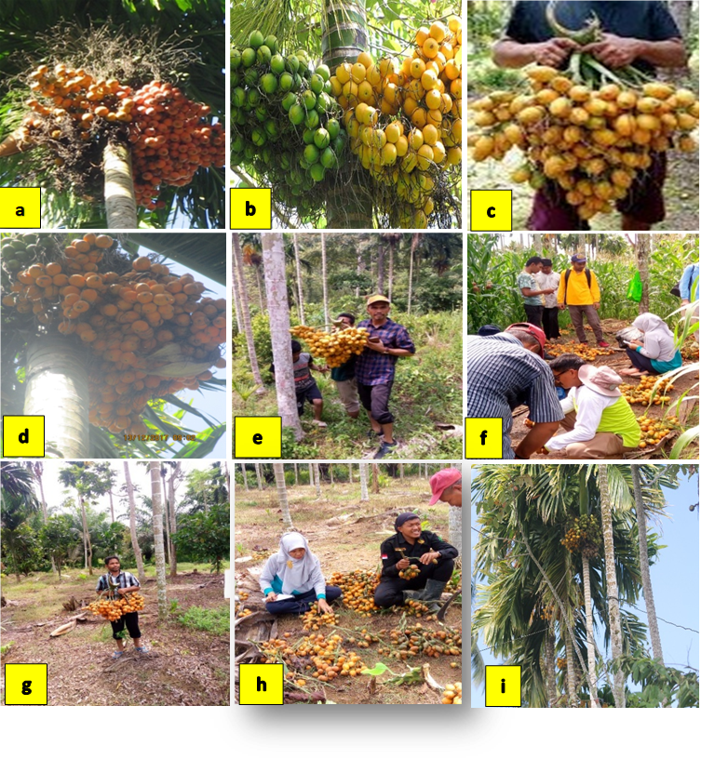

**Figure 4. (a) Betara Arecanut, (b) Pinang emas Arecanut, (c) pinang wangi Arecanut, (d local Arecanut of Pariaman, (e) Gampong Gunci Arecanut, (f) Alue Arecanut, (g) Rantau Panjang Arecanut, (h) Krueng Simpo Arecanut, (i) Batee Arecanut**

**5. IN SITU COLLECTION AS HIGH PRODUCTION BLOCK OF ARECANUT**

Until 2019, the PalmNuta Research Institute evaluated high producing blocks of the Areca nut plantations in several key provinces known as planting centers; Aceh, West Sumatra, Jambi, and North Sulawesi. This evaluation identified nine high-yielding blocks that could be used as sources for seed, as detailed in Table 4 and Figure 4.

The Minister of Agriculture has designated three Areca nut varieties as national superior varieties (blue labels), namely Pinang Betara released in 2013 under Decree No. 199/Kpts/SR.120/1/2013; Pinang Emas released on February 1, 2019, under Decree No. 39/KPTS/KB/2/2019, originates from Kotamobagu, North Sulawesi, and Pinang Wangi released in 2024 under Decree No. 15/Kpts/KB.010/01/2024, comes from from Padang Pariaman, West Sumatera Province. The potential for seed production from both national and local Areca nut is around 3,109,611, which can cover an area of 2,270 hectares of Areca nut every year.

**6. CONCLUSION**

Indonesia boasts a rich diversity of genetic resources across most of its regions, with the Areca nut plant being a key germplasm source and a significant export commodity. Indonesia's Areca nut plantations cover 143,202 hectares, with 66.71% (95,532 hectares) located on the island of Sumatra. The country’s ex-situ germplasm collection includes 41 accessions, and three these accessions have been officially released as national superior varieties: Pinang Betara from West Tanjung Jabung Regency, Jambi Province; Pinang Emas from Kotamobagu City, North Sulawesi Province, and Pinang Wangi from Padang Pariaman, West Sumatera. These varieties have a combined potential to produce 3,109,611 seeds, which can support the rejuvenation of 2,270 hectares of Areca nut plantations every year.

**References**

Ahuja, S. C. & Ahuja, U. 2011. Betel leaf and betel nut in India: History and uses. *Asian Agriculture History*, 15(1), pp. 13-35.

Ananda, K. S., Karun, A. & Parthasarathy, V. A. 2017. Arecanut. In: *Breeding of Horticultural Crops Vol. 1 - Part B: Plantation Crops*. pp. 569-589.

Ananda, K. S. & Nagaraja, N. R. 2015. New Arecanut Varietes Of Icar-CPCRI. *Indian Journal of Arecanut, Specis and Medicinal Plants*, 17(3), pp. 1-4.

Anjana, M. K., Sravani, K., Veena, K. M., Prasanna, K. R. J., Laxmikanth, C., Prasanth, S., Rachana, V. P., Tashika, K. R., Pratima, S. & Shaul, H. 2015. Arecanut and its effects on the human body. *American Journal of Oral Medicine and Radiology*, 2(1), pp. 10-14.

Anonim. 1985. *Arecanut Cultivation Practice*. Kerala, India: Central Plantation Crops Research Institute.

Athukorala, I. A., Tilakaratne, W. M. & Jayasinghe, R. D. 2021. Areca nut chewing: initiation, addiction, and harmful effects emphasizing the barriers and importance of cessation. *Hindawi Journal of Addiction*, 9967097, pp. 1-9.

Bavappa, K. V. A., Nair, M. K. & Kumar, T. P. 1988. *The Arecanut PalmNut (Areca catechu Linn)*. Kasaragod, Kerala, India: Central Plantation Crops Research Institute.

Bharath, B. G., Ananda, K. S., Rijith, J., Nagaraja, N. R., Chandran, K. P., Karun, A. & Rajesh, M. K. 2015. Studies on genetic germplasm utilizing RAPD markers. *Journal of Plantation Crops*, 43(2), pp. 117-125.

Cahyani, I. S., Hadriyati, A. & Yulianis. 2020. Antioxidant Activity Test of Extracts and Fractions of Areca Nut Peel (Areca catechu L.) from West Tanjung Jabung Regency. *Journal of Healthcare Technology and Medicine*, 6(1), pp. 179-184.

Chavan, Y. & Singhal, R. S. 2013. Ultrasound-Assisted Extraction (UAE) of Bioactives from arecanut (Areca catechu L.) and optimization study using response surface methodology. *Innovative Food Science & Emerging Technologies*, 17(3), pp. 106-113.

Directorate General of Plantations of the Ministry of Agriculture. 2022. *National Non-Primitive Plantation Statistics 2021-2023*.

Guo, Z., Wang, Z., Luo, Y., Ma, L., Hu, X., Chen, F., Li, D. & Jia, M. 2024. Extraction and identification of bioactive pompounds From areca nut (Areca catechu L.) and Potential for future applications. *Food Frontiers*, 5(5), pp. 1909–1932.

Gupta, A. K., Tulsyan, S., Thakur, N., Sharma, V., Sinha, D. N. & Mehrotra, R. 2020. Chemistry, metabolism and pharmacology of carcinogenic alkaloids present in areca nut and factors affecting their concentration. *Regulatory Toxicologi and Pharmacology*, 110, 104548.

Humaryanto, Hanina & Lipinwati. 2023. Antimicrobial effect of arecanut ethanol extract agains methicillin-resistant staphylococcus aureus (MRSA) and methicillin-sensitive staphylococcus aureus (MSSA). *Riset Informasi Kesehatan*, 12(1), pp. 67-72.

Jam, N., Hajimohammadi, R., Gharbani, P. & Mehrizad, A. 2021. Evaluation of antibacterial activity of aqueous, ethanolic and methanolic extracts of areca nut fruit on selected bacteria. *BioMed Research International*, 6663399, pp. 1-8.

Jannah, M., Machfud & Sugiarto. 2021. Potential added value of areca nut products in Aceh. *Jurnal Teknologi Industri Pertanian*, 31(2), pp. 190-197.

Miftahorrachman, Mantau, N. F. N. & Hervina, D. 2018. Evaluation of morphological for Arecanut (Areca Cathecu.L) genetic Improvment in Padang Pariaman. *Buletin PalmNuta*, 19(1), pp. 15–25.

Nilasary, R. S., Chintami, S. P., Citra, M. S. & Camali. 2020. Ethanol extract toothpaste of betel leaf, areca nut, and gambier against inhibition of pseudomas aeruginosa bacteria. *Jurnal Ilmu Kedokteran Gigi*, 3(2), pp. 6-13.

Pathirana, R. & Carimi, F. 2022. Management and utilization of plant genetic resources for sustainable agriculture. *Plants*, 11(15).

Rahman, A. O., Kusdiyah, E., Herlambang & Victoria, A. 2020. Test of the aphrodisiac effect of young areca nut (Areca Catechu L) extract on male rats. *Jambi Medical Journal*, 8(1), pp. 34-39.

Silalahi, M. 2020. Benefits and toxicity of areca nut (Areca catechu L) in human health. *Bina Generasi Jurnal Kesehatan*, 11(2), pp. 26-31.

Warnakulasuriya, S. & Chen, T. H. H. 2022. Areca nut and oral cancer: evidence from studies conducted in humans. *Journal of Dental Research*, 101(10), pp. 1139–1146.

Wen-hua, Z., Ai-min, J., Yi-xin, P., Hai-de, Z. & Honghao, R. 2011. Arecanut oil with arecoline can enhance hypolipidemia in rats. *Journal of Medicinal Plants Research*, 5(11), pp. 2143-2148.

Wida, N. 2018. Formulation and antibacterial effectiveness test of edible film of nreca nut extract (Areca catechu Linn.). *Jurnal Ilmu Farmasi dan Farmasi Klinik (JIFFK)*, 15(2), pp. 71-76.