Characteristics of Self-Compacting Concrete Incorporating Palm Kernel Shell Ash with Variations in Superplasticizer Content

ABSTRACT

The low water-to-cement ratio in Self-Compacting Concrete (SCC) aims to increase the compressive strength of concrete, but the lower amount of water results in lower workability. Thus, it is necessary to use chemical additives of superplasticizer (SP). SP improves workability while maintaining the specified water-to-cement ratio. This study aims to determine the characteristics of SCC incorporating palm kernel shell ash (PKSA) with varying SP content. The SP content in SCC was 1.5%, 2.0%, and 2.5% of the concrete total mass. The PKSA was 0% and 10% of the total binder mass. Some tests of fresh and hardened SCC produced characteristic data. The addition of SP content increased the flow distribution diameter, flowability, and passing ability, and decreased viscosity. PKSA, as a partial replacement for cement, reduced the density of SCC and increased the compressive strength, but not significantly. The highest compressive strength was obtained in SCC with 10% PKSA and 1.5% SP of 34.75 MPa at the age of 28 days. The use of SP by more than 1.5% increased workability but reduced the compressive strength of SCC by inhibiting the binding process.

Keywords: ash, compacting, concrete, superplasticizer.

1. INTRODUCTION

In the casting process, compaction is necessary to reduce air trapped in the concrete mixture so as not to form air cavities that can reduce compressive strength. In concrete casting that requires easy-flowing concrete, Self-Compacting Concrete (SCC) is one of the solutions. SCC can flow through construction with dense reinforcement without experiencing segregation (Mansour et al., 2024; Ranjithkumar et al., 2024). SCC utilizes its weight to fill all spaces in the formwork, even between closely spaced steel reinforcement. SCC is resistant to segregation due to its high level of homogeneity, and does not require a vibration process for placement and compaction (TSCCEPG, 2005). Other advantages of using SCC compared to conventional concrete are ease of casting, which speeds up the duration of construction work, reduces the use of concrete compaction vibrators, thus reducing costs, and reduces noise levels at the project site (Cepcianska et al., 2025; Guo et al., 2025).

The composition of SCC materials differs from conventional concrete. SCC uses relatively smaller aggregates than conventional concrete, a lower water-cement ratio, chemical additives of superplasticizers (SP) (He et al., 2025), and mineral additives of pozzolanic materials. Initial research on SCC resulted in a composition limiting coarse aggregates to approximately 50% of the solid volume, fine aggregates to approximately 40% of the mortar volume, a lower water-to-cement ratio than conventional concrete, and a higher percentage of SP than conventional concrete (Okamura & Ouchi, 2003). Using a low water-to-cement ratio in SCC aims to produce concrete with a higher compressive strength, but using less water causes a low concrete workability. Thus, the use of chemical additives of SP is necessary (He et al., 2025).

SP is a F type chemical admixture that reduces water use in the concrete mixture in large enough quantities to produce concrete with a certain consistency (ASTM C494/C494M-24, 2024). SP increases workability in the concrete mixing while maintaining a low water-to-cement ratio. SP dissolved in water in the concrete mixture covers the cement granules, increasing the negative charge on its surface. This results in an electrostatic repulsive force between cement particles and causes a large dispersion between cement particles, thereby increasing the workability of fresh concrete (Tian et al., ​​2025). SP can make fresh concrete flow to fill the space in the formwork and reduce the formation of cavities in the concrete, thus increasing the density and compressive strength of the concrete (Kalauni et al.,2025). The addition of SP must consider the dosage recommended by the manufacturer. Using a small amount of SP makes fresh concrete not reach the required workability, while excessive SP causes the concrete to experience a long setting and produces a lower compressive strength than the designed one (Yang et al., 2016). The percentage of SP in the concrete mixture must be determined to obtain an optimal concrete compressive strength. SP with a chemical composition of Polycarboxylate Ether (PCE) has a long molecular chain bond that increases the ability of cement particles to maintain distance between each other, which is called steric repulsion (Tian et al., ​​2025). The distance between particles resulting in SP with a chemical composition of PCE performs most effectively in spreading cement particles, maintaining excellent cement particle dispersion, and reducing slump loss values ​​(Fang et al., 2023). One of the SPs with a chemical composition of PCE is BASF MasterGlenium SKY 8614, which was used in this study.
In addition to adjusting the water-to-cement ratio and SP percentage, the compressive strength of concrete can be increased using pozzolanic materials. Pozzolanic materials are widely found in industrial waste such as kaolin, fly ash, rice husk ash, and palm kernel shell ash (PKSA). PKSA results from burning palm kernel shells, palm fiber, and oil palm bunches, which are used as fuel to produce steam for electricity generation in palm oil factories. Palm kernel shells, fibers, and empty bunches are used as fuel to fulfill the electricity needs of palm oil factories by burning at a temperature of 600 ̊C. This combustion produces solid waste of boiler ash, which leaves environmental problems because it is usually only dumped in open areas of the factory without proper management. PKSA waste is abundant, along with the increasing number of palm oil processing factories (Nurjannah et al., 2024). PKSA is a reactive pozzolan material with a high potential to partially replace cement as a binder in concrete mixtures (Tangchirapat & Jaturapitakkul, 2010). Partial cement replacement with pozzolanic materials such as PKSA in concrete production can result in efficient solid waste management, improve concrete durability, reduce hydration heat, and cost efficiency (Siregar et al., 2024). Research on SCC utilizing PKSA waste as a partial cement replacement still requires further analysis, especially regarding the effect of SP and PKSA on workability and compression strength.

This study aimed to analyze the characteristics of SCC incorporating PKSA as a pozzolanic material and the effect of variations in the percentage of SP on SCC performance.

2. material and methods

This research method is experimental and conducted at the Structure, Construction, and Materials Laboratory of Sriwijaya University. This study was conducted to understand the effect of SP variations on the characteristics of SCC containing PKSA. The percentage of SP variations was 1.5%, 2.0%, and 2.5% of the SCC total mass. Each SP variation was distinguished using PKSA of 0% and 10% to determine the effect of adding PKSA as a partial cement substitute. There were six SCC mixtures, each with five hardened cylindrical samples for density and compressive strength tests. Fresh concrete tests were the slump flow, V-funnel, and L-box tests. At the ages of 7, 14, and 28 days, the density and compressive strength of SCC were tested. All hardened SCC samples were manufactured using cylindrical formwork with a diameter of 10 cm and a height of 20 cm.

2.1 SCC Component Materials

The SCC materials in this study consisted of cement, fine aggregate, coarse aggregate, water, ACS, and SP from local sources. The following details the materials.
1. Type I cement from PT Semen Baturaja was used in this study and is shown in Figure 1.
2. The fine aggregate was natural sand from the Tanjung Raja subdistrict in Figure 2.
3. The coarse aggregate was crushed stone with a maximum diameter of 10 mm from Banjarnegara regency in Figure 3.
4. The water came from the Structure, Construction, and Materials Laboratory of Sriwijaya University. Visually, the water was odorless, colorless, and free of mud and other substances. The water is shown in Figure 4.
5. PKSA is a waste product from the combustion of palm kernel shells at a temperature of 500 ̊C - 600 ̊C originating from PT Sriwijaya Palm Oil Indonesia factory. The PKSA passed the no. The 200 sieve is shown in Figure 5.
6. The SP was BASF MasterGlenium SKY 8614, which was included in the chemical admixture type F in Figure 6.

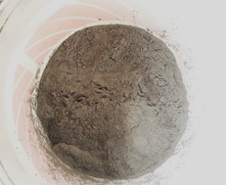 | 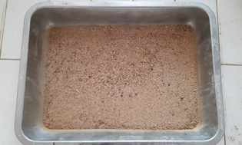 | 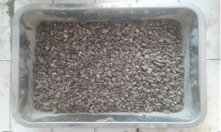
Fig. 1. Baturaja Type I cement | Fig. 2. Fine aggregate | Fig. 3. Coarse aggregate
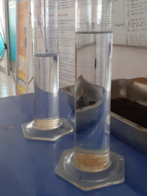 | 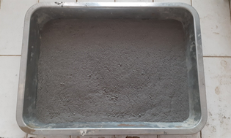 | 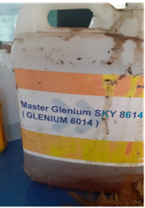
Fig. 4. Water | Fig. 5. PKSA | Fig. 6. SP

2.2 Equipment for Testing

The equipment in this study includes a material testing apparatus, a material mixing apparatus, a fresh concrete testing apparatus, a specimen molding apparatus, and a hardened concrete testing apparatus. The following details the equipment used.
1. Aggregate sieves are used to separate aggregate sizes, both coarse and fine aggregates. The sieves have a diameter sequence of 37.5 mm, 25 mm, 19 mm, 12.5 mm, 9.50 mm, 4.75 mm (sieve no. 4), 2.36 mm (sieve no. 8), 0.15 mm (sieve no. 100), 0.075 mm (sieve no. 200), and were equipped with a pan. A sieve shaker assisted the aggregate sieve process. The aggregate sieve and sieve shaker are depicted in Figure 7.
2. Scales were used to measure the weight of the SCC constituent materials. Two scales were used in this study: a 5 kg capacity scale with an accuracy of 0.001 kg in Figure 8 and a 20 kg capacity scale with an accuracy of 0.005 kg in Figure 9.
3. Measuring glass tubes were used to measure liquid materials such as water and SP, as shown in Figure 10.
4. The mixer is used to mix all the SCC components evenly with a capacity of 60 liters.
5. The steel formwork was 10 cm in diameter and 20 cm high.
6. The slump flow test tool was an Abrams slump cone in Figure 11.
7. The V-funnel test tool with a door at the bottom that could be closed and opened as shown in Figure 12.
8. The L-box test apparatus was rectangular and equipped with reinforcing steel arranged to form gaps for the fresh concrete flow, as shown in Figure 13.
9. The compressive strength test tool was the Universal Testing Machine (UTM), which, as shown in Figure 14, has a load capacity of up to 2000 kN.

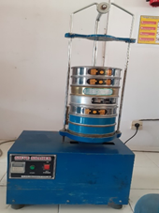 | 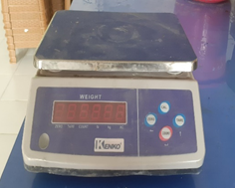
Fig. 7. Aggregate sieve shaker | Fig. 8. Scales with a capacity of 6 kg
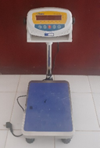 | 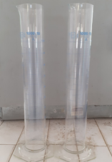 | 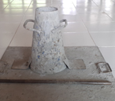
Fig. 9. Scales with a capacity of 20 kg | Fig. 10. Measuring glass tubes | Fig. 11. Slump test equipment
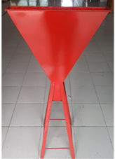 | 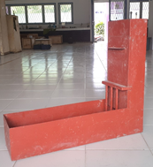 | 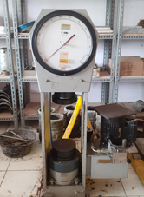
Fig. 12. V-funnel test equipment | Fig. 13. L-box test equipment | Fig. 14. Concrete compressive strength equipment

The PKSA was dried under the sunlight to facilitate the next filtering process. The PKSA drying process is shown in Figure 15. Then the filtering process was carried out using a No. 200 sieve and a sieve shaker, as shown in Figure 16.

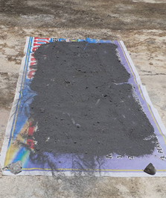 | 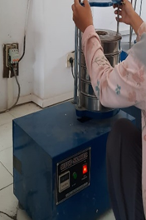
Fig. 15. PKSA drying process | Fig. 16. PKSA filtering process with a sieve equipment

2.3 SCC Mixture Composition

The SCC mixture design in this study referred to a standard (ACI PRC-237-07, 2019) as shown in Table 1. The variations in SP were 1.5%, 2.0%, and 2.5% of the total SCC mass. The PKSA percentage was 0% and 10% (58.57 kg) of the binder mass.

Table 1. SCC mixture composition design

Sample | W/C ratio | Cement (kg/m³) | PKSA (kg/m³) | CA (kg/m³) | FA (kg/m³) | Water (kg/m³) | SP
 |  |  |  |  |  |  | % | kg/m³
M 0-1.5 | 0.35 | 585.71 | 0 | 594.12 | 650.11 | 205 | 1.5 | 8.8
M 0-2.0 | 0.35 | 585.71 | 0 | 594.12 | 650.11 | 205 | 2.0 | 11.7
M 0-2.5 | 0.35 | 585.71 | 0 | 594.12 | 650.11 | 205 | 2.5 | 14.6
M 10-1.5 | 0.35 | 527.14 | 58.57 | 594.12 | 650.11 | 205 | 1.5 | 8.8
M 10-2.0 | 0.35 | 527.14 | 58.57 | 594.12 | 650.11 | 205 | 2.0 | 11.7
M 10-2.5 | 0.35 | 527.14 | 58.57 | 594.12 | 650.11 | 205 | 2.5 | 14.6
Note: CA: coarse aggregate; FA: fine aggregate

2.4 Fresh Concrete Testing

The SCC constituent materials were weighed according to the mixture design, as depicted in Figure 17. The fine and coarse aggregates were added first and mixed until they were evenly mixed. Afterward, the cement and PKSA were poured and mixed until the mixture was evenly distributed, as shown in Figure 18. Water was added every third of the mixture with the mixer still running. SP was then added to the fresh SCC and stirred until evenly mixed.

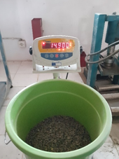 | 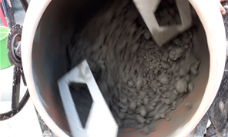
Fig. 17. Weighing the SCC mixture | Fig. 18. Material mixing process

Fresh concrete testing included the slump flow test, V-funnel test, and L-box test. The slump flow test was conducted to determine the flowability of each variation of the SCC fresh concrete mixture by measuring the diameter of the fresh concrete flow distribution in Figure 19. The V-funnel test was conducted to determine the viscosity of each variation of the fresh SCC mixture by measuring the time required for the fresh SCC to flow through the test equipment, as shown in Figure 20. The L-box test determined the passing ability by measuring the heights of the fresh SCC mixtures before and after passing through the reinforcement gaps, as shown in Figure 21.

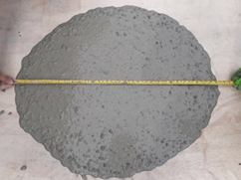 | 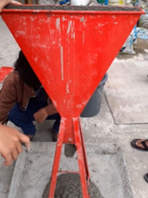 | 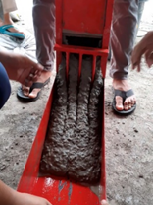
Fig. 19. Slump flow testing | Fig. 20. V-funnel testing | Fig. 21. L-box testing

2.5 SCC Cylinder Sample Treatment

Aggregate testing includes sieve analysis (ASTM C136/C136M-19, 2019), unit weight (ASTM C29/C29M-23, 2023), water content (ASTM C566-19, 2019), specific gravity and absorption for fine aggregate (ASTM C128-25, 2025) and coarse aggregate (ASTM C127-25, 2025), and silt content (ASTM D2419-22). The freshly tested SCC was then cast into a pre-oiled steel cylinder formwork as depicted in Figure 22. The formworks were removed after 24 hours from the sample molding process. Then, the samples were cured using wet burlap sacks, as shown in Figure 23.

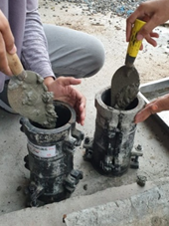 | 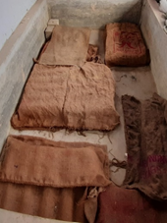
Fig. 22. Casting of samples with cylindrical molds. | Fig. 23. Curing of test specimens with wet burlap sacks

2.6 Compressive Concrete Strength Testing

Before the compressive strength test was conducted, the concrete was weighed to determine the weight of each mixture variation, as shown in Figure 24. The concrete compressive strength test was conducted on each SCC mixture variation at 7, 14, and 28 days in Figure 25.

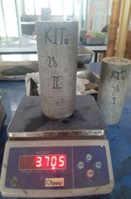 | 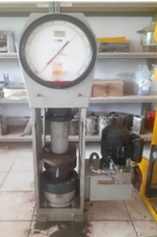
Fig. 24. Weighing the sample | Fig. 25. Compressive concrete strength testing

3. results and discussion

3.1 X-Ray Fluorescence Testing

The Minerals and Advanced Materials Laboratory, Faculty of Mathematics and Natural Sciences, State University of Malang, conducted an X-ray fluorescence (XRF) test to determine the chemical composition of the PKSA. The results are presented in Table 2.

Table 2. XRF test results

Chemical Compound Content | Mass Percentage (%)
SiO₂ | 81.560
Al₂O₃ | 1.440
P₂O₅ | 1.600
K₂O | 4.160
CaO | 8.660
MnO | 0.350
Fe₂O₃ | 1.960
NiO | 0.007
CuO | 0.032
ZnO | 0.023
RB₂O | 0.040
Eu₂O₃ | 0.090
Yb₂O₃ | 0.020
Re₂O₇ | 0.050

3.2 X-Ray Diffraction Testing

An X-Ray Diffraction (XRD) test was conducted to determine the structural properties of the PKSA material. The structure of a material could be amorphous or crystalline. Amorphous materials would be reactive to other materials in the concrete mixture, while crystalline materials would not be reactive. This XRD test was conducted at the Physics Laboratory of the Faculty of Mathematics and Natural Sciences, Sriwijaya University. The results of the XRD test on PKSA are presented in Figure 26. The PKSA structure was crystalline owing to many diffraction peaks or high refraction intensity. The crystalline nature of PKSA indicates that it was less reactive with other compounds in the SCC mixture, thus not increasing the compressive strength significantly, even though the SiO₂ content in PKSA was 81.55%.

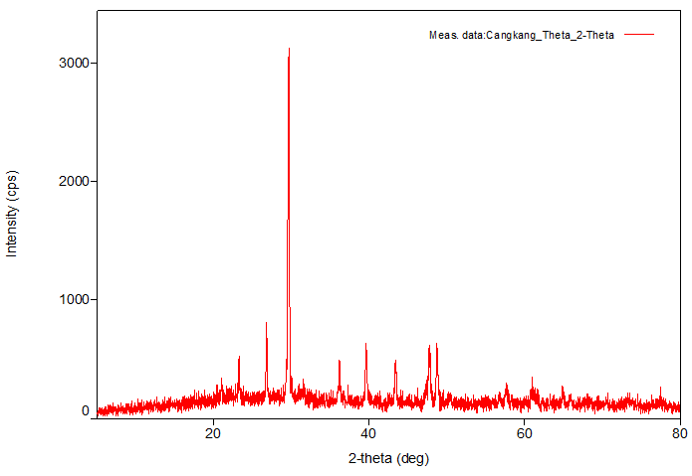
Fig. 26. XRD test results on PKSA

3.3 Fresh Concrete Test Results

Concrete is categorized as SCC if it has the following characteristics: flowability, viscosity, and passing ability. These characteristics are identified from the results of fresh SCC tests, such as slump flow tests, V-funnel tests, and L-box tests (TSCCEPG, 2005).

3.1.1 Slump Flow Test

The results of the slump flow test for all variations of the SCC mixture in this study are presented in Table 3. The diameter of fresh SCC ranged from 687.50 mm to 721.25 mm. The smallest diameter was found in the SCC mixture with a variation of 1.5% SP and 10% PKSA, which was 687.50 mm. The SCC mixture performed the largest slump flow diameter with a variation of 2.5% SP and 0% PKSA, which was 721.25 mm. The test results showed that using SP and PKSA greatly affected the flowability of fresh SCC. PKSA decreased workability, while SP increased workability (Tian et al., ​​2025).

The smallest and largest slump flow diameters used were 1.5% SP and 2.5% SP, respectively. This indicated that the addition of SP increased the flowability of the fresh SCC mixture. This was owing to the working principle of the SP mechanism, which caused repulsion or dispersion between cement particles and resulted in the expanded distribution and increased diameter of fresh SCC (Tian et al., ​​2025).

The fresh SCC with 10% PKSA performed a smaller slump flow diameter than its 0% PKSA counterpart. This indicated that the 10% PKSA made the fresh SCC mixture more difficult to flow, and the decreased diameter of the SCC flow distribution was due to the absorption of water in the fresh SCC by the PKSA granules (Siregar et al., 2024).

Table 3. Slump flow test results

Sample | Variation |  | Diameter (mm) | EFNARC specifications (2005) | Qualify
Sample | PKSA (%) | SP (%) | Diameter (mm) | EFNARC specifications (2005) | Qualify
M 0-1.5 | 0 | 1.5 | 699.00 | 550 – 850 | Yes
M 0-2.0 | 0 | 2.0 | 712.00 | 550 – 850 | Yes
M 0-2.5 | 0 | 2.5 | 721.25 | 550 – 850 | Yes
M 10-1.5 | 10 | 1.5 | 687.50 | 550 - 850 | Yes
M 10-2.0 | 10 | 2.0 | 701.50 | 550 - 850 | Yes
M 10-2.5 | 10 | 2.5 | 714.00 | 550 - 850 | Yes

3.1.2 V-funnel Test

The results of the V-funnel test for all variations of the fresh SCC mixture are shown in Table 4. The duration of the V-funnel test results ranged from 7.32 to 11.41 seconds. The smallest duration was found in the SCC mixture with a variation of 2.5% SP and 0% PKSA, which was 7.32 seconds. The SCC mixture performed the largest duration with a variation of 1.5% SP and 10% PKSA, which was 11.41 seconds. The duration decreased with the addition of the percentage of SP in the fresh SCC concrete mixture. A small duration indicated that the viscosity of fresh SCC was low; thus, the time required to flow was very fast. Fresh SCC containing 10% PKSA needed a longer duration than 0% PKSA. This showed that using 10% PKSA increased the mixture's viscosity. Thus, it took a longer time to flow through the V-funnel apparatus (Aisheh et al., 2023).

Table 4. V-funnel test results

Sample | Variation |  | Duration (sec) | EFNARC specifications (2005) (sec) | Qualify
Sample | PKSA (%) | SP (%) | Duration (sec) | EFNARC specifications (2005) (sec) | Qualify
M 0-1.5 | 0 | 1.5 | 10.71 | 1 – 25 | Yes
M 0-2.0 | 0 | 2.0 | 9.24 | 1 – 25 | Yes
M 0-2.5 | 0 | 2.5 | 7.32 | 1 – 25 | Yes
M 10-1.5 | 10 | 1.5 | 11.41 | 1 – 25 | Yes
M 10-2.0 | 10 | 2.0 | 10.21 | 1 – 25 | Yes
M 10-2.5 | 10 | 2.5 | 8.15 | 1 – 25 | Yes

3.1.3 L-box Test

The results of the L-box tests for all variations of the SCC mixture are presented in Table 5. The results of the L-box test in a passing ratio of ${H_{2}}/{H_{1}}$ ranged from 0.86 to 0.91, where $H_{2}$ and $H_{1}$ were the heights of fresh concrete after and before passing through the gaps between three 12 mm diameter reinforcing steel bars, respectively. The smallest passing ratio was shown by the SCC mixture with variations of 1.5% SP and 10% PKSA, namely 0.86. The SCC mixture performed the largest passing ratio with 2.5% SP and 0% PKSA variations, namely 0.91. Using 10% PKSA resulted in a smaller passing ratio than 0% PKSA. This indicated that using 10% PKSA caused a decreased passing ability due to the high viscosity of fresh SCC. It was due to water absorption from PKSA granules that reduced the amount of fresh SCC that passes through the reinforcement gaps (Aisheh et al., 2023). The passing ratio increased with the addition of the percentage of SP in the fresh SCC mixture. The increased SP percentage influenced an adequate L-box passing ratio (Tian et al., ​​2025).

Table 5. L-box test results

Sample | Variatiom |  | Passing ability |  |  | EFNARC specifications (2005)  (H₂/H₁) | Qualify
Sample | PKSA (%) | SP (%) | H1 (cm) | H2 (cm) | H₂/H₁ | EFNARC specifications (2005)  (H₂/H₁) | Qualify
M 0-1.5 | 0 | 1.5 | 8.60 | 7.50 | 0.87 | ≥ 0.8 | Yes
M 0-2.0 | 0 | 2 | 8.70 | 7.70 | 0.89 | ≥ 0.8 | Yes
M 0-2.5 | 0 | 2.5 | 8.70 | 7.90 | 0.91 | ≥ 0.8 | Yes
M 10-1.5 | 10 | 1.5 | 8.70 | 7.50 | 0.86 | ≥ 0.8 | Yes
M 10-2.0 | 10 | 2 | 8.95 | 7.85 | 0.88 | ≥ 0.8 | Yes
M 10-2.5 | 10 | 2.5 | 8.85 | 7.90 | 0.89 | ≥ 0.8 | Yes

3.5 Concrete Density Testing

Density testing was conducted at 7, 14, and 28 days of age. The concrete density was obtained by calculating the ratio between the mass and volume of the test specimen, which was the average of five test specimens for each type of SCC mixture. The concrete density can be seen in Table 6.

Table 6. SCC density

Sample | Variation |  | Density (kg/m³)
Sample | PKSA (%) | SP (%) | 7 days | 14 days | 28 days
M 0-1.5 | 0 | 1.5 | 2396.42 | 2381.40 | 2360.78
M 0-2.0 | 0 | 2.0 | 2391.84 | 2376.05 | 2355.69
M 0-2.5 | 0 | 2.5 | 2383.18 | 2369.18 | 2349.33
M 10-1.5 | 10 | 1.5 | 2384.20 | 2372.24 | 2355.44
M 10-2.0 | 10 | 2.0 | 2379.36 | 2368.16 | 2350.60
M 10-2.5 | 10 | 2.5 | 2373.51 | 2362.82 | 2343.73

The smallest density was found in SCC with 2.5% SP 10% PKSA for the ages of 7, 14, and 28 days, respectively, amounting to 2373.51 kg/m³, 2362.82 kg/m³, and 2343.73 kg/m³. The largest density was obtained for the SCC mixture with 1.5% SP and 0% PKSA for the ages of 7, 14, and 28 days, respectively, amounting to 2396.42 kg/m³, 2381.40 kg/m³, and 2360.78 kg/m³. The density decreased along with the increased SP percentage. The use of SP dosage of more than 1.5% in the SCC mixture resulted in more water rising to the surface of the concrete. Thus, the water evaporation that occurred was greater during the SCC hardening process. This revealed that excessive use of SP resulted in a lighter SCC density (Al-Shwaiter et al., 2023; Cavusoglu et al., 2024). Test specimens at the ages of 7, 14, and 28 days experienced a decreased density using 10% PKSA compared to that of 0% PKSA for each SP percentage. This showed that the use of 10% PKSA resulted in decreased SCC density (Aisheh et al., 2023). The SCC density in all variations decreased as the test age increased.

3.6 Concrete Compressive Strength Testing

This study's concrete compressive strength testing was conducted at 7, 14, and 28 days of age. The compressive strengths in Table 7 were obtained from the average of five cylindrical samples for each SCC mixture. The lowest compressive strengths were obtained by samples with 2.5% SP and 0% PKSA for ages 7, 14, and 28 days, respectively, amounting to 23.55 MPa, 26.22 MPa, and 31.31 MPa. The highest compressive strengths were found in samples with 1.5% SP and 10% PKSA for the ages of 7, 14, and 28 days, respectively, amounting to 27.75 MPa, 30.80 MPa, and 34.75 MPa.

The compressive strength decreased with increasing SP percentage, with a range of 1.47% - 5.75%. The use of SP dosage of more than 1.5% in the SCC mixture inhibited the hydration process between cement and water. It was owing to the surface of the cement particles that should react with water, being covered by SP. This caused the binding or setting process of SCC to be hampered, thus decreasing the compressive strength (Tian et al., ​​2025). Test specimens aged 7, 14, and 28 days for each SP variation experienced an increased compressive strength using 10% PKSA compared to 0% PKSA, with a percentage change of 2.22% - 3.51%. The increased compressive strength was not significant. It was owing to the crystalline behavior of the PKSA, thus it had a low ability to react with other materials in the SCC mixture. The compressive strength of SCC in all variations increased with increasing test age. This was because the cement hydration process took the role with increasing concrete age (Ujwal et al., 2025).

Table 7. SCC compressive strength

Sample | Variation |  | SCC compressive strength (MPa)
Sample | PKSA (%) | SP (%) | 7 days | 14 days | 28 days
M 0-1.5 | 0 | 1.5 | 26.22 | 28.51 | 33.98
M 0-2.0 | 0 | 2.0 | 25.33 | 27.87 | 33.22
M 0-2.5 | 0 | 2.5 | 23.55 | 26.22 | 31.31
M 10-1.5 | 10 | 1.5 | 27.75 | 30.80 | 34.75
M 10-2.0 | 10 | 2.0 | 27.36 | 30.29 | 34.24
M 10-2.5 | 10 | 2.5 | 25.84 | 29.02 | 32.45

4. Conclusion

Based on the results of research on the effect of variations in the percentage of SP on the characteristics of SCC concrete containing PKSA, the following conclusions can be drawn:
- The use of BASF MasterGlenium SKY 8614 SP on the characteristics of SCC had a significant effect on the workability of the fresh mixture. SP improved flowability, reduced viscosity, and increased the passing ratio of fresh SCC. Along with the addition of SP percentage, the size of the distribution diameter of the fresh SCC flow increased, the flow time became faster due to the low viscosity of fresh SCC, and the ability of fresh SCC increased when passing through the gaps of reinforcing steel.
- The optimum compressive strength was achieved using BASF MasterGlenium SKY 8614 SP at 1.5% of the binder mass. Using SP exceeding 1.5% hampered the binding process, reduced the compressive strength of the SCC, and led to greater evaporation during the hardening process. The excessive SP resulted in a decreased SCC density.
- Using 10% PKSA of the binder mass reduced the flowability, slowed the flow time, and decreased the passing ratio of fresh SCC. The absorption of water in the SCC mixture by PKSA caused increased viscosity. Thus, the diameter of the fresh SCC flow distribution decreased, the required time for fresh SCC to flow increased, and the ability of fresh SCC to pass through the gaps between the reinforcing steel bars was reduced.
- Using 10% PKSA of the binder mass increased the compressive strength of SCC while reducing its density. The percentage change in compressive strength was 2.22%—3.51%. Owing to the crystalline behavior of PKSA, the increase in SCC compressive strength was not significant.

DISCLAIMER (ARTIFICIAL INTELLIGENCE)

Author(s) hereby declare that NO generative AI technologies such as Large Language Models (ChatGPT, COPILOT, etc.) and text-to-image generators have been used during the writing or editing of this manuscript.

References
Aisheh, Y. I. A. (2023). Palm oil fuel ash as a sustainable supplementary cementitious material for concrete: A state-of-the-art review. Case Studies in Construction Materials, 18, e01770. https://doi.org/10.1016/j.cscm.2022.e01770.
Al-Shwaiter, A., Awang, H., Khalaf, M. A. (2023). The influence of superplasticiser on foam concrete's mechanical, transport, and microstructure properties. Journal of King Saud University - Engineering Sciences, 35(2), 101-109. https://doi.org/10.1016/j.jksues.2021.02.010.
American Concrete Institute. (Reapproved 2019). ACI PRC-237-07 Self-Consolidating Concrete. Farmington Hills: ACI.
American Society for Testing and Materials. (2023). ASTM C29/C29M-23. Standard Test Method for Bulk Density (“Unit Weight”) and Voids in Aggregate. West Conshohocken: ASTM.
American Society for Testing and Materials. (2025). ASTM C127-25. Standard Test Method for Relative Density (Specific Gravity) and Absorption of Coarse Aggregate. West Conshohocken: ASTM.
American Society for Testing and Materials. (2025). ASTM C128-25. Standard Test Method for Relative Density (Specific Gravity) and Absorption of Fine Aggregate. West Conshohocken: ASTM.
American Society for Testing and Materials. (2019). ASTM C136/C136M-19. Standard Test Method for Sieve Analysis of Fine and Coarse Aggregates. West Conshohocken: ASTM.
American Society for Testing and Materials. (2024). ASTM C494/C494M-24. Standard Specification for Chemical Admixture for Concrete. West Conshohocken: ASTM.
American Society for Testing and Materials. (2019). ASTM C566-19. Standard Test Method for Total Evaporable Moisture Content of Aggregate by Drying. West Conshohocken: ASTM.
American Society for Testing and Materials. (2022). ASTM D2419-22. Standard Test Method for Sand Equivalent Value of Soils and Fine Aggregate. West Conshohocken: ASTM.
Cavusoglu, I. 2024. "Superplasticizer Dosage Effect on Strength, Microstructure and Permeability Enhancement of Cementitious Paste Fills" Minerals 14, no. 12: 1242. https://doi.org/10.3390/min14121242.
Cepcianska, J., Palou, M. T., Czirak, P., Slaný, M., Matejdes, M., Zemlicka, M. (2025). Mechanical and structural properties of fiber-reinforced heavyweight self-compacting concrete incorporating supplementary cementitious materials. Results in Engineering, 26, 105324. https://doi.org/10.1016/j.rineng.2025.105324.
Fang, Y., Lin, Z., Yan, D., Zhang, X., Ma, X., Lai, J., Liu, Y., Chen, Z., Wang, Z. (2023). Study on the Effect of Polycarboxylate Ether Molecular Structure on Slurry Dispersion, Adsorption, and Microstructure. Polymers, 15, 2496. https://doi.org/10.3390/polym15112496.
Guo, X., Liao, L., Xie, K., Xu, W., Lu, L., Kang, H. (2025). Early-age mechanical and shrinkage performance of CaO-MgO expansive agent self-compacting concrete. Journal of Building Engineering, 111, 113165. https://doi.org/10.1016/j.jobe.2025.113165.
He, M., Zhang, L., Zhao, J., Hadi, M. N. S. (2025). A review of mixture design methods for self-compacting recycled concrete. Journal of Building Engineering, 113, 114085. https://doi.org/10.1016/j.jobe.2025.114085.
Kalauni K., Czirak, P., Chaturvedi, S., Palou, M. T., Vedrtnam, A. (2025). Performance and design considerations for heavyweight self-compacting concrete using magnetite and barite aggregates. Journal of Building Engineering, 111, 113626. https://doi.org/10.1016/j.jobe.2025.113626.
Mansour, A. Mohyeddin, A., Lee, J. (2024). Load-bearing behaviour of anchors in fibre-reinforced concrete – A state of the art review. Journal of Building Engineering, 91, 109580. https://doi.org/10.1016/j.jobe.2024.109580.
Nurjannah, S. A., Muliawan, S., Nurazizah, E. T. R., Asmarani, D. (2024). Influence of Steam Curing Temperature on the Characteristic of Self-Compacting Concrete Incorporating Palm Shell Ash. Cantilever, 13(1). https://doi.org/10.35139/cantilever.v13i1.235.
Okamura, H., Ouchi, M. (2003). Self-Compacting concrete. Journal of Advanced Concrete Technology, 1(1), 5–15. https://doi.org/10.3151/jact.1.5.
Ranjithkumar, S., Muthuraja, M., Khaderi S. N., Prakash S. S. (2024). Compression behaviour of self-compacting concrete under dynamic loading at different ages. Magazine of Concrete Research, 76(19): 1137-1149. https://doi.org/10.1680/jmacr.24.00012.
Siregar, S. M., Humaidi, S., Bukit, N., & Frida, E. (2024). Palm Oil Fuel Ash and Fly Ash for a Partial Replacement of Cement in High-Quality, Environmentally Friendly Mortar as a Solution to Industrial Waste. Science and Technology Indonesia, 9(1), 59–68. https://doi.org/10.26554/sti.2024.9.1.59-68.
Tangchirapat, W., Jaturapitakkul, C. (2010). Strength, Drying Shrinkage, and Water Permeability of Concrete Incorporating Ground Palm Oil Fuel Ash. Cement and Concrete Composites. 32(10): 767-774. https://doi.org/10.1016/j.cemconcomp.2010.08.008.
The Self-Compacting Concrete European Project Group (TSCCEPG). (2005). The European Guideline for Self-Compacting Concrete: Specification, Production and Use. The European Federation of Specialist Construction Chemicals and Concrete Systems.
Tian, H., Zhang, S., Liao, J., Kong, X., Wang, Y. (2025). A novel type of superplasticizer with linear polymer structure for alkali-activated slag pastes. Construction and Building Materials, 494, 143508. https://doi.org/10.1016/j.conbuildmat.2025.143508.
Ujwal, M. S., Shiva, K. G., Pramod, S. H., Sridhar, H. N., Poornachandra, P. (2025). Toward sustainable self-compacting concrete: Rheological, mechanical, durability, and microstructural evaluation of biomaterial-based cement substituents. Results in Engineering, 27, 106504. https://doi.org/10.1016/j.rineng.2025.106504.
Yang, Z., Zhao, H., Sun. W. (2016). Effect of the Types of Superplasticizers on the Fresh, Mechanical, and Durability Properties of the High-Performance Concrete. Journal of Testing and Evaluation, 44(1): 699–709. https://doi.org/10.1520/JTE20140442.

___________________________________________________________________________________

