Nutritional Assessment and Associated Emergent Risk Factors of Newly Diagnosed Tuberculosis Patients in Windhoek, Namibia

Abstract
TB is still a big problem for public health around the world, especially in developing countries. In Namibia, the incidence of TB is notably high and is often exacerbated by malnutrition and other socio-economic factors. Namibia is ranked 10th highest in the world due to the incidence rate of 457 per 1000 population; with a population of about 3 million, they shared a percentage of the global TB burden. The aim of the study was to assess the efficacy of nutritional status and risk factors militating against the health/well-being of newly diagnosed TB patients in Windhoek, Namibia. This study was designed as a cross-sectional study, and non-probability, convenient sampling techniques were used. The study adopted a dynamic uncontrolled process, assessing the nutritional intake of TB patients and not testing an intervention. No sample size calculations were performed. To get the Body Mass Index (MBI) of participants, height and weight were measured at Direct Observed Treatment (DOT) clinics. The BMI was measured and taken during the last four months of the treatment regime, taking measurements once a month as the participants were coming back for follow-up treatment. In total, 111 respondents participated in the study. BMI evaluated their nutritional status. Males formed a significant majority, representing 67.6%, and females represented 32.4%. The study revealed that 38.7% of patients were malnourished. Malnutrition was more common in males than females (27%). The result shows significant association with age group (0.018), marital status (0), educational status (0.0252), and employment status (0.0106) with nutritional status. The data analysis and findings from this study highlight significant insights into the socio-economic and nutritional challenges faced by tuberculosis (TB) patients in Windhoek, Namibia. Moreover, the analysis identifies a strong correlation between Body Mass Index (BMI) and TB status, emphasizing that lower BMI is associated with higher TB risk. Factors such as monthly income emerged as significant predictors of nutritional status, suggesting that economic stability was crucial for improving health outcomes among TB patients.

Key words: Risk factors, Tuberculosis, Malnutrition, Socio-demographic BMI, Nutrition

Introduction
Tuberculosis (TB) is an infectious disease that is caused by Mycobacterium tuberculosis. Most often it affects the lungs, although it can spread to other organs in the body (Gurung et al., 2018 & Feleke et al., 2019). It spreads through the air when infected people cough, sneeze, or spit. Despite scientific progress and the availability of drugs, TB remains a great challenge and global public health concern. According to the World Health Organization (WHO), TB claimed the lives of 1.25 million people in 2023 and remained the world's biggest infectious agent-related cause of death (WHO, 2024). While TB is curable and preventable, an estimated 10.8 million people fell ill with TB worldwide in 2023. These include 6.0 million men, 3.6 million women, and 1.3 million children, according to WHO (2024).
According to recent data, Namibia is considered a high tuberculosis (TB) burden country, with an estimated incidence of around 450 cases per 100,000 people, placing it among the top countries globally with the highest TB prevalence; this translates to roughly 12,000 new cases annually (WHO, 2024 & MoHSS, 2023). Notably, approximately 4.5% of new TB cases and 7.9% of previously treated cases in Namibia are classified as multidrug-resistant (MDR-TB) (WHO, 2024 & MoHSS, 2023). In 2023, Namibia reported approximately 9,200 new TB cases. A significant proportion of these TB cases was associated with human immunodeficiency virus (HIV) co-infection. While progress has been made, the country is still working towards achieving high treatment success rates for both drug-sensitive and drug-resistant TB (MohSS, 2024). The reason for this might not be surprising since the Khomas region houses the capital city of the country, where a quarter of the population resides. The number of people residing in the informal settlements in the capital city might have made this situation worse. Addressing this complex interplay of high TB cases is crucial for improving health outcomes and saving lives in affected populations.
More than 80% of patients with TB live in low- and middle-income countries, particularly in sub-Saharan Africa, where poverty and extreme hunger are endemic and devastating public health issues. Musuenge et al. (2020) included Namibia (according to the Global Hunger Index [GHI], 2024). Namibia is an upper-middle-income country with a population of 3 million people (Namibian Statistics, 2023). In 2023, unemployment rates stood at 19.6 percent for the population and 46.1 percent for young people; despite economic recovery, they still face persistent socioeconomic challenges (World Food Programme [WFP], 2024). According to the GHI (2024), Namibia suffers from a serious level of hunger, ranking 86th out of 121 countries.
In Namibia, an estimated 1.2 million people (40% of the analyzed population) experience high levels of acute food insecurity and require urgent action to reduce food gaps and protect livelihoods (Acute Food Insecurity Analysis [AFIA], 2024). These are the most vulnerable groups (unemployed and marginalized communities).
Patients with active TB are more likely to be emaciated (Musuenge et al., 2020) and have a low body mass index (BMI), with a value less than 18.5 kg/m, which is considered an index of undernutrition (Hina Afnan et al., 2020). Studies show that patients with TB are malnourished because of the reduction in BMI and macronutrient status (Hina Afnan et al., 2020). WHO (2016) put BMI into different groupings: underweight ˂18.5 kg/m², severe ˂16.00 kg/m², moderate underweight ˂16.00–16.99, and mild underweight ˂17.00–18.46. Among the numerous known risk factors for tuberculosis, malnutrition is regarded as one of the most significant (Das et al., 2018).
According to the National Planning Commission [NPC] (2014), Namibia experiences high rates of poverty, and many people find it difficult to access nutritious food due to high costs and limited availability. This is further exacerbated by factors like income inequality, which results in widespread malnutrition.
By supplying the nutrients required to promote general health and support body functions, nutrition plays a critical role in controlling current medical disorders (Reber et al., 2019). In Namibia, hunger remains a major challenge to advancement (GHI, 2024). Even though the government has reduced poverty rates from 58% to 27% and unemployment to 28%, undernourishment remains high at 37% (Namibia Zero Hunger Strategic Review Report [NZHSRR], 2020). The Namibian government is persistent in ensuring that these challenges are addressed to sustain the development gains the country has made so far (Namibia Country Strategic Plan [NCSP], 2017-2024 & NZHSRR, 2020). As a fundamental element of recovery and illness management, nutrition plays a vital role in treatment by giving the body the nutrients it needs to combat disease, promote general health, and mend the body (Reber et al., 2019 & Communicable Disease Control [CDC], 2024).
Alarmingly, a significant percentage of tuberculosis (TB) patients suffer from varying degrees of malnutrition, which not only exacerbates the severity of TB but also complicates management strategies. This stark reality underscores the urgent need for routine nutritional evaluations and targeted interventions. By addressing nutritional deficiencies, it is possible to significantly enhance the effectiveness of TB treatment and accelerate patient recovery. Prioritizing nutrition is not just an option; it is a vital component in the fight against TB, promising better health outcomes for this vulnerable population.
Malnutrition and TB are intricately linked, creating a formidable health crisis in resource-limited settings, as highlighted by Vonasek et al. (2022). While the expansion of antiretroviral therapy in nations like Namibia has made significant strides in alleviating the burden of HIV among TB patients, the grim reality remains.
Namibia is currently dealing with a dual health challenge as it transitions from a landscape where communicable diseases predominate to one where non-communicable diseases are increasingly prevalent. This shift has led to alarming co-morbidities, with TB frequently occurring alongside diabetes mellitus and cancer, as noted (Chipare et al., 2020 & Nyanhanda et al., 2023).
The rise of drug-resistant TB, including multidrug-resistant and extensively drug-resistant strains, is placing unprecedented strain on already fragile healthcare systems. In Namibia, the situation is exacerbated by significant underassessment and underreporting of TB cases, often linked to dwindling funding that forces individuals to pay for consultations., despite the availability of free TB treatment at public-sector primary healthcare centers, as highlighted by Chipare et al. (2020), a staggering number of cases go undetected and untreated. This lack of adherence to treatment not only leads to relapses and recurrences but also delays crucial sputum culture conversions.
This study aimed to establish the nutritional status and associated risk factors of newly diagnosed TB patients in Namibia, emphasizing the urgent need for integrated care that prioritizes both medical and nutritional support.
Tuberculosis and Nutrition: A Complex Relationship
The existing literature underscores a critical, bidirectional relationship between TB and malnutrition, revealing a troubling cycle where malnutrition not only heightens the risk of TB infection but also exacerbates treatment outcomes (Khan et al., 2020 & WHO, 2021). Namibia is currently dealing with a dual health challenge as it transitions from a landscape where communicable diseases predominate to one where non-communicable diseases are increasingly prevalent. This shift has led to alarming co-morbidities, with TB frequently occurring alongside diabetes mellitus and cancer, as noted (Chipare et al., 2020 & Nyanhanda et al., 2023). Despite this pressing concern, there remains a significant gap in comprehensive studies that evaluate the nutritional status of newly diagnosed TB patients in Namibia and the risk factors that contribute to their plight. This research is poised to address this critical gap, offering an in-depth analysis of the nutritional hurdles faced by this vulnerable population and paving the way for targeted interventions that can improve health outcomes and break the cycle of TB and malnutrition.
It is now known that there is a complex relationship between TB and nutrition (Tellez-Navarrete et al., 2021). In developing countries with high rates of TB and malnutrition, two aspects are associated with the high prevalence of TB: (1) Malnutrition is a predisposing factor in those who are otherwise susceptible but not infected. It increases the risk of contracting TB, weakening the body's defenses against the infection, and (2) an increased risk of TB infection, at least in cases of TB-related malnourishment, among other potential causes of persistent moderate to severe malnutrition. Nutrition influences recovery from TB; monitoring nutritional status is important, as it has a significant effect on susceptibility and recovery from the disease. There may also be a certain metabolic state associated with this disease that includes symptoms of wasting and happens in phosphotoxic conditions that can affect nutritional status. Ethnic disparities, however, may exist, depending on the frequency of natural infection in developing populations. Yu et al. (2020) opine that TB remains one of the most serious threats to global health and causes approximately 1.1 to 1.5 million deaths per year.
Moreover, the role of nutrition in bolstering the immune system and preventing communicable diseases is largely overlooked. The absence of nutritional screening and tailored dietary plans for TB patients at the earliest stages of their diagnosis is a critical gap that must be addressed. Unfortunately, nutritional care for TB patients remains a low priority on the global agenda, resulting in fragmented and insufficient evidence (Nyanhanda et al., 2023). Globally it is essential that national TB policies are regularly updated to incorporate best practices and ensure comprehensive care for all TB patients. Additionally, food-assistance policies must be carefully considered in relation to local TB epidemics, in collaboration with TB and HIV partners.
Methodology
The study was cross-sectional in design. A non-probability, convenient sampling technique was used. The study was not a controlled investigation testing an intervention but rather assessing the nutritional intake of TB patients; no sample size calculations were performed (Damji et al., 2022). A total of 165 registered patients were diagnosed with TB across three health facilities. A total of 111 newly diagnosed TB patients participated in the study; 8 declined to participate. Notably, 25 patients experienced TB reinfection, and 21 had comorbidities such as HIV, high blood pressure and diabetes. All newly diagnosed patients who were older than 18yrs, had a diagnosis of acute pulmonary TB, were registered under DOT therapy, and were on treatment for more than 8 weeks were included in the study (Damji et al., 2022). Patients with other comorbidities, for example, HIV or diabetes, or who had recent acute illnessess were excluded. Those unable to provide consent were excluded from the study, as were the ones that refused to take part in the study. A questionnaire-based survey was used to collect demographic information such as age, gender, education level, marital status, employment status, type of occupation, and household income level, as well as behavioral variables such as smoking habits and alcohol consumption.
Nutritional status assessment was carried out for TB patients using a routinely calibrated weighing scale for measuring weight, and a vertical measuring rod was used for measuring height. The questionnaire administration was carried out by the researcher with the assistance of trained healthcare personnel and DOT supporters that were stationed at the Direct Observe Treatment (DOT) Clinics. The data was collected for a period of six months, from Sept 2022 to March 2023. The preliminary data was formulated in Microsoft Excel and later analyzed with Epidata software using the Statistical Package of Social Science (SPSS) version 29. Consequently, further statistical analysis was conducted using t-test to ensure retrieval of data through SPSS. Permission to collect data: Firstly, ethical consideration to conduct this study was granted from Namibia University of Science and Technology (NUST) and from the Permanent Secretary of the Ministry of Health and Social Services (MoHSS). Prior to data collection, permission was sought from Khomas Regional Directorate, Windhoek, Namibia.
Results
The demographic analysis revealed that the highest representation in the data was evident in the 40-49 age range, which comprised 48% (53 individuals) of the total population of Windhoek. The number of people in the subsequent age group (30-39) was 34, accounting for 30% of individuals, and the least was the under-20 age group with only 1% (1 person).
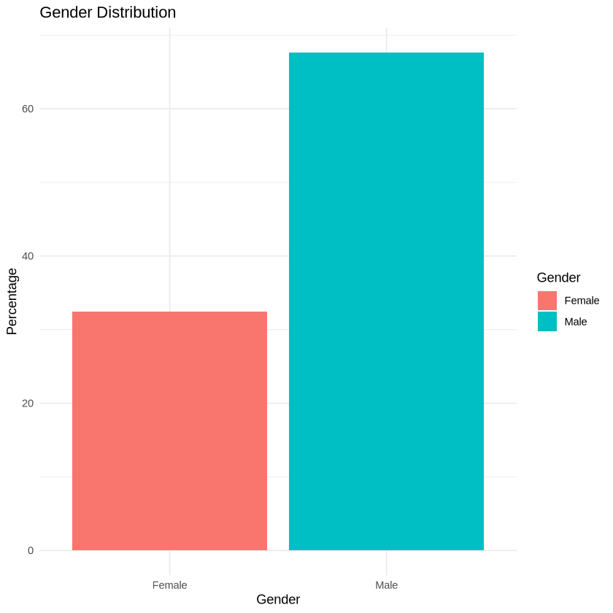
Figure 1: Gender Distribution
The graph in Figure 1 above clearly shows that males formed a significant majority, representing 67.6% of the total population of participants. Females were 32.4% of the participants, which was less than half of the male share. There was a considerable gender gap between male and female representation (35.2 percentage points) (67.6% — 32.4%). There were roughly 2.09 males for every female. The percentages sum up to 100%, indicating that this was a complete representation of the gender distribution for the population in question.
The majority of the respondents (80.2%) were single, followed by married individuals (14.4%). Most respondents (41.5%) were not working. Among the 52.3% that were employed, 33.3% worked for 7 to 8 hours, while fewer worked for extended hours (8 to 10 hours: 1.8%). This indicated a relatively balanced working schedule for those employed. Sixty-four (64%) of the employed earned from N$600.00 to N$1000.00 monthly, while 22.5% were the highest earners, with the range of N$1100.00–N$5000.00. Most employed respondents fell under "other" occupations, with a notable number of domestic workers and factory workers.
Almost half (45%) of respondents attained a secondary school education level, while 43.2% ended at the primary level and 7.3% reached the highest tertiary level, which showed that very few of the participants were illiterate.
Variables | Frequency | Valid Percent %
< 4 | 33 | 29.7%
5 -10 | 61 | 55.0%
11 - 15 | 3 | 2.7%
16 - 20 | 13 | 11.7%
21 - 30 | 1 | 0.9%
Total | 111 | 100.0%
Table 1: Size of the family
Table 1 provides a summary of the distribution of family sizes in a sample of 111 families. Families with fewer than 4 members made up 23.9% of the total sample but accounted for 29.7% of the valid responses (excluding missing data). Families with 5–10 members were the most common, comprising 44.2% of the total sample and 55.0% of the valid responses. This indicated that most families fell within this size range. Families with 21–30 members were extremely rare, accounting for just 0.7% of the total sample and 0.9% of the valid responses.

Out of 111 respondents, 44 (39.6%) indicated that they were vaccinated with Bacillus Calmette-Guerin (BCG), a vaccine against tuberculosis, with the mean being 1.97 and standard deviation of ± 0.879. 23.4% of respondents (n = 26) had not received the BCG vaccine. This might predispose the recipient to the possibility of TB infection, while 41 (36.9%) of the respondents were unsure of receiving BCG vaccination. Enough current participants (23.4%), and those unsure if they received the vaccine (36.9%), pointed to gaps that needed to be filled with immunization coverage or awareness.
In terms of type of TB, 73 respondents (65.8%) were diagnosed with pulmonary TB with a mean of 1.34 and a standard deviation of 0.477, the most frequent and communicable form of the disease. 38 respondents (34.2%) were diagnosed with extrapulmonary TB, which affects areas outside the lungs. Pulmonary TB (65.8%) is more prevalent than extrapulmonary TB (34.2%), consistent with global patterns of TB, where the pulmonary form is typically more common and severe.
The study provides insights into the living conditions of TB patients in Windhoek based on variables such as the number of rooms, windows, window usage, and house ventilation. About 91% of respondents lived in a one- to two-room house, which was an overcrowded living condition and a condition conducive to the spread of TB. Almost half of the respondents (48.6%) reported low ventilation with zero to one window, and nearly two in five people (39.6%) lived in homes with no windows. Poor ventilation was a major risk factor for TB transmission.
Regarding the duration of windows being kept open, less than 4 % respondents kept windows open for the whole day, while 46.8% opened them for half a day. However, 39.6% indicated this was "not applicable," likely because they lived in houses with no windows. This underscored limited airflow in many homes and increased TB infection risk. Only a small proportion of responders (9.9%) reported good ventilation. Most of them had either fair (51.4%) or poor (38.7%) ventilation, indicating that air circulation was also poor among TB patients, resulting in increased transmission risk.
In the smoking-related findings, over 40% of respondents were found to be smokers, a risk factor that is known to exacerbate TB, while 38.7% are heavy smokers, smoking over 11 cigarettes per day, showing heavy cigarette habits among TB-sick people.
It was also widely recognized in the study that alcohol consumption was prevalent among TB patients, and it could weaken the immune system and aggravate TB outcomes. The majority (61.3%) of alcohol consumers drank on a weekly basis, indicating frequent alcohol consumption among TB patients. The fact that most people drank less than 500 ml of water per day suggested that respondents were dehydrated, which is obviously not a good thing in terms of overall health and had a good impact on TB recovery.
One-third of respondents lived with other TB-infected adults, indicating clustering of TB in households. In households where TB was prevalent, TB treatment was an ongoing process for a specific period, but adherence to the treatment needed to be emphasized.
Recent Nutritional status | Frequency | Percentage
BMI- Severe underweight | 8 | 7.2%
BMI-Underweight | 35 | 31.5%
BMI-Normal | 54 | 48.6%
BMI-Overweight | 12 | 10.8%
BMI-Obese | 2 | 1.8%
Total | 11 | 100%
Mean=1.86 | Standard deviation=1.069 | Min=1 and Max=5
Table 2: Nutritional Status of TB Patients
Table 2 presents descriptive statistics for the BMI of a sample population, along with the frequency distribution across BMI categories. Most respondents (48.6%) had a normal BMI. Around 31.5% of a significant proportion were underweight, including 7.2% who were severely underweight. 10.8% were overweight, and a minimal percentage of 1.8% were obese. This distribution indicates that underweight conditions were prevalent in this population, which might affect nutritional challenges.
Odds Ratio | Confidence interval-lower | Confidence Interval | p-value
0.6556 | 0.4232 | 0.9917 | 0.0497
Table 3: Logistical regression model: BMI is a significant factor influencing TB patients (p < 0.05).
Table 3 shows the odds ratio (OR), confidence intervals (CI), and p-value for BMI. The results show that BMI has a statistical effect on or correlates with TB status and attained an OR of 0.6556. This implies that for each unit increase in BMI, the odds of contracting TB decrease by about 34.4 percent.
Since the confidence interval (0.4232, 0.9917) does not cover 1, it further validates (statistically) the importance and applicability of the result. Additionally, the low p-value of this result is 0.0497, indicating that the association of the BMI with the TB status is unlikely to be due to probability. This indicates that BMI is a statistically significant variable with respect to TB status.
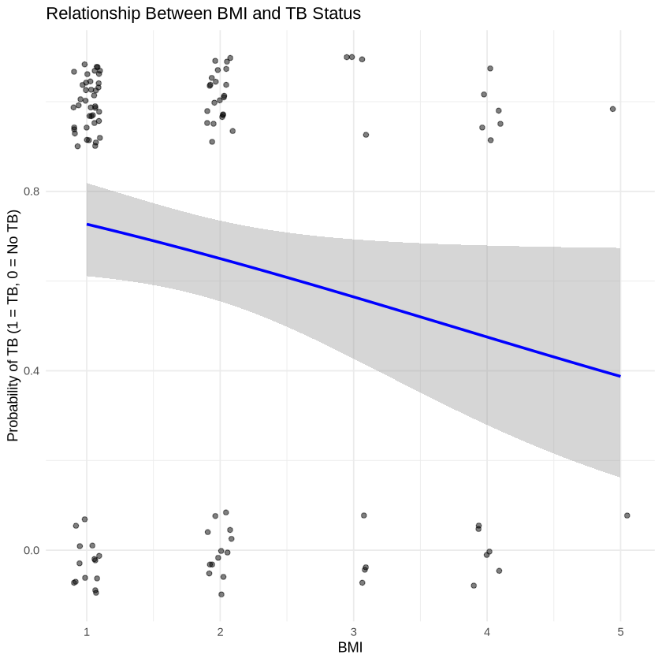
Figure 2: Scatter plot showing the relationship between BMI and TB contraction
In Figure 2, a scatter plot with a logistic regression trend line was also used to visualize the correlation between the probability of TB contraction and BMI. The fitted logistic regression model (blue line) indicates a negative relationship between BMI and the log odds of having TB. As BMI increases, the odds of TB decrease (Y = 1). This offers credence to the theory that a malnourished state (lower BMI) is a risk factor for TB, emphasizing the need for integrated nutritional and medical care in TB management programs.
Table 4: Risk factors that predispose the wasting conditions among TB patients
The logistical regression model results in Table 4 show the coefficients, standard errors, z-values, and p-values for each predictor. From the table above, it was observed that the most significant predictor was monthly income (p = 0.0251), which showed its strong associations with most of the wasting conditions (p = 0.0251). People with lower income were more likely to be underweight. No other component, such as gender, age group, education status, and family size, appeared to correlate with wasting conditions in this dataset. This suggests that economic factors, such as income, play a critical role in predisposing TB patients to wasting conditions.
Variable | Chi-square | Degrees of freedom | p-value | Cramer’s V
Gender | 2.434 | 4 | 0.6565 | 0.148
Age Group | 30.004 | 16 | 0.018 | 0.26
Religion | 0.82 | 4 | 0.9357 | 0.086
Marital status | 43.302 | 12 | 0 | 0.361
Educational status | 28.818 | 16 | 0.0252 | 0.255
Employment Status | 26.031 | 12 | 0.0106 | 0.28
Alcohol consumption | 8.843 | 4 | 0.0651 | 0.282
Cigarette smoking | 3.912 | 4 | 0.4181 | 0.188
TB Type | 4.216 | 4 | 0.3776 | 0.195
Table 5: Association between Nutritional Status (BMI) and Various Predictor Variables
Table 5 shows the results of a chi-square test analyzing the association between nutritional status and predictor variables like gender, age of the participants, religion, marital status, educational level, employment status, alcohol consumption, cigarette smoking, and TB type. The results indicate significant association between the age group, marital status, educational status, and employment status with nutritional status. The strongest association is with marital status (Cramer’s V = 0.361), while age group, educational status, and employment status show moderate associations. Gender, religion, alcohol consumption, cigarette smoking, and TB type did not show significant associations with nutritional status.
Nutritional Status | Alcohol |  | Smoking
 | Yes | No | Yes | No
BMI-normal | 41 | 14 | 22 | 33
BMI-underweight | 32 | 6 | 19 | 19
BM-severe-underweight | 2 | 2 | 2 | 2
BMI-Overweight | 9 | 3 | 3 | 9
BMI-obese | 2 | 0 | 1 | 1
Table 6 (a) Nutritional Status and Risk Factors
Nutritional Status | Gender |  | Employment Status
 | F | M | Employed | Unemployed
BMI-normal | 17 | 38 | 34 | 21
BMI-underweight | 11 | 27 | 15 | 2
BM-severe-underweight | 1 | 3 | 2 | 3
BMI-Overweight | 6 | 6 | 12 | 0
BMI-obese | 1 | 1 | 2 | 0
Table 6 (b) Nutritional Status and Risk Factors

Discussion, conclusions, and recommendations for further research
The study revealed that males formed a significant majority, representing 67.6% of the total number of participants, while females made up 32.4% of the total, which is less than half of the male shares. There are roughly 2.09% more males than females. A similar study conducted in Nepal and Burkina Faso shows that male was higher than female with 53.6% (Subedi et al., 2019 & Musuenge et al., 2020), but in contrast to this study is the investigation conducted in Ethiopia by Feleke et al. (2019). The report from the WHO also clearly supports this connotation, that globally, the male-to-female ratio was 2:1 among patients with TB (WHO, 2019).
The study shows that the highest representation in the data was in the 40-49 age range, which comprised 48% (53 individuals) of the total population. The number of people in the subsequent age group (30-39) was 34 people, accounting for 30% of individuals, and the least populous was the under 20 age group with only one percent (1 person). Adding the 30-39 and 40-49 age groups, a total of 78% of the whole population are in their working age. This is similar to the study conducted by Subedi et al. (2019) that showed that 86.3% of cases were in the economically productive age group.
Almost half (45%) of the respondents had a secondary school educational level, while 43.2% ended at the primary level and 7.3% reached the highest level, the tertiary level. The situation showed that few were illiterate. The majority of the respondents (80.2%) were single, followed by married individuals (14.4%). The study revealed 41.5% of respondents were unemployed, while 52.3% of respondents were employed.

In terms of type of TB, 73 respondents (65.8%) were diagnosed with pulmonary TB with a mean of 1.34 and standard deviation of 0.477, the most frequent and communicable form of the disease. Thirty-eight (38) respondents, representing 34.2% of the total number of respondents, were diagnosed with extrapulmonary TB, which affects areas outside the lungs. Pulmonary TB (65.8%) is more prevalent than extrapulmonary TB (34.2%), consistent with global patterns of TB, where the pulmonary form is typically more common and severe.
This indicates a relatively balanced working schedule for those employed. Sixty-four (64%) of the employed earned from N$600.00 to N$1000.00 monthly, while 22.5% were the highest earners, with the range of N$1100.00–N$5000.00. Overall, the respondents were primarily single, low-income individuals, with over half in employment, but a substantial number were unemployed. Poverty might be a barrier to getting health care services, which could, in turn, prolong the period of infectiousness of the TB patients and could infect close contacts.
This is evident from the results of this study, with 33.3% having indicated that members of the same households had contracted TB and received medication. Similar results were documented in the study conducted by (Saad et al., 2014). Several studies documented (Saad et al., 2014 & Casha & Scarci, 2017) that there was an association between TB, poor socioeconomic factors, and poverty. People of low socioeconomic status tended to live in overcrowded conditions with poor ventilation, which was a major risk factor for the transmission of the TB bacteria, which could result in a high incidence of TB disease in these people.
This is noticeable from the reports carried out in Namibia, NPC (2014) & GHI (2024), that the country experienced high rates of poverty while access to nutritious food due to high costs remained a major challenge. This interrelationship connection might explain why socioeconomic factors such as education status, employment status, and monthly income were significantly associated with malnutrition, as revealed in this study. A similar study conducted in Burkina Faso showed that high prevalence of undernutrition might replicate the low socioeconomic factors (Musuenge et al., 2020).
The study revealed that over 40% of respondents were found to be smokers, a risk factor known to exacerbate TB, while 38.7% were heavy smokers, smoking over 11 cigarettes per day, showing heavy cigarette habits among people sick with TB. It was also widely recognized in the study that alcohol consumption is prevalent among TB patients, and it could weaken immunity and aggravate TB outcomes. The majority (61.3%) of alcohol consumers drank on a weekly basis, indicating frequent alcohol consumption among TB patients. TB patients that consumed alcohol had a higher risk of becoming malnourished. This finding agrees with the study in Ethiopia by Feleke et al. (2019). This is due to the fact that alcoholic patients ate poorly and had poor digestion and absorption of nutrients, according to Feleke et al. (2019).
Table 6(a) shows that below 50% of the respondents that consumed alcohol were underweight: 28.2%. This is like the study conducted in China by Musuenge et al. (2020) that showed that 29.6% were underweight and consumed alcohol. This study also showed that patients who smoked and were underweight were only 17%, in contrast to the study conducted in China (Ren et al., 2019 & Musuenge et al., 2020).
Thirty-eight respondents (34.2%) were diagnosed with extrapulmonary TB, which affects areas outside the lungs. Pulmonary TB (65.8%) is more prevalent than extrapulmonary TB (34.2%), and this is consistent with global patterns of TB, where the pulmonary form is typically more common and severe.
Malnutrition in TB patients has been revealed in many studies (Subedi et al., 2019) & Feleke et al., 2019) & Saad et al., (2014) & Casha & Scarci, (2017) and once again in this study. Nutritional status was assessed based on WHO Assessment criteria (WHO, 2016). The results showed that most of the respondents (48.6%) had a normal BMI. Around 31.5% of a significant proportion are underweight, including 7.2% who are severely underweight. This distribution indicates that underweight conditions are prevalent in this population, which may affect nutritional challenges. Similar studies conducted in different countries like Nepal, Ethiopia, Ghana, Burkina Faso, India, and Pakistan have found similar results (Subedi et al., 2019, Feleke et al., 2019 & Saad et al., 2014 & Casha & Scarci, 2017).
Correspondingly, in this study, nutritional status was not statistically significant with age, gender, education status, religion, and family size. A similar study conducted in Nepal also found no significant association between marital status, age, gender, religion, education status, marital status, and family size. But there was a significant association between nutritional status and monthly income and marital status (Subedi et al., 2019). There was a highly strong association with nutritional status and marital status (Cramer V = 0.361), p-value of 0.
The odds of malnutrition were 2.0 times higher in males than in females, meaning there were roughly 2.0 males for every female. This contrasts with the findings from the study conducted in Ethiopia (Feleke et al., 2019) but agrees with the study conducted by Saad et al. (2014). The odds of malnutrition were higher in the age group between 30 and 49. This result is like studies in Ghana and Ethiopia (Feleke et al., 2019; Saad et al., 2014; & Casha & Scarci, 2017). This could be because when one grows older, the risks of comorbid conditions such as communicable diseases are higher. It is believed that the immune system of the young is generally stronger than that of the aged, and they can recover from the stress of illness better than the aged (Casha & Scarci, 2017).
In conclusion, the study findings demonstrated the presence of malnutrition among TB patients in Windhoek. From the findings, it is worth noting that the socio-economic factors contribute to malnutrition among TB patients. This study could also be used as a baseline reference for further studies in the similar field. The findings advocate for targeted interventions, including awareness on enhancing BCG vaccination coverage, improving housing conditions, and implementing lifestyle modification programs to address smoking and alcohol consumption.
Overall, the study calls for a comprehensive approach that integrates nutritional support and socio-economic improvements to effectively combat TB and enhance patient recovery in Windhoek. The study was limited to three health facilities in Windhoek only. However, further studies should be conducted to apply results to other health facilities in all 14 regions in Namibia.

References

Casha, R.A., Scarci, M. (2017). The link between tuberculosis and body mass index. Journal of Thoracic Diseases. J. Thorac Dis. 2017 Mar; 9(3): E301-E303. Doi 10.21037/jtd.2017.03.47.
CDC (2024). Nutrition: Benefits of Healthy Eating for Adults https://www.cdc.gov/nutrition/php/resources/healthy-eating-benefits-for-adults.html
Chipare, M. A., Tapera, R., Pachawo, R. F., & January, J. (2020). Exploring the evolution of health promotion in Namibia: opportunities and obstacles during the post-independence era. Global Health Promotion, 27(4), 107-113.
Feleke, B.E., Feleke, T.E., Biadglegne, F. (2019). Nutritional status of tuberculosis patients: a comparative cross-sectional study. BMC Pulmonary Medicine. 19:182.
Gurung, L.M., Bhatt, L.D., Karmacharya, I., Yadav, D.K. (2018). Dietary Practice and Nutritional Status of Tuberculosis Patients in Pokhara: A Cross-Sectional Study. Front. Nutr. 5:63. doi: 10.3389/fnut.2018.00063
Ministry of Health and Social Services. (2019). National Tuberculosis Control Programme Report.
Musuenge, B.B., Poda, G.G., Chun Chen, P. (2020), Nutritional Status of Patients with Tuberculosis and Associated Factors in the Health Centre Region of Burkina Faso. Nutrients 202, 2540; doi:10.3390/nu12092540
Namibia: Acute Food Insecurity Analysis. 2024) https://www.ipcinfo.org/fileadmin/user_upload/ipcinfo/docs/IPC_Namibia_Acute_Food_Insecurity_Apr_Sept%202024_report.pdf
Namibia Population and Housing Census Main Report (2023). https://namibia statistics agency census 2023 report - Google Search
National Planning Commission. 2014. The root causes of poverty in Windhoek. Namibia https://www.npc.gov.na/wp-content/uploads/2023/06/Root-Causes-of-Poverty.pdf

Namibia Zero Hunger Strategic Review Report. 2020. https://www.wfp.org/operations/na01-namibia-country-strategic-plan-2017-2024 Namibia Country Strategic Plan (2017-2024)
Nutrition Assessment, Counselling and Support (NACS) Service Implementation in Namibia (2013) Retrieved on 12 May 2021 from https://pdf.usaid.gov/pdf_docs/PA00K11Q.pdf
Nyanhanda, T., Mwanri, L., & Mude, W. (2023). Double burden of malnutrition: A population-level comparative cross-sectional study across three sub-Saharan African countries—Malawi, Namibia, and Zimbabwe. International Journal of Environmental Research and Public Health, 20(10), 5860.
Reber E, Strahm R, Bally L, Schuetz P, Stanga Z. (2019). Efficacy and Efficiency of Nutritional Support Teams. Journal of Clinical Medicine; 8(9):1281. doi: 10.3390/jcm8091281. PMID: 31443543; PMCID: PMC6780521.
Ren, Z., Zhao, F., Chen, H., Hu, D., Yu, W., Xu, X., Lin, D., Luo, F. (2019). Nutritional intakes and associated factors among tuberculosis patients: a cross-sectional study in China. BMC Infectious Diseases. 19:907 https://doi.org/10.1186/s12879-019-4481-6
Subedi, S., Mehta, R. S., Parajuli, P., Mandal, G., Yadav, D. K. (2019). Nutritional Status of Patients with Pulmonary Tuberculosis Receiving Anti-Tuberculosis Treatment at BP Koirala Institute of Health Sciences, Nepal. Journal of Nursing & Health Science, 8, 6, http://iosrjournals.org/iosr-jnhs/papers/vol8-issue6/Series-5/A0806050105.pdf
Téllez-Navarrete, N. A., Ramón-Luing, L. A., Muñoz-Torrico, M., Osuna-Padilla, I. A., & Chávez-Galán, L. (2021). Malnutrition and tuberculosis: the gap between basic research and clinical trials. The Journal of Infection in Developing Countries, 15(03), 310-319.
Thomas, A. (2014). Comparing the risk of tuberculosis infection in the households with and without tb patients in Tsumkwe constituency, Otjozondjupa region, Namibia. University of Namibia. Retrieved from https://repository.unam.edu.na › thomas_2014
Vonasek, B. J., Radtke, K. K., Vaz, P., Buck, W. C., Chabala, C., McCollum, E. D., ... & Garcia-Prats, A. J. (2022). Tuberculosis in children with severe acute malnutrition. Expert review of respiratory medicine, 16(3), 273-284.

WHO (2016). Global Database on Body Mass Index; World Health Organization: Geneva, Switzerland, 2006. http://www.assessmentpsychology.com/icbmi.htm (accessed on 05 December 2020)
WHO (2011). Guideline: Nutritional care and support for patients with tuberculosis. Department of Nutrition for Health and Development World Health Organization Avenue Appia 20, CH-1211 Geneva 27, Switzerland Fax: +41 22 791 4156 https://www.who.int/health-topics/nutrition (accessed on 05 December 2020)
World Health Organization. (2021). Global Tuberculosis Report. https://www.who.int/publications/digital/global-tuberculosis-report-2021
WHO (2019). World Health Organization Tuberculosis. Key Fact. 2019. Available online. https://www.who.int/teams/global-tuberculosis-programme/tb-reports/global-tuberculosis-report-2020 (accessed on 05 December 2020).
World Health Organization. (2024). Various forms of malnutrition. https://www.who.int/health-topics/malnutrition#tab=tab_1
World Food Programme. Namibia Country Brief. 2024 http://www.wfp.org/countries/Namibia
Yu, E. A., Finkelstein, J. L., Brannon, P. M., Bonam, W., Russell, D. G., Glesby, M. J., & Mehta, S. (2020). Nutritional assessment among adult patients with suspected or confirmed active tuberculosis disease in rural India. PloS one, 15(5), e0233306.

