Analysis of High-Growth Business Strategies through the Lens of Lightning Expansion

Abstract:
This paper delves into the concept of Lightning Expansion, a strategic approach inspired by the Blitzkrieg strategy employed during World War II. By examining the rapid expansion of enterprise scale and market area, Lightning Expansion aims to create industry leaders through economies of scale and market globalization. Utilizing the example of Pinduoduo, a high-growth e-commerce company in China, we analyze the success factors that align with the principles of Lightning Expansion.

Key words: Lightning expansion; High-growth enterprises

Introduction:
Lightning Expansion, as a business concept, emphasizes rapid and decisive moves to capture market share and expand operations globally.

It requires a blend of strategic vision, technological prowess, and operational excellence. Pinduoduo's meteoric rise in the e-commerce landscape serves as a prime example of how this strategy can be effectively implemented.

Rapid expansion of enterprise scale and market area and Lightning Expansion

Analyze the success factors that align with the principles of Lightning Expansion.
Lightning Expansion aims to create industry leaders through economies of scale and market globalization

The core findings and perspectives of Lightning Expansion
- Market Penetration and Segmentation:
Pinduoduo targeted niche markets, particularly focusing on the elderly demographic, and leveraged innovative group sales models to penetrate these segments. This strategy aligned with the principle of market positivity, where firms boldly invest in customer differentiation and scalability.
- Economies of Scale and Globalization:
By rapidly expanding its customer base and business areas, Pinduoduo leveraged economies of scale to reduce costs and increase profits. This expansion facilitated a global market reach, a hallmark of Lightning Expansion.
- Advanced Technology Utilization:
Pinduoduo integrated advanced digital technologies, including big data analytics and algorithms, to optimize its sales channels and personalize product recommendations. This demonstrates the use of advanced technology as a key driver of high-growth enterprises.

The relevance and usefulness of the law of lightning expansion for high-growth firms
- All high-growth, high-growth companies share three attributes:
- The use of advanced technology: research and development capabilities, proprietary algorithms, Internet focus, omni-channel marketing.
- Market positivity: bold investment, customer differentiation, scalability, brand profitability.
- Functional excellence: Supply chain partnerships, cross-selling, upselling, operational excellence, retail.
High-growth enterprises will show the phenomenon of rapid expansion of the number of customers and business area, and the annual growth rate of business revenue can reach 60% or more. High-growth enterprises are in the stage of lightning expansion. Such rapid growth is inseparable from the lightning expansion of the number of customers and business area.
In the process of lightning expansion, high-growth enterprises exert the enthusiasm of maximizing the market through Internet marketing according to the unique research and development ability or algorithm of their founders. Entrepreneurs will make bold investments, whether expanding production capacity internally or expanding market areas externally, which will increase their overall investment volume^{[5]}. They will segment their customers and capture niche markets. Generally, it is an asset-light enterprise with rapid expansion, great brand influence, high brand premium space, and brand can be converted into monetary profits. These companies also demonstrate functional excellence, stable supply chain partnerships, and cross-selling and upselling to increase their profits. They have a level of operational excellence and a strong retail presence.
It is based on these rapid expansion of market share and talent, the leader from a policy maker to a good manager, the start-up can quickly take advantage of the scale of the global market advantages to achieve winner-takes-all, become stable mature enterprises.
- Key learnings
- Many high-growth companies sprouted from traditional industries, not necessarily high-tech companies. They succeed because they adopt new and innovative business models and combine them with proven technology and best management practices.
- A growing business may not be located anywhere, but location is not the determining factor. Because access to key resources is the most important thing, for example, production firms must locate close to access to factors of production.
- High-growth start-ups penetrate niches by market share rather than finding gaps by flooding new or adjacent industries with products.

Business leaders need to be aware of rapid expansion, and in the process of rapid expansion, they face the challenge of playing many roles. Because the leader is not only the visionary specified by the policy, but also the actor of the implementation of the policy, which requires the leader to have both the overall view and the system view, can hold the direction of the sail, but also the ability to pull the anchor paddle^{[6]}. In the long road of entrepreneurship, leaders should always uphold values, not be confused by interests, be able to respond to different scenarios and status quo quickly adjust strategies and capabilities, and always be result-oriented. The only criterion for a good leader is whether the execution process and the results are consistent.
Under good leadership, a startup will achieve rapid growth through lightning expansion, and the corporate cash flow will follow the classic curve^{[7,8]} shown in the chart below.

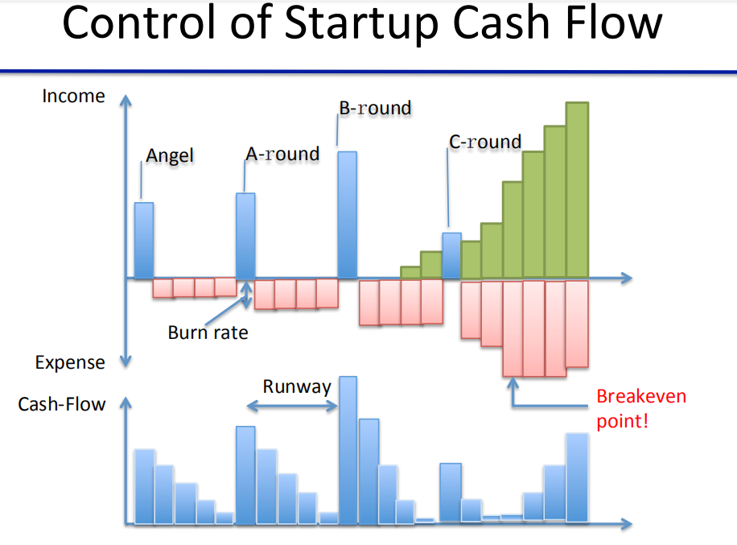
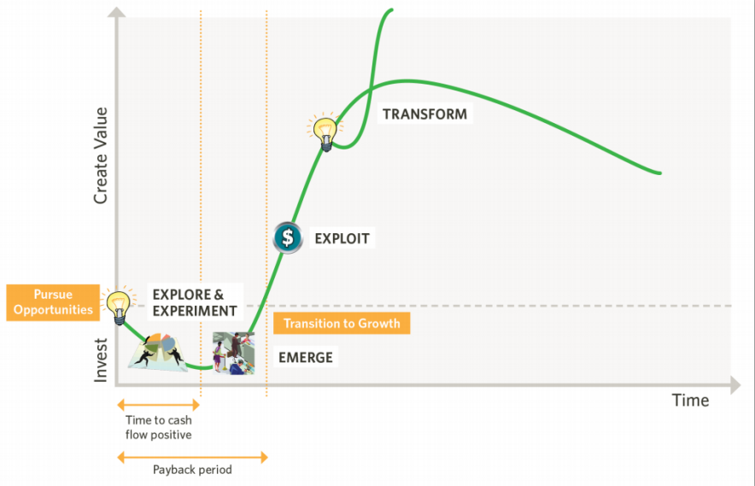
The classic cash flow curve of a high-growth startup's lightning expansion
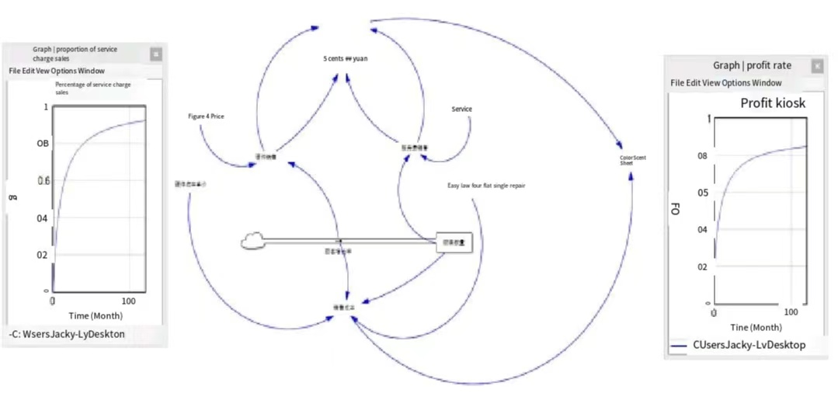
The high-growth enterprise system structure and the classic profit curve
Case study
(1) Successful company: Pinduoduo.
Pinduoduo is a private enterprise in China, and it started late in the field of e-commerce. Before it, there were two giant companies, Alibaba Group, which was mature and huge, and Jingdong Group, which was stable and solid, occupying almost all the market share.
However, Pinduoduo has made a sudden rise, taking the marginal market as the entrance point, and taking the "rural encircling the city" e-commerce. Starting from the niche market of the elderly, it quickly achieved its unique group sales model, which obtained a huge number of customers by using the way of pulling people, and the customer group has also spread to all age groups^{[9]}.
Its successful expansion experience is completely consistent with the lightning expansion mentioned in the article. Based on the arguments of the article, I summarize its success factors as follows:
- Adopt advanced technology: Pduo has its own unique group digital technology, and will model and analyze the Internet big data, and expand omni-channel sales according to the Internet. app online channels and algorithms, etc., often recommend our recently interested products and services.
- Bold investment: Pinduoduo has spent huge costs to cooperate with fruit farmers and launched a lot of fruit activities. Starting from online mini-games, customers can actually harvest fruits and vegetables in the future by watering and planting trees virtually. Popular among the elderly, it is simple to operate and convenient to receive goods, rapidly expanding its influence.
- Customer differentiation, created an advanced membership system, one yuan to open members, according to the rhythm of giving five yuan a week coupons for four consecutive weeks, continued to pull the number of new members exploded. Good shopping experience will firmly grasp the new members do not lose.
- Cross-selling, bundling, up-selling, etc. : Through the person-to-person order system, Pinjoduo group purchase quantity requires only two orders to complete the group purchase price. Under normal circumstances, we will send the link to other relatives and friends, one to help negotiate the price, two to collect the order, three to receive the bounty. When you buy a membership, you usually buy some extra vouchers, because they're good for 50 years. If you don't worry about expiration, you'll need it in the future.
- Brand profitability, on the basis of mature e-commerce, launched the second main business - community group buying, community group buying market is huge, the commercialization of group buying products into the community to buy vegetables and other life goods above, will get a huge cash flow. With the rapid expansion of community group buying, Pinduoduo has entered the ranks of mature enterprises.
- Excellent operation and marketized mature supply chain: Pinduoduo has no stores or warehouses of its own. Its strong brand platform influence has attracted many shops to operate on its platform. These countless competing shops have become the best marketized supply chain. In terms of operation and management, Pinduoduo handles the complaints of illegal merchants and customers in a timely and fair manner, which are all factors that help its lightning expansion succeed.
- Entrepreneur leadership: Huang Zheng has a distinctive temperament and thinks in black and white. Many similar products in accordance with the PC category to find traffic development, traffic logic is search, people find information or people find goods; And more is the logic of people, is the recommended action, is the information to find people or goods to find people, the use of big data algorithms to intelligently recommend to users they need more products, so that more goods to match more people, e-commerce mobile world, the lack of people rather than goods. This kind of people-oriented mentality of courage, let him from the founding of Pinduoduo set up a three-year listing ambition.
(2) Failed companies: Groupon
Groupon was first launched in November 2008 as a way to sell online deals. Its unique features are: only one discount product is promoted per day, each person is limited to one auction per day, the discount product must be the type of service, the service is regional, and the offline sales team is far larger than the online team. The market is mainly distributed in Europe and the United States. In recent years, due to the poor development, it has been withdrawing from some market areas, and the revenue is often thunderstruck and there are rumors of financial fraud. As a typical representative of the Web 2.0 era, it started very well, developed rapidly, and there was a situation of lightning expansion, but the solution was not good, because it did not grasp and control the key factors in the process of lightning expansion.
When Groupon quickly reached the mid-level, it faced strong competition at both the high and low end of the market. By failing to scale quickly enough to capture a major market share and create a strong, sustainable and scalable product, Groupon missed an opportunity^{[10]} to revolutionize an industry. That opportunity was snatched up by Amazon, Google, Alibaba, and even Pinduoduo.
After the enterprise develops to the intermediate stage, it wants to quickly jump to the advanced stage. At this time, in addition to the rapid expansion of the market area, the more important thing is that the product can not be a single product. The market value created by a single product is more and more limited in the fierce competition, and the innovation to create a second new product can be undefeated, expand the previous advantages, so that they become mature and stable multinational companies. Groupon is so old-fashioned that it did not innovate the second product at the intermediate stage, because it was divided up by other competitors. The industry grew unusually well, and huge fortunes were stolen by others.
There is plenty of talent in international markets, where many entrepreneurs could pose a competitive threat. But execution risk can't be underestimated. You rarely hear startups say, "We failed because we focused too much on our core business."
Yahoo has done that better than anyone else, especially in the most insurmountable of markets, China. Instead of building their own Yahoo and hiring a local team, they bought a stake in Alibaba. The value of that stake has become an important part of Yahoo's market capitalization, which has been teetering lately.
What emerged later, Pinduoduo, was a more Chinese version of Groupon, but more advanced and humane. The specific explanation is analyzed in the previous successful case.
Group buying deals are not good for small businesses. "It was expected to make up for the losses, but it didn't," he said. Retailers are attracting price-sensitive customers who are always looking for good deals. If there are no group deals, they won't patronize." So Groupon's business model broke down when it got to the mid-level. When customers came in, they came in because of the low price, and then when there were no cheap prices and Groupon deals, the number of customers quickly dropped. Groupon should consider and design how to convert its large and rapidly growing number of customers into long-term loyal and stable customers, and make it and its partner merchants profit from these customers, which is the long-term solution.
Coupled with the occurrence of Groupon's financial fraud incident, it fully demonstrates that Groupon's talent framework and corporate culture have serious problems, which can not support a huge valuation.
It can be said that Groupon only learned the surface of lightning expansion, and the deep essence is not the point. Groupon's leadership is flawed, its talent development and culture is flawed, its business model is flawed and its growth strategy is flawed. All of these problems led to Groupon's eventual downfall.

Conclusion
Pinduoduo's effective utilization of Lightning Expansion underscores how a startup can swiftly transition into a high-growth entity through pioneering business strategies, utilizing advanced technologies, and undertaking aggressive investments. Focusing on market dynamism, economies of scale, and operational excellence, Pinduoduo has evolved from a niche player into a significant competitor in the e-commerce sector. Its journey provides a valuable lesson for future entrepreneurs seeking to employ Lightning Expansion in their pursuit of high growth prospects.

Disclaimer (Artificial intelligence)

Option 1:

Author(s) hereby declare that NO generative AI technologies such as Large Language Models (ChatGPT, COPILOT, etc) and text-to-image generators have been used during writing or editing of manuscripts.

Option 2:

Author(s) hereby declare that generative AI technologies such as Large Language Models, etc have been used during writing or editing of manuscripts. This explanation will include the name, version, model, and source of the generative AI technology and as well as all input prompts provided to the generative AI technology

References
[1] Brozović, Danilo et al. “Strategic flexibility and growth of small and medium-sized enterprises: a study of enablers and barriers.” Management Decision (2023): n. pag. DOI:10.1108/md-05-2022-0577
[2] Liu, Hsian-Ming and Hsin-Feng Yang. “Managing Network Resource and Organizational Capabilities to Create Competitive Advantage for SMEs in a Volatile Environment.” Journal of Small Business Management 57 (2019): 155 - 171. DOI:10.1111/jsbm.12449
[3] Navarro, Jose Luis Barbero et al. “Forms of growth: How SMEs combine forms of growth to achieve high growth.” Journal of Management & Organization 18 (2012): 81-97. DOI:10.1017/S1833367200001085
[4] Imarhiagbe, Bernard Owens et al. “Firm Growth.” Advances in Business Strategy and Competitive Advantage (2018): n. pag. DOI:10.4018/978-1-5225-6942-8.CH009
[5] Bramati, Maria Caterina et al. “International Trade and Domestic Competition: Evidence from Belgium.” Review of Industrial Organization 46 (2015): 383-399. DOI:10.1007/S11151-015-9454-3
[6] Opoku, Eric Evans Osei et al. “Reaching Up and Reaching Out: The Impact of Competition on Firms’ Productivity and Export Decisions.” ERN: Other Emerging Markets Economics: Firm Behavior & Microeconomic Issues (Topic) (2018): n. pag. DOI:10.1111/1468-0106.12287
[7] Fung, Hung-Gay et al. “Impact of Competitive Position on Export Propensity and Intensity: An Empirical Study of Manufacturing Firms in China.” The Chinese Economy 41 (2008): 51 - 67. DOI:10.2753/CES1097-1475410503
[8] Lu, Jiangyong et al. “Motives for Outward FDI of Chinese Private Firms Firm Resources, Industry Dynamics, and Government Policies.” Management and Organization Review 7 (2011): 223 - 248. DOI:10.1111/j.1740-8784.2010.00184.x
[9] Pradhan, Jaya Prakash. “National Innovation System and the Emergence of Indian Information and Software Technology Multinationals.” Labor: Human Capital eJournal (2007): n. pag. DOI:10.2139/SSRN.1515648
[10] Pradhan, Jaya Prakash. “Emerging Multinationals from India and China: Origin, Impetus and Growth.” International Finance eJournal (2009): n. pag. DOI:10.2139/ssrn.1515676

