An Analysis Hainan Province Tourism Development
-- Taking Sanya Rose Valley as An Example

Abstract
Yalong Bay International Rose Valley Scenic Spot in Sanya is a comprehensive tourist destination that combines the beauty of nature and humanistic feelings. With the core theme of "beauty, romance and love", relying on the natural features of farmland, reservoir and mountain forest, and centered on colorful roses, it has created a large-scale comprehensive scenic spot integrating rose planting, cultural display and tourism and leisure. It is the largest rose valley in Asia. As a tourist city in China, Sanya's tourism industry has contributed significantly to its GDP. In recent years, tourism revenue has been accounting for more than 60% of Sanya's GDP, and it reached 93.41% in 2019. Although the COVID-19 pandemic has reduced the proportion since 2020, tourism revenue still accounts for more than 50 percent of Sanya's GDP, reaching 51.32 percent in 2022. It is crucial to reinforce governmental oversight, enhance the tourism service framework, fortify the monitoring of the corporate marketplace, and propel Hainan's tourism sector to an elevated echelon. By integrating our unique regional culture into this process and crafting a distinct tropical island brand persona, we can significantly augment Hainan's GDP.
Keywords: COVID-19, GDP, Hainan's tourism, cultural festivals

Introduction
Through diligent research, our team discovered that while Hainan's GDP is expanding swiftly, tourist arrivals are declining. This study proposes strategic adjustments for the Yalong Bay International Rose Valley Scenic Spot in Sanya to enhance visitor experiences, thereby boosting its popularity and profitability. We intend to convert tourists into revenue through value-added services and unique initiatives after the implementation of free tickets. Strategies include incorporating culture, artistry, and novel technologies such as VR/AR to heighten visitor engagement; offering tailored travel packages to cater to diverse tourists; initiating an AI personal assistant for streamlined navigation; and harnessing the power of internet celebrities by hosting events such as internet celebrity camping, Hanfu cultural festivals, and exclusive check-in areas to appeal to younger demographics. These modifications aim to augment the tourist numbers, satisfaction levels, and financial returns of the scenic spot, ensuring sustained growth for Yalong Bay International Rose Valley Scenic Spot in Sanya.

Current situation of tourism

(1) Sanya's contribution to tourism
On January 13, Haikou hosted the first session of the seventh National People's Congress of Hainan Province. Governor Feng Fei said in the Government Work Report that Hainan's economy as a whole is stable and improving in 2022, and the regional GDP is expected to show positive growth, while the expected target for 2023 is about 9.5 percent growth.

 | 2019 | 2020 | 2021 | 2022 | 2023
Target GDP | 7-7.5% | 6.50% | 9% | 9% | 9.50%
Real GDP | 5.80% | 3.50% | 11.20%

Sanya has earned the reputation of "Hawaii of the East" for its beautiful tropical coastal scenery, attracting many tourists to visit it every year. In 2019, the city received 23.9633 million overnight visitors, up 6.86 percent year on year. However, due to the impact of COVID-19, the number of tourists declined significantly in 2020. Although there was a brief recovery in 2021, the number of tourists decreased again in 2022, with a total of 13.1479 million visits, down 39.2 percent from the previous year. Specifically, the number of domestic overnight tourists was 13,0333,200, down 39.3 percent; And the number of overnight inbound tourists was 114,700, down 19.2 percent.
As a tourist city in China, Sanya's tourism industry has contributed significantly to its GDP. In recent years, tourism revenue has been accounting for more than 60% of Sanya's GDP, and it reached 93.41% in 2019. Although the COVID-19 pandemic has reduced the proportion since 2020, tourism revenue still accounts for more than 50 percent of Sanya's GDP, reaching 51.32 percent in 2022.
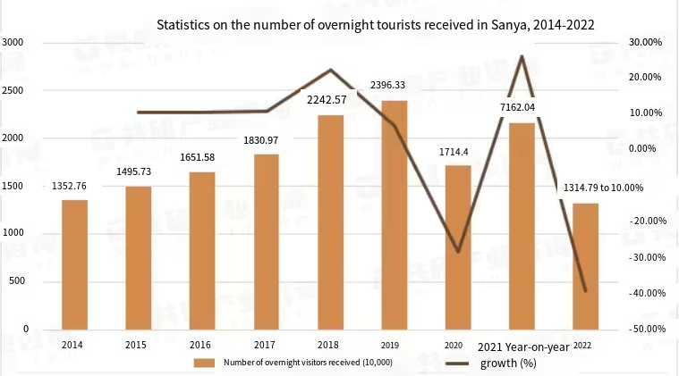

After the pandemic, according to statistics released by the Sanya Municipal Development and Reform Commission, Sanya's tourism industry performed well in the first half of 2023. In the first half of the year, the city received 13.2736 million overnight tourists, an increase of 5.3462 million over the same period in 2022, achieving a year-on-year growth of 67.44 percent. Breakdown data showed that the number of domestic overnight visitors was 13.186 million, representing a year-on-year increase of 67.53%; The number of inbound overnight tourists was 87,600, up 54.58 percent year on year.
Further by quarter, Sanya received 7.518,100 overnight visitors in the first quarter of 2023, up 33.22% year on year. However, in the second quarter, the number of overnight tourists received was 5.7555 million, with the year-on-year growth rate soaring to 152.00%, marking a strong recovery of Sanya's tourism industry.

(2) Development status of the International Rose Valley Scenic Spot
Yalong Bay International Rose Valley Scenic Spot in Sanya is a comprehensive tourist destination that combines the beauty of nature and humanistic feelings. With the core theme of "beauty, romance and love", relying on the natural features of farmland, reservoir and mountain forest, and centered on colorful roses, it has created a large-scale comprehensive scenic spot integrating rose planting, cultural display and tourism and leisure. It is the largest rose valley in Asia.
At the economic level, although the entrance fee of the scenic spot is 60 yuan, it still attracts more than 1.5 million tourists every year. This number of tourists proves the strong attraction of Rose Valley and its solid position in the tourism market. It is worth noting that ticket revenue is not the main economic source of the scenic spot. Sales of extended products, including all kinds of goods and services related to the rose theme, account for more than half of its annual revenue, with annual turnover of more than 100 million yuan, showing the diversification of the scenic spot's business model and strong profitability. This business strategy has enabled Sanya Yalong Bay International Rose Valley Scenic Spot to hold a favorable position in the highly competitive tourism market, not only providing rich and diverse tourism experiences, but also achieving steady economic growth.

The current issues and challenges

(1) The impact of charging tickets
At present, the entrance fee of Yalong Bay International Rose Valley Scenic Spot in Sanya may become an important factor restricting the flow of tourists. Ticket prices may lead tourists with limited budgets or those who don't know enough about the scenic spot to choose other free or low-cost destinations. In non-peak seasons or non-holidays, the entrance fee may even exacerbate the decrease in the number of tourists, affecting the overall income of the scenic spot and the satisfaction of tourists.

(2). Make full use of natural and cultural resources
Although Yalong Bay International Rose Valley Scenic Area is rich in natural and cultural resources, it is still a challenge to effectively integrate these resources into the experience of tourists. The scenic spot needs to find innovative ways to integrate the original ecology of farmland, reservoir and mountain forest with the rich and colorful rose culture to provide tourists with a richer and deeper experience.

（3）Tourist experience and satisfaction
Scenic spots are under pressure to continuously improve tourists' experience and satisfaction. In a highly competitive tourism market, tourists' expectations for service quality and experience are constantly improving. In particular, personalized service and the integration of science and technology have become increasingly important aspects, and scenic spots need to make improvements in these aspects to meet the diverse needs of tourists.

(4) Market competition and location advantages
The tourism competition in Sanya and its surrounding areas is quite fierce. A major challenge for Yalong Bay International Rose Valley Scenic Spot is how to stand out among the many tourist destinations and enhance its appeal. In order to highlight the theme of "beauty, romance and love", the scenic spot needs to strengthen brand building and innovate marketing strategies.

Innovative measures and strategies
The 2023 Mid-Autumn Festival and National Day holidays overlap to form an eight-day "Super Golden Week". During the holiday, Sanya Tianya Haijiao Tourist Area, Big and small Dongtian Tourist area, Luhuitou Scenic area three free ticket scenic spots have made efforts to deliver ideal report card. According to statistics from the Sanya Tourism and Culture Bureau, the total number of tourists in the three free scenic spots during the "Super Golden Week" exceeded 190,000.

Government policies
According to statistics, young people play a dominant role in tourism, especially college students, the frequency of travel is high, the government can implement students, the elderly, military and other special groups free tickets, teachers, doctors and other preferential ticket policies, in order to introduce more tourists into the scenic spot, and then in the scenic spot investment introduction of young people favorite play facilities to solve the problem of scenic spot income.
Sanya's released numbers indicate a notable boost in tourism at key areas: Luhuitou Park experienced an increase of 113% over 2019 and 299% over 2022; Fairyland grew by 172% year-on-year in 2019 and 353% year-on-year in 2022; “The remotest corners of the globe” will offer unrestricted entry starting June 1st, 2023. Visitors to the site surged by 60% in the inaugural month post-free entry, surpassing both May and 2022 figures; Total secondary consumption revenue (excluding tickets) for these three sites rose by 129% year-on-year in 2022 and 77% year-on-year in 2019.
The environment of Rose Valley scenic spot is pleasant and unique. The government can use Rose Valley as a long-term cooperation venue for variety TV series and other activities in the next batch of documents, so as to attract fans and increase the popularity of Rose Valley through star popularity and program publicity effect. In order to strengthen the promotion of the core scenic area of Rose Valley, strengthen publicity efforts, and strive to build the core brand of Sanya tourism. To create a tourism business card with distinctive Sanya culture, fully tap the unique local culture, and create a rich and beautiful tourism business card integrating natural resources and scenery with regional culture. In contrast, Wuzhizhou Island has attracted a large number of tourists because of the artists' team to record variety shows here. The number of tourists received has increased from 21,700 in 22 years to 51,300, which has driven the supporting facilities such as the island's tourism projects and considerable economic income.

(2) Enhance art and culture, virtual and reality (VR/AR) experience
In Yalong Bay International Rose Valley Scenic Spot, the government should invest heavily in the protection and development of cultural, historical and natural resources in the scenic spot, introduce novel experience activities, cooperate with local enterprises or entrepreneurs, introduce novel experience activities with local characteristics, set up cultural experience, handicrafts production, and let tourists participate in the production of roses by themselves. DIY a unique rose of their own to enhance tourist experience and ensure the diversity of tourist experience.
The application of digital technology to promote the digital upgrade of scenic spots, the introduction of virtual reality (VR), augmented reality (AR) technology, to provide tourists with a richer visit experience. We will launch an innovative and deeply immersive VR/AR experience, specifically, where visitors can personally "step into" the growing process of roses through VR/AR glasses and explore the history and modern applications of rose culture. According to a report, tourist satisfaction has increased by an average of 40 percent after the introduction of VR/AR technology at tourist attractions. We will work with technology companies to customize software so that visitors can personally experience the whole process of growing roses, curing them and picking them.

(3) We will launch customized travel packages
We realize that each tourist has his or her unique needs and interests, so we will introduce customized travel packages. These packages will be tailored to different interests and needs, such as "romantic couple packages" that can include private garden Tours, specialty meals and customized souvenirs, among others. According to market data, personalized visitor experiences can boost scenic spots' revenue by 35 percent. We expect to achieve at least 30% revenue growth in the next fiscal year through these customized packages.

(4) Establish an intelligent navigation and service system
Yalong Bay International Rose Valley Scenic Spot will develop an AI-based intelligent tour guide and service APP. Visitors can download the APP through their mobile phones and get real-time navigation information, activity recommendations, traffic guides and other services during the tour. At the same time, AI technology will help us analyze tourists' interests and behaviors to provide more personalized services and recommendations. A survey showed that tourist satisfaction increased by 50 percent and visit time increased by 20 percent in scenic spots guided by AI. With the help of AI technology, we estimate that the average stay time of tourists will increase by one hour, and the satisfaction rate will increase to more than 90%.

(5) Cultural integration and promotion
To further attract young tourists, Yalong Bay International Rose Valley Scenic Spot will add online celebrity elements and launch a series of featured projects and activities in line with current popular culture and young people's preferences.
- Influencer camping base: A camping base featuring the perfect integration of modernity and nature will be built in the scenic spot. Each camping unit will be designed with a unique theme and provide supporting camp facilities, such as BBQ and starry sky observation. According to the forecast, the camping program combined with Internet celebrity elements can increase the number of visitors to the scenic spot by 20 percent in the short term.
- Hanfu Culture Festival: We will hold a Hanfu culture festival on a regular basis, where visitors can walk in the sea of roses wearing Hanfu and enjoy a time-traveling experience. According to the data, similar cultural experience activities can attract a large number of young tourists and increase the attention of the scenic spot on social media by 50%.
- Internet celebrity checking points: Set up Internet celebrity checking points in each core area of the scenic spot, combining the natural and cultural characteristics of the scenic spot, designed into a visual scene in line with the aesthetic of Internet celebrities. We predict that these spots will be widely disseminated on social media, driving at least a 30% increase in the flow of young tourists.
In addition, we will cooperate with well-known Internet celebrities to promote these featured programs and activities through social media and online platforms, and launch preferential activities such as group purchase coupons and lucky tourists with free tickets. It is expected that in the next one year, it will attract a large number of young tourists, improve tourist satisfaction and scenic spot income.
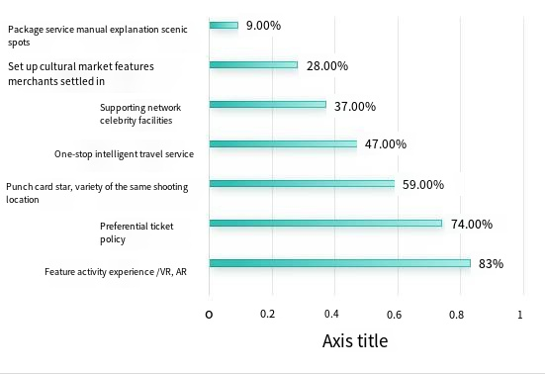

Concluding Remarks

In tandem with the establishment of a free trade port, it is imperative that Hainan bolsters its reform efforts and welcomes enhanced tourism progression. In contrast to previous models where each entity was solely responsible for its own operations, Hainan ought to amalgamate the province's diverse resources, substantial capital, and robust strengths under a centralized administration, thereby forming a provincial tourism "task force." This approach will enable us to collaborate effectively in addressing the complexities of the prevailing global scenario while fully utilizing the opportunities presented by the new free trade port and Hainan's distinctive cultural attributes. It is crucial to reinforce governmental oversight, enhance the tourism service framework, fortify the monitoring of the corporate marketplace, and propel Hainan's tourism sector to an elevated echelon. By integrating our unique regional culture into this process and crafting a distinct tropical island brand persona, we can significantly augment Hainan's GDP.

References
[1] Liu M & Meng K. 28 local third quarterly reports released, Hubei and Hainan GDP growth temporarily lead [N]. Securities daily, 2021-10-26 (A01.) DOI: 10.28096 / n.c. Nki NCJRB. 2021.004559.
[2] Zheng H M. The GDP of 11 key parks in Hainan accounts for 15.3% of the province [N]. Consumption daily, 2021-06-24 (how A02). DOI: 10.28866 / n.c. Nki NXFRB. 2021.001166.
[3] Kong C L, Li G H, Shi M, et al. [3] [KONG C L, LI G H, SHI M, et al.Forecasting Hainan GDP and its influencing factors based on GM(1,1) and principal component regression [J]. Mathematics in Practice and Understanding,2016,46(17):66-80.
[4] Kong C L, Li G H, Huang M T, et al. [4] [KONG C L, LI G H, HUANG M T, et al.Relationship between per capita GDP and three industries in Hainan based on Ridge regression [J]. Science and Technology and Industry,2016,16(06):42-46.]
[5] HUANG M T, Kong C L, Li G H et al. [5] [HUANG M T, KONG C L, LI G H, et al.Analysis and forecast of Hainan's per capita GDP based on summation autoregressive moving average model [J]. Modern Economic Information,2016(09):474.
[6] Kong C L, Huang M T, Shi M et al. Hainan GDP per capita prediction model based on autoregressive [J]. Journal of statistics and management, 2016 (02) : 34 and 35. DOI: 10.16722 / j.i SSN. 1674-537 - x. 2016.02.008.

