Study on the Allocation and Development of Tourism Resources in Sanya

Abstract:
Sanya, located in the southernmost part of Hainan Island, is a famous tropical coastal tourism city in our country. In the past 30 years since the establishment of the provincial special economic zone, Sanya has rapidly grown from a small border town to a tourism and leisure resort with high reputation and reputation. This paper will start from the resource allocation and development of Sanya's tourism industry to discuss the development status quo of Sanya's tourism industry, the existing problems and the corresponding liberation plan.

Present situation of Tourism in Sanya

Proportion of tourism GDP

Total tourism revenue statistics of Sanya from 2014 to 2022
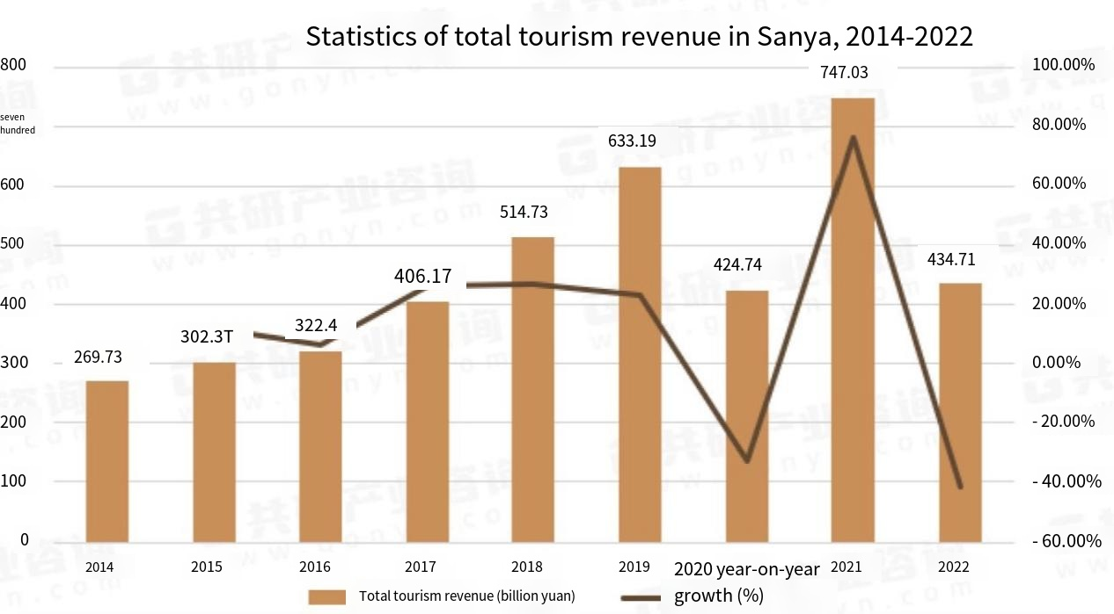

Tourism data of Sanya in 2023
In 2023, Sanya's tourism market continued to be hot, and the total revenue exceeded the pre-epidemic level: in the first quarter of 2021, the city received 7.5181 million overnight tourists, an increase of 33.2% over the previous year, and the growth rate was 72.4 percentage points higher than that of the previous year. Among them, the number of overnight domestic tourists reached 7.479,200, with a year-on-year increase of 33.5%; And 38,800 overnight inbound tourists, down 1.7 percent year on year. Total tourism revenue was 28.185 billion yuan, up 44.1 percent year-on-year and 85.9 percentage points faster than that of the whole of last year, with total revenue 1.5 times that of the same period in 2019. Among them, domestic tourism revenue reached 28.087 billion yuan, up 44.3 percent year-on-year; And the foreign exchange income from tourism was 14.298 million US dollars, down 7.3 percent year-on-year. Phoenix Airport handled 6.195,400 passengers, up 51.1 percent year on year. (Data from Sanya Bureau of Statistics)
Index name | Units | This month | January-july cumulative | Increase or decrease (%) from the same period last year
 |  |  |  | This month | Cumulative
1. Number of overnight visitors received | 10,000 Visitors | 166.89 | 1259.87 | 14.2 | 11.2
Overnight Domestic visitors | 10,000 Visitors | 159.79 | 1213.40 | 14.2 | 10.9
Tourist hotels | 10,000 Visitors | 113.99 | 881.74 | 2.1 | 2.9
Other tourist accommodation facilities | 10,000 Visitors | 40.21 | 292.46 | 78.6 | 47.6
Domestic cruise visitors | 10,000 Visitors | 0.002 | 0.051 | 360.0 | _92. 4
Day short rental tourists | 10,000 Visitors | 5.58 | 39.15 | -2.9 | 1.8
Overnight arrivals | 10,000 Visitors | 7.10 | 46.47 | 14.1 | 21.2
Inbound tourists from tourist hotels | 10,000 Visitors | 7.10 | 45.99 | 14.1 | 22.1
# Foreigners | 10,000 Visitors | 5.23 | 35.88 | 24.0 | 24.3
Taiwanese compatriots | 10,000 Visitors | 0.92 | 5.63 | -8.2 | 26.8
Macao compatriots | 10,000 Visitors | 0.14 | 0.48 | 34.5 | 37.3
Hong Kong compatriots | 10,000 Visitors | 0.81 | 3.99 | -9.7 | -0.6
Inbound international cruise visitors | 10,000 Visitors | 0.000 | 0.48 |  | -27.7
2. Total revenue from overnight tourism | Billion Yuan | 37.06 | 314.95 | 15.5 | 11.2
Domestic tourism revenue | Billion Yuan | 33.13 | 288.42 | 13.7 | 9.9
Foreign exchange income from tourism | $10,000 | 5933 | 40085 | 32.2 | 27.4
Average occupancy rate of tourist hotels | % | 65.50 | 70.57 | 0.9 | 0.4

(Tourism Data of Sanya City from January to July 2023)

Flight and passenger related data of Phoenix Airport
From July 1 to 31, 2023, Sanya Phoenix Airport secured 11,315 flights and transported 1.798 million passengers, up 7.6 percent and 18.3 percent year-on-year. Year-on-year growth of 15.5 percent and 18.4 percent respectively in 2019, setting the highest monthly record since the airport's opening. Sanya Phoenix Airport has been actively communicating and coordinating with airlines to optimize capacity allocation and route network by increasing frequencies and changing aircraft types, among which Sichuan Airlines and Beibu Gulf Airlines have encrypted flights between Chengdu Tianfu and Nanning respectively. Some airlines have optimized flights to key passenger destinations such as Beijing, Shanghai, Guangzhou, Shenzhen, Chongqing, Chengdu, Taiyuan, Nanjing, Hangzhou, Kunming, Xiamen and Hohhot. Since the new international terminal of the airport was put into use, international and regional routes to Sanya = Hong Kong, Sanya = Seoul and Sanya = Jakarta have been opened one after another, and the international and regional route network is constantly improving.

Related Attractions Information

Categories of Sanya Scenic Spots
Broad Categories | Medium Class | Unit name
Natural Resources class | Geography landscape class | Luhuitou Ridge, Hongxia Ridge, Aoshan Mountain, Dog Ridge, Jinji Ridge
Natural Resources class | Geography landscape class | Yalong Bay, Dadonghai Bay, Xiaodonghai Bay, Sanya Bay, Haitang Bay, Yulin Bay, Zhu Bay, Sun Bay, Sanmei Bay, Tianya Bay, Yazhou Bay, Kanyan Bay, Baali Bay, Baifu Bay, Lover Bay, Tianya Maling Silver Beach
Natural Resources class | Geography landscape class | Tianya Haijiao
Natural Resources class | Geography landscape class | Stone stalactite inside the Ligui Cave
Natural Resources class | Geography landscape class | Fossils of organisms in Liubi Cave
Natural Resources class | Geography landscape class | Stone boat, fairy ladder, stone horse, stone monkey, stone turtle, stone deer,  Banana Bed
Natural Resources class | Geography landscape class | Pen hole, big hole, small hole
Natural Resources class | Geography landscape class | West Island, Wuzhizhou Island, Phoenix Island, West MAO Island, East MAO Island, Wild Boar Island, Xiao Chau Island, East Chau Island, West Chau Island, Coconut Island, East Causeway Island, West Drum Island
Natural Resources class | Geography landscape class | Coral Reef (Northwest of Xizhou Island, south of Wuzhizhou Island), Shuanglian Shi (Open reef in the sea)
Natural Resources class | Water scenery category | Yalong River, Sanya River, Tengqiao River, Bepenang River, Dalong Reservoir
Natural Resources class | Water scenery category | Mangrove wetland
Natural Resources class | Water scenery category | Shenzhou Nantian First Spring, Zhujiang Nantian Hot Spring, Nantian Yiyang Hot Spring, Pastoral Hot spring,  Banling Hot Spring
Natural Resources class | Water scenery category | Yalong Bay Sea area, Dadonghai Sea area, Xiaodonghai Sea area, Sanya Bay Sea area, Haitang Bay Sea area, Yulin Bay Sea area, Zhuwan Sea area, Sun Bay Sea area, Sanmei Bay Sea area, Tianya Bay Sea area, Yazhou Bay Sea area, Kangqiu Bay Sea area, Bailiwan Sea area, Baifu Bay Sea area, Sun Bay Sea area, Lover's Bay Sea area, Tianya Haijiao, Big Dongtian, Little Dongtian, West Island, Wuzhizhou Island, Dongluo Island, Xilao Island and so on
Natural Resources class | Biolandscape classes | Sanya Bay Forest zone, Luhuitou forest zone, East/West MAO Forest zone, Nanshan Forest zone, Yalong Bay Forest zone, Ganshiling Forest zone
Natural Resources class | Biolandscape classes | Yuechuan Mangrove, Linchun Mangrove, Sanya River Mangrove
Natural Resources class | Biolandscape classes | Coconut, Casuarina, Tamarind Tree, Acacia macrophylla, Erythrina, Jiulixiang, Chicken tip, Dragon's Blood Tree, French loquat, FIG tree Macrophylla, Litchi, Huali, Agarwood, Longan, Slender Zi Dragon, Umo, Rooster's tail pine, small leaf FIG Tree, Tie School, Phoenix Tree, Qingpi, Hongnan, Hongluo, Youtan
Natural Resources class | Biolandscape classes | Tropical orchid planting base, Yunfeng Orchid Art Exposition Park, Longpo Village orchid base
Natural Resources class | Biolandscape classes | West Island, Wild boar Island, Wuzhizhou Island, Dongzhou Island tropical fish, coral and other habitats
Natural Resources class | Biolandscape classes | Sanya Bay Wildlife Park, Hengtai apiary
Natural Resources class | Biolandscape classes | Yalong Bay Butterfly Valley
Natural Resources class | Weather & Meteorology Class | Yalong Bay coastal cold resort, Dadonghai Cold resort, XiaoDonghai Cold resort, Bozhizhou Island cold resort, Luhuitou cold resort, Sanya Bay cold Resort, Haitang Bay cold resort
Cultural tourism resource category | Sites and relics category | The site of ancient human activity in the Stone Age of Luobidong
Cultural tourism resource category | Sites and relics category | Signzhen eastbound river landing, Huang Daozi flow landing, the southern end of the 11th Asian Games, the first stop of the 2008 Beijing Olympic Games domestic torch relay
Cultural tourism resource category | Sites and relics category | Yazhou Ancient City, eight people's sedan chair, Yacheng Academy, Yingwang Tower, Shengde Hall, Guangji Bridge, Wandai Bridge, Yalong Bay Dune site, Longwang Temple, Dadan Port, High Mountain kiln site, Guanguou, Gumin Village, Jiting Hot water pool, Yalong Bay ancient residential buildings, "Three Surname Yixue" Hall, Republic of China Street, Republic of China Pavilion architectural sample, Yalong Bay Dune Site, Qiongtian miners killed by the Japanese Army, Sun Family Ancestral Hall
Cultural tourism resource category | Buildings and facilities | Dadonghai Resort, Yalong Bay Resort, Nantian Hot Spring Resort, Wuzhizhou Island Resort, Banyan Tree Resort
Cultural tourism resource category | Buildings and facilities | Nanshan Temple, Mosque
Cultural tourism resource category | Buildings and facilities | Luhuitou Park, Sanya Bay Tropical Botanical Garden, Egret Park, City Paradise
Cultural tourism resource category | Buildings and facilities | Dadonghai Square, Nanshan Buddhist Culture Park, Sanya Museum of Nature
Cultural tourism resource category | Buildings and facilities | "Love World", Tropical Marine Zoo, Taling Plant Sightseeing Area
Cultural tourism resource category | Buildings and facilities | Universal Theatre, Urban Planning Hall, "Crown of Beauty" Guild Hall
Cultural tourism resource category | Buildings and facilities | Sunrise Sightseeing Golf Club, Yalong Bay Golf Club, Yalong Bay Red Canyon Golf International Club, Dadonghai International Golf Club, Luhuitou Golf Club, Hongtang Bay International Golf Club
Cultural tourism resource category | Buildings and facilities | Tianya Haijiao Stone Carvings, "Stone Boat Story", "Tour Size Dongtian Story", cliff stone carvings in Nanshan Scenic area
Cultural tourism resource category | Buildings and facilities | Ding Jian Zhong Gong also Jin Liao preface monument, Yacheng grass life martyrs monument, Cixi "longevity" character tablet
Cultural tourism resource category | Buildings and facilities | Dadonghai Square, Yalong Bay Square, Haiyue Square, Phoenix Square, Sports Square
Cultural tourism resource category | Buildings and facilities | Yalong Bay Architectural sketches, Sanya Bay architectural sketches, Totem sculpture Group
Cultural tourism resource category | Buildings and facilities | Tree HOUSE
Cultural tourism resource category | Buildings and facilities | Shopping streets: Jiefang Road Pedestrian Street, Jiefang Road, Yuejin Street, Commodity Street, Red Flag Street, First Farmers Market  Dining street: Sunshine Coast Food and Leisure Street, Jinjiling Street, Times Coast Bar Street, Dadonghai Bar Promenade
Cultural tourism resource category | Buildings and facilities | Liupan Village, Coconut Village, Xidao Fishing Village, Shuinan Village, Houhai Village, Penang Village, Tianya Li Miao Happy Valley, Luhuitou Romantic Garden, Sanya Li Village Miao Village, Wenmen New Socialist Countryside
Cultural tourism resource category | Buildings and facilities | Lin Zhitong former residence, He Bingli former residence, Ludosun Memorial Hall
Cultural tourism resource category | Buildings and facilities | Jingrun Pearl Museum, Sanya Hailun Pearl Science Museum

Statistics on the number of Class A and above scenic spots in Sanya from 2014 to 2022
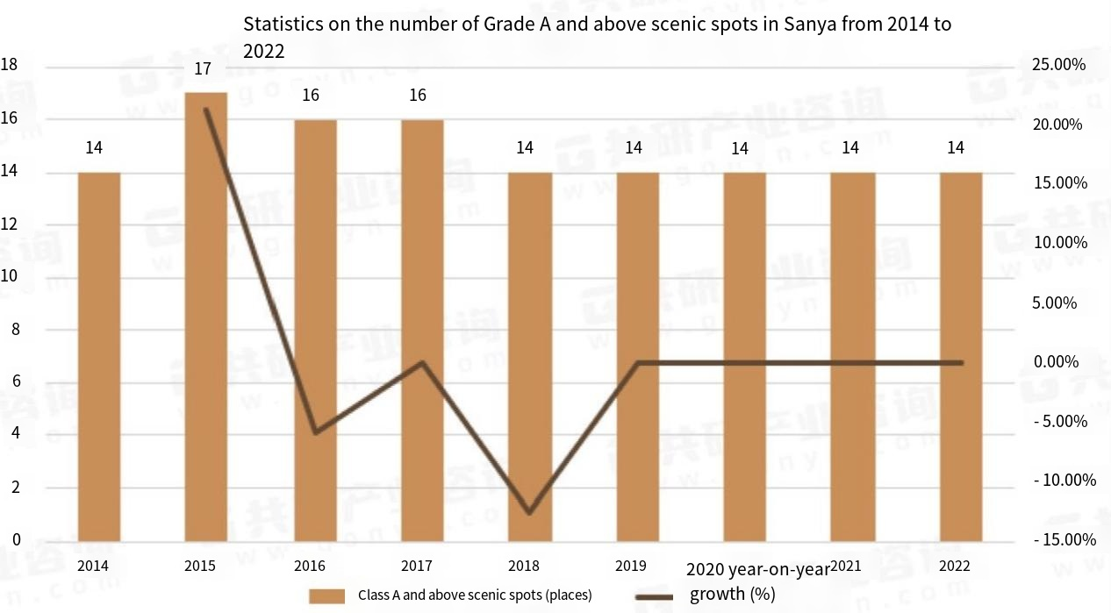

Tourist Information of Sanya

Visitor age
According to the Sanya Tourism Big Data Platform, middle-aged and elderly people over the age of 50 account for 21.3 percent of Sanya's inbound tourists. Young tourists aged between 18 and 35 account for 42.3%, and young tourists are the main consumer group in Sanya's tourism market.

Tourist Information
Tourists who chose a free tour accounted for 59.1 percent, up 15.23 percentage points year on year. In terms of the number of visits, the proportion of "repeat" tourists reached 64.8 percent, an increase of 13.29 percentage points year-on-year. In terms of the choice of travel mode after arriving in Sanya, the proportion of self-driving tour with rental car is the highest, reaching 24.5%, and the proportion of self-driving tour with own car is the second, accounting for 18.9%. In terms of travel purposes, leisure vacation accounts for the highest proportion, reaching 33.1%, followed by sightseeing and family reunion.

Tourist travel purpose
Among the top ten images of Sanya that attract tourists the most, the first is duty-free shopping; 58.2 percent of tourists said they would visit Sanya International Duty Free City.
In terms of leisure activities in the city, according to the sample survey of tourists, the top three are tasting seafood, visiting the night market and shopping malls/duty-free shops, accounting for 26.2%, 25.6% and 25.5% respectively. Other leisure activities, such as tasting Hainan cuisine/local snacks, soaking in hot springs, going to bars, and taking night cruises, were also prominent. In terms of night travel, night activities such as visiting night markets are the most popular leisure activities among tourists. In terms of sports and leisure travel, most tourists intend to choose sports and leisure items, among which diving accounted for 27.5% and surfing accounted for 24.3%, ranking the top two leisure sports.
While the content consumption of "non-scenic spots" is hot, Sanya scenic spots and rural tourism spots also show a recovery scene. A total of 919,700 tourists were received at 17 o 'clock from October 1 to 8, an increase of 1.24%. Major scenic spots have promoted secondary consumption through new projects and diversified activities. A sample survey of tourists shows that 57.5 percent of them intend to choose rural tourism, up from 47.17 percent in the same period last year. In terms of rural homestays, Sanya has 184 (excluding urban homestays and tourist rentals), with 4,409 rooms and about 7,000 beds. According to the sample survey, the average occupancy rate during the National Day Golden week is 84 percent.

Tourist travel preferences
According to the questionnaire, the following data are obtained:
- What kind of travel do you like?
- Plan ahead and execute it then
- We'll discuss it when we get there. Whatever you want
- Make a general plan and adjust it as you go
- 8. General leisure travel, vacation mode
- All here, in order to get to one more spot, accept the occasional special forces
- Young physical strength, special forces travel is no problem

- What kind of role do you usually play in traveling?
- A Guide
- Tourist Corpse
- Excuse me, I'm a tourist corpse that sometimes moves

- What is your preference for the tour route?
- Choose the mainstream route and punch in the hot spots
- Focus on popular spots, interspersed with niche spots
- Focus on niche attractions (not too commercial), supplemented by popular ones

Related supporting services
In the first quarter of 2023, the value added of the service sector (tertiary industry) increased by 9.5 percent year-on-year, 13.7 percentage points faster than the whole of the previous year. Among them, the added value of wholesale and retail industry, transportation and warehousing and postal industry, accommodation and catering industry and financial industry increased by 9.4 percent, 10.6 percent, 20.7 percent and 10.2 percent, respectively. The operating income of the service industry above designated size was 6.335 billion yuan, up 58.6 percent year on year and 84.9 percentage points higher than that of the whole of the previous year. Among them, the service industry of information transmission, software and information technology increased by 23.2 percent, and the service industry of leasing and business increased by 150.5 percent. The import and export of goods in the city grew, driven by the accelerated recovery of duty-free sales and a substantial increase in the export of mechanical and electrical products. In the first quarter, the total import and export of goods in the city was 8.057 billion yuan, an increase of 8.3% over the same period last year, and the growth rate was 9.8 percentage points higher than that of the whole year of last year. Among them, the import value was 7.366 billion yuan, up by 4.3 percent year-on-year; And the export value was 691 million yuan, up 85.9 percent year-on-year. (Data from Sanya Bureau of Statistics)

Hotel accommodation prices
The average consumption of overnight tourists at Sanya tourist accommodation facilities was 2446.86 yuan per person day, an increase of 439.86 yuan year-on-year; The average consumption of sojourning tourists was 198.64 yuan/person day, an increase of 30.64 yuan year-on-year; One-day tourists spent 1,251.05 yuan per person on average, an increase of 468.27 yuan year-on-year.

Transportation trips
Sanya means of transportation: bus, taxi, three-wheeled and two-wheeled motorcycles, rickshaws, bicycles.
- Public Transportation
Step fares. According to the query Sanya public transport network shows that the fare is segmsegmed (stepped fare), 2-12 yuan, most of the urban area is no one to brush the card, 2 yuan on the car, far point has manual ticket sales, up to 12 yuan, Sanya city has more than ten bus lines, operating time in the morning to 11 o 'clock.
- Taxi
Sanya taxis start at 11 yuan for a Class 1 car and 10 yuan for a class 2 car. After 2.5 kilometers of starting distance, Class 1 cars charge 2.4 yuan per kilometer and Class 2 cars charge 2.2 yuan per kilometer. Taxi fares in Sanya are roughly: Airport - Yalong Bay, 80-100 yuan one way, Yalong Bay - City: 25-40 yuan one way, Yalong Bay - Nanshan Temple: about 100 yuan one way, Yalong Bay - Tianya Haijiao: 60-70 yuan, Yalong Bay - Wuzhizhou: 50 yuan round trip, Dadonghai - Yalong Bay: about 40 yuan one way.

Ticket to the scenic spot
The location | Name of scenic spot | Ticket price (Yuan)
Sanya Bay | West Island | 95
Sanya Bay | Tianya | 0
Sanya Bay | The ends of the earth | 0
Sanya Bay | Nanshan Cultural Park | 103
Sanya Bay | Big and Small Dongtian | 0
Sanya Bay | Coconut Dream Promenade | 0
Dadongdong | Luhuitou | 0
Dadongdong | Mid-levels Peninsula Sailing Harbor | 0
Dadongdong | Kiqing Plaza, Mid-Levels Peninsula | 0
Dadongdong | Xiaodonghai Photography Base | 0
Yalong Bay | Momofuku
Yalong Bay | Rose Valley | 34
Yalong Bay | Underwater World | 230
Yalong Bay | Sun Bay Highway | 0
Yalong Bay | Yalong Bay Beach | 0
Yalong Bay | Paradise Forest Park | 158
Begonia Bay | Wuzhizhou Island | 133
Begonia Bay | Houhai Village | 0
Begonia Bay | Sanya International Duty Free City | 0
Begonia Bay | Atlantis Water World | 228
Begonia Bay | Atlantis Aquarium | 168
Begonia Bay | Haichang Dream Ocean City that never sleeps | 0
Other | Boundary Island | 122
Other | Penang Gok | 96
Other | Silly Island | 92
Other | Sanya through the ages | 280
Other | Phoenix Mountain Pledge | 96
Other | Ah Norda rain shower | 168

Existing problems of tourism in Sanya

Sanya's "rip-off" image has gained widespread popularity
Many businessmen just want to "kill a wave and say again", but do not want to do repeat customers, especially seafood shops, negative news frequently on the hot search, ruin the tourists' first impression of Hainan, naturally will not come again. Sanya, as a popular tourist city, has frequently appeared the phenomenon of "rippers" in recent years, and the high price makes tourists difficult to accept. This situation has triggered people's attention to the tourism market, and triggered the development of tourism industry, the rationality of prices and the protection of tourists' rights and interests.

High prices in Sanya
The price of goods in Sanya has always been the focus of tourists' concern. Although the price level is relatively low in China as a whole, the high level of consumption in Sanya, a tourist city, stands out. Even just a plate of vegetables can cost a lot of money, tourists said, while sea view rooms have soared in price, often costing thousands of yuan for fashionable accommodation. This has led some tourists to wonder if Sanya's tourism has gone to the other extreme and lost its original purpose of being close to the people. When they find high prices and unsatisfactory service at the destination, they become disappointed and dissatisfied with the experience. This arouses the emotional resonance of tourists and deepens their concern for their own rights and interests.

Related Solutions

Government policy

Stimulate consumption:
We will implement actions to promote consumption. Launch cultural travel vouchers to attract tourists from outside the island to Qiong and activate domestic consumption.

Launch tourism measures to benefit the people:
encourage tourist attractions to implement off-peak season promotional prices, encourage performing arts venues to implement time-limited discounts, implement Tianya Haijiao tourist area and other state-owned scenic spots free ticket policy, and gradually realize the "ticket economy" to "comprehensive consumption economy"; Launch promotional packages and themed activities such as islanders' special offers, graduation season activities, summer camps, etc., to guide and stimulate consumption.

Organize large-scale cultural activities:
Guide market players to hold high-quality large-scale tourism and cultural activities around various themes such as concerts, e-syllables, e-sports festivals, and art festivals.

Standardize the development of the tourism market:
strengthen the supervision and management of merchants and create a fair and reasonable consumer market.

Speed up the development of health tourism:
combining rich health tourism resources, focus on the development of natural health tourism, traditional Chinese medicine recuperation tour, hot spring recuperation tour.

Scenic spots themselves

Explore market demand:
The scenic spot mainly relies on traditional handicrafts, which are far from the modern lifestyle. These products can only be defined as tourist souvenirs, rather than real tourism cultural and creative products. Therefore, cultural and creative products in scenic spots eventually need to return to the potential demand of tourists. For example, for the inheritance of Li Jin culture, Li Jin souvenirs in scenic spots are large and expensive. We can consider producing small works such as Li Jin pendants to reduce their prices.

Creating scenic IP:
A good IP has the characteristics of less fungibility, greater stickiness, richer cultural content, more business models and stronger monetization ability. Whether the scenic IP is introduced or developed based on its own cultural heritage, IP culture should be the main tone, combining pop culture elements to create fashionable and interesting cultural creative products.

Improve scenic service:
improve the sanitary conditions of scenic spots, protect the natural ecological environment, improve the efficiency of related services, and reduce the phenomenon of long queues.

Combination of tourist routes

Urban routes. Urban tourist routes can be combined as follows:
- Haitang Bay - Wuzhizhou Island - Butterfly Valley - underwater world - Yalong Bay - Dadonghai - Luhuitou - Love world - West Island - the ends of the earth - Nanshan - the size of Dongtian - Yazhou Ancient City.
This route allows tourists to appreciate the whole of Sanya's famous scenic spots (points), so as to produce a comprehensive experience and understanding.
- Yazhou Ancient city - size Dongtian - Nanshan - Luhuitou - Sea egg family fishing village - coconut field and papaya style Garden.
This route highlights the history and culture of Sanya, allowing tourists to appreciate the unique cultural connotation of Sanya, thus producing a cultural recognition.
- Sun Bay Hong Kong Jockey Club venue - Dadonghai International Sailing Training Competition Base - Hedong District National Sports Winter Training Base - Sanya Bay Extreme Park - Dongluo Island Enterprise development base.
This route highlights the sports element of Sanya tourism, allowing tourists to appreciate the sports facilities and related events in Sanya, so as to meet their own corresponding needs.
- Dongluo Island-West Island-WestIsland, Dongzhou Island-Wuzhizhou Island.
The route takes the islands surrounding Sanya city as its destination, allowing tourists to get a taste of the ecological conditions and charming customs of the tropical island.
- Yalong Bay Golf Course - Red Canyon Golf Course - Hong Tong Bay Golf Course.
This route, with a tour of Sanya's unique golf courses as its main content, enables visitors to learn about golf and recognize Sanya's remarkable achievements in developing its golf leisure and resort industry.

References:
[1] With GDP growth of 8.6% year-on-year in the first half of the year, Hainan's economy has shown "quantity and quality progress" [N]. Business in China, 2023-07-25 (002). The DOI: 10.38304 / n.c. Nki NZGSB. 2023.001084.
[2] Li Mengyao. In the first half of the GDP grew by 8.6% year on year in hainan [N]. Hainan daily, 2023-07-20 (A01). DOI: 10.28356 / n.c. Nki NHLRB. 2023.003945.
[3] LI Lingxi. Hainan's GDP is expected to increase by 9.5%, and the closure operation is fully carried out [N]. Shanghai securities journal, 2023-01-14 (004). DOI: 10.28719 / n.c nki. NSHZJ. 2023.000202.

