Research on the Optimal Allocation of Sanya's Tourism Resources

ABSTRACT:This paper studies the optimal allocation of tourism resources in Sanya. Based on the analysis of the distribution and characteristics of various tourism resources in Sanya city, the best resource allocation scheme is determined by combining the needs of tourists and market demands. In this scheme, a variety of tourism resources are rationally matched to form a diversified and complete tourism product line. This way of resource allocation can attract more tourists to travel to Sanya and promote the development of local tourism economy. At the same time, the local natural environment and cultural heritage can be protected to the greatest extent and sustainable development can be achieved.
Keywords: Sanya tourism Resource allocation Sustainable development
1.Sanya Tourism Background
1.1.Government Policies
The full implementation of the Hainan Free Trade Port policy has brought new opportunities to Sanya's tourism, under the background of creating an international tourist destination, Sanya has launched the "Sanya International Tourist Destination Construction Plan",[1] dynamically planned 117 key projects, with a total investment of more than 138.5 billion yuan. By 2025, Sanya aims to become a leading domestic and international influential tourism destination. The government will actively promote the development of the tourism industry,[2]increase investment in tourism infrastructure construction, and enhance the competitiveness of Sanya as an international tourism destination.

1.2.Classification of Sanya Scenic Spots

broad heading | Minor defects | name of organization
Natural resources | Geography landscape class | Luhuitou Ridge, Hongxia Ridge, Aoshan Mountain, Dog Ridge, Jinji Ridge
Natural resources | Geography landscape class | Yalong Bay, Dadonghai Bay, Xiaodonghai Bay, Sanya Bay, Haitang Bay, Yulin Bay, Bamboo Bay, Sun Bay, Sanmei Bay, Tianya Bay, Yazhou Bay, Kanyan Bay, Baali Bay, Baifu Bay, Lover Bay, Tianya Maling Silver Beach
Natural resources | Geography landscape class | ends of the earth
Natural resources | Geography landscape class | Stone stalactite in the pen hole
Natural resources | Geography landscape class | Fossils of creatures in the cave
Natural resources | Geography landscape class | Stone boat, fairy ladder, stone horse, stone monkey, stone turtle, stone deer, plantain bed in small cave
Natural resources | Geography landscape class | Pen hole, big hole, small hole
Natural resources | Geography landscape class | West Island, Wuzhizhou Island, Phoenix Island, West MAO Island, East MAO Island, Wild Boar Island, Xiao Chau Island, East Chau Island, West Chau Island, Coconut Island, East Causeway Island, West Drum Island
Natural resources | Geography landscape class | Coral Reef (Northwest of Xizhou Island, south of Wuzhizhou Island), Shuanglianshi (offshore reef)
Natural resources | waterscape | Yalong River, Sanya River, Tengqiao River, Bepenang River, Dalong Reservoir
Natural resources | waterscape | mangrove wetland
Natural resources | waterscape | Shenzhou Nantian first spring, Pearl River Nantian hot spring, Nantian Yiyang hot spring, garden hot spring, Banling hot spring
Natural resources | waterscape | Yalong Bay Sea area, Dadonghai Sea area, Xiaodonghai Sea area, Sanya Bay Sea area, Haitang Bay Sea area, Yulin Bay Sea area, Zhuwan Sea area, Sun Bay Sea area, Sanmei Bay Sea area, Tianya Bay Sea area, Yazhou Bay Sea area, Kangqiu Bay Sea area, Bailiwan Sea area, Baifu Bay Sea area, Sun Bay Sea area, Lover's Bay Sea area, Tianya Haijiao, Big Dongtian, Little Dongtian, West Island, Wuzhizhou Island, Dongluo Island, West Causeway Island and so on
Natural resources | biolandscape | Sanya Bay forest belt, Luhuitou forest belt, East/West MAO forest district, Nanshan Forest district, Yalong Bay forest district, Ganshiling Forest district
Natural resources | biolandscape | Yuechuan mangrove, Linchun mangrove, Sanya River mangrove
Natural resources | biolandscape | Coconut, casuarina, Tamarind Tree, Acacia macrophylla, Erythrina, nine Lixiang, Chicken tip, Dragon's Blood Tree, French loquat, Banyan tree, Litchi, flower pear, Agarwood, Longan, Small Zi dragon, Umo, Rooster's tail pine, small leaf FIG tree, Tie School, Phoenix Tree, Qingpi, Hongnan, Hongluo
Natural resources | biolandscape | Tropical orchid planting base, Yunfeng Orchid Art Expo Park, Longpo village orchid base
Natural resources | biolandscape | West Island, wild boar Island, Wuzhizhou Island, Dongzhou Island tropical fish, coral and other habitats
Natural resources | biolandscape | Sanya Bay wildlife Park, Hengtai bee farm
Natural resources | biolandscape | Yalong Bay Butterfly Valley
Natural resources | Weather and meteorology | Yalong Bay coastal cold resort, Dadonghai cold resort, XiaoDonghai cold resort, Bozhizhou Island cold resort, Luhuitou cold resort, Sanya Bay cold resort, Haitang Bay cold resort
Cultural tourism resources category | ichnoidea | The site of ancient human activity in the Stone Age
Cultural tourism resources category | ichnoidea | Signzhen east river landing, Huang Daozi flow landing, the south end of the 11th Asian Games, the first stop of the 2008 Beijing Olympic Games domestic torch relay
Cultural tourism resources category | ichnoidea | Yazhou Ancient City, Eight people's Chair, Yacheng School Palace, Yingwang Tower, Shengde Hall, Guangji Bridge, Wandai Bridge, Yalongwan Sand Dune Site, Longwang Temple, Datan Port, High Mountain kiln site, Guanguou, Gumin Village, Jijting Hot pool, Yacheng ancient residential buildings, "Three Surname Yixue" Hall, Republic of China Street, Republic of China building sample, Yalong Bay Sand Dune Site, Qiongtian miners killed by the Japanese Army, Sun Family Ancestral Hall
Cultural tourism resources category | Buildings and facilities | Dadonghai Resort, Yalong Bay Resort, Nantian Hot Spring Resort, Wuzhizhou Island Resort, Banyan Tree Resort
Cultural tourism resources category | Buildings and facilities | Nanshan Temple, mosque
Cultural tourism resources category | Buildings and facilities | Luhuitou Park, Sanya Bay Tropical Botanical Garden, Egret Park, City Paradise
Cultural tourism resources category | Buildings and facilities | Dadonghai Square, Nanshan Buddhist Culture Park, Sanya Museum of Nature
Cultural tourism resources category | Buildings and facilities | "Love World", Tropical Marine Zoo, Taling Plant sightseeing area
Cultural tourism resources category | Buildings and facilities | Universal Theatre, Urban Planning Hall, "Crown of Beauty" guild hall
Cultural tourism resources category | Buildings and facilities | Sunrise Sightseeing Golf Club, Yalong Bay Golf Club, Yalong Bay Red Canyon
Cultural tourism resources category | Buildings and facilities | Golf International Club, Dadonghai International Golf Club, Luhuitou Golf Club, Hongtang Bay International Golf Club
Cultural tourism resources category | Buildings and facilities | Stone carvings of the ends of the Earth, "Stone Boat", "Tour size Dongtian", Nanshan scenic cliff stone carvings
Cultural tourism resources category | Buildings and facilities | Dingjian Zhong Gong also Jin Liao preface monument, Cliff city grass life martyrs monument, Cixi "longevity" character tablet
Cultural tourism resources category | Buildings and facilities | Dadonghai Square, Yalong Bay Square, Haiyue Square, Phoenix Square, Sports Square
Cultural tourism resources category | Buildings and facilities | Yalong Bay architectural sketches, Sanya Bay architectural sketches, totem sculpture group tree house
Cultural tourism resources category | Buildings and facilities | Shopping street: Jiefang Road Pedestrian Street, Jiefang Road, Yuejin Street, Commodity Street, Red Flag Street, the first farmers market
Cultural tourism resources category | Buildings and facilities | Dining Street: Sunshine Coast Food and Leisure Street, Jinji Ling Street, Times Coast Bar
Cultural tourism resources category | Buildings and facilities | Liupan Village, Coconut Village, West Island fishing village, Shuinan Village, Houhai Village, Penang Village, Tianya Li Miao Happy Valley, Luhuitou Romantic Garden, Sanya Li Village Miao Village, Wenmen new socialist countryside
Cultural tourism resources category | Buildings and facilities | Lin Jitong former residence, He Bingli former residence, Luduosun Memorial Hall
Cultural tourism resources category | Buildings and facilities | Jingrun Pearl Museum, Sanya Hailun Pearl Science Museum

1.3.Statistics on the Number of Sanya A-level Scenic Spots
By the end of 2022, Sanya had a total of 14 A-level or higher scenic spots, including 3 5A scenic spots, 5 4A scenic spots.
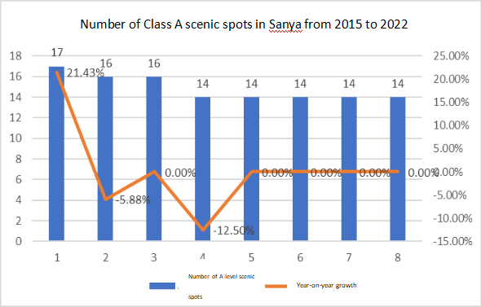

Fig. 1.Number of Class A scenic spots in Sanya from 2015 to 2022

1.4.Current Tourism Situation
In the whole year, the city received 25.71 million overnight visitors, an increase of 95.56% over the previous year. Among them, 25.41 million overnight domestic tourists, an increase of 95%; overnight inbound tourists 290,000, an increase of 159%. The total tourism revenue for the year was 89.664 billion yuan, an increase of 106.26%, of which domestic tourism revenue was 88.722 billion yuan, an increase of 105.59%; tourism foreign exchange income was 1.318202 billion US dollars, an increase of 172.45%.
Fig. 2. 2023 Sanya City overnight tourism reception statistics
2.Finding Problems
With the development of Sanya's tourism industry, there has been a severe imbalance between various tourist attractions in Sanya. During the National Day holiday,[3] popular scenic spots such as the Nanshan Cultural Tourism Area received 157,500 visitors, an increase of 994.59% over the same period last year, and the Tianya Haijiao Scenic Area received 101,200 visitors, an increase of 1876.38%. However, the flow of people to unpopular scenic spots was very bleak, such as the Red Detachment of Women Performing Arts Park (Sanya Silk Road Joy World) received 7,300 visitors, an increase of 152.97% over the same period last year. According to this data, it can be seen that resources between scenic spots have not been effectively allocated. According to several days of field research, it was found that these unpopular scenic spots have similar problems. [4]
2.1.Historically Significant Unpopular Scenic Spots Have Not Been Effectively Protected
These historically significant unpopular scenic spots have not been adequately protected, firstly, the government's lack of attention to cultural heritage protection is an important reason why scenic spots have not been effectively protected. When formulating policies and regulations,[5]the government often pays more attention to economic development and urban construction, while not giving enough attention to the protection of cultural heritage. This leads to a lack of in-depth understanding of the historical value of the scenic spots and insufficient investment in protection measures, which cannot effectively prevent damage to the scenic spots. Secondly, the lack of effective laws and regulations is also one of the reasons for the weak protection of scenic spots. In some places, the laws and regulations on the protection of cultural heritage are not well formulated and not implemented. Even if there are corresponding protection documents, due to the lack of effective law enforcement agencies or the weak supervision of relevant departments,[6]scenic spots still face the threat of damage and infringement. In addition, the pressure of land development is also a challenge to the protection of scenic spots. With the acceleration of urbanization, land resources are tense, developers and the government often pay more attention to the economic value of land, while ignoring the historical and cultural value of scenic spots. This has led some historically significant scenic spots to face the risk of being demolished, developed, or transformed, threatening their integrity and uniqueness.
2.2.Unpopular Scenic Spots Offer Unattractive Projects
Improvement Measures First of all, the projects in unpopular scenic spots lack uniqueness and attraction. In today's highly competitive travel market, tourists are more interested in experiencing unique, innovative and interesting projects. The projects provided by these rare scenic spots are the same as those in other places, lacking new ideas, and tourists may lack interest.[7]
At the same time, service quality is also an important factor affecting the attraction of scenic spots. If the project provided by the scenic spot has problems in terms of service and experience, such as inadequate tour guide service, outdated facilities,[8]chaotic management, etc., tourists may have a negative impression of the scenic spot and be reluctant to go again or recommend it to others.
2.3.The supporting facilities of the unpopular scenic spots are not perfect
2.3.1.Catering and rest facilities
Some scenic spots around the lack of restaurants, cafes, rest areas and other facilities, tourists in the tour can not easily enjoy the rest and dining services. [9]
2.3.2.Toilet facilities
The lack of sufficient quantity and quality of restrooms in rare scenic spots, or the uneven distribution of restrooms, has a certain impact on the comfort and convenience of tourists.
2.3.3.Guided Tours and information services
Rare scenic spots lack of guide maps, information boards, interpreters and other services to provide detailed information and guidance, tourists can not fully understand the history, culture and characteristics of scenic spots. [10]
2.4.Popular scenic spots lack certain publicity
First of all, because of its remote geographical location or inconvenient transportation, the difficulty and cost of tourists to go to the scenic spot is high. Therefore, these scenic spots are often not widely publicized, resulting in low visibility. Secondly, popular scenic spots lack professional publicity teams or resources. The role of the publicity team is very important, they can deeply dig the highlights and characteristics of the scenic spot, and disseminate these information through various channels. However, due to the limitations of financial and human resources, rare scenic spots are often unable to build a professional publicity team, or can not invest enough publicity resources. In addition, less popular scenic spots may lack tourism-related partnerships. Tourism related partners such as hotels, travel agencies, and tour guides can help little-known scenic spots improve their visibility and exposure through cooperative promotion. However, due to the lack of partners or the partnership is not close, the publicity channels of unpopular scenic spots are limited and can not be promoted more. [11]

3.improvement measures
3.1.The architectural culture of the unpopular scenic spot is further excavated
3.1.1Protect and rearrange buildings in unpopular scenic spots
The Sanya Municipal Government should effectively protect scenic spots with rich cultural resources, carry out planning and compilation, infrastructure upgrading and transformation, regular maintenance of buildings, and call on the public to refrain from leaving marks on buildings. [12] At the same time, the surrounding protection areas should also be fundamentally transformed, replanned, and layout, so that there is no strong sense of separation between the surrounding villages and the scenic spots but allow villages to blend into the scenic spots, letting the villages complement the scenic spots, such as the Lu Xun Former Residence, where villagers actively participate in the development of cultural products, integrating the cultural atmosphere of the Lu Xun Former Residence into fans, wood carvings, and other products. [13] Especially after Sanya closes its borders, there will be a large influx of people and capital into Hainan, which will also require a lot of commercial land. Therefore, the official can communicate with the surrounding residents for such scenic spots, similar to Yazhou Ancient City scenic spot, which can also be adapted to local conditions to achieve the integration of local village culture and scenic spot culture.

3.1.2.Further Develop the Culture of Unpopular Scenic Spots
Understanding the culture of a place is a tedious process, but today is an era of highly developed internet. We can create digital interactive scenic spots, just like the historical interactive videos on Bilibili, where tourists will personally play as a character in the local culture, clicking different options to experience different plot directions, and unlock different story endings. At the end of the video, Artificial Intelligence AI will personally give a brief evaluation of the tourists' choices. Tourists can choose to DIY the evaluation on fans or other peripheral products; or create a large-scale script murder, hiring staff to play NPCs, tourists can complete their tasks by communicating with staff or answering questions, and receive a fine gift at the end of the task.
1.7
Fig. 3.Interactive Video Data
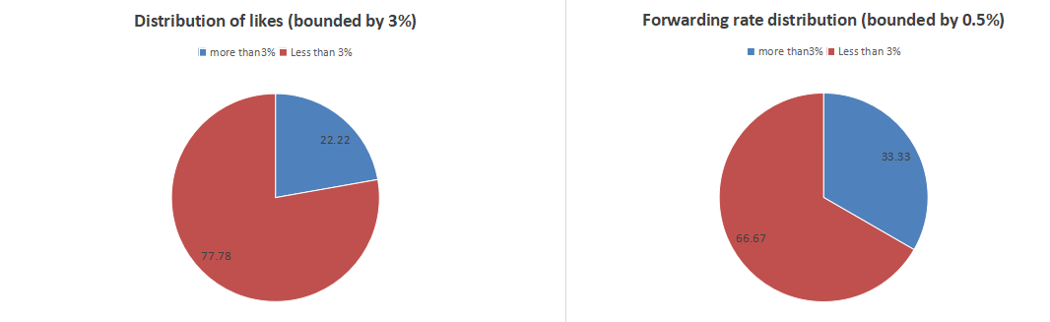

Fig. 4.Interactive Video Engagement Situation

3.1.3.Large Scenic Spots Drive Small Scenic Spots
Take Yazhou Ancient City as an example, which is close to Yazhou Bay Beach and Nanshan Cultural Tourism Area, and their travel routes are on the same road. Therefore, Yazhou Ancient City can be linked with Yazhou Bay Beach and Nanshan Cultural Tourism Area. Currently, the online ticket price for Nanshan Cultural Tourism Area is 122 yuan, so the local government can provide a certain travel subsidy for tourists visiting three scenic spots. This way, after tourists learn about the history and culture of Yazhou Ancient City, they can go to Yazhou Bay Beach for beach check-in and photos, and Yazhou Bay is the westernmost bay in Sanya, the best sunset viewing point in Sanya, so the Yazhou Bay scenic spot can also provide wedding photo shooting services for couples about to enter marriage; after finishing the tour of Yazhou Bay, tourists can go to Nanshan Cultural Tourism Area along the road. Therefore, this kind of scenic spot can inject fresh vitality into the scenic spot by driving small scenic spots through large scenic spots.

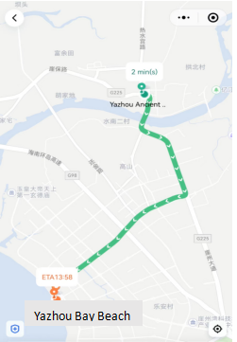
Fig. 5.Route Map

3.2.Innovative Play Projects
Tourists who come to Sanya are mainly aged 18-35, and they are very interested in innovative projects. Therefore, we can optimize resource allocation through the following measures.

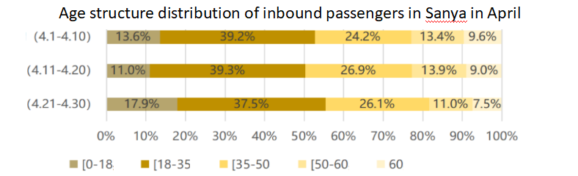
Fig. 6.Sanya Airport Passenger Age Structure Distribution in April 2023
3.2.1.Develop Unique Adventure Experiences
Unpopular scenic spots in Sanya may not be fully developed, and unique adventure experience projects can be developed in combination with the natural environment and characteristics of the scenic spots. For example, jungle adventures, cliff diving, mountain hiking, etc., are set up, allowing tourists to feel the thrill and challenge of adventure while ensuring safety.
3.2.2.Launch Cultural Experience Activities
Sanya has a rich cultural heritage, and cultural experience activities with characteristics can be launched in combination with the historical and cultural characteristics of unpopular scenic spots. For example, hosting traditional handicraft workshops, cultural performance exhibitions,[14] folk custom garden activities, etc., allowing tourists to deeply understand the history and culture of Sanya, increasing interactivity and participation.
3.2.3.Develop Eco-tourism Projects
Combining the beautiful natural environment of Sanya, eco-tourism projects can be launched, advocating sustainable development and ecological protection. For example, organizing beach cleaning activities, launching marine life protection experience projects, promoting eco-friendly travel methods, etc., allowing tourists to pay attention to environmental protection and sustainable development while playing.
3.2.4.Combine Technological Innovation and Interactive Experiences
Using technological innovation, design innovative interactive experience projects for unpopular scenic spots. For example, using augmented reality, virtual reality technology, creating immersive touring experiences; setting up interactive display areas, increasing tourists' participation; launching personalized guided tour services, providing personalized travel experiences.
3.2.5. Strengthen Leisure and Entertainment Facilities
Adding leisure and entertainment facilities in unpopular scenic spots to meet tourists' entertainment and leisure needs. For example, building viewing platforms, setting up children's playgrounds, setting up rest areas and cafes, etc., allowing tourists to enjoy comfort and entertainment while touring.
In conclusion, to innovate the play projects of Sanya's unpopular scenic spots, we can start from developing adventure experiences, launching cultural experience activities, developing eco-tourism projects, combining technological innovation, and strengthening leisure and entertainment facilities. By innovating and enhancing the attractiveness and experience of scenic spots, more tourists can be attracted to visit and enrich their travel experiences.

3.3.Strengthen the Construction of Supporting Measures
3.3.1 Improve Infrastructure Construction
Firstly, it is necessary to strengthen infrastructure construction, including road traffic, parking lots, toilets, rest areas, etc. Improve the convenience of transportation, enhance the convenience of tourist travel; increase the setting of toilets and rest areas to provide a comfortable rest environment for tourists; improve the planning and management of parking lots to solve the parking problem for tourists.
3.3.2. Enrich Dining and Accommodation Choices
Strengthen the construction of dining and accommodation facilities around unpopular scenic spots, providing diversified dining choices and accommodation services. Introducing local specialty restaurants, homestays, etc., allowing tourists to enjoy rich food and comfortable accommodation experiences around scenic spots.
3.3.3. Increase Guided Tour and Interpretation Services
Providing professional guided tour and interpretation services to increase the value of scenic spot tours. Training professional tour guide teams, developing multilingual guided tour services, providing rich explanations and interpretations to help tourists better understand the history, culture, and characteristics of scenic spots.
3.3.4. Launch Interactive Experience Projects
Designing interactive experience projects to increase tourists' sense of participation and experience effect. For example, setting up interactive display areas, experience zones, interactive science projects, etc., allowing tourists to participate in them, increasing their interactive experience and participation.
3.3.5. Strengthen Safety Guarantee Facilities
Strengthening the construction of safety guarantee facilities to ensure the safety of tourists. Setting up warning signs, safety fences, etc., in scenic spots, strengthening safety education and protection for tourists, improving tourists' sense of security.
3.3.6. Introduce Convenient Service Facilities
Adding convenient service facilities to meet tourists' daily needs. For example, providing convenience stores, ATM machines, charging facilities, children's facilities, etc., to meet various convenience needs of tourists.

4.Summary
In summary, the rational optimization and allocation of Sanya's tourism resources can only be achieved through the joint efforts of the government, scenic areas, and surrounding residents. The government needs to formulate corresponding support policies, and scenic areas must actively develop their tourism and cultural resources with the government's assistance. Different scenic areas also need to cooperate to develop differentiated marketing strategies and create both large and small-scale events. Additionally, the local residents should strive to showcase their village culture and promote Sanya's unique ethnic culture to the public, which will help achieve a reasonable optimization of Sanya's tourism resources.

Citation:
[1] Yu Mengmeng. Sanya unveils plan to build International Tourism resort [N]. China Securities Journal,2022-10-31(A06).
[2] Hu Yixin. The status quo, problems and countermeasures of the integrated development of "Big Sanya" tourism economic circle [J]. Commerce 2.0,2023,(05):42-44.
[3] Yang Fan. Analysis on the existing problems and countermeasures of tourism service management in Sanya Scenic area [J]. Modern Economic Information,2020,(03):27-29.
[4] Ren Chongxun, Wu Jiang. Investigation and analysis of tourism environment protection in Sanya [J]. Journal of Qiongzhou University,2011,18(02):30-32.
[5] Liu Zhiyu, Fan Hua, Luo Peixuan. Development path of Lu Xun's former Residence from the perspective of cultural resources protection [J]. Cultural Industry,2022,(12):33-35.
[6] Li Xue, Yang Hantao. Study on low-altitude tourism consumption behavior in Sanya under the background of free trade port: Influencing factors and policy response [J]. Western Tourism,2023,(23):34-36.
[7] Zhang Weiwei, Chen Wanting, Wang Ling. Research on evaluation and improvement of Sanya tourism logistics capability [J]. Business Economics,2024,(05): 23-26.
[8] Li Ying, Wen Ling. Ways to improve the quality of regional tourism statistics: Inspiration from Sanya [J]. Tourism Tribune, 2019,39(02):5-6. (in Chinese)
[9] Xiao Jianhong, Li Xiaosong. Study on the relationship between non-use value payment intention and household income level of Marine tourism resources: A case study of Zhoushan and Sanya [J]. Marine Economy, 2019,13(06):62-73.
[10] Cheng Wenbo. Research on countermeasures of smart tourism construction in Sanya City [J]. Western Tourism,2024,(03):17-18.
[11] Zhao Chenghuan. Study on tourism attraction of Internet celebrities' punch card spots in Sanya Tianya Town [J]. Cooperative Economy and Technology,2024,(02):63-64.
[12] Ling Xuan, Ma Yong, Ren Jie. Spatial and temporal evolution and formation mechanism of tourism and leisure industry in Sanya City [J]. World Geographical Research,2023,32(10):110-111. (in Chinese)
[13] Zhang Haoyu, Chen Lin. Integration of immovable cultural relics and reuse of tourism resources in Sanya City [J]. Cultural Industry,2023,(10):20-22.
[14] An Meng, Song Hongjuan. Study on the development of rural tourism in Sanya from the perspective of global tourism [J]. Shanxi Agricultural Economics,2023,(06):43-45.

