A Forecast Analysis of the Gold Stock Price

Abstract
This paper addresses the practical challenge of forecasting and analyzing gold stock prices, presenting insights on their impact. The proposed method involves data exploration, preprocessing, model building, tuning, prediction, evaluation, and result analysis to predict gold closing price trends for informed investment decisions. Data preprocessing includes cleaning and refining data by handling outliers and missing values to support subsequent model establishment. The time series model is selected in the model building stage with detailed explanation of the selection process. Suitable methods are chosen for model tuning to achieve optimal performance. The model is then used to forecast gold closing prices over the next four months and its performance is evaluated by comparing predicted results with actual outcomes. Finally, a comprehensive analysis combining gold shares, fundamentals, important industry factors affecting gold prices along with predictive modeling results reveals the value of gold in complex financial markets.

Key words: fundamentals; Time series; Forecasting; Preserving value

Introduction

The idea of gold stock price prediction
The price of gold is symbolically important in the field of economy and finance, and it is widely seen as an important index of the health of the global economy and market sentiment. Gold's share price, which corresponds to the price of gold, is positively correlated, and the price of gold has a real link to the U.S. dollar. Money itself has no value, with its directly with gold exchange quantity is given a monetary value. Before the collapse of the bretton woods system, the dollar is equal to the status of gold, the vast majority of countries have adopted the gold standard in the world, the issue of the currency amount on its store of gold weight as collateral; After the collapse of the bretton woods system, the dollar peg with gold, but to a certain extent, to replace the position of gold, in the age of dollar hegemony is general national credit currencies, then the price of gold is inversely proportional to the dollar, dollar is strong, weak or gold dollar weak, jin-qiang huang.

Today's gold price is contrary to this rule, due to the hegemony of the United States, the dollar harvest of the world for many times, countries suffering, the decentralization of currency gradually expanded, the relationship between the dollar and gold weakened, due to the accelerated depreciation of the world currency, it is speculated that people will buy a large number of gold in order to preserve wealth, resulting in the rise of gold prices, gold stock prices. The price of gold will be affected by policy guidance, the crowd preferences, war, social factors and international factors, the influence of natural factors and the market situation. Gold market price trend is not only can reflect through the stock market, also can be controlled by individual gold business enterprise of the company's share price trend reflected, in particular, shares the most affected by the enterprise the company's business situation, that is to say, people demand for gold, is to determine the decisive factors in gold shares. Through the analysis of the fundamentals of gold stock, using data analysis software for each period of stock price analysis, calculation to predict the next period of the shares, as the basis of gold price forecast analysis. Through the visual analysis of the gold price indicators, cleaning frequency after the data analysis and time series analysis, reveals the science changes under the objective factors analysis, provide a reference basis for the investors.
According to statistics, in the 40 years from 1978 to 2018, the increase of gold only tripled. In the era of dollar hegemony, heavy gold was a losing proposition, as the dollar credit system collapse, silicon valley bank BaoLei, Evergrande filed for bankruptcy, a variety of uncertain factors, sweeping through the global economy, gold hedging function gradually. Combined with the precious gold resources scarcity, gold handicrafts and beautiful love, policy interest rates, in the face of sluggish investment environment, investment gold became a feasible path, certainly will absorb a lot of money, cause gold price rise. Prices in the price of gold is not only a commodity market, but also a complex signal, covers the global economic, political and market sentiment, and many other factors. Therefore, analysis of gold price in understanding global economic conditions and investment strategy is of great significance.

Factors affecting gold stock prices
Gold price affected by many factors, these factors include the macro economy and financial markets, geopolitics and industry, and other aspects. Gold's share price and the price of gold itself influence, in perfectly valid market, gold shares is a true reflection of the value of gold. Gold shares positively related with gold, gold rising value of gold shares will no doubt have a positive impact, positive in the gold market.

Global economic conditions will produce very big effect on the gold price. BaoLei silicon valley bank, for example, Evergrande filed for bankruptcy hit people's confidence in the current economic situation, when investors perceive economic instability, risk-averse investors tend to seek safe havens, while gold is precisely their of choice, with a global currency.

Dollars before the collapse of the bretton woods system with equivalent to gold status, the value of the dollar is often the value of gold, gold and dollar exchange rate is fixed, which is the gold standard. And after the collapse of the bretton woods system, gold prices began to float, its price is determined by international market supply and demand, in addition, investors will also receive the supply and demand, geopolitics, the influence of such factors as inflation expectations, lead to fluctuations in the price of gold had increased. Holding the dollar value of attitude change in different countries of the world, the internationalization of currency types increase, holding gold is the right thing to do, can be any monetary credit collapse, but gold is absolutely not, and the ability to change any of a country's currency.

Inflation is a natural factor. As an asset against inflation, the trend of gold price is positively correlated with the inflation rate. Inflation is rising too fast, beyond the expectations of investors, investors for gold stocks, derivatives and other financial products, investment will increase.

The interest rate policy as an indicator of social investment, have an effect on gold price also. In general, the market interest rates rise, which is beneficial to the increase of the final value, market investors are more willing to hold an asset and interest to reduce does not produce the balance of interest, such as gold stocks demand, combining with the current market interest rate cut, a lot of money into the society, is bound to promote investment, securities, stock gold stock is part of the capital inflows, guide the gold price increases.

Regional conflicts to market signal is not stable, affected the exchange rates between countries are often violent change, a large number of the existence of arbitrage behavior will make part of the assets of the investors suffer losses, so when geopolitical risk occurs, high risk averse investors tend to be more safe havens of gold, and because of money flowing into the gold market, gold prices will rise.

In circulation amount of gold is also the important factors that affect the price of gold, gold reserves on earth big mining cost is high, but the United States geological survey, according to data released now available for mining global reserves of about 53000 tons of gold resources, which has proven reserves of 33000 tons of gold. Even in today's developed science and technology, the exploration and mining of gold resources is still a difficult, high investment, high cost enterprise. The amount of gold circulating in the market is limited, even if there is one

Rich reserves but due to high mining costs and handicrafts processing fees and other value-added behaviors, will also lead to the rise of gold value, exquisite technology with better value and quality preservation characteristics, gold stock price will also rise.
The professionalism of securities practitioners will also have a certain impact on the gold stock price, and the words of a senior expert are bound to guide the trend of gold stock price. Subjective point of view of professional securities practitioners, equipped with computer equipment, the data analysis ability and so on influence of judgment of gold shares, also affect the investors' psychology and market trends, gold price have a certain impact on the short term.

Gold's share price influence the dynamic of the industry, are the most fundamental of gold in the industry dynamics, industry peer competition will suppress the price of gold, in different parts of the mining laws and regulations, cause the price of gold is different in different areas of the technology innovation, different companies of gold price will be different, gold plate's share price volatility in Shanghai stock exchange less affected by the industry, Before the great breakthrough in technology, the fluctuation can be ignored.

Data analysis of gold stock prices
Since the trend prediction of gold stock price does not conform to linear regression, the time series prediction of nonlinear regression is used. Firstly, the paper makes a visual analysis of each index of gold stock price, and clarifies the fluctuation trend of each index.

(1) Visual analysis
Figure 1: Visualization of the stock price trend of Open
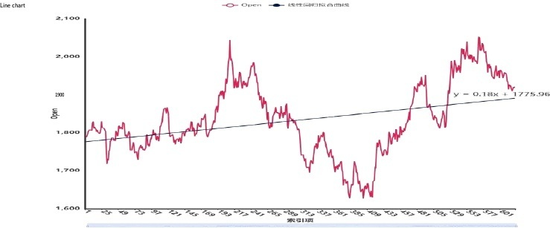
Figure 2: Visualization of High stock price trend
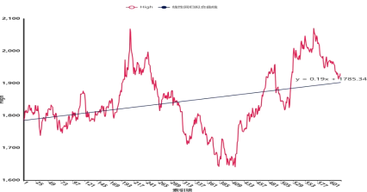

Figure 3: Low stock trend visualization
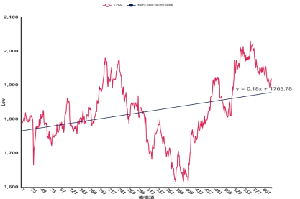
Figure 4: Close stock trend visualization
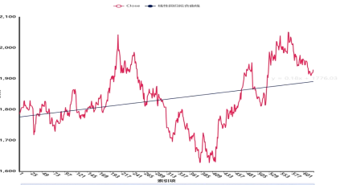
Figure 5: Change(pips) trend visualization
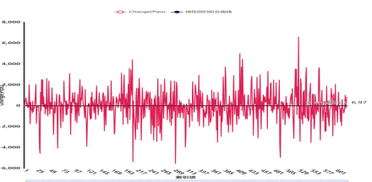
Figure 6: Area plot of Change(pips)
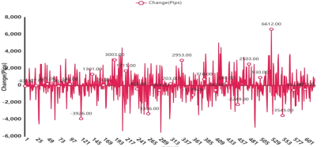

Figure 7: Change(pips) violin diagram
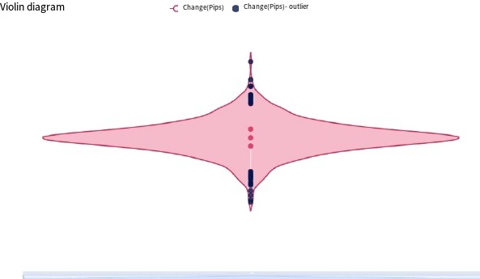
Figure 8: Box plot of Change(pips)
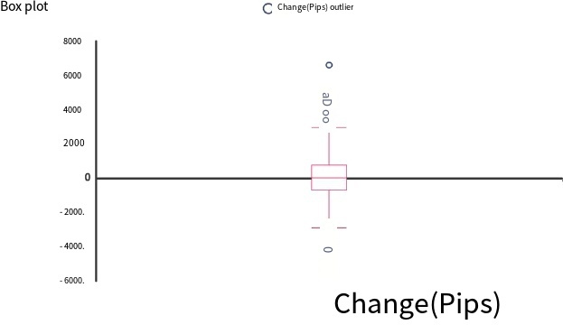
Figure 9: Close Actual forecast Q-Q plot
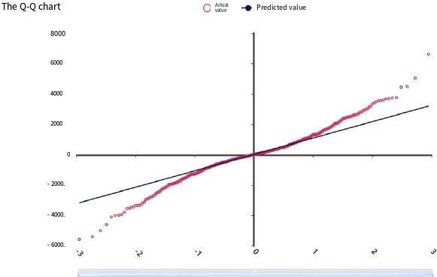
Figure 10: Close Actual forecast P-P plot
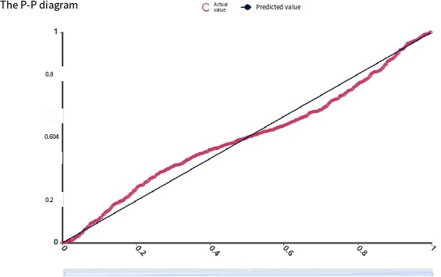
Secondly, for the cleaning after analyzing frequency data, to locate gold shares most likely settles range.

(Figure 11) Frequency analysis
import pandas
from spsspro.algorithm import descriptive_analysis
# Generate case data
data = pandas.DataFrame({ "A": [1, 2, 3, 4, 5], "B": [10, 20, 30, 40, 50], })
print(descriptive_analysis.frequency(data))

Table 1: Results of frequency analysis
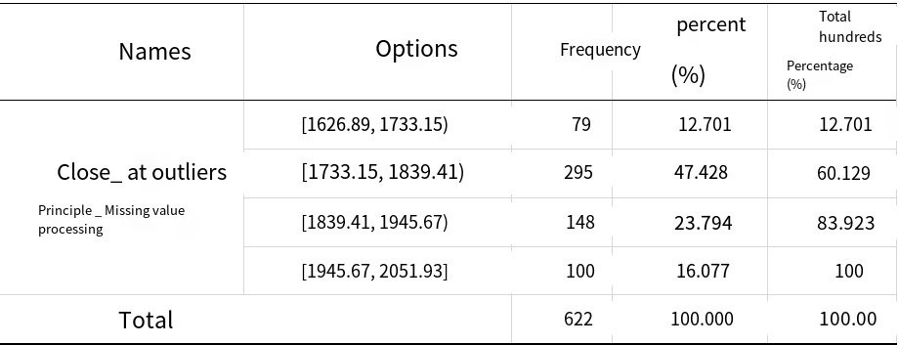

Figure 12: Frequency analysis diagram
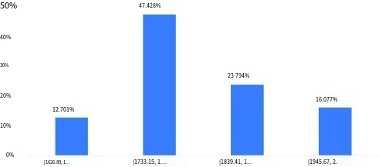
Illustration of the chart:
The table above shows the results of frequency analysis, including variables, frequencies, percentages, etc. The price of gold is most likely to fall between 1733.15 and 1839.41 after a shock.

Smart Analysis:
By Close_ outliers treatment _ missing value frequency analysis results show that: [1626.89, 1733.15) frequency for 79, the percentage of 12.701%; [1733.15, 1839.41) frequency for 295, the percentage by 47.428%; [1839.41, 1945.67) frequency for 148, the percentage by 23.794%; [1945.67,2051.93] frequency was 100, accounting for 16.077%.
The [1733.15, 1839.41), the highest (47.428%), [1626.89, 1733.15) (12.701%), minimum.
Finally, the same data after cleaning for time series analysis (ARIMA), intended to find the variation, features of the gold price in time.

(3) the time series analysis
Run the code:
import numpy
import pandas
from spsspro.algorithm import statistical_model_analysis
# Generate case data
data = pandas.DataFrame({ "A": numpy.random.random(size=20) })
result = statistical_model_analysis.arima_analysis(data=data, p=0, d=0, q=0, forecast_num=10) print(result)

analysis result：
Time series analysis (ARIMA) is based on a number of historical period, according to data to forecast the future period: the model of optimal fitting degree R squared is 0.976, model performance is good. Prediction of the future 120 were 1929.880692431562, 1930.111384863124, 1930.3420772946859, 1930.5727697262478, 1930.8034621578097, 1931.0341545893716, 1931.2648470209335, 1931.4955394524954, 1931.7262318840574, 1931.9569243156193, 1932.1876167471812, 1932.4183091787431, 1932.649001610305, 1932.879694041867, 1933.110386473429, 1933.3410789049908, 1933.5717713365527, 1933.8024637681146, 1934.0331561996766, 1934.2638486312385, 1934.4945410628004, 1934.7252334943623, 1934.9559259259242, 1935.1866183574862, 1935.417310789048, 1935.64800322061, 1935.878695652172, 1936.1093880837338, 1936.3400805152958, 1936.5707729468577, 1936.8014653784196, 1937.0321578099815, 1937.2628502415434, 1937.4935426731054, 1937.7242351046673, 1937.9549275362292, 1938.1856199677911, 1938.416312399353, 1938.647004830915, 1938.8776972624769, 1939.1083896940388, 1939.3390821256007, 1939.5697745571626, 1939.8004669887246, 1940.0311594202865, 1940.2618518518484, 1940.4925442834103, 1940.7232367149722, 1940.9539291465342, 1941.184621578096, 1941.415314009658, 1941.64600644122, 1941.8766988727818, 1942.1073913043438, 1942.3380837359057, 1942.5687761674676, 1942.7994685990295, 1943.0301610305914, 1943.2608534621534, 1943.4915458937153, 1943.7222383252772, 1943.9529307568391, 1944.183623188401, 1944.414315619963, 1944.6450080515249, 1944.8757004830868, 1945.1063929146487, 1945.3370853462106, 1945.5677777777726, 1945.7984702093345, 1946.0291626408964, 1946.2598550724583, 1946.4905475040202, 1946.7212399355822, 1946.951932367144, 1947.182624798706, 1947.413317230268, 1947.6440096618298, 1947.8747020933918, 1948.1053945249537, 1948.3360869565156, 1948.5667793880775, 1948.7974718196394, 1949.0281642512014, 1949.2588566827633, 1949.4895491143252, 1949.7202415458871, 1949.950933977449, 1950.181626409011, 1950.4123188405729, 1950.6430112721348, 1950.8737037036967, 1951.1043961352586, 1951.3350885668206, 1951.5657809983825, 1951.7964734299444, 1952.0271658615063, 1952.2578582930682, 1952.4885507246302, 1952.719243156192, 1952.949935587754, 1953.180628019316, 1953.4113204508778, 1953.6420128824398, 1953.8727053140017, 1954.1033977455636, 1954.3340901771255, 1954.5647826086874, 1954.7954750402494, 1955.0261674718113, 1955.2568599033732, 1955.4875523349351, 1955.718244766497, 1955.948937198059, 1956.1796296296209, 1956.4103220611828, 1956.6410144927447, 1956.8717069243066, 1957.1023993558686, 1957.3330917874305.
Analysis steps:
- ARIMA model sequence meet stationarity, view the ADF test results, according to the analysis of t value, whether can analyze its significance in refusing to sequence is not smooth hypothesis (P < 0.05).
- Check the difference before and after data contrast figure, determine whether smooth (modest) fluctuates up and down, and at the same time to the time sequence
- Column (autocorrelation analysis), according to the truncation situation estimate the p, q value.
- ARIMA model requires models have pure randomness, namely the model residuals for white noise, the inspection table view model, according to the P value of the Q statistic (P > 0.05) for the test in the white noise, can also be combined with information criterion AIC and BIC value analysis (the lower the better), Can also through the model residuals ACF/PACF were analyzed according to the model parameter table, draw a model formula of comprehensive analysis with time series analysis, the backward prediction order results.

Table 2 : ADF test table
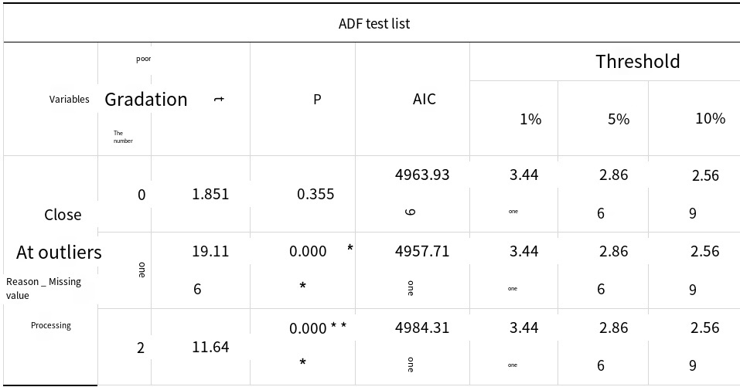
Note: ***, ** and * represent significance levels at 1%, 5% and 10%, respectively

The graph illustrates:
The above table shows the results of the ADF test, including variables, difference orders, t-test results, and AIC values, which are used to test whether the time series is stationary.
- The model requires that the series must be stationary time series data. By analyzing t value, we analyze whether it can significantly reject the null hypothesis that the series is not stationary.
- If the present significant (P < 0.05), then reject the null hypothesis, the sequence as a stationary time series, vice versa Shows the sequence of a stationary time series.
- Comparing the statistical value of the null hypothesis with the ADF Test result at the critical values of 1%, 5% and 10%, the ADF Test result is less than 1%, 5% and 10%, indicating that the hypothesis is very well rejected.
- Difference order: in essence, it is the next value, minus the previous value, mainly to eliminate some fluctuations and make the data tend to be stable. Non-stationary series can be transformed into stationary series by difference transformation.
- 5.AIC value: a standard to measure the goodness of statistical model fit, the smaller the better.
- The critical value, the critical value is corresponding to a given significant levels of fixed value. Intelligent analysis:
The results of this sequence test show that based on the variable close_outlier treatment _ missing value treatment:
- When the difference of zero order, significant P value is 0.355, don't show significant level, cannot reject the null hypothesis, the sequence is not stationary time series.
- When the difference is 1 order, significant P value is 0.000 * * *, level is significant, reject the null hypothesis, the sequence as a smooth time series.
- When the difference of 2 order, significant P value is 0.000 * * *, level is significant, reject the null hypothesis, the sequence as a smooth time series.

Figure 13: best difference sequence diagrams
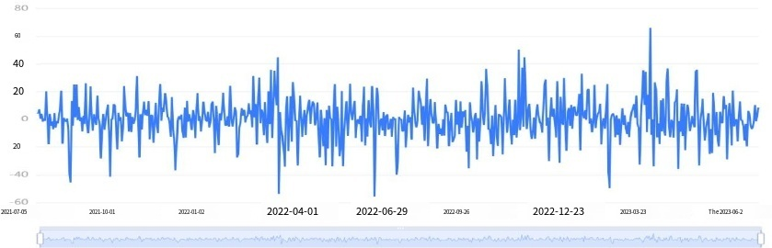
Illustration: The figure above shows the timing diagram after the first difference of the original data.

Figure 14: Autocorrelation plot of final difference data (ACF)
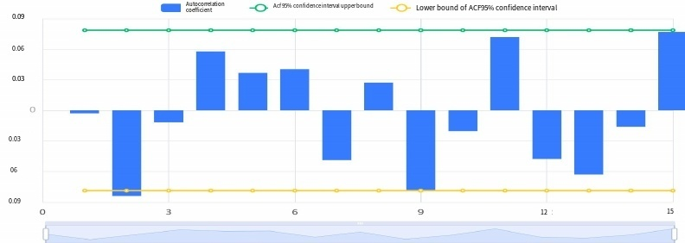
Illustration of the chart:
The figure above shows the autocorrelogram (ACF), including the coefficients, upper and lower confidence limits.
- The horizontal axis represents the number of delay, the vertical axis represents the correlation coefficient.
- The autocorrelation (ACF) figure in q order truncation, partial autocorrelation (PACF) figure trailing, ARMA model can be simplified as MA (q)
Model.
- If both autocorrelation and partial autocorrelation graphs are lagged, the most significant order (minimum) in PACF and ACF graphs can be combined as p and q values.
- If the autocorrelation and partial autocorrelation figure are truncated, can choose to replace the higher difference, or are not suitable for ARMA model is set up.
- The truncation is within the confidence interval, ACF or PACF after an order is identical to zero (or random fluctuations near zero).
- The tail is within the confidence interval, ACF or PACF always has a non-zero value, is not present in a certain order after is identical to zero (or random fluctuations near zero).

Figure 15: the final difference data of partial autocorrelation figure (PACF)
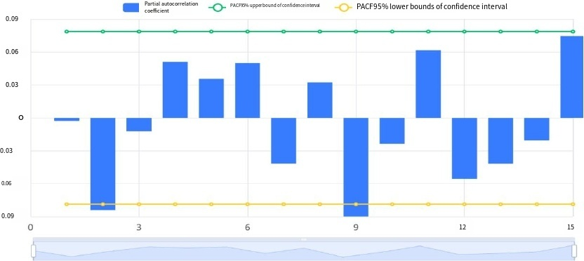
Illustration of the chart:
The picture above shows the partial autocorrelation figure (PACF), including the coefficient, maximum confidence and confidence lower limit.
- partial autocorrelation (PACF) figure in the truncation order p, autocorrelation (ACF) figure trailing, ARMA model can be simplified as AR (p) model.
- If the autocorrelation and partial autocorrelation figure trailing, can be combined with PACF, ACF figure of one of the most striking order (minimum) as p and q value.
- If the autocorrelation and partial autocorrelation figure are truncated, can choose to replace the higher difference, or are not suitable for ARMA model is set up.
- The truncation is within the confidence interval, ACF or PACF after an order is identical to zero (or random fluctuations near zero).
- The tail is within the confidence interval, ACF or PACF always has a non-zero value, is not present in a certain order after is identical to zero (or random fluctuations near zero).

Table 3: Model parameters table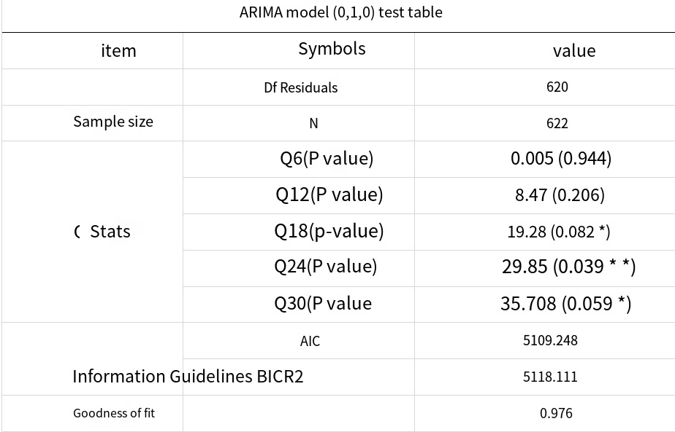
Note: * * *, * *, *, respectively 1%, 5% and 10% significance level
Illustration:
The table above shows the results of this model test, including the number of samples, degrees of freedom, Q statistics and the goodness of fit of the information criterion model.
1. ARIMA model for residual error of the model does not exist since the correlation, namely the model residuals for white noise, the inspection table view model, according to the P value of the Q statistic (P value is greater than 0.1 for white noise) for the test in the white noise.
2. According to the information criterion AIC and BIC values used in the model of multiple analysis contrast, the lower the better).
3. R squared represent the fitting degree of time series, the close to 1, the better the results.
Intelligent analysis:
Information system based on the AIC criterion automatically search the optimal parameters of the model results for ARIMA model (0, 0) test table, based on the variables: Close_ outliers treatment _ missing value, from the Q statistic results can be obtained: Q6 is not present significant level, can't refuse to model the residuals for white noise sequence of hypothesis, goodness of fit of the model at the same time R squared is 0.976, fine model, model of basic meet the requirements.

Figure 16: model residual autocorrelation figure (ACF)
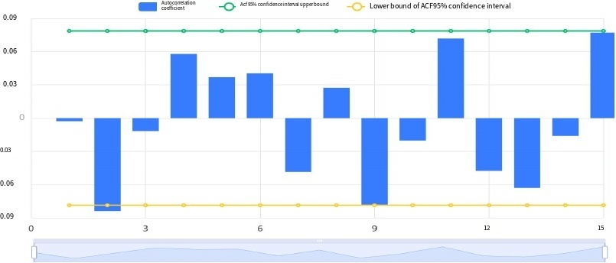

Illustration:
The figure above shows the residual autocorrelogram (ACF) of the model, including the coefficients, upper and lower confidence limits.
1. The horizontal axis represents the number of delay, the vertical axis represents the correlation coefficient.
2. If the correlation coefficient of both within the dotted line, autoregressive (AR) model residuals for white noise sequence, time series model residuals to white noise sequence.

Figure 17: Partial Autocorrelation Plot of Model Residuals (PACF)
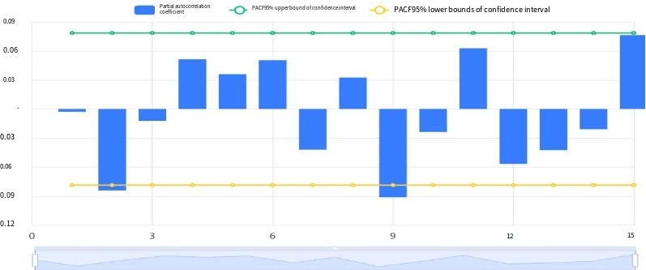
Illustration of the diagram:
The picture above shows the residual error of the model of partial autocorrelation figure (PACF), including the coefficient, maximum confidence and confidence lower limit.
If the correlation coefficients are all within the dotted line, the moving average model (MA) residual is a white noise series, and the time series requires the model residual to be a white noise series.

Table 4:

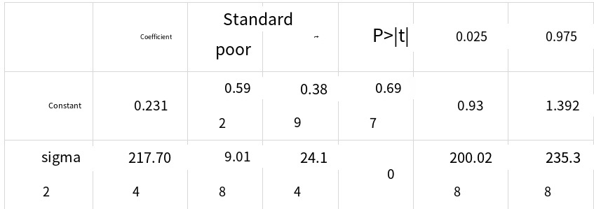
Note: ***, ** and * represent significance levels at 1%, 5% and 10%, respectively
Illustration of the chart:
The above table shows the model parameter results, including the model coefficient, standard deviation, T test results, etc., which are used to analyze the model formula.
Intelligent analysis:
Based on the variable close_outlier processing _ missing value processing, the system automatically finds the optimal parameters based on AIC information criterion. The model results are ARIMA model (0,1,0) test table, and the model formula is as follows:
Y (t) = 0.231
Figure 18: Time series plot
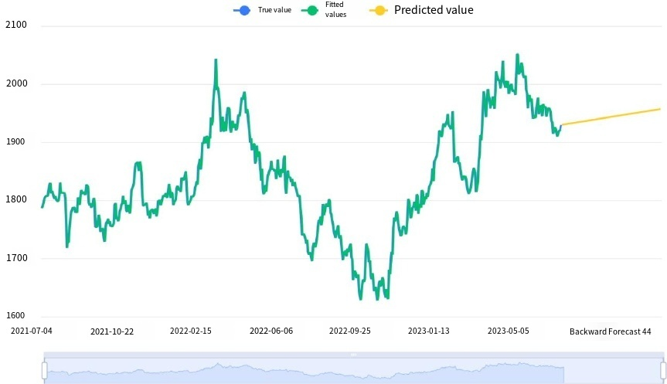
Illustration of the chart:
The figure above shows the original data plot of the time series model, the model fitting value, and the model prediction value.

Table 5: Time series prediction table
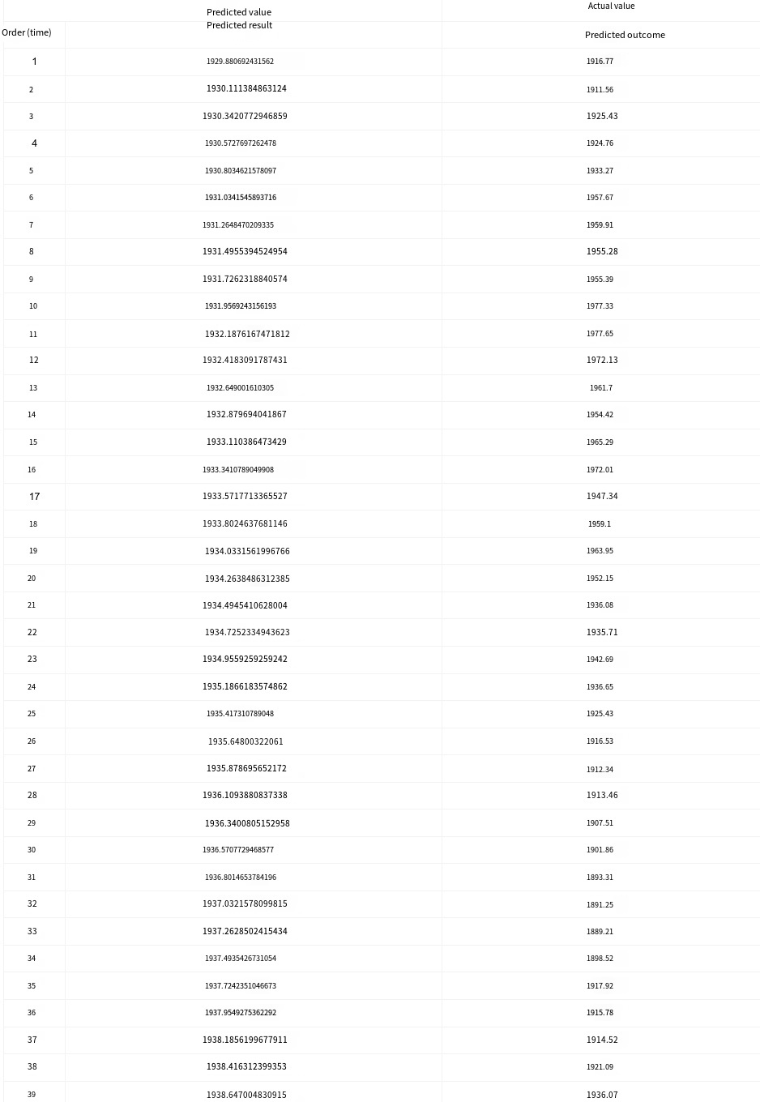
17

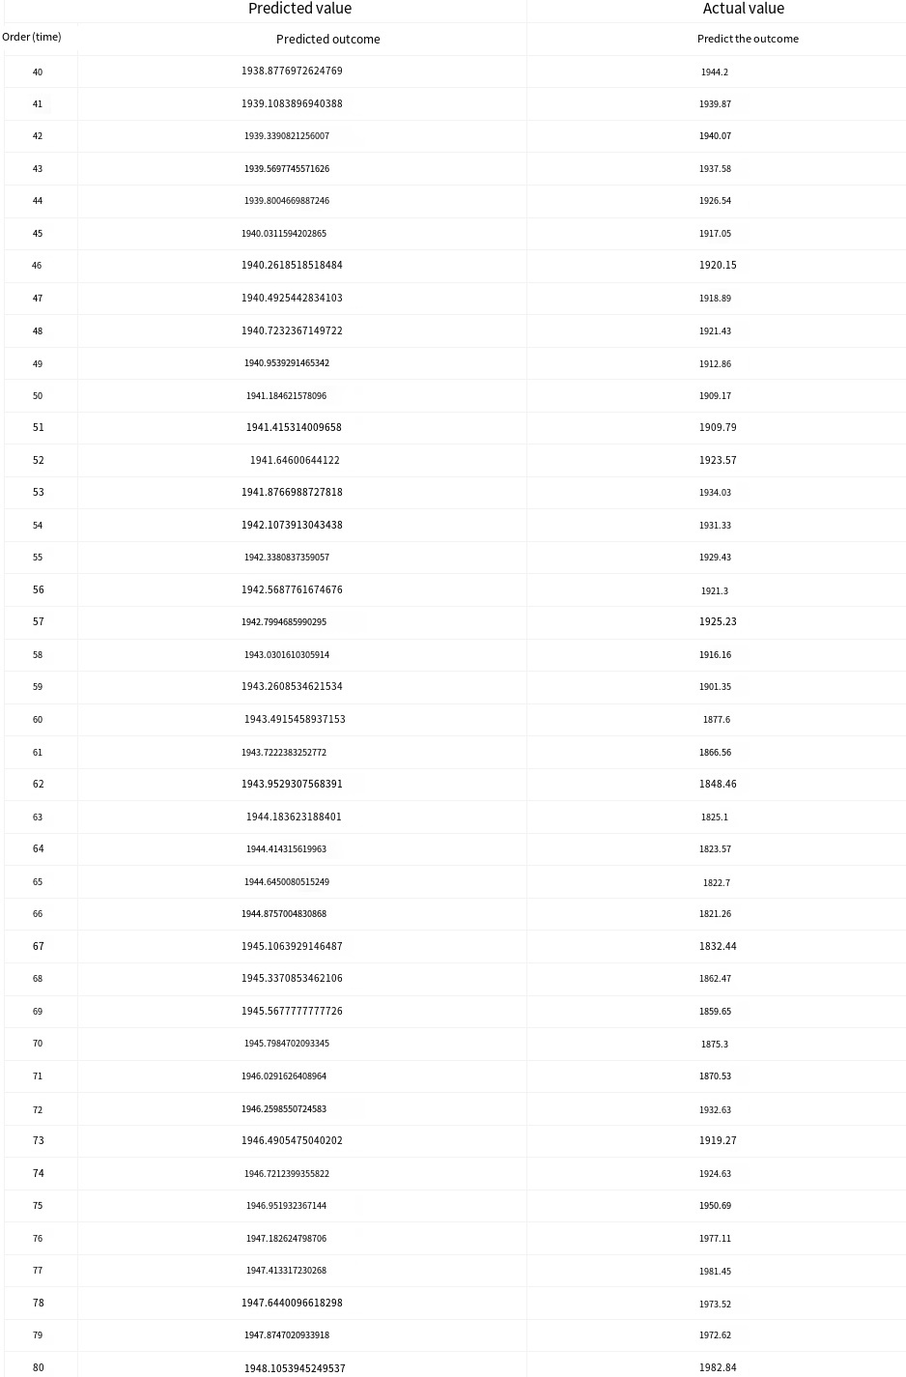
18

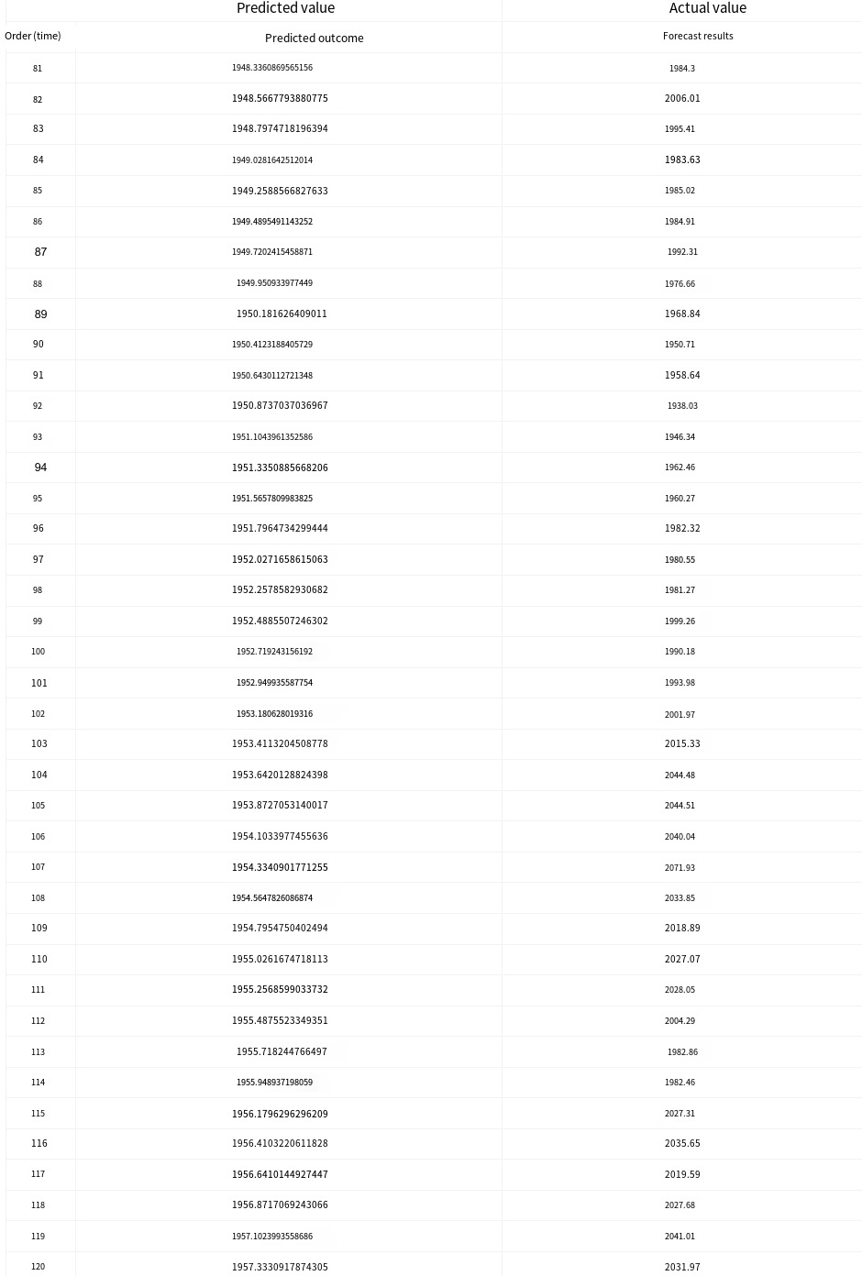

Chart description:
The above table shows the forecasts of the time series model for the last 120 periods of data. It can be clearly seen that stock prices experienced a brief decline and then quickly recovered, showing an overall upward trend of volatility.

Figure 19: Trend chart of the predicted value versus the actual value
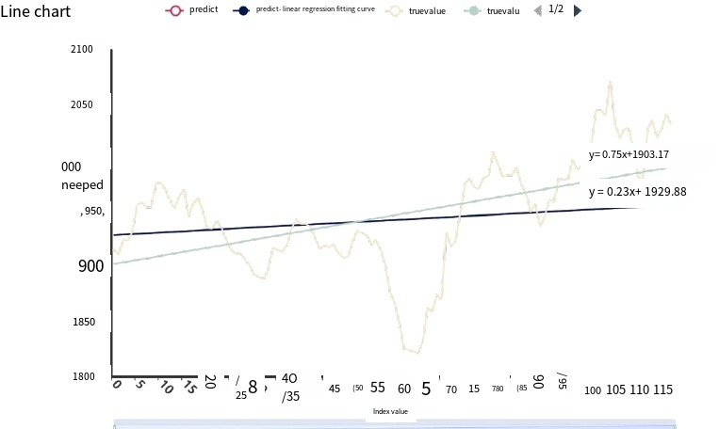

Suggestions for gold stock price forecasts
Prior to making any investment decisions, thorough research and careful consideration are essential. While achieving comprehensive and effective research and analysis may pose challenges; however they can offer valuable guidance for investments within the precious metal market. Over time, gold presents numerous benefits including its antioxidative properties that help combat free radicals within the human body; its use as jewelry for adornment signifying nobility; its enduring store of value serving various purposes such as talismans or international reserves; its aesthetic appeal promoting tranquility; its potential health benefits including relief from muscle fatigue; attraction towards wealth generation through symbolism; promotion of blood circulation; hedging against inflationary pressures by reducing harmful elements; therapeutic applications like massage therapy; participation in margin trading activities testing currency or commodity values acting as media vehicles regulating endocrine functions while also minimizing facial wrinkles.
The historical fluctuations in its worth along with periodic variations in market pricing underscore how ownership offers potential returns over time alongside ease of storage facilities. In light of recent developments such as multiple interest rate reductions by central banks throughout 2022 followed by significant increases in golden equities post-mortgage rate cuts during September 2023 indicating policy-driven backing for real estate prompting temporary surges which subsequently lead to adjustments lowering projected security balances due to exchanges resulting ultimately withdrawal from golden assets amidst property market recoveries.
Consequently given these circumstances prioritizing adjustments within asset allocations particularly favoring holdings exhibiting resilience against volatile shifts becomes imperative where disparities between pre-and-post-holding valuations remain relatively modest.
Following this rationale despite apprehensions stemming from uncertainties dampening enthusiasm towards property acquisitions leading individuals adopting a cautious stance awaiting potentially favorable pricing dynamics fund outflows from golden assets could be overshadowed by inflows originating elsewhere thereby surpassing outward movements.
For steadfast investors committed towards long-range objectives embracing golden investments continues representing an optimal avenue preserving wealth thus warranting disregard towards transient equity fluctuations albeit acknowledging forthcoming trends likely characterized by heightened oscillations.
References:
[1] Wang, H., Dong, X., Qu, H., Liao, J., & Ma, D. (2024). Gold Stock Price Forecasting Based on Nonlinear Weighted Particle Swarm (IPSO) Optimised Support Vector Machine (SVM) Time Series. Advances in Economics, Management and Political Sciences. DOI:10.54254/2754-1169/85/20240857
[2] Shi, S., Liu, W., & Jin, M. (2012). Stock price forecasting using a hybrid ARMA and BP neural network and Markov model. 2012 IEEE 14th International Conference on Communication Technology, 981-985. DOI:10.1109/icct.2012.6511341
[3] Yujun, Y., Yimei, Y., & Wang, Z. (2021). Research on a hybrid prediction model for stock price based on long short-term memory and variational mode decomposition. Soft Computing, 25, 13513 - 13531. DOI:10.1007/s00500-021-06122-4
[4] Mensi, W., Gubareva, M., Ko, H., Vo, X.V., & Kang, S.H. (2023). Tail spillover effects between cryptocurrencies and uncertainty in the gold, oil, and stock markets. Financial Innovation, 9. DOI:10.1186/s40854-023-00498-y
[5] Ha, L. (2023). An application of Bayesian vector heterogeneous autoregressions to study network interlinkages of the crude oil and gold, stock, and cryptocurrency markets during the COVID-19 outbreak. Environmental Science and Pollution Research International, 30, 68609 - 68624. DOI:10.1007/s11356-023-2

