Further mathematical analysis of ‘The Roller Conduction Effect’
--From stock market data

Overview:
Within the aftermath of the pandemic, patterns of consumption recovery exhibit distinct temporal and spatial dynamics, and different consumption sectors are evaluated by various criteria. various criteria evaluate different consumption sectors Analyzing A-share data during the initial four months of 2022, this study in quantitative terms assesses the rotational shifts among different consumption sectors as their valuations approach rational levels. Through the innovative categorization termed "sensory-based consumption," the explanation is provided for digital consumption as a mechanism facilitating consumption enhancement and its link to elevated valuation targets, accompanied by an examination of examining the "echo transmission effect. "This paper explores the laws governing the period for consumption recovery and valuation normalization through the lens of spatial-temporal transmission. The findings reveal that consumer confidence rebounds slowly in the initial phase of recovery recovery phase. During this stage, A-shares were primarily influenced by stock capital manoeuvers, with a clear pattern of sector rotation evident. Understanding this pattern is crucial as it aids policymakers in refining policy direction and equips financial investors with insights for optimizing investment strategies. However, the limitation of this study lies in its exclusion of the ripple effects across the global financial markets and the need for more robust mathematical models to better define to define better stock fund dynamics, which will be the primary focus of future research by the author.

Keywords:
Exploring consumption that engages the senses; the cascading impact of trends; strategies for investment

Presenting
Considering the economic progression of China in 2022 and the strategic policies introduced for 2023, this analysis delves into how digital consumption acts as an accelerant for enhancing consumer spending and impacts the rise in valuation standards., paving the way for an investment blueprint characterized by a cascading effect. Research by Wang Qing, Wang Zhongli, and colleagues underscores that stock price reactions to pandemic influences exhibit a delayed response, typically spanning a mere day. This delay stems from the investor psyche—rife with apprehension and panic due to the pandemic—triggering a sell-off of stocks and consequent market fluctuations. Moving forward into 2023, the government's agenda underscores a fortified market milieu, an enhanced corporate governance framework for public entities, the introduction of superior-quality publicly listed companies, and a push for robust investor safeguard measures. Furthermore, a commitment to the profound reform of the capital marketplace, augmenting and refining the regulatory framework, and elevating the market ambiance ambience to boost investor morale, aim to sustain the capital market’s vibrant growth.
This narrative delves into the propagation mechanisms of post-pandemic consumption recovery, offering a clear delineation of clearly delineating sensory consumption and refining valuation principles for consumer-centric corporations. From an investment standpoint, digital consumption is attributed with a loftier appraisal, and the "cascade effect" is introduced as a pivotal element in the transmission mechanism of recovery. Utilizing empirical evidence from The cascade effect's practical implications are showcased using empirical evidence from Data from China's A-share market spanning January to April, the cascade effect’s practical implications are showcased.

2. Concept definition
The consumption value obtained from goods and services is intricately sorted by sensory interactions, with each type aimed at fulfilling one or more sensory delights. The benefit gained from experiences engaging sight, sound, and touch demonstrates considerable variation.
Valuation models across sectors influenced by sensory inputs diverge significantly, often leading to elevated valuations which in turn, can precipitate unusual movements in stock prices. Drawing on insights from valuation tendencies and stock price deviations:
visual stimuli > auditory stimuli > scent stimuli > tactile stimuli > gustatory stimuli;
A holistic approach to understanding service experiences considers the cumulative effect of sensory inputs, assigning them a hierarchical value. For example, digital devices such as smartphones, which combine visual, auditory, and tactile stimuli, are more prone to receiving higher valuations and, consequently, may experience more frequent stock price anomalies. Observations from consumer behaviors in advanced economies highlight the profound impact of digital consumption within the overall consumer sector.
The following review compares time series data across the general consumer sector and the electronics (hereafter referred to as called digital consumption) sector within the A-share market.
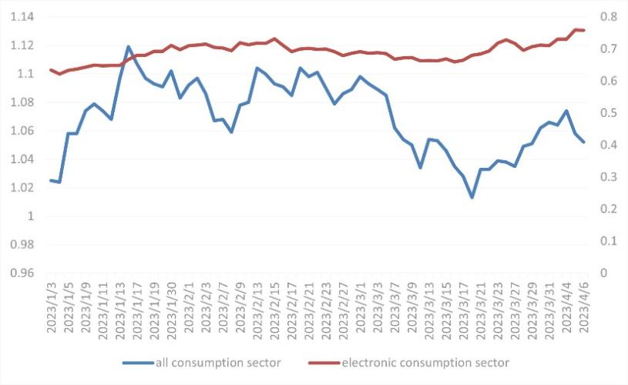
Figure 1. Patterns in General Consumer Spending and Electronics Consumption Trends
The stock market frequently acts as an indicator of indicates the overall economic health, typically anticipating developments by approximately six months. Observations from January 3, 2023, to the present illustrate a 2.63% uptick in the overall consumption sector, characterized by an initial increase followed by a decrease. This fluctuation hints at a sluggish rebound in the consumption patterns of the real economy, where demand has not met expectations. On the other hand, the consumer electronics segment witnessed a notable 19.56% ascent, underscoring a vibrant demand and supply equilibrium for electronics even amidst overall subdued consumer spending. This trend substantiates the thesis of this paper, drawing a stark contrast between the recovery velocities of the general consumption domain and that of the consumer electronics sphere.

3.The phenomenon of rolling conductance
Predicting the valuation of financial assets with absolute precision is challenging, yet historical patterns, particularly in the realm of price volatility and reasonable valuation adjustments, reveal certain regularities.
In prior research, the concept of the "roller conduction effect" was introduced by the author. This theory operates under the assumption that the aggregate financial resources in the stock market and over-the-counter trades remain relatively constant over certain periods. Given this fixed total, it is impractical for all stocks demonstrating fair value to simultaneously experience and sustain proportional increases; Furthermore, fund managers represent a mix of investment styles—long-term, short-term, sentiment-driven, and regulatory influenced—whose decision-making processes are inherently diverse. Consequently, even if there exists a uniform long-term outlook across one or several market segments (both horizontally and vertically), the short-term effects will likely be desynchronized due to this diversity, compounded by speculative trading and retail investor sentiment,
amplifying the rotation’s magnitude. Historical observations clearly delineate strength and weakness patterns among these segments.
It is important to underline that the barrel transmission effect is predominantly utilized in forecasting the dynamics of stock fund movements. Should the constraints of this model be disrupted or if significant capital inflows or outflows occur, such as substantial northbound investments into the A-share market, the established "barrel wall" rule might be compromised, altering the typical barrel transmission dynamics.
For investors navigating an imperfect market, pursuing the ephemeral gains akin to chasing water levels in a barrel (the frequent state of speculative buying and selling) is advised against. Instead, the prudent approach involves holding specific assets patiently and capitalizing on the roller effect to glean profits over time.

4. Building the Framework

4.1 Harmonization Degree Framework
The concept of energy flow and control algorithms in electric circuits has been repurposed to explore the links between different economic frameworks. Presently, the coupling coordination degree model is extensively employed in academic research to quantify the interdependencies and reciprocal influences among multiple systems. To enhance the study of interrelations between four stock index sectors, it is essential to construct four distinct coupling degree models tailored to the specific conditions. The formula to be used is outlined as follows:
In the equation, 'c' denotes the degree of coupling, with larger values of 'c' indicating a stronger coupling between the systems. A 'c' value of 1 signal that the subsystems are undergoing highly orderly development. 'Arc' represents the integrated development index across the subsystems of operational innovation and encompasses not only research and development activities but also the support for and the ecosystem surrounding innovative practices.

4.2 Holistic Development Level Indicator
According to the coupling degree framework, the intensity of the system's coupling is linked to the developmental indices of its lindividua subsystems. The index 'U' serves as a reliable measure of each subsystem's growth level and the relative rate of development, illustrating how system indicators contribute to the system's overall functionality. It's presupposed that each indicator initially holds equal weight in the calculation.

4.3 Model for Coupling Coordination Degree in Innovation Ecosystems
Although the coupling degree model effectively illustrates the interaction level among systems, it can sometimes overestimate the overall coupling level when various systems are at similar stages of high or low development. This issue highlights the need for a more precise and scientific model of coupling coordination degree, designed to more accurately evaluate the cooperative innovation occurring between systems.

"D represents the level of synchronization and integration within the innovation ecosystem. Conversely, T symbolizes the overall effect of each subsystem's composite development index on the collective equilibrium. The coefficients α, β, χ, and δ are yet to be specified, denoting the equitable importance attributed to the four constituents of the innovation environment. Each has a weight weights of 0.25, cumulatively equaling one."
The degree of interconnection and the level of coordination are each divided into four distinct categories. | Values | stage
the degree of integration | 0<C≤0.3  0.3<C≤0.5  0.5<C≤0.8  0.8<C≤1 | The initial coupling stages  Low-level coupling stage  Intermediate coupling stage  Advanced coupling stage
level of synchronicity | 0<D≤0.3  0.3<D≤0.5  0.5<D≤0.8  0.8<D≤1 | Initial coordination stage  Low-level coordination stage  Intermediate coordination stage  Advanced coordination stage
Table 1. Based on the outlined range for levels of coordination, the degree of coupling and the degree of coordination are classified into four separate tiers.

5. Observational Study

5.1 Illustrations of the Ripple Effect in China's A-share Market:
Interrelationships among the SSE Index, SZI, GEI, and STAR 50

Assessment of Overall Capital Magnitude: By analyzing the variation curve of market capitalization for each segment, it is observed that the combined market value of the four principal indices oscillated between 8.6 trillion and 8.9 trillion from mid-January through April 2023. This pattern highlights the state of equity capital, with no marked capital inflows or outflows detected during this period，
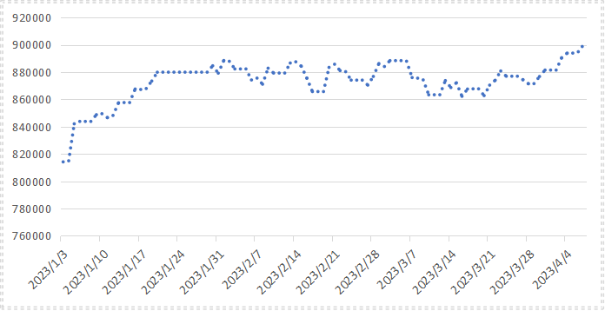
Figure 2. Total GMV (RMB) Across Four Indices.
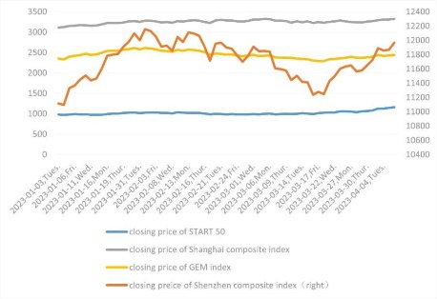
Figure 3. Analysis of Trajectories for the Shanghai Composite, Shenzhen Composite, GEM, and STAR 50 Indexes
As illustrated in Figure 2, a synchronized increase across the four indices was observed from January 3 to February 1, indicating collective momentum. However, Spaning from February 1st to March 15th, while Shanghai’s benchmark index remained steady, the remaining trio indices experienced notable declines, highlighting a strategic reallocation of stock funds. During this period, investors redirected their investments towards the sectors represented by the Shanghai Composite Index, which initiated the emergence of a roller effect. Post March 15, there was a significant uptick across all four indices, with the Science and Technology Innovation Board’s premier index witnessing the majority of pronounced surge. The STAR Market alongside the Growth Enterprise Market (GEM Board) in China stands as the premier platform for enterprises characterized by innovation and rapid growth and exhibits a synergistic relationship, with the former primarily focusing on burgeoning high-tech enterprises, and the latter on well-established, large-scale high-tech firms. Without considering the infusion of additional capital, the growth trajectories of both boards are expected to align gradually, leading to a redistribution of capital stemming from scientific and innovative advancements from sectors encompassing entrepreneurial endeavors to various other classification groups within the index
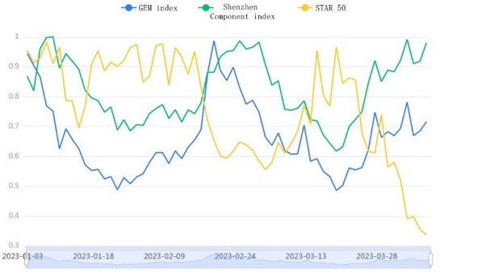
Figure 4. Inverse relationship between STAR 50 (yellow), Shenzhen Component Index (green), and GEM Index (blue).

Figure 3, which excludes the Shanghai Composite Index for baseline comparison, showcases a trend analysis relying on grey correlation. Here, the STAR 50 index displays a distinct inverse trend compared to the Shenzhen Component and GEM indices. This divergence underscores a palpable shift in stock funds moving from the GEM index towards the STAR 50 index, reflecting strategic investment reallocations within the market.
Subsequently, the analysis focuses on the coupled coordination degree among the four indices, using the Shanghai Composite Index as the reference point. The variation trends in the coupled coordination degrees for the three indices are examined, revealing distinct dynamics in index interactions.
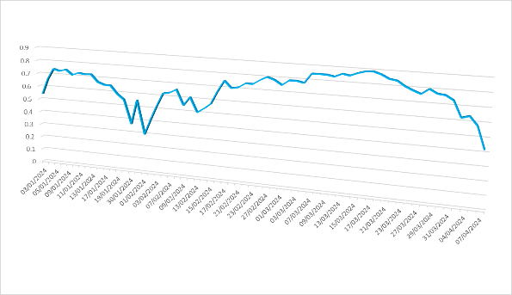
Figure 5. Degree of Coupling Coordination, denoted as D value
By early April, the coupling coordination level between STAR 50 and other sectors has fallen into a poorly matched, low-coupling condition, scoring a mere 0.41. This highlights a pronounced 'rolling barrel' effect amidst the valuation recovery phase, characterized by significant fund shifts, extended cycles, and a lackluster coordination trend across the sectors.

5.2. Example of Barrel Effect of Hong Kong Stock:
Relationship between the Hang Seng Index and Exchange Rate

In our study, our panel regression analysis of the Hang Seng Index and the offshore RMB exchange rate shows two significant explanatory strengths. Specifically, as of January 1, 2022, according to Table 1, the strength of this interpretation had reached 76.4 per cent; similarly, by November 1, 2022, the strength of this interpretation reached 89.3 per cent. See Table 2 for details. These data reveal an important economic phenomenon: the direction of international capital flows in foreign exchange markets, particularly between China and the United States.
From a global perspective, this phenomenon is often referred to as " the barrel effect," especially during periods of economic recovery and rising asset valuations. Because of the unpredictability of cross-border capital flows, it can provide investors with valuable market information and help them make more informed investment decisions.
Through this study, we further confirm the view that this particular impact can be observed when financial markets are affected by external factors, such as monetary policy and macroeconomic indicators. In addition, we note that while short-term fluctuations may occur, long-term trends tend to be stable and predictable. Thus, such panel regression provides valuable insights for investors seeking to understand current economic dynamics and future directions.
In future work, we plan to further explore the relationships between these indicators over time and how they change over time. At the same time, we hope to be able to identify these short-term fluctuations behind the deeper macroeconomic dynamics. Through such in-depth research, we can provide policymakers, economists and other stakeholders with more insights to better cope with the complex and changing international financial environment.
When we probe into the interaction between the stock index and exchange rate, if we observe that the fluctuation of the exchange rate has a positive correlation with the fluctuation of the stock market, we can infer that it reflects the popularity and influence of offshore RMB in the international market. In turn, the stock market's ups and downs reflect the popularity of financial assets denominated in yuan. Since these financial assets are traded in renminbi, they are likely to also be affected by exchange rate fluctuations, showing a dynamic relationship similar to the roll-barrel effect. However, if there is no such positive correlation between the two variables, then the cointegration effect should be considered, that is, there should be a long-term stable equilibrium relationship between them.
To further determine the strength and direction of this causality, researchers often use the Granger causality test to determine whether there is a causal link between them. This test determines whether there is a two-way or one-way causal relationship between variables by analyzing their changing trends. Once the Granger causality test is supported, researchers can use the VAR model to quantify specific causal coefficients to more accurately assess the dynamic relationship between the two variables. In this way, researchers can uncover complex patterns of interaction between two variables, providing a better understanding of the dynamics of financial markets.

（1）Cointegration test
Comparison of different lagging orders
Lagging order | AIC | SC | HQ | FPE | logL
0 | 7.33 | 7.383 | 7.352 | 1526.138 | -648.312
1 | 3.118 | 3.275* | 3.182 | 22.604 | -429.296
2 | 3.146 | 3.409 | 3.252 | 23.237 | -422.245
3 | 3.02 | 3.392 | 3.17 | 20.502 | -407.745
4 | 3.056 | 3.536 | 3.25 | 21.258 | -401.107
5 | 3.07 | 3.661 | 3.309 | 21.583 | -393.415
6 | 2.871* | 3.575 | 3.155* | 17.722* | -375.708
7 | 2.95 | 3.767 | 3.28 | 19.217 | -371.103
8 | 2.912 | 3.844 | 3.288 | 18.548 | -361.025
9 | 2.899 | 3.947 | 3.322 | 18.375 | -352.129
10 | 3.004 | 4.171 | 3.474 | 20.521 | -348.586
11 | 3.022 | 4.309 | 3.541 | 21.036 | -341.062
According to the comprehensive evaluation of the four evaluation indicators of FPE (free cash flow discount rate), AIC (average absolute error), SC (standard deviation) and HQ (forecast residual error under high confidence level), it is suggested that the lagging order shall be 6. This decision is based on a detailed analysis of several evaluation indicators. By studying the relationship between these indexes and their importance in prediction, we find that the 6th order lag order can balance the accuracy and robustness of the model better. In addition, the order selection also takes into account the sensitivity to data fluctuations and the impact of long-term trends, ensuring that the model can adapt to different market environments. Therefore, combined with the analysis results of various indicators, we believe that the 6th order is a more appropriate choice, which not only guarantees the performance of the model but is also easy to operate and explain.
2：Cointegration test result
Original hypothesis | Characteristic root | Trail (largest root) | Critical value of 10% | 5% critical value | 1% threshold
Non-cointegration relation | 0.083 | 10.848 | 13.429 | 15.494 | 19.935
Up to 1 cointegration | 0.03 | 2.832 | 2.705 | 3.841 | 6.635
In the cointegration test, we adopt a strict hypothesis: there is a long-term equilibrium relationship between a set of data. If, in the course of testing, the observed trace (residual) is less than or equal to a critical value of 5%, this usually means that there is insufficient evidence to refute the original hypothesis. In other words, in this case, we cannot declare that there is no co-integration of any kind, because at this level, the residual coefficient may be close to zero, indicating that there may be non-stationary trends or random fluctuations among the variables. Therefore, based on the results of these residual analyses, we can conclude that current economic indicators do not support the existence of long-term equilibrium relations.

（2）Granger causality test
ADF test
Variable | t | P | Critical value
Variable | t | P | 1% | 5% | 10%
Exchange rate deviation | -1.95 | 0.309 | -3.498 | -2.891 | -2.583
Hengzhi | -2.092 | 0.248 | -3.498 | -2.891 | -2.583
Note: * * *, * * * and * represent significant levels of 1%, 5% and 10% respectively
In our research, the relationship between the variable Hang Seng Index (HSI) and the exchange rate is analyzed in depth. Using statistical methods, we tested the correlation between the two variables. The results show that when the ordinary least squares (OLS) model is used to fit the data, the significance P-value reaches 0.661, which does not significantly exceed the zero line. Therefore, we cannot reject the null hypothesis proposed before, that is, the Hang Seng index will not affect the change of the exchange rate. In other words, we conclude that there is no statistically significant correlation between the Hang Seng Index and the exchange rate.
However, when we further explore the relationship between the variable "exchange rate divergence" and the Hang Seng Index, the situation changes significantly, with a significance P-value of 0.006***. This means that there is sufficient statistical evidence to show that exchange rate divergence can indeed cause changes in the Hang Seng Index. This finding strongly supports the previously proposed hypothesis that exchange rate divergence may have an impact on the Hang Seng Index. Based on this new observation, we can say with greater confidence that exchange rate movements can indeed explain or predict to some extent the volatility of the Hang Seng index. This interpretation not only provides financial market participants with more insight into how exchange rate movements affect the stock market but also lays the foundation for future academic research and practical applications.
Granger causality test results table
Paired sample |  | F | P
Hang Seng index | Exchange rate deviation | 0.416 | 0.661
Exchange rate deviation | Hang Seng index | 5.482 | 0.006***
Note: ***, ** and * represent significance levels of 1%, 5% and 10% respectively
In this study, we carefully analyze the deviation relationship between the Hang Seng index and the exchange rate. Through statistical testing of the data, the results show that it is significant that we cannot determine whether the Hang Seng Index actually affects the exchange rate fluctuations, or whether such effects exist outside the statistical error margin.
However, the P-value of the property is 0.661, which is not significant, so we cannot easily reject the null hypothesis that the Hang Si index cannot explain the exchange rate deviation. This means that when we look further at the correlation between exchange rates and the Hang Seng, the picture changes. A more rigorous statistical approach was used here to assess the causal relationship between the two. After careful analysis, the significance level P value is 0.006***, which indicates strong statistical significance. It strongly supports our null hypothesis that changes in exchange rates can be viewed as caused by the Hang Seng Index. That said, we have enough evidence to reject the previous assumption and admit that exchange rate movements are not just random, but have a clear and measurable correlation with the Hang Seng Index. This finding has important implications for researchers of financial markets, as it may reveal more complex interactions behind market dynamics.

（3）VAR model quantization
Comparison of different lag orders
Order of lag | logL | AIC | SC | HQ | FPE
0 | -648.312 | 7.33 | 7.383 | 7.352 | 1526.138
1 | -429.296 | 3.118 | 3.275* | 3.182 | 22.604
2 | -422.245 | 3.146 | 3.409 | 3.252 | 23.237
3 | -407.745 | 3.02 | 3.392 | 3.17 | 20.502
4 | -401.107 | 3.056 | 3.536 | 3.25 | 21.258
5 | -393.415 | 3.07 | 3.661 | 3.309 | 21.583
6 | -375.708 | 2.871* | 3.575 | 3.155* | 17.722*
7 | -371.103 | 2.95 | 3.767 | 3.28 | 19.217
8 | -361.025 | 2.912 | 3.844 | 3.288 | 18.548
9 | -352.129 | 2.899 | 3.947 | 3.322 | 18.375
10 | -348.586 | 3.004 | 4.171 | 3.474 | 20.521
11 | -341.062 | 3.022 | 4.309 | 3.541 | 21.036
After a comprehensive analysis of FPE (variance inflation factor), AIC (information criterion), SC (structural mutation index) and HQ (high order moment) four evaluation indexes, we reached a conclusion: based on the existing data characteristics and model prediction ability evaluation, the lag order should be selected as 6 order. This decision means that a VAR (6) model will be built, that is, a six-order time series model. Such models can provide a more accurate dynamic of the interaction between long-term trends and short-term fluctuations, while also capturing more lag effects, making forecasts of economic activity more reliable and accurate.
Model parameter estimation table
argument | estimator | Exchange rate deviation | Hang Seng index
Exchange rate separation (-1) | coefficient | 1.071 | -3745.725
Exchange rate separation (-1) | Standard deviation | 0.101 | 1563.768
Exchange rate separation (-1) | t | 10.576 | -2.395
Exchange rate separation (-2) | coefficient | -0.144 | 2260.349
Exchange rate separation (-2) | Standard deviation | 0.103 | 1587.405
Exchange rate separation (-2) | t | -1.405 | 1.424
Hang Seng Index (-1) | coefficient | 0 | 0.887
Hang Seng Index (-1) | Standard deviation | 0 | 0.103
Hang Seng Index (-1) | t | 0.857 | 8.645
Hang Seng Index (-2) | coefficient | 0 | 0.007
Hang Seng Index (-2) | Standard deviation | 0 | 0.098
Hang Seng Index (-2) | t | -0.912 | 0.068
constant | coefficient | 0.481 | 11848.657
constant | Standard deviation | 0.267 | 4120.682
constant | t | 1.804 | 2.875

In the fluctuation of the foreign exchange market, the exchange rate is a key indicator, which directly affects the cost of cross-border transactions. Specifically, this formula embodies the complex process of value conversion between different currencies: First calculate the movement based on the current exchange rate level, which is 1.071 as the base, and then adjust according to the fluctuation of 1 percentage point (the exchange rate (-1)) and 2 percentage points (the exchange rate (-2)). These changes are then multiplied by the corresponding changes in the Hang Seng Index (Hang Seng Index) (0.0 Hang Seng Index (-1) and 0.0 Hang Seng Index (-2)), and finally 0.481 is added to determine the final result. This is done to reflect changes in the relative purchasing power between currency pairs.
The Hang Seng Index, which represents the performance of the Hong Kong stock market, is calculated in a slightly different way. First, start from negative 3745.725, which indicates the decline of the Hang Seng relative to the benchmark exchange rate since a certain point in time. We then multiply the decline by 2260.349, as the Hang Seng index usually rises somewhat to compensate for currency movements. Then, we multiply 0.887 by the decline of the Hang Seng (-1), since the Hang Seng can also fall. Add 0.007 times the rise of the Hang Seng Index (-2) to ensure that the overall calculation is fair. The result is 11,848.657, which represents the actual increase in the Hang Seng index after exchange rate changes are taken into account.
Through this detailed mathematical calculation, traders can better understand the interaction between forex and the stock market, so as to make more accurate investment decisions. Every small change can be a key factor in determining where wealth flows. Therefore, mastering this complex and precise calculation method is essential for professionals working in financial markets.
VAR model stability test
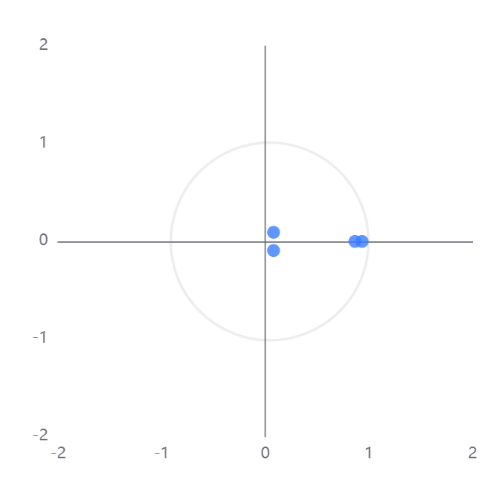
The figure above clearly shows the structure of the VAR model, including the key chart of the AR root diagram. Looking at this graph, we can find an important feature: all lines are tightly around the unit circle, which indicates that there is a stable relationship between the variables of the VAR model. On this basis, we can further explore the dynamic characteristics of the model and carry out advanced statistical techniques such as impulse response analysis (IPR) and variance decomposition (VAR). Through these analysis methods, researchers can more accurately understand the complex and subtle interaction between economic data and the factors behind it, so as to provide a more accurate basis for policy making and market forecasting.
Impulse response analysis Impact variable: exchange rate, impact variable: HSI, order: 100
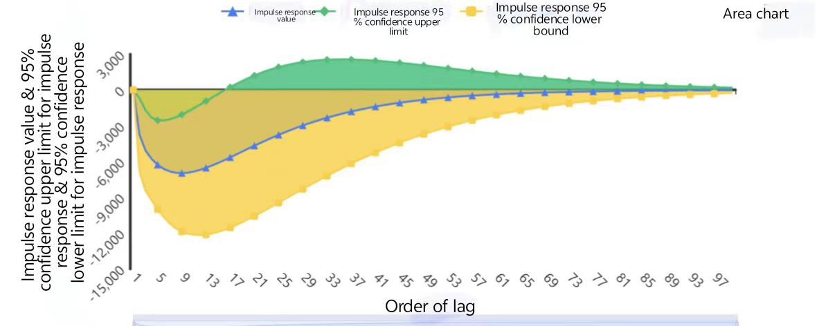
The above figure clearly depicts the essence of the impulse response analysis diagram, which shows in detail how an impact variable exerts an influence on an endogenous variable in the VAR model, and how the impact acts on the impacted variable. Through this graph, we can see how sensitive each variable is to shocks and the dynamic relationship between them. Impulse response charts provide an important visual aid for understanding and predicting transient changes in economic systems, enabling researchers to gain insight into the broad effects of small changes in the system.

Variance decomposition results table
Order of lag | Standard deviation | Exchange rate deviation | Hang Seng index %
1 | 0.017 | 100 | 0
2 | 0.025 | 99.644 | 0.356
3 | 0.031 | 99.538 | 0.462
4 | 0.034 | 99.527 | 0.473
5 | 0.037 | 99.544 | 0.456
6 | 0.039 | 99.569 | 0.431
7 | 0.041 | 99.594 | 0.406
8 | 0.042 | 99.616 | 0.384
9 | 0.043 | 99.634 | 0.366
10 | 0.044 | 99.649 | 0.351

In the table above, we can clearly observe the results of variance decomposition. The variance decomposition is mainly used to explore how the change of the predicted residual standard deviation is affected by different shock events. Through this decomposition method, we can determine the proportion of different types of shocks that contribute to the standard deviation of the residual. In other words, it reveals the specific extent to which endogenous variables influence this standard deviation. Through such analysis, we can not only better understand the causal relationships behind the data, but also provide more accurate and reliable input to the predictive model.

6. Conclusions
Through in-depth analysis of the closing price and total market value data of the four major A-share indexes, this study reveals the phenomenon of "the roller conduction effect" in the process of stock market price transmission. This finding shows that in the stock market price fluctuations, the behavior of investors can produce a chain reaction like turning a roller, driving the fluctuation of market prices. This effect may be due to the interaction between individual investors, information sharing and psychological expectations. By carefully tracking and analyzing these data, this paper provides a new perspective for understanding the market microstructure and has important reference value for the formulation of future market strategies.
In the realm of stock investing, the concept of the roller conduction effect holds a prominent position. This phenomenon is particularly apparent when analyzing the dynamics of stock prices over time. Generally, it can be observed that as stock market participants navigate through the cycles of economic growth and recession, there are instances where the value of stock indices experiences significant pullbacks. These dips in price reflect cyclical movements that occur within the broader economy, such as seasonal trends or macroeconomic uncertainties. However, in the end, these pullbacks serve as catalysts for the stock markets to consolidate and potentially stage a comeback, with the stock index eventually recovering its lost ground. Thus, the roller conduction effect suggests that even during periods of volatility and downturns, the stock market maintains an underlying resilience that can lead to eventual recoveries.
In the stock market, the entry and exit transactions of funds do not occur at the same time. Investors have different options for buying and selling strategies, which creates a roller-coaster effect in multiplayer games. Mainstream funds typically exhibit a rolling flow trend - a roller coaster that follows a certain real-world economic logic and exhibits a degree of volatility over a long-term investment sequence. This volatility means investors may need to be flexible with their portfolios in response to this dynamic change.
When rolling, the regions involved usually do not show a cointegration effect, but rather a game of trade-offs. By using the Granger causality test method, we can indirectly test the sequence of the roll, while the VAR model is able to can quantify the specific parameters of the capital variable in the roll. This shows that although there are many uncertainties in the rolling process, it can still be deeply analyzed and understood with precise mathematical tools.
As investors, we must be proficient in observing and effectively capitalizing on this wave effect, adopting strategies in the process of trend formation, and following the prevailing capital flow trends to trade for a higher success rate. In the investment world, understanding and applying these dynamics is critical. Through in-depth analysis of market trends and flexible responses, investors can find favorable entry points in the changing market environment, so as to realize asset appreciation. Therefore, maintaining keen market insight and decisive decision-making ability is undoubtedly a necessary skill for investors who pursue long-term stable returns.

Reference
[1] Lyu W.， Zhu J.，Ding Y.， Zhang K. (2023) An Analysis of the Recovery Path of the Consumer Sector in the Post-Pandemic Era. Open Journal of Business and Management ., Vol.11 No.3, May . https://doi.org/10.4236/ojbm.2023.113061
[2] Scientific Platform Serving for Statistics Professional. (2021) SPSSPRO. (Version 1.0.11)[Online Application Software]. Retrieved from https://www.spsspro.com.
[3] Essayem, A., Gormus, S., & Guven, M. (2023). The GCC's regional roller coaster: Do regional factors affect stock market dynamics in the GCC Region? Evidence from non-parametric quantile regression. Borsa Istanbul Review, 23(2), 473-494. https://doi.org/10.1016/j.bir.2022.11.018
[4] Olasehinde-Williams, G., Olanipekun, I., & Özkan, O. (2023). Stock market response to quantitative easing: evidence from the novel rolling windows nonparametric causality-in-quantiles approach. Computational Economics, 1-31. https://doi.org/10.1007/s10614-023-10450-y
[5] Pata, U. K., Usman, O., Olasehinde-Williams, G., & Ozkan, O. (2023). Stock returns, crude oil and gold prices in Turkey: evidence from rolling window-based nonparametric quantile causality test. Asia-Pacific Financial Markets, 1-19. https://doi.org/10.1007/s10690-023-09430-x
[6] Mensi, W., Boubaker, F. Z., Al-Yahyaee, K. H., & Kang, S. H. (2018). Dynamic volatility spillovers and connectedness between global, regional, and GIPSI stock markets. Finance Research Letters, 25, 230-238. https://doi.org/10.1016/j.frl.2017.10.032.
[7] Ilalan, D., & Pirgaip, B. (2019). The Impact of US Dollar Index on Emerging Stock Markets: A Simultaneous Granger Causality and Rolling Correlation Analysis. In Essays in Financial Economics (pp. 145-154). Emerald Publishing Limited. https://doi.org/10.1108/S0196-382120190000035007
[8] Nakhli, M. S., Dhaoui, A., & Chevallier, J. (2022). Bootstrap rolling-window Granger causality dynamics between momentum and sentiment: implications for investors. Annals of Finance, 1-17. https://doi.org/10.1007/s10436-021-00399-z
[9] Obalade, A. A., Tshutsha, A., Mvuyana, L., Ndlovu, N., & Muzindutsi, P. F. (2022). Are Frontier African Markets Inefficient or Adaptive? Application of Rolling GARCH Models. Journal of Economics and Financial Analysis, 6(1), 19-35. http://dx.doi.org/10.1991/jefa.v6i1.a49
[10] Khan, K., Su, C. W., Khurshid, A., & Rehman, A. U. (2018). How often does the exchange rate Granger cause the stock market in Pakistan? A Bootstrap Rolling Window Approach. Applied Economics Journal, 25(1), 65-78. http://dx.doi.org/10.22004/ag.econ.338440
[11] Şimşek, T., & Özkan, O. (2020). The time-varying impact of covid-19 on stock returns: evidence on developed countries from a bootstrap rolling window causality method. Ekonomi Politika ve Finans Araştırmaları Dergisi, 5(Özel Sayı), 1-12. https://api.semanticscholar.org/CorpusID:249226931
[12] Degiannakis, S., Livada, A., & Panas, E. Examine arch and levy-stable models using rolling samples: Evidence from the greek stock market. https://www.researchgate.net/publication/241305685
[13] Wu, H., Zhu, H., Chen, Y., & Huang, F. (2023). Time-Frequency connectedness of policy uncertainty, geopolitical risk and Chinese commodity markets: evidence from rolling window analysis. Applied Economics, 55(1), 90-112. https://doi.org/10.1080/00036846.2022.2056571
[14] Pandian, P., & Jeyanthi, B. J. (2008). Rolling settlement and market efficiency of NSE. SMART Journal of Business Management Studies, 4(1), 42-46. https://api.semanticscholar.org/CorpusID:112208423
[15] Engle, R. F., Ghysels, E., & Sohn, B. (2013). Stock market volatility and macroeconomic fundamentals. Review of Economics and Statistics, 95(3), 776-797. https://doi.org/10.1162/REST_a_00300
[16] Shahbaz, M., Shahzad, S. J. H., Kablan, S., & Hammoudeh, S. (2019). Do Commodity Prices Cause Financial Instability in the United States? A Time-Varying Perspective through Rolling Window Bootstrap Approach. In Handbook of Global Financial Markets: Transformations, Dependence, and Risk Spillovers (pp. 335-357). https://doi.org/10.1142/9789813236653_0014
[17] Li, X. L., Li, Y. N., & Bai, L. (2019). Stock Market Cycle and Business Cycle in China: Evidence from a Bootstrap Rolling Window Approach. Review of Economics & Finance, 17, 35-50. https://ideas.repec.org/a/bap/journl/190303.html
[18] Tiwari, A. K., Mutascu, M. I., & Albulescu, C. T. (2016). Continuous wavelet transform and rolling correlation of European stock markets. International Review of Economics & Finance, 42, 237-256. https://doi.org/10.1016/j.iref.2015.12.002
[19] Kollias, C., Mylonidis, N., & Paleologou, S. M. (2012). The nexus between exchange rates and stock markets: evidence from the euro-dollar rate and composite European stock indices using rolling analysis. Journal of Economics and Finance, 36, 136-147. https://doi.org/10.1007/s12197-010-9129-8
[20] Nakhli, M. S., Dhaoui, A., & Chevallier, J. (2022). Bootstrap rolling-window Granger causality dynamics between momentum and sentiment: implications for investors. Annals of Finance, 1-17. https://doi.org/10.1007/s10436-021-00399-z
[21] Gaies, B., Nakhli, M. S., Ayadi, R., & Sahut, J. M. (2022). Causal Links Between Investor Sentiment and Financial Instability: New Evidence from a Bootstrap Rolling Window Approach. Journal of Economic Behavior & Organization, 290-303. https://doi.org/110.1016/j.jebo.2022.10.013.
1.

