Recovering Tourism Industry in the Post-Pandemic Era

-- the leverage effect of special digital fiat currency

Abstract
After the COVID-19 epidemic, the global tourism industry has suffered a huge blow and has entered a long road to recovery. In the era of the digital economy, digital production factors operate efficiently, which has a major role in promoting economic recovery, especially the recovery of tourism. Among them, digital legal currency has a significant leverage-increasing effect. Starting from the concept of system design, the article designs the characteristics, methods, circulation methods and leverage of Singapore's the digital legal currency in detail, quantifies the economic index of Singapore's tourism industry, and obtains reliable policy suggestions. Finally, the article conducts empirical data analysis from the perspective of China's digital renminbi, proves the promotion effect of digital legal currency with facts, and gives corresponding suggestions to government departments.

Keywords
Pandemic; Tourism Recovery; Empirical Research; Digital Legal Currency; e-CNY

1. Pain points and current situation
Post-pandemic era: The era of economic recovery after the liberalization of pandemic policies. Due to the impact of the epidemic on tourism resources, a large number of idle, the income of employees sharply reduced. Take the Singapore Aquarium for example, the daily expenditure is fixed, because the maintenance of Marine animals is the main expenditure and cannot be interrupted, and the employees need to work and get their salaries. The government cannot support its operation and maintenance with financial subsidies all the time, but more importantly, the number of tourists needs to be increased, so that the market mechanism can ease the cash flow dilemma of the aquarium.
During the epidemic period, with the increase in the number of confirmed COVID-19 cases, the passenger flow showed a reverse change. Almost all industries related to tourism are in a state of suspension. On the one hand, it is the mandatory epidemic restriction policy of the government. On the other hand, with the diminishing marginal travel desire of the public, local tourists and foreign tourists have been sharply reduced, making it difficult for tourism businesses to sustain themselves.
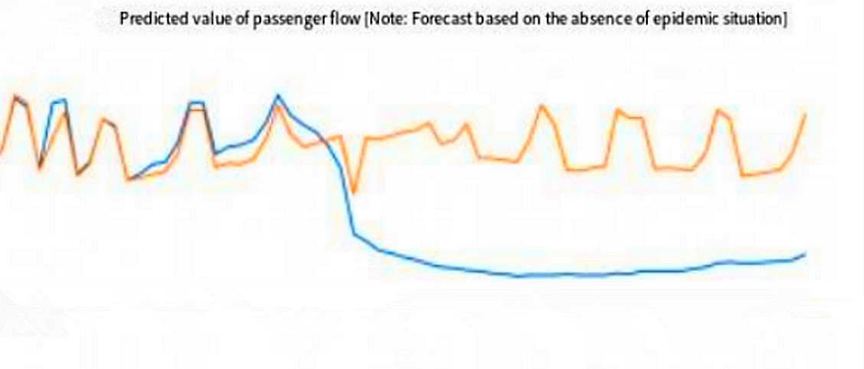
Although the government has given rent relief, issued vouchers, increased advertising and even direct cash distribution to stimulate consumption to reduce the burden, but these traditional ways have little effect, a drop in the water. As the epidemic becomes normal and the novel coronavirus becomes a local epidemic, how to quickly recover and improve the tourism industry is a test for the government.

2. The six-step design thinking method

➢ Step 1: Requirements understanding
(1) Personas: Singapore government agencies such as MAS in the post-pandemic era;

(2) Addiction framework: Singapore government agencies in the post-pandemic era;
Triggers:  Can increase the number of passengers, increase tourism  consumption | Activities:  Distributing tourism-specific  digital currency
Input:  Give out more currency and run  more advertising promotions | Rewards:  The GDP of the tourism industry  The chain has been restored and improved
(3) Framework to be completed: the Singapore government needs to complete the work of increasing the number of tourists in the post-epidemic era;
(4) Future customers: tourists willing to enjoy a 50% discount on digital currency; Comprehensive understanding of needs, can get the empathy map:
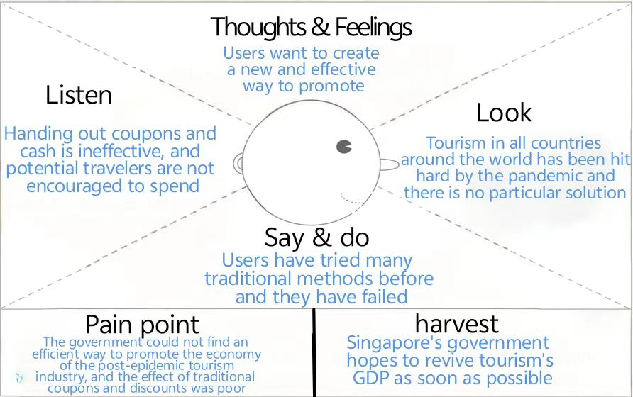

➢ Step 2 : 6WH
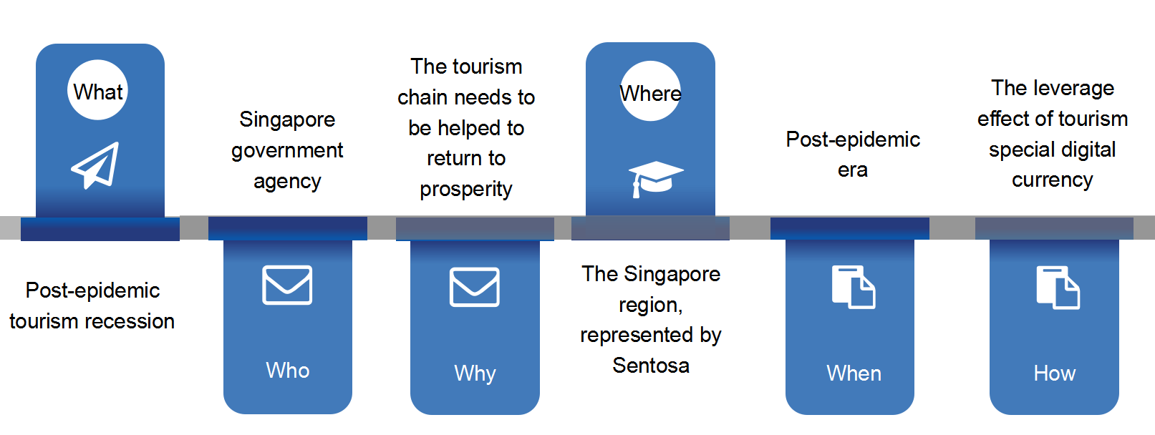

➢ Step 3: Define the perspective
How can the Singapore Government formulate a policy that will facilitate the rapid recovery and growth of tourism GDP in the post-pandemic era?
The past | The Present | The future
peer-to-peer | Singapore fiat currency  freely traded | The borderless  blockchain system
Blockchain 1.0 | Blockchain 2.0 | Blockchain 3.0
Cash coupon | Coupons | Digital currency

➢ Step 4: Creative ideas
- Brainstorming (divergence): Lots of ideas, right and wrong.
Available Options: coupons, shop discounts, free tickets, cash, lottery, free shuttle, free tour guide, new special entertainment activities, free food and accommodation, blockchain digital currency, etc
② Idea screening and classification (convergence) :
(1) Business: discount, increase entertainment activities, lottery, etc
(2) Government: send money, send coupons, blockchain digital currency, etc
(3) Social welfare: free tour guide, free shuttle, etc
Blockchain digital currency (for the masses)
Free guided tour, free shuttle (future)
Discounts,
raffles, coupons (existing)

Convergence conclusion: Digital currency has the greatest advantages and can produce the largest range, the longest time and the fastest impact

➢ Step 5: Prototype design
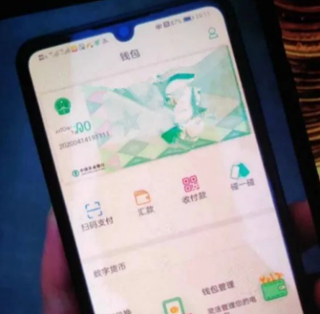 Without Power 

➢ Step 6: Test feedback
We surveyed a total of 169 local and foreign tourists with higher education and some income via the Internet and found that:
(1) Tourism-specific digital currency is very popular among higher education groups, and there is still a lot of room for expansion;
(2) The proportion of people willing to accept special digital currency is 44%, indicating that the policy can be implemented and there is a lot of room to increase the effect through advertising and other ways;
(3) The government's expected leverage cash increment per 200 Singapore dollars/person is about 2,000 Singapore dollars, with a marginal variance of 500. The multiple is 1.5;
(4) If it is an official APP issued by the government, everyone is willing to trust it. However, it is suggested that the government strengthen sandbox management for potential financial risks.

Conclusion:
This solution is completely feasible, has a broad customer base, is innovative and unique, and the expected results will be very significant.
(Attached are the 169 questionnaire details (EXCEL) and analysis report (WORLD).
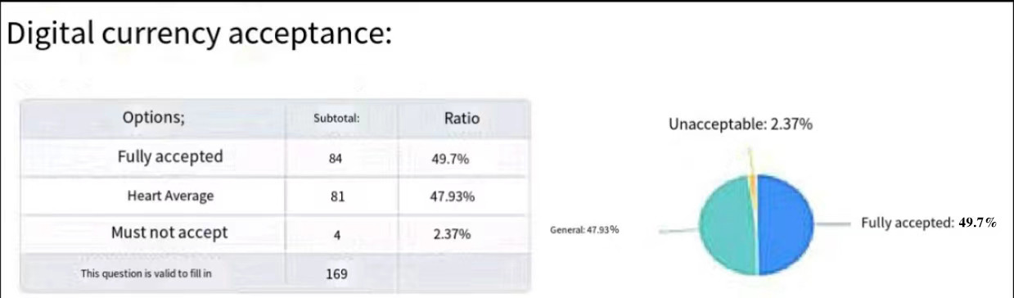
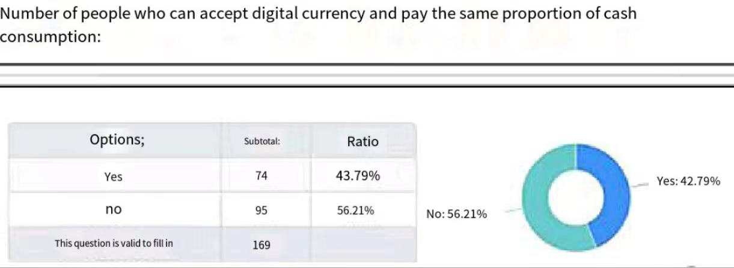

3. Product effect Outlook
This special tourism digital currency is designed so that the currency can eventually be used for tax payment. The currency is designed as a fully circulating B2B, B2C and C2B tourism tool to stimulate the revitalization of Singapore's tourism industry. The design subject relies on MAS, the Monetary Authority of Singapore, to design the system as a financial sandbox.
(1) All tourism operators related to Singapore Sentosa Island will be selected as the pilot units in the financial sandbox, no matter pavilion, catering, cultural innovation, transportation, accommodation, tourism supplies and other businesses; No matter it is state-owned or private, as long as it is operating in the Sentosa area all shortlisted.
(2) For individual residents of the city and individual tourists entering the country in the future, we will issue 200 Singapore dollars per person for tourism special digital currency, which can be collected and spent directly using personal mobile phones. The requirement is that only 50% of the total consumption can be paid with digital currency, and the other 50% needs to be paid in cash. This means that all Sentosa purchases will be 50% off, but not the traditional discount or coupon method.
(3) After receiving the digital currency paid by individual customers, the merchants can finally use it for tax payment or payment between enterprises in the tourism sandbox. The excess digital currency of individual customers can only be spent in sandbox enterprises or pay 50% of the communication fee of the monthly phone card package (to prevent some individual customers from wasting digital currency because they do not want to spend. By paying the phone card communication fee, the digital currency can be fully circulated by the communication company).
(4) If the test period (e.g. 3 months) is significant and no potential financial risks are found, the sandbox can be further expanded by region or industry.5. Expand gradually in batches. In case of risk, it can be controlled and resolved in the sandbox.
3. Design of digital currency specially designed for the Singapore tourism industry
We design a tourism-specific digital currency in the financial sandbox model with the MAS Monetary Authority of Singapore as the main role, which is only applicable to sandbox businesses within the Sentosa region, using the public key and blockchain technology of MAS project Ubin open platform (the prototype of the digital currency payment network jointly developed by MAS officials, JP Morgan Chase and Temasek last year).
Advantages of dedicated tourism digital currency and previous regular promotion methods:
(1) Traditional discount coupons or even cash are not as powerful as 50% discount, and the total amount is small, which is not so attractive to customers. Moreover, there are costs in the issuing process. In addition, in the traditional promotion activities, the number of people who actually get the coupons and go on the tour is very small. People think this is easy to get, the value is not so high, and it doesn't matter whether to go to the scenic spot.
(2) There is no innovation in traditional promotion, but digital currency is a brand new blockchain technology. Many people are curious about digital currency and can't wait to know and experience it.
(3) After the special digital currency is put into the market, it will actually produce the effect of leverage expansion. The final digital currency is guaranteed by the government through tax collection. People do not worry about the depreciation and loss of effect of the digital currency, and the circulation will be more full. Calculated according to the tax rate ranging from 7%-17%, each person issued 200 Singapore dollars will eventually be taxed, so it can generate 1170-2860 cash flow increment, that is, the GPD excess output of the tourism industry chain. The effect is very big.
(4) The newly issued digital currency will eventually be returned to the central bank through taxes, so there will be no risk of currency inflation. And The traditional notes and cash cannot be used on a large scale for a long time, also because of the risk of inflation. Because the ultimate flow of digital currency can be used for tax payment, all individual consumers and merchants have a strong willingness to accept it, and the circulation of digital currency in the market sandbox will be very full. Calculated according to the tax rate ranging from 7% to 17%, each person will issue 200 Singapore dollars for tax payment, so it can generate 1170-2860 cash flow increments. Take an average of 2000 Singapore dollars (that is, the average tax rate of 10%) for a rough calculation of, a conservative forecast, after the promotion month, according to an additional 20,000 local and 30,000 foreign tourists a month to participate in the digital currency tourism consumption, the GPD of the tourism industry chain can produce more than 100 million Singapore dollars per month just because of the digital currency.
With the advertising effect, the number of people participating in digital currency consumption will show exponential growth every month. The tourism industry in the post-epidemic era of Singapore can not only recover quickly but also have a blowout development. The expansion and addition of tourism resources will be the next stage of the government's layout work.
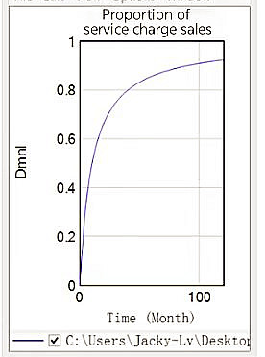

4. Research on the impact of e-CNY (Digital RMB/Yuan) on consumption promotion

(1) research objective
As a product of economic progress and technological development, digital RMB can promote the high-speed and high-quality development of the economy and the progress of society in a reverse direction. In the process of market application of digital RMB, it is extremely necessary to study the factors that promote consumption. By analyzing the importance of the influencing factors, it is possible to distinguish the primary and secondary contradictions, and thus propose targeted measures to improve the development of digital RMB. It is also possible to promote the use of digital RMB more efficiently, better serve many users, and more steadily advance the development process of digital RMB.
Since 2014, the People's Bank of China has set up a special team to conduct special research on issues such as the framework for issuing digital currencies, key technologies, the environment for issuing and circulating, and relevant international experience. The pilot work of the digital yuan has been implemented steadily and progressively as planned and has achieved remarkable results. However, as a new thing, there is little mention of the impact of digital yuan on consumption promotion in relevant research fields. Based on this background, this article conducts relevant data and analysis to analyze the importance of various factors affecting the consumption promotion of digital yuan. Combined with the actual market and financial development situation, suggestions and countermeasures are proposed for the better development of the digital yuan, which has certain theoretical significance for better promoting the development of China's economic market.

(2) Literature review
Digital Renminbi is a type of legal digital currency. Many domestic and foreign scholars have conducted detailed discussions and explanations on the origin and development of digital currencies, but due to the diversity of research objects and methods, their views on digital currencies are not the same.
In 1983, Chaum proposed E-cash, which achieved data untrace ability and anonymity, but still failed to break away from third-party payment systems, so it cannot be strictly called digital currency. [1] In the 2008 financial crisis, the advent of the cryptocurrency Bitcoin marked the birth of a global digital currency. According to Satoshi Nakamoto's idea of designing and releasing open-source software and constructing a P2P network on it, Bitcoin is a P2P digital currency. [2]
Regulatory banks in various countries are cautious about private digital currencies. As the first sovereign country to issue digital currencies, China established a research group for legal digital currencies in 2014, built the first generation of CBDC concept prototype in 2016, and officially began research and development work in 2017 with the approval of the State Council. In 2019, pilot tests were carried out in Shenzhen, Suzhou, Xiong'an, Chengdu and other places. Currently, China's mobile payment methods, especially daily consumer payments, are dominated by third-party payment platforms, which hold a large amount of payment data in the hands of private enterprises, which is not conducive to the overall development of the national digital economy. Therefore, it is necessary for the state must release the suppressed data potential. Domestic experts have also carried out research and published results. Yao Qian took the lead in conducting empirical research on the economic effects of legal digital currencies and found that the impact of issuing legal digital currencies on the financial system is controllable. Liu Kai and others optimized Yao Qian's model and found that the transmission efficiency and countercyclical adjustment of monetary policy were improved under the joint action of digital RMB and digital payment, which also enhanced the monetary multiplier. Gong Liutang believes that digital RMB can enhance the coordination between monetary policy and fiscal policy, improve financial inclusiveness and fiscal direct speed, and promote the expansion of domestic demand and common prosperity. Ma Yang and Yang Dong constructed an analytical framework for the fiscal application of digital currency, which believes that digital RMB can enhance the stability effect of automatic stabilizers and compensate for the deficiencies of discretionary policies from two aspects: shortening policy time lag and standardizing the use of fiscal funds. Chen Wen et al. believe that issuing conditional trigger-based digital currencies can help solve the negative externality problem in data transaction pricing and promote the market allocation of data elements. Yang Dong and Zheng Qingyang believe that after combining technology companies' traffic portals with digital RMB, there will be a win-win value for the implementation of domestic macroeconomic regulation and control as well as the cross-border use of digital RMB. Digital finance not only changes traditional financial service methods but also brings new development opportunities and challenges to all walks of life, which has a profound impact on the optimization and upgrading of economic structure.
Some experts and scholars have made outstanding contributions in the field of practical application. Lu Minfeng believes that as China's legal digital currency, the digital yuan mainly targets retail customers and adopts a two-tier operating system, which belongs to the category of cash (M0), and therefore does not pay interest. Mu Changchun believes that technological development and economic demand have promoted the digitization of fiat currency. In response to the limitations of electronic payment tools in meeting the functions of the value scale, the unit of account, improving payment efficiency, scenario coverage, and privacy protection, as well as the high dependence on cash in regions with insufficient financial services. Liu Jian's research shows that digital finance has a significant positive impact on the innovation level of the industrial chain, while Zhu Dongbo et al. found that digital finance promotes industrial structure upgrading through technological innovation. Lu Minfeng pointed out that digital finance is the deep integration of digital technology and finance, which greatly improves the efficiency and effectiveness of the financial industry
In summary, domestic experts and scholars have conducted in-depth research on the digital yuan, but due to the short trial period of the digital yuan project and other reasons, there is a lack of research results on the relationship between the digital yuan and consumption promotion in China.
The current research findings reveal the key role of the digital yuan in the digital financial industry and its contributions to regional economic development, financial services for the real economy, and technological innovation. As an important component of the digital economy, the digital yuan not only plays an important role in the domestic economy but also demonstrates its potential in the international financial landscape. It provides insight into the position and role of the digital yuan in the digital financial industry.
Foreign literature mainly describes and studies the origin of digital currencies.
Domestic research on digital yuan mainly starts from the main body of digital yuan and conducts research from a top-down perspective. First, the study of the nature definition of digital yuan. It has conducted detailed research on the concept and core characteristics of digital yuan. The literature mainly studies the concept explanation, positioning development, technical architecture, operation mode, core characteristics, etc. of digital yuan from the central bank. Second, the study of the legal system construction of digital yuan. It focuses on the positioning of digital yuan, the revision of the legal framework system of digital yuan, and a series of legal rules related to the issuance and circulation of digital yuan. Third, it studies the impact of issuing digital yuan on various subjects. The impact of issuing digital yuan on commercial banks is worried that it may impact the traditional banking operation system. The impact on third-party payment is to squeeze the living space of third-party payment or collaborate with third-party payment methods, innovate the circulation mechanism of digital yuan, and create multiple payment channels. There are also impacts of issuing digital yuan on macro and micro monetary policies and financial systems. Finally, the study also involves the impact of issuing digital yuan on the internationalization and cross-border payment of RMB.
However, almost all domestic research is conducted from the top down, ignoring the popularity of the digital yuan itself and the reaction of the market to the digital yuan. In order To improve the research on the digital yuan, we must carefully consider and study the consumption of the digital yuan and the market.

(3) Theoretical Basis and Research Hypothesis
(I) Connotation of digital RMB
Digital Renminbi, also known as Digital Currency Electronic Payment (DC/EP), is a digital form of legal currency issued by the People's Bank of China. Qualified operating institutions are designated to participate in the operation and exchange of digital Renminbi to the public. Based on a generalized account system, it supports loose coupling of bank accounts, is equivalent to paper money and coins, supports controlled anonymity, and has legal compensation and value characteristics. The concept of digital Renminbi has two key points. First, it is a digital form of legal currency. Second, it is equivalent to paper money and coins. Its main positioning is MO, which refers to physical currency in circulation. It is used to meet the public's demand for digital cash in the market, while also facilitating inclusive finance. It will also coexist with the physical Renminbi for a long time.
(II) Features and management of digital RMB
First, it has national credit endorsement and legal capacity. Unlike virtual digital currencies such as Bitcoin, the digital yuan is equivalent to fiat currency in terms of effectiveness and security. Bitcoin is only a virtual asset lacking a value foundation and national credit endorsement, making it difficult to ensure stable value. This is the fundamental difference between the two.
Second, adopt a two-tier operating system. The People's Bank of China first exchanges the digital yuan to designated operating institutions such as commercial banks and other financial institutions, and then these institutions exchange the digital yuan to the public. Qualified operating institutions are required to pay 100% reserve to the People's Bank of China. This two-tier operating system is basically the same as traditional banknotes issuance, and will not have a significant impact on the existing financial system. The two-tier operating model adopted by the digital yuan does not compete with the traditional business model of commercial banks, and can also fully utilize the enthusiasm of relevant financial institutions in technological innovation. The central bank's delivery system ensures that the digital yuan is not over-issued, and will be delivered according to market demand.
Third, based on a generalized account system. Under the digital RMB system, anything that can form a unique identifier for personal user identity can become an account.
Fourth, support for loosely coupled bank accounts. Public users can open a digital RMB wallet without a bank account. For Users who cannot or do not have access to bank accounts they can also enjoy financial services from corresponding institutions through digital wallets, which will enhance the user experience and help achieve financial inclusion.
In addition, it also has dual offline payments, higher security, multiple information intensities, peer-to-peer delivery, multiple terminal choices, and high traceability. Get rid of the drawbacks of paper money and coins, and provide some small normal anonymous payment needs, such as small payments; Save various costs related to banknote making: At present, electronic payment is occupied by Alipay, WeChat payment, etc., and once this service with the attribute of public goods goes wrong, it will cause huge losses to the economy and society. Therefore, relevant government departments should adapt to the needs of the times and strive to provide corresponding public products as a backup in the digital economy era. The research and development, promotion, application, and circulation of digital RMB can help meet the needs of the market public in the digital economy era, thereby improving the transaction convenience, security, and anti-counterfeiting capabilities of retail payments, and accelerating the healthy development of China's digital economy.
(III) Economic theory
Lancaster's consumer theory
Consumer theory can be used to explain the behavioral laws of consumer utility, preference, choice, and demand. It is also known as consumer behavior theory or utility theory. It is mainly divided into ordinal utility theory and cardinal utility theory. The former uses indifference curves for analysis, while the latter uses marginal effects for analysis. Lancaster's consumer theory differs from traditional consumer theory in that he emphasizes that the utility obtained by consumers comes from various factors inherent in the goods themselves, rather than directly from the product itself, breaking through traditional views. In fact, The process of consumers purchasing goods based on their own preferences and purchasing power is also a process of decision-making and trade-offs among various factors of the goods.
The differences between Lancaster's consumer demand theory and traditional theories can be summarized into three points: First, consumer utility does not come from the product itself, but from the various factors that the product possesses. Second, a product is composed of multiple factors, and these factors may be shared by multiple products. Third, different products have different combinations of factors, meaning that the corresponding factor combinations for different products are different.
Taking the Central Bank digital currency (CBDC) as an example, the basic connotation of Lancaster's consumer theory can be further elaborated through CBDC. According to Lancaster's consumer theory, residents use CBDC to obtain utility from the various attributes of CBDC rather than CBDC itself. The attributes of CBDC generally include security (legal limit and national endorsement guarantee), privacy (degree of anonymity), convenience (time and platform restrictions), cost (usage fee), and account mode (integration degree). Consumers can rank the utility generated by different combinations of factors at different levels, and choose a combination of monetary factors based on their own consumption preferences to maximize their utility.
Consumer sovereignty theory
Modern consumption is based on the market economy, while traditional consumption is based on the natural economy or the planned economy. In the natural economy, the family is the unit of production and consumption, and what is produced is consumed, and how much is produced is consumed. There is no problem of inter-temporal choice, nor transnational or trans-regional choice, so consumers have little power. In the planned economy period, production is determined by sales, and what is produced is sold and consumed; how much is produced is sold and consumed. When there is a shortage of supply, administrative measures or a ticket system are adopted to restrict consumption, and consumers have no choice. In the market economy, production is determined by sales, and what can be sold on the market (what residents buy) is produced; how much is sold (how much residents buy) is produced. In other words, what consumers need is produced and sold; how much consumers need is produced and sold. The needs of consumers are the starting point of production and sales. After comparing the three types of economic forms mentioned above, it is not difficult to find that the traditional consumption theory based on the natural economy and the planned economy is a producer sovereignty theory, while the modern consumption theory based on the market economy is a consumer sovereignty theory.
As China transforms from a planned economy to a market economy, traditional consumption in China is changing into modern consumption, traditional consumption theory is transforming into modern consumption theory, producer sovereignty theory is transforming into consumer sovereignty theory, and consumers are changing from having no power to having power. This is a major change in the consumption system and consumption thinking.
Consumer Confidence Index
The consumer confidence index is an indicator that reflects the strength of consumer confidence. It comprehensively reflects and quantifies consumers' subjective feelings about the current economic situation, economic prospects, income levels, income expectations, and consumer psychological states, and predicts economic trends and consumption trends. It consists of the consumer satisfaction index and the consumer expectation index. The former refers to consumers' evaluation of current economic life; the latter refers to consumers' expectations of future changes in economic life. They are composed of several secondary indicators: satisfaction with income, quality of life, macroeconomic conditions, consumption expenditure, employment status, purchase of durable consumer goods and savings, as well as expectations for the next year and the next two years for purchasing housing and decoration, purchasing cars, and changes in the stock market in the next six months. The index reflects the changes in the consumer confidence index through questionnaire surveys conducted among urban consumers. The National Bureau of Statistics China Economic Monitoring Center is responsible for surveying and statistics. The base period is the end of 1997, and the index value reflects the changes in the consumer confidence index dynamically. The higher the index value, the stronger the consumer confidence.
(IV) Research hypothesis
As a digital form of fiat currency issued by the central bank, the digital yuan is more stable and secure while ensuring an efficient and convenient payment experience, and has a wider scope of application. The design of the digital yuan combines the advantages of physical yuan and electronic payment tools, which not only have the characteristics of "payment and settlement" and anonymity of physical yuan, but also have the characteristics of low cost, strong portability, high efficiency, and difficulty to forge of electronic payment tools. The digital yuan is based on a generalized account system and supports loose coupling of bank accounts, which means that even if users do not have bank accounts, they can still open digital wallets using unique identifiers such as mobile phone numbers to make payments, which is also conducive to bridging the digital divide and allowing the public to better enjoy fair and inclusive modern financial services. Based on the above, this paper proposes the hypothesis:
The implementation of the digital yuan has a positive impact on consumption promotion, thus accelerating economic development.

5. Research Design
(1) Sample design and data source
This article selects the per capita consumption expenditure of Chinese residents from 2019 to 2023 as the research object and uses the National Bureau of Statistics and other databases as the main source of sample data in the empirical analysis process. Missing and abnormal data are excluded, so the data is highly accurate, comprehensive, and authoritative. By constructing a multiple regression model, the relationship between digital RMB and consumption is explored.
(2) Define variables
1). The explanatory variable. The theme of this article is to explore the impact of the digital yuan on the promotion of consumption and its impact mechanism. In order To comprehensively analyze this issue, we will study the direct impact of the digital yuan on per capita consumption capacity, as well as the indirect impact on per capita consumption capacity through various control variables. Therefore, this article selects the per capita consumption expenditure of Chinese residents as the explanatory variable.
2). Explanatory variables. This article draws on the analytical processes of many scholars and draws on them as a foundation. This article chooses the number of pilot cities for digital RMB as an explanatory variable.
3). Control variables. This article summarizes the influencing factors of consumption promotion into multiple aspects, including the macroeconomic environment, economic policies, market environment, and consumer confidence index. On this basis, a simple model is constructed to reduce the interference of such factors inour research.

6. Empirical analysis and results
Time series data is different from cross-sectional data, as the data is a variable that changes over time. Therefore, there may be false regression due to different trends in data changes and non-stationarity in the same order. Therefore, it is necessary to first perform unit root tests on the data. If the data is in the original sequence or first-order difference stable state, that is, in the same order of stationarity, the next step can be analyzed. Then perform cointegration tests to verify the relationship between the variable data is a long-term equilibrium state. Subsequently, perform a regression analysis to verify how the relationship between the data is. This study uses research data from 2019-2023.
Establish OLS model
According to the research objective of this article, the model is set based on the variables set:
$$LnY_{t}=α_{0}+α_{1}X1_{t}+α_{2}LnX2_{t}+ε_{t}$$
Among them, $α_{0}$ is a constant term, $α_{1}$ is the regression coefficient, which needs to be estimated, and t represents the year or time, $ε_{t}$ represents the random error term, which represents the unobserved values that affect LnY. Since Y and X2 are absolute values, in order To reduce the differences between values and make the coefficients more reasonable, they are log-transformed.
Next, descriptive statistics of variable data are conducted to understand the basic distribution, minimum and maximum values, and mean of the data. The standard deviation is used to judge the fluctuation level of the data, which can provide a basic understanding of the research data in this article.
Descriptive Statistics
 | Mean | Median | Maximum | Minimum | Std. Dev. | Skewness | Kurtosis
LNY | 8.4388 | 8.5236 | 9.2241 | 7.6271 | 0.5646 | -0.1213 | 1.6139
X1 | 4.3152 | 4.6207 | 6.3250 | 1.8781 | 1.6269 | -0.2060 | 1.3022
LNX2 | 9.4890 | 10.2206 | 11.3743 | 6.2299 | 1.6435 | -0.7872 | 2.4542
The above chart shows that the mean value of LnY is 8.4388, the minimum value is 7.6271, and the maximum value is 9.2241, indicating that LnY is in the middle level. The mean value of X1 is 4.3152, and the mean value of LnX2 is 9.4890.
Next, we conduct unit root tests to test the stability of the data. If the original series is not stable, we continue to perform differential processing until the data is stable. If the data is stable in the same order, we can continue to perform regression analysis on the original series data. If both are stable at the original series level, there is no need for cointegration test verification and direct regression can be performed. If both are stable at the first or higher order, regression analysis needs to be performed on the original series data, and a cointegration test is needed to verify whether the relationship between the data is not spurious. The following unit root test is shown below:
ADF test of variables
 | ADF test value | 1% critical value | 5% threshold | 10% threshold | conclusion
LnY | -0.8327 | -3.7529 | -2.9981 | -2.6388 | Unstable
D(LnY) | -4.8120 | -4.4163 | -3.6220 | -3.2486 | stable
X1 | -0.2695 | -3.7379 | -2.9919 | -2.6355 | Unstable
D(X1) | -3.3945 | -3.7529 | -2.9981 | -2.6388 | stable
LNX2 | -1.0018 | -4.5326 | -3.6736 | -3.2774 | Unstable
D(LnX2) | -2.6156 | -2.6694 | -1.9564 | -1.6085 | stable
Wherein, D represents the first-order difference.
Through the unit root test, the ADF test value of LnY is -0.8327, which is greater than the 10% critical value of -2.6388, indicating that LnY is not stationary, while the first-order difference of LnY is stationary, with an ADF test value of -4.8120, which is less than the 10% critical value of -3.2486, indicating that the difference sequence is in a stable state. Inferencing all other variable sequences, all sequences are in a first-order stable state and can continue to the next step of analysis.
The series are not stationary in the original series but are first-order stationary. If we want to perform regression analysis on the original series, we need to conduct a cointegration test to verify it. First, we need to determine the optimal lag order based on relevant criteria.
Selection of optimal lag order
Lag | LogL | LR | FPE | AIC | SC | HQ | Lag | LogL
0 | -40.6789 | NA | 0.0090 | 3.7982 | 3.9463 | 3.8354 | 0 | -40.678
1 | 42.5861 | 137.56* | 1.42e-05* | -0.6596* | -.06725* | -0.5106* | 1 | 42.5861
2 | 48.8737 | 8.7481 | 0.0000 | -2.4238 | -1.3870 | -2.1631 | 2 | 48.8737
Judging from the asterisks automatically labelled by the software, the number of satisfying criteria is the highest for the first order, therefore, the optimal lag order is 1.
Cointegration Test
Unrestricted Cointegration Rank Test (Trace)
Hypothesized |  | Trace | 0.0500
No. of CE(s) | Eigenvalue | Statistic | Critical Value | Prob.**
None * | 0.6782 | 41.6215 | 35.1928 | 0.0088
At most 1 | 0.4043 | 15.5460 | 20.2618 | 0.1967
At most 2 | 0.1461 | 3.6322 | 9.1645 | 0.4696
Unrestricted Cointegration Rank Test (Maximum Eigenvalue)
Hypothesized |  | Max-Eigen | 0.0500
No. of CE(s) | Eigenvalue | Statistic | Critical Value | Prob.**
None * | 0.6782 | 26.0754 | 22.2996 | 0.0141
At most 1 | 0.4043 | 11.9138 | 15.8921 | 0.1910
At most 2 | 0.1461 | 3.6322 | 9.1645 | 0.4696
As can be seen, there are two types of tests: trace test and maximum eigenvalue test. Both tests show that the trace statistic or the max statistic is greater than the 5% critical value, thus rejecting the null hypothesis of no cointegration relationship between the variables. The consistency of the two test results indicates that the cointegration test has passed.
Next, we will have a basic understanding of the relationship between variable data. Correlation analysis refers to the correlation between two variables without the influence of additional control variables. Therefore, it can only provide a preliminary judgment of the relationship between variables, but cannot be used as the final regression result. Next, we will conduct a correlation analysis to make a preliminary judgment:
Correlation analysis
 | LNY | X1 | LNX2
LNY | 1.0000
 | -----
X1 | 0.9663*** | 1.0000
 | 0.0000 | -----
LNX2 | 0.9506*** | 0.9190*** | 1.0000
 | 0.0000 | 0.0000 | -----
Note: ***, **, * indicate significant correlation at the significance levels of 0.01, 0.05, and 0.1, respectively.
At this time, the correlation coefficient between the X1 indicator and LnY is 0.9663, which is significant at the 1% significance level. The correlation coefficients between LnX2 and LnY are also significant, indicating a positive relationship between X1, LnX2, and LnY.
Next, we use OLS regression analysis to analyze the quantitative relationship between variables and can perform t-tests, F-tests, and goodness-of-fit tests to make a comprehensive overall judgment on the model and obtain results.
Regression analysis
Variable | Coefficient | Std. Error | t-Statistic | Prob.
C | 6.2337*** | 0.2176 | 28.6495 | 0.0000
X1 | 0.2070*** | 0.0380 | 5.4449 | 0.0000
LnX2 | 0.1382*** | 0.0376 | 3.6726 | 0.0013
R-squared | 0.9590
Adjusted R-squared | 0.9552
F-statistic | 257.0851
Prob(F-statistic) | 0.0000
Note: *** represents a significant effect at the 1% significance level, ** represents a significant effect at the 5% significance level, and * represents a significant effect at the 10% significance level. The t-value is in parentheses.
Regression results: The R-square of the model is 0.9590, indicating a high degree of model fit. The F-test value is 257.0851, indicating that there is a probability of over 99% that the significance of the entire model passes. The significance of individual variables can be observed. The influence coefficient of explanatory variable X1 is 0.2070, which passes the significance test at a significance level of 1%. For every unit increase in X1, Y increases by an average of 20.70%. For every 1% increase in X2, Y increases by an average of 0.1382%. X2 also has a significant impact.
According to the analysis of empirical results, we can see that as the number of pilot cities for digital yuan increases, the consumer confidence index follows it, and national GDP and per capita consumption expenditure also rise straightly. Therefore, the development of the digital yuan has a positive effect on consumption promotion. The hypothesis is established.

7. Research conclusions and suggestions
(I) Research conclusions
This article uses relevant data representing consumption power as a sample to construct a regression model for the digital yuan and conducts regression analysis on it. The research results show that the development of the digital yuan has a positive effect on consumption promotion and has a huge impact. In addition, the research results also show that in turn, the promotion of consumption and economic development is also conducive to promoting the implementation of the digital yuan project. Therefore, by accelerating the promotion and implementation of the digital yuan project, it can effectively increase the consumption power of Chinese residents and accelerate the high-quality development of China's economy.
(II) Research suggestions
Based on the research and analysis in this article, it is found that the development of digital RMB has a significant positive impact on the consumption power of Chinese residents and the speed of economic development. Based on this, this article proposes the following policy recommendations based on the research conclusions and combined with relevant literature review.
(1) Overall planning to ensure the stability of the monetary system
Avoid vicious competition between third-party payment and digital yuan, set up a benign cooperation policy, which can promote the market circulation of digital yuan, and mobilize third-party payment and other relevant parties to participate in the construction of the circulation mechanism of digital yuan. Maintain the service system of digital yuan with the central bank as the core. The public's trust in currency is the cornerstone of stability. To ensure that existing financial institutions, big technology companies, and new innovators in the future enter an open market to compete, it is necessary to build on the public goods of the central bank. Ensure that users are provided with convenient services at low cost, as well as security, privacy and a wide range of payment options. Take advantage of big data and DLC to promote the establishment of a competitive and orderly currency system structure with a public welfare nature. For social services
The central bank acts as the operator, supervisor, and catalyst of the payment market, and carries out the regulation of commercial banks and other financial institutions for the benefit of users
Supervision and regulation.
Supporting innovative applications of digital yuan, protecting users and the financial system from risks, while promoting technological progress, government policymakers should allow the private sector to participate in collaborative governance of digital yuan under controlled conditions. The design of currency has consequences for the entire socio-economic system: the integrity and stability of reporting and payment, market concentration and efficiency. Enhance monetary trust, ensure user trust in the digital age, and ensure the establishment of an efficient digital yuan financial system that is trusted by the public. Economic society and mass users need a monetary and financial system institution that can withstand the test of time. Ensure the stability of currency as the main unit of account, medium of exchange, and store of value in the economy, and ensure the security and integrity of payment. As a public policy institution, the People's Bank of China, while adapting to rapid economic and social changes, has become a key institution supporting this trust in currency. While constantly adapting to economic and social changes, it also participates in digital innovation. Innovate in a robusty and sustainably manner, ensure that the financial system is built on existing foundations, serve public interests, and benignly collaborate with technology companies, all starting from the interests of users.
(2) Improve the laws and regulations of digital RMB
The issuance and circulation of digital yuan have made rapid progress, but there is still a certain lag in the corresponding laws and regulations. The central bank and other relevant departments should solve the problem of the incompatibility between the issuance and circulation of digital yuan and the current laws and regulations as soon as possible. First, it is necessary to improve and repair the relevant laws such as the "Law of the People's Bank of China" and the "Regulations on the Administration of RMB". Second, it is necessary to request the National People's Congress to make decisions on the laws and regulations related to digital yuan and solve the problems in the issuance and circulation process, so as to determine the nature of various issues related to digital yuan from the perspective of the Constitution. Third, it is necessary to formulate a new "Digital Yuan Law" for digital yuan, which specifically addresses the legal issues in the whole process of subsequent issuance, circulation, trading, etc. of digital yuan, so that all parties involved can have laws to rely on in the process of trading digital yuan and use the law to effectively safeguard their own rights and interests.
(3) Strengthen the popularization of education and improve the financial literacy of users
Zuo Ping and others believe that people's actions often follow the principle of maximizing benefits, and the greater the uncertainty of a thing, the more people
The more concerns arise, the more likely people will give up their behavioral choices in related areas. Therefore, the country should find ways to dispel the public's concerns about the new digital yuan.
First, strengthen public users' understanding of digital RMB, pay attention to the use of Internet means, and give practical play to various main players
Innovate the publicity, methods, and content of the digital yuan, strengthen the obligation and responsibility of users, and guide them to correctly
To understand the digital yuan and then use it. At the same time, we should give full play to the second-tier operating entity of the dual-tier operating entity and strive to
Give full play to the role of commercial banks, financial technology companies, financial infrastructure service providers and other relevant institutions, and guide users to some service operation platforms to understand the digital yuan. For different groups of targets of the digital yuan, carry out targeted publicity
We should carry out education activities, innovate education methods and forms, and urge the issuers, circulation and exchange of digital RMB by the central bank and other relevant entities
E-platform and other platforms should handle the relationship between circulation and education well, for example, when carrying out financial knowledge activities such as the Financial Knowledge Month, they can
Selectively conduct digital yuan-themed activity propaganda. Second, popularize relevant financial rights protection knowledge, and guide users to conduct platform transactions
Problems encountered during the process can be reflected through channels and through legal means,and rights can be protected. In publicity, it is gradually becoming clear
Defining the rights and obligations of users.

References
[1]CHAUM D.Blind Signatures for Untraceable Payments[C]//Advances in Cryptology.Boston.MA:Springer US.1983:199-203.
[2] Gaocheng District Government, Popularizing Financial Knowledge - The "Past and Present" of Bitcoin - Preventing Illegal Fundraising https://www.gc.gov.cn/col/1531469842998/2018/11/14/1542180969706.html
[3] People's Bank of China, White Paper on the Research and Development Progress of China's Digital Renminbi [EB/OL]. (2021-07-16) [2022-10-22]. https://www.gov.cn/xinwen/2021-07/16/5625569/files/e944faf39ea34d46a256c2095fefeaab.pdf
[4] Feng Sixian, Yang Jing. The Mechanism of Digital RMB in Preventing Data Monopoly Risks on Internet Platforms [J]. Reform, 2021 (12): 69-80
[5] Yao Qian: "An Analysis of the Economic Effects of Legal Digital Currencies: Theory and Empirical Evidence", International Finance Research, 2019, Issue 1.
[6] Liu Kai, Guo Mingxu, Li Yu: Research on the Macroeconomic Impact of the Issuance of Digital Renminbi and the Development of Digital Payment, China Industrial Economics, 2023, Issue 3.
[7] Gong Liutang: "The Prospects and Opportunities of Digital Renminbi under the New Development Pattern", People's Tribune, 2022, Issue 7.
[8] Ma Yang and Yang Dong: "Complementing the whole picture of digital currency research: an analytical framework for fiscal applications of digital currency", International Economic Review, 2023, Issue 2.
[9] Chen Wen, Zhang Lei, Yang Tao: "Innovation in the Design of Central Bank Digital Currency Issuance from the Perspective of Data Governance", Reform, No. 9, 2020.
[10] Yang Dong and Zheng Qingyang: "TikTok Event and the Path Selection of Digital Currency: From Traffic Inlet to Financial Advantages"
Journal of Xinjiang Normal University (Philosophy and Social Sciences Edition), 2021, Issue 4.
[11] Lu Minfeng, Shi Zhihui, Strategies for Promoting the RMB's Internationalization and Currency Standardization under the Financial Power Strategy [J], Rural Finance Research, 2023 (12); 11-19
[12] Mu Changchun. Adapting to technological evolution and economic development trends and actively promoting the development of our own legal digital currency [J]. Banner, 2020 (11): 65-66
[13] Liu Jian. Can digital finance promote industrial chain innovation? [J]. Modern Management Science, 2023(04): 46-56
Zhu Dongbo, Zhang Xiangwei. Has digital finance promoted industrial structure upgrading through technological innovation? [J]. Journal of Scientific Research Management, 2023, 44(07): 73-82
[15] Lu Minfeng. Research on the Path of High-quality Development of the Real Economy Empowered by Data Elements under the New Development Pattern [J]. Journal of Social Sciences, 2023(02); 149-157
[16] Zuo Ping, Wang Jianzhong. The Identification and Concerns of the Resettlement Policy of the Xiaolangdi Reservoir Resettlement [J]. People's Yellow River, 2005 (4): 37-39

