Quantumctek (688027) Analysis and Improvement

Abstract
Quantumctek is mainly engaged in the research and development, production, sales and technical services of quantum secure communication products. It is the quantum equipment provider of the world's first long-distance quantum secure communication trunk line "Beijing-Shanghai Trunk Line", "National Wide Area Quantum Backbone Network (Phase I)" and other projects, and participated in the construction of "Micius" quantum satellite secure communication ground station. Google's Gidney and Ekera have shown how a quantum computer could use 20 million qubits to break RSA encryption, which is now the most widely used, at 2048 bits. They demonstrated that such a device could perform a calculation calculate in just eight hours. In the future, the company must build a platform, continue to open API ports to market forces, gradually establish a complete industrial value chain, and realize the high growth of network effects as soon as possible.
Keywords: Quantumctek, quantum satellite, decryption technology, future society

Company profile
Quantumctek Co., LTD. (Shanghai: 688027, referred to as: QuantumCTEK), formerly known as Anhui Quantum Communication Technology Co., LTD., was founded in 2009, jointly initiated by the affiliated enterprises of the University of Science and Technology of China and Pan Jianwei et al., mainly engaged in the research, development and sales^{[1]} of quantum communication technology equipment and applications. Quantum communication technology is an unreplicable and indecipherable encryption and decryption technology in the pure sense, which has trans-era significance in the field of information transmission and will become the safest and most reliable means of communication in the future society, whether it is national defense, military or civil and commercial fields.
The company was listed on the Science and Technology Board of Shanghai Stock Exchange on July 9, 2020, with a maximum increase of more than 1000% on the first day and a closing price of 923.85% higher than the opening price, setting a new historical record of the science and technology board. After listing, the highest market value once reached about 50 billion yuan, while the annual turnover was only more than 100 million yuan.
Taking the full industrialization of quantum information technology as its responsibility, QuantumCTEK takes the lead in the field of quantum communication. After more than ten years of exploration and innovation, QuantumCTEK has grown into a leading enterprise in the domestic and even global quantum secure communication industry, and is a pioneer, practitioner and^{[2]} leader in the industrialization of quantum communication.
Quantumctek is mainly engaged in the research and development, production, sales and technical services of quantum secure communication products. It is the quantum equipment provider of the world's first long-distance quantum secure communication trunk line "Beijing-Shanghai Trunk Line", "National Wide Area Quantum Backbone Network (Phase I)" and other projects, and participated in the construction of "Micius" quantum satellite secure communication ground station. As of 2020, there are more than 7,000 kilometers of practical optical fiber quantum secure communication networks in China, of which more than 6,000 kilometers have used QuantumCtek products and are in online operation.

Quantum communication is undecipherable and unrepeatable
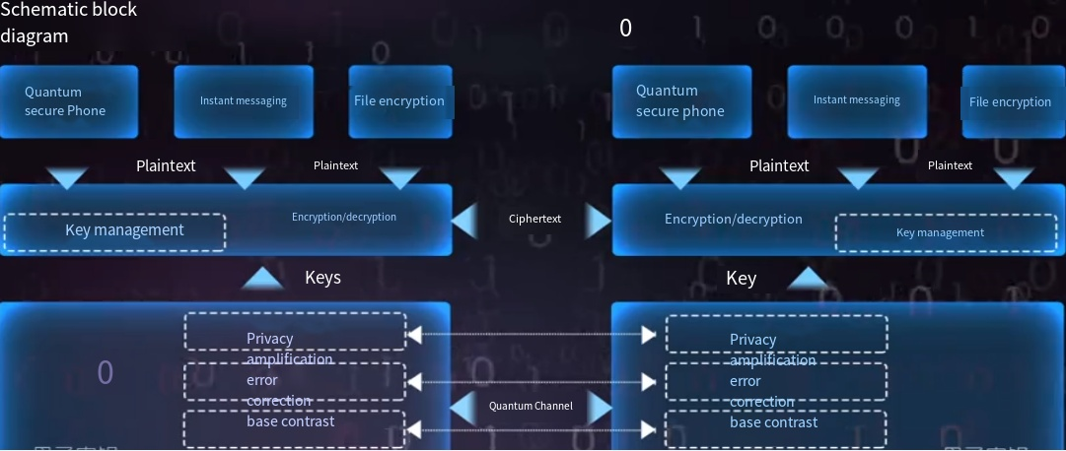
Schematic diagram of quantum communication technology
Headquartered in Hefei, the company is mainly engaged in the research and development, production, sales and technical services of quantum communication products, providing hardware and software products for various types of optical fiber quantum secure communication networks and the construction of satellite-earth integrated wide-area quantum secure communication ground stations, and providing networking and quantum security application solutions for government affairs, finance, electric power, national defense and other fields.
The essence of quantum communication is quantum key distribution. Quantum key distribution is carried out through classical channels, using fiber optics and so on, which are also used on a large scale in communication today. So quantum key distribution does it one secret at a time, which was invented by Major Joseph Mauborgne and Gilbert Vernam of AT&T in 1917. In contrast to the current widespread public/private key system ^{[5]} of RSA encryption, quantum key distribution is characterized by updating the private key with each communication, and by the properties of quantum mechanics, it is possible to know whether each private key transmission is being monitored.
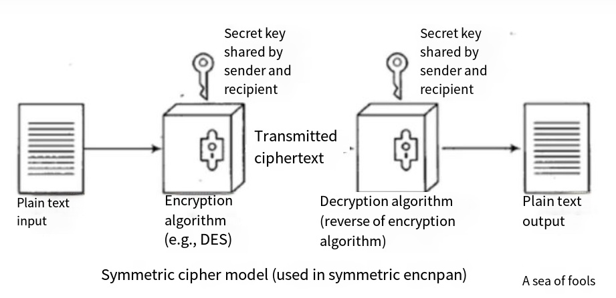
At present, the most mainstream commercial encryption method is RSA algorithm, and at present, the classical computer can not crack the RSA in a limited time. RSA and other asymmetric encryption algorithms are essentially mathematical problems such as prime factorization of large numbers. Compared with the classical prime factorization algorithm, a Shor quantum algorithm has the parallel advantage and can compress the prime factorization time of large numbers to a short ^{[6]} time, which threatens the traditional Internet technology based on RSA and other asymmetric encryption algorithms.
Google's Gidney and Ekera have shown how a quantum computer could use 20 million qubits to break RSA encryption, which is now the most widely used, at 2048 bits. They demonstrated that such a device could perform a calculation calculate in just eight hours. A 20-million-qubit quantum computer certainly seems a long way off ^{[7]} today, but what experts need to know is whether it will be possible in 25 years, and if it does, it will require updating existing encryption methods, of which quantum key distribution is one alternative ^{[8]}.
Even Quantumshield chose the code 688027, reportedly because it is a prime number that cannot be decomposed.
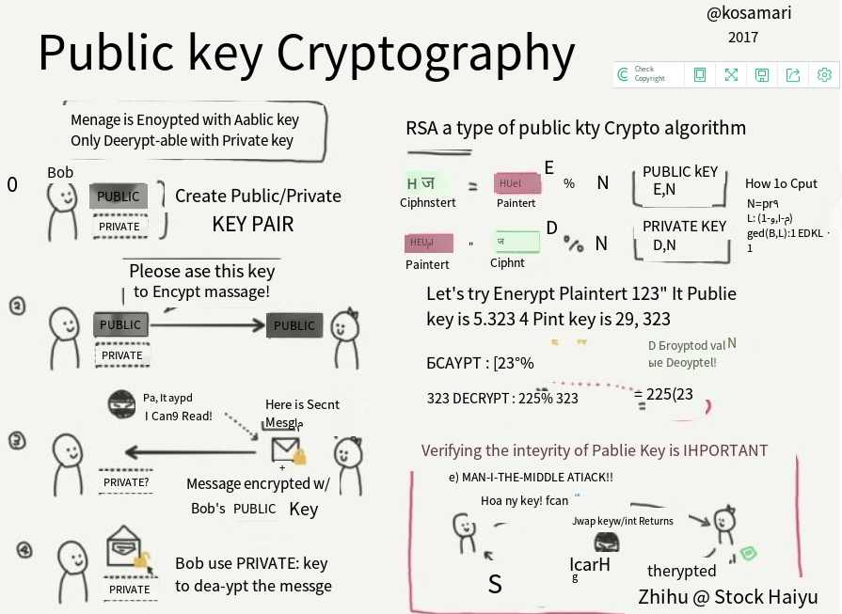
What other post-quantum encryption algorithms are there besides quantum key distribution?
The NIST PQC standard solicitation was officially launched in 2016. After an initial selection, NIST published 69 "complete and appropriate" drafts. Among the 69 candidate drafts, there are mainly post-quantum cryptographic algorithms constructed by the following four mathematical methods: Lattice-based, Code-based, Multivariate and Hash-based. Nearly a year ^{[9]} has passed since the NIST's announcement (2018.9). The cryptography community has carried out detailed cryptanalysis of these algorithms. At present, nearly 1/3 of the algorithms have been found to have various defects, and nearly 1/5 of the algorithms have been completely broken. Whether the remaining encryption algorithms can resist the cracking of quantum computers also depends on the development of future quantum computer algorithms.
It can be confidently said that the track and technology involved in Guadun quantum will inevitably play a pivotal role in the future of social science. There are also Google, Microsoft, Arqit Quantum (ARQQ), IonQ (IONQ), Quantum Computing (QUBT) and other companies actively layout quantum communication and quantum computing and other tracks ^{[10]}, and have achieved partial commercialization.
Although a wide range of civil and commercial quantum industries has not yet arrived, but government agencies have struggled in this field, and the United States even directly pulled Quanta into the trade black ^{[11]}list at the end of 2021, reflecting the potential and influence of Quanta in the future, as well as the trend of incandescent national competition.

The current business challenges
At present, the company's main business is to customize quantum communication equipment and regional networks for the needs of a few major customers such as the government. Each project has unique products and technologies to match with it. At the same time, due to the confidentiality and advanced technology, there are not many market industry chains that can participate in the company's business. Almost all the industrial value chains from upstream to downstream are in their own hands, which on the one hand is caused by the advanced uniqueness of the technology, on the other hand, it also shows that the company's business has not been widely recognized by the market. The company's cash flow mainly relies on financing and government subsidies, as well as the party bidding and procurement of government agencies. In the civil market, the company has not obtained considerable and sustained market share.
During the two years of the novel coronavirus epidemic, government procurement expenditure was biased towards the areas of people's livelihood and consumption promotion, and the construction of quantum projects of metropolitan area network and backbone network had a large area of delay and payment slowdown, which had a huge negative impact on the development of the company. The company's sales and net profit declined year by year, and even suffered a huge loss in 2021.
Due to the company's business model and operation problems, the company's sales and net profit have declined continuously in the past five years, and there was a loss of 37 million yuan in 2021. The company's main products currently include quantum communication network construction and superconducting quantum computers and systems. The company's main customers are government agencies and university research institutes. The company's top ten customers account for more than 80% of the total sales, relying heavily on a few key customers, and the market flexibility is poor. The gross profit margin of its products has been declining year by year by a large margin. Competitors and competitive products appear rapidly in the market, and QuantumCtek's competitive advantage has shown a downward trend.
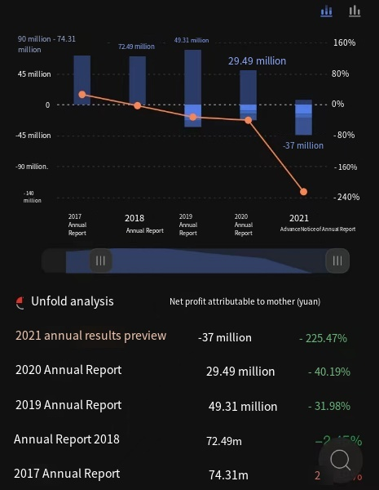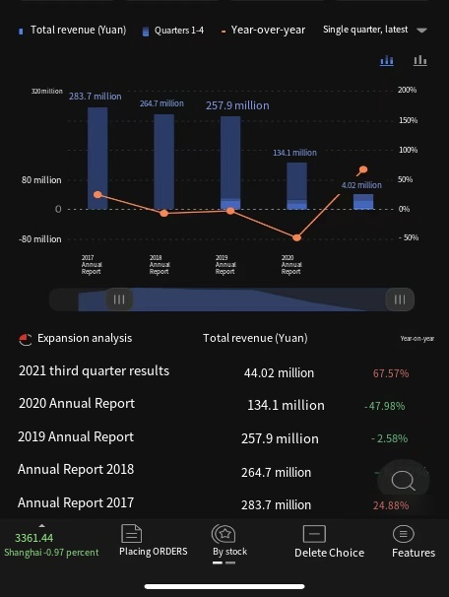
Net profit curve of recent five years Sales curve of recent five years

Current business model
The current business model canvas is shown below:







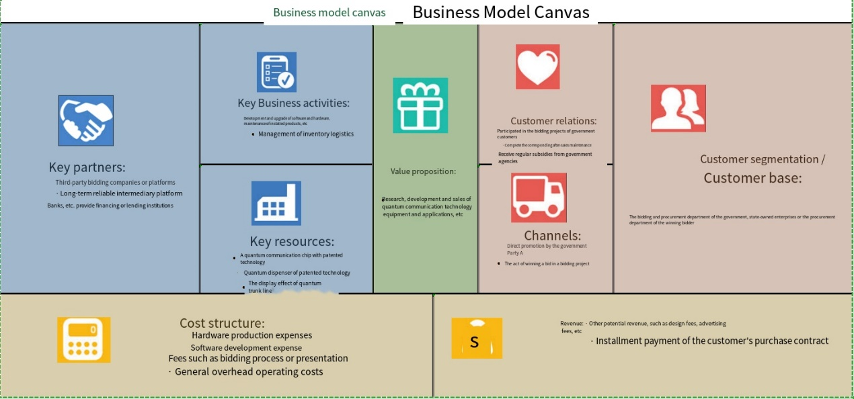
First, the company's business structure relies on a single large project, resulting in revenue growth and an unstable structure. According to the application fields disclosed by the company, it is mainly divided into a backbone network, metropolitan area network and local area network.
The backbone network is a long-distance network that connects the country's important communication nodes. The early construction was carried out by the University of Science and Technology of China, and later by CQUantum.com or its affiliates. The contractors were generally system integrators such as Digital China System Integration, and QuantumShield mainly provided quantum communication products to the contractors. The project amount of the backbone network is generally relatively large, and the impact of a single project on the company's gross profit is also relatively significant. At present, backbone network projects that have been built or are under construction mainly include Beijing-Shanghai Line, Wuhe Line, Han-Guangzhou Line and Shanghai-Shanghai Line. The total investment of the Beijing-Shanghai Line reached 565 million yuan, and the combined investment of the Shanghai-Shanghai and Han-Guangzhou lines also amounted to 173 million yuan. At present, the construction of the metropolitan area network covers Hefei, Jinan, Wuhan, Beijing, Urumqi and other cities. Only the Wuhan metropolitan area network has invested more than 100 million yuan, and most of the others are less than 50 million yuan.
This kind of dependence on a few projects also makes the company's income structure fluctuate greatly. In the past three years, the backbone network income is 0.20, 143 and 57 million yuan respectively, and the metropolitan area network income is 2.19, 0.73 and 150 million yuan respectively. The proportion of the backbone network and metropolitan area network structure is dominated by each other, indicating that the two parts of income are not sustainable enough. In addition, because the company's income depends on government investment, in 2018 and 2019, the company's revenue was -6.7% and -2.6%, respectively. The government's investment in backbone networks and metropolitan area networks is not sustainable enough. Among the more than 7,000 kilometers of fiber optic quantum security communication networks built, QuantumCtek has a total length of 6,475 kilometers, which can be said to be basically the participation of the company. These risks were also reflected in the inventory increase at the end of 2018, mainly because the promotion of the metropolitan area network was not as expected. In the case of marginal weakening of promotion efforts, the company faces a decline in revenue volume and price.
In fact, the core problem facing the company is the immaturity of the business model, which leads to the company's fragile performance in the financial side. At the commercialization level, the company's products are not competitive in price compared with the current encryption products, and the company's products are greatly limited for enterprise customers when quantum secure communication is not a top priority. Just like Ren Zhengfei said, "One step ahead is advanced, two steps ahead is a pioneer, three steps ahead is a martyr." Products that are too ahead of downstream applications may become martyrs.
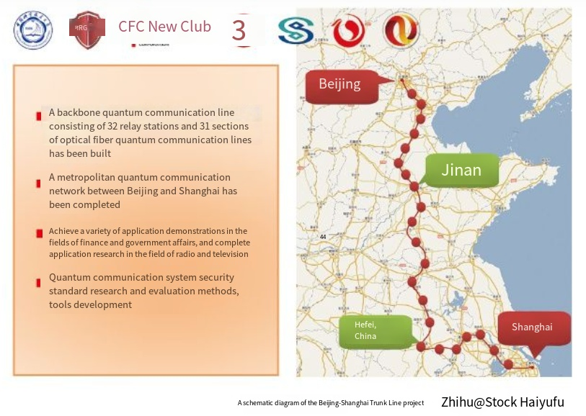

Suggestions and improvements

4.1 Develop new business models
To build the platform, open the development right of products and services to the industrial chain customer base.
It should not be limited to customized products for government customers, let alone rely on government subsidies to supplement cash flow. Let the work of custom design procedures be done by market forces to achieve high growth of the platform.
Although the company's products and services are advanced and fewer institutional companies participate in the industrial chain, the company can fully take advantage of its own advantages as an industry standard setter, develop a system and build a platform, open APIs, and realize network effects.
First of all, to obtain direct network effects, the quantum communication system platform can directly obtain downstream customers in this industry, so that they can use the platform to obtain their own confidential communication services. For example, QuantumCtek and China Telecom cooperate to withdraw the quantum sim card and realize the quantum privacy of mobile phone traffic and voice calls. All China Telecom sim card users may become its customers and generate revenue for the company.
Secondly, to obtain indirect network effect and open system API, which allows software companies and service companies to develop and embed their own apps or programs on the platform to achieve different functions for different segments of customer groups. Let competitors or subsystem services and products add value to their own platforms. For example, Chinese petroleum companies can query cloud computing and cloud data on the open platform of Guodong, learn the dynamic flow trend of oil products around the world and predict the trend of oil prices, so as to make the updated layout of oil trading, storage, logistics and transportation. Even some small start-up companies can also participate in the development of apps on the Guodong platform. For example, medical diagnosis start-up companies can use the quantum privacy platform to upload all their medical records and customer information, making these key confidential data become the company's hard assets and obtain the best confidentiality.
Thirdly, the Guodong platform should have the thinking and design of transferring cost. Let the customers of the platform generate and bear higher costs when they switch to the platform. This increases customer loyalty and generates long-term cash flow.
The new business model canvas is as follows: business focus shifts to platform building and service.
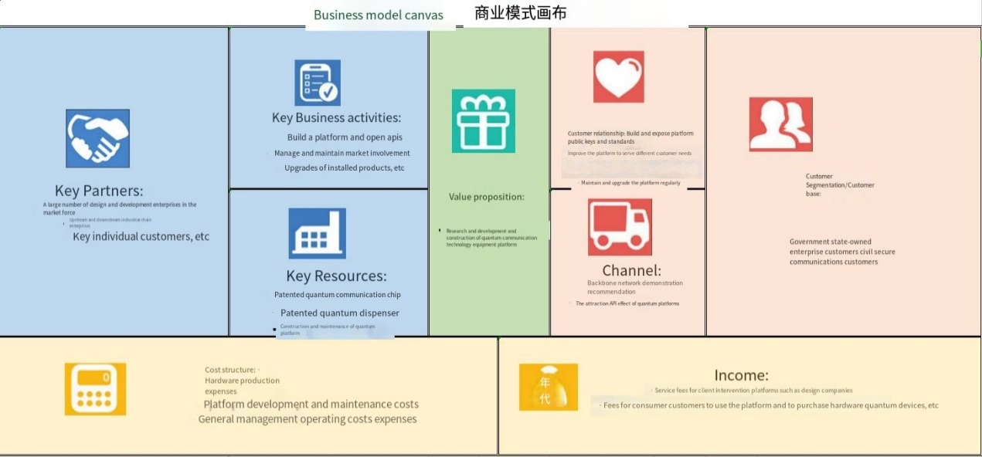

4.2 Designing Network Effects
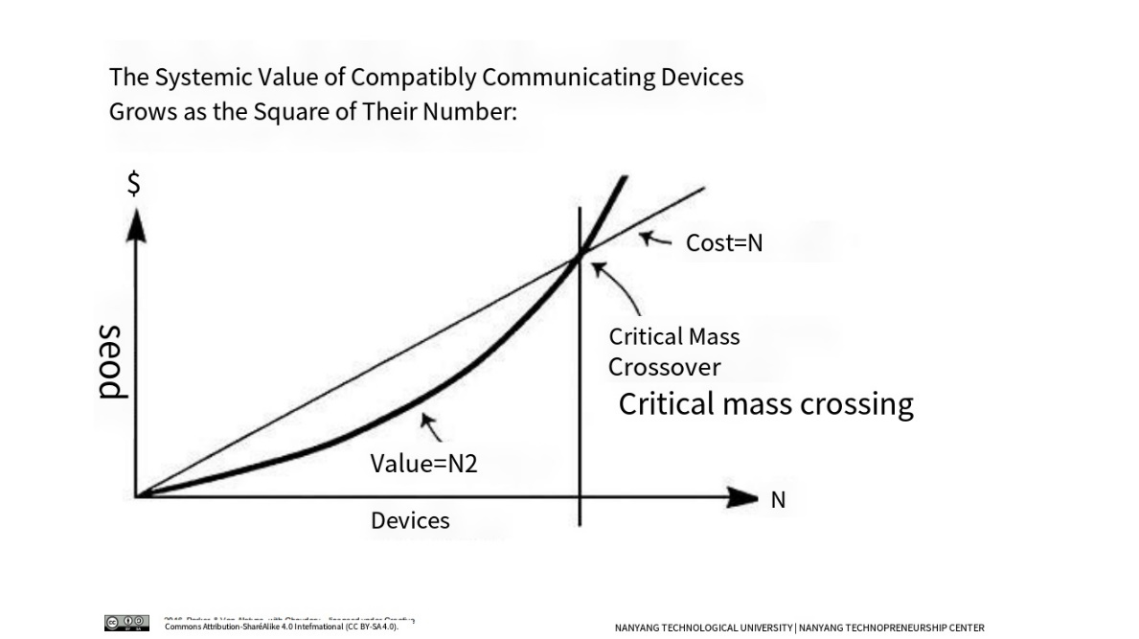
Where V1 is revenue, is the value of network effect, the more the number of customers n, the more income, and the exponential relationship; V2 is expenditure, sales expenditure changes positively with the number of customers n, but the basis is in a linear relationship. The intersection of V1 and V2 is the critical point at which the company's cash flow is positive.
Through the platform network effect classic graph, combine the formula
V1=a*n (n-1) ≈an²,
Vcm V1=V2=an²=c+βn,
The value n can be obtained, that is, when the number of customers reaches how many can realize the first positive cash flow. And this kind of customer cash flow has good continuity, because they are not oligarchic government customers, but customers in the civilian market.

4.3 Design a high-growth system model
According to the above business model, design the system model as follows:
When the government is the main customer's growth limit, change to an open platform, develop civilian customers, attract market enterprise customers to enter the platform, the work of customized services and products to market enterprises to do, the company mainly maintain and upgrades the platform, through a period of marketing, will generate platform use service fees, one of the income. At the same time, after the service types of the platform are diversified, more customers in subdivided fields will use this platform and become direct customers of QuantumCTEK's direct customers and indirect customers of the platform company. The platform has realized the network effect and achieved high growth.
The revenue is divided into three parts: the sales revenue of quantum communication equipment, the royalty income of quantum platform and the royalty fee of quantum device software developed by the company.
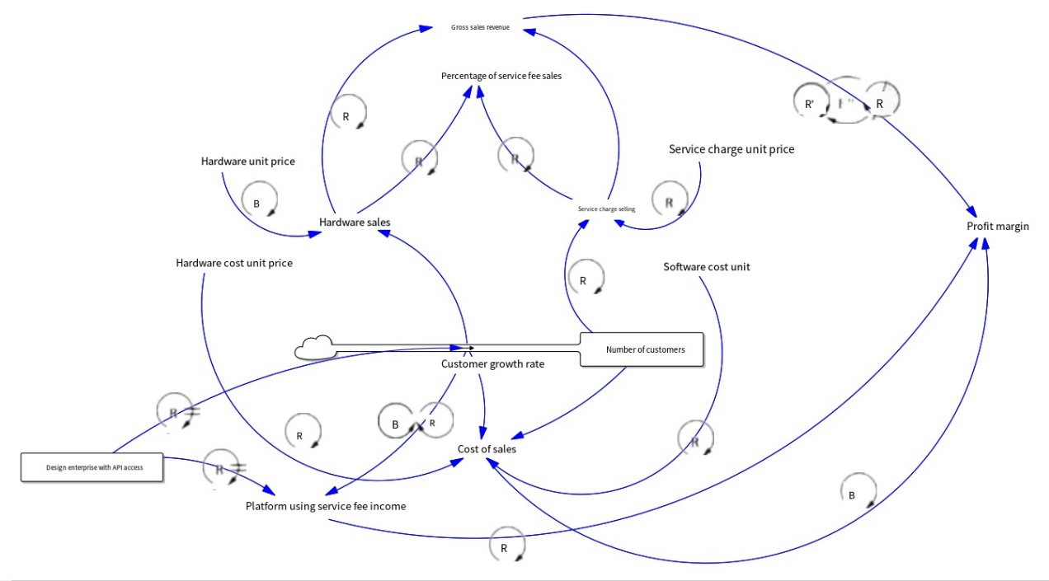

4.4 External environment analysis and opportunity suggestion
In January 2022, The State Council of China issued the 14th Five-Year Plan for Digital Economy Development (hereinafter referred to as the Plan). As the first national special plan to systematically plan the development of China's digital economy, the Plan details the quantitative objectives of the digital economy by 2025 and specific tasks ^{[12]} in the fields of data factor market, industrial digitalization, digital industrialization, digital public services, digital economy governance system, digital infrastructure, digital economy security system, and digital economy international cooperation.
We can see that the exploration of Firestone in the past six years has fallen in the national strategic direction one by one. Each product line of Firestone -- industrial data service, industrial brain, industrial Internet, intelligent investment selection platform^{[13]}, all correspond to the key development areas of the national digital economy one by one.
With the comprehensive expansion of the digital economy, the emergence of new computing technologies represented by quantum technology and new application models represented by cloud computing, the Internet of Things, digital currency and big data, the field of information security is facing a new revolutionary development opportunity. The company will continue to develop products and technologies related to quantum communication, support downstream application access and secondary development, and enable quantum security in big data, cloud computing, artificial intelligence, Internet of things, 5G and other fields, and promote the prosperity^{[14]} of industrial ecology. As a cutting-edge information security means, the company's quantum communication technology and products can serve the transformation and upgrading of finance, electric power and other fields related to the national economy and people's livelihood, the development and growth of emerging fields such as big data and artificial intelligence, the high-quality development of China's economy, and the national strategies such as innovation-driven development strategy, sustainable development strategy, and military-civilian integration development strategy. And serve supply-side structural reform.
Quantum technology, represented by quantum information science, can break through the bottleneck of classical technology in ensuring information security, improving computing speed and improving measurement accuracy, and become the source of major technological innovation in the fields of information, energy, materials and life, providing the core strategic force for safeguarding national security and supporting the high-quality development of the national economy. At present, quantum information technology is mainly concentrated in three aspects^{[15]}: quantum communication, quantum computing and quantum measurement.
The world's first announcement of quantum superiority is the 53-bit superconducting quantum computing prototype "Suspensewood" released by Google in 2019; In 2020, the optical quantum computing prototype "Jiuzhang" built by the team of China University of Science and Technology realized "quantum computing superiority". In 2021, the team of China University of Science and Technology successfully developed the 62-bit programmable superconducting quantum computing prototype "^{[16]}Zu Chongzhi", and on this basis realized programmable two-dimensional quantum walking, which became an important milestone of China's superconducting quantum computing. At present, only Google and the University of Science and Technology team in the world have achieved "quantum computing superiority".
At present, the company has decided to use the super-raised funds to build a "high-performance superconducting quantum computing prototype and quantum computing cloud platform project", which will form a new generation of quantum control technology suitable for high-performance superconducting quantum computers, complete superconducting quantum computer integration technology and other core technologies, laying a foundation for the company to further expand the field of quantum computing scientific research instruments related business.
Quantumctek's losses are mainly due to excessive expenditure and insufficient income, including expenditure, the company invested 32,262,700 yuan in research and development in the first half of the year, maintaining a high level, participating in "Zuchongzhi", "428 km two-field quantum key distribution" and other international frontier research and development projects, to further promote the integration of production, research and use, and promote the industrialization^{[17]} of quantum science and technology. At the same time, in order to further improve the long-term incentive mechanism of the company and attract and retain excellent talents, the company launched an employee equity incentive plan. And The revenue sector, any advanced science, before the industrial chain is mature, is dominated by the government and scientists, these pioneers shoulder the mission^{[18]} of leading in the future, and there will inevitably be periods of loss and profit deficiency. Think back to the early days of Apple Inc., the early days of Google Inc., and the chip giants of the AI core of the future world are all coming out of losses and lows (as shown below)[19]. Looking back today, these companies not only created huge social and economic value but also became a national powerhouse, But also let the early investors get thousands of times the return[20].
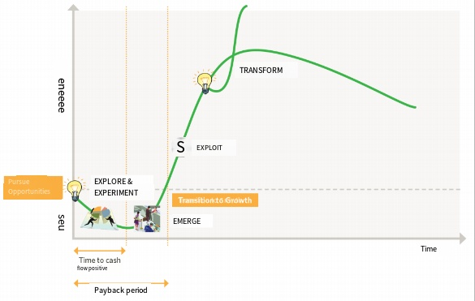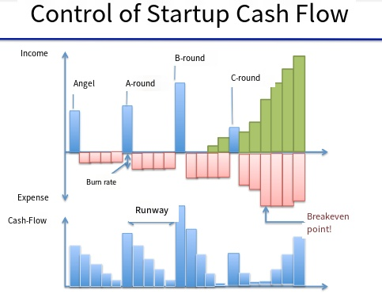
Classic cash flow curve of start-ups Classic bar chart of cash flow of start-ups

In the future, the company must build a platform, continue to open API ports to market forces, gradually establish a complete industrial value chain, and realize the high growth of network effects as soon as possible. It will continue to be guided by the needs of civilian users, continue to increase market exploration efforts, accelerate the extension and expansion to industrial customers and individual customers, and constantly improve the maturity of technology, in order to enhance the depth and width of cooperation with customers, and make faster and greater contributions to China's quantum technology.

Reference materials
1. Strategic Cooperation between Hefei S&T Rural Commercial Bank and HKUST National Shield. Enter the era of "quantum + finance" technology -- Anhui channel -- People's Daily Online
2. Why the "quantum technology first Stock" is popular. Anhui Daily
3. "Quantum technology first stock" listed QuantumCtek surged 10 times in intraday, the first day of a record rise, a profit of more than 160,000 yuan. Securities Times
4. Quantumctek targets quantum communication sector
5. Quantumctek, which surged 10 times on its first day of listing, is a dark horse or a "demon stock"? - Titanium media official website. Titanium media
6.习近平总书记考察中国科大 .南方网
7. Haikou Daily Digital News · Haikou net. Haikou Daily
8. Dagan New infrastructure | How to open the Yangtze River Delta quantum communication network? 16 units reached a consensus. Thepaper.cn
9. Interpretation: Why is the "first quantum technology" popular? .Fenghuang Anhui
10. Build core competitiveness to enter the industrial "no man's land" - China Intellectual Property Information Network. China Intellectual Property Information Network
11. Jinan Quantum Industry Development Chronicle - Qilu Evening News Digital newspaper. Qilu Evening News
12. Quantum secure communication has been written into the Yangtze River Delta integration plan, and several networks have been built. Thepaper.cn
13. Towards the domestic first-class level! Hefei "new infrastructure" implementation plan released. Anhui net
14. European Commission and European Space Agency plan to build Pan-European quantum communication infrastructure. Thepaper.cn
15. Us Department of Energy announces Quantum Internet Development Strategy Blueprint. Xinhuanet.com
16. India's budget allocates huge amount of money for the national quantum mission: Rs 8,000 crore over five years. Thepaper.cn
17. 24 EU Member States jointly launch Quantum Communication Infrastructure Project. Ministry of Science and Technology of the People's Republic of China
18. South Korea officially commercializes 5G quantum communication technology. NetEase Finance
19. Company Profile. Shanghai Stock Exchange
20. Added to the "entity list" by the United States, China Science and Technology fell 19 percent. People's News

