STUDY ON PHYSICO-CHEMICAL CHARACTERISTICS AND DIVERSITY OF AQUATIC MACROPHYTES OF NINGTHOUKHONG RIVER IN MANIPUR

ABSTRACT
The present investigation has made an attempt to assess the variation in the physicochemical status of the Ningthoukhong River. Water samples were collected from two sites (upstream and downstream) from April 2024 to February 2025 on a monthly basis and evaluated. This assessment indicates significant variations in various water quality parameters between the two sites throughout the study period. The average water temperatures measured were 20.88°C in the upstream site and 21.3°C in the downstream site. The pH levels were found to be 7.57 in the upstream and 7.44 in the downstream. Free carbon dioxide (CO₂) concentrations were recorded at 7.66 mg/l in the upstream and 13.93 mg/l in the downstream. Dissolved oxygen (DO) levels were 5.59 mg/l in the upstream and 3.75 mg/l in the downstream. Biochemical oxygen demand (BOD) was measured at 7.07 mg/l in the upstream and 4.56 mg/l in the downstream. Chemical oxygen demand (COD) values were 17.43 mg/l in the upstream and 9.37 mg/l in the downstream. Hardness levels were recorded at 44 mg/l in the upstream and 59.16 mg/l in the downstream. Macrophytes were collected and identified according to standard literature, resulting in the documentation of a total of 32 macrophyte species during the study period.
Keywords: Physicochemical status, macrophytes, Ningthoukhong River, Manipur.

INTRODUCTION
All organisms on Earth rely on water for their growth and survival. Water is a crucial factor in nearly every element of life on our planet. Freshwater is a limited resource that is vital for agriculture, industry, and human life itself, and without sufficient quality and quantity, sustainable development cannot be achieved (Sarkar, R., et al., 2020). The decline in the quality of freshwater resources is

accelerating, resulting in a worldwide issue (Mahananda, H., et al., 2005). Surface water mainly includes the water found in streams, rivers, springs, ponds, lakes, and reservoirs. This type of water comes from precipitation that occurs in watershed regions, flowing through streams and rivers before sometimes settling in ponds and lakes (Manahan, S. E., 2010). This is the primary source of water utilized for residential, agricultural, and industrial needs across the globe (Khan, M. Y. A., et al., 2016). The anthropogenic activities and atmospheric deposition of pollutants are also a source of surface water pollution in many countries (Kumar, B., & Singh, U. K., 2018). The water quality of the river is deteriorated mainly by natural processes and through anthropogenic activities like discharge of industrial sewage, domestic wastewater and agricultural drainage water to the river (Shil, S., et al., 2019). However, the main pollutants for river pollution are the industrial sewage, domestic wastewater and agricultural drainage water (Barakat, A., et al., 2016). Since river is the main source of freshwater for the human beings for use in different purposes, it is wise to protect and control the rivers from pollution and to have reliable information on water quality for effective management. Therefore, regular monitoring and evaluation of the water quality are required to protect, control and manage the river water from deterioration (Shil, S., et al., 2019). To evaluate the quality of river water for the purpose of irrigation, health, domestic and fisheries, we need to identify the physicochemical characteristics that are important for respective fields, and their acceptable levels of concentrations (Uddin, M. N., et al., 2014).
Aquatic macrophytes are photosynthetic organisms that are large enough to be seen by the naked eye that actively develop either permanently or periodically while floating on, growing up through, or submerged beneath the water's surface. Seven plant divisions—Cyanobacteria, Chlorophyta, Rhodophyta, Xanthophyta, Bryophyta, Pteridophyta, and Spermatophyta—represent aquatic macrophytes (Chambers, P. A., et al., 2008).
Aquatic macrophytes are classified as floating; that have their foliage above the surface of water with roots hanging free underneath, emergent; rooted in the bottom but having their foliage and flowers above the water surface, submerged; may or may not be rooted and marginal that are mostly rooted and spread through the shallow fore sore areas of water bodies (Sanyal, T. (2017).
Macrophytes are an important component of many freshwater ecosystems that play different roles. Macrophytes serve as a crucial element within numerous freshwater ecosystems, fulfilling various functions (Dar, N. A., et al., 2014). These include being primary producers, providing refuge for macro-invertebrates, zooplankton, and habitat for the feeding, breeding, and refuge of littoral fish. Moreover, macrophytes affect the cycling of nutrients and contaminants, reducing shoreline erosion and sediment re-suspension. They can also be used as indicators of water quality (Chibsa, Y., et al.,

2021). Aquatic vegetation serves as quantifiable indicators of the ecological status of surface waters. In particular, submerged species that are highly reliant on water quality have demonstrated susceptibility to alterations in the aquatic ecosystem (Robach F., et al.,1996; Dawson FH., et al., 1999).
The present study mainly focuses on the quality of the river water and effects of contamination coming from the human settlements into the river. This study endorses some important limnological parameters like temperature, pH, free CO₂, DO, BOD, COD, calcium, sodium, potassium, nitrate, phosphate, total hardness and chloride. The present study intended to highlight the diversity of flora
i.e. variations of macrophytic vegetations in the selected river.

MATERIALS AND METHODS

Study area
Ningthoukhong River is a feeder stream of Loktak Lake, which originates in the eastern slope of the northern part of the Thangjing Hill Range. The total length of the Ningthoukhong River is observed to be 10.67 km and has a catchment area of 9.55 km². The catchment boundary of the river encompasses the villages of Shantipur and the central part of Ningthoukhong town, Manipur, India. The water samples were collected from two sites of the river, upstream (24° 34' 22.336" N, 93° 44' 27.254" E) and downstream (24° 34' 15.349" N, 93° 46' 22.450" E), on a monthly basis.
Instruments/Chemical Requirements:

Analysis

Data Collection
Collection of water samples for analysis
The samples were collected on a monthly basis during the study period from April 2024 to March 2025. The physicochemical characteristics of water, like temperature, pH, free CO₂, DO, BOD, COD, hardness, chlorides, calcium, sodium, potassium, nitrate, and phosphate, were determined by following standard methods of APHA (1998), Trivedy and Goel (1984). Temperature, pH, and DO of the river water were measured at their collection sites. Temperature was recorded with the help of a mercury thermometer, pH was recorded by a hand pH meter, whereas DO was measured by following Winkler’s iodometric method. For the measurement of other physicochemical parameters, water samples were collected in plastic sampling bottles and transported to the laboratory, were analysed and expressed as Mean ± SD.
Plant data

An intensive field survey cum documentation were conducted during the study period along the length of the river. The plants were identified using relevant flora literature. The plant names were verified in websitehttp://www.plantsoftheworldonline.org.

RESULTS

The value of physico-chemical parameters of water is presented in the Table 1 for upstream and Table 2 for downstream. The macrophytes of the Ningthoukhong river include a total of 33 species of macrophytes, which are represented by 28 angiospermic plants and 5 species of pteridophytes. The recorded plants were under 28 genera represented by 23 families, as given in Table 3.
Table 1: Monthly variation in physicochemical characteristics of the upstream water sample of the Ningthoukhong river (April 2024 to March 2025)

Parameters | Different Concentrations in Different Months |  |  |  |  |  |  |  |  |  |  |  | Mean | Standard deviation
Parameters | April | May | June | July | Aug | Sept | Oct | Nov | Dec | Jan | Feb | March | Mean | Standard deviation
Temperature (^{O}C) | 21.5 | 24 | 22 | 23 | 22 | 20 | 20 | 20 | 19 | 18 | 19 | 22.1 | 20.88 | 1.7972
pH | 7.72 | 8.5 | 9.52 | 7.83 | 7.59 | 6.7 | 7.9 | 7.9 | 6.9 | 6.8 | 6.7 | 6.8 | 7.57 | 0.8232
Free CO2 (mg/l) | 9.9 | 6.6 | 4.4 | 4.4 | 6.6 | 24.2 | 4.4 | 4.4 | 5 | 5.5 | 6.6 | 9.9 | 7.64 | 5.3325
DO (mg/l) | 3.2 | 2.43 | 3.04 | 8.10 | 3.64 | 6.28 | 9.12 | 9.12 | 6.4 | 5 | 4.4 | 6.4 | 5.59 | 2.2505
BOD (mg/l) | 4.9 | 4.13 | 6.25 | 7.49 | 7.70 | 5.87 | 11.59 | 12 | 8 | 6 | 6 | 4.9 | 7.07 | 2.3986
COD (mg/l) | 9 | 8 | 12.5 | 14.98 | 48 | 11.74 | 28.98 | 24 | 16 | 15 | 12 | 9 | 17.43 | 10.9630
Hardness (mg/l) | 78 | 52 | 52 | 37 | 20 | 40 | 44 | 44 | 36 | 37 | 36 | 52 | 44 | 13.4350
Chlorides (mg/l) | 32.66 | 38.34 | 22.72 | 34.08 | 22.72 | 59.64 | 45.44 | 45.44 | 44 | 43 | 53 | 31 | 39.33 | 10.8148
Calcium (mg/l) | 9.61 | 14.43 | 12.82 | 24 | 5.61 | 32.064 | 15.23 | 15.23 | 15 | 15.5 | 9 | 10 | 14.87 | 6.8047
Sodium (mg/l) | 2.7 | 6 | 4.1 | 1.9 | 1.9 | 0.8 | 2.4 | 2.4 | 2.5 | 2.7 | 5.3 | 5.5 | 3.18 | 1.5747
Potassium (mg/l) | 0.5 | 1.6 | 1.3 | 1.1 | 1.1 | 3.0 | 0.4 | 0.4 | 1.1 | 1.5 | 1.4 | 1.3 | 1.23 | 0.6672
Nitrate (mg/l) | 0.250 | 0.150 | 0.277 | 0.313 | 0.332 | 0.332 | 0.168 | 0.168 | 0.171 | 0.175 | 0.171 | 0.250 | 0.23 | 0.0675
Phosphate (mg/l) | 0.193 | 0.238 | 0.205 | 0.211 | 0.211 | 0.305 | 0.060 | 0.259 | 0.070 | 0.141 | 0.121 | 0.100 | 0.18 | 0.0738

Table 2. Monthly variation in physicochemical characteristics of the downstream water sample of the Ningthoukhong river (April 2024 to March 2025)

Parameters | Different Concentrations in Different Months |  |  |  |  |  |  |  |  |  |  |  | Mean | Standard deviation
Parameters | April | May | June | July | Aug | Sept | Oct | Nov | Dec | Jan | Feb | March | Mean | Standard deviation
Temperature (^{O}C) | 21 | 25 | 23 | 23 | 22 | 21 | 21 | 21 | 20 | 20 | 21 | 21.3 | 21.60 | 1.3738
pH | 7.30 | 7.9 | 8.82 | 7.36 | 7.49 | 6.8 | 7.76 | 7.1 | 7.48 | 7.2 | 7.1 | 7 | 7.44 | 0.5115
Free CO2 (mg/l) | 21.9 | 41.8 | 11 | 13.2 | 6.6 | 13.2 | 8.8 | 8.8 | 11 | 4 | 12.9 | 14 | 13.93 | 9.4186
DO (mg/l) | 0.3 | 2.02 | 1.41 | 2.43 | 3.64 | 2.84 | 7.76 | 7.76 | 5 | 4.6 | 2.6 | 4.6 | 3.75 | 2.2256
BOD (mg/l) | 1.62 | 4.09 | 4.25 | 2.43 | 4.66 | 2.43 | 4.82 | 5 | 9 | 6 | 8 | 24 | 4.56 | 2.1695
COD (mg/l) | 3.24 | 8 | 8.5 | 4.86 | 4.86 | 4.86 | 12.06 | 10 | 18 | 15.5 | 16 | 6 | 9.37 | 4.7978
Hardness (mg/l) | 118 | 116 | 62 | 58 | 24 | 36 | 64 | 64 | 34 | 33 | 39 | 62 | 59.16 | 29.1979
Chlorides (mg/l) | 32.66 | 42.6 | 26.98 | 36.92 | 28.4 | 38.34 | 44.02 | 44.02 | 45 | 39 | 49 | 31 | 38.16 | 6.8112
Calcium (mg/l) | 15.23 | 23.25 | 14.42 | 18.43 | 7.21 | 16.032 | 11.22 | 11.22 | 13 | 13 | 12 | 14 | 13.67 | 3.8788
Sodium (mg/l) | 3.5 | 6.5 | 4.7 | 1.9 | 1.9 | 1.2 | 3.0 | 3.0 | 3.3 | 3.1 | 8.5 | 9 | 4.13 | 2.4467
Potassium (mg/l) | 1.3 | 3.3 | 2.1 | 1.3 | 1.3 | 2.5 | 1.3 | 1.3 | 1.3 | 1.3 | 6.8 | 8.2 | 2.67 | 2.2643
Nitrate (mg/l) | 0.252 | 0.132 | 0.279 | 0.305 | 0.288 | 0.288 | 0.146 | 0.146 | 0.162 | 0.166 | 0.162 | 0.258 | 0.215 | 0.0648
Phosphate (mg/l) | 0.220 | 0.297 | 0.079 | 0.206 | 0.206 | 0.406 | 0.045 | 0.223 | 0.046 | 0.100 | 0.101 | 0.124 | 0.171 | 0.1043

Table 3. Macrophytes found in the Ningthoukhong River

Macrophytes | Family | Habitat
Acorus calamus L. | Acoraceae | Emergent
Alisma plantago-aquatica L. | Alismataceae | Emergent
Alternanthera philoxeroides (Mart.) Griseb. | Amaranthaceae | Floating
Alternanthera sessilis (L.) R.Br. ex D.C. | Amaranthaceae | Floating
Azolla pinnata R.Br. | Salviniaceae | Floating

Brachiaria mutica (Rorssk.) Stapf | Poaceae | Emergent
Centella asiatica (L.) Urban. | Apiaceae | Emergent
Ceratophyllum demersum L. | Ceratophyllaceae | Submerged
Colocasia cuculata (L.) Schott. | Araceae | Emergent
Commelina benghalensis L. | Commelinaceae | Emergent
Commelina diffusa L. | Commelinaceae | Emergent
Pontederia crassipes (Mart.) Solms. | Pontederiaceae | Floating
Eleusine indica (L.) Gaertn, | Poaceae | Emergent
Equisetum ramosissimum Desf. | Equisetaceae | Emergent
Hydrilla verticillata (L.f.) Royle | Hydrocharitaceae | Submerged
Hydrocotyle sibthorpioides Lam. | Araliaceae | Submerged
Hydrolea zeylanica (L.) Vahl | Hydroleaceae | Submerged
Ipomoea aquatica Forssk | Convolvulaceae | Floating
Marsilea minuta L. | Marsileaceae | Floating
Monochoria vaginalis (Burm.f.) C.Presl ex Kunth | Pontederiaceae | Emergent
Nymphoides indica (L.) Kuntze | Menyanthaceae | Floating
Oenanthe javanica (Blume) DC | Apiaceae | Emergent
Pistia stratiotes L. | Araceae | Floating
Plantago major L. | Plantaginaceae | Emergent
Portulaca oleracea L. | Portulaceae | Floating
Ranunculus scleratus L. | Ranunculaceae | Emergent
Rotala rotundifolia (Buch.-Ham.ex Roxb.) Koehne | Lythraceae | Emergent
Rumex maritimus L. | Polygonaceae | Emergent
Rumex nepalensis Spreng. | Polygonaceae | Emergent
Salvinia cucullata Roxb. | Salviniaceae | Floating

Salvinia natans (L.) All | Salviniaceae | Floating
Utricularia aurea Lour. | Lentibulariaceae | Submerged
Vallisneria spiralis L. | Hydrocharitaceae | Emergent

DISCUSSION

In the upstream, the highest temperature is observed in the month of May. Likewise, in the downstream also the highest temperature is observed in the month of May. The pH of the upstream ranges from 6.7 to 9.52, which indicates the neutral conditions to slightly alkaline conditions in the month of June. The pH level is a crucial factor in assessing the acid-base equilibrium of river water (Sarkar, R., et al., 2020). Free CO₂ is highest during the month of September, with a value of 24.2 mg/l in the upstream, whereas in the downstream it is highest in the month of May with a value of 41.8 mg/l. The higher values of free CO₂ recorded in summer might have been due to deoxygenation. The rise in temperature in the river water could be correlated with an increase in CO₂ levels (Singh, M.R., et al.,2010). The DO value ranges from 2.43 to 9.12 mg/l in the upstream, whereas in the downstream it ranges from 0.3 to 7.76 mg/l. The lower value in the downstream might be due to human activities, which implies that the river water was more polluted in the downstream. (Chouchan et al., 2021) studied DO values between 0.21 mg/l to 6.7 mg/l of drinking water at various sites of Kota, Rajasthan, which showed a lack of an adequate treatment and drainage system in Kota.
In the present study, BOD values ranged from 4.3 mg/l to 12 mg/l maximum value recorded in November and a minimum in May in the upstream. Whereas, in the downstream, it ranges from 1.62 mg/l to 9 mg/l, maximum value recorded in December and the minimum value in April. The reason for high BOD might be due to several microorganisms present in the water body, which might have accelerated their metabolic activities with a concentrated amount of organic matter and hence required more amount of oxygen. (Indu et al., 2015) studied the BOD of the surface water of Nawabganj Lake. The mean BOD was similar in Winter, 2 to 8 mg/l and in Summer, 2 to 7 mg/l. In most cases, the BOD was higher during the Summer and Winter seasons, which might be due to a reduced rate of water flow and the accumulation of waste from anthropogenic activities. COD is the estimation of the amount of oxygen required to chemically oxidize the organic and inorganic matter present in water. In the present study, COD values range from 8 mg/l to 48 mg/l in the upstream and 3,24 mg/l to 18 mg/l in the downstream. Estimation of COD along with BOD is helpful in indicating toxic conditions and the presence of nonbiodegradable substances in the water (Bhargavi & Aruna, 2023). The values of hardness range from 20 mg/l to 78 mg/l in the upstream and 24 mg/l to 118 mg/l in the downstream.

Alam et al., (2007) studied water quality parameters along rivers. They observed total hardness of the Surma River increases along the downstream. In the present study, the maximum value was recorded in the month of April and the minimum value was recorded in the month of August. The presence of calcium and magnesium salts plays a role in the hardness of water. The values of chlorides range from 22.72 mg/l to 59.64 mg/l in upstream and 31 mg/l to 49 mg/l in downstream. The maximum values of chlorides were obtained in the month of September in the upstream and in the month of February in the downstream. Arasu et al., (2007) reported that chloride concentration varied between 9.67 and 62.33 mg/l. This finding was observed in the Tamirabarani River of South India. The results of the study indicate that chloride levels varied within this range, suggesting a potential impact of various factors on chloride concentration in the river water. The maximum value of calcium ranges from 32.064 mg/l in the month of September and the lowest value of 9 mg/l in the month of February in the upstream. The maximum value of calcium was 23.25 mg/l in the month of May and the minimum value was 7.21 mg/l in the month of August in the downstream was obtained. In aquatic ecosystems, calcium serves as an important micronutrient to many aquatic organisms. The calcium concentrations in both upstream and downstream areas show significant seasonal variations, with higher levels observed during certain months. Upstream, calcium ranged from 32.064 mg/l in September to 9 mg/l in February. Downstream, calcium ranged from 23.25 mg/l in May to 7.21 mg/l in August. This variation may be influenced by factors like increased precipitation and runoff, which can dilute calcium levels in the warmer months. The acceptable limit for calcium for the WHO standards is 75 mg/l and the values are within this limit. The maximum value of sodium is 5.5 mg/l and the minimum value of 0.8 mg/L was obtained in the upstream. In the downstream, a maximum value of 9 mg/l and 1.2 mg/l was obtained in downstream. The value of potassium ranges from 0.4 mg/l to 3 mg/l in the upstream and from 1.3 mg/l to 6.8 mg/l in the downstream. In the upstream, the value of nitrate ranges from 0.150 mg/l to 0.332 mg/l, whereas in the downstream it lies between 0.132 mg/l to 0.30 mg/l. The high concentration was probably a result of runoff from an agricultural field. The phosphate contains lie between the values of 0.060 mg/l to 0.305 mg/l in the upstream and in downstream it lies between the values of 0.045 mg/l to 0.406 mg/l in the downstream. An increase in nitrogen and phosphorus, either one or the other, will lead to eutrophication, which could lead to unpleasant taste and odour of the water when the algae die and decompose, thus deteriorating the water quality and heavy infestation of weeds.
Diversity of macrophytes

The macrophytes of the Ningthoukhong river include a total of 33 species of macrophytes, which are represented by 28 angiospermic plants and 5 species of pteridophytes. The recorded plants were under 28 genera represented by 23 families. The Pteridophytic macrophytes are Azolla pinnata R.Br.,

Equisetum ramosissimum Desf., Marsilea minuta L., Salvinia cucullata Roxb., and Salvinia natans (L.) All. more abundant in the downstream. These plants are known for their ability to thrive in aquatic environments and are often found in water bodies like lakes, rivers, and wetlands.
The pie chart given below shows that 52% of the species were of emergent habit and shows dominant occurrence near in the mouth of the river. Floating habit represents 33% of the species and 15% of the species were under submerged habit.

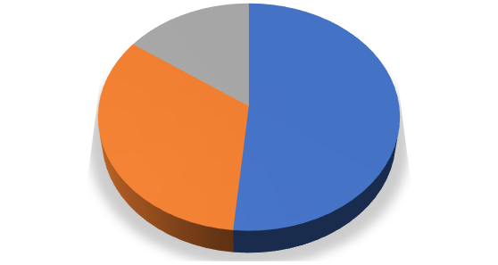





No of species

15%
52%
33%
Emergent Floating
Submerged

Figure 1: Showing the types of macrophytes recorded during the survey.

Interestingly, all the majority of the macrophytes were available throughout the year except some floating species Marsilea minuta L., Pistia stratiotes L. Salvinia cucullata Roxb. and Salvinia natans (L.), which were carried during the rainy seasons. During the winter seasons when the river water is in lotic condition, these species infiltrated from the mouth adjoining the Loktak lake. Some species were seasonal are Rotala rotundifolia (Buch.-Ham.ex Roxb.) Koehne, Rumex maritimus L., Rumex nepalensis Spreng. and Alisma plantago-aquatica L. The submerged species Ceratophyllum demersum L., Hydrilla verticillata (L.f.) Royle, Hydrolea zeylanica (L.) Vahl. and Utricularia aurea Lour. were available throughout the year and throughout the mouth of the river. The recorded macrophytes were also used for as wild edible, medicinal purposes and as fodder plants.

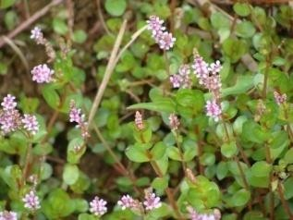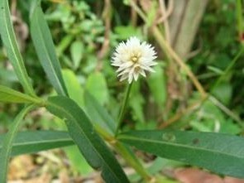

1. Rotala rotundifolia (Buch.-Ham.ex Roxb.) Koehne 2. Alternanthera philoxeroides (Mart.) Griseb.
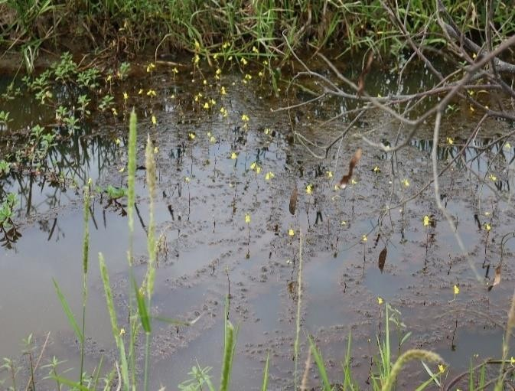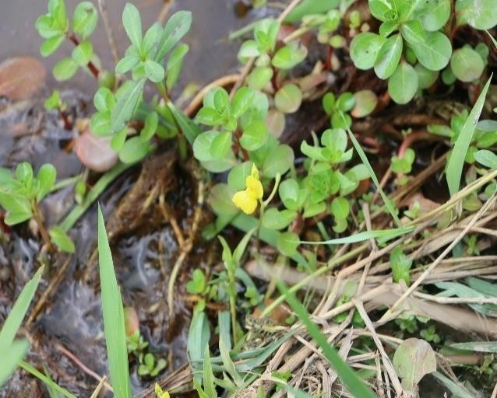

3. Utricularia aurea Lour. 4. Portulaca oleracea L.

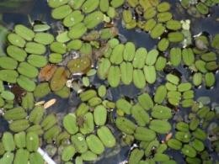
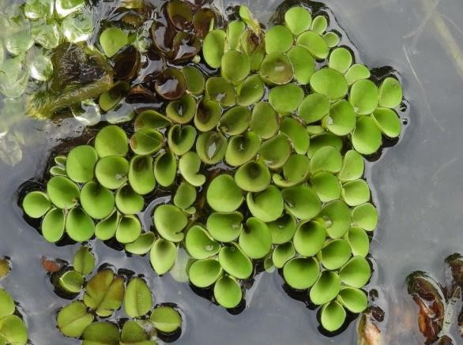

5. Salvinia natans (L.) All 6. Salvinia cucullata Roxb.

Figure 2: Figure showing some macrophytic plants found in Ninthoukhong river.

CONCLUSION
In conclusion, there is a higher variation in COD, hardness and chlorides in upstream and higher variations in free CO₂, hardness parameters in downstream. It is visible that hardness increases in

downstream and also the value of DO is lower in downstream, with a lowest value of 0.3 mg/l during the month of April. The macrophytes distribution and diversity have little influence with the parameters of the water. The study will give a baseline data of the water parameters and diversity of macrophytic plants found in Ningthoukhong river. Moreover, it will give new insights and will pave a way for further research and scientific ventures.

REFERENCES
Alam, M. J., Islam, M. R., Muyen, Z., Mamun, M., & Islam, S. (2007). Water quality parameters along rivers. International Journal of Environmental Science & Technology, 4(1), 159-167. https://doi.org/10.1007/bf03325974
Barakat, A., El Baghdadi, M., Rais, J., Aghezzaf, B., & Slassi, M. (2016). Assessment of spatial and seasonal water quality variation of Oum Er Rbia River (Morocco) using multivariate statistical techniques. International Soil and Water Conservation Research, 4(4), 284-292. https://doi.org/10.1016/j.iswcr.2016.11.002
Rasakatla, B., & Aruna, M. (2023). Analysis of physico-chemical parameters of a fresh water lake in Nizamabad District Telangana State. World Journal of Biology Pharmacy and Health Sciences, 16(01), 021–030. https://doi.org/10.30574/wjbphs.2023.16.1.0408
Chambers, P. A., Lacoul, P., Murphy, K. J., & Thomaz, S. M. (2008). Global diversity of aquatic macrophytes in freshwater. In Freshwater animal diversity assessment (pp. 9-26). https://doi.org/10.1007/978-1-4020-8259-7_2
Chibsa, Y., Mengistou, S., & Kifle, D. (2021). Distribution and Diversity of Macrophytes in Relation to Some Physico-Chemical Factors in the Ketar River, Ziway Catchment, Ethiopia. Environmental Science. https://doi.org/10.21203/rs.3.rs-629396/v1
Chouhan, R. K., Bansal, A. K., & Chhipa, R. C. (2021). Evaluation of physico-chemical parameters of drinking water at various sites of Kota, Rajasthan. *International Journal of Environment, Science and Technology*, *7*(1). https://www.gyanvihar.org/journals/index.php/2021/01/24/evaluation-of-physico-chemical-parameters-of-drinking-water-at-various-sites-of-kota-rajasthan/
Dar, N. A., Pandit, A. K., & Ganai, B. A. (2014). Factors Affecting the Distribution Patterns of Aquatic Macrophytes. Limnological Review, 14(2), 75-81. https://doi.org/10.2478/limre-2014-0008
Dawson, F. H., Newman, J. R., Gravelle, M. J., Rouen, K. J., & Henville, P. (1999). Assessment of the trophic status of rivers using macrophytes: Evaluation of the Mean Trophic Rank. Environment Agency R&D Technical Report E39. https://assets.publishing.service.gov.uk/government/uploads/system/uploads/attachment_data/file/291000/scho0999bbrc-e-e.pdf
Khan, M. Y. A., Gani, K. M., & Chakrapani, G. J. (2016). Assessment of surface water quality and its spatial variation. A case study of Ramganga River, Ganga Basin, India. Arabian Journal of Geosciences, 9(1), 1-9. https://doi.org/10.1007/s12517-015-2134-7
Kumar, B., & Singh, U.K. (2018). Source apportionment of heavy metals and their ecological risk in a tropical river basin system. Environmental Science and Pollution Research, 25(25), 25443-25457. https://doi.org/10.1007/s11356-018-2480-6
Mahananda, H. B., Mahananda, M. R., & Mohanty, B. P. (2005). Studies on the physico-chemical and biological parameters of a fresh water pond ecosystem as an indicator of water pollution. *Ecology, Environment and Conservation*, *11*(3/4), 537-541. https://www.eminternational.com/journal/ecology-environment-conservation/archieved-issues
Manahan, S. E. (2010). Water chemistry: Green science and technology of nature's most renewable resource. CRC Press. https://doi.org/10.1201/b11794

Rameshkumar, S., Radhakrishnan, K., Aanand, S., & Rajaram, R. (2019). Influence of physicochemical water quality on aquatic macrophyte diversity in seasonal wetlands. *Applied Water Science*, *9*(1), 1-8. https://doi.org/10.1007/s13201-018-0888-2
Robach, F., Thiébaut, G., Trémolières, M., & Muller, S. (1996). A reference system for continental running waters: plant communities as bioindicators of increasing eutrophication in alkaline and acidic waters in north-east France. Hydrobiologia, 340, 67-76. https://doi.org/10.1007/BF00012736
Sanyal, T. (2017). Aquatic weed biodiversity and its impact on fish productivity of pisciculture ponds in some specific sites of South Bengal. International Journal of Engineering Sciences Research Technology. https://doi.org/10.5281/zenodo.1013996
Sarkar, R., Ghosh, A.R., & Mondal, N.K. (2020). Comparative study on physicochemical status and diversity of macrophytes and zooplanktons of two urban ponds of Chandannagar, WB, India. Applied Water Science, 10, 1-8. https://doi.org/10.1007/s13201-020-1146-y
Shil, S., Singh, U. K., & Mehta, P. (2019). Water quality assessment of a tropical river using water quality index (WQI), multivariate statistical techniques and GIS. Applied Water Science, 9, 1–21. https://doi.org/10.1007/s13201-019-1045-2
Simpson, M. G. (2019). Plant systematics. Academic Press. https://www.elsevier.com/books/plant-systematics/simpson/978-0-12-812628-8
Singh, M. R., Gupta, A., & Beeteswari, K. H. (2010). Physico-chemical properties of water samples from Manipur river system, India. Journal of Applied Sciences and Environmental Management, 14(4), 85-89. https://www.bioline.org.br/ja
Thillai Arasu, P., Hema, S., & Neelakantan, M. A. (2007). Physico-chemical analysis of Tamirabarani river water in South India. Indian Journal of Science and Technology, 1(2), 1-5. https://doi.org/10.17485/IJST/2007/V1I2/29211
Uddin, M. N., Alam, M. S., Mobin, M. N., & Miah, M. A. (2014). An assessment of the river water quality parameters: A case of Jamuna River. Journal of Environmental Science and Natural Resources, 7(1), 249-256. https://doi.org/10.3329/jesnr.v7i1.22179

