Numerical Investigation of Internal–External Coupled Free-Surface Flow in a Liquid-Containing Tank

Abstract
This study presents a numerical investigation of an internal–external coupled free-surface flow system using STAR-CCM+ and the Volume of Fluid (VOF) method. Three numerical models were established, including an external wave-field model, an internal sloshing model, and an internal–external coupled model. The external model was used to simulate the interaction between incident waves and a partially submerged cylindrical tank, while the internal model was employed to analyze the sloshing behavior of liquid inside a baffled tank under horizontal harmonic excitation. The results show that both the external wave field and the internal liquid motion can be effectively captured by the present numerical method. In the coupled case, the external wave excitation is transmitted to the internal liquid domain, leading to a clear oscillatory response of the internal free surface. The time history of internal wave height further demonstrates the hydrodynamic interaction between the outer and inner fluids. These results indicate that the combination of STAR-CCM+ and the VOF method provides an effective numerical approach for simulating external wave propagation, internal sloshing, and their coupled behavior, and can serve as a useful basis for the analysis of liquid-containing marine structures under wave excitation.
Keywords: Internal–external coupled flow; Free-surface flow; STAR-CCM+; Volume of Fluid (VOF) method; Sloshing; Numerical simulation.

1. Introduction
Liquid-containing structures are widely used in marine engineering, offshore transportation, and floating storage systems [12]. Under external waves or imposed motion, the liquid inside these structures may undergo sloshing, which can cause free-surface deformation, pressure impact, and additional hydrodynamic loads [13]. These effects may influence the dynamic performance and safety of the whole system [1–3].
Previous studies on liquid sloshing mainly focused on tanks under prescribed excitations, such as horizontal or vertical harmonic motion [11, 14]. In such problems, the internal free-surface response is usually analyzed in terms of wave height, pressure, and resonance behavior. It has also been shown that internal devices such as baffles can effectively suppress sloshing and improve liquid stability [2–5]. Meanwhile, with the development of CFD techniques, numerical wave tanks have been widely used to simulate external wave–structure interaction. Compared with simplified analytical methods, CFD can directly capture nonlinear free-surface evolution and transient flow details [6–8].
In many practical situations, however, the external wave field and the internal liquid motion are strongly coupled. External waves may excite the tank motion and further induce internal sloshing, while the internal liquid response may in turn affect the overall hydrodynamic behavior of the system. This makes the internal–external coupled flow problem much more complicated than pure sloshing or pure wave–body interaction alone [8–10].
In the present study, an internal–external coupled flow system is numerically investigated using STAR-CCM+ and the VOF method. Three numerical models are established, including an external wave-field model, an internal sloshing model under horizontal excitation, and an internal–external coupled model. The objective is to provide a numerical basis for analyzing the interaction between external wave propagation and internal liquid motion in a partially submerged cylindrical tank.
The remainder of this paper is organized as follows. Section 2 introduces STAR-CCM+. Section 3 presents the VOF method. Sections 4–6 describe the external flow model, the internal flow model, and the coupled model, respectively. Finally, the conclusions are given in Section 7.
2. Introduction to STAR-CCM+
STAR-CCM+ is an integrated computational fluid dynamics (CFD) software package developed for the simulation of complex fluid flow and multiphysics problems. Owing to its robust numerical framework and versatile modeling capabilities, it has been widely used in marine hydrodynamics, wave–structure interaction, sloshing analysis, and other free-surface flow problems. Compared with traditional CFD tools that require separate modules for geometry construction, mesh generation, solver setup, and post-processing, STAR-CCM+ provides a unified simulation environment, which improves both modeling efficiency and numerical consistency.
For the simulation of internal–external coupled flow systems, STAR-CCM+ is particularly suitable because it can handle transient free-surface motion, multiphase interaction, and complicated flow evolution within a single framework. In the present study, the external fluid domain is subjected to wave excitation, while the internal fluid domain experiences liquid motion and free-surface deformation. The interaction between these two flow regions involves energy transfer, interface evolution, and transient hydrodynamic response. Therefore, a reliable CFD platform with strong multiphase and transient simulation capabilities is essential, and STAR-CCM+ provides an effective numerical basis for such analyses.
One of the major advantages of STAR-CCM+ lies in its flexible and efficient meshing technology. The software supports a variety of mesh types, including polyhedral meshes, trimmed meshes, prism-layer meshes, and local mesh refinement. Among them, polyhedral meshes are especially advantageous for complex geometries because they usually offer good numerical stability and accuracy with fewer cells than conventional tetrahedral meshes. This is particularly helpful for problems involving liquid tanks, floating bodies, and curved boundaries, where both geometric complexity and local flow details must be captured. Moreover, mesh refinement can be applied near the free surface, walls, and regions of strong velocity or pressure gradients, thus improving the resolution of important flow structures without introducing an excessive computational burden.
Another important feature of STAR-CCM+ is its broad range of physical models. It supports incompressible and compressible flow, laminar and turbulent flow, heat transfer, multiphase flow, and fluid–body interaction. For wave-related and sloshing-related problems, the multiphase-flow model is particularly important because the interface between water and air must be accurately tracked. In free-surface hydrodynamics, the evolution of the interface largely determines the wave motion, pressure distribution, and fluid impact process. As a result, the ability of STAR-CCM+ to simulate such interface-dominated flows makes it highly relevant to the present study.
In addition, STAR-CCM+ has strong capabilities for wave simulation. It can be used to construct numerical wave tanks and simulate the propagation of incident waves under prescribed boundary conditions. At the same time, damping regions or wave-absorbing techniques can be introduced to reduce artificial wave reflection at the domain boundaries. These functions are essential for reproducing a stable external wave field, which serves as the excitation source for the internal–external coupled system considered in this work. Accurate representation of the external wave environment is a prerequisite for obtaining reliable predictions of the dynamic response of the structure and the internal liquid.
Besides modeling the external flow, STAR-CCM+ is also suitable for simulating the liquid motion inside partially filled tanks or compartments. Under external excitation, the internal liquid may exhibit free-surface oscillation, sloshing, vortex formation, and transient pressure variation. These phenomena are strongly nonlinear and sensitive to parameters such as liquid depth, excitation frequency, and structural geometry. By using STAR-CCM+, the internal free surface and the associated flow field can be resolved in time, making it possible to analyze the dynamic characteristics of the internal liquid motion in detail.
The advantage of STAR-CCM+ becomes more significant when the internal and external flows are considered simultaneously. In such coupled problems, the external wave field can induce structural motion or pressure fluctuations, which then affect the internal liquid behavior. In turn, the internal sloshing may alter the overall hydrodynamic response of the system. This bidirectional interaction requires the numerical model to capture both the external wave process and the internal free-surface motion in a consistent manner. STAR-CCM+ provides such a capability by integrating multiphase flow modeling, transient solution strategies, and force analysis within one platform. Therefore, it is well suited for studying the coupled hydrodynamic mechanism of systems containing both outer wave fields and inner liquid domains.
Another practical advantage of STAR-CCM+ is its powerful post-processing capability. The software allows direct visualization and quantitative analysis of pressure contours, velocity fields, free-surface evolution, and time histories of hydrodynamic quantities. This helps reveal the physical mechanism of the coupled flow behavior and facilitates the comparison of different simulation conditions. For example, the evolution of the external wave field, the sloshing amplitude of the internal liquid, and the pressure response at critical locations can all be extracted and analyzed within the same software environment.
the internal–external coupled flow problem under wave excitation. The external wave field, the internal liquid motion, and the air phase are all included in a unified transient multiphase framework. With its advanced meshing strategy, flexible physical models, and strong free-surface simulation capability, STAR-CCM+ provides the technical foundation for the numerical investigation presented in this paper. Therefore, its use in this study is not only convenient from a computational perspective, but also well justified by the physical characteristics of the problem.

3. Introduction to the VOF Method
The Volume of Fluid (VOF) method is one of the most widely used numerical approaches for simulating immiscible multiphase flows with moving interfaces. It is particularly suitable for free-surface problems in which the interface between two fluids, such as water and air, undergoes large deformation, fragmentation, or merging during the flow evolution. In marine hydrodynamics, sloshing analysis, wave propagation, and wave–structure interaction, the VOF method has been extensively employed because of its ability to capture transient interface motion within a fixed computational mesh. In the present study, both the external wave field and the internal liquid motion involve time-dependent free-surface evolution. Therefore, the VOF method is adopted as the core numerical technique for resolving the air–water interface in the internal–external coupled flow system.
The basic idea of the VOF method is to introduce a scalar variable, usually referred to as the volume fraction, to describe the distribution of each fluid phase within a computational cell. For a typical two-phase flow consisting of water and air, the volume fraction of one phase is tracked throughout the computational domain. If the volume fraction in a given cell is equal to one, the cell is completely filled with that phase; if it is zero, the cell contains only the other phase; and if it lies between zero and one, the cell is intersected by the interface. In this way, the position and evolution of the free surface can be represented implicitly without explicitly reconstructing the interface as a moving boundary. This treatment makes the VOF method highly efficient and robust for problems with complex and strongly time-dependent interface deformation.
A major advantage of the VOF method is that it combines interface capturing with the solution of a single set of governing equations for the entire multiphase system. Instead of solving separate flow equations in each phase with explicit interface tracking, the VOF framework treats the two fluids as a unified continuum with spatially varying properties. The density and viscosity in each computational cell are determined according to the local volume fraction, and the momentum equations are solved over the whole domain. As a result, the motion of the interface is naturally coupled with the velocity and pressure fields. This feature is particularly beneficial for free-surface hydrodynamic problems, where strong interaction exists between the interface shape and the surrounding flow field.
For wave propagation problems, the VOF method is well suited to capturing the continuous evolution of the water surface under gravity and fluid inertia. The generation, propagation, reflection, and deformation of waves can all be represented within the same numerical framework. In addition, the method can describe nonlinear free-surface features that are difficult to handle using linear or weakly nonlinear analytical approaches. For example, steep wave fronts, local splashing, interface distortion, and transient impact on solid boundaries can be resolved more naturally by a VOF-based simulation. These advantages are important for the external flow domain of the present study, where the incident wave field serves as the main excitation source for the coupled system.
The VOF method is equally effective in the simulation of internal sloshing flows. When a partially filled tank or liquid-containing structure is subjected to external excitation, the liquid inside undergoes oscillatory motion, leading to free-surface elevation, wave overturning, and transient pressure loads on the tank walls. In many cases, the internal flow behavior is strongly nonlinear, especially when the excitation frequency approaches the natural sloshing frequency. Under such conditions, simplified potential-flow models may become insufficient for describing local interface deformation and flow details. By contrast, the VOF method can directly capture the internal free-surface motion and the associated velocity and pressure fields, making it suitable for analyzing the dynamic characteristics of sloshing in confined liquid domains.
Another important strength of the VOF method is its applicability to coupled flow systems involving both external and internal free surfaces. In the internal–external coupled problem considered in this work, the outer wave field interacts with the structure and affects the motion of the liquid inside. At the same time, the internal liquid response may influence the overall hydrodynamic behavior of the system. Since both the external and internal domains contain air–water interfaces, a consistent numerical treatment of the two free surfaces is required. The VOF method provides such consistency by using the same interface-capturing principle in all fluid regions. This unified treatment facilitates the simulation of energy transfer and dynamic interaction between the inner and outer fluids.
Despite its wide applicability, the VOF method also requires careful numerical treatment to achieve accurate and stable results. Since the interface is represented through the transport of volume fraction, numerical diffusion may smear the free surface if the mesh resolution or discretization scheme is not sufficiently refined. Therefore, local mesh refinement near the interface and appropriate high-resolution convection schemes are often necessary to maintain a sharp air–water boundary. In transient free-surface simulations, the time step must also be chosen carefully to ensure numerical stability and to capture the dynamic evolution of the interface with adequate temporal resolution. These considerations are especially important for wave-related problems, where interface shape and phase accuracy directly affect the reliability of the predicted hydrodynamic response.
In practical CFD applications, the VOF method is often combined with the Reynolds-averaged Navier–Stokes (RANS) equations or other turbulence models when viscous and turbulent effects are relevant. For many wave–sloshing problems, however, the main role of the VOF method is to represent the interface accurately while the governing momentum equations describe the overall fluid motion. In this sense, the success of the simulation depends not only on the volume fraction transport equation itself, but also on the compatibility between the interface-capturing approach, mesh distribution, boundary conditions, and solver settings. When these aspects are properly designed, the VOF method can provide reliable predictions for both qualitative flow features and quantitative hydrodynamic responses.
In the present work, the VOF method is employed to simulate the air–water two-phase flow in both the external wave field and the internal liquid domain. By tracking the evolution of the volume fraction, the method enables the free surfaces inside and outside the structure to be captured simultaneously within a unified transient framework. This is essential for reproducing the coupled hydrodynamic process under wave excitation. Therefore, the VOF method serves as a fundamental numerical tool in this study, providing the basis for the subsequent simulations of the external flow, the internal flow, and their coupled interaction.

4. External Flow Field Simulation
To investigate the hydrodynamic behavior of the external flow field, a three-dimensional numerical wave tank was established in STAR-CCM+. The computational domain was 100 m in length and 5 m in width. In the vertical direction, the water depth was set to 10 m and the air region above the free surface was 2 m, resulting in a total height of 12 m. A cylindrical tank was placed in the numerical wave tank, with a draft of 2 m and a radius of 2 m. Both the external fluid and the liquid inside the tank were assumed to be water, and the free-surface motion was simulated using the first-order VOF wave model. In order to focus on the fundamental hydrodynamic characteristics of the coupled flow system, the fluid was treated as inviscid in the present simulation.
Figure 1 illustrates the geometric model adopted in the computation. The external numerical tank consists of a rectangular wave flume containing both air and water regions, while the cylindrical tank is partially submerged near the free surface. This configuration was designed to reproduce the interaction between the incident wave field and the floating liquid-containing structure. Since the free-surface evolution plays an important role in the present problem, special attention was paid to the mesh resolution around both the tank and the water surface.

Figure 1. Geometric model of the external numerical wave tank and the partially submerged cylindrical tank.
The background mesh size in the main computational domain was set to 1.25 m, while the mesh size in the vicinity of the cylindrical tank was refined to 0.7 m. To improve the resolution of local flow structures around the tank, a rectangular volumetric control region was introduced, covering the range from (−3,−2.5,−3) to (3,2.5,3). Within this region, isotropic refinement was applied, and the cell size was reduced to 10% of the background mesh size. This refinement strategy ensures that the local pressure distribution, free-surface deformation, and flow details around the tank can be captured more accurately.
In addition, in order to better resolve the propagation and deformation of the free surface, a second refinement region was specified around the water surface, extending from(−50,−2.5,−0.5) to (50,2.5,0.5). In this region, anisotropic mesh refinement was employed to improve the vertical and near-surface resolution without excessively increasing the total number of cells. The mesh was refined with directional scaling factors of 25% in the xxx-direction, 30% in the y-direction, and 3.125% in the z-direction relative to the background mesh size. Such a treatment is particularly effective for free-surface simulations, since the interface evolution is generally more sensitive to the vertical resolution.
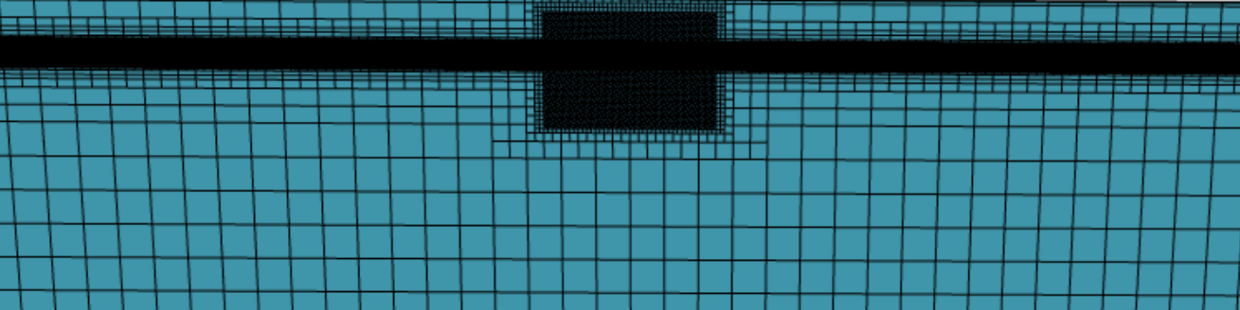
Figure 2. Global mesh distribution of the external computational domain.
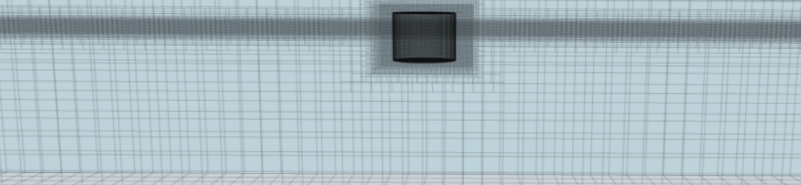
Figure 3. Local mesh refinement around the cylindrical tank and the free-surface region.
Figures 2 and 3 show the mesh distribution of the computational domain. As can be seen, the mesh remains relatively coarse in the far-field region in order to reduce the computational cost, while significant local refinement is introduced near the cylindrical tank and around the free surface. This non-uniform mesh strategy achieves a balance between computational efficiency and numerical accuracy. Figure 4 presents the scalar distribution on the y-plane, where the air and water phases are clearly distinguished. The result confirms that the initial phase distribution and free-surface position were properly defined in the numerical model.

Figure 4. Initial scalar distribution on the y-plane showing the phase interface between air and water.
Overall, the present computational setup provides the basis for simulating the external wave field and its interaction with the partially submerged tank. The combined use of local isotropic refinement near the tank and anisotropic refinement near the free surface ensures that both the body-induced flow disturbance and the wave evolution can be resolved effectively.

5. Internal Flow Field Simulation
To investigate the sloshing behavior of the internal liquid, a separate three-dimensional numerical model was established for the tank equipped with an internal elliptical baffle. As shown in Fig. 5, the tank was cylindrical with a radius of 1 m. An elliptical baffle was arranged inside the tank, with the major and minor axes of the opening equal to 0.5 m and 0.3 m, respectively. In this part of the study, no external flow field was considered, and only the internal liquid motion under prescribed horizontal excitation was analyzed.
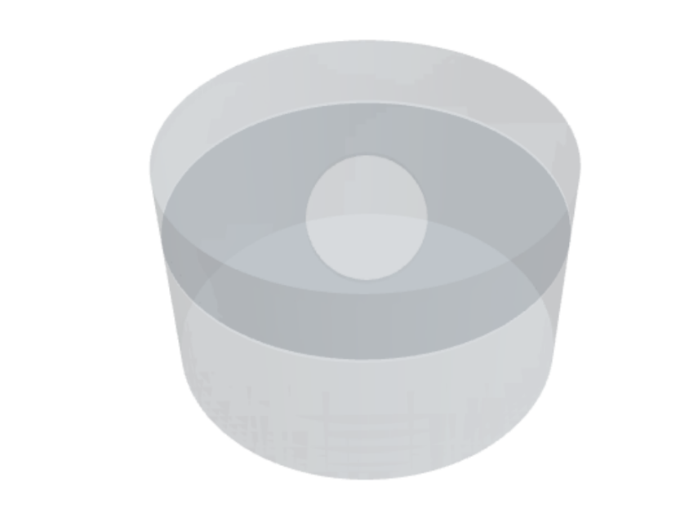
Figure 5. Geometric model of the cylindrical tank equipped with an internal elliptical baffle.
The tank was filled with water, and the free-surface motion was simulated using the VOF method. In order to resolve the liquid motion with sufficient accuracy, the basic mesh size of the internal computational domain was set to 0.2 m. Since the free-surface evolution plays a key role in sloshing dynamics, local anisotropic refinement was introduced near the water surface. The refinement ratios in the y and z-directions were taken as 25%, 30%, and 3.125% of the background mesh size, respectively. This treatment significantly improved the vertical resolution near the interface and helped capture the transient deformation of the free surface more effectively. Figures 6 and 7 show the mesh distribution of the internal domain, where it can be seen that the mesh is refined near the free surface and around the baffle region, while a relatively coarser mesh is retained in the lower part of the tank to reduce the overall computational cost.
To excite the internal liquid motion, a horizontal harmonic excitation was imposed on the tank. In order to avoid a sudden start and reduce nonphysical numerical oscillations, a smooth ramp function was adopted at the initial stage of motion. The excitation was defined as
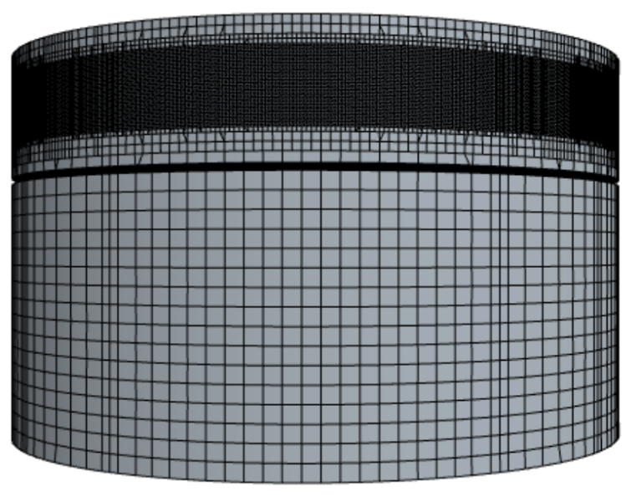
Figure 6. Local mesh distribution in the internal flow domain.
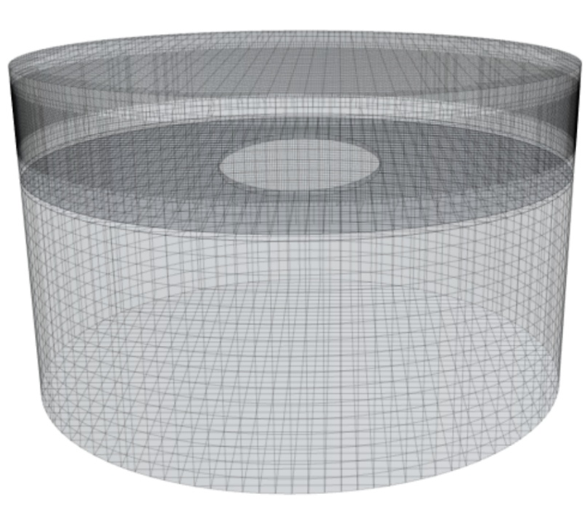
Figure 7. Overall mesh of the baffled tank with free-surface refinement.
This excitation form ensures a gradual transition from rest to steady harmonic motion, which is beneficial for obtaining a stable numerical response. Under this horizontal forcing, the internal liquid undergoes free-surface oscillation and interacts with the elliptical baffle, leading to a characteristic sloshing response inside the tank.
Figure 8 presents the scalar distribution on a representative section, where the air–water interface inside the tank can be clearly identified. The result indicates that the free surface evolves continuously under the imposed excitation and is evidently influenced by the presence of the internal baffle. Figure 9 shows the time history of the internal wave height. It can be seen that the wave amplitude increases gradually during the initial stage and then develops into an approximately periodic oscillatory response. This reflects the progressive establishment of the sloshing motion under horizontal excitation. The growth of the early-stage response is mainly associated with the ramped excitation, while the subsequent regular oscillation indicates that the internal flow gradually reaches a stable dynamic state.
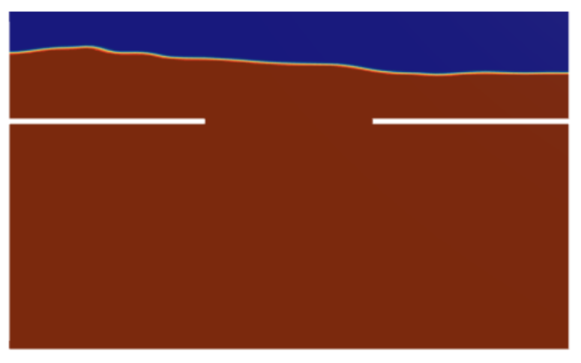
Figure 8. Scalar distribution on a representative section showing the internal air–water interface.
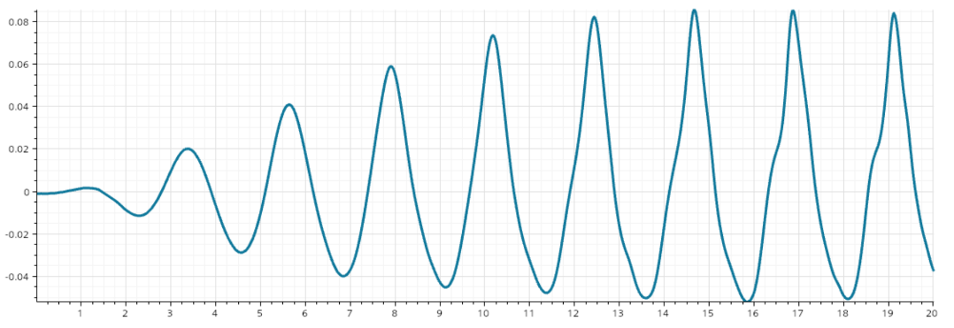
Figure 9. Time history of the internal wave height under horizontal harmonic excitation.
Overall, the present internal-flow model provides the basis for analyzing the sloshing characteristics of the liquid in a baffled cylindrical tank under horizontal harmonic excitation. The combined use of local free-surface refinement and smooth excitation loading allows the internal wave evolution to be captured with sufficient stability and accuracy.

6. Internal–External Coupled Flow Simulation
To further investigate the interaction between the external wave field and the internal liquid motion, a three-dimensional internal–external coupled numerical model was established in STAR-CCM+. As shown in Fig. 10, the cylindrical tank was placed in a rectangular numerical wave flume, and both the outer and inner fluids were treated as water. The tank radius was 1 m and the draft was 2 m. The coupled model was designed to simultaneously resolve the wave propagation in the outer domain and the sloshing response inside the tank, thereby providing a direct description of the hydrodynamic interaction between the two fluid regions.

Figure 10. Geometric model of the internal–external coupled flow system.
The dimensions of the external computational domain were defined by a rectangular box extending from (−50,−2,−5) to (50,2,5). Within this wave tank, the cylindrical liquid container was located near the central region of the domain. A first-order VOF wave model was employed to generate the external wave field, and the fluid was assumed to be inviscid in order to focus on the essential free-surface dynamics of the coupled system. The incident wave amplitude was set to 0.01 m. Under wave excitation, the tank was subjected to hydrodynamic disturbance from the surrounding fluid, while the internal liquid experienced sloshing motion induced by the coupled interaction.
To achieve a suitable balance between numerical accuracy and computational efficiency, local mesh refinement was introduced in the key regions of the model. A tank-centered refinement zone was specified within the rectangular region from (−2,−2,−2) to (5,2,2). In this region, isotropic refinement was adopted, and the cell size was reduced to 10% of that in the background computational domain. This treatment was used to improve the resolution of the local flow details around the tank, including the near-body pressure variation, interface deformation, and flow exchange associated with the coupled motion.
In addition, since the free-surface evolution is one of the most important features in the present problem, a second refinement region was arranged around the still-water level, covering the range from (−50,−2,−0.5) to (50,2,0.5). In this region, anisotropic refinement was applied to enhance the resolution near the air–water interface without excessively increasing the total cell number. The directional scaling factors were taken as 25% in the x-direction, 30% in the y-direction, and 3.125% in the z-direction relative to the background mesh size. Such a refinement strategy is particularly effective for wave simulations, because the free-surface profile is much more sensitive to the vertical mesh resolution than to the horizontal one.
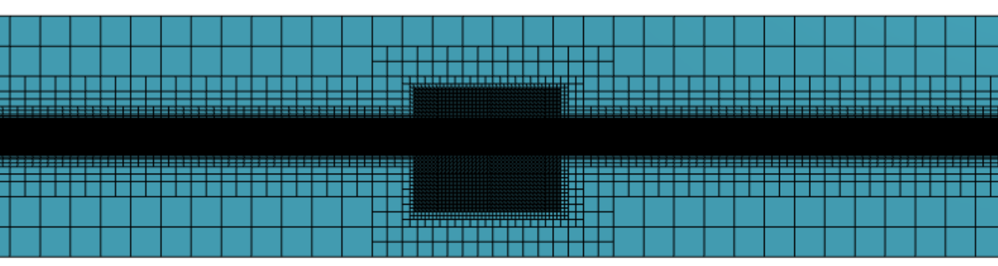
Figure 11. Local mesh refinement around the cylindrical tank and the free-surface region in the coupled domain.
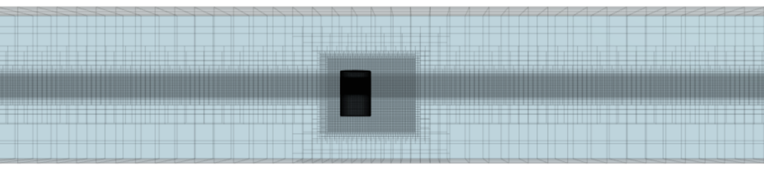
Figure 12. Overall mesh distribution of the internal–external coupled computational domain.
Figures 11 and 12 present the mesh distribution of the coupled computational domain. It can be seen that the mesh is significantly refined in the vicinity of the cylindrical tank and near the free surface, while the far-field region remains relatively coarse. This non-uniform mesh arrangement allows the incident wave propagation and the local coupled response around the tank to be captured simultaneously with reasonable computational cost. Figure 13 shows the scalar distribution on a representative section, where the air and water phases in the external domain are clearly distinguished and the partially submerged tank is properly represented. The result confirms that the initial phase distribution and the geometric configuration of the coupled model were correctly established.

Figure 13. Scalar distribution on a representative section of the coupled model.
Figure 14 shows the time history of the internal wave height in the liquid tank. It can be observed that the internal free surface exhibits an oscillatory response under the action of the external wave field. Compared with the purely internally excited case, the internal wave motion in the coupled model is governed by the external wave forcing transmitted through the tank–fluid interaction. The wave-height curve indicates that the internal sloshing response is continuously affected by the outer wave environment and gradually develops into a characteristic coupled oscillation pattern. This demonstrates that the external excitation is effectively transmitted into the internal liquid domain through the coupled hydrodynamic process.
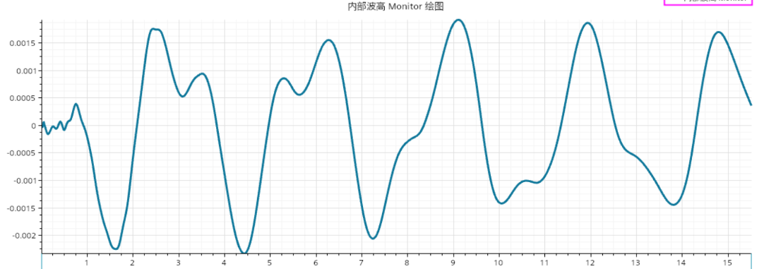
Figure 14. Time history of the internal wave height under external wave excitation.
Overall, the present internal–external coupled model provides the numerical basis for investigating the interaction between the ambient wave field and the liquid motion inside the tank. By combining local isotropic refinement near the tank with anisotropic refinement near the free surface, the model is able to capture both the external wave propagation and the internal liquid response with sufficient clarity. Therefore, it serves as the foundation for the subsequent analysis of the coupled hydrodynamic characteristics.

7. Conclusion
In this study, a numerical investigation of the internal–external coupled flow system was carried out using STAR-CCM+. The VOF method was adopted to capture the free-surface evolution of the air–water interface, and three types of numerical models were established, including the external wave field model, the internal sloshing model, and the coupled internal–external flow model. Through these simulations, the applicability of STAR-CCM+ and the VOF method to complex free-surface problems involving wave propagation, liquid sloshing, and coupled hydrodynamic interaction was demonstrated.
For the external flow field, a three-dimensional numerical wave tank was constructed to simulate the interaction between incident waves and a partially submerged cylindrical tank. By applying local mesh refinement near the tank and anisotropic refinement around the free surface, the external wave propagation and the local flow features around the tank were captured effectively. The results showed that the numerical model was able to represent the geometric configuration, phase distribution, and free-surface characteristics of the external flow domain in a stable and reasonable manner.
For the internal flow field, a cylindrical tank equipped with an internal elliptical baffle was established and subjected to horizontal harmonic excitation. The numerical results indicated that the internal free surface evolved continuously under the imposed motion and gradually developed into an approximately periodic sloshing response. The mesh refinement strategy near the free surface improved the resolution of the interface deformation and helped describe the dynamic wave-height variation inside the tank. These results confirm that the present internal-flow model can be used to simulate sloshing phenomena in baffled liquid tanks.
For the internal–external coupled case, the outer wave field and the inner liquid motion were solved within a unified computational framework. The coupled simulations showed that the external wave excitation could be effectively transmitted into the internal liquid domain, resulting in a distinct oscillatory response of the internal free surface. The time history of the internal wave height further demonstrated the existence of hydrodynamic interaction between the outer and inner fluids. This confirms that the present numerical model is capable of describing the essential features of internal–external flow coupling.
Overall, the present study provides a numerical framework for analyzing free-surface flow problems involving external wave action, internal sloshing, and their coupled interaction. The results indicate that the combination of STAR-CCM+, the VOF method, and appropriate local mesh refinement offers an effective approach for simulating such multiphase hydrodynamic systems. The developed model may serve as a useful basis for future investigations on coupled liquid motion in floating or partially submerged tanks under more complicated wave conditions.

COMPETING INTERESTS DISCLAIMER:
Authors have declared that they have no known competing financial interests OR non-financial interests OR personal relationships that could have appeared to influence the work reported in this paper.

Reference
Hirt, C. W., & Nichols, B. D. (1981). Volume of fluid (VOF) method for the dynamics of free boundaries. J. Comput. Phys., 39(1), 201–225.
Ibrahim, R. A., Pilipchuk, V. N., & Ikeda, T. (2001). Recent advances in liquid sloshing dynamics. Appl. Mech. Rev., 54(2), 133–199.
Faltinsen, O. M., & Timokha, A. N. (2009). Sloshing. Cambridge: Cambridge University Press.
Windt, C., Davidson, J., Schmitt, P., & Ringwood, J. V. (2019). On the assessment of numerical wave makers in CFD simulations. J. Mar. Sci. Eng., 7(2), 47.
Jiang, S. C., & Bai, W. (2020). Coupling analysis for sway motion box with internal liquid sloshing under wave actions. Phys. Fluids, 32(7), 072106.
Zhuang, Y., & Wan, D. (2019). Numerical study on ship motion fully coupled with LNG tank sloshing in CFD method. Int. J. Comput. Methods, 16(6), 1840022.
Zhang, Z., Wu, Q., Xie, Y., & Yu, H. (2023). Experimental and numerical investigations on the liquid tank sloshing in regular waves. Ocean Eng., 271, 113668.
Xue, M. A., He, Y., Yuan, X., Cao, Z., & Odoom, J. K. (2023). Numerical and experimental study on sloshing damping effects of the porous baffle. Ocean Eng., 285, 115363.
Li, Z., et al. (2019). Comparison of wave modeling methods in CFD solvers for ocean engineering applications. Ocean Eng.
He, T., et al. (2022). CFD simulation and experimental study on coupled sloshing and ship motion in beam waves. J. Mar. Sci. Eng.
Konar, T., & Das, A. (2025). A review of numerical modelling of liquid sloshing in partially filled containers. Ships and Offshore Structures, 1-26.
Khot, S. M., & Maghrabi, S. H. S. (2022). Experimental investigation of stability analysis of liquid containing structure. Materials Today: Proceedings, 62, 3244-3252.
Zhang, Z., Zhou, Y., Zhou, L., Sui, Y., Bao, C., Zhang, W., & Zhang, G. (2025). Smoothed particle hydrodynamics simulation of sloshing dynamics considering internal–external fluid–structure interactions. Physics of Fluids, 37(7).
Qi, X., Zhang, Y., & Gao, B. (2023). Observing Liquid Sloshing Based on a Multi-Degree-of-Freedom Pendulum Model and Free Surface Fluctuation Sensor. Sensors, 23(21), 8831. https://doi.org/10.3390/s23218831
‌

