Case report

Pediatric Primary Parotid Tuberculosis: Case Report and Literature Review

Abstract
Objectives: To report a rare case of primary parotid gland tuberculosis in a 12-year-old child and to highlight the diagnostic challenges associated with this condition.
Case report: A 12-year-old child with no significant medical history presented with a progressively enlarging, painless swelling of the right parotid region. Physical examination revealed a soft, mobile mass measuring approximately 3 cm, with no facial nerve involvement or intraoral purulent discharge. MRI suggested a cystic lesion, initially favoring a pleomorphic adenoma. Laboratory investigations were normal except for a mildly elevated erythrocyte sedimentation rate. The patient underwent a conservative parotidectomy, and histopathological analysis of the specimen revealed epithelioid and giant cell granulomas with caseous necrosis, confirming tuberculosis. Antituberculous therapy was administered with 6 months
Discussion: Parotid tuberculosis is extremely rare, especially in children, and may mimic benign or malignant parotid tumors. Clinical, radiological, and biological findings are often nonspecific, making the diagnosis challenging. Fine-needle aspiration cytology and PCR-based methods can aid diagnosis and reduce unnecessary surgery, but histopathology remains the gold standard. Management is primarily medical, with prolonged antituberculous therapy leading to favorable outcomes.
Conclusion: Although exceptionally rare in children, primary parotid tuberculosis should be considered in the differential diagnosis of parotid masses, particularly in endemic regions.

Introduction
Tuberculosis is a chronic granulomatous infection caused by Mycobacterium tuberculosis or Mycobacterium bovis and may involve any organ. Within the otorhinolaryngological sphere, lymph node involvement is the most common presentation. Isolated tuberculosis of the salivary glands, particularly the parotid gland, is extremely rare [1,2], even in countries with a high tuberculosis burden such as Morocco. In children, only a few cases have been reported in the literature.
The clinical presentation is polymorphic and non-specific. Through a case of parotid tuberculosis in a 12-year-old child and a review of the literature, the authors aim to highlight the different diagnostic, therapeutic, and prognostic aspects of this condition.
Case report
A 12-year-old child with no significant past medical history presented to our department with a right parotid swelling that had been evolving for approximately three months, with a progressive increase in size. There were no associated clinical signs, particularly no pain, fever, weight loss, chewing discomfort, trismus, or intraoral purulent discharge.
The child was in good general condition and presented with a soft, mobile, painless swelling of the right parotid region at its inferior pole, measuring approximately 3 cm in its longest axis. There was no limitation of mouth opening and no peripheral facial nerve palsy.

Examination of the oral cavity and the opening of Stensen’s duct revealed no inflammation or purulent discharge. Examination of the cervical lymph node areas was normal. The remainder of the ENT and general examination was unremarkable.
Magnetic resonance imaging (MRI) revealed a well-defined oval solid–cystic lesion with regular margins. The solid component showed intermediate signal intensity on T1- and T2-weighted images with intermediate ADC values and heterogeneous enhancement after gadolinium injection, following a type A enhancement curve. The cystic, septated component with thin septa showed fluid signal intensity with diffusion hypointensity and elevated ADC values.(Figure 1 et 2)
These imaging findings were suggestive of a pleomorphic adenoma.

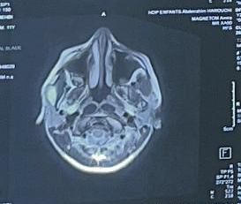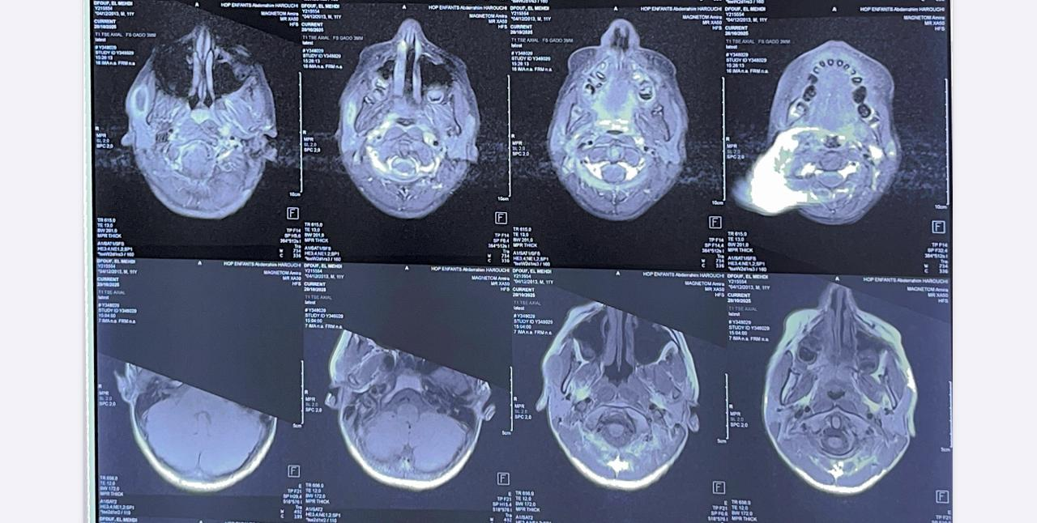
FIGURE 1: MRI PAROTID T2 FIGURE 2 : MRI PAROTID T1

Laboratory investigations were normal, except for a slightly elevated erythrocyte sedimentation rate (55 mm in the first hour), as well as the chest radiograph.
The patient underwent surgery with a conservative parotidectomy preserving the facial nerve. Histopathological examination of the cyst wall revealed epithelioid and giant cell granulomas with caseous necrosis. ( figure 3)
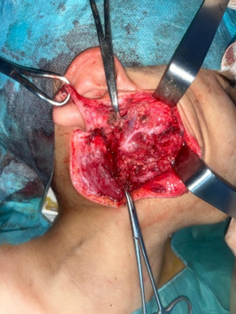
FIGURE 3: intraoperative image of superficial parotidectomy

The child received antituberculous therapy consisting of an initial 2-month intensive phase with rifampicin, isoniazid, ethambutol, and pyrazinamide, followed by a 4-month continuation phase with rifampicin and isoniazid. The outcome was favorable, with no recurrence observed after a 6-month follow-up period

Discussion
First described in 1894 by von Stubenrauch, parotid tuberculosis is rare, with approximately 200 cases reported in the literature since that time. More than 90% of reported cases occur in developing countries [3]. It most commonly affects young adults between 20 and 40 years of age, with children being very rarely affected [1].
Parenchymal parotid involvement most often occurs in the setting of disseminated tuberculosis, with spread via hematogenous or lymphatic routes from a pulmonary focus, but it may also be isolated, as in our patient, thereby posing a differential diagnostic challenge with parotid gland tumors. In such cases, Mycobacterium localized in the oropharynx may spread retrogradely through Stensen’s duct. This entity must be distinguished from tuberculosis of intraparotid lymph nodes, which is far more common.
Clinically, parotid tuberculosis usually presents as a unilateral, progressively enlarging parotid swelling, which may be diffuse or nodular, producing a pseudotumoral syndrome. Facial nerve palsy, pain, and trismus may be observed but are more suggestive of malignancy. Conversely, the presence of a cutaneous fistula is highly suggestive of an inflammatory condition. General symptoms of tuberculosis are rarely present but should be sought, as they may orient the diagnosis, along with the patient’s geographic origin [3,4].
Radiological findings on ultrasound, CT, and MRI generally do not allow a definitive diagnosis. Various and nonspecific appearances may be observed, including parotid tissue nodules, diffuse sialadenitis, cystic or fluid-containing lesions, sometimes associated with intraparotid or jugulocarotid lymphadenopathy. Sialography is not specific, nor are technetium-99m or gallium-67 scintigraphy. A chest radiograph should always be performed to search for a potential primary focus. Biologically, an inflammatory syndrome is usually present, and the tuberculin skin test is not consistently positive [2,6].
Thus, no clinical, radiological, or biological feature alone can confirm the diagnosis of parotid tuberculosis. Consequently, the differential diagnosis of diffuse forms mainly includes lithiasic parotitis or carcinoma, while localized forms more commonly suggest a cyst, adenitis, or pleomorphic adenoma [4]. The clinician’s challenge is therefore to establish the diagnosis prior to surgical exploration and histological examination of the parotidectomy specimen, especially in pediatric cases, which are exceptional and in which the diagnosis is rarely considered.
Fine-needle aspiration cytology with culture of the aspirated fluid may be useful, although it is only contributive when positive. Reported specificity is 81% and sensitivity 94% [6]. Currently, most authors recommend gene amplification techniques using PCR (polymerase chain reaction) after culture of glandular cellular material to improve diagnostic yield [7]. Others advocate a therapeutic trial of antituberculous drugs when the diagnosis is strongly suspected [3,5]. However, in some cases, only histological examination of a satellite lymph node or even parotidectomy allows confirmation by demonstrating the classic epithelioid giant-cell granuloma with caseous necrosis [4,6].
Management is primarily medical. Exofacial parotidectomy was long recommended for diagnostic purposes and to facilitate diffusion of antituberculous drugs; however, it is now abandoned by most authors due to its significant morbidity and the proven effectiveness of medical treatment alone. Treatment relies on prolonged antituberculous therapy, usually for 6 to 9 months, leading to rapid resolution of the parotid mass [3,6,7].
Conclusion
Although exceptionally rare in children, primary parotid tuberculosis should be considered in the differential diagnosis of parotid masses, particularly in endemic regions. Early recognition and appropriate medical management can prevent unnecessary surgery and ensure rapid recovery

Références
1] Chatterjee A, Varman M, Quinlan TW. Parotid abscess caused by Myco bacterium tuberculosis. Pediatr Infect Dis J 2001;20:912–4.
[2] Kim YH, Jeong WJ, Jung KY, et al. Diagnosis of major salivary gland tuberculosis: experience of eight cases and review of the literature. Acta Otolaryngol 2005;125:1318–22.
[3] Suleiman AM. Tuberculous parotitis: report of three cases. Br J Oral Maxillofac Surg 2001;39:320–3.
[4] Raji A, Mahtar M, Essaadi M, et al. La tuberculose parotidienne. À propos de 6 cas. Med Mal Infect 2002;32:196–7.
5] Sethi A, Sareen D, Sabherwal A, et al. Primary parotid tuberculosis: varied clinical presentations. Oral Dis 2006;12:213–5.
[6] Handa U, Kumar S, Punia RS, et al. Tuberculous parotitis: a series of five cases diagnosed on fine needle aspiration cytology. J Laryngol Otol 2001; 115:235–7.
[7] Kontopoulou T, Fanourgiakis P, Samarkos M, et al. Tuberculosis of the parotid gland: case report and literature review. Med Mal Infect 2004;34: 488–90

