Case report
Laparoscopic Management of Median Arcuate Ligament Syndrome in a Young Female with Right Renal Agenesis and Left-Sided Nutcracker Phenomenon: A Rare Triple Vascular-Anatomical Association

Abstract
Background
Median Arcuate Ligament Syndrome (MALS), also known as celiac artery compression syndrome or Dunbar syndrome, is a rare vascular disorder caused by external compression of the proximal celiac artery by the median arcuate ligament of the diaphragm. Although radiological compression of the celiac axis may be identified in up to 10–24% of individuals, only a small proportion develop symptomatic disease. Patients typically present with postprandial epigastric pain, nausea, vomiting, and weight loss, and the condition predominantly affects young, thin females. Diagnosis relies on correlation of characteristic clinical symptoms with vascular imaging findings, particularly CT angiography demonstrating focal narrowing of the proximal celiac artery with a typical hooked appearance and post-stenotic dilatation. The coexistence of MALS with other vascular compression disorders or congenital anomalies is extremely rare.
Case Presentation
We report the case of a 19-year-old female presenting with progressive postprandial abdominal pain, recurrent vomiting, and significant weight loss over a five-month period. Clinical examination was largely unremarkable except for a low body mass index (17.1 kg/m²). Contrast-enhanced CT angiography revealed focal narrowing of the celiac trunk with a characteristic hooked configuration consistent with MALS. Imaging also demonstrated an anatomical variant in which the common hepatic artery originated from the superior mesenteric artery, along with incidental findings of right renal agenesis and compression of the left renal vein between the aorta and superior mesenteric artery consistent with nutcracker phenomenon. The patient underwent successful laparoscopic median arcuate ligament release with circumferential decompression of the celiac artery and celiac plexus neurolysis.
Conclusion
This report highlights an extremely rare coexistence of MALS with unilateral renal agenesis and nutcracker phenomenon. Awareness of such vascular and congenital associations is important for accurate diagnosis and surgical planning. Laparoscopic median arcuate ligament release remains a safe and effective treatment for symptomatic MALS with favorable postoperative outcomes.
Keywords: Median arcuate ligament syndrome, celiac artery compression, nutcracker phenomenon, renal agenesis, laparoscopic decompression.

Introduction
Median Arcuate Ligament Syndrome (MALS), also referred to as celiac artery compression syndrome or Dunbar syndrome, is an uncommon vascular compression disorder caused by extrinsic compression of the proximal celiac artery by the median arcuate ligament of the diaphragm. The median arcuate ligament normally forms a fibrous arch connecting the right and left diaphragmatic crura anterior to the aortic hiatus. In certain individuals, a low insertion of this ligament or a high origin of the celiac trunk results in compression of the celiac artery, particularly during expiration when diaphragmatic descent accentuates the narrowing. Although anatomical compression of the celiac axis can be detected incidentally in a significant proportion of asymptomatic individuals on imaging studies, only a small subset develop the characteristic clinical features of symptomatic MALS.
The estimated incidence of symptomatic Median Arcuate Ligament Syndrome is approximately 2 per 100,000 individuals, with a female predominance and typical presentation in young patients with low body mass index.

Patients with MALS typically present with chronic postprandial epigastric pain, nausea, vomiting, early satiety, and progressive weight loss. The condition most commonly affects young females with a low body mass index. The pathophysiology is considered multifactorial, involving both mesenteric ischemia due to reduced blood flow through the compressed celiac artery and neuropathic pain resulting from irritation or compression of the celiac plexus. Because the symptoms are often nonspecific and overlap with other gastrointestinal disorders, MALS remains a diagnosis of exclusion and requires careful clinicoradiologic correlation.
Advances in vascular imaging have significantly improved the diagnostic evaluation of this condition. Contrast-enhanced computed tomography angiography (CTA) and duplex Doppler ultrasonography are widely used to demonstrate focal narrowing of the proximal celiac artery with a characteristic “hooked” configuration and post-stenotic dilatation. Dynamic imaging during inspiration and expiration may further help differentiate extrinsic compression from intrinsic atherosclerotic stenosis. Identification of associated vascular variations is also important because such anomalies may influence surgical planning.
Surgical decompression remains the definitive treatment for symptomatic MALS. Traditionally performed through an open approach, median arcuate ligament release is increasingly undertaken using minimally invasive techniques, including laparoscopic and robotic approaches, which have been associated with reduced postoperative morbidity, shorter hospital stay, and favorable clinical outcomes. In selected cases, endovascular intervention may be considered for persistent stenosis following adequate surgical decompression.
The coexistence of MALS with other vascular compression syndromes or congenital anomalies is rare. Nutcracker phenomenon, characterized by compression of the left renal vein between the aorta and superior mesenteric artery, represents another vascular compression disorder that may present with hematuria, flank pain, or pelvic congestion but may also remain asymptomatic. Similarly, unilateral renal agenesis is a congenital anomaly that is often detected incidentally but may coexist with other developmental vascular variations.
Here, we report a rare case of symptomatic Median Arcuate Ligament Syndrome in a young female in whom CT angiography revealed a unique association with right renal agenesis, left-sided nutcracker phenomenon, and an anomalous origin of the common hepatic artery from the superior mesenteric artery. This unusual constellation highlights the importance of comprehensive vascular imaging in patients with suspected MALS and underscores the need for careful preoperative evaluation when planning surgical management.

Case Presentation
A 19-year-old female presented to the surgical outpatient department with complaints of recurrent abdominal pain for approximately five months. The pain was predominantly located in the epigastric region, insidious in onset, and progressively increasing in severity. It was typically aggravated after meals and occasionally radiated to the back. The patient also reported associated symptoms of postprandial fullness, recurrent episodes of vomiting, and progressive weight loss during this period. There was no history of fever, hematemesis, melena, altered bowel habits, or previous abdominal surgery. Her past medical history and family history were unremarkable.
On clinical examination, the patient appeared thin and undernourished. Her height was 152 cm and weight was 39.2 kg, corresponding to a body mass index (BMI) of 17.1 kg/m². Vital signs were stable. Abdominal examination revealed a soft, flat abdomen without tenderness, palpable mass, organomegaly, or signs of peritonitis. Bowel sounds were normal. Systemic examination did not reveal any significant abnormality.
Routine laboratory investigations including complete blood count, liver function tests, renal function tests, and serum amylase and lipase levels were within normal limits. Due to persistent symptoms suggestive of chronic mesenteric ischemia or vascular compression, contrast-enhanced computed tomography angiography (CTA) of the abdomen was performed.
CTA demonstrated focal narrowing at the origin of the celiac trunk with a characteristic hooked configuration and mild post-stenotic dilatation, findings consistent with Median Arcuate Ligament Syndrome. In addition, an anatomical vascular variant was noted in which the common hepatic artery originated from the superior mesenteric artery rather than from the celiac trunk. The imaging also revealed absence of the right kidney consistent with right renal agenesis. Furthermore, compression of the left renal vein between the abdominal aorta and the superior mesenteric artery was identified, suggestive of the nutcracker phenomenon. As
the patient did not exhibit hematuria, flank pain, or proteinuria, the renal vein compression was considered incidental and managed conservatively.
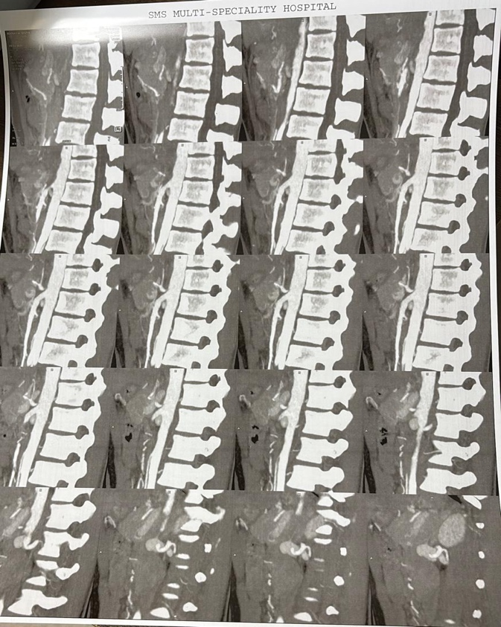
Figure 1: Sagittal CT angiographic reconstruction demonstrating focal narrowing of the proximal celiac artery with a characteristic hooked appearance caused by compression from the median arcuate ligament, with mild post-stenotic dilatation.

After multidisciplinary evaluation and exclusion of other gastrointestinal causes of chronic abdominal pain, a diagnosis of symptomatic Median Arcuate Ligament Syndrome was established. The patient was planned for laparoscopic median arcuate ligament release.
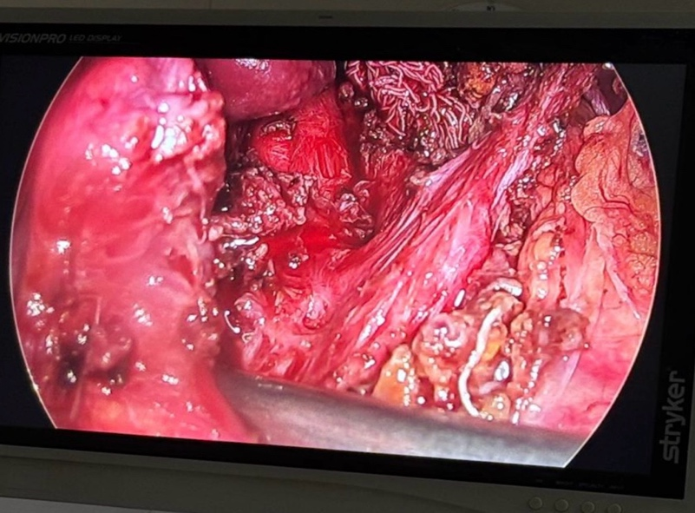
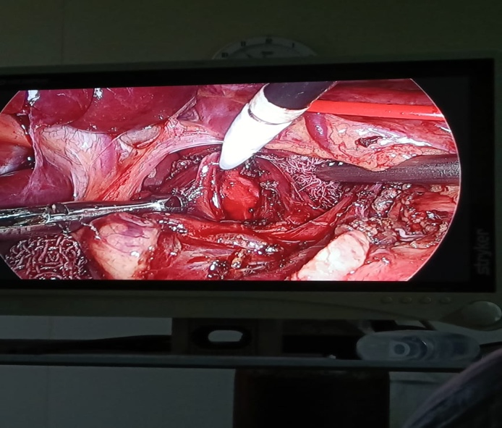
Under general anesthesia, the patient was positioned supine in a semi-lithotomy position. Pneumoperitoneum was established and laparoscopic access was obtained. The gastrohepatic ligament was divided to enter the lesser sac and expose the diaphragmatic crura. Careful dissection was performed to identify the left gastric artery and splenic artery, allowing exposure of the origin of the celiac trunk from the abdominal aorta. The median arcuate ligament was identified crossing anterior to the proximal celiac artery, causing extrinsic compression. Fibro-muscular bands surrounding the vessel were meticulously divided using harmonic energy devices and hook cautery. Complete circumferential skeletonization of the celiac trunk was achieved, and celiac plexus neurolysis was performed to ensure adequate decompression.
Figure 2: Intraoperative laparoscopic view demonstrating fibrous compression of the proximal celiac artery by the median arcuate ligament prior to surgical division.

The procedure was completed laparoscopically without intraoperative complications or need for conversion to open surgery. Adequate hemostasis was achieved.
The postoperative course was uneventful. Oral intake was resumed gradually on postoperative day one, and the patient tolerated diet well. She was discharged in stable condition on postoperative day four. At follow-up, the patient reported significant improvement in symptoms with resolution of postprandial abdominal pain.

Discussion
Median Arcuate Ligament Syndrome (MALS), also known as celiac artery compression syndrome or Dunbar syndrome, is a rare vascular compression disorder caused by extrinsic compression of the proximal celiac artery by the median arcuate ligament of the diaphragm. The condition is estimated to affect approximately 2 per 100,000 individuals, although anatomical compression of the celiac axis can be observed in a much larger proportion of asymptomatic individuals on imaging studies. Radiologic compression of the celiac artery may be seen in up to 25% of the population, yet only a small minority develop clinically significant symptoms.
The pathophysiology of MALS remains incompletely understood and is considered multifactorial. Two principal mechanisms have been proposed. The first involves mesenteric ischemia caused by reduced blood flow through the compressed celiac artery, particularly during expiration when the diaphragm descends and accentuates the compression. The second mechanism involves neurogenic pain due to irritation or compression of the celiac plexus, which lies adjacent to the celiac trunk. This dual ischemic and neurogenic mechanism may explain the variability in symptoms and the sometimes inconsistent relationship between the degree of arterial stenosis and clinical manifestations.
Patients with symptomatic MALS most commonly present with postprandial epigastric pain, nausea, vomiting, early satiety, and progressive weight loss, often leading to a delay in diagnosis because these symptoms overlap with many gastrointestinal disorders. Young females with a low body mass index appear to be disproportionately affected. Imaging plays a critical role in diagnosis, with CT angiography demonstrating a characteristic focal narrowing of the proximal celiac artery with a “hooked” or “J-shaped” appearance, often accompanied by post-stenotic dilatation.
Several recent case series and observational studies have emphasized the importance of multimodal imaging in confirming the diagnosis. Doppler ultrasonography can demonstrate elevated peak systolic velocities in the celiac artery that vary with respiratory phases, while CT angiography provides detailed anatomical visualization of the celiac axis and surrounding structures. Such imaging also allows detection of associated vascular anomalies, which may influence surgical planning.
The present case is notable because it demonstrates the coexistence of MALS with two additional vascular-anatomical abnormalities: unilateral renal agenesis and the nutcracker phenomenon. Nutcracker syndrome refers to symptomatic compression of the left renal vein between the abdominal aorta and the superior mesenteric artery, whereas the term nutcracker phenomenon describes the same anatomical compression in the absence of symptoms. This condition may lead to venous hypertension and clinical manifestations such as hematuria, flank pain, or pelvic congestion, although many cases remain asymptomatic and are detected incidentally on imaging.
The coexistence of multiple vascular compression syndromes has been described only rarely in the literature. Recent reviews of vascular compression disorders have suggested that anatomical variations—such as reduced retroperitoneal adipose tissue, altered vascular angles, and congenital variations in arterial branching—may predispose certain individuals to more than one compression syndrome simultaneously. Lean body habitus, commonly seen in patients with MALS, may further accentuate these anatomical relationships and contribute to symptom development.
Surgical decompression remains the mainstay of treatment for symptomatic MALS. Historically, open surgical release of the median arcuate ligament was the standard approach. However, over the past two decades, minimally invasive laparoscopic and robotic approaches have increasingly become the preferred treatment, offering advantages such as reduced postoperative pain, shorter hospital stay, and faster recovery while achieving comparable rates of symptom relief. Several contemporary series report symptomatic improvement in a majority of patients following surgical decompression when appropriate patient selection criteria are applied.
In our patient, laparoscopic median arcuate ligament release with circumferential dissection of the celiac trunk and celiac plexus neurolysis resulted in successful decompression and early symptomatic improvement. The nutcracker phenomenon was considered an incidental finding because the patient did not demonstrate hematuria, flank pain, or renal dysfunction. Current literature suggests that asymptomatic cases of renal vein compression may be managed conservatively with observation and periodic follow-up, reserving intervention for patients who develop significant symptoms or complications.
The presence of unilateral renal agenesis in this patient adds further clinical significance to the case. Although renal agenesis is a congenital anomaly that may remain asymptomatic throughout life, its identification necessitates careful monitoring of renal function and avoidance of potential nephrotoxic insults, particularly in patients with a solitary functioning kidney.
This case therefore highlights several important clinical considerations. First, clinicians should maintain a high index of suspicion for MALS in young, thin patients presenting with unexplained chronic postprandial abdominal pain and weight loss. Second, comprehensive vascular imaging is essential not only for confirming the diagnosis but also for identifying associated vascular anomalies that may influence management. Finally, minimally invasive surgical decompression remains a safe and effective treatment strategy for appropriately selected patients with symptomatic MALS.

Conclusion
Median Arcuate Ligament Syndrome is an uncommon vascular compression disorder that should be considered in young, thin patients presenting with chronic postprandial abdominal pain and unexplained weight loss after exclusion of more common gastrointestinal causes. Accurate diagnosis requires careful clinicoradiologic correlation, with contrast-enhanced CT angiography playing a central role in demonstrating the characteristic compression of the proximal celiac artery.
This case highlights an extremely rare association of symptomatic Median Arcuate Ligament Syndrome with right renal agenesis and left-sided nutcracker phenomenon, along with an anomalous origin of the common hepatic artery from the superior mesenteric artery. Recognition of such vascular and congenital variations is important because they may influence both diagnostic evaluation and operative planning.
Minimally invasive laparoscopic median arcuate ligament release provides effective decompression of the celiac artery and can result in significant symptomatic improvement with low morbidity when performed in appropriately selected patients. Comprehensive vascular imaging and multidisciplinary evaluation remain essential for identifying associated anomalies and guiding individualized management strategies.
Early recognition and comprehensive vascular imaging are essential for diagnosis, while minimally invasive surgical decompression provides effective symptom relief with favorable outcomes.

References
1. Williams NS, O’Connell PR, McCaskie AW. Bailey & Love’s Short Practice of Surgery. 28th ed. Boca Raton: CRC Press; 2022.
2. Brunicardi FC, Andersen DK, Billiar TR, Dunn DL, Hunter JG, Matthews JB, Pollock RE. Schwartz’s Principles of Surgery. 11th ed. New York: McGraw-Hill Education; 2019.
3. Townsend CM, Beauchamp RD, Evers BM, Mattox KL. Sabiston Textbook of Surgery: The Biological Basis of Modern Surgical Practice. 21st ed. Philadelphia: Elsevier; 2022.
4. Standring S. Gray’s Anatomy: The Anatomical Basis of Clinical Practice. 42nd ed. London: Elsevier; 2021.
5. Iqbal S, et al. Median arcuate ligament syndrome (Dunbar syndrome): a review of diagnosis and management. Cardiovasc Diagn Ther. 2021;11(3):1156-1164.
6. Upshaw W, et al. Overview of median arcuate ligament syndrome. Cureus. 2023;15(10):e45413.
7. Narwani P, et al. Median arcuate ligament syndrome diagnosis on computed tomography angiography. Radiology Case Reports. 2021;16(10):3027-3031.
8. Kiudelis M, et al. Median arcuate ligament syndrome: case report and literature review. Int J Surg Case Rep.2025;116:109521.
9. Alnahhal KI, Tedesco A, Khan ZZ, Irshad A, Salehi P. Median arcuate ligament syndrome: comparison of open and laparoscopic management. Ann Vasc Surg.2023;96:215-222.
10. Manchella MK, et al. Management of median arcuate ligament syndrome: contemporary perspectives. Ann Vasc Surg. 2025.
11. Maharaj D, et al. Nutcracker syndrome: a case-based review. Ann R Coll Surg Engl. 2023;105(7):509-514.
12. Ananthan K, Onida S, Davies AH. Nutcracker syndrome: an update on current diagnostic criteria and management guidelines. Eur J Vasc Endovasc Surg.2017;53(6):886-894.
13. Hangge PT, Gupta N, Khaja MS. Degree of left renal vein compression predicts nutcracker syndrome. J ClinMed. 2018;7(5):107.
14. Ribeiro FS, et al. Prevalence of left renal vein compression (nutcracker phenomenon) in asymptomatic individuals. J Vasc Surg Venous Lymphat Disord.2020;8(5):808-815.
15. Penfold D, et al. Nutcracker syndrome and left renal vein entrapment. In: StatPearls. Treasure Island (FL): StatPearls Publishing; 2024.
16. Dunphy L, et al. Left renal vein entrapment syndrome: nutcracker syndrome. BMJ Case Rep. 2019.
17. Wang Y, et al. Clinical manifestations and complications of median arcuate ligament syndrome. Ann Med. 2025.
18. Kozhimala M, et al. Prevalence and characteristics of patients with median arcuate ligament syndrome. J VascSurg. 2023.

