Original Research Article
GLOBIMETULA CUPULATA AS A POTENTIAL SOURCE OF LARVICIDES FOR THE CONTROL OF CULEX QUINQUEFASCIATUS

.

Aims: Globimetula cupulata, a parasitic shrub that grows widely in Nigeria, is commonly used in ethnomedicine to treat fever, malaria, high blood pressure and diabetes mellitus. This plant was investigated for probable activity against Culex quinquefasciatus larvae as there is currently no such report.
Study design: The methanol extracts of G. cupulata leaf, stem and flower were separately tested against Cx. Quinquefasciatus larvae. The most active extract was partitioned in order to identify the most active fraction from which the active compound could be isolated.
Place and duration of study: Department of Pharmacognosy, Faculty of Pharmacy, Obafemi Awolowo University, Ile-Ife, Nigeria; between November 2023 and August 2024.
Methodology: The leaf, stem and flower of G. cupulata growing on Leucaena leucocephala were collected from the university’s research farm. It was authenticated and deposited under reference number FPI 2469. They were air dried separately, weighed and macerated in methanol for 72 hours, filtered, concentrated in vacuo at 35°C and tested against the fourth instar larvae of Cx. quinquefasciatus according to WHO, 2005 guidelines. The most active extract was retaken in water and successively partitioned into n-hexane and ethylacetate. Each fraction was tested for activity. The methanol extract of Nicotiana tabaccum leaf and Tween 80 in water (0.2%v/v) were the positive and negative controls respectively.
Results: After 48 hours of exposure, the flower extract was the most active, followed by the leaf while the stem was the least active. Also, throughout the period of exposure, the hexane and the ethylacetate fractions had comparable activities while the aqueous fraction was inactive.
Conclusion: The methanol extract of G. cupulata flower has activity against the fourth instar larvae of Cx. quinquefasciatus. This activity is concentrated in the n-hexane and ethylacetate fractions. Globimetula cupulata therefore is a potential source of larvicidal compounds.
Keywords: Globimetula cupulata, morphological parts, larvicidal activity, partitioned fractions, mistletoes, flower extract
1. INTRODUCTION
The mistletoe, Globimetula cupulata syn. Elytranthe cupulata (DC.) G.Don and Loranthus cupulatus DC. (Loranthaceae) is a parasitic shrub that grows widely in some tropical African countries, including Nigeria (Boussim et al., 2004; Akinmoladun et al., 2016).The leaf is commonly used in ethnomedicine to treat high blood pressure and diabetes mellitus (Talha et al., 2011). The plant’s extract has been demonstrated to have hypoglycemic, antioxidant, antidiabetic and antihypertensive activities. Also, the hydromethanol extract of the plant growing on cocoa and kola nut had been shown to protect against ischemia/reperfusion injury in rat hearts (Edem, 2008; Muhammad, 2024; Ojewole and Adewole, 2007; Okpuzor et al 2009; Osungunna et al., 2013). The plant is safe for use as there was neither adverse biochemical changes nor hepatocellular or renal damage upon the administration of the aqueous extract to mice (Edem, 2009). The methanol extract had been reported to contain steroids, terpenoids, cardiac glycosides, alkaloids, saponins, tannins and flavonoids (Akinmoladun et al., 2010). As there is currently no report on the larvicidal activity of the extract of G. cupulata, in this study, the plant was investigated for probable activity against Cx. quinquefasciatus larvae.
2. material and methods
2.1. Plant collection, Preparation of Extracts and Fractions
The leaf, stem, and flower of G. cupulata growing on Leucaena leucocephala were collected from the Obafemi Awolowo University Research farm, Ile-Ife, Osun state, Nigeria. It was authenticated and voucher specimen deposited at the Herbarium of the Department of Pharmacognosy, Faculty of Pharmacy, Obafemi Awolowo University, Ile-Ife under reference number (FPI 2469). The collected parts were air dried separately and powdered using a grinding machine. The powder of each plant part was weighed and macerated in methanol for 72 hours. Each extract was filtered, concentrated in vacuo at 35°C and tested against the fourth instar larvae of Cx. quinquefasciatus. The most active extract was suspended in water, successively partitioned into n-hexane and ethylacetate, and concentrated in vacuo to give the corresponding fractions. Each partitioned fraction was also tested for activity.
2.2. LARVICIDAL ASSAYS
The larvicidal assay of each extract and partitioned fraction was carried out according to WHO, 2005 guidelines with slight modifications (Famuyiwa et al., 2020). Stock solutions of the extracts were prepared by solubilising in Tween 80 (0.2 %). Appropriate volumes of each stock solution (25 mg/mL) was pipetted into bioassay cups and made up with distilled water to get five different concentrations (1, 2, 3, 4, 5 mg/mL) for the extract and the partitioned fractions. Each concentration was repeated five times. Thereafter, twenty five fourth-instar larvae were introduced into each container. The methanol extract of Nicotiana tabacum leaf was used as the positive control (Famuyiwa et al., 2020) while Tween 80 in distilled water (0.2%v/v) was the negative control. Larval mortality was observed after 24 and 48 h and the number of surviving larvae was recorded. The larvae were considered dead if they did not move when prodded with a needle in the siphon or cervical region (WHO, 2005; Adebajo et al., 2014). The percentage mortality was calculated using the formula:
Percentage of mortality = (25 - Number of surviving larvae)/(25) × 100
The percentage mortality was used to predict the LC₅₀ and LC₉₀ using Microsoft Excel 2010. Statistical analysis of the data was done using one-way analysis of variance (ANOVA) followed by Student Newmann Keul's post hoc's test (p < 0.05).
3. results and discussion
Mosquito control has been supported by the World Health Organisation as a supplementary strategy to reduce transmission of mosquito-borne infections (WHO, 2020; 2023). Furthermore, targeting the mosquito at the larva stage has been reported to be efficient as they are relatively immobile and a large population can be killed in their breeding sites with little effort (Alvarez et al., 2016). However, development of resistance to currently available synthetic larvicides especially in the tropics and environmental concerns has stimulated continued efforts towards developing plant based larvicides (Ali and El-Rabaa, 2010; Lima et al., 2011; Famuyiwa et al., 2020). As a contribution to this search, the plant G. cupulata was screened for activity against the fourth instar larvae of Cx quinquefasciatus. This mosquito is the vector of lymphatic filariasis, one of the neglected tropical diseases.
3.1. LARVICIDAL ACTIVITY OF THE METHANOL EXTRACTS
The extracts of the leaf, stem and flower of G. cupulata were each tested against the fourth instar larvae of Cx. quniquefasciatus. This was with a view to identifying the morphological part in which the active constituent(s) is concentrated qualitatively or quantitatively. Each part produces and stores different types and concentrations of bioactive secondary metabolites based on its unique function, developmental stage, and environmental interaction (Cseke et al., 2016). At 24 hours, the morphological parts had varying activities with the flower extract (LC₅₀ 8.91±0.50 and LC₉₀ 11.34±0.72 mg/mL) having the least value. The leaf (LC₅₀ 10.93±1.02 and LC₉₀ 15.04±0.7 mg/mL) and the stem (LC₅₀ 10.75±1.0 and LC₉₀ 13.48±1.02 mg/mL) had comparable activities (Fig. 1). However, the activity of the most active flower extract could not be compared to the activity of the positive control, N. tabacum leaf extract (NTL). Many plants had been reported to have larvicidal activity against different mosquito species. For example Curcuma longa, Ocimum americanum

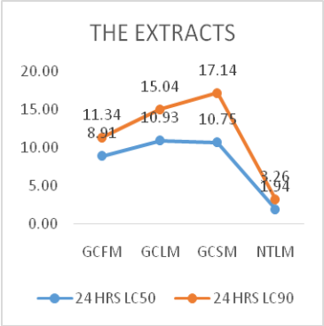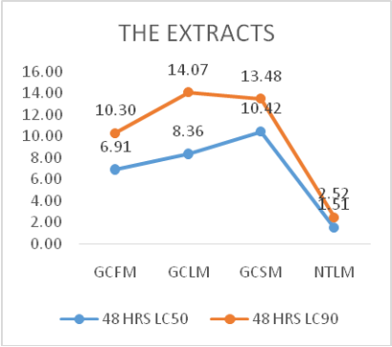
Figure 1: The Larvicidal Activities of the Leaf, Stem and Flower of G. cupulata.
KEY: GCFM: G. cupulata flower extract; GCLM: G. cupulata leaf extract; GCSM: G. cupulata stem extract; NTLM: N. tabacum leaf extract
and Petroselinum crispum against Aedes albopictus (Lim et al., 2023), Bryophyllum pinnatum, Tapinanthus bangwensis, Phragmanthera incana, Tapinanthus globiferus (Famuyiwa et al., 2025a, b).
After 48 hours of exposure of the larvae to the extracts, the flower extract was also the most active with LC₅₀ 6.91±0.41 and LC₉₀ 10.30±0.50 mg/mL (Fig. 1). There was a significant (p=0.05) improvement in the activity of the extract after prolonged contact. The lethality value of each of the morphological parts was quite high and the plant could be classified as inactive (Adebajo et al., 2014), but based on the suggestion that plants extract with moderate or low activity should be fractionated and the resulting fractions tested before discarding (Wilcox et al., 2004), the methanol extract of the flower was suspended in water and successively partitioned into n-hexane and ethylacetate. Each of the resulting fractions was tested against the larvae of Cx. quinquefasciatus.
3.2. LARVICIDAL ACTIVITY OF THE PARTITIONED FRACTIONS
After 24 hours of exposure, the hexane fraction (GCFH) had LC₅₀ and LC₉₀ of 1.86±0.06, 3.56±0.07 mg/mL respectively; while the ethylacetate fraction (GCFE) had LC₅₀ and LC₉₀ 1.97±0.05, 3.52±0.04 mg/mL respectively (Fig. 2) This showed that the activities of GCFH and GCFE are comparable. This may suggests that there are two sets of larvicidal compounds in the plant extract i.e. the non-polar and the moderately polar. Also, their activities compared very well with that of NTL. GCFH and GCFE are significantly more active than the extract (Fig 2) suggesting that the compounds are not working in synergy. The aqueous fraction (GCFA) containing the polar compounds gave a very weak activity with LC₅₀ 7.34±1.63 and LC₉₀ 11.89±3.07 mg/mL. This is not surprising; a search of the literature showed that non-polar fractions are usually more active against mosquito larvae than the polar ones. This may be due to the ability of the non-polar compounds to penetrate the cuticle of the larvae more easily than the polar ones (Annie et al., 2016; Famuyiwa et al., 2018).
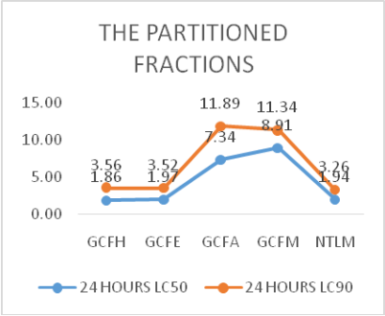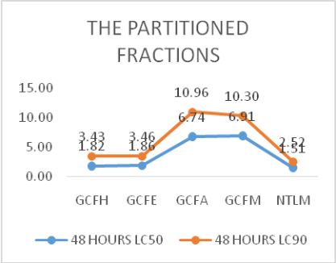
Figure 2: The Larvicidal Activities of the Partitioned Fractions of the at 24 and 48 hour.
KEY: GCFH: hexane fraction;GCFE: ethylacetate fraction;GCFA: aqueous fraction; GCFM: flower methanol extract; NTL: N. tabacum leaf extract.
At 48 hours there was no significant improvement in the activity of GCFH and GCFE. This may mean that the active phytochemicals in the extract bind to their target sites very quickly and achieve their maximal effect within a short exposure time. Therefore extending the contact time provided no additional benefit. Also it could be that the susceptible larvae are killed rapidly while the remaining ones may be naturally resistant or less susceptible, so further exposure does not change the overall population response. On the other hand there was a significant increase in the activity of GCFA, this may explain the improved activity observed in the extract at this hour.
4. Conclusion
The study concluded that the methanol extract of G. cupulata has larvicidal compounds that are concentrated in the flower. The n-hexane and the ethylacetate partitioned fractions were comparably more active than the aqueous fraction. This may mean that there are two sets (non-polar and moderately polar) of larvicidal compounds in the methanol extract of the flower. Globimetula cupulata therefore is a potential source of larvicidal compounds.
References
Boussim, I. J., Guinko, S., Tuquet, C., & Sallé, G. (2004). Mistletoes of the agroforestry parklands of Burkina Faso. Agroforestry systems, 60(1), 39-49.
Akinmoladun, A. C., Olowe, J. A., Komolafe, K., Ogundele, J., & Olaleye, M. T. (2016). Antioxidant activity and protective effects of cocoa and kola nut mistletoe (Globimetula cupulata) against ischemia/reperfusion injury in langendoff-perfused rat hearts. Journal of Food and Drug Analysis, 24, 417-426.
Talha J., Priyanka M., & Akanksha A. (2011). Hypertension and Herbal Plants. International Research Journal of Pharmacy, 2(8), 26-30.
Edem, D. O. (2008). Effect of aqueous extracts of leaves of Globimetula cupulata (DC) Van Tieghem in Normoglycemic Rats. The internet J Alt Med., 8(1), 1–6.
Muhammad, K. J. (2024). Pharmacological Activities of the Genus Globimetula and Scurrula. Journal of Science and Mathematics Letters, 12(1), 58-71. DOI: https://doi.org/10.37134/jsml.vol12.1.8.2024.
Ojewole, J. A. O., & Adewole, S. O. (2007). Hypoglycaemic and hypotensive effects of Globimetula cupulata (DC) Van Tieghem (Loranthaceae) aqueous leaf extract in rats. Cardiovascular Journal of South Africa, 18(1),9-15.
Okpuzor, J & Kareem G. (2009). Lipid lowering Activity of Globimetula braunii. Research Journal of Medicinal Plant, 3(2), 45-51.
Osungunna, O., Osungunna, M. O., & Abimbola, Y. (2013). Phytochemical and antimicrobial screening of Globimetulla oreophila (Olive) Van Tiege and Phragmenthera capitate (Spreng) Balle. International Journal of Green Pharmacy, 7, 127-130.
Edem, D. O. (2009). Biochemical Changes in Wistar Rats on Oral Doses of Aqueous Extracts of Leaves of Globimetula cupulata (Dc) Van Tieghem. Pharmacologyonline, 3, 275-282.
Akinmoladun, A. C., Obutor, E. M., & Farombi, E. O. (2010). Evaluation of antioxidant and free radical scavenging capacities of some Nigerian indigenous medicinal plants. J Med Food, 13:444e51.
World Health Organisation (2005). Guidelines for laboratory and field testing of mosquito larvicides (No. WHO/CDS/WHOPES/GCDPP/2005.13)
Famuyiwa, F. G., Adewoyin, F. B, Oladiran, O. J., & Obagbemi, O. R. (2020) Larvicidal Activity of Some Plants Extracts and Their Partitioned Fractions against Culex quinquefasciatus. IJTDH, 41(11), 23-34.
Adebajo, A. C., Famuyiwa, F. G., & Aliyu, F. A. (2014). Properties for sourcing Nigerian larvicidal plants. Molecules, 19(6), 8363-8372.
World Health Organization, (2020). Global programme to eliminate lymphatic filariasis. WHO Weekly Epidemiological report. 81:221-32. (Accessed May 22, 2024).
World Health Organization, (2023). Fact sheet on Lymphatic filariasis.
Alvarez, M. R., Heralde III, F., & Quiming, N. (2016). Screening for larvicidal activity of ethanolic and aqueous extracts of selected plants against Aedes aegypti and Aedes albopictus larvae. Journal of Coastal Life Medicine, 4(2), 143-147.
Ali, N. O. M. & El-Rabaa, F. M. A. (2010). Larvicidal activity of some plant extracts to larvae of the mosquito Culex quinquefasciatus (Say). Eur. Rev. Med. Pharmaco., 14:925-933.
Lima, M. A. A., Oliveira, F. F. M., Gomes, G.A., Lavor, P. L., Santiago, G. M. P., Nagao-Dias, A. T., Arriaga, A. M. C., Lemos. T. L. G., & Geraldo de Carvalho, M. (2011). Evaluation of larvicidal activity of the essential oils of plants species from Brazil against Aedes aegypti (Diptera: Culicidae). Afr. J. Biotech., 10(55),11716-11720. DOI: 10.5897/ajb11.1102
Cseke, L. J., Kirakosyan, A., Kaufman, P. B., Warber, S., Duke, J. A., & Brielmann, H. L. (2016). Natural Products from Plants. CRC press.
Lim, H., Lee, S.Y., Ho, L.Y., & Sit, N.W. (2023). Mosquito Larvicidal Activity and Cytotoxicity of the Extracts of Aromatic Plants from Malaysia. Insects, 14, 512. https://doi.org/10.3390/insects14060512
Famuyiwa, F., Olusola, A., Ugwo, J., Akinyuwa, S., Arowojolu, G., Alimi, A. & Faloye, K. (2025). Larvicidal and Dengue Virus Inhibitory Potential of Terpenoids from Bryophyllum pinnatum: An in-Silico Study. Journal of Applied Life Sciences International, 28(5), 71-87.
Wilcox M, Bodeker G, Rasonaivo P. (2004). Traditional medicinal plants and malaria CRC Press, USA. 4(16), 262.
Annie, S. W., Raveen, R., Paulraj, M. G., Samuel, T., & Arivoli, S. (2016). Screening of Hydrilla verticillata (LF) Royle (Hydrocharitaceae) crude leaf extracts for larvicidal efficacy against the filarial vector Culex quinquefasciatus say (Diptera: Culicidae). Screening, 1(3), 43-48.
Famuyiwa, F. G., Famuyiwa, S. O., & Aladesanmi, A. J. (2018). Activity of the compounds isolated from Blighia sapida (Sapindaceae) stem bark against Aedes aegypti larvae. Ife Journal of Science, 20(3), 601-605.

