Original Research Article

Spatio-Temporal Dynamics of Groundwater Levels in Alluvial Aquifers of Anand District, Gujarat Using Geostatistical Approaches

Abstract
Groundwater plays a vital role in sustaining agriculture and water security in semi-arid regions of India, where increasing extraction pressures necessitate a clear understanding of its variability. This study examines the spatio-temporal dynamics of groundwater levels in the alluvial aquifers of Anand district, Gujarat, over a 20-year period (2000–2020) using pre and post-monsoon data from India-WRIS. Geostatistical analysis through Ordinary Kriging within a GIS framework was employed to map and analyze groundwater distribution. Results indicate significant spatial and temporal variability, with pre-monsoon groundwater declining from 4.4-22.0 m below ground level (bgl) in 2000 to 5.6-26.1 m bgl in 2020, reflecting progressive depletion. Spatially, northern and western regions consistently showed shallower water levels, while southeastern areas remained critically deeper. Post-monsoon analysis revealed an initial recovery phase (2000–2008) due to effective recharge, followed by a reversal after 2012, with expansion of deeper zones exceeding 26 m bgl by 2020. The study highlights a shift from recovery to depletion driven by combined natural and anthropogenic factors, emphasizing the need for sustainable groundwater management strategies, including regulated extraction and improved recharge interventions.
Keywords: Groundwater variability, Spatio-temporal analysis, Ordinary Kriging, Alluvial aquifers, Groundwater depletion
1.Introduction
Water is crucial for human survival and is a vital input for producing food. To ensure sustainable food production, efficient use of water for crop irrigation is essential (Mali & Singh 2016; Kambale et al., 2017). Groundwater is one of the largest freshwater reservoirs globally, which plays a critical role in providing drinking water to half of the global population (Gleeson et al., 2012), sustaining 40 % of the global irrigated land (Siebert et al., 2010; Pandey et al. 2023). It has been estimated that between 20-30% of the world’s largest groundwater aquifers are being used unsustainably due to factors such as climate change, population growth, and increased industrial activity (Pagendam et al. 2023; Sahoo et al. 2021; Kaur et al. 2021). Groundwater extraction has become the backbone of India's agriculture and drinking water security, with the national average extraction rate at 63% (CGWB, 2019). However, groundwater extraction is not uniform across the country, with 16% of assessment units categorized as over-exploited and 4% as critical, indicating extraction exceeding annual recharge and between 90-100% of annual extractable resources, respectively. An additional 15% of assessment units are semi-critical, while 64% are categorized as safe. Finally, 1% of assessment units are saline, with brackish or saline groundwater in phreatic aquifers. Nevertheless, large-scale development and utilization of groundwater in various parts of India have led to the depletion of groundwater resources.
Spatio-temporal variability of groundwater levels is important for understanding the changes in groundwater resources over time and space (Patle et al. 2015; Ware et al. 2023). Various methods are used to analyze the spatio-temporal variability of groundwater levels, including geostatistical analysis, spatial interpolation, and remote sensing techniques (Roy et al. 2023). Geostatistical analysis involves the use of statistical techniques to quantify the spatial patterns and correlations of groundwater levels. Spatial interpolation methods, such as Kriging and Inverse Distance Weighting, are used to estimate groundwater levels at unmeasured locations based on the observed values at nearby monitoring wells. Remote sensing techniques, such as satellite imagery and aerial photography, can provide valuable information on the spatial and temporal variations of groundwater levels in large regions. Therefore, accurate prediction of groundwater levels requires the integration of various data sources, including hydrological, meteorological, and socio-economic data. Moreover, accurate prediction of future trends of groundwater levels is crucial for ensuring the long-term sustainability of groundwater resources. Therefore, the objective of this research is to investigate the groundwater variability in the alluvial aquifers of Anand district of Gujarat for sustainable use of groundwater.

2.Material and Methods
2.1 Study Area
The Anand district of Gujarat state, India which is roughly 2900 km² in size, has a semi-arid climate. The area has scorching summers and comparatively cold winters, according to meteorological data from the closest India Meteorological Department (IMD) station in Ahmedabad. The mean maximum temperature ranges from 28.4°C in January to about 41.8°C in May, while mean minimum temperatures vary from 11.7°C in January to 27°C in June. Relative humidity fluctuates between 32% in March and 79% in August. Wind velocity varies from approximately 74 km/day in November to 174 km/day in June. The long-term average annual rainfall is about 799.6 mm, with the majority of precipitation occurring during the southwest monsoon season (June–September). Agriculture in the district is practiced across all three seasons, with paddy and jowar dominating the kharif season, wheat and pulses in the rabi season, and jowar and groundnut during summer. In this study, long-term pre- and post-monsoon groundwater level data from 2000 to 2020 were utilized to assess the spatial variability of groundwater levels.
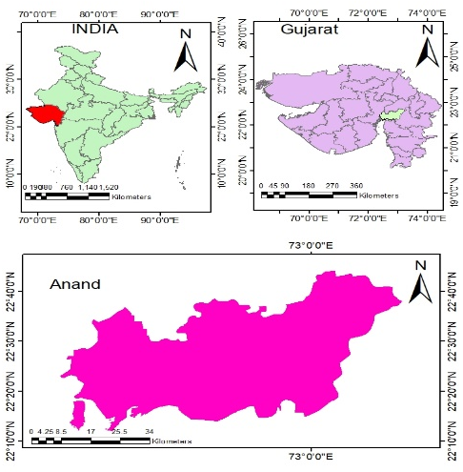
Fig. 1 The map showing location of the study area Anand district, Gujarat, India.
2.2 Data Collection
The study utilized long-term groundwater level data for the period 2000–2020 to assess spatial and temporal variability. Pre-monsoon (June) and post-monsoon (October) groundwater level data from observation wells located across Anand district were collected from the India-WRIS (Water Resources Information System) portal. The groundwater monitoring network is maintained by the Central Ground Water Board (CGWB). The groundwater level data was reported as depth to water level below ground level (m bgl). Only wells having consistent and continuous records for the study periods was considered for analysis to ensure data reliability. Ancillary data such as district boundary maps and administrative layers were collected from secondary sources for spatial analysis.

2.3 Spatial Analysis
Spatial analysis was conducted to quantify the spatial variability and distribution of groundwater levels in Anand district during the period 2000–2020. Groundwater level observations from monitoring wells were georeferenced using their geographic coordinates and analyzed within a Geographic Information System (GIS) framework. Separate datasets were prepared for pre-monsoon (June) and post-monsoon (October) seasons to capture seasonal variations in groundwater levels.
To transform discrete point observations into continuous groundwater level surfaces, geostatistical interpolation techniques were applied. Among various interpolation methods, ordinary kriging was adopted due to its capability to account for spatial autocorrelation and provide unbiased estimates with minimum estimation variance. Prior to interpolation, exploratory spatial data analysis was performed to examine data distribution and identify outliers.
The Ordinary Kriging estimator is expressed as:
$$\hat{Z}(X_{0})=\sum_{i=1}^{n}{λ_{i}}Z(X_{i})$$
where,
$\hat{Z}(X_{0})$= estimated groundwater level at the unsampled location x₀,
$Z(X_{i})$ = observed groundwater level at location xᵢ,
$λ_{i}$ = Kriging weight assigned to the iᵗʰ observation,
n = number of neighboring observation points used in estimation.
The unbiasedness condition is given by:
$\sum_{i=1}^{n}{λ_{i}}$ = 1
The Kriging system of equations is written as:
$$\sum_{j=1}^{n}{λ_{i}}γ\left(X_{i}-X_{j}\right)+µ=γ\left(X_{i}-X_{o}\right), i=1,2,…,n$$
where,
$γ\left(X_{i}-X_{j}\right)$ = semivariance between locations xᵢ and xⱼ,
$γ\left(X_{i}-X_{o}\right)$ = semivariance between the observation point xᵢ and estimation point x₀,
μ = Lagrange multiplier.
The estimation variance of Ordinary Kriging is given by:
$${σ^{2}}_{OK}=\sum_{i=1}^{n}{λ_{i}γ\left(X_{i}-X_{o}\right)+µ}$$
3. Results and Discussions
The geostatistical analysis using Ordinary Kriging revealed pronounced spatio-temporal variability in groundwater levels across Anand district during the period 2000–2020 for both pre- and post-monsoon seasons. The interpolated maps clearly illustrate that groundwater depth is highly heterogeneous, governed by a combination of hydrogeological conditions and anthropogenic influences.
3.1 Pre-Monsoon Spatial variability of groundwater level
Spatial distribution maps generated using Ordinary Kriging illustrate the pre-monsoon groundwater depth variability across Anand District, Gujarat, at four-year intervals from 2000 to 2020. Over the two-decade period, pronounced spatio-temporal fluctuations in groundwater levels were observed, reflecting the combined influence of natural processes and anthropogenic interventions (Todd and Mays, 2005; Kambale et al., 2017). In 2000, groundwater depths ranged between 4.4 and 22.0 m below ground level (bgl), with relatively shallow water tables observed in the northern and parts of the western and central regions, while deeper groundwater conditions prevailed in the southern region. By 2004, groundwater levels had further declined, with depths extending up to 26.1 m bgl, particularly in the southeastern part, although the spatial pattern of shallow zones remained largely unchanged. A temporary improvement was evident in 2008, when groundwater depths ranged from 2.1 to 20.7 m bgl, and shallow zones expanded, particularly in recharge-favorable areas, indicating the role of effective recharge processes (Gleeson et al., 2012). However, in 2012, groundwater levels again showed deterioration, with depths reaching up to 26.5 m bgl and a noticeable reduction in shallow zones, suggesting increased groundwater extraction and reduced recharge. In 2016, partial recovery was observed with depths ranging from 4.6 to 24.4 m bgl, especially in the western region, although deeper zones persisted. By 2020, groundwater depths ranged between 5.6 and 26.1 m bgl, with a clear contraction of shallow zones and continued dominance of deeper water tables. Throughout the study period, the northern and western regions consistently maintained relatively shallow groundwater levels, whereas the southeastern region remained critically affected, with depths often exceeding 22–28.6 m bgl. The progressive expansion of deeper groundwater zones highlights increasing stress on aquifer systems driven by both climatic variability and intensive groundwater abstraction, emphasizing the urgent need for sustainable groundwater management strategies (Rodell et al., 2009; Sahoo et al., 2021). 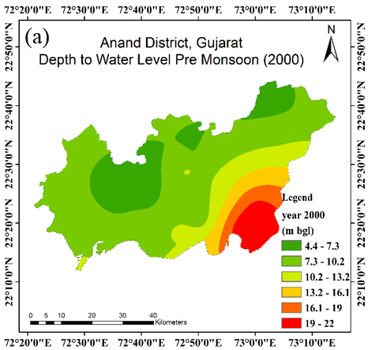 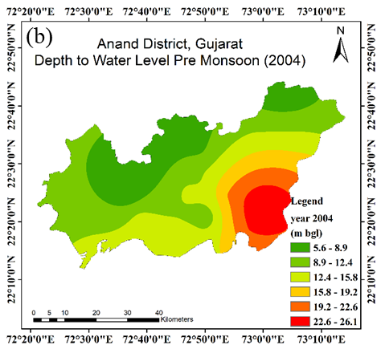
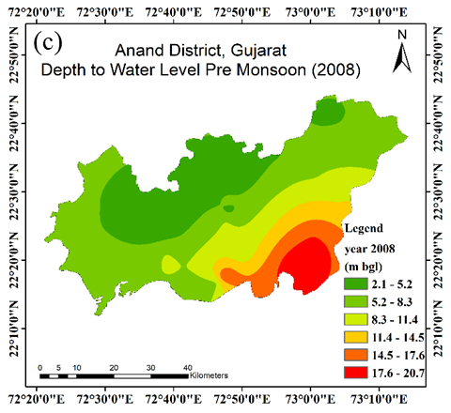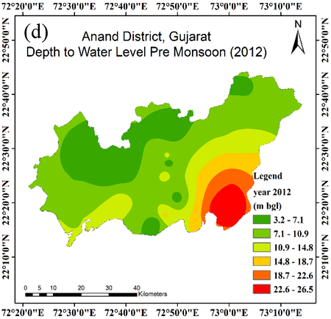
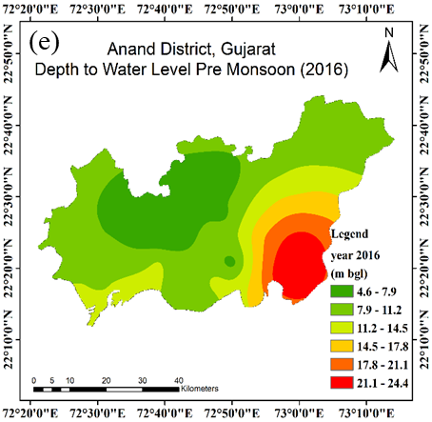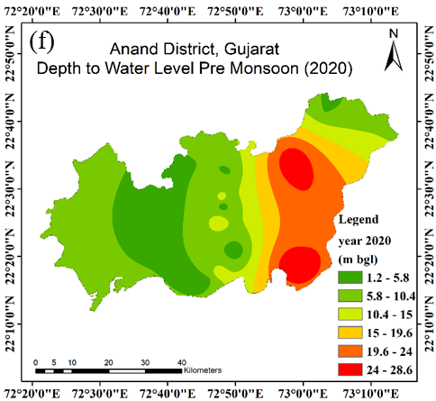
Fig. 2(a-f) Spatial variation of groundwater depth in Anand District, Gujarat, over the pre-monsoon seasons for year 2000 to 2020.
3.2 Post-Monsoon Spatial variability of groundwater level
GIS-based maps generated using Ordinary Kriging for the post-monsoon periods (2000–2020) at four-year intervals reveal substantial spatial and temporal variability in groundwater depth across Anand District, Gujarat. In 2000, groundwater conditions were predominantly stressed, with deeper water levels ranging from 15.8 to 20.7 m below ground level (bgl) dominating the southeastern region, while moderately deep levels (10.8–15.8 m bgl) prevailed in central areas and shallow zones (5.7–8.2 m bgl) were restricted to limited pockets in the northern and western parts. This distribution indicates significant groundwater stress, particularly in the southeastern region (Todd and Mays, 2005). By 2004, a marked improvement was observed, characterized by the expansion of shallow groundwater zones (0.3–4.4 m bgl) in the northern and western regions and a reduction in deeper zones in the southeast, suggesting enhanced recharge conditions. This recovery trend continued in 2008, with widespread shallow groundwater levels (0.2–8.0 m bgl) across much of the district and a contraction of deeper zones, representing the peak of groundwater recovery during the study period (Gleeson et al., 2012).
In 2012, groundwater conditions remained relatively favourable, with shallow to moderately shallow depths (1.1–9.6 m bgl) dominating large areas; however, isolated pockets of deep groundwater (22.4–26.1 m bgl) persisted in the southeastern region, indicating localized stress. A reversal of this recovery trend became evident by 2016, when deeper groundwater zones (15.3–20.1 m bgl) expanded significantly across central and southeastern regions, while shallow zones became confined to the northern and western parts, suggesting increasing groundwater abstraction and declining recharge efficiency (Rodell et al., 2009; Sahoo et al., 2021). By 2020, groundwater conditions further deteriorated, with extensive areas in the southeastern region exhibiting depths exceeding 26.2–31.1 m bgl, accompanied by the expansion of moderately deep zones (21.3–26.1 m bgl) in central areas. Shallow groundwater zones (1.2–6.2 m bgl) remained limited to the northern and western regions, indicating widespread depletion across the district.
The comparative analysis of groundwater maps from 2000 to 2020 highlights a distinct transition from an initial phase of recovery (2000–2008) to progressive and widespread depletion after 2012. While favourable monsoonal recharge contributed to short-term improvements, the long-term decline is primarily attributed to increased groundwater extraction and reduced recharge efficiency (Siebert et al., 2010; CGWB, 2019). The persistence of critically deep groundwater levels in the southeastern region underscores the influence of localized hydrogeological and anthropogenic factors (Patle et al., 2015). Overall, these findings emphasize the urgent need for targeted groundwater management and conservation strategies to ensure sustainable utilization of groundwater resources in semi-arid regions.
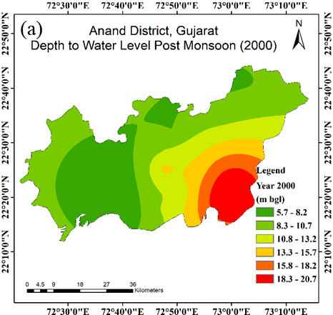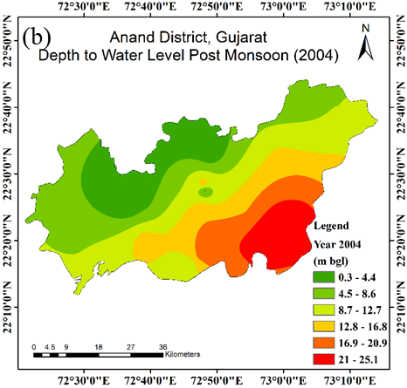
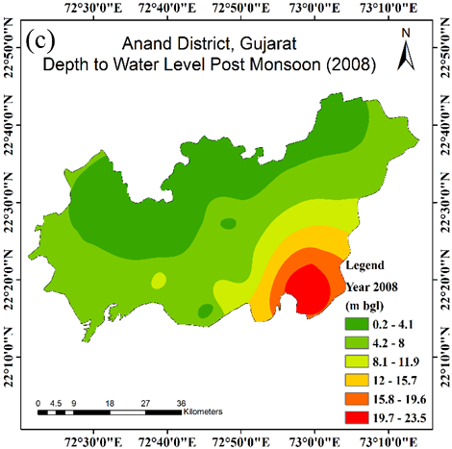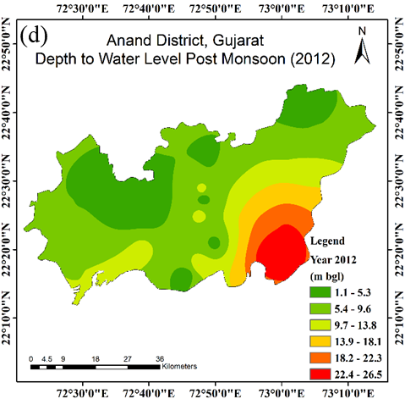
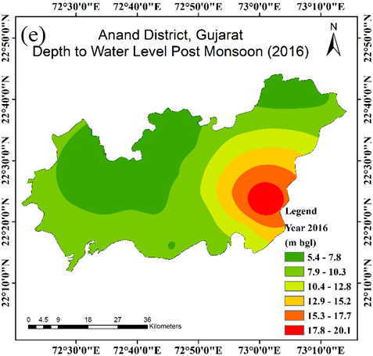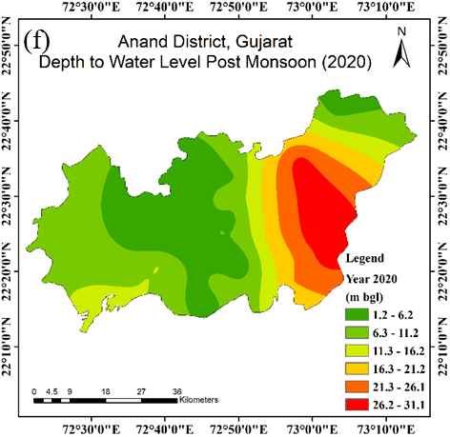
Fig. 3(a-f) Spatial variation of groundwater depth in Anand District, Gujarat, over the post-monsoon seasons for year 2000 to 2020.
4. Conclusions
The present study provides a comprehensive assessment of the spatio-temporal dynamics of groundwater levels in the alluvial aquifers of Anand district, Gujarat, over a 20-year period (2000–2020) using geostatistical techniques. The results reveal a clear transition from an initial phase of groundwater recovery (2000–2008) to a sustained period of depletion after 2012, with a pronounced expansion of deeper water table zones, particularly in the southeastern and central regions. Persistent spatial heterogeneity, characterized by relatively stable shallow groundwater in the northern and western parts and critical deepening in other areas, underscores the combined influence of hydrogeological settings and anthropogenic pressures, including intensive groundwater extraction and variability in recharge. The application of Ordinary Kriging effectively captured these spatial patterns and temporal shifts, demonstrating its robustness for groundwater assessment in data-sparse regions. Overall, the findings shows groundwater decline and emphasize the need for integrated and region-specific management strategies, including regulated abstraction, artificial recharge enhancement, and climate-resilient water planning, to ensure long-term sustainability of groundwater resources in semi-arid alluvial aquifer systems.

References:
CGWB. (2019). Ground water year book, Gujarat state Central Ground Water Board, Ministry of Jal Shakti, Government of India.
Gleeson, T., Wada, Y., Bierkens, M. F., & Van Beek, L. P. (2012). Water balance of global aquifers revealed by groundwater footprint. Nature, 488(7410), 197-200.
Kambale, J. B., Singh, D. K., & Sarangi, A. (2017). Impact of climate change on groundwater recharge in a semi-arid region of northern India. Applied Ecology and Environmental Research, 15(1), 335-362.
Mali, S. S., & Singh, D. K. (2016). Groundwater modeling for assessing the recharge potential and water table behaviour under varying levels of pumping and recharge.
Pagendam, D., Janardhanan, S., Dabrowski, J., & MacKinlay, D. (2023). A log-additive neural model for spatio-temporal prediction of groundwater levels. Spatial Statistics, 55, 100740.
Pandey, A., Padhya, V., Chakra, S., Ganguly, A., & Deshpande, R. D. (2023). Groundwater recharge in Central India and its spatio-temporal variation: Insights and implications from oxygen and hydrogen isotopes. Journal of Hydrology, 617, 129040.
Patle, G.T., Singh, D.K., Sarangi, A., Rai, A., Khanna, M. &Sahoo, R. N. (2015). Time series analysis of groundwater levels and projection of future trend. J. GeolSoc India; 85:232–242.
Rodell, M., Velicogna, I., & Famiglietti, J. S. (2009). Satellite-based estimates of groundwater depletion in India. Nature, 460(7258), 999-1002.
Roy, S., Taloor, A. K., & Bhattacharya, P. (2023). A geospatial approach for understanding the spatio-temporal variability and projection of future trend in groundwater availability in the Tawi basin, Jammu, India. Groundwater for Sustainable Development, 100912.
Sahoo, S., Swain, S., Goswami, A., Sharma, R., & Pateriya, B. (2021). Assessment of trends and multi-decadal changes in groundwater level in parts of the Malwa region, Punjab, India. Groundwater for Sustainable Development, 14, 100644.
Siebert, S., Burke, J., Faures, J. M., Frenken, K., Hoogeveen, J., Doll, P. &Portmann, F. T. (2010). Groundwater use for irrigation– a global inventory. Hydrol Earth SystSci; 14(10):1863–1880.
Todd, D. K., & Mays, L. W. (2004). Groundwater hydrology. John Wiley & Sons.
Ware, H. H., Mengistu, T. D., Yifru, B. A., Chang, S. W., & Chung, I. M. (2023). Assessment of spatiotemporal groundwater recharge distribution using SWAT-MODFLOW model and transient water table fluctuation method. Water, 15(11), 2112.
Kaur, N., Kaur, S., Kaur, P. and Aggarwal, R. (2021). Impact of climate change on groundwater levels in Sirhind Canal Tract of Punjab, India. Groundwater for Sustainable Development, 15, p.100670.

