Case reports
Influence of Multirooted teeth on Periodontitis and Treatment outcomes. A Case Series.

ABSTRACT:
Root morphology, particularly root trunk length and crown–root ratio, plays a critical role in periodontal disease progression, diagnosis, and treatment outcomes. Anatomical variations influence accessibility for periodontal instrumentation, timing and pattern of furcation involvement, and therapeutic complexity. Teeth with long root trunks typically show delayed furcation involvement however, they present significant challenges to periodontal therapy due to difficulty in achieving complete furcation debridement. In contrast, teeth with short root trunks demonstrate early furcation involvement, increased mobility, and compromised biomechanical support, making periodontal management particularly challenging despite requiring less periodontal destruction for furcation exposure. Premolar furcation involvement further complicates diagnosis and limits therapeutic access. Overall, root morphology substantially influences disease severity and treatment complexity, emphasizing the need for careful morphological assessment during periodontal diagnosis and treatment planning.
KEYWORDS: Root morphology, long root trunk, short root trunk, premolar furcation involvement.
INTRODUCTION
The relationship between root morphology and periodontal disease progression is well recognized, as the anatomical features of a tooth play a central role in how periodontal disease begins, advances, and responds to treatment¹. Root morphology including factors such as root length, crown–root ratio, root trunk height, root concavities, developmental grooves, and furcation architecture directly influences plaque accumulation, the pathway of inflammatory spread, and the clinician’s ability to provide effective instrumentation².
These anatomic variations determine not only how easily plaque and calculus colonize the root surface but also how accessible these sites are for periodontal therapy. Consequently, root morphology becomes a guiding factor in both disease susceptibility and treatment complexity^{2,3}.
This influence is especially evident in maxillary molars, which exhibit greater anatomical variability due to multiple roots, diverse root divergence patterns, and differences in the height of the root trunk^{4,5}. Such complexity makes these teeth more prone to undetected disease progression and more difficult to manage clinically. Furcation involvement in multirooted teeth further complicates diagnosis and treatment, as access limitations and anatomical irregularities make debridement challenging^{6,7}.
Among these features, root-trunk length plays a particularly important role. A short root trunk leads to early exposure of the furcation as periodontal destruction begins, making detection easier but increasing the risk of early involvement⁸. In contrast, a long root trunk masks early disease by delaying the clinical entry of furcation involvement, allowing significant subgingival bone loss to occur before detection⁹.
Understanding these anatomical characteristics in an integrated manner enables clinicians to diagnose more accurately, anticipate disease progression, predict prognosis, and plan appropriate periodontal therapy tailored to the individual tooth anatomy¹⁰. Ultimately, root morphology is not an isolated concept but a continuous factor influencing every stage of periodontal health and management.
This case report presents three clinical scenarios highlighting the influence of different root morphological characteristics - long root trunk length, premolar furcation involvement, and short root trunk length on periodontal disease presentation and treatment outcomes.
CASE REPORT
Case 1: A 59-year-old male reported to the periodontal department with the chief complaint of food lodgment and receding gum. He was non-smoker and systemically healthy with no history of diabetes, and reported irregular dental check-ups.
On Clinical examination overall 5-6 mm of pockets were seen with generalized gingival recession. On Radiographic examination, OPG revelled Vertical/angular defect on the mesial aspect and long root trunk height. Through both clinical and radiographic evaluation, the affected molars exhibited a long root trunk, characterized by an extended distance between the cemento-enamel junction (CEJ) and the furcation entrance. This anatomical configuration delayed clinical exposure of the furcation area, masking its involvement until substantial attachment loss had already occurred.
Generalized chronic periodontitis with furcation involvement with long root trunk morphology was diagnosed. In treatment plan scaling and root planning were don. On surgical interventions under local anaesthesia, conventional flap was reflected and thorough debridement of root surfaces was done. PRF membrane placement over the defect, Collagen membrane was placed on buccal surface of 16,17. Sutures were placed and cover with periodontal dressing.

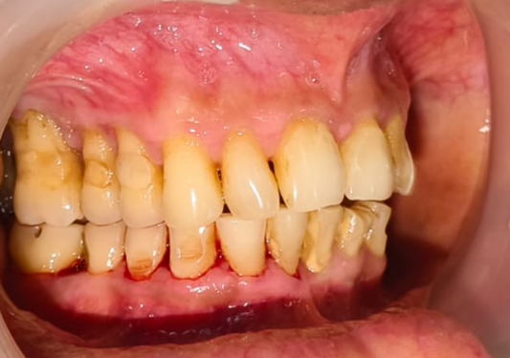
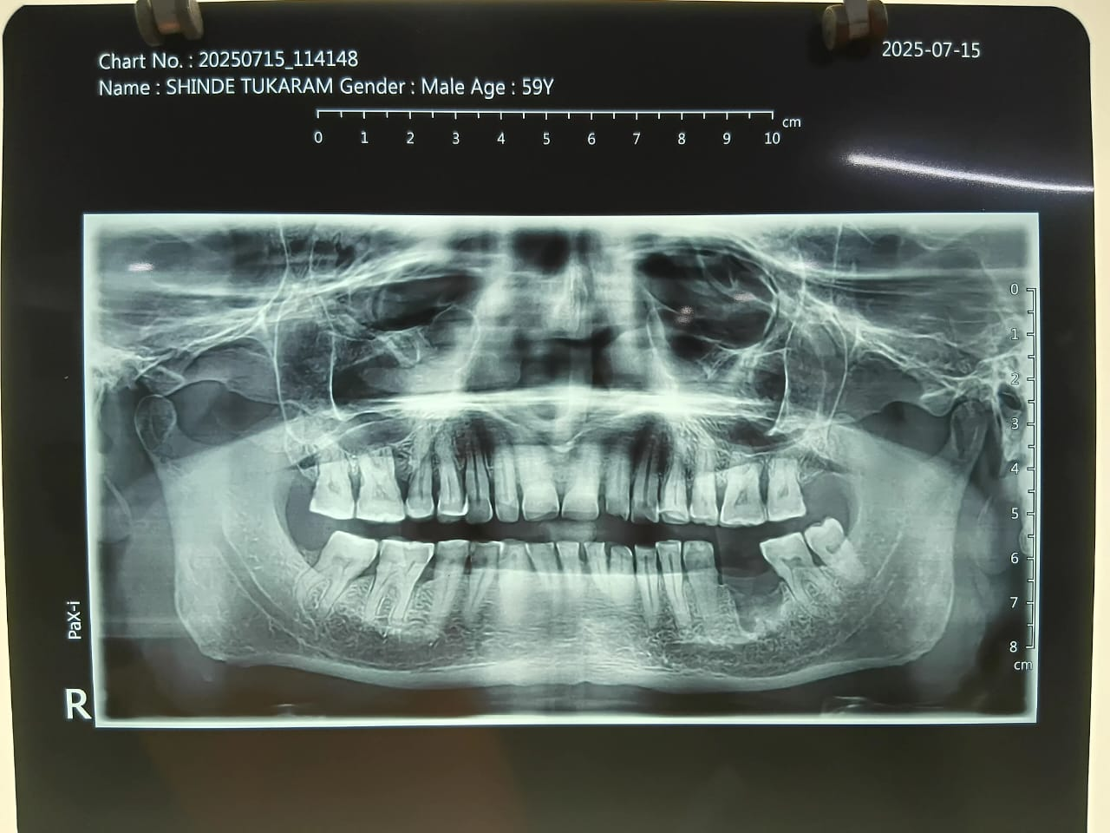

Fig. 1: OPG
Fig. 2: Intra Oral
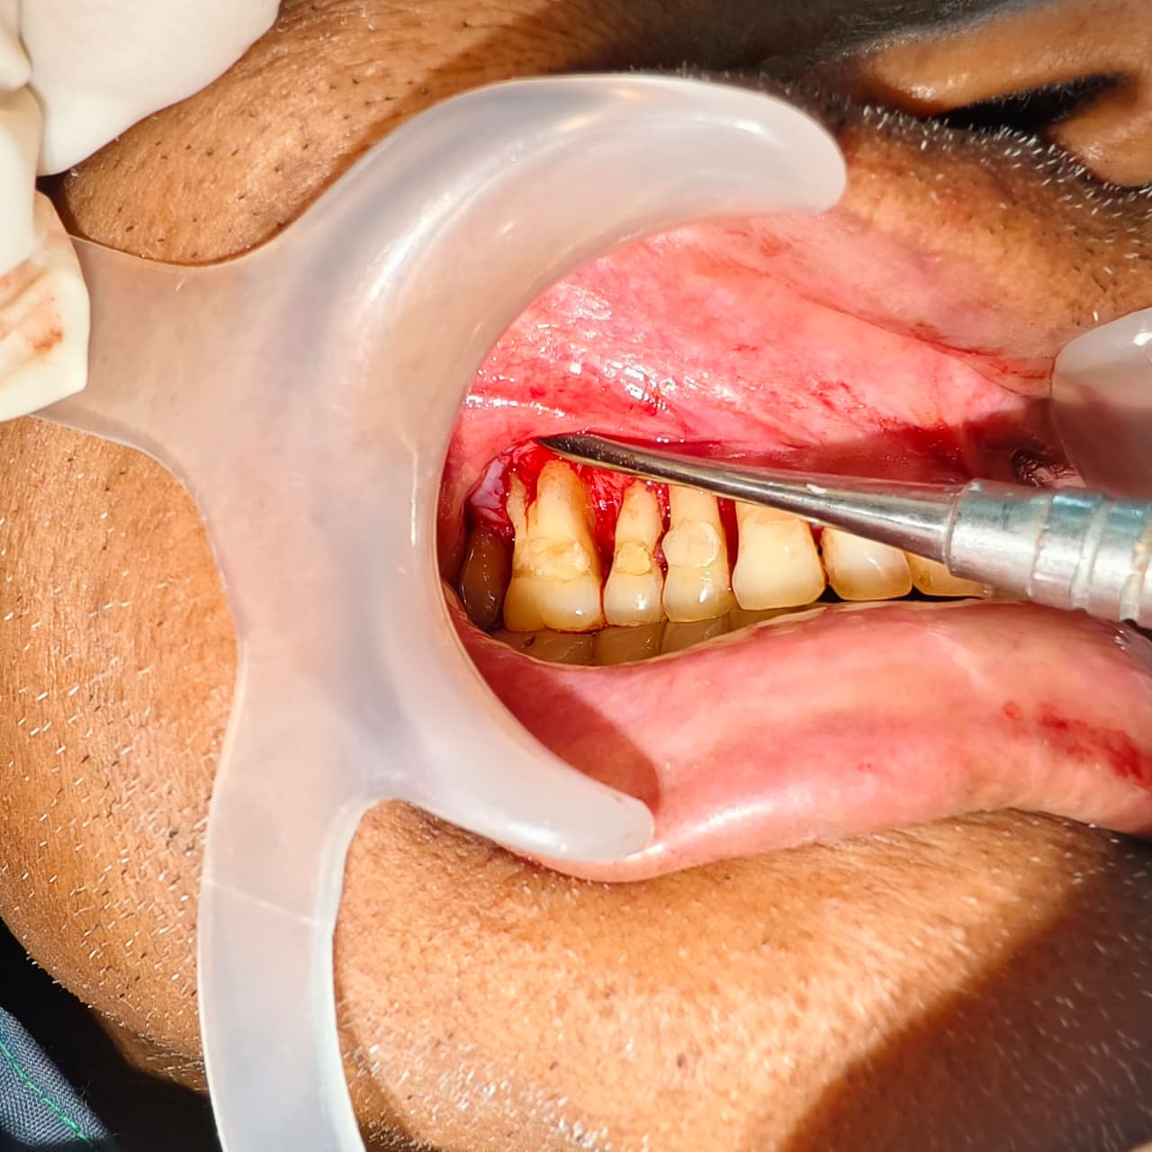
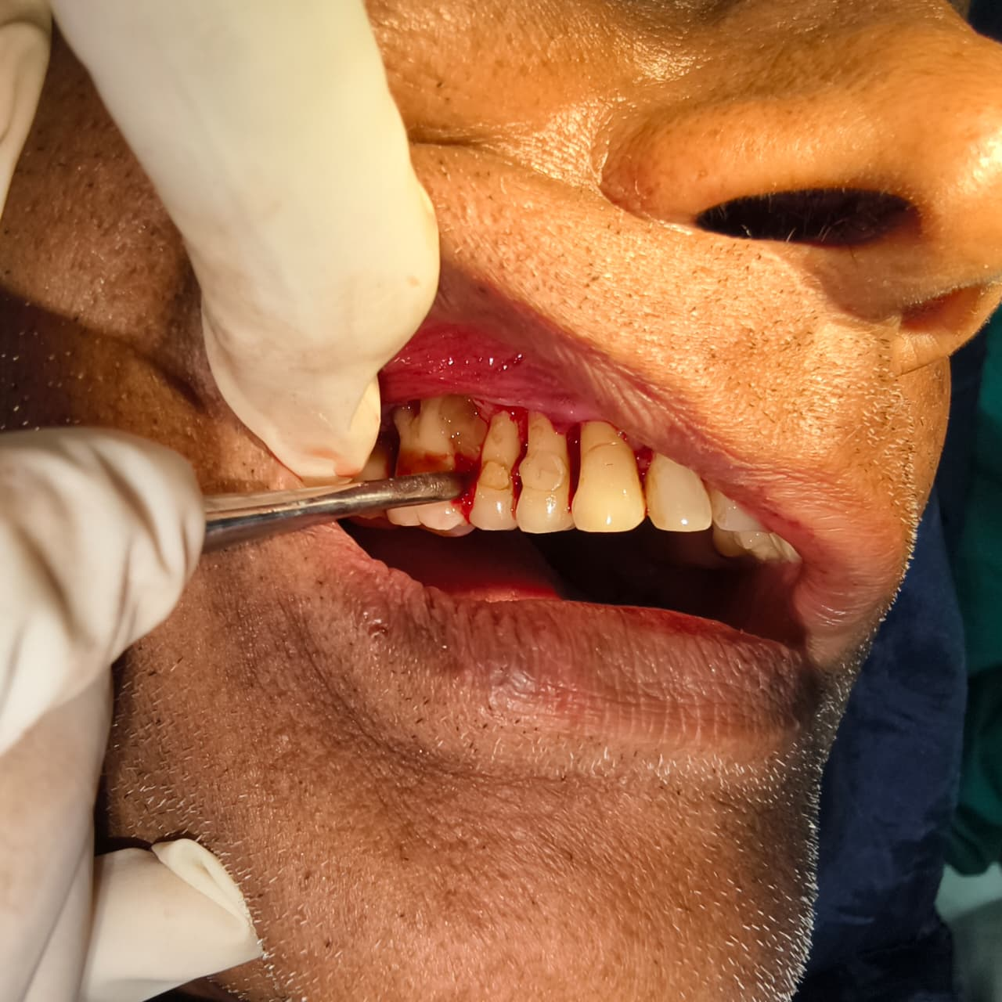

Fig. 4: PRF placed in defect
Fig. 3: Long root trunk seen with 16
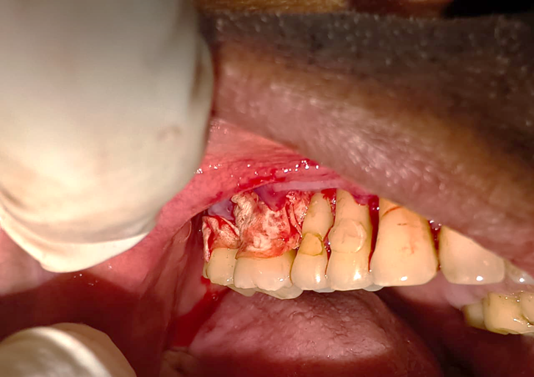
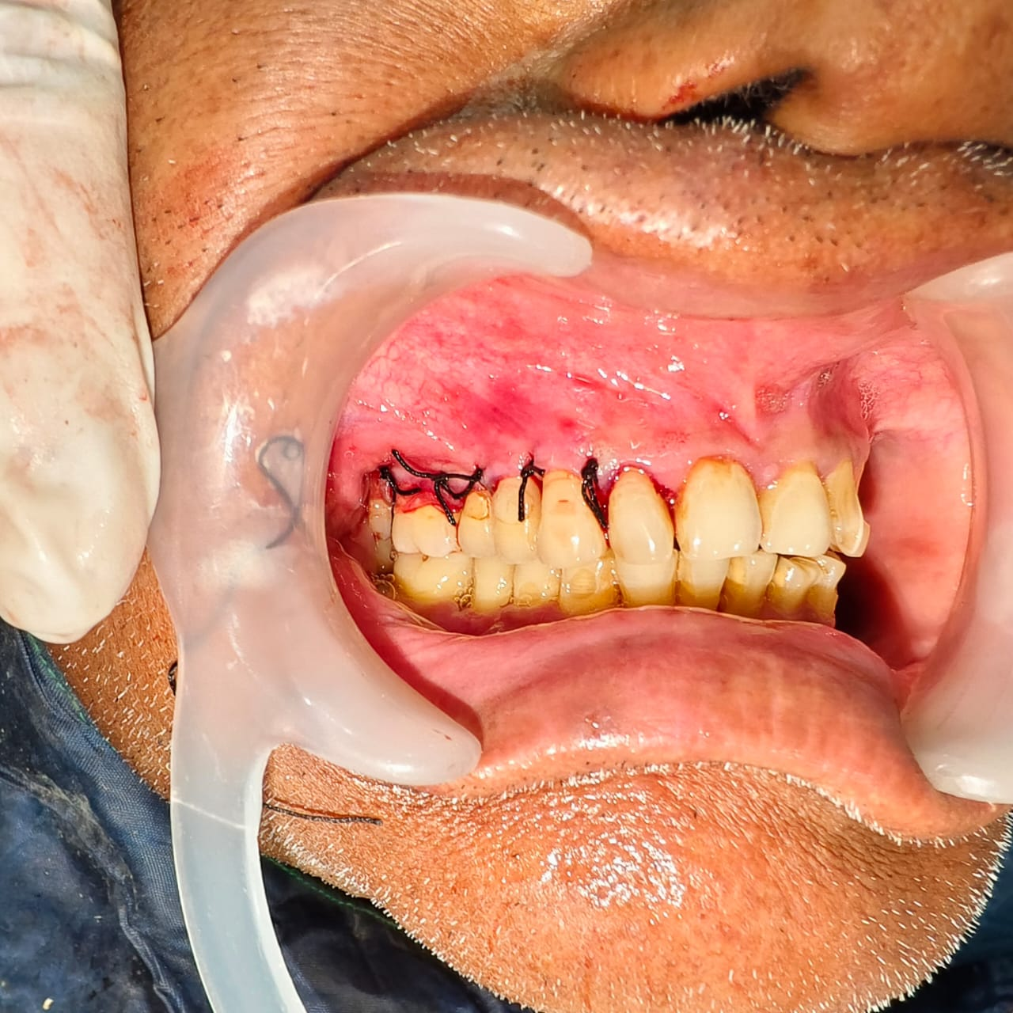

Fig. 6: Sutures placed
Fig. 5: Collagen membrane placed on buccal surface of 16,17
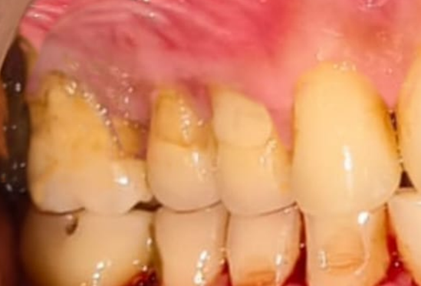

Fig. 7: 4 months post operative

Intraoperative findings confirmed furcation involvement that was not easily detectable during initial probing. Although the long root trunk delayed furcation involvement, once exposed, the furcation region posed significant challenges for instrumentation and long-term plaque control. Thus, the patient was placed on a strict supportive periodontal therapy regimen.
Case 2: A 46-year-old male reported to the periodontal department with the chief complaint of bleeding gums and overgrowth. He was non-smoker and systemically healthy with no history of diabetes, and reported irregular dental check-ups.
On Clinical examination overall 6-7 mm of pockets were seen with 24. On radiographic examination, OPG revelled moderate bone loss.
In treatment plan Scaling and root planning. On surgical interventions under local anesthesia, conventional flaps were reflected and thorough debridement of root surfaces was done. PRF membrane placement over the defect.

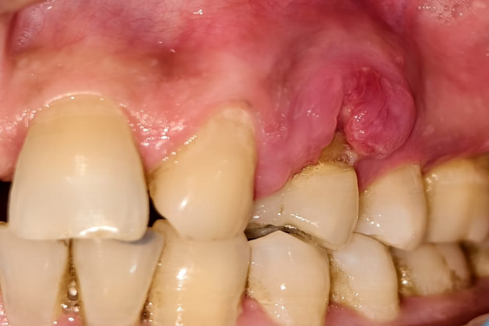
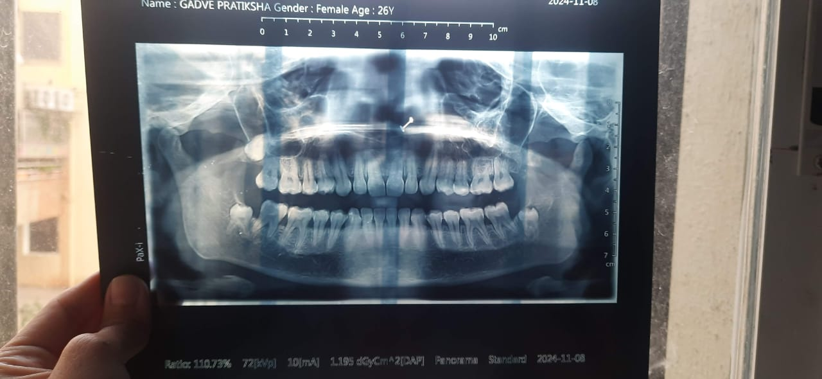

Fig. 9: OPG
Fig. 8: Pre-operative
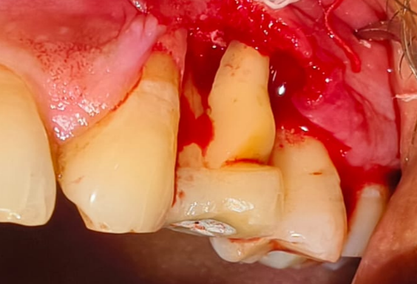
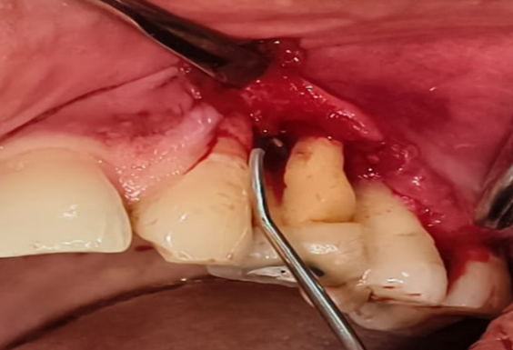

Fig. 10: Premolar Furcation involvement
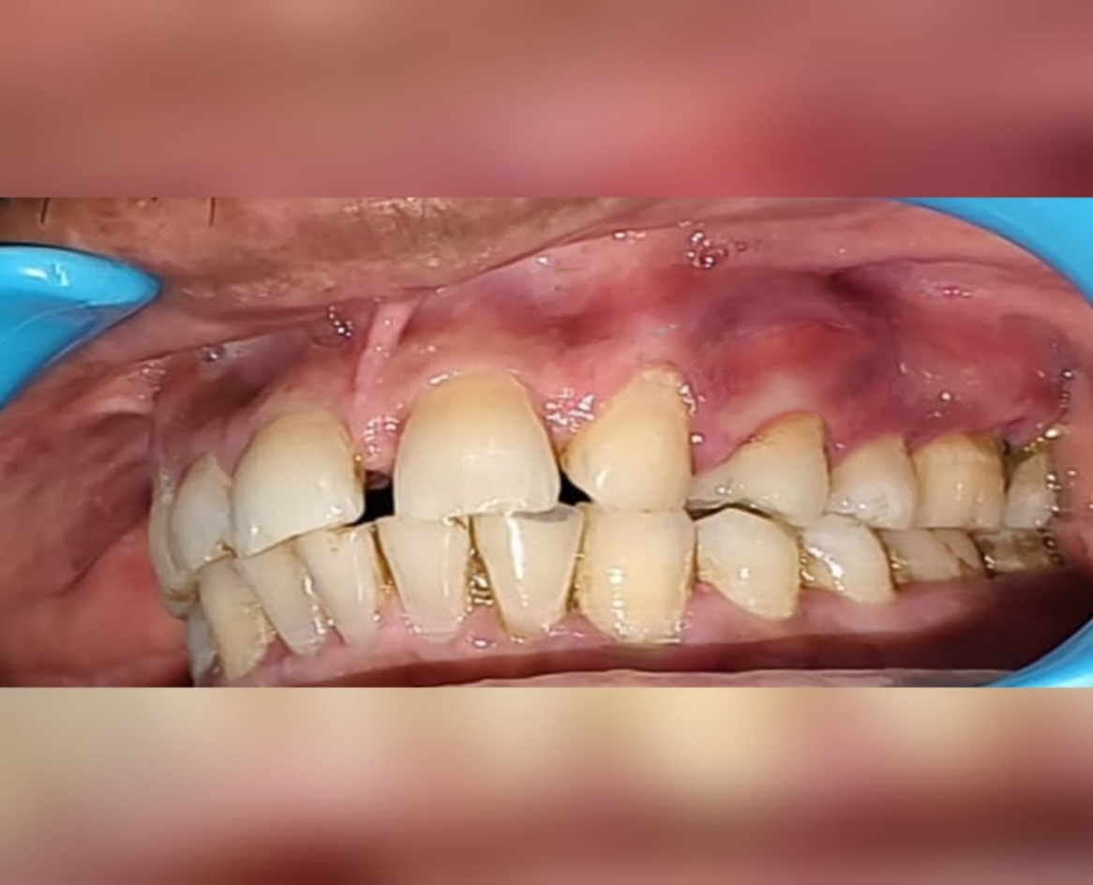

Fig. 11: 6 months post operative.

Premolar furcation involvement is often overlooked due to its rarity. Maxillary first premolars with bifurcated roots can present early furcation involvement, complicating diagnosis and requiring careful radiographic and clinical evaluation.
Case 3: A 13-year-old patient reported to the Department of Periodontology with the chief complaint of localized swelling in the posterior region of the oral cavity. The swelling was associated with mild discomfort and intermittent discharge. On clinical examination, the gingiva in the affected area appeared inflamed, and a sinus tract opening was evident on the lingual aspect of 46.
The patient’s dental history revealed that root canal treatment (RCT) had been performed on 46 six months earlier at a private dental clinic. There was no history of trauma or systemic illness.
Intraoral periapical radiographic examination demonstrated: Radiolucency in the furcation region seen. These findings were suggestive of furcation involvement, despite the patient’s young age and relatively short duration since endodontic therapy.
Based on clinical and radiographic findings, a diagnosis of early furcation involvement associated with short root trunk length was made.
On surgical interventions under local anesthesia, conventional flap was reflected to gain access to the furcation area. Intraoperatively, furcation involvement was confirmed at an early level, consistent with short root trunk anatomy. Thorough debridement of granulation tissue was carried out. And bone graft was placed in the defect. Sutures were placed and periodontal dressing was given.

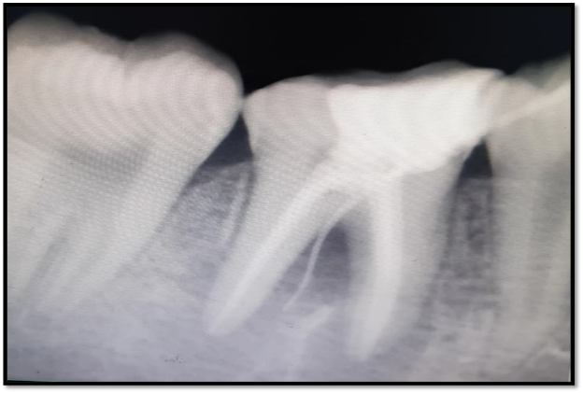
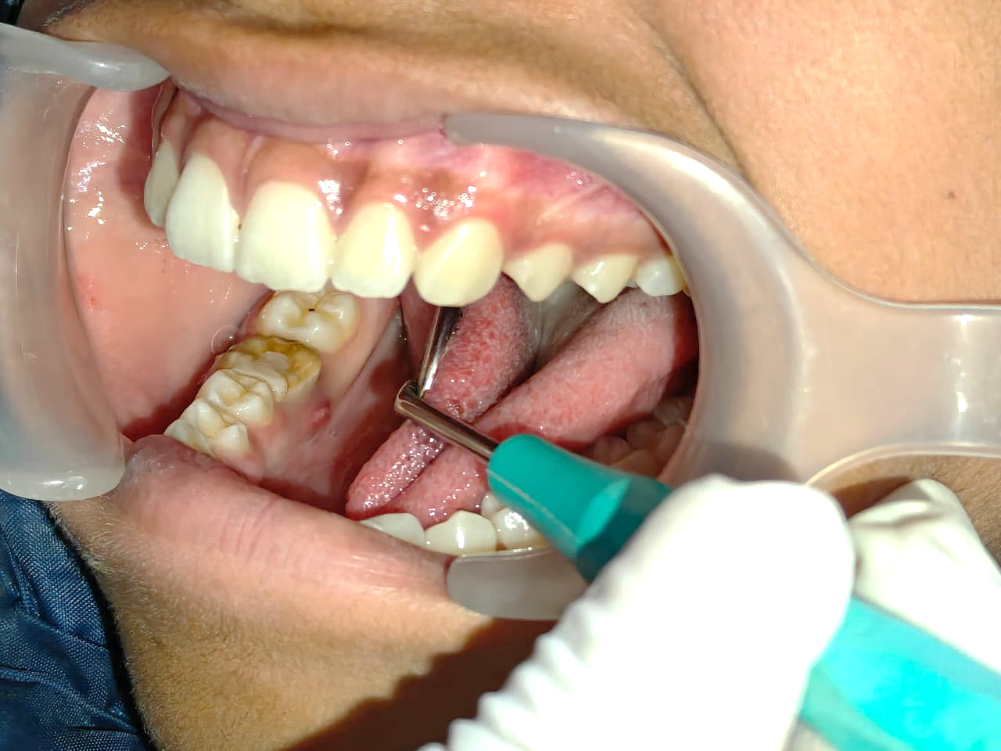

Fig. 12: Sinus Tract seen with 46
Fig. 13: RVG w.r.t 46
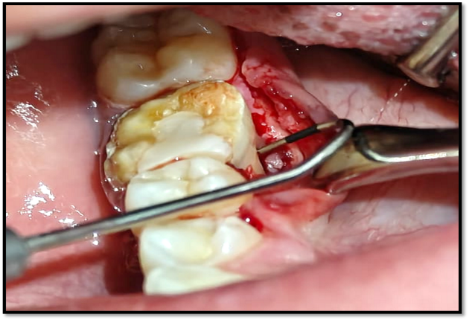
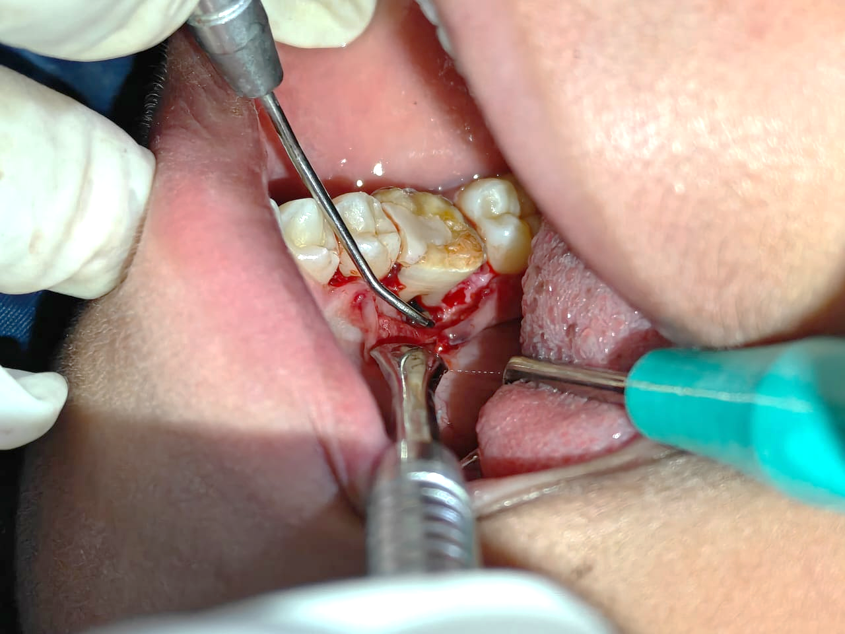

Fig. 14: Furcation involvement seen on lingual aspect of 46
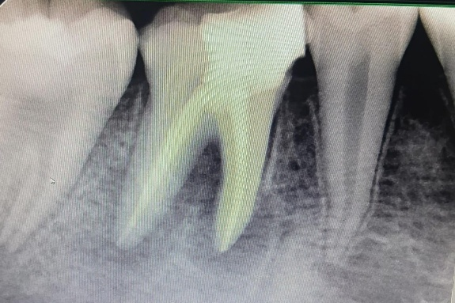
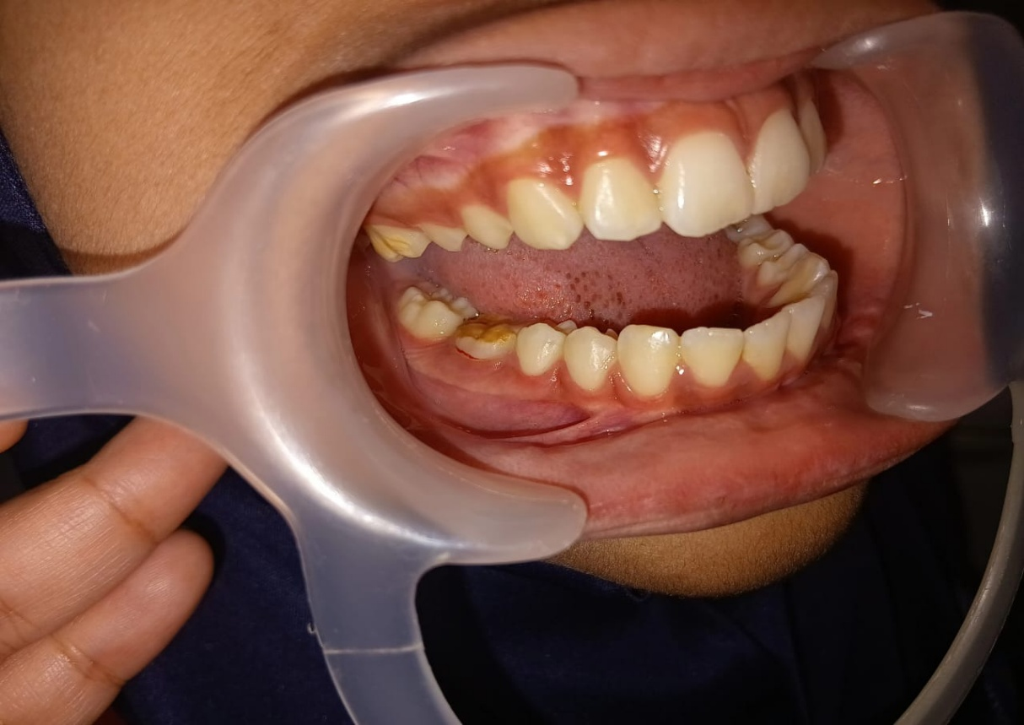

Fig. 15: Post-operative
Fig. 16: Post-operative RVG

In teeth with a short root trunk, the furcation area become exposed early in the course of periodontal disease, even with limited attachment loss.
In the present case, the short root trunk allowed periodontal inflammation and plaque accumulation to rapidly extend into the furcation region. This resulted in:
- Early interradicular bone loss
- Difficulty in effective plaque control
- Rapid progression of periodontal destruction
- Formation of a sinus tract despite recent endodontic therapy

DISCUSSION
Root morphology has a significant impact on the onset, progression, and treatment outcomes of periodontal disease, especially in molar teeth where root trunk length and root configuration determine the susceptibility to furcation involvement.
Reem Dababneh et al.¹² reported that, the average root lengths of maxillary and mandibular first molars have been reported as 12.6 mm and 13.7 mm, with maxillary mesiobuccal and palatal roots being longer than distobuccal roots, while root trunk heights may extend up to 7.8 mm in maxillary and 6.6 mm in mandibular molars. Teeth with long root trunks and short roots demonstrate delayed clinical detection of furcation involvement but experience greater periodontal destruction once furcal invasion occurs, making them poor candidates for root resection procedures¹¹.
Additionally, long root trunks combined with wide furcation entrances and high-positioned furcation fornix have been associated with reduced success of periodontal therapy due to challenges in achieving complete debridement in these areas¹³. According to McClain & Schallhorn¹⁴, teeth with short root trunks become vulnerable to early furcation involvement; however, they tend to show better post-treatment prognosis since the extent of periodontal destruction required for furcation exposure is comparatively less.
Beyond trunk length alone, the presence of developmental grooves and root surface concavities significantly influences plaque retention and treatment predictability, particularly in regenerative procedures where anatomical irregularities can compromise outcomes even in teeth with short trunk morphology¹⁵. Lu et al.¹⁶ Reported that 94% of the furcations possessed variant depth of developmental concavities on the root trunks. These superficial irregularities at the entrances of furcations may prevent complete adaptation of the coronal microstructure of the membrane along their root surfaces, so they suggested that subgingival application of guided tissue membranes 1-2 mm below CEJ cannot ensure complete adaptation of furcation defects with their coronal microstructures in the majority of molars
Joseph et al.¹⁷ reported that furcation involvement in maxillary first premolars is uncommon but clinically significant because a substantial proportion of these teeth exhibit bifurcated roots. Due to this relative rarity, furcation involvement in premolars is often overlooked, resulting in delayed diagnosis and progression of periodontal destruction, as seen in the present case. Whereas Chen et al.¹⁸ demonstrated that mesial root concavities of maxillary first premolars are significantly associated with increased periodontal inflammation and alveolar bone loss. Such concavities act as plaque-retentive areas, accelerating periodontal destruction and contributing to furcation involvement, findings that correlate well with the clinical presentation in the present case.
Takei and Han et al.¹⁹ highlighted that root trunk length should be considered a key factor in treatment planning for furcation-involved teeth. Mandibular molars with short root trunks are often more amenable to open flap debridement and regenerative therapy, aligning with the treatment strategy employed in this case. Bowers et al.⁵ reported that Class II furcation defects, commonly encountered in mandibular molars with short root trunks, show better regenerative potential compared to advanced furcation defects. This supports the treatment approach and outcome achieved in the present case.
Newell et al.²⁰ emphasized that early detection of furcation involvement in mandibular molars can result in a more favorable prognosis, provided appropriate periodontal therapy is instituted. The early identification in the present case contributed to timely management and improved treatment predictability.
Overall, these findings demonstrate that successful management of furcation-involved molars requires a comprehensive understanding of root trunk length, inter-root morphology, and surface characteristics to tailor periodontal treatment effectively.
CONCLUSION
Root morphology is a decisive determinant of periodontal disease progression, diagnostic accuracy, and therapeutic success. Anatomical variations such as root trunk length, furcation anatomy, and root surface characteristics profoundly influence plaque retention and accessibility for periodontal instrumentation. Comprehensive evaluation of root morphology should form an integral part of periodontal diagnosis and treatment planning. An individualized, morphology-based approach enhances treatment outcomes and contributes to long-term tooth presentation.

REFERENCES:
- Carranza FA, Newman MG, Takei HH, Klokkevold PR. Carranza’s Clinical Periodontology. 13th ed. Elsevier; 2019.
- Gher ME, Vernino AR. Root morphology—clinical significance in periodontal disease. J Am Dent Assoc. 1980;101(4):627–633.
- Goldman HM, Cohen DW. Periodontal Therapy. 6th ed. Mosby; 1980.
- Svärdström G, Wennström JL. Furcation topography of the maxillary and mandibular first molars. J Clin Periodontol. 1988;15(5):271–275.
- Bowers GM, Chadroff B, Carnevale R, et al. Histologic evaluation of new attachment apparatus formation in humans. J Periodontol. 1989;60(12):683–693.
- Nabers CL. The anatomy of the furcation area in maxillary and mandibular molars. J Periodontol. 1954;25(2):123–128.
- Bowers GM, Schallhorn RG, McClain PK, Morrison GM, Morgan R. Factors influencing the outcome of regenerative therapy in furcation defects. J Periodontol. 2003;74(9):1257–1268.
- Hou GL, Tsai CC. Relationship between periodontal furcation involvement and root trunk length. J Periodontol. 1997;68(4):356–362.
- Ochsenbein C, Ross S. A reevaluation of osseous surgery. Dent Clin North Am. 1969;13(1):87–102.
- Waerhaug J. Healing of the dento-epithelial junction following subgingival plaque control. J Periodontol. 1978;49(3):119–134.
- Reem Dababneh et al., Root Trunk: Types and Dimension and their Influence on the Diagnosis and Treatment of Periodontally Involved First Molars. Journal of The Royal Medical Services, 2011.
- Al-Shammari KF, Kazor CE, Wang HL. Molar root anatomy and management of furcation defects. J Clin Periodontol. 2001;28(8):730–740
- Horwitz J, Machtei EE, Reitmeir P, Holle R, Kim TS, Eickholz P. Radiographic parameters as prognostic indicators for healing of class II furcation defects. J Clin Periodontol 2004; 31: 105–111.
- Mcclain PK, Schallhorn RG. Focus on furcation defects – guided tissue regeneration in combination with bone grafting. Periodontology 2000; (22): 190–212.
- Svdrdstrom G, Wennstrom JL. Furcation topography of the maxillary and mandibular first molars. J Clin Periodontol 1988.
- Lu HKJ. Topographical characteristics of root trunk length related to guided tissue regeneration. Journal of Periodontology 1992 Mar; 63: 215- 219.
- Joseph I et al., Clinical significance of furcation anatomy of the maxillary first premolar: A biometric study on extracted teeth. Journal of Periodontology, 1996
- Chen F, Liu Q, Liu X, Fang Q, Zhou B, Li R, et al. Periodontitis was associated with mesial concavity of the maxillary first premolar: A cross-sectional study. Scientific Reports, 2024.
- Takei HH, Han TJ, Carranza FA. et al., The furcation problem: etiology, diagnosis, and treatment considerations. Periodontology 2000, 1996.
- Newell DH. et al., The role of the furcation in periodontal disease. Periodontology 2000, 1998.

