Development and Quality Assessment of blend squash from Mangifera indica L. (Mango) and Aloe barbadensis Miller (Aloe Vera) Gel

Abstract
Mango fruit has lots of health benefits but has short shelf-life. Preserving mango in the form of beverage will enhance its shelf life. Aloe vera contains various nutrients, including vitamins (A, B, C, E), minerals (calcium, potassium, sodium, etc.), and amino acids. It's also a good source of natural sugars, enzymes, and antioxidants. The blend squash of fruit pulp, vegetable juice and medicinal plant of alove vera gel demand is increase day by day in National and International markets. The ripe mango pulp and aloe vera gel squash was prepared at laboratory of Department of Post Harvest Technology, Banda University of Agriculture and Technology, Banda Uttar Pradesh. The experiment was conducted in Competently Randomized Design with three replications. The investigation blend squash prepared from best recipe viz. 25 per cent blend (70:30 mango pulp and aloe vera gel), 50 per cent TSS, 1.20 per cent acidity and 350 ppm SO₂, to ten liter squash was prepared with the recipe no.5 was significantly best over the rest treatments The prepared squash was packed in sterilized glass bottle and can be stored successfully for 5 month at ambient temperature. During storage period of mango squash TSS, titratable acidity, reducing sugars and total sugars was continuously increased whereas non-reducing sugar, vitamin-A, carotenoids and browning content and organoleptic quality was continuously decreased from first month of storage to end of the storage period.
Key Words: Mangifera indica L., Aloe vera, Vitamin-A, Squash, Health drink, Carotenoids.

Introduction
Mangifera indica (MI), also known as mango, aam, it has been an important herb in the Ayurvedic and indigenous medical systems for over 4000 years. Mangoes belong to genus Mangifera which consists of about 30 species of tropical fruiting trees in the flowering plant family Anacardiaceae. According to ayurveda, varied medicinal properties are attributed to different parts of mango tree. Mango undoubtedly deserves to be the national and tropical fruit of India and it has strong flavour, nutritional value, exotic flavour, succulent and digestive properties ¹. Sandhyarani ² advocated that the popularity and importance of mango is often name king of fruits for its luscious flavour and taste. It is an outstanding source of vitamin-A and a good source of ascorbic acid. The fruits have acidity, carotene, ascorbic acid therefore its considered as a source of antioxidants. According to Annon, ³ reported that mango fruits contain protein 0.3%, fiber 0.8%, ascorbic acid-83%, vitamin-A 650-25940 IU, carbohydrate 11.6-24.3%, protein 0.3-1.0%, minerals 0.3-0.7% and iron 4.5 mg/100g. Some mango varieties are consumed as fresh fruit but some non fibrous pulpy, therefore those mango variety are used for processing. Ripe mango fruits are used in the development of RTS, squash, syrup, nectar, juice, jam, jelly, preserve, leather, toffee, candy and many different products.
Aloe barbadensis Miller popularly known as Aloe vera or ghritkumari or gwar patha is succulent, perennial, drought resistant and its belong to family Liliaceae. Its gel is transparent, slippery and colorless, mucilage, containing water and bioactive, polysaccharides mainly acemannan and glucomannan. Glucomannan also plays an important role in wound healing, stimulating the immune system and acemannan is the main component. Aloe vera also has antiviral, antifungal and antibacterial property. The day by day demand of increased this plant because traditionally being used as a very popular herbal treatment of skin and other disorders. Its contains Thimin, Riboflavin, Acidity, Ascorbic acid, Reducing sugars, Non-reducing sugar, Total sugars, Niacin, Cobalamine, Pyrodoxine, Tocopherol and Folic acid etc. Aloe vera comes under food related products ⁴ and is being used for the preparation of gel containing drink like squash, syrup, RTS, health drink, energy drink and other type of beverage. The demands of natural drink because it has rich in nutrients and medicinal values, are increasing due to changing life style, health consciousness and purchasing capacity of the consumers. The present studies were carried out the blend beverages of fruits and medicinal plants are rich source of nutrients, medicinal properties and flavors therefore consumers demand is increase day by day in National and International markets

Materials and Methods
The present study was carried out at Post Harvest Technology laboratory of Department of Post Harvest Technology, College of Horticulture, Banda University of Agriculture and Technology, Banda U. P. The ripe fruits of mango and mature aloe vera leaves were procured from local market of Banda District.

Extraction of pulp from mango fruits and aloe vera leaves
The pulp extracted from ripe mango fruits Fig- 1, picture-1, and mature aloe vera leaves as per flow sheet depicted in Fig-2.

Chemical characteristics of mango pulp and mature aloe vera leaves
The obtained data from analyzed fruits regarding on chemical characteristics of mango pulp and aloe vera gel, which used for the preparation of blended squash from mango and aloe vera gel was presented in Table- 1

Preparation of squash
For formulation of recipes total soluble solids and total titratable acidity present in extracted mango pulp and aloe vera gel was first determined by hand refractometer and titration, respectively. Thereafter determine the acidity and sugar content in the fruit pulp for remaining amount of sugars, citric, water and potassium metabisulphite required to prepare the final squash in different proportions according to desired recipes.
squash of each recipe were prepared in one liter by mixing the calculated amount of pulp, sugar, citric acid and water in different proportions (as per recipes) then organoleptically evaluated by a panel of seven semi trained judges on a 9.0 Point Hedonic Rating Scale to find out the best one recipe of blended squash. Finally best recipe viz. 25 per cent blend (70:30 mango pulp and aloe vera gel), 50 per cent TSS, 1.20 per cent acidity, to ten liter squash was prepared. The methods used for making blend squash is given in Fig 2.0. Prepared blend squash was filled in sterilized bottles (750 mL capacity) by leaving 2cm head space. Bottled squash was stored at room temperature for further study and biochemical composition were analyzed up to 5 months.

Determine the biochemical composition
The TSS was determined by ERMA made hand refractometer of 0-32% and 28-62 % ranges at ambient condition. The reading was corrected at 20°C with the help of reference table No. 28-3 on the page- 874 ⁵ and the mean value was expressed as per cent total soluble solids content in the sample.
Titratable acidity:
The total titratable acidity present in sample was ascertained by titration of samples against NaOH solution. The total titratable acidity was expressed as anhydrous citric acid present in 100 mL of liquid sample or in 100g of solid sample. The following formulae was used for calculation of titratable acidity-
. Ascorbic acid (Vitamin-C):
The sample was titrated against 2, 6-dichlorophenol-indophenol dye solution ⁶. The determination procedure was followed as described by ⁵. The ascorbic acid content was calculated with the following formulae and expressed in mg per 100 g sample.
3.7.6. Sugars:
The Fehling’s ‘A’ and ‘B’ solutions ⁷ were used to estimate the sugars content in squash and following the procedure as suggested by ⁵.
Reducing sugars:
To determine the reducing sugars, aliquot and both Fehling’s solutions were mixed thoroughly and titrated against 1.0 % dextrose solution. The completion of reaction was indicated by the decolourization of the methyl blue indicator and appearance of brick-red colour precipitates of cuprous oxide. The reducing sugars per cent were calculated by the following equation:
$$Reducing sugars \left(\%\right)=\frac{Blank titre value \left(mL\right)- Sample titre value \left(mL\right)×Volume madeup (mL) }{Aliquot taken \left(mL\right)×Weight of sample taken (g)}×100$$
Non-reducing sugar:
Non reducing sugar was calculated by deducting the quantity of reducing sugars from total invert sugars and multiplying the difference by factors 0.95. The result was calculated with the help following formulae:
Non-reducing sugar (%) = [Total invert sugars (%) – Reducing sugars (%)] x 0.95
Total sugars:
The summation of percentage of reducing sugars and non-reducing sugar were expressed as total sugars in per cent:
Total sugars (%) = Reducing sugars (%) + Non-reducing sugar (%)
Vitamin-A:
Vitamin-A was estimated with the help of acetone solution then in petroleum ether and thereafter in sodium sulphate up to the appearance of dark yellow-greenish colour The OD wad observed at 452 and 503 nanometer with the help of spectrophotometer.
Carotenoids:
The total carotenoids were determined in fresh fruit sample as well as blend squash as described by Sagar and Samuel⁸. The O.D. was noted at 452 nm on ELICO made spectrophotometer model SL 160. The carotenoids were expressed as mg/100 g:
Organoleptic quality
The organoleptic evaluation for assessing the sensory attributes like- colour, appearance, flavour, aroma, taste and texture of blended squash was conducted by a panel of seven semi trained judges on 9.0 point Hedonic Rating scale⁹. Evaluation of sensory organs offers the opportunity to obtain a complete analysis of the various properties of squash as perceived by human sense.
Statistical analysis
The study of mango and aloe vera gel blended squash data were recorded at monthly interval on different parameters were subjected to statistical analysis using completely randomized design of analysis of variance¹⁰ and results were interpreted at significance level of 5 per cent.

Results and Discussion
Data furnished in Table-1, showed that the extracted mango pulp was contained total soluble solids 22.64 per cent, titratable acidity 0.62 per cent, ascorbic acid 18.82 mg/ 100mL, reducing sugars 6.84 per cent, non-reducing sugar 12.08 per cent and total sugars 18.92 per cent, Carotenoids 11.60 mg/ 100g and vitamin-A 2632.65 (IU) as well as in aloe vera gel contains total soluble solids 2.12 per cent, titratable acidity 0.18 per cent, ascorbic acid 2.16 mg/ 100mL, reducing sugars 1.13 per cent, non-reducing sugar 1.08 per cent and total sugars 2.21 per cent which affected the palatability and quality of blended squash. The squash manufactured from different proportions of blended mango pulp and aloe vera gel, sugars and citric acid are furnished in Table-2. It is clear from the data that the recipe no.5 consisting 25 per cent blended pulp, 50 per cent TSS and 1.20 per cent acidity was significantly best. Therefore, recipe no.5, mango pulp70 per cent, aloe vera gel 30 per cent, Total Soluble Solids 50 per cent, acidity 1.20 per cent and 350 ppm SO₂ was used in blended squash making for storage studies.

Total soluble solids
Observations with respect to per cent of total soluble solids content in table-3 and fig.-4 clearly revealed that the total soluble solids of mango and aloe vera gel blended squash gradually increased with storage period. An increase in total soluble solids content in squash during storage period might be due to the conversion of polysaccharides into sugars in the presence of organic acids. Similar observations increase in TSS during entire period of research has also been reported in other beverages such as in mango-ginger RTS ¹¹, in blend RTS beverage ¹², in RTS from pomegranate and plum fruit ¹³ and in blend water apple RTS ¹⁴.

Titratable acidity
It is evident from the observations for the acidity content of mango and aloe vera gel squash presented in table-3 and fig.-4 apparently indicated that per cent acidity of blended squash was increased gradually during shelf life study. The slight increase in titratable acidity might be due to formation of organic acids by the degradation of the ascorbic acid as it decreased with storage period of the drink. The results of present study are in close conformity to the findings of Tiwari and Deen ¹⁵ in blended RTS from bael and aloe vera, Priyanka et al. ¹⁶ in jamun blended squash, Pali et al. ¹² in RTS beverage from carrot, orange and ginger juice and Masoumi ¹³ in blended RTS of pomegranate and plum fruit.

Ascorbic acid
Data pertaining to ascorbic acid content of blended squash was depicted in table-3 and fig.-5 indicated that the ascorbic acid content of mango aloe vera gel blended squash showed that it was decreased continuously during storage period. Decrease in ascorbic acid content of the drink could be due to oxidation by trapped oxygen in glass bottles which results a formation of highly volatile and unstable dehydro ascorbic acid followed by further degradation to 2, 3- diketogulonic acid and finally to furfural compounds. Similar observations were also observed by the several workers like reported by Priyanka et al. ¹⁶ in jamun blended squash, Kumar and Deen ¹⁷ in wood apple RTS and Pali et al. ¹² in blend RTS beverage.

Reducing and total sugars
Data with respect to per cent change in reducing and total sugars content in blended squash of bael as illustrated in table -3 and fig.-6 indicated clearly the reducing and total sugars of the squash were increased continuously throughout the entire period of investigation. The increase in reducing and total sugars content of squash could be due to inversion of non-reducing sugar into reducing sugars as decreases in non-reducing sugar corresponded to increase in reducing sugars content. The analogous findings observed by the several authors like Deen and Kumar ¹¹ in mango-ginger RTS, Tiwari and Deen ¹⁵ in blended RTS from bael and aloe vera, Chaudhary et al. ¹⁸ in blend squash of mango and aloe vera and Harendra and Deen ¹ in blended squash.

Non-reducing sugar
Data as embodied in table-3 and fig.-6 clearly reflected that non-reducing sugar content in mango and aloe vera squash was decreased with increase storage period. The non-reducing sugar of blended squash, decreased continuously throughout the entire period of storage inversion of sugars. The earlier authors reported by Tiwari and Deen ¹⁵ in blended RTS from bael and aloe vera, Kumari et al. ¹⁹ in papaya and aloe vera squash and Harendra and Deen ¹ in blend squash and Patel et al. ²⁰ in bael squash.

Carotenoids
Data with respect to carotenoids in mango and aloe vera squash as illustrated in table-3 and fig.-5 clearly reflected that carotenoids of blended squash was continuous decreased till termination of the research at ambient temperature. The decrease in carotenoids of storage might be due to oxidative breakdown, isomerization or enzymatic destruction of the pigments and/or auto oxidative degradation during processing and storage period. Reductions in carotenoids are also reported in mango aloe vera squash ¹⁸, in commercial fruit beverage ²¹ and in blend RTS beverage ¹². In present findings the carotenoids in blend squash remained acceptable organoleptically.

Vitamin-A
Data on Vitamin-A content in mango and aloe vera squash on furnished in table-3 and fig.-7 showed that the Vitamin-A content was continually decreased during the entire period of study. The Vitamin-A content was continuously reduced from the storage time (715.38 IU) to termination of the investigation (713.65). The decrease in Vitamin-A of storage might be due to oxidative breakdown, isomerization or enzymatic destruction of the pigments. Similar decreasing trend in Vitamin-A was observed during period ¹ in blend squash of mango, citrus, aloe vera and ginger.

Browning
The data incorporated in table-3 and fig.-8 indicated clearly the browning was increased increase in blended squash was observed with the increasing storage period reflected in picture 2. This might be due to reduction in ascorbic acid content during storage of squash corresponding an increase in browning of the mango and aloe vera squash. This is in consonance with the findings of Deen and Kumar ¹¹ in mango-ginger RTS, Chaudhary et al. ¹⁸ in mango and aloe vera squash and Kumar and Deen ¹⁷ in wood apple RTS These referred findings are in supports of present findings.

Organoleptic quality
Data with respect to, organoleptic quality was decreased gradually with increase storage period in blended squash as illustrated in table-3 and fig.-8. Loss in organoleptic quality of blend squash temperature plays an important role in inducing certain undesirable reactions of biochemical in the squash, leads to the changing the original colour as well as off flavour of the blend squash. Similarly, decrease organoleptic quality with increase storage period has also been reported Kumari et al., ¹⁹ in papaya and aloe vera squash, and Patel et al., ²⁰ in bael squash and Nagaraju et al., ¹⁴ in RTS blends from water apple fruit these reported observations support the present findings.

Conclusion
Total Soluble Solids (TSS), titratable acidity, reducing sugars, and total sugars were increased during the 5 months storage period. This increase in TSS and sugars is likely due to the conversion of complex carbohydrates into simpler sugars. Whereas, Non-reducing sugars, Vitamin-A, carotenoids, and organoleptic quality (color, appearance, flavor, aroma, taste, and texture) were decreased. The reduction in vitamins and carotenoids is attributed to oxidative breakdown, isomerization, or enzymatic destruction, while the decline in organoleptic quality is linked to biochemical reactions leading to color changes and off-flavors. Browning content were also increase likely due to the reduction in ascorbic acid during storage. Despite some decreases in certain nutritional components and sensory attributes, the carotenoid content remained organoleptically acceptable throughout the storage period. This study demonstrates a viable method for preserving mango and creating a health-benefiting beverage by incorporating aloe vera. The developed blend is a rich source of antioxidants and vitamins. Therefore, the blend can be successfully utilized for the preparation of fortified value added products. The honey and natural sweetner based blends further enhanced its medicinal properties and market value of product. The product being thirst quenching also satisfies the consumer’s demand for nutritious health food.
Conflict of interest
The authors declare that there is no conflict of interest in the publication of this paper.
Ethical issues: None

References:

1. Harendra and Deen B. Studies on development of squash from mango (Mangifera indica L.), citrus (Citrus aurantifolia Swingle), Aloe vera (Aloe barbadensis Miller) and ginger (Zingiber officinalie Rose) blends, The Pharma Innovation Journal. 2021; 10(7): 374-380.
2. Sandhyarani M, Lakshmi R.R, Madhavi M., Mahalakshmi B K., Rao M P, Sekhar V. Studies on self incompatibility in mango (Mangifera indica L) germplasm. Journal of Advance in Biology & Biotechnology. 2024; 27(8): 1398-1401. https://doi.org/10.9734/jabb/2024/v27i81262.
3. Anonymous. Special Report Series No.4, Indian Council of Medical Research, New Delhi; 1966.
4. Dubick, Michale A. Dietary supplements and health aids. A critical evaluation: Part.3: Natural Miscellaneous Products, Journal of Nutrition Education (USA). 1983; 26(6): 259-265.
5. Ranganna S. Handbook of Analysis and Quality Control for Fruit and Vegetable Products, (Tata McGraw–Hill Education Pvt. Ltd.), New Delhi; 2010.
6. AOAC, Official Methods of Analysis of AOAC International, 19th edition, AOAC International, Gaithersburg, MD, USA. 2012.
7. Lane J H, Eynone L. Determination of reducing sugars by Fehling Solution with Methylene blue as an indicator. Journal of the Society of Chemical Industry London. 1923; 42: 37-7.
8. Sagar VR, Samuel DVK. Laboratory Manual on Analysis of Fruit and Vegetable Products. Discipline of Post Harvest Technology, IARI, New Delhi. 2008.
9. Amerine M A, Pangborn R M, Roessler E B. Principles of Sensory Evaluation of Food. Academic Press: London. 1965; 236-268.
10. Panse V G, Sukhatme P V. Statistical methods for agricultural workers 5th Ed. ICAR, New Delhi. 19685; 147-157.
11. Deen B, Kumar A. Development and storage of mango ginger RTS beverage. International Journal of Food, Agriculture and Veterinary Sciences. 2014; 4(3): 15-20.
12. Pali O, Verma A. Gond G. Quality assessment of ready-to-serve (RTS) beverage from blends of carrot, orange and ginger juice. The Pharma Innovation Journal. 2023; 12(6): 4657-4663.
13. Masoumi, A. Development of blended RTS (Ready to Serve) drink from pomegranate and plum fruits. Journal of Natural Science Review. 2014; 2(Special issue): 100-108. https://doi.org/10.62810/jnsr.v2iSpecial.Issue.119
14. Nagaraju D. Prasad MS, Lakshmi KS. Krishna M M. To standardize the process technique for preparation of RTS blends from water apple fruit and study their storage behavior. International Journal of Advanced Biochemistry Research. 2025; 9(3): 82-86. https://doi.org/10.33545/26174693.2025.v9.i3Sb.3918.
15. Tiwari D K. Deen B. Preparation and storage of blended ready-to-serve beverage from Bael and Aloe vera. The Bioscan. 2015; 10(1): 113-116.
16. Priyanka N. Dorajeerao AVD. Sudhavani V. Umakrishna K. Physico-chemical characters and sensory evaluation of jamun based blended squash beverages during storage, Plant Archives. 2015; 15(2): 939-946.
17. Kumar A. Deen B. Study on Preparation and Storage Stability of Wood Apple RTS Beverage. International Journal of Pure and Applied Bioscience. 2017; 5(6): 879-886. http://dx.doi.org/10.18782/2320-7051.5097.
18. Chaudhary M. Deen B. Gautam D K Mishra KK. Studies on development of squash from mango (Mangifera indica L.) and aloe vera (Aloe barbadensis Miller) gel blend. International Journal of Current Microbiology and Applied Science. 2017; 6(7): 1962-1969. https://doi.org/10.20546/ijcmas.2017.607.233.
19. Kumari P. Singh R, Kumar A. Kumar R. Kumar A. Preparation of squash from papaya (Carica papaya L.) and aloe vera (Aloe barbadensis Miller) pulp. Indian Journal of agriculture and allied Sciences. 2020; 6(3)2:49-53. https:// dOI:10.22271/chemi.2020.v8.i3h.9279
20. Patel N.B. Mayani J M. Sangani S.L Raj D. Standardization of bael [Aegle marmelos (Linn) Corr] fruit squash. The Pharma Innovation Journal. 2023; 12(4): 1775-1778.
21. Sethy S. Sharma K. Dagar A Mogra R. Effect of storage on physico-chemical and sensory qualities of commercial fruit beverages. International Journal of Current Microbiology and Applied Sciences. 2018; 7(10): 1138-1147. https://doi.org/10.20546/ijcmas.2018.710.126

Table-1: Chemical characteristics of mango pup and aloe vera gel
SN. | Chemical characteristics | Mean Value
SN. | Chemical characteristics | Mango pulp | Aloe Vera gel
1. | Total Soluble Solids (%) | 22.64 | 2.12
2. | Titratable acidity (%) | 0.62 | 0.18
3. | Vitamin- C (mg/100g.) | 18.82 | 2.16
4. | Reducing sugars (%) | 6.84 | 1.13
5. | Non-reducing sugar (%) | 12.08 | 1.08
6. | Total sugars (%) | 18.92 | 2.21
7. | Vitamin-A (IU) | 2632.65 | -
8. | Carotenoids (mg/100g.) | 11.60 | -

Table-2: Organoleptic quality of squash prepared with different blended recipes from mango pup and aloe vera gel
Treatments | Different combination of pulp |  | Blended pulp | TSS (%) | Acidity (%) | Organoleptic Quality
Treatments | Mango pulp (%) | Aloe Vera gel (%) | Blended pulp | TSS (%) | Acidity (%) | Rating | Score
1 | 100 | NILL | 25 | 50 | 1.20 | 7.85 | Like Very Much
2 | NILL | 100 | 25 | 50 | 1.20 | 7.10 | Like Moderately
3 | 80 | 20 | 25 | 50 | 1.20 | 8.45 | Like Very Much
4 | 20 | 80 | 25 | 50 | 1.20 | 7.40 | Like Moderately
5 | 70 | 30 | 25 | 50 | 1.20 | 8.72 | Like Extremely
6 | 30 | 70 | 25 | 50 | 1.20 | 7.35 | Like Moderately
7 | 60 | 40 | 25 | 50 | 1.20 | 7.79 | Like Very Much
8 | 40 | 60 | 25 | 50 | 1.20 | 7.15 | Like Moderately
SEm ± |  |  |  |  |  | 0.089
CD at 5% |  |  |  |  |  | 0.029

Table-3: Changes in biochemical characteristics during storage of blended squash.
Storage period (months) | TSS (%) | Acidity (%) | Ascorbic acid (mg/100mL) | Reducing sugars (%) | Non-reducing sugar (%) | Total sugars (%) | Vitamin-A (IU) | Carotenoids (mg/100g.) | Browning (OD) | Organoleptic Quality
 |  |  |  |  |  |  |  |  |  | Score | Rating
0 | 50 | 1.20 | 12.65 | 1.75 | 46.52 | 48.27 | 715.38 | 3.40 | 0.47 | 8.72 | Like Extremely
1 | 50 | 1.30 | 12.40 | 2.45 | 46.45 | 48.90 | 715.10 | 3.37 | 0.49 | 8.55 | Like Extremely
2 | 51.60 | 1.42 | 12.13 | 2.90 | 46.26 | 49.16 | 714.75 | 3.33 | 0.52 | 7.90 | Like moderately
3 | 51.90 | 1.63 | 11.80 | 3.65 | 46.31 | 49.96 | 714.32 | 2.92 | 0.56 | 7.65 | Like moderately
4 | 52.10 | 1.77 | 11.45 | 4.12 | 45.98 | 50.10 | 714.15 | 2.83 | 0.58 | 7.40 | Like moderately
5 | 52.92 | 1.85 | 11.13 | 4.86 | 45.79 | 50.65 | 713.65 | 2.70 | 0.62 | 7.10 | Like moderately
SEm ± | 0.224 | 0.135 | 0.135 | 0.11 | 0.025 | 0.16 | 0.021 | 0.106 | 0.028 | 0.154
CD at 5 % | 0.072 | 0.043 | 0.043 | 0.036 | 0.008 | 0.051 | 0.007 | 0.034 | 0.009 | 0.049

Ripe mango fruits
Washing
Peeling and stone removal
Passing through pulper
Pulp/Juice

Fig.-1: Flow sheet for extraction of pulp from mango fruits
Mature aloe vera leaves
Left for 24 hours at
Room temperature
Washing
Cutting into halves
Removing peel by knife
Extracting gel by spoon
Passing through mixer
Aloe vera gel

Fig.-2: Flow sheet for extraction of gel from aloe vera leaves

Sugar + citric acid + water according to recipe
Mango pulp

Straining through muslin cloth
Mixing with syrup
Syrup
Addition of preservative
Homogenization

Bottling
Capping

Cooling
Labelling

Storage

Fig.-3: Flow sheet for preparation of mango and aloe vera blend squash

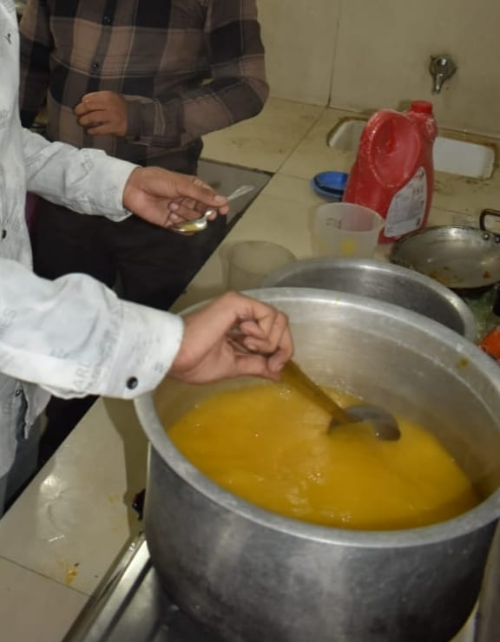
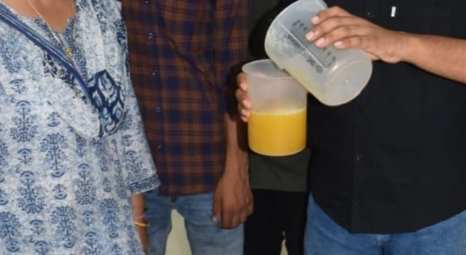

Picture- 1: Pulp extract from ripe mango fruits

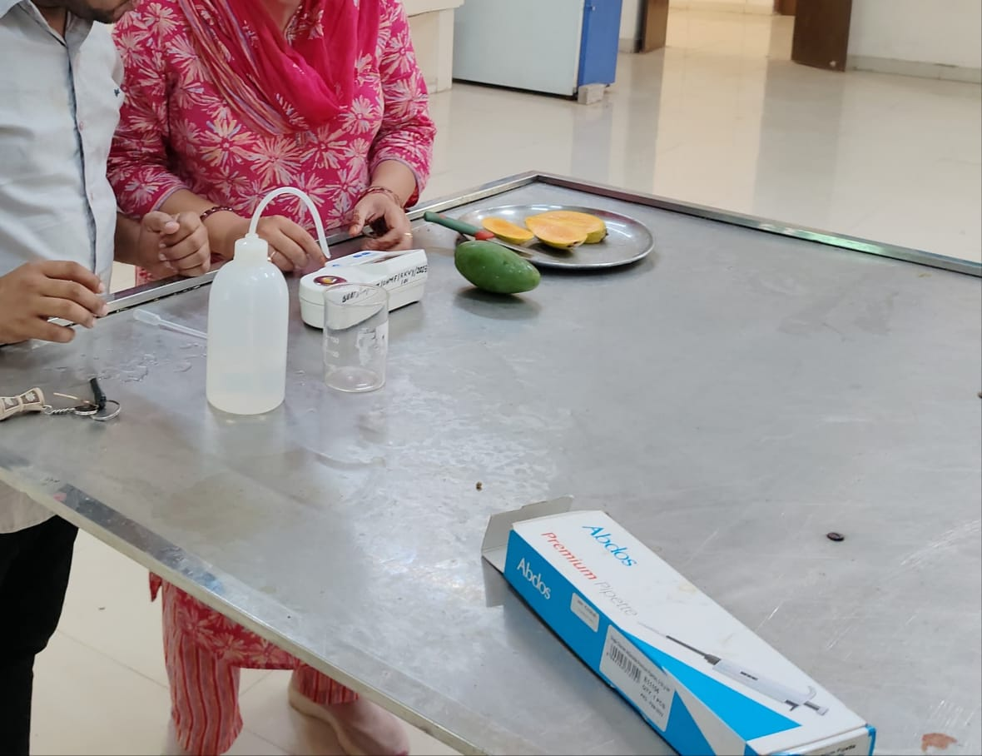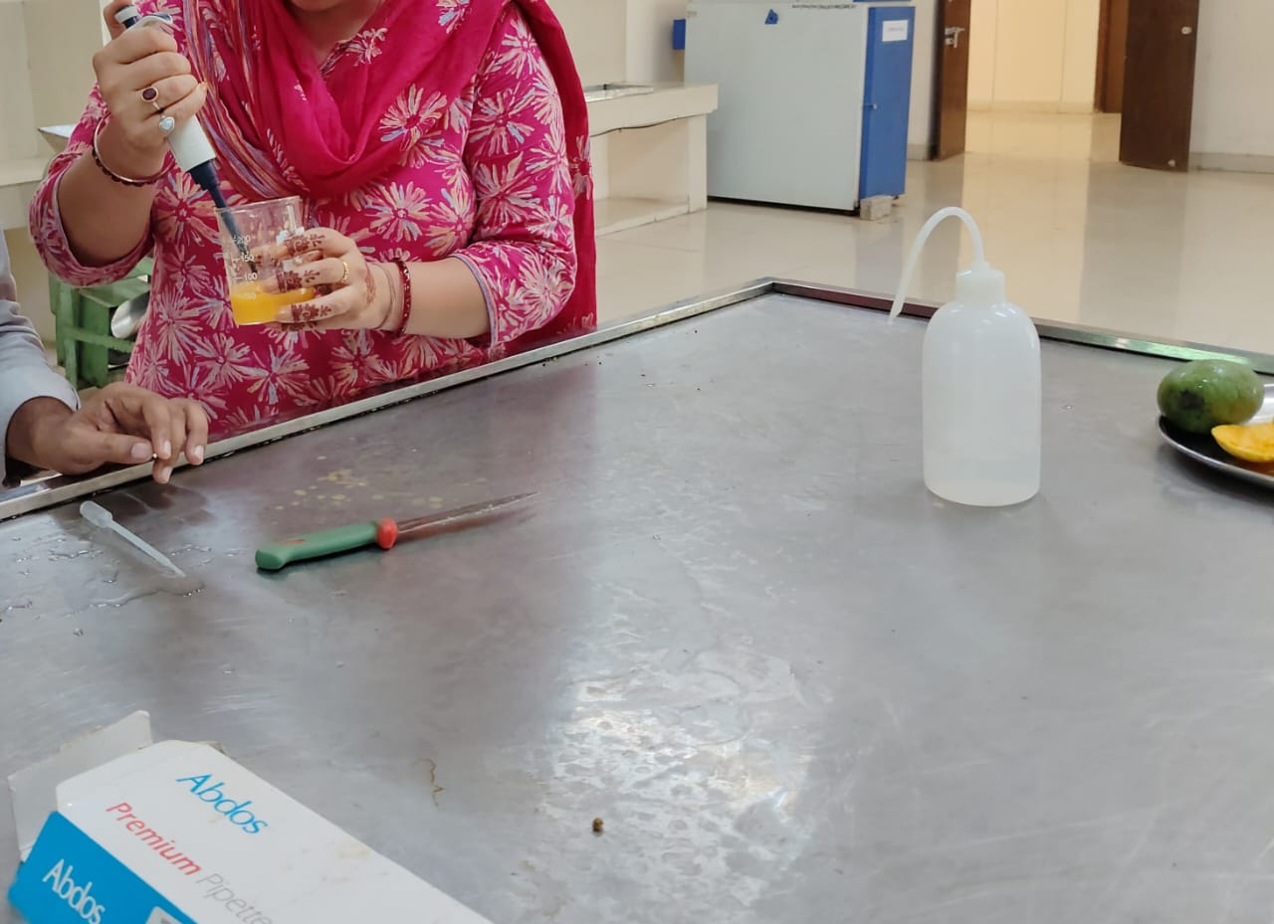

Picture-2: Estimation of chemical composition of pulp as well as blend
squash

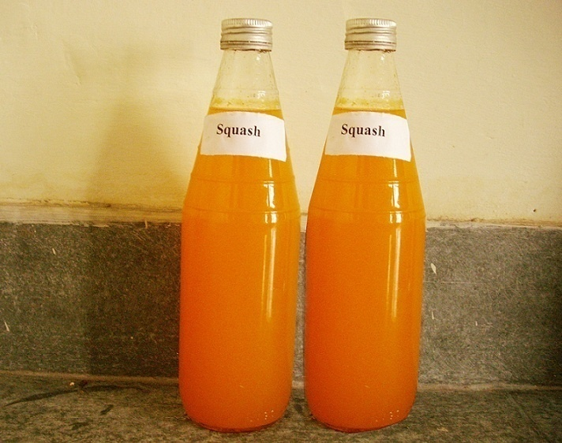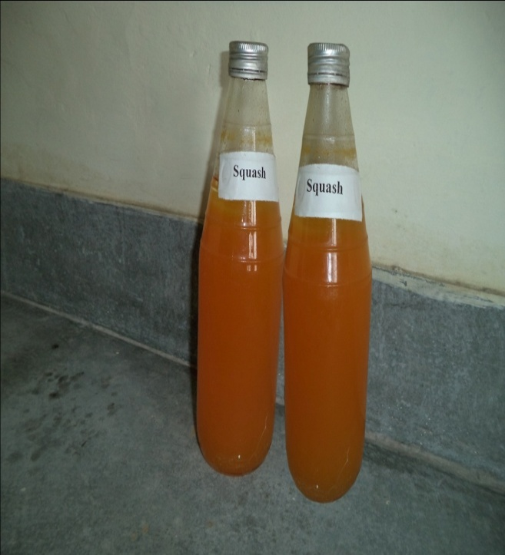
B
A

Picture-3: Browning in mango and aloe vera blend squash after storage.

- At the time of storage.
- After 4 months of storage.

Fig.4: Changes in total soluble solids (%) and acidity (%) of blend squash, during storage

Fig.5: Changes in ascorbic acid (mg/100mL) and carotenoids (mg/100g.) of blend squash,
during storage.

Fig.6: Changes in reducing sugars (%), Non reducing sugar(%) and total sugars (%) of
blend squash during storage

Fig.7: Changes in Vitamin A (IU) of blend squash during storage

Fig.8: Changes in Browning (OD) and organoleptic rating of blend squash during storage

