Evaluation of Zinc Oxide Nanoparticles for Managing Anthracnose and Southern Blight in Green Gram

Original Research Article

ABSTRACT

Nanotechnology has rapidly advanced in the 21st century, with significant developments in the synthesis and application of nanoparticles. ZnNps (Zinc nanoparticles) were synthesized using extracts from mehandi (Lawsonia inermis), neem (Azadirachta indica), marigold (Tagetus erecta) and ginger (Zingiber officinalis). ZnNps were synthesized after analyzing the compatability of the plant extracts with the test pathogens.
This study investigates the antifungal activity of green synthesized zinc nanoparticles (ZnNps) in the laboratory against Colletotrichum lindemuthianum, the causative agent of anthracnose in mung beans and Sclerotium rolfsii causing southern blight in mung bean using the poisoned food technique. Various concentrations (100ppm, 250ppm and 500ppm) of zinc nanoparticles derived from neem, mehandi, marigold and ginger were evaluated alongside corresponding plant extracts and Zinc nitrate hexahydrate at 250ppm. Results indicated significant fungistatic activity, with Mehandi ZnNps at 500ppm exhibiting the highest efficacy, demonstrating minimal mycelial growth (28.00mm) and a growth inhibition rate of 68.88% followed by Marigold and Neem ZnNps against Colletotrichum. As for Sclerotium, Neem ZnNps at 500 ppm exhibiting the highest efficacy, demonstrating minimal mycelial growth (15.00 mm) and a growth inhibition rate of 83.33% followed by ginger and Mehandi. All tested ZnNps concentrations outperformed their respective plant extracts and Zinc nitrate hexahydrate, confirming the potential of green synthesized ZnNps as effective agents. This study provides an eco-friendly alternative to chemical fungicides, addressing the increasing need for sustainable agricultural practices to combat fungal diseases in mung beans. These findings underscore the potential of green synthesized ZnNps as effective ecofriendly fungicides.

Keywords: Anthracnose; Colletotrichum lindemuthianum; zinc nanoparticles; In vitro; southern blight; Sclerotium rolfsii.

1. INTRODUCTION

Green gram or Mung bean (Vigna radiata) belongs to the family Leguminaceae. Numerous fungal diseases namely anthracnose, southern blight, powdery mildew, cercospora leaf spot etc frequently hinder the ability of the affected plants to germinate, kill them or significantly lower their capacity for production. Anthracnose caused by Colletotrichum lindemuthianum and Southern blight caused by Sclerotium rolfsii causes significant problem in green gram. In anthracnose, the symptoms manifested as spherical, black, shrunken lesions on pods, seeds, stems and leaves, that contained flesh-coloured spores and leaves wilt. Padder et al. (2017). Colletotrichum causes early defoliation, early flower and pod fall, degradation of the seeds and in severe cases, plant death (Campa et al. 2014). As in southern blight caused by Sclerotium rolfsii the fungal hyphae developed upward on the surface of stems and covered the lesion with a cottony, white mass of mycelium. The infected stems' exterior and interior white mycelium spread to the surrounding soil surface. Numerous uniformly sized, roundish, white immature sclerotia were formed by the fungus, which matured to a dark brown or black colour. The fungus encircled the stem, expanded into the cortex and finally killed the plant (Kwon et al., 2002).

Nanoparticles are extremely small particles, whose sizes are expressed in nanometers (1 nm =10⁻⁹ meter). Various nanoparticles can be used against seedborne pathogens and soil borne pathogens on green gram. Zinc nanoparticles were also used against Colletotrichum sp, which causes anthracnose diseases in Fabaceae family (Mosquera et al., 2020). Zinc nanoparticles were effectively used against Sclerotium rolfsii, which causes southern blight on mung bean crop (Kamel, 2024). This study was conducted to analyze the efficacy of zinc oxide nanoparticles against Colletotrichum lindemuthianum causing anthracnose on green gram and Sclerotium rolfsii causing southern blight on green gram.

2. MATERIALS AND METHODS

The efficacy of zinc nanoparticles synthesized from neem (Azadirachta indica), mehandi (Lawsonia inermis), marigold (Tagetus erectus) and ginger (Zingiber officinalis) were assessed against Colletotrichum lindemuthianum and Sclerotium rolfsii using Poisoned food technique where varying concentrations of ZnNps were incorporated into the growth medium to assess their effect on fungal growth (Nene & Thapliyal, 1993) by utilizing Potato dextrose agar medium as the base culture. The nanoparticles were synthesized from neem, mehandi, marigold and ginger plant extracts after testing compatibility with plant extracts and the test pathogens. The plant extracts of neem, mehandi, marigold and ginger shows significant fungistatic against the respective fungus. Hence these four plant extracts were selected for nanoparticles synthesis. Zinc nanoparticles synthesized from neem, mehandi and marigold plant extracts were evaluated against Colletotrichum lindemuthianum at 100, 250 and 500 ppm. Neem plant extracts at 250 ppm, mehandi plant extracts at 250ppm, marigold plant extracts at 250ppm and Zinc nitrate hexahydrate at 250 ppm were also evaluated against Colletotrichum lindemuthianum in order to find out the potential of antifungal activity of zinc nanoparticles against the fungus.

Zinc nanoparticles synthesized from neem, mehandi and ginger plant extracts were evaluated against Sclerotium rolfsii at 100, 250 and 500 ppm. The synthesized nanoparticles from plant extracts were analysed by uv visible spectroscopy and Fesem analysis. Neem plant extracts at 250 ppm, mehandi plant extracts at 250ppm, ginger plant extracts at 250ppm and Zinc nitrate hexahydrate at 250 ppm were also evaluated against Sclerotium rolfsii in order to find out the potential of antifungal activity of zinc nanoparticles against the fungus.

The nanoparticles were synthesized from the plant extracts by the mixing of plant extracts and the precursor Zinc nitrate hexahydrate at 1:3 ratio and magnetic stirred at 80°C temperature and 60-minute incubation period. Soon the colour change occurred and the synthesis was further analysed by the characterization using uv spectroscopy and Fesem analysis. The PDA medium containing appropriate quantity of zinc nanoparticles or plant extracts or zinc nitrate hexahydrate at 250ppm were poured aseptically into Petri dishes (90 mm in diameter), where it solidifies at room temperature. All of the plates were inoculated aseptically with a 5 mm culture disc made from an actively growing pure culture of a pathogen. The disc was positioned in the middle of the petri plate on PDA, and the plates then be incubated at a temperature of 27 ± 2°C. Three replication of treatment were made. Petri plates with basic PDA containing the pathogen's culture disc were continued to be used as the untreated control. Thus, replications with14 treatments and by using design CRD for Colletotrichum and Sclerotium.

2.1 Mechanism of Nanoparticles

The ions released by the nanoparticles interfered with the cell wall membrane of the fungus and it will cause the death of the fungus at later stage. (Martínez-Camacho et al., 2010). The oxidation of proteins in cells of the fungus were mediated by ROS (Reactive Oxygen Species) but the degradation of DNA is a ROS-independent phenomenon caused by the intracellular release of ions (Chatterjee et al., 2014).

Observations on radial colony diameter of the test isolates were recorded at an interval of 24 hrs and continued till untreated control plates were fully covered with growth of the test pathogen. Per cent growth inhibition of the test pathogens over untreated control was calculated by following formula (Vincent, 1927).

List 1. Treatment details for Colletotrichum

Tr.  No | Treatments | Tr. No | Treatments
T1 | Neem ZnNps @100ppm | T8 | Marigold ZnNps @ 250ppm
T2 | Neem ZnNps @250ppm | T9 | Marigold ZnNps @ 500ppm
T3 | Neem ZnNps @ 500ppm | T10 | Neem extracts @ 250ppm
T4 | Mehandi ZnNps @ 100ppm | T11 | Mehandi extracts @ 250ppm
T5 | Mehandi ZnNps @ 250ppm | T12 | Marigold extracts @ 250ppm
T6 | Mehandi ZnNps @ 500ppm | T13 | Zinc Nitrate Hexahydrate @250ppm
T7 | Marigold ZnNps @ 100ppm | T14 | Control (Untreated)

List 2. Treatment details for Sclerotium

Tr. No | Treatments | Tr. No | Treatments
T1 | Neem ZnNps @100ppm | T8 | Ginger ZnNps @ 250ppm
T2 | Neem ZnNps @250ppm | T9 | Ginger ZnNps @ 500ppm
T3 | Neem ZnNps @ 500ppm | T10 | Neem extracts @ 250ppm
T4 | Mehandi ZnNps @ 100ppm | T11 | Mehandi extracts @ 250ppm
T5 | Mehandi ZnNps @ 250ppm | T12 | Ginger extracts @ 250ppm
T6 | Mehandi ZnNps @ 500ppm | T13 | Zinc Nitrate Hexahydrate @250ppm
T7 | Ginger ZnNps @ 100ppm | T14 | Control (Untreated)

$$Per cent inhibition (I) =\frac{(C-T) × 100}{(C)}$$

Where, I = Per cent inhibition
C = Growth of test fungus on untreated control plates
T = Growth of test fungus pathogen on treated plates

3. RESULTS AND DISCUSSION

After analyzing the nanoparticles by uv visible spectroscopy, it was found resonance band at maximum of 300 nm and 400 nm of Mehandi ZnNPs, at 400 nm of Neem ZnNPs and at 350 nm of Marigold ZnNPs and 300nm of Ginger ZnNps, respectively. FeSem analysis of neem, mehandi, ginger and marigold nanoparticles showed individual ZnNps as well as a number of aggregates. In general, particles were spherical in shape and the particle size of neem zinc nanoparticles were found in the range of 9-25 nm, Mehandi Zinc nanoparticles images were found to be homogeneous and agglomerated in the range of 10-45 nm, ginger zinc nanoparticles 30-40nm and Marigold zinc nanoparticles in the range of 25-80 nm.

In case of Colletotrichum, the results indicated that solutions of zinc nanoparticles derived from Neem, Mehandi and Marigold at concentrations of 100ppm, 250ppm and 500ppm exhibited significant fungistatic effects. Notably, Mehandi zinc nanoparticles at 500ppm showed the greatest efficacy, resulting in minimal mycelial growth (28.00mm), followed closely by Marigold and Neem at the same concentration (29.00mm and 30.00mm, respectively). In terms of growth inhibition percentages, Mehandi zinc nanoparticles achieved the highest inhibition rate at 68.88%, with Marigold and Neem following at 67.77% and 66.66%, respectively. All tested concentrations of the zinc nanoparticles proved to be more effective than the corresponding plant extracts and zinc nitrate hexahydrate. Results shows that all the treatments at all concentration were significant over the control in inhibiting the growth of test pathogen (Table 1, Plate 1, Fig. 1).

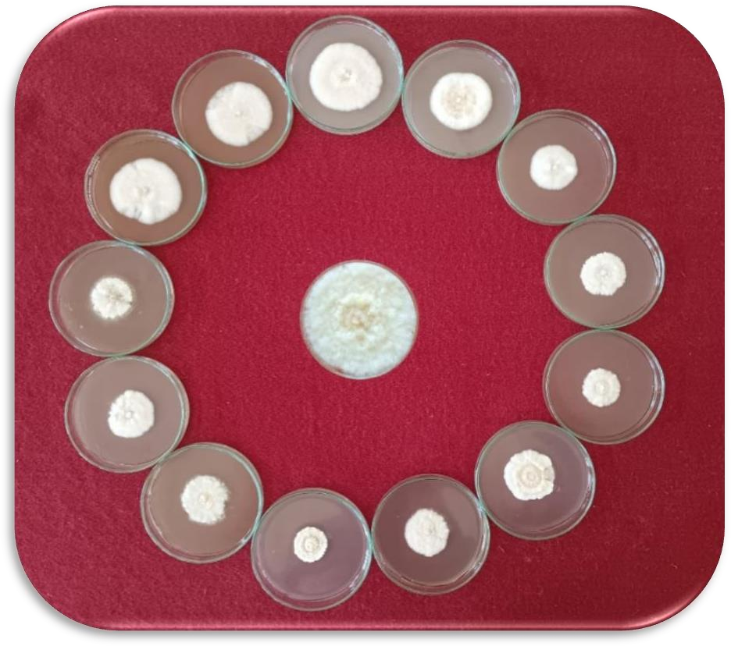
T12
T11
T13
T10
T1
T14
T2
T9
T3
T8
T4
T7
T6
T5

Plate 1. In vitro evaluation of biosynthesized Zinc nanoparticles against Colletotrichum lindemuthianum by poisoned food technique

Table 1. In vitro evaluation of green synthesized Zinc nanoparticles against Colletotrichum lindemuthianum by poisoned food technique

Tr. No. | Treatment at different concentration | Colony Diameter* (mm) | % Inhibition
T1 | Neem ZnNps @100ppm | 40.00 | 55.55  (48.18)
T2 | Neem ZnNps @250ppm | 35.00 | 61.11  (51.41)
T3 | Neem ZnNps @ 500ppm | 30.00 | 66.66  (54.73)
T4 | Mehandi ZnNps @ 100ppm | 42.00 | 53.33  (46.90)
T5 | Mehandi ZnNps @ 250ppm | 38.00 | 57.77  (49.47)
T6 | Mehandi ZnNps @ 500ppm | 28.00 | 68.88  (56.09)
T7 | Marigold ZnNps @ 100ppm | 41.00 | 54.44  (47.54)
T8 | Marigold ZnNps @ 250ppm | 34.00 | 62.22  (52.07)
T9 | Marigold ZnNps @ 500ppm | 29.00 | 67.77  (55.40)
T10 | Neem extracts @ 250ppm | 55.00 | 38.88  (38.52)
T11 | Mehandi extracts @ 250ppm | 57.00 | 36.66  (37.26)
T12 | Marigold extracts @ 250ppm | 56.00 | 37.77  (37.92)
T13 | Zinc Nitrate Hexahydrate @250ppm | 47.00 | 47.77  (43.72)
T14 | Control (Untreated) | 90.00 | 0.00  (0.00)
 | S.E. ± | 0.55 | 0.58
 | C.D. (P=0.01) | 2.17 | 2.28
Mean of three replications. **Figures in parenthesis are arc sine transformed values

These findings align with previous research indicating that zinc nanoparticles possess notable antifungal properties. For instance, Mosquera et al. (2020) reported that ZnO nanoparticles significantly inhibited Colletotrichum growth, while T-Thienprasert et al. (2021) found a substantial inhibition rate using nanoparticles derived from banana peel extract. Additionally, Saranya (2023) highlighted that zinc nanoparticles from mustard seeds also demonstrated strong inhibitory effects on mycelial growth. Overall, the results underscore the potential of green synthesized zinc nanoparticles as effective antifungal agents against Colletotrichum lindemuthianum causing anthracnose in green gram suggesting their applicability in agricultural practices for managing fungal diseases.

In case of Sclerotium rolfsii (causing southern blight in mung bean), the results indicated that solutions of zinc nanoparticles derived from Neem, Mehandi and Ginger at concentrations of 100ppm, 250ppm and 500ppm exhibited significant fungistatic effects. The results showed that all treatments significantly inhibited fungal growth compared to the untreated control. Among the treatments, Neem ZnNps at 500ppm exhibited the highest effectiveness, resulting in the lowest mycelial growth (15.00mm), followed by Ginger ZnNps (19.00mm) and Mehandi ZnNps (27.00mm) at the same concentration. Lower concentrations also demonstrated antifungal activity, though less effectively. In terms of growth inhibition percentages, Neem zinc nanoparticles achieved the highest inhibition rate at 83.33%, with Ginger zinc nanoparticles and Mehandi following at 78.88% and 70.00%, respectively. All tested concentrations of the zinc nanoparticles proved to be more effective than the corresponding plant extracts and zinc nitrate hexahydrate. (Table 2, Plate 2, Fig. 2). These findings align with the previous research indicating that zinc nanoparticles possess notable antifungal properties. For instance, Ali et al. (2020) found that 60 mg ZnO-NPs from Azadirachta indica inhibited mycelial growth of Sclerotium rolfsii by 41%, while chemically synthesized ZnO-NPs had no effect. Zaki et al. (2021) tested various concentrations (20, 40, and 100 μg/mL) of ZnO-NPs against Rhizoctonia solani, Fusarium sp. and Macrophomina phaseolina, observing significant growth inhibition across all concentrations. Jomeyazdian et al. (2024) reported that ZnO-NPs synthesized from Trichoderma harzianum inhibited the growth of Fusarium oxysporum in a dose- dependent manner, with higher concentrations leading to greater inhibition.

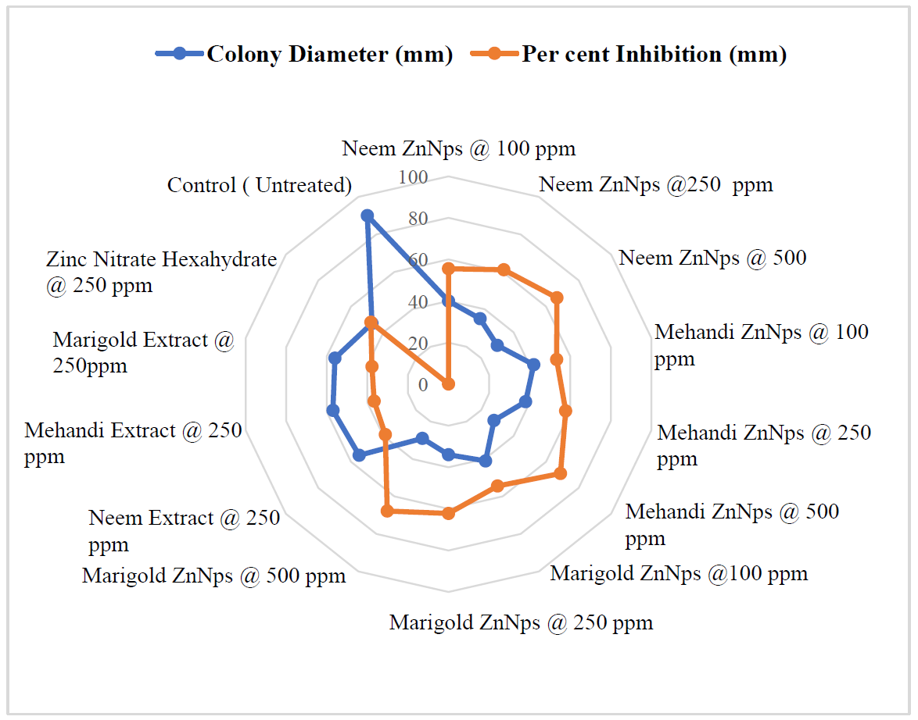

Fig. 1. In vitro evaluation of biosynthesized Zinc nanoparticles against Colletotrichum lindemuthianum by poisoned food technique

Table 2. In vitro evaluation of green synthesized Zinc nanoparticles against Sclerotium rolfsii by poisoned food technique

Tr. No. | Treatment at different concentrations | Colony Diameter* (mm) | % Inhibition
T1 | Neem ZnNps @100ppm | 36.00 | 60.00  (50.76)
T2 | Neem ZnNps @250ppm | 30.00 | 66.66  (54.73)
T3 | Neem ZnNps @ 500ppm | 15.00 | 83.33  (65.90)
T4 | Mehandi ZnNps @ 100ppm | 50.00 | 44.44  (41.80)
T5 | Mehandi ZnNps @ 250ppm | 40.00 | 55.55  (48.18)
T6 | Mehandi ZnNps @ 500ppm | 27.00 | 70.00  (56.78)
T7 | Ginger ZnNps @ 100ppm | 52.00 | 42.22  (40.52)
T8 | Ginger ZnNps @ 250ppm | 39.00 | 56.60  (48.79)
T9 | Ginger ZnNps @ 500ppm | 19.00 | 78.88  (62.64)
T10 | Neem extracts @ 250ppm | 70.00 | 22.22  (28.12)
T11 | Mehandi extracts @ 250ppm | 60.00 | 33.33  (35.26)
T12 | Ginger extracts @ 250ppm | 58.00 | 35.55  (36.60)
T13 | Zinc Nitrate Hexahydrate @250ppm | 55.00 | 38.88  (38.52)
T14 | Control (Untreated) | 90.00 | 0.00  (0.00)
 | S.E. ± | 0.55 | 0.56
 | C.D. (P=0.01) | 2.17 | 2.20
Mean of three replications. **Figures in parenthesis are arc sine transformed values

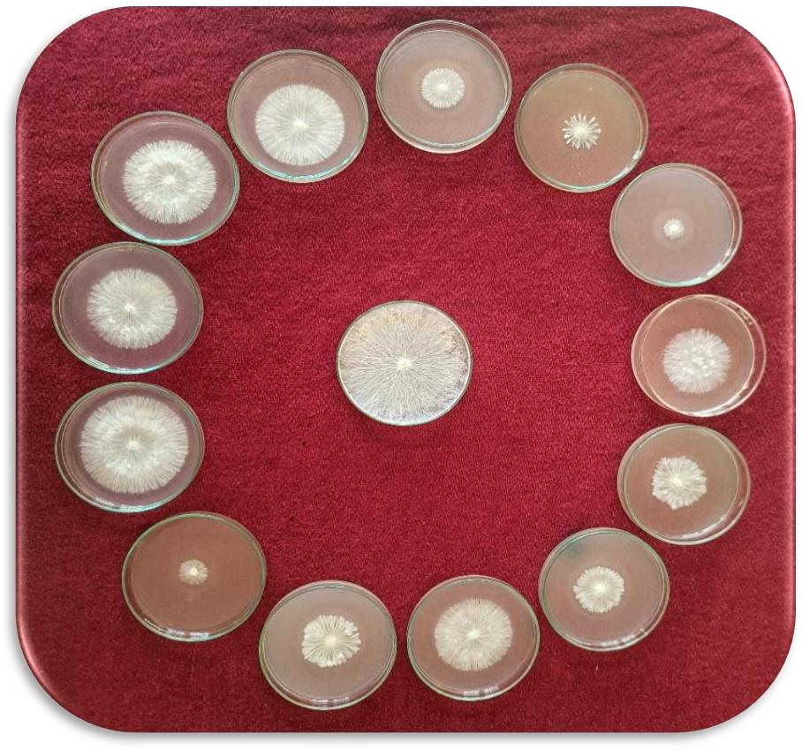
T13
T1
T2
T12
T3
T11
T14
T4
T10
T5
T6
T9
T8
T7

Plate 2. In vitro evaluation of biosynthesized Zinc nanoparticles against Sclerotium rolfsii by poisoned food technique

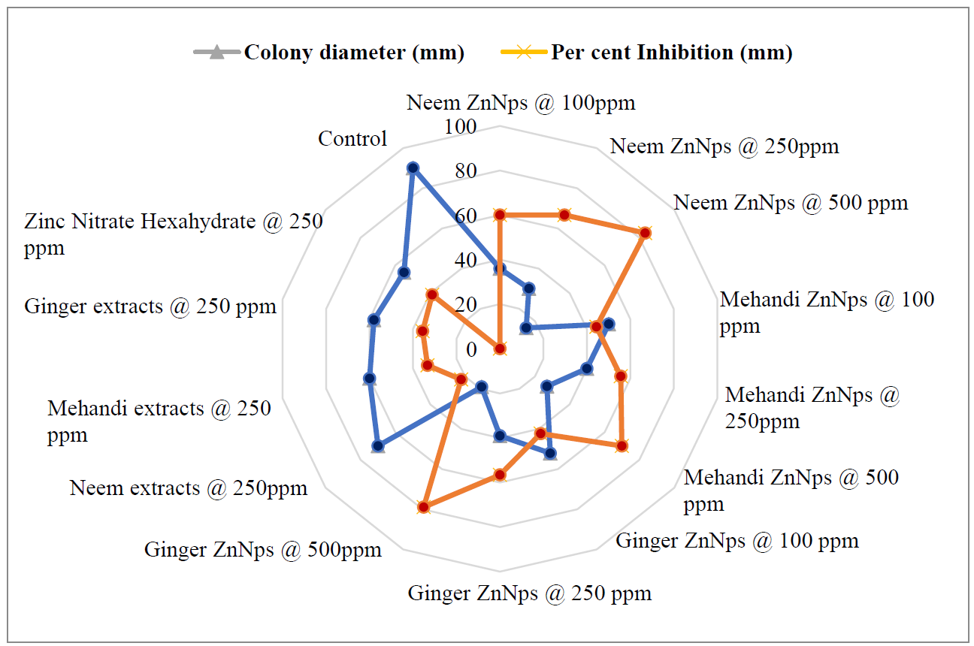

Fig. 2. In vitro evaluation of biosynthesized Zinc nanoparticles against Sclerotium rolfsii by poisoned food technique

4. CONCLUSION

The study demonstrated that zinc nanoparticles (ZnNps) derived from Mehandi, Marigold and Neem significantly inhibit the radial mycelial growth of Colletotrichum lindemuthianum, the pathogen responsible for anthracnose in mung bean and in case of Sclerotium rolfsii the nanoparticles synthesized from neem, mehandi and ginger were effective. Among the treatments, Mehandi ZnNps at 500 ppm exhibited the highest inhibition rate at 68.88%, followed closely by Marigold and Neem ZnNps at the same concentration in case of Colletotrichum while, for Sclerotium Neem ZnNps at 500ppm followed by ginger and mehandi. The effectiveness of these nanoparticles surpassed that of traditional plant extracts and zinc nitrate hexahydrate, indicating their potential as a novel approach for managing fungal diseases in crops. These findings underscore the importance of utilizing zinc nanoparticles as a promising alternative for enhancing plant disease resistance and improving agricultural productivity. Further research may explore the mechanisms undelying the antifungal activity of ZnNps, their stability under field conditions and their environmental impact, including potential effects on soil health and non- target organisms.
DISCLAIMER (ARTIFICIAL INTELLIGENCE)

I hereby declare that NO generative AI technologies such as Large Language Models (ChatGPT, COPILOT, etc) and text-to-image generators have been used during writing or editing of this manuscript.

COMPETING INTERESTS

Authors have declared that no competing interests exist.

REFERENCES

Ali, J., Mazumder, J. A., Perwez, M., & Sardar, M. (2020). Antimicrobial effect of ZnO nanoparticles synthesized by different methods against food borne pathogens and phytopathogens. Materials Today: Proceedings, 36(3), 609–615.
Campa, A., Rodríguez-Suárez, C., Giraldez, R., & Ferreira, J. J. (2014). Genetic analysis of the response to eleven Colletotrichum lindemuthianum races in a RIL population of common bean (Phaseolus vulgaris L.). BMC Plant Biology, 14, 1–12.
Chatterjee, A. K., Chakraborty, R., & Basu, T. (2014). Mechanism of antibacterial activity of copper nanoparticles. Nanotechnology, 25(13), 135101.
Jomeyazdian, A., Pirnia, M., Alaei, H., Taheri, A., & Sarani, S. (2024). Control of Fusarium wilt disease of tomato and improvement of some growth factors through green synthesized zinc oxide nanoparticles. European Journal of Plant Pathology, 13(1), 333–345.
Kamel, W. M. (2024). Antifungal activity of some nanoparticles against kidney bean root rots pathogens. Caspian Journal of Environmental Sciences, 22(1), 103–110.
Kwon, J. H., & Park, S. C. (2002). Stem rot of tomato caused by Sclerotium rolfsii in Korea. Mycobiology, 30(4), 244–246.
Martínez-Camacho, A., Cortez-Rocha, M., Ezquerra-Brauer, J., Graciano-Verdugo, A., Rodriguez-Félix, F., Castillo-Ortega, M., Yépiz-Gómez, M., & Plascencia-Jatomea, M. (2010). Chitosan composite films: Thermal, structural, mechanical and antifungal properties. Carbohydrate Polymers, 82(2), 305–315.
Mosquera-Sánchez, L. P., Arciniegas-Grijalba, P. A., Patiño-Portela, M. C., Guerra-Sierra, B. E., Muñoz-Florez, J. E., & Rodríguez-Páez, J. E. (2020). Antifungal effect of zinc oxide nanoparticles (ZnO-NPs) on Colletotrichum sp., causal agent of anthracnose in coffee crops. Biocatalysis and Agricultural Biotechnology, 25, 101579.
Nene, Y. L., & Thapliyal, P. N. (1993). Fungicides in plant disease control (3rd ed.). International Science Publisher.
Padder, B. A., Sharma, P., Awale, H. E., & Kelly, J. D. (2017). Colletotrichum lindemuthianum, the causal agent of bean anthracnose. Journal of Plant Pathology, 99, 317–330.
Saranya, R. (2023). Biogenesis of zinc oxide nanoparticles from mustard seed extract and its antifungal activity against Colletotrichum falcatum causing red rot in sugarcane. The Pharma Innovation Journal, 12(8), 53–56.
T-Thienprasert, N. P., T-Thienprasert, J., Ruangtong, J., Jaithon, T., Srifah Huehne, P., & Piasai, O. (2021). Large-scale synthesis of green synthesized zinc oxide nanoparticles from banana peel extracts and their inhibitory effects against Colletotrichum sp., isolate KUFC 021, causal agent of anthracnose on dendrobium orchid. Journal of Nanomaterials, 2(1), 562–599.
Vincent, J. M. (1927). Distortion of fungal hyphae in presence of certain inhibitors. Nature, 159–180.
Zaki, S. A., Ouf, S. A., Albarakaty, F. M., Habeb, M. M., Aly, A. A., & Abd-Elsalam, K. A. (2021). Trichoderma harzianum-mediated ZnO nanoparticles: A green tool for controlling soil-borne pathogens in cotton. Journal of Fungi, 7(11), 952.

