Observation of Air Quality in Iraq During
March, 2026

----------------------------------------------------------------------------------
ABSTRACT
Air quality monitoring index for Iraq during March , 2026 for pollutants of Nitrogen Dioxide (NO₂), Ground- level Ozone (O₃) Particulates Matter (PM10 and PM2.5) , Carbon Monoxide (CO) and Sulfur Dioxide (SO₂) for the three Iraqi Governorates of Duhok in the north, Baghdad in the center, and Basra in the south regarding the differences and similarities in index values.
The observation data of air quality in Iraq started from 1 to 31March 2026 of three Governorates Duhok, Baghdad and Basra. Daily readings of air quality of these pollutants were recorded for the three Iraqi Governorates.

Figures were drawn showing the daily readings for each individual pollutant recorded during March, 2026 in order to compare the air quality index level for the three Iraqi Governorates under test. The pollution level rating from the air quality index guide is interpreted as follows: Good (0-50), Moderate (51-100), Unhealthy for Sensitive (101- 150), Unhealthy (151-200), Very Unhealthy (201-300) and Hazardous (300 and above).

Results of the air quality monitoring for the three Iraqi Governorates of Duhok, Baghdad and Basra during March 2026, according to the degree shown in the Air Quality Index Guide for each pollutant and at the highest level of pollution are as follows:

Nitrogen Dioxide (NO₂) in Baghdad Governorate on March 19th was at a (Moderate level) , Ground- level Ozone (O₃) in Duhok Governorate on March 2nd was at a (Moderate) level, Pollutant (PM10) in Basra Governorate on March 10th was at an (Unhealthy) level , and pollutant (PM2.5) in Basra Governorate on March 22nd was at a (Very Unhealthy) level ,Carbon Monoxide in (CO) in Baghdad Governorate on March 7th was at a (Good) level, and finally, Sulfur Dioxide (SO₂) in Baghdad Governorate was at a (Good) level.

Key words: Air quality index, Iraqi air quality, Air Pollution, Environment Pollutants, Public Health.

1.Introduction
Iraq was very different two decades ago. Dust fills the air and is stirred up by hot winds. There are vast areas of barren land dotted with stubborn palm trees that struggle patiently to withstand the elements. It is clear that climate change has negatively affected on Iraq [1]
Climate change in Iraq is having impacts that make Iraq's environment, security, politics, and economic challenges worse, high temperatures, severe drought, declining rainfall, desertification, salinization, and the increased prevalence of dust storms have undermined the agricultural sector in Iraq. In addition, Iraq's water security depends on the deteriorating Tigris and Euphrates river system. National and regional political uncertainty will make mitigating climate change and addressing transnational water governance very difficult on the state of Iraq for years to come. Greenhouse gas emissions per capita are higher than the global average [2].
Climate change in Iraq is having impacts that make Iraq's environment, security, politics, and economic challenges worse, high temperatures, severe drought, declining rainfall, desertification, salinization, and the increased prevalence of dust storms have undermined the agricultural sector in Iraq. I n addition, Iraq's water security depends on the deteriorating Tigris and Euphrates river system. National and regional political uncertainty will make mitigating climate change and addressing transnational water governance very difficult on the state of Iraq for years to come. Greenhouse gas emissions per capita are higher than the global average [3].

The Air Quality Index is based on measuring Particulates Matter (PM2.5 and PM10), Ozone (O₃), Nitrogen Dioxide (NO₂), Sulfur Dioxide (SO₂), and Carbon Monoxide (CO). The particulates matter are small, visible particles of dust, ash, soot, or any other visible material. Particles less than 2.5 microns in diameter are labeled PM2.5 Particles up to 10 microns in diameter are labeled PM10. In addition to reducing visibility, particulates can be inhaled and embed themselves in lung and bronchial tissue. Fig. (1) show the size of PM2.5 and PM10 with respect to human hair [4].

Fig. (1)- The size of particulate matter PM2.5 and PM10 with respect to human hair.

This work is conducted a scientific study by recording daily air pollutant readings during March 2026 on air quality across Iraq, from north to south, covering three Governorates: Duhok in the north, Baghdad in the center, and Basra in the south. The results of the study will then be analyzed, examining their relationship to public health through the spread of dust and other pollutants and their negative effects on human health. Fig. (2) show the air quality index guide [5].


Fig. (2)- The Air Quality Index Guide

2.Sources of Air Pollution

The world climate change is due to greenhouse gases emission causing global warming. Greenhouse gases act similarly to the glass in a greenhouse: they absorb the sun’s heat that radiates from the Earth’s surface, trap in the atmosphere and prevent it from escaping into space The greenhouse effect keeps the Earth’s temperature warmer than it would otherwise be, supporting life on Earth.

Carbon dioxide (CO₂) is just one of many greenhouse gases. CO₂ is naturally produced by animals during respiration and through the decay of biomass. It also enters the atmosphere through burning fossil fuels and chemical reactions. It is removed from the atmosphere by plants in the process known as photosynthesis that turns sunlight into energy and also transforms CO₂ and water into sugar and oxygen. The absorbed CO₂ is kept out of the atmosphere until plants die and that is why forest play an important role in capturing carbon dioxide [5].

Climate change” and “global warming” are often used interchangeably but have distinct meanings. Similarly, the terms "weather" and "climate" are sometimes confused, though they refer to events with broadly different spatial- and timescales [6].

Most air pollution comes from one human activity: burning fossil fuels—natural gas, coal, and oil—to power industrial processes and motor vehicles. Among the harmful chemical compounds this burning puts into the atmosphere are carbon dioxide, carbon monoxide, nitrogen oxides, sulfur dioxide, and tiny solid particles—including lead from gasoline additives—called particulates. Between 1900 and 1970, motor vehicle uses rapidly expanded, and emissions of nitrogen oxides, some of the most damaging pollutants in vehicle exhaust, increased 690 percent. When fuels are incompletely burned, various chemicals called volatile organic chemicals (VOCs) also enter the air. Pollutants also come from other sources. For instance, decomposing garbage in landfills and solid waste disposal sites emits methane gas, and many household products give off VOCs [7].

Once in the atmosphere, pollutants often undergo chemical reactions that produce additional harmful compounds. Air pollution is subject to weather patterns that can trap it in valleys or blow it across the globe to damage pristine environments far from the original sources [8].

Climate change can affect air quality, and certain air pollutants can affect climate change. For example, hot sunny days associated with a warming climate can increase ground-level ozone in some areas. Ground-level Ozone is also a greenhouse gas that contributes to climate change by trapping heat in the heat in the atmosphere [9]

3. Methodology
Air quality monitoring relies on pollutant concentrations as outlined in World Health Organization (WHO) guidelines, which include six variables air quality indicators :as Nitrogen Dioxide (NO₂), Ground-level Ozone (O₃), particulates matter (PM10 and PM2.5), Carbon Monoxide (CO), and Sulfur Dioxide.(SO₂).
The concentrations of the air quality pollutants mentioned above were recorded daily from March 1, 2026, to March 31, 2026, using data based on the Google Global Climate Index, readings were recorded at midday between 1 PM and 2 PM for three Iraqi governorates. under study located in the north ( Duhok ) , the central ( Baghdad } and the south ( Basra ) [10].

The daily readings taken during March 2026 for three Iraqi Governorates under study and for all pollutants affecting air quality, as previously indicated, were audited and the results compared with the World Health Organization (WHO) Air Quality Index Guide shown in Fig.(2) for the purpose of determining the degree of pollution and its relationship to human health.

An example of the observation data of air quality in Iraq started in 1 March 2026 for the three Iraqi Governorates Duhok, Baghdad and Basra is shown in Fig. (3).
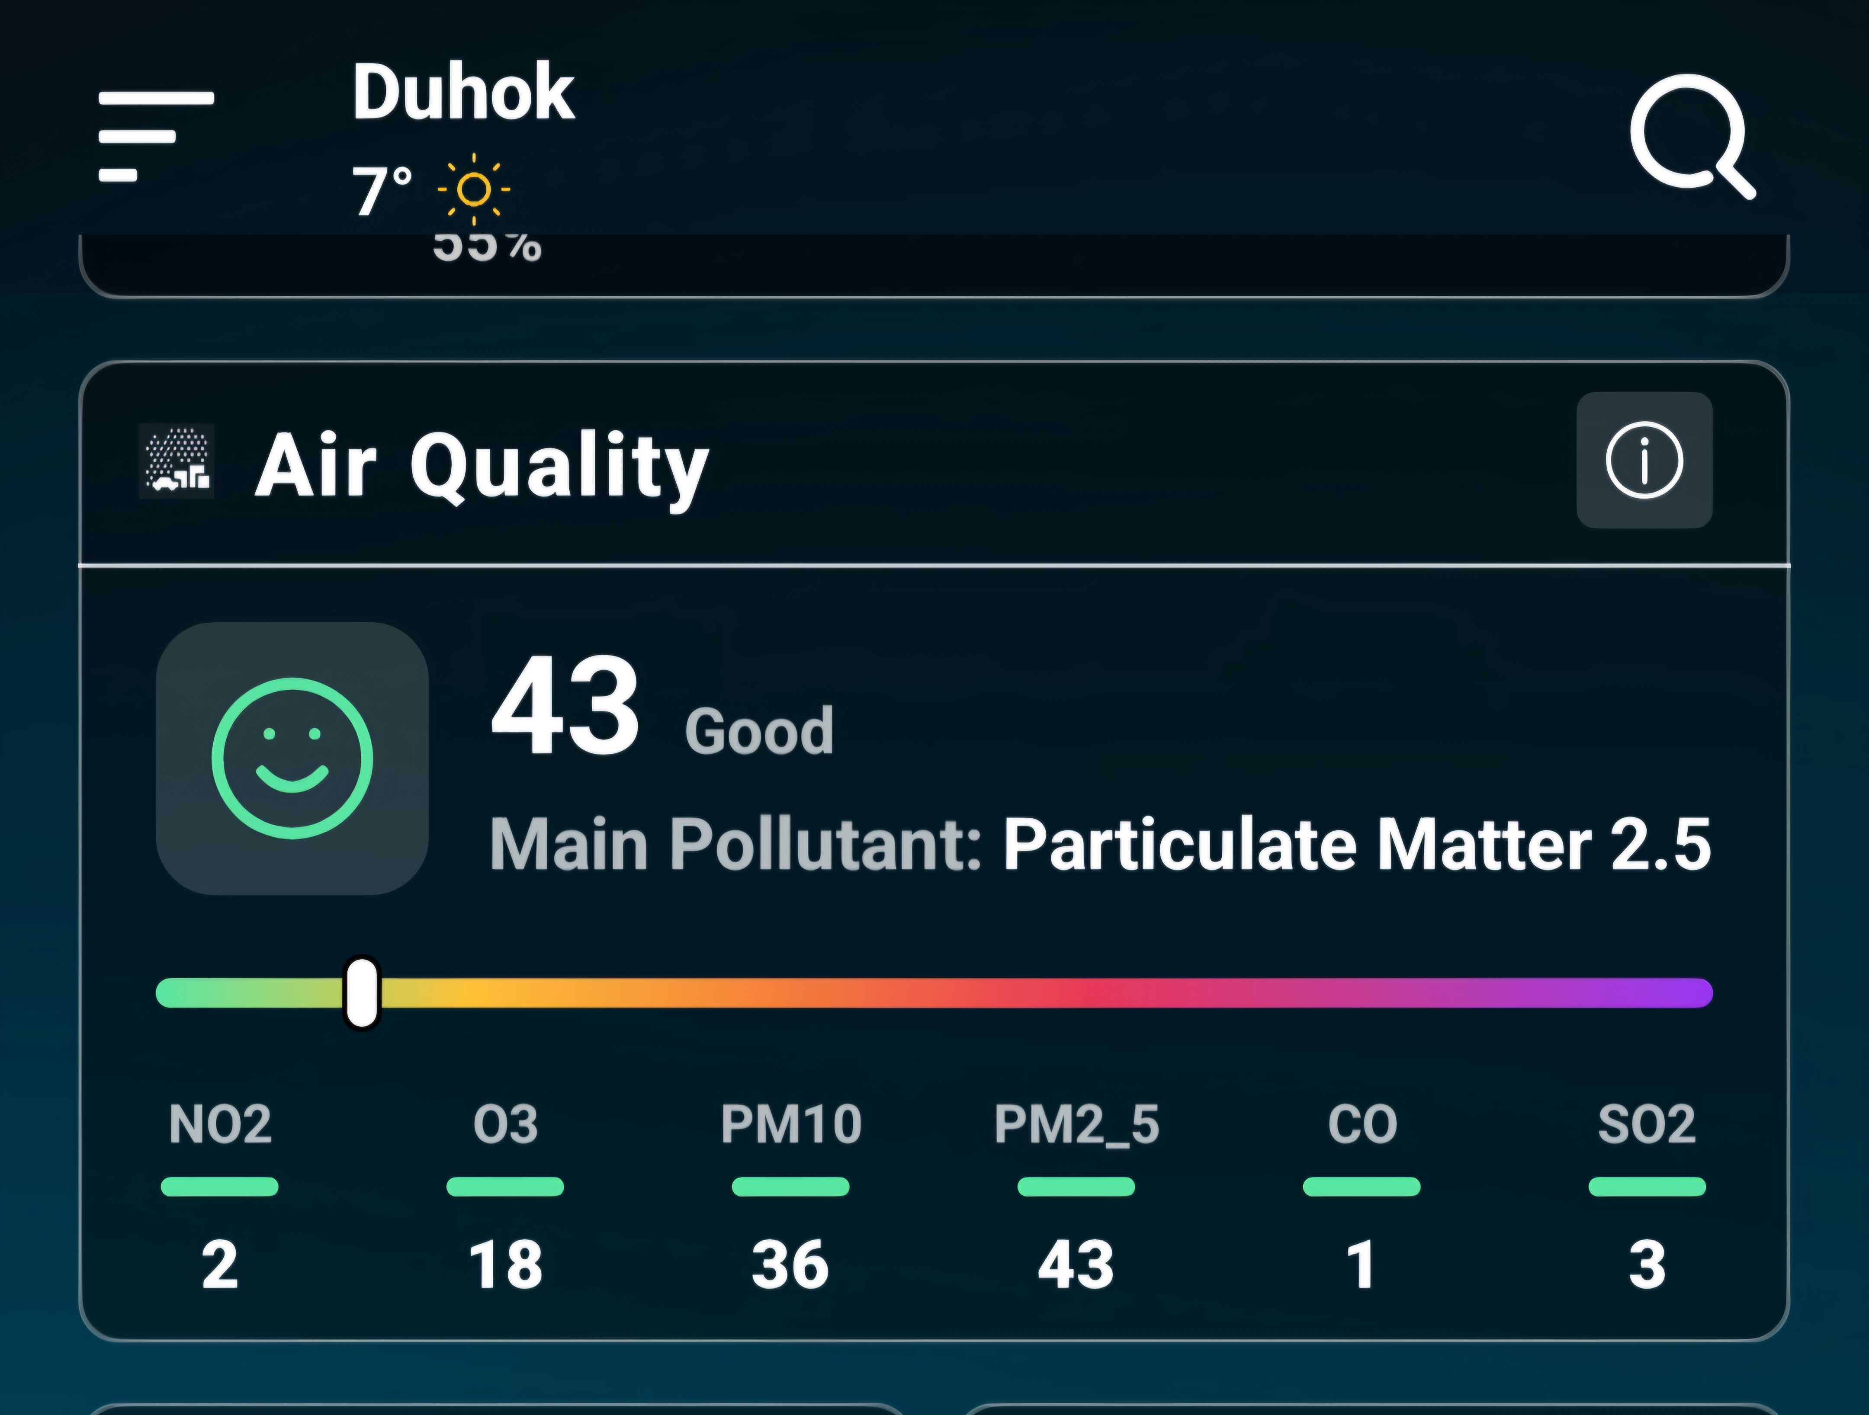

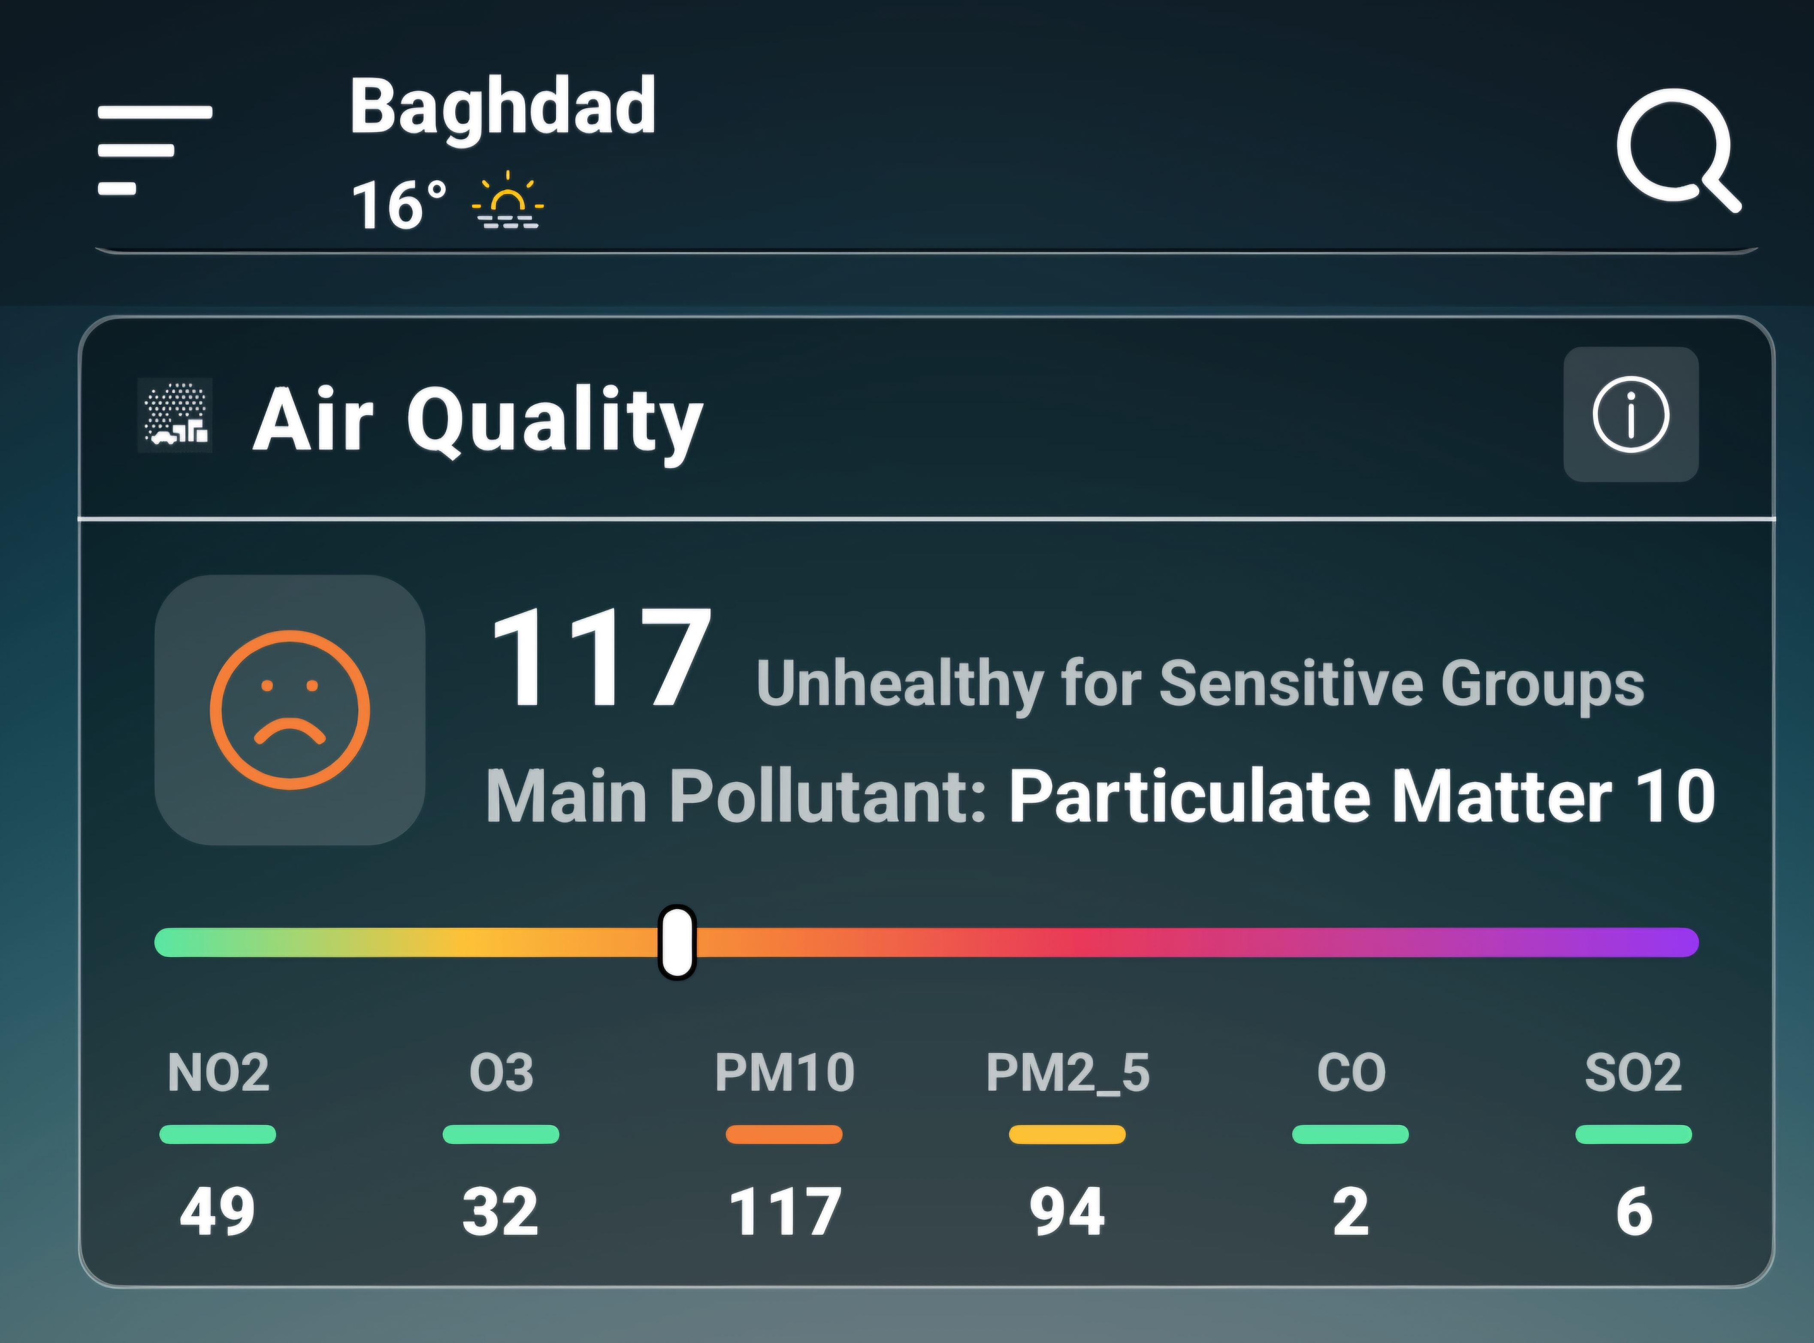

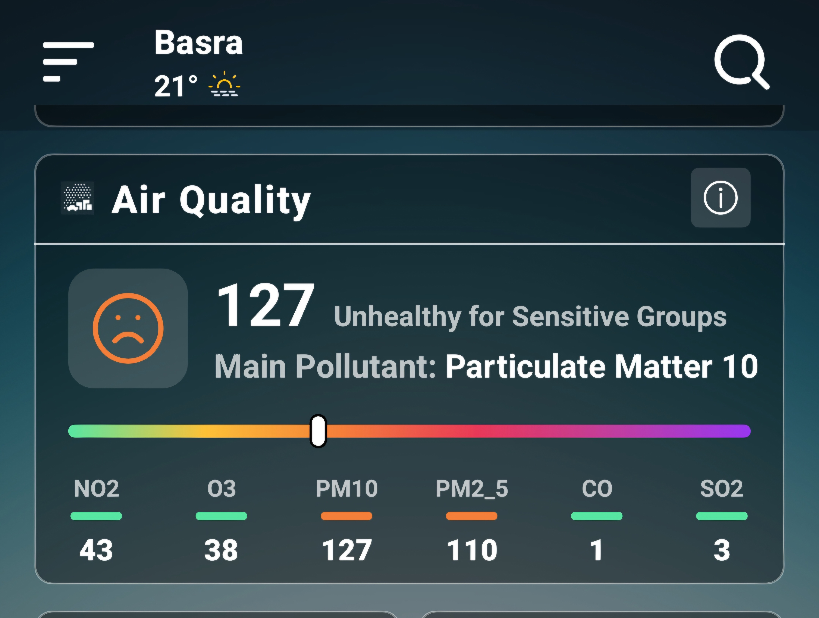

Fig.(3) – Show an example of recording air quality readings on March 1, 2026 for three Iraqi Governorates: (Duhok) in the north, (Baghdad) in the center, and (Basra) in the south.

4. Results
Air quality data monitoring in Iraq for three Governorates Duhok in the North, Baghdad in the Center, and Basra in the South, was recorded and documented daily in Table (1) from March 1, to March 31, 2026, as shown follows in Table (1). The daily readings for air quality monitoring in three Iraqi Governorates: under study , where .the numbers highlighted in red between (100 and 150) indicate an ( Unhealthy for Sensitive ) index, while the red numbers between (151 and 200) indicate ( Unhealthy ) index and the numbers (201 and 300) indicate to (Very Unhealthy)index according to the air quality index guide shown in Fig. (2).
It should be noted that all readings were recorded at midday between 1:00 and 2:00 PM for the three Iraqi Governorates under study, so that the reading should be recorded under the same conditions.

Table (1)- Shows the daily readings for air quality monitoring in three Iraqi Governorates: Duhok in the North, Baghdad in the Center, and Basra in the South. The numbers highlighted in red between (100 and 150) indicate an ( Unhealthy for Sensitive ) index, while the red numbers between (151 and 200) indicate to ( Unhealthy ) index and the red numbers (201 and 300) indicate to (Very Unhealthy) index according to the air quality index guide shown in Fig. (2).

Basra Governorate
South of Iraq

Baghdad Governorate
Center of Iraq

Duhok Governorate
North of Iraq

Date

March,
2026
 | NO2 |  | O3 | PM10 | PM2.5 | CO | SO2 | NO2 | O3 | PM10 | PM2.5 | CO |  | SO2 | NO2 |  |  | O3 |  | PM10 |  | PM2.5 | CO |  | SO2
1 | 2 |  | 18 | 36 | 43 | 1 | 3 | 49 | 32 | 117 | 94 | 2 |  | 6 | 43 |  |  | 38 |  | 127 110 1 |  |  |  |  | 3
2 | 1 |  | 64 | 11 | 20 | 1 | 2 | 40 | 44 | 100 | 78 | 1 |  | 9 | 36 |  |  | 39 |  | 133 109 1 |  |  |  |  | 3
3 | 12 |  | 24 | 67 | 72 | 1 | 2 | 45 | 34 | 61 | 69 | 1 |  | 2 | 32 |  |  | 44 |  | 117 104 1 |  |  |  |  | 6
4 | 14 |  | 17 | 90 | 99 | 1 | 4 | 38 | 40 | 107 | 86 | 1 |  | 7 | 34 |  |  | 40 |  | 101 106 1 |  |  |  |  | 8
5 | 15 |  | 21 | 51 | 59 | 1 | 5 | 27 | 37 | 167 | 157 | 1 |  | 4 | 47 |  |  | 49 |  | 137 131 1 |  |  |  |  | 3
6 | 12 |  | 18 | 46 | 79 | 1 | 4 | 36 | 44 | 148 | 131 | 1 |  | 9 | 36 |  |  | 46 |  | 135 121 1 |  |  |  |  | 3
7 | 11 |  | 43 | 93 | 97 | 1 | 6 | 44 | 39 | 123 | 118 | 2 |  | 4 | 38 |  |  | 47 |  | 133 125 1 |  |  |  |  | 6
8 | 8 |  | 30 | 32 | 54 | 1 | 2 | 19 | 40 | 163 | 128 | 1 |  | 6 | 46 |  |  | 43 |  | 121 116 1 |  |  |  |  | 4
9 | 15 |  | 20 | 21 | 61 | 1 | 1 | 33 | 42 | 117 | 103 | 1 |  | 7 | 46 |  |  | 45 |  | 151 128 1 |  |  |  |  | 4
10 | 0 |  | 54 | 5 | 8 | 1 | 0 | 37 | 39 | 110 | 96 | 1 |  | 6 | 25 |  |  | 60 |  | 197 154 1 |  |  |  |  | 7
11 | 0 |  | 58 | 8 | 13 | 1 | 1 | 33 | 44 | 110 | 78 | 1 |  | 1 | 50 |  |  | 56 |  | 123 115 1 |  |  |  |  | 3
12 | 11 |  | 29 | 78 | 58 | 1 | 1 | 44 | 43 | 108 | 87 | 1 |  | 17 | 41 |  |  | 38 |  | 136 118 1 |  |  |  |  | 2
13 | 0 |  | 46 | 23 | 27 | 1 | 2 | 35 | 47 | 128 | 113 | 1 |  | 6 | 38 |  |  | 31 |  | 120 112 1 |  |  |  |  | 1
14 | 8 |  | 31 | 94 | 106 | 1 | 4 | 44 | 29 | 125 | 124 | 1 |  | 6 | 31 |  |  | 33 |  | 103 94 1 |  |  |  |  | 3
15 | 15 |  | 18 | 28 | 41 | 1 | 0 | 33 | 27 | 126 | 122 | 1 |  | 4 | 35 |  |  | 37 |  | 135 136 1 |  |  |  |  | 1
16 | 1 |  | 31 | 10 | 26 | 1 | 1 | 22 | 45 | 120 | 98 | 1 |  | 10 | 38 |  |  | 44 |  | 143 125 1 |  |  |  |  | 6
17 | 4 |  | 48 | 17 | 31 | 1 | 2 | 32 | 39 | 126 | 111 | 1 |  | 10 | 30 |  |  | 47 |  | 144 140 1 |  |  |  |  | 7
18 | 0 |  | 56 | 14 | 23 | 1 | 2 | 37 | 44 | 104 | 73 | 1 |  | 12 | 33 |  |  | 51 |  | 97 94 1 |  |  |  |  | 8
19 | 1 |  | 45 | 15 | 21 | 1 | 1 | 54 | 17 | 118 | 110 | 2 |  | 5 | 20 |  |  | 42 |  | 116 119 1 |  |  |  |  | 5
20 | 4 |  | 44 | 7 | 11 | 1 | 1 | 25 | 34 | 128 | 131 | 1 |  | 2 | 29 |  |  | 35 |  | 144 122 1 |  |  |  |  | 2
21 | 9 |  | 26 | 21 | 33 | 1 | 4 | 31 | 32 | 119 | 110 | 1 |  | 1 | 15 |  |  | 43 |  | 141 142 1 |  |  |  |  | 2
22 | 13 |  | 22 | 17 | 46 | 1 | 1 | 37 | 48 | 117 | 110 | 1 |  | 2 | 36 |  |  | 55 |  | 186 202 1 |  |  |  |  | 5
23 | 5 |  | 33 | 28 | 38 | 1 | 4 | 40 | 39 | 115 | 101 | 1 |  | 12 | 23 |  |  | 39 |  | 119 98 1 |  |  |  |  | 2
24 | 10 |  | 26 | 38 | 44 | 1 | 1 | 38 | 19 | 101 | 75 | 1 |  | 3 | 23 |  |  | 33 |  | 122 111 1 |  |  |  |  | 5
25 | 13 |  | 37 | 25 | 28 | 1 | 2 | 40 | 28 | 95 | 65 | 1 |  | 5 | 38 |  |  | 28 |  | 91 95 1 |  |  |  |  | 5
26 | 9 |  | 49 | 9 | 15 | 1 | 1 | 22 | 22 | 53 | 68 | 1 |  | 1 | 23 |  |  | 29 |  | 106 88 1 |  |  |  |  | 1
27 | 13 |  | 19 | 24 | 35 | 1 | 1 | 46 | 22 | 125 | 140 | 1 |  | 6 | 30 |  |  | 41 |  | 1 110 114 |  |  |  |  | 1
28 | 5 |  | 33 | 25 | 45 | 1 | 4 | 25 | 35 | 112 | 104 | 1 |  | 5 | 47 |  |  | 35 |  | 120 110 1 |  |  |  |  | 1
29 | 9 |  | 43 | 31 | 69 | 1 | 3 | 32 | 41 | 130 | 123 | 1 |  | 4 | 43 |  |  | 19 |  | 121 106 1 |  |  |  |  | 1
30 | 2 |  | 58 | 12 | 21 | 1 | 1 | 30 | 50 | 104 | 69 | 1 |  | 2 | 33 |  |  | 53 |  | 133 112 1 |  |  |  |  | 1
31 | 6 |  | 45 | 13 | 27 | 1 | 1 | 34 | 40 | 116 | 104 | 1 |  | 12 | 31 |  |  | 47 |  | 119 117 1 |  |  |  |  | 4

The results shown in Table )1) are illustrated by drawing Figures )4 to 9 ( for each pollutant individually and comparing the readings for each pollutant with the readings recorded for each Iraqi governorate under study.
Figure {4 ( is drawn showing the comparison of the air quality index of the pollutants Nitrogen Dioxide (NO₂) for the three Iraqi Governorates under study, as follows:

Fig (4)- Show the comparison of the air quality of the pollutants Nitrogen Dioxide (NO₂) for the three Iraqi Governorates under study,

Figure {5( is drawn showing the comparison of the air quality index of the pollutants Ground – level Ozone (O₃) for the three Iraqi Governorates under study, as follows:

Fig (5)- Show the comparison of the air quality of the pollutants Ozone (O₃) for the
three Iraqi Governorates under study,

Figure {6 ( is drawn showing the comparison of the air quality index of the pollutant Particulate Matter (PM10) for the three Iraqi Governorates under study, as follows

Fig (6)- Show the comparison of the air quality of the pollutants (PM10) for the
three Iraqi Governorates under study,

Figure {7( is drawn showing the comparison of the air quality index of the pollutant Particulate Matter (PM10) for the three Iraqi Governorates under study, as follows

Fig (7)- Show the comparison of the air quality of the pollutants (PM2.5) for the
three Iraqi Governorates under study,

Figure {8( is drawn showing the comparison of the air quality index of the pollutant Carbon Monoxide (CO) for the three Iraqi Governorates under study, as follows

Fig (8)- showing the comparison of the air quality of the pollutants Carbon Monoxide (CO) for the three Iraqi Governorates under study

Figure {9( is drawn showing the comparison of the air quality index of the pollutant Sulfur Dioxide (SO₂) for the three Iraqi Governorates under study, as follows

Fig (9)- showing the comparison of the air quality of the pollutants Sulfur Dioxide (SO₂) for the three Iraqi Governorates under study,

5. Discussion
Results of air quality monitoring for Iraq during March , 2026 showed pollutants of Nitrogen Dioxide (NO₂), Ozone (O₃) PM10 , PM2.5 , Carbon Monoxide (CO) and Sulfur Dioxide (SO₂) for the three Iraqi Governorates of Duhok , Baghdad, and Basra regarding the differences and similarities in index values.
Figure (4) shows the Nitrogen Dioxide (NO₂) index is higher in Baghdad Governorate than Duhok and Basra Governorates , while Fig.(5) shows that the Ozone index is higher in Duhok Governorate than Baghdad and Basra Governorates, the Particulate Matters (PM10 and PM2.5) index (Fig.6 and Fig.7) are higher in Basra Governorate compared with Duhok and Baghdad Governorates ,
Figure (8) shows the Carbon Monoxide (CO) index is higher in Baghdad ​​Governorate than Duhok and Basra Governorates, while (Fig.9) shows the Sulfur Dioxide (SO₂) index in Baghdad Governorate is higher compared with Basra and Duhok Governorates.
The air quality index for pollutant (NO₂) reach in Baghdad Governorate to a scale of recorded on March 19, 2026, which according to the indicator Guide Index means (Moderate). This index value greater in values compared with Duhok and Basra Governorates
The factors made Duhok Governorate affected by the highest value of the air quality index compared to the Governorates of Baghdad and Basra, where the index reached the highest value, which is recorded on March 2, 2026, and is classified according to the Index Guide as (Moderate) and not harmful to public health.
The air quality index for pollutant (PM10) reach in Basra Governorate reach a scale of recorded on March 10, 2026, which according to the indicator air quality index Guide means (Unhealthy). for pollutant (PM2.5), it reached a value of (202), recorded on March 22, 2026, which according to the air quality index Guide means (Very Unhealthy).
Baghdad Governorate affected by pollutant Carbon Monoxide (CO) the air quality index is recorded to scale of (3) which recorded on March 7, 2026 which means (Good) according to the air quality index guide and for the pollutant Sulfur Dioxide (SO₂) , the air quality index value reach to recorded on March 12, 2026 which means (Good) according to the air quality index guide compared with the Basra and Duhok Governorates.

6. Conclusion
The results showed that the pollutants of Nitrogen Dioxide (NO₂), Ozone (O₃) PM10 , PM2.5 , Carbon Monoxide (CO) and Sulfur Dioxide (SO₂) monitored and recorded daily during March , 2026 in the three Iraqi Governorates of Duhok in the north, Baghdad in the center, and Basra in the south ranged in air quality index between (Very Unhealthy) and (Good), according to the index guide shown in Fig.(2)..
The pollutant harmful to public health is PM2.5 and PM10 in Basra Governorate first, followed by Baghdad Governorate, due to the pollution level listed in the air quality Index guide. Basra Governorate is affected by these weather factors, especially the dust storms, due to its geographical location, where the southwesterly winds blowing from the Saudi desert, in addition to other pollutants due to the burning of gas associated with the oil operations,
The dust particles are fine solid and visible particles suspended in the air, coming from desert areas, bare dry soil, household dust, ash, soot and burning fuel. It results from natural sources such as wind erosion and volcanic eruptions, or human sources such as construction, agriculture, and industry. It consists of mineral materials and is also produced from dead skin, animal fur, and plant pollen. These particles can penetrate deeply into the respiratory tract, causing respiratory irritation, exacerbating existing conditions such as asthma and chronic obstructive pulmonary disease and increasing the risk of cardiovascular problems [11].
The other pollutant affecting the Governorates of Baghdad and Basra is Nitrogen Dioxide (NO₂ , the level is described as (Moderate) according to the air quality index. guide. The (NO₂) is a reddish-brown gas with a pungent odor, a major air pollutant, and is responsible for the formation of smog and acid rain. Primarily produced from fuel combustion in vehicles and factories, it is a powerful and dangerous oxidizing agent that causes respiratory and eye irritation when inhaled [12].
Although the Ground - level Ozone pollutant index reached a (Moderate) level across all Iraqi Governorates under study, Duhok Governorate had the highest levels of this pollutant, which is not considered a danger to public health. The Ground - level Ozone pollution is a serious secondary pollutant formed from the interaction of sunlight with emissions from cars and factories such as Nitrogen Oxides and Volatile Organic Compounds (VOCs). It is a major component of smog, causes severe respiratory problems and premature death, damages crops, and is entirely different from the protective Ozone layer in the upper atmosphere. [13].
Based on air quality monitoring for Carbon Monoxide (CO) and Sulfur Dioxide (SO₂) pollutants, Baghdad Governorate stood out for its high air quality index compared to Basra and Duhok Governorates. These pollutants are emitted due to fuel combustion in power plants, brick factories, and asphalt plants. However, the pollution levels remain within acceptable limits to public health.
DISCLAIMER (ARTIFICIAL INTELLIGENCE)
I have declared that NO generative AI technologies such as Large Language Models (ChatGPT, COPILOT, etc.) and text-to-image generators have been used during writing or editing of manuscripts.
I also declare that all the solutions that were developed in this research are from the core of my ideas stemming from my experience with the reality of the environmental pollution situation in Basra Province in particular and in all of Iraq.
Competing interests
I declared that no competing interests exist.
References
[1]- IOM Rapper Aziz | Department of Media and Communication, (2023).
[2]-G. Ishaqzai, Deputy Special Representative of the Secretary- General, Resident and Humanitarian Coordinator in Iraq, COP27, November (2022).
[3]-Kieran, C. Iraq's climate stresses are set to worsen. Archived on November (2018).
[4]-EPA United States Environmental Protection Agency, Particulate Matter (PM) Basics, (2026).
[5]- UN Environment Programme , Air Quality in the world, IQ Air, ((2026).
[6]-.Topics, European Parliament, Published at 23 Mar (2023).
[6[-- NASA, National Aeronautics and Space Administration Goddard for Space Studies, (2024).
[7]- GHK International Ltd. In association with Operations Research Group, New Delhi. (2000).
[8]- MOEF. Annual report (1998-1999), Ministry of Environment and Forests, New Delhi. (1999).
[9]- Climate Change Impacts on Air Quality, US EPA Dec 13, (2022)
[10]- Air Quality Index, www.google weather. Com. (2026).
[11]- NSW Government Health, Dust Storms, development and quality assurance of health, review
Mar. (2025).
[12[-U.Schumann and H.Huntreser , The Global Lighting- Induced Nitrogen Oxides Source, Phy.7(14),
May, (2016).
[13[- EPA – U.S. Environmental Protection Agency, Ground – level Ozone Pollution, Feb. 18, (2026).

