Numerical Investigation of Internal–External Coupled Free-Surface Flow in a Liquid-Containing Tank

Abstract
This study numerically investigates the internal–external coupled free-surface flow in a liquid-containing cylindrical tank using STAR-CCM+ and the Volume of Fluid (VOF) method. Three dimensional models were established, including an external wave-field model, an internal sloshing model for a baffled tank under horizontal harmonic excitation, and an internal–external coupled model. The external model was used to simulate the interaction between incident waves and a partially submerged cylindrical tank, while the internal model was employed to analyze the free-surface response of the liquid inside the tank. Based on these two models, the coupled model was further developed to examine the transmission of external wave excitation into the internal liquid domain. The results show that the proposed method can effectively reproduce both the external wave evolution and the internal sloshing behavior within a unified numerical framework. In the internal sloshing model with the elliptical baffle, the maximum free-surface wave height reaches 0.08 m, where as in the coupled case the internal free-surface response is about 0.002 m under the present simulation condition. Although these values correspond to different models and are not directly comparable, they indicate that the internal liquid exhibits distinct response characteristics under imposed excitation and external-wave-induced coupled excitation. These findings demonstrate that the STAR-CCM+–VOF framework is a reliable numerical tool for analyzing coupled wave–sloshing problems and can provide useful support for the hydrodynamic assessment of liquid-containing marine structures under wave excitation.
Keywords: Internal–external coupled flow; Free-surface flow; STAR-CCM+; Volume of Fluid (VOF) method; Sloshing; Numerical simulation.

1. Introduction
Liquid sloshing is a typical free-surface flow phenomenon widely encountered in marine engineering, liquid cargo transportation, offshore storage systems, and floating structures. When a partially filled tank is subjected to external disturbances, such as body motion or incident waves, the internal liquid may experience severe free-surface deformation, pressure fluctuation, and impact loading, which can further affect the safety and dynamic performance of the entire system [1,2]. Owing to its engineering significance, sloshing has long been an important topic in fluid mechanics and hydrodynamics.
A large number of studies have focused on the sloshing response in partially filled tanks under prescribed excitations. In particular, the use of internal damping devices, such as porous baffles, perforated plates, and flexible suppression structures, has been shown to be effective in reducing free-surface oscillation and impact intensity [3–9]. These studies have significantly improved the understanding of sloshing suppression mechanisms and have provided useful guidance for the design of anti-sloshing devices. Meanwhile, the development of interface-capturing methods, especially the volume of fluid (VOF) method, has made it possible to simulate complex free-surface evolution in a robust and efficient manner [10]. Together with advances in numerical wave generation techniques and CFD-based wave modeling methods, these approaches have greatly promoted the study of wave-induced hydrodynamic problems involving moving bodies and internal liquids [11,12].
In addition to isolated internal sloshing problems, increasing attention has been paid to the coupling between internal liquid motion and external wave-induced body response. Jiang and Bai [13] investigated the coupling effect between internal sloshing and the sway motion of a box section under wave action, showing that the liquid motion may significantly affect the dynamic response of the carrier structure. Zhuang and Wan [14] numerically studied ship motion fully coupled with LNG tank sloshing in a CFD framework, while He et al. [15] further combined numerical simulation and experimental observation to examine the coupled behavior of ship motion and sloshing in beam waves. Lyu et al. [16] extended this topic to forward-speed conditions in oblique waves and demonstrated that ship motion–sloshing interaction may vary remarkably with wave heading and advancing speed. Experimental and numerical work by Zhu et al. [17] also confirmed that internal sloshing can noticeably influence the hydrodynamic performance of wave-excited ships.
More recent studies have further enriched the understanding of wave–sloshing coupling under more complicated operating conditions. Wang et al. [18] analyzed the coupling between liquid sloshing and sway motion under irregular wave actions and emphasized the importance of sloshing-induced feedback near resonant conditions. Jiao et al. [19] simulated LNG ship motions coupled with tank sloshing in regular waves using DualSPHysics, and Chen et al. [20] investigated the coupling effect between sloshing and ship motion responses in uni- and bi-directional waves. Jiao et al. [21] also considered the interaction of two side-by-side LNG ships with coupled tank sloshing, further showing that the problem becomes more complicated in multi-body environments. These recent works indicate that the interaction between external waves, carrier motion, and internal liquid response is an active and important research area.
Despite these developments, existing studies still mainly focus on either internal sloshing under imposed excitation or coupled ship–tank dynamics under specific motion conditions. Comparatively fewer studies have addressed the internal–external coupled free-surface flow problem in a unified numerical framework for a partially submerged liquid-containing structure, where the external wave field, the structural response, and the internal liquid motion coexist and interact simultaneously. In such cases, the internal liquid response is not merely the result of an imposed motion, but is affected by the transmission of hydrodynamic energy from the outer fluid domain. Therefore, a direct numerical treatment of both external and internal free-surface flows is needed to better reveal the coupled mechanism.
In addition, although many studies have demonstrated the effectiveness of porous or perforated internal structures in suppressing sloshing [3–9], their hydrodynamic role has been investigated mainly for tanks under prescribed motion. Much less attention has been paid to how such internal flow-control structures behave when the excitation originates from an external wave field and is transferred through an internal–external coupled system. Recent work by Dong et al. [22] further confirmed that porous baffles can strongly modify sloshing flow characteristics, which suggests that internal structures may also play an important role in more complex coupled free-surface systems.
Motivated by the above considerations, this study numerically investigates the internal–external coupled free-surface flow in a liquid-containing cylindrical tank by using STAR-CCM+ and the VOF method. Three dimensional numerical models are established, namely an external wave-field model, an internal sloshing model, and an internal–external coupled model. The objective is to clarify the free-surface evolution and hydrodynamic response in the outer and inner fluid domains, and to provide a numerical basis for the analysis of liquid-containing marine structures under wave excitation.

2. Governing equations
The numerical simulations in this study were performed based on the incompressible Navier–Stokes equations combined with the Volume of Fluid (VOF) method for tracking the air–water interface. The governing equations are given as follows. For incompressible flow, the continuity equation is:
Where is the velocity vector. The momentum equation is written as:
Where is the fluid density, is the pressure, is the dynamic viscosity, is the gravitational acceleration vector, anddenotes the surface tension force. Since the present study mainly focuses on gravity-dominated free-surface motion, the influence of surface tension is relatively small.
In the VOF method, the volume fraction of water, denoted by α\alphaα, is introduced to capture the free surface. The transport equation for the volume fraction is:
Where represents the water phase, represents the air phase, and indicates the interface region.
The density and viscosity in each computational cell are determined from the volume fraction as:
Where and are the densities of water and air, respectively, and and are the corresponding dynamic viscosities.
These equations were solved in STAR-CCM+ to simulate the external wave field, the internal sloshing flow, and the internal–external coupled free-surface interaction.
3. Introduction to STAR-CCM+
STAR-CCM+ was adopted in this study to simulate the internal–external coupled free-surface flow in a liquid-containing tank. The software provides a unified framework for transient multiphase simulations and is suitable for resolving both the external wave field and the internal liquid motion within the same model. In the present work, it was used to establish three numerical models, namely the external wave-field model, the internal sloshing model, and the internal–external coupled model.
For the current problem, the main advantage of STAR-CCM+ is its ability to combine wave generation, multiphase flow simulation, and local mesh refinement in one computational platform. This makes it possible to capture the free-surface evolution in both the outer and inner fluid domains and to analyze the associated hydrodynamic response under wave excitation. In addition, local mesh refinement was introduced near the tank and the free surface to improve the resolution of the key flow features relevant to the present study.

4. Introduction to the VOF Method
The Volume of Fluid (VOF) method was employed in this study to capture the air–water interface in the external wave field, the internal liquid domain, and the coupled internal–external flow system. Since both the outer and inner fluids involve time-dependent free-surface motion, the VOF method provides a consistent way to simulate the interface evolution within a unified transient framework.
In the VOF approach, the free surface is represented by the transport of volume fraction, which allows the interface motion to be resolved without explicit interface tracking. This is suitable for the present problem, where wave propagation outside the tank and sloshing inside the tank occur simultaneously. To maintain numerical accuracy, local mesh refinement was applied near the free surface, and the same method was used in all three models to ensure consistency in the comparison of external, internal, and coupled flow responses.

5. External Flow Field Simulation
The numerical settings used in the three models were identical. The time step size was set to 0.001 s, and 10 inner iterations were performed at each time step. The residual convergence criterion was set to. These settings were adopted for the external wave-field model, the internal sloshing model, and the internal–external coupled model to ensure numerical stability and reproducibility.
To investigate the hydrodynamic behavior of the external flow field, a three-dimensional numerical wave tank was established in STAR-CCM+. The computational domain was 100 m in length and 5 m in width. In the vertical direction, the water depth was set to 10 m and the air region above the free surface was 2 m, resulting in a total height of 12 m. A cylindrical tank was placed in the numerical wave tank, with a draft of 2 m and a radius of 2 m. Both the external fluid and the liquid inside the tank were assumed to be water, and the free-surface motion was simulated using the first-order VOF wave model. In order to focus on the fundamental hydrodynamic characteristics of the coupled flow system, the fluid was treated as inviscid in the present simulation. In the present study, viscosity was neglected because the main objective is to capture the gravity-dominated free-surface evolution and the overall hydrodynamic response of the internal–external coupled system. Under the small-amplitude wave condition considered here, viscous effects are expected to mainly contribute to additional dissipation near solid boundaries and the interface, while having a limited influence on the primary wave propagation and global free-surface response. Therefore, the inviscid assumption is adopted as a reasonable simplification for the present analysis. Figure 1 illustrates the geometric model adopted in the computation. The external numerical tank consists of a rectangular wave flume containing both air and water regions, while the cylindrical tank is partially submerged near the free surface. This configuration was designed to reproduce the interaction between the incident wave field and the floating liquid-containing structure. Since the free-surface evolution plays an important role in the present problem, special attention was paid to the mesh resolution around both the tank and the water surface.

Figure 1. Geometric model of the external numerical wave tank and the partially submerged cylindrical tank.
The background mesh size in the main computational domain was set to 1.25 m, while the mesh size in the vicinity of the cylindrical tank was refined to 0.7 m. To improve the resolution of local flow structures around the tank, a rectangular volumetric control region was introduced, covering the range from (−3,−2.5,−3) to (3,2.5,3). Within this region, isotropic refinement was applied, and the cell size was reduced to 10% of the background mesh size. This refinement strategy ensures that the local pressure distribution, free-surface deformation, and flow details around the tank can be captured more accurately.
In addition, in order to better resolve the propagation and deformation of the free surface, a second refinement region was specified around the water surface, extending from(−50,−2.5,−0.5) to (50,2.5,0.5). In this region, anisotropic mesh refinement was employed to improve the vertical and near-surface resolution without excessively increasing the total number of cells. The mesh was refined with directional scaling factors of 25% in the x-direction, 30% in the y-direction, and 3.125% in the z-direction relative to the background mesh size. Such a treatment is particularly effective for free-surface simulations, since the interface evolution is generally more sensitive to the vertical resolution.
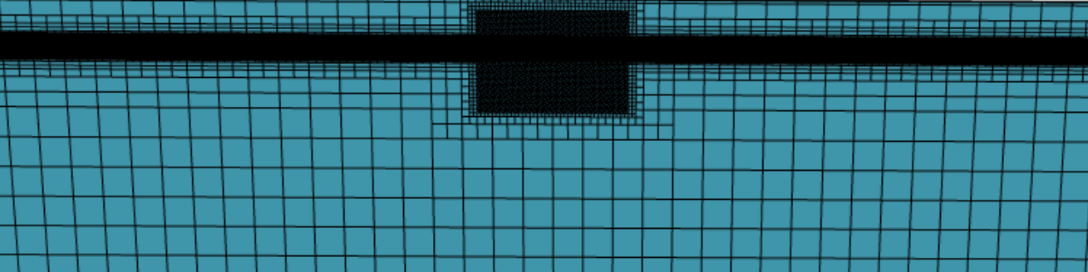
Figure 2. Global mesh distribution of the external computational domain.
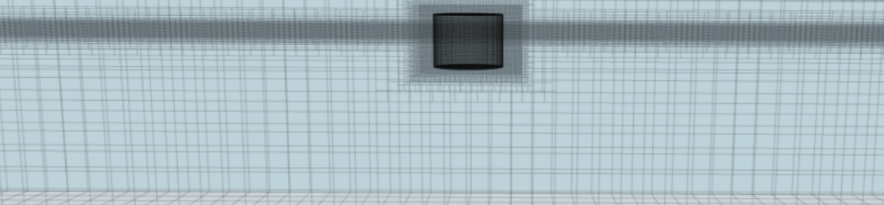
Figure 3. Local mesh refinement around the cylindrical tank and the free-surface region.
Figures 2 and 3 show the mesh distribution of the computational domain. As can be seen, the mesh remains relatively coarse in the far-field region in order to reduce the computational cost, while significant local refinement is introduced near the cylindrical tank and around the free surface. This non-uniform mesh strategy achieves a balance between computational efficiency and numerical accuracy. Figure 4 presents the scalar distribution on the y-plane, where the air and water phases are clearly distinguished. The result confirms that the initial phase distribution and free-surface position were properly defined in the numerical model.

Figure 4. Initial scalar distribution on the y-plane showing the phase interface between air and water.
Overall, the present computational setup provides the basis for simulating the external wave field and its interaction with the partially submerged tank. The combined use of local isotropic refinement near the tank and anisotropic refinement near the free surface ensures that both the body-induced flow disturbance and the wave evolution can be resolved effectively.

6. Internal Flow Field Simulation
To investigate the sloshing behavior of the internal liquid, a separate three-dimensional numerical model was established for the tank equipped with an internal elliptical baffle. As shown in Fig. 5, the tank was cylindrical with a radius of 1 m. An elliptical baffle was arranged inside the tank, with the major and minor axes of the opening equal to 0.5 m and 0.3 m, respectively. In this part of the study, no external flow field was considered, and only the internal liquid motion under prescribed horizontal excitation was analyzed.
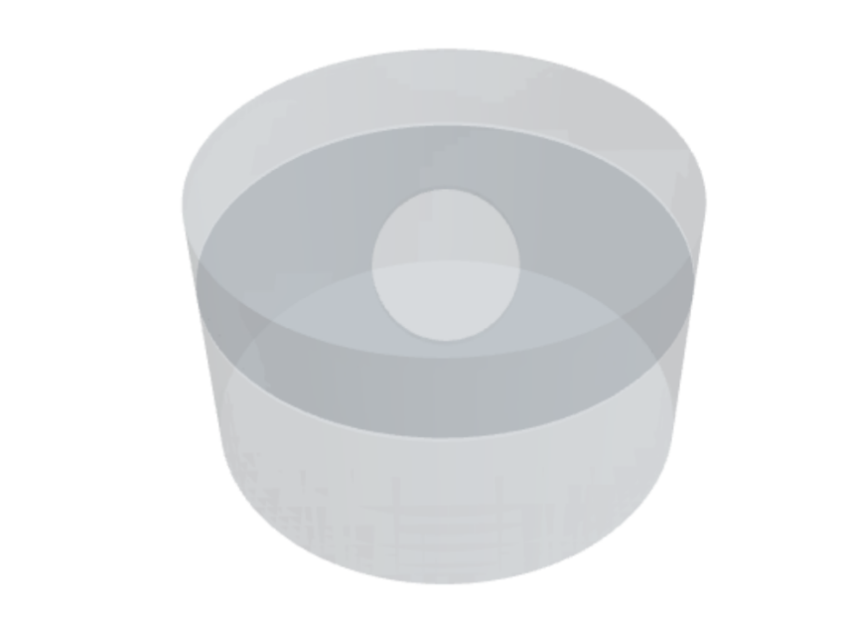
Figure 5. Geometric model of the cylindrical tank equipped with an internal elliptical baffle.
The tank was filled with water, and the free-surface motion was simulated using the VOF method. In order to resolve the liquid motion with sufficient accuracy, the basic mesh size of the internal computational domain was set to 0.2 m. Since the free-surface evolution plays a key role in sloshing dynamics, local anisotropic refinement was introduced near the water surface. The refinement ratios in the y and z-directions were taken as 25%, 30%, and 3.125% of the background mesh size, respectively. This treatment significantly improved the vertical resolution near the interface and helped capture the transient deformation of the free surface more effectively. Figures 6 and 7 show the mesh distribution of the internal domain, where it can be seen that the mesh is refined near the free surface and around the baffle region, while a relatively coarser mesh is retained in the lower part of the tank to reduce the overall computational cost.
To excite the internal liquid motion, a horizontal harmonic excitation was imposed on the tank. In order to avoid a sudden start and reduce nonphysical numerical oscillations, a smooth ramp function was adopted at the initial stage of motion. The excitation was defined as:
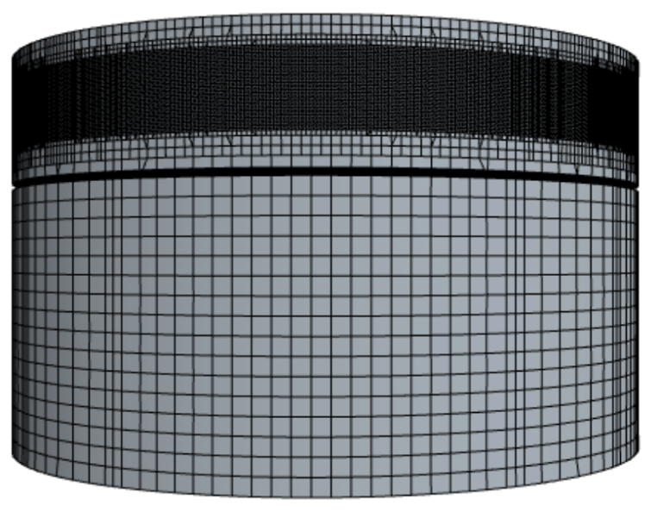
Figure 6. Local mesh distribution in the internal flow domain.
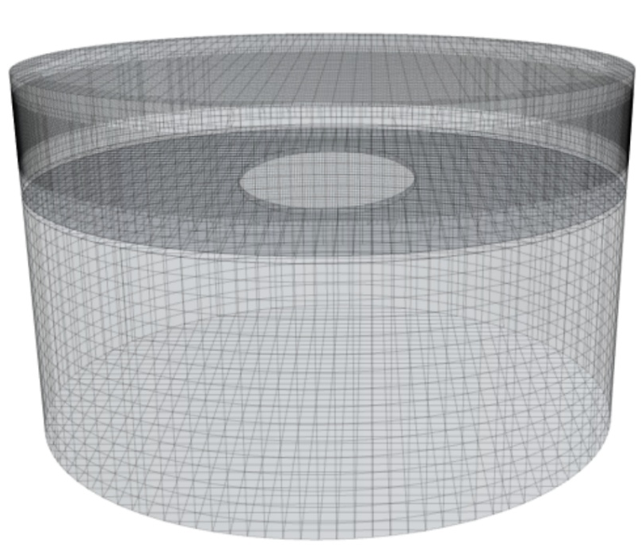
Figure 7. Overall mesh of the baffled tank with free-surface refinement.
This excitation form ensures a gradual transition from rest to steady harmonic motion, which is beneficial for obtaining a stable numerical response. Under this horizontal forcing, the internal liquid undergoes free-surface oscillation and interacts with the elliptical baffle, leading to a characteristic sloshing response inside the tank.
Figure 8 presents the scalar distribution on a representative section, where the air–water interface inside the tank can be clearly identified. The result indicates that the free surface evolves continuously under the imposed excitation and is evidently influenced by the presence of the internal baffle. Figure 9 shows the time history of the internal wave height. It can be seen that the wave amplitude increases gradually during the initial stage and then develops into an approximately periodic oscillatory response. This reflects the progressive establishment of the sloshing motion under horizontal excitation. The growth of the early-stage response is mainly associated with the ramped excitation, while the subsequent regular oscillation indicates that the internal flow gradually reaches a stable dynamic state.
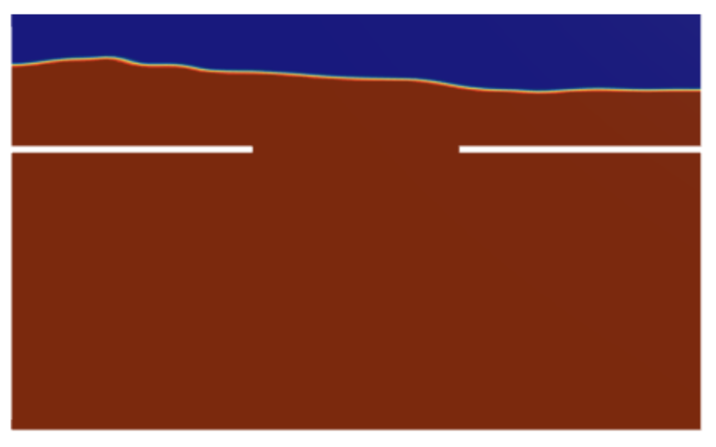
Figure 8. Scalar distribution on a representative section showing the internal air–water interface.
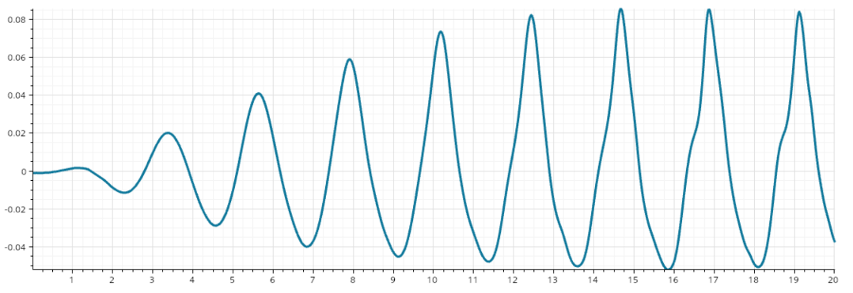
Figure 9. Time history of the internal wave height under horizontal harmonic excitation.
The internal free surface exhibits a clear periodic response under the imposed excitation. The maximum wave height reaches approximately 0.08 m, and the oscillation gradually approaches a steady-state pattern after about 14 s.
Overall, the present internal-flow model provides the basis for analyzing the sloshing characteristics of the liquid in a baffled cylindrical tank under horizontal harmonic excitation. The combined use of local free-surface refinement and smooth excitation loading allows the internal wave evolution to be captured with sufficient stability and accuracy.

7. Internal–External Coupled Flow Simulation
To further investigate the interaction between the external wave field and the internal liquid motion, a three-dimensional internal–external coupled numerical model was established in STAR-CCM+. As shown in Fig. 10, the cylindrical tank was placed in a rectangular numerical wave flume, and both the outer and inner fluids were treated as water. The tank radius was 1 m and the draft was 2 m. The coupled model was designed to simultaneously resolve the wave propagation in the outer domain and the sloshing response inside the tank, thereby providing a direct description of the hydrodynamic interaction between the two fluid regions.

Figure 10. Geometric model of the internal–external coupled flow system.
The dimensions of the external computational domain were defined by a rectangular box extending from (−50,−2,−5) to (50,2,5). Within this wave tank, the cylindrical liquid container was located near the central region of the domain. A first-order VOF wave model was employed to generate the external wave field, and the fluid was assumed to be inviscid in order to focus on the essential free-surface dynamics of the coupled system. The incident wave amplitude was set to 0.01 m. Under wave excitation, the tank was subjected to hydrodynamic disturbance from the surrounding fluid, while the internal liquid experienced sloshing motion induced by the coupled interaction.
To achieve a suitable balance between numerical accuracy and computational efficiency, local mesh refinement was introduced in the key regions of the model. A tank-centered refinement zone was specified within the rectangular region from (−2,−2,−2) to (5,2,2). In this region, isotropic refinement was adopted, and the cell size was reduced to 10% of that in the background computational domain. This treatment was used to improve the resolution of the local flow details around the tank, including the near-body pressure variation, interface deformation, and flow exchange associated with the coupled motion.
In addition, since the free-surface evolution is one of the most important features in the present problem, a second refinement region was arranged around the still-water level, covering the range from (−50,−2,−0.5) to (50,2,0.5). In this region, anisotropic refinement was applied to enhance the resolution near the air–water interface without excessively increasing the total cell number. The directional scaling factors were taken as 25% in the x-direction, 30% in the y-direction, and 3.125% in the z-direction relative to the background mesh size. Such a refinement strategy is particularly effective for wave simulations, because the free-surface profile is much more sensitive to the vertical mesh resolution than to the horizontal one.
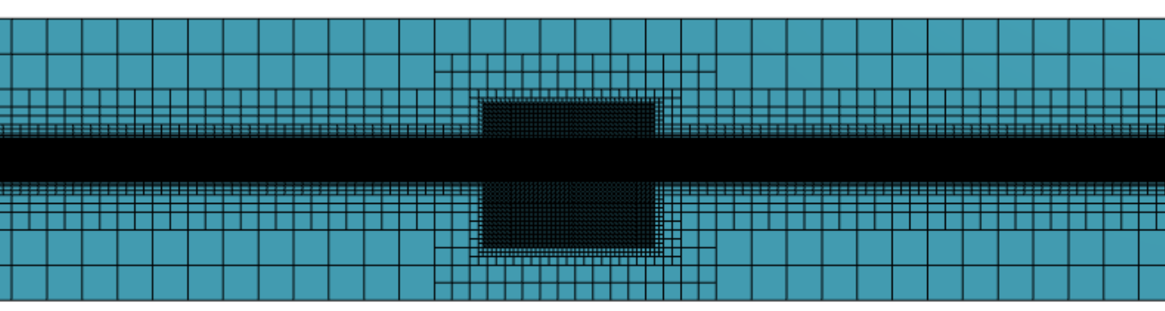
Figure 11. Local mesh refinement around the cylindrical tank and the free-surface region in the coupled domain.
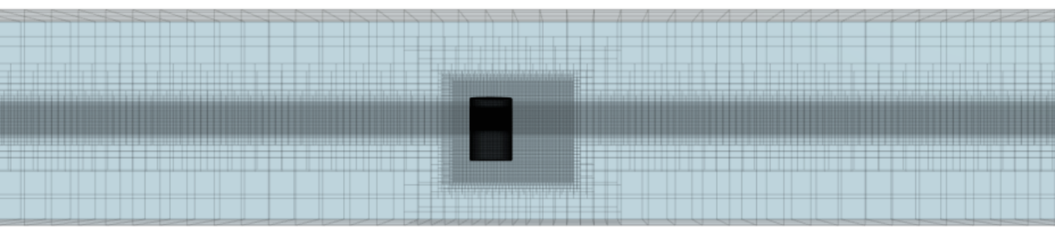
Figure 12. Overall mesh distribution of the internal–external coupled computational domain.
Figures 11 and 12 present the mesh distribution of the coupled computational domain. It can be seen that the mesh is significantly refined in the vicinity of the cylindrical tank and near the free surface, while the far-field region remains relatively coarse. This non-uniform mesh arrangement allows the incident wave propagation and the local coupled response around the tank to be captured simultaneously with reasonable computational cost. Figure 13 shows the scalar distribution on a representative section, where the air and water phases in the external domain are clearly distinguished and the partially submerged tank is properly represented. The result confirms that the initial phase distribution and the geometric configuration of the coupled model were correctly established.

Figure 13. Scalar distribution on a representative section of the coupled model.
Figure 14 shows the time history of the internal wave height in the liquid tank. It can be observed that the internal free surface exhibits an oscillatory response under the action of the external wave field. Compared with the purely internally excited case, the internal wave motion in the coupled model is governed by the external wave forcing transmitted through the tank–fluid interaction. The wave-height curve indicates that the internal sloshing response is continuously affected by the outer wave environment and gradually develops into a characteristic coupled oscillation pattern. This demonstrates that the external excitation is effectively transmitted into the internal liquid domain through the coupled hydrodynamic process.
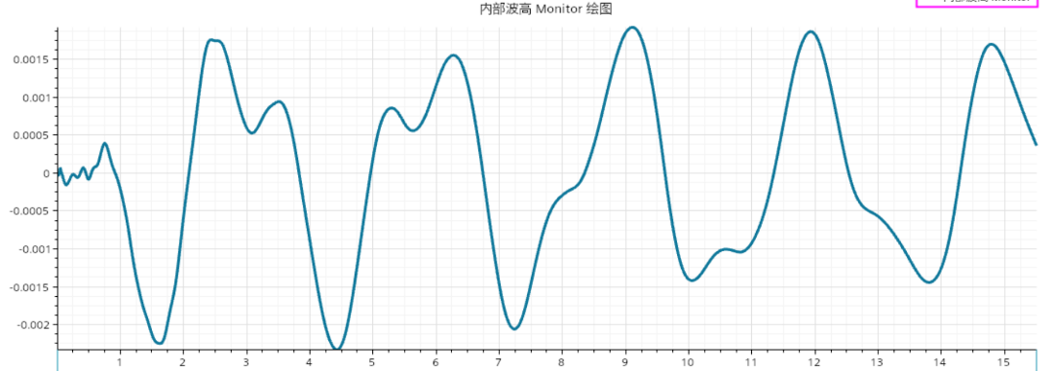
Figure 14. Time history of the internal wave height under external wave excitation.
In the internal–external coupled case, the internal free-surface response does not show an obvious periodic behavior. The peak response is about 0.0015 m, and the time history shows a tendency toward a stable state after approximately 14 s.
Overall, the present internal–external coupled model provides the numerical basis for investigating the interaction between the ambient wave field and the liquid motion inside the tank. By combining local isotropic refinement near the tank with anisotropic refinement near the free surface, the model is able to capture both the external wave propagation and the internal liquid response with sufficient clarity. Therefore, it serves as the foundation for the subsequent analysis of the coupled hydrodynamic characteristics.

8. Conclusion
In this study, a STAR-CCM+–VOF framework was developed to investigate the free-surface behavior of a liquid-containing cylindrical tank under external wave excitation, internal harmonic excitation, and internal–external coupled conditions. Three numerical models, namely the external wave-field model, the internal sloshing model, and the coupled internal–external model, were established within a unified transient multiphase framework. The results demonstrate that the proposed numerical approach can effectively reproduce both the external wave evolution and the internal free-surface response.
For the internally excited baffled tank, the free surface gradually developed into an approximately periodic sloshing response after the initial transient stage, and the maximum wave height reached about 0.08 m under the present simulation condition. This indicates that the internal model can capture the main sloshing characteristics of the liquid in the baffled cylindrical tank and resolve the time-dependent wave-height variation with sufficient clarity.
For the internal–external coupled case, the external wave excitation was successfully transmitted into the internal liquid domain, leading to a much weaker internal free-surface response of about 0.002 m in the present simulation. Compared with the purely internally excited case, the coupled response showed different dynamic characteristics, indicating that the internal liquid motion is strongly influenced by the external-wave-induced hydrodynamic interaction rather than by direct prescribed excitation.
Overall, the present results show that the internal liquid exhibits distinct response features under imposed excitation and external-wave-induced coupled excitation. The developed STAR-CCM+–VOF model therefore provides an effective numerical tool for analyzing wave–sloshing interaction in liquid-containing structures and can serve as a useful basis for future studies under more complex wave conditions and structural configurations.
COMPETING INTERESTS DISCLAIMER:
Authors have declared that they have no known competing financial interests OR non-financial interests OR personal relationships that could have appeared to influence the work reported in this paper.
Disclaimer (Artificial intelligence)
Author(s) hereby declare that NO generative AI technologies such as Large Language Models (ChatGPT, COPILOT, etc.) and text-to-image generators have been used during the writing or editing of this manuscript.

References
Ibrahim, R. A., Pilipchuk, V. N., & Ikeda, T. (2001). Recent advances in liquid sloshing dynamics. Appl. Mech. Rev., 54(2), 133–199. http://dx.doi.org/10.1115/1.3097293
Faltinsen, O. M., & Timokha, A. N. (2009). Sloshing. Cambridge: Cambridge University Press.
Xue, M. A., He, Y., Yuan, X., Cao, Z., & Odoom, J. K. (2023). Numerical and experimental study on sloshing damping effects of the porous baffle. Ocean Eng., 285, 115363. https://doi.org/10.1016/j.oceaneng.2023.115363
Zhang, Z., Wu, Q., Xie, Y., & Yu, H. (2023). Experimental and numerical investigations on the liquid tank sloshing in regular waves. Ocean Eng., 271, 113668. https://doi.org/10.1016/j.oceaneng.2023.113668
Poguluri, S. K., & Cho, I.-H. (2023). Effect of vertical porous baffle on sloshing mitigation of two-layered liquid in a swaying tank. Ocean Eng., 289, 115952. https://doi.org/10.1016/j.oceaneng.2023.115952
George, A., & Cho, I.-H. (2022). Optimal design of vertical porous baffle in a swaying oscillating rectangular tank using a machine learning model. Ocean Eng., 244, 110408. https://doi.org/10.1016/j.oceaneng.2021.110408
Cho, I.-H. (2021). Liquid sloshing in a swaying/rolling rectangular tank with a flexible porous elastic baffle. Marine Structures, 75, 102865. https://doi.org/10.1016/j.marstruc.2020.102865
Saghi, H., Ning, D., Pan, S., & Saghi, R. (2022). Optimization of a dual-baffled rectangular tank against the sloshing phenomenon. J. Mar. Sci. Appl., 21(1), 116–127. https://doi.org/10.1007/s11804-022-00257-y
Yu, X., Wu, Y., Wang, Q., & Li, Q. (2025). Sloshing in tanks with an internal horizontal perforated plate based on an immersed-boundary generalized harmonic polynomial cell method. Phys. Fluids, 37(2), 027118. https://doi.org/10.1063/5.0252935
Hirt, C. W., & Nichols, B. D. (1981). Volume of fluid (VOF) method for the dynamics of free boundaries. J. Comput. Phys., 39(1), 201–225. http://dx.doi.org/10.1016/0021-9991(81)90145-5
Windt, C., Davidson, J., Schmitt, P., & Ringwood, J. V. (2019). On the assessment of numerical wave makers in CFD simulations. J. Mar. Sci. Eng., 7(2), 47. http://doi.org/10.3390/jmse7020047
Li, Z., Deng, B., Lin, Z., Sun, Z., & Wang, J. (2019). Comparison of wave modeling methods in CFD solvers for ocean engineering applications. Ocean Eng., 188, 106237. https://doi.org/10.1016/j.oceaneng.2019.106237
Jiang, S. C., & Bai, W. (2020). Coupling analysis for sway motion box with internal liquid sloshing under wave actions. Phys. Fluids, 32(7), 072106. https://doi.org/10.1063/5.0015058
Zhuang, Y., & Wan, D. (2019). Numerical study on ship motion fully coupled with LNG tank sloshing in CFD method. Int. J. Comput. Methods, 16(6), 1840022. https://doi.org/10.1142/S0219876218400224
He, T., Feng, D., Liu, L., Wang, X., & Jiang, H. (2022). CFD simulation and experimental study on coupled motion response of ship with tank in beam waves. J. Mar. Sci. Eng., 10(1), 113. https://doi.org/10.3390/jmse10010113
Lyu, W., el Moctar, O., & Schellin, T. E. (2022). Ship motion-sloshing interaction with forward speed in oblique waves. Ocean Eng., 250, 110999. https://doi.org/10.1016/j.oceaneng.2022.110999
Zhu, Z., Lee, J., Kim, Y., Lee, J.-H., & Park, T.-H. (2021). Experimental measurement and numerical validation of sloshing effects on resistance increase in head waves. Ocean Eng., 234, 109321. https://doi.org/10.1016/j.oceaneng.2021.109321
Wang, Z.-H., Jiang, S.-C., & Geng, B.-L. (2024). Coupling analysis of liquid sloshing and box sway motion under irregular wave actions. Ocean Eng., 291, 116451. https://doi.org/10.1016/j.oceaneng.2023.116451
Jiao, J., Ding, S., Zhao, M., Jiang, M., Bu, S., & Shi, Y. (2024). Simulation of LNG ship's motions coupled with tank sloshing in regular waves by DualSPHysics. Ocean Eng., 312, 119148. https://doi.org/10.1016/j.oceaneng.2024.119148
Chen, Z., Gao, Y., Liao, X., Zhao, W., & Guo, D. (2024). Numerical analysis of coupling effect between sloshing and motion responses of a KCS in uni- and bi-directional waves. Ocean Eng., 313, 119592. https://doi.org/10.1016/j.oceaneng.2024.119592
Jiao, J., Zhao, M., Jia, G., & Ding, S. (2024). SPH simulation of two side-by-side LNG ships’ motions coupled with tank sloshing in regular waves. Ocean Eng., 297, 117022. https://doi.org/10.1016/j.oceaneng.2024.117022
Dong, Y.-J., Wang, S., & Dong, G.-H. (2025). Numerical investigation of sloshing flow interaction with porous baffles in a 2D rectangular tank. Ocean Eng., 327, 120904. https://doi.org/10.1016/j.oceaneng.2025.120904
‌

