Pediatric Primary Parotid Tuberculosis: Case Report and Literature Review

Abstract
Tuberculosis (TB) is an airborne infection disease, caused by Mycobacterium tuberculosis or Mycobacterium bovis considered among the leading causes of mortality in India. The present case describes a rare case of primary parotid gland tuberculosis in a 12-year-old child, and highlights the diagnostic challenges associated with this condition. A 12-year-old child with no significant medical history presented with a progressively enlarging, painless swelling of the right parotid region. Physical examination revealed a soft, mobile mass measuring approximately 3 cm, with no facial nerve involvement or intraoral purulent discharge. MRI suggested a cystic lesion, initially favouring a pleomorphic adenoma. Laboratory investigations were normal except for a mildly elevated erythrocyte sedimentation rate. The patient underwent a conservative parotidectomy, and histopathological analysis of the specimen revealed epithelioid and giant cell granulomas with caseous necrosis, confirming tuberculosis. Antituberculous therapy was administered for 6 months. Parotid tuberculosis is extremely rare, especially in children, and may mimic benign or malignant parotid tumours. Clinical, radiological, and biological findings are often nonspecific, making the diagnosis challenging. Fine-needle aspiration cytology and PCR-based methods can aid diagnosis and reduce unnecessary surgery, but histopathology remains the gold standard. Management is primarily medical, with prolonged antituberculous therapy leading to favourable outcomes. Although exceptionally rare in children, primary parotid tuberculosis should be considered in the differential diagnosis of parotid masses, particularly in endemic regions. It is recommended that early recognition and appropriate medical management can prevent unnecessary surgery and ensure rapid recovery.
Key Words: Tuberculosis, Parotid tuberculosis, Medical management, Antituberculous therapy.

Introduction
Tuberculosis (TB) is a chronic granulomatous infection caused by Mycobacterium tuberculosis or Mycobacterium bovis and may involve any organ. TB is an airborne infection disease, considered among the leading causes of mortality in India, which is transmitted by means of invisible droplet nuclei containing the organisms that have left the reservoir during breathing, sneezing or coughing, of which this organism may remain air borne upto 6hours [8,11]. Various risk factors predispose individuals to TB infection and disease progression. Immunocompromised conditions, such as HIV/AIDS, malnutrition, and diabetes, significantly increase susceptibility to TB. Additionally, socioeconomic determinants such as poverty, homelessness, and inadequate access to health care contribute to the burden of TB, particularly in vulnerable populations [9]. The incubation period of TB varies; it takes two to ten weeks after exposure to infection before clinical manifestation for a small proportion of newly infected persons [10,12].
Within the field of otorhinolaryngology, lymph node involvement represents the most frequent manifestation of tuberculosis. In contrast, isolated tuberculosis of the salivary glands—particularly of the parotid gland—is exceedingly uncommon [1,2], even in regions with a high endemic burden of tuberculosis, such as Morocco. Paediatric cases are especially rare, with only a limited number of reports documented in the available literature, underscoring the exceptional nature of this presentation in children.
The clinical features of parotid tuberculosis are heterogeneous and largely non-specific, often mimicking other inflammatory or neoplastic conditions of the salivary glands. This polymorphic presentation poses significant diagnostic challenges and may result in delayed recognition or misdiagnosis. Through the presentation of a case involving parotid tuberculosis in a 12-year-old child, accompanied by a comprehensive review of the relevant literature, the authors seek to elucidate the key diagnostic considerations, therapeutic strategies, and prognostic implications associated with this rare entity. By doing so, they aim to contribute to improved clinical awareness and more timely management of this unusual manifestation of tuberculosis in the paediatric population.
Case report
A 12-year-old child with no significant past medical history presented to our department with a right parotid swelling that had been evolving for approximately three months, with a progressive increase in size. There were no associated clinical signs, particularly no pain, fever, weight loss, chewing discomfort, trismus, or intraoral purulent discharge.
The child was in good general condition and presented with a soft, mobile, painless swelling of the right parotid region at its inferior pole, measuring approximately 3 cm in its longest axis. There was no limitation of mouth opening and no peripheral facial nerve palsy.

Clinical examination of the oral cavity, including inspection of the opening of Stensen’s duct, demonstrated no evidence of local inflammation or purulent discharge. Palpation and assessment of the cervical lymph node regions revealed no lymphadenopathy. Furthermore, the remainder of the otorhinolaryngological and general physical examinations was within normal limits, with no additional abnormalities detected.
Magnetic resonance imaging (MRI) revealed a well-defined oval solid–cystic lesion with regular margins. The solid component showed intermediate signal intensity on T1- and T2-weighted images with intermediate ADC values and heterogeneous enhancement after gadolinium injection, following a type A enhancement curve. The cystic, septated component with thin septa showed fluid signal intensity with diffusion hypointensity and elevated ADC values. (Figures 1 and 2)
These imaging findings were suggestive of a pleomorphic adenoma.

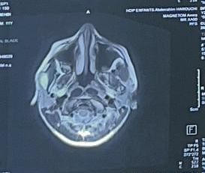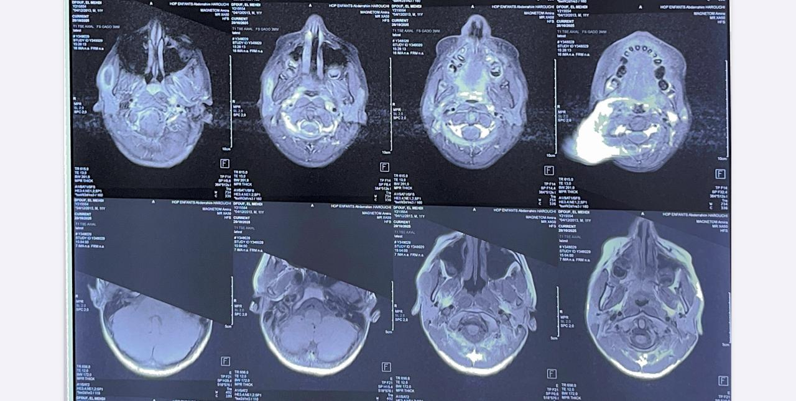
FIGURE 1: MRI PAROTID T2 FIGURE 2 : MRI PAROTID T1

Laboratory investigations were normal, except for a slightly elevated erythrocyte sedimentation rate (55 mm in the first hour), as well as the chest radiograph.
The patient subsequently underwent surgical management consisting of a conservative parotidectomy, with meticulous preservation of the facial nerve. Histopathological analysis of the excised cyst wall demonstrated granulomatous inflammation characterised by epithelioid cell aggregates and multinucleated giant cells, centred around areas of caseous necrosis (Figure 3). These findings were consistent with a tuberculous aetiology. 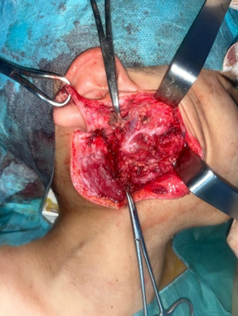
FIGURE 3: Intraoperative image of superficial parotidectomy

The patient was commenced on standard antituberculous chemotherapy, comprising a two-month intensive phase with rifampicin, isoniazid, ethambutol, and pyrazinamide, followed by a four-month continuation phase with rifampicin and isoniazid. The treatment was well tolerated, and the clinical course was favourable. No evidence of local recurrence or systemic involvement was observed during a follow-up period of six months, indicating a satisfactory therapeutic response.

Discussion
First described in 1894 by von Stubenrauch, parotid tuberculosis is rare, with approximately 200 cases reported in the literature since that time. More than 90% of reported cases occur in developing countries [3]. It most commonly affects young adults between 20 and 40 years of age, with children being very rarely affected [1].
Parenchymal parotid involvement most often occurs in the setting of disseminated tuberculosis, with spread via hematogenous or lymphatic routes from a pulmonary focus, but it may also be isolated, as in our patient, thereby posing a differential diagnostic challenge with parotid gland tumours. In such cases, Mycobacterium localised in the oropharynx may spread retrogradely through Stensen’s duct. This entity must be distinguished from tuberculosis of intraparotid lymph nodes, which is far more common.
From a clinical perspective, parotid tuberculosis most commonly manifests as a unilateral, gradually enlarging swelling of the parotid region. The lesion may present in either a diffuse or nodular form, often giving rise to a pseudotumoural presentation that can closely resemble neoplastic pathology. Although facial nerve palsy, localised pain, and trismus may occasionally be encountered, these features are more frequently associated with malignant processes and should therefore prompt careful differential diagnostic consideration.

In contrast, the development of a cutaneous fistula is strongly indicative of an underlying inflammatory aetiology. Constitutional symptoms classically associated with tuberculosis—such as fever, weight loss, and night sweats—are infrequently observed in cases of isolated parotid involvement. Nevertheless, their presence should be actively investigated, as they may provide important diagnostic clues. Similarly, the patient’s geographical origin and epidemiological background constitute relevant elements in orienting the diagnostic approach, particularly in individuals originating from regions with a high prevalence of tuberculosis [3,4]. Radiological findings on ultrasound, CT, and MRI generally do not allow a definitive diagnosis. Various and nonspecific appearances may be observed, including parotid tissue nodules, diffuse sialadenitis, cystic or fluid-containing lesions, sometimes associated with intraparotid or jugulocarotid lymphadenopathy. Sialography is not specific, nor are technetium-99m or gallium-67 scintigraphy. A chest radiograph should always be performed to search for a potential primary focus. Biologically, an inflammatory syndrome is usually present, and the tuberculin skin test is not consistently positive [2,6].
Accordingly, no single clinical, radiological, or biological parameter is sufficient, in isolation, to establish a definitive diagnosis of parotid tuberculosis. The condition therefore poses a significant diagnostic challenge. In its diffuse form, the principal differential diagnoses include lithiasic parotitis and parotid carcinoma, whereas localised presentations more commonly evoke the possibility of a cystic lesion, adenitis, or pleomorphic adenoma [4]. The clinician’s primary difficulty lies in reaching an accurate diagnosis prior to surgical exploration and subsequent histopathological assessment of the parotidectomy specimen. This challenge is particularly pronounced in paediatric patients, in whom the condition is exceptional and consequently seldom suspected at the initial stage of evaluation.

Fine-needle aspiration cytology (FNAC), combined with microbiological culture of the aspirated material, may contribute to the diagnostic work-up; however, its utility is largely dependent on obtaining a positive result. Reported diagnostic performance indicates a specificity of approximately 81% and a sensitivity of 94% [6]. In recent years, most authors have advocated the use of molecular diagnostic techniques, notably polymerase chain reaction (PCR)-based gene amplification following culture of glandular cellular material, in order to enhance diagnostic accuracy and yield [7]. Some clinicians also propose a therapeutic trial of antituberculous chemotherapy in cases where clinical suspicion is strong [3,5]. Nevertheless, in a proportion of cases, definitive confirmation is achieved only through histopathological examination of a satellite lymph node or the parotidectomy specimen itself, demonstrating the characteristic epithelioid and multinucleated giant-cell granulomas with central caseous necrosis [4,6]. Management of parotid tuberculosis is predominantly medical. Historically, exofacial parotidectomy was advocated both as a diagnostic procedure and with the intention of enhancing the penetration of antituberculous agents into the glandular tissue. However, this surgical approach has largely been abandoned by most authors owing to its considerable morbidity, particularly the risk of facial nerve injury, and the well-established efficacy of exclusive medical therapy.

Current management is based on prolonged antituberculous chemotherapy, generally administered for a duration of six to nine months. This regimen has been shown to result in progressive and often rapid regression of the parotid swelling, with favourable clinical outcomes in the majority of cases [3,6,7].
Conclusion
The study revealed that the child received antituberculous therapy consisting of an initial 2-month intensive phase with rifampicin, isoniazid, ethambutol, and pyrazinamide, followed by a 4-month continuation phase with rifampicin and isoniazid. The outcome was favourable, with no recurrence observed after a 6-month follow-up period. Although exceptionally rare in children, primary parotid tuberculosis should be considered in the differential diagnosis of parotid masses, particularly in endemic regions. Early recognition and appropriate medical management can prevent unnecessary surgery and ensure rapid recovery.
Consent
As per international standards, parental written consent has been collected and preserved by the author(s).

Disclaimer (Artificial intelligence)

Author(s) hereby declare that NO generative AI technologies such as Large Language Models (ChatGPT, COPILOT, etc.) and text-to-image generators have been used during the writing or editing of this manuscript.

Références
1] Chatterjee A, Varman M, Quinlan TW. Parotid abscess caused by Myco bacterium tuberculosis. Pediatr Infect Dis J 2001;20:912–4.
[2] Kim YH, Jeong WJ, Jung KY, et al. Diagnosis of major salivary gland tuberculosis: experience of eight cases and review of the literature. Acta Otolaryngol 2005;125:1318–22.
[3] Suleiman AM. Tuberculous parotitis: report of three cases. Br J Oral Maxillofac Surg 2001;39:320–3.
[4] Raji A, Mahtar M, Essaadi M, et al. La tuberculose parotidienne. À propos de 6 cas. Med Mal Infect 2002;32:196–7.
5] Sethi A, Sareen D, Sabherwal A, et al. Primary parotid tuberculosis: varied clinical presentations. Oral Dis 2006;12:213–5.
[6] Handa U, Kumar S, Punia RS, et al. Tuberculous parotitis: a series of five cases diagnosed on fine needle aspiration cytology. J Laryngol Otol 2001; 115:235–7.
[7] Kontopoulou T, Fanourgiakis P, Samarkos M, et al. Tuberculosis of the parotid gland: case report and literature review. Med Mal Infect 2004;34: 488–90
[8] Vidyadevi, B., Veena, B., Chandrakantsing, P., & Ingle, P. (2021). An Overview on Tuberculosis and Worldwide Steps to Combat TB Including Awareness Programme in India. Journal of Pharmaceutical Research International, 33(60A), 956–971. https://doi.org/10.9734/jpri/2021/v33i60A34572
[9] Davidson, G., Davidson, D. U., Okoye, O. K., Mensah, L. S., Ukaegbu, E. C., Agbor, D. B. A., … Uche, C. J. (2024). Overview of Tuberculosis: Causes, Symptoms and Risk Factors. Asian Journal of Research in Infectious Diseases, 15(9), 8–19. https://doi.org/10.9734/ajrid/2024/v15i9370
[10] Olabiyi, O. E., Okiki, P. A., Daramola, G. O., & Edogun, H. A. (2021). Mycobacterium Tuberculosis Control: An Overview. Journal of Advances in Microbiology, 21(3), 63–75. https://doi.org/10.9734/jamb/2021/v21i330337
[11] Wessels, Q., Taylor, A. M., & Correia, J. C. (2019). Anatomical Aspects of Mycobacterium tuberculosis-Associated Destructive Cranial Lesions. International Journal of Medical and Pharmaceutical Case Reports, 11(5), 1–5. https://doi.org/10.9734/ijmpcr/2018/v11i530093
[12] Yayan, J., Franke, K. J., Berger, M., Windisch, W., & Rasche, K. (2024). Early detection of tuberculosis: a systematic review. Pneumonia, 16(1), 11. https://doi.org/10.1186/s41479-024-00133-z

