Characterization of Lowland Rice Farming Systems in The Haut-Sassandra Region, Central Western Côte D’ivoire
ABSTRACT
Background: Rice demand in Côte d’Ivoire exceeds local production, increasing reliance on imports. Lowland rice farming has strong potential but remains underperforming due to constraints and limited system understanding. Aims: This study aimed to contribute to a better understanding of lowland rice farming systems in the Haut-Sassandra region by analyzing farmer’s characteristics, cultivated rice varieties, and technical approaches adopted by rice farmers. Study location and duration: The research was conducted in four localities of the Haut-Sassandra Region (Central Western Côte d'Ivoire), from March to August 2022. Methodology: Surveys were carried out using a random sample of sixty-nine rice farmers per locality. Information was obtained through field interviews. These interviews focused on the types of rice farmers, the different cultivated rice varieties, and the technical approaches adopted by the farmers. The collected data were analyzed using STATISTICA software (version 7.1). Results: The surveyed producers were of diverse origins, with a significant presence of non-native farmers (56.43%). The study revealed a low level of female participation in lowland rice farming (7.53%) and a high rate of illiterate farmers (87%). A total of 22 rice varieties were identified, including nine (9) local varieties, three (3) introduced varieties, and 10 improved varieties. They were cultivated using six (6) different farming practices, the most common of which was no-till farming, followed by hill sowing. The distribution of varieties according to farming practices allowed for the definition of four (4) groups. Thus, each variety was associated with one or more farming practices. Wita 9 variety was the most widely cultivated and proved to be the most profitable (4.25 t/ha). Conclusion: Characterizing lowland rice farming systems is crucial for the sustainable improvement of local production. Experimental studies are recommended for each rice variety to determine the exact yield per hectare and the appropriate cultivation practices.
Keywords: Rice, farming practices, typology, Haut-Sassandra region, Côte d’Ivoire.

1. INTRODUCTION
In Côte d’Ivoire, rice is the largest food expense for households, ahead of tubers and protein. Rice cultivation represents 26% of the country’s food production, 57% of the land sown with cereals, and 17% of agricultural employment (Agency for the Development of the Rice Sector, 2022). However, rice production does not meet national needs for milled rice. In fact, in 2023, the rate of national production meeting needs was only 45%, with 1,080,000 tons of milled rice produced. Furthermore, it is noted that national rice production declined considerably from 2014 to 2023 (Food and Agriculture Organization of the United Nations (FAO, 2024). Conversely, imports have increased considerably, rising from 919,000 tonnes in 2019 to 1,600,000 tonnes of milled rice at a cost of over $722 million in 2023 (FAO, 2024).
Faced with this situation, promoting different rice farming systems is a major challenge for increasing national rice production. Among these systems, lowland rice farming stands out as one of the most promising thanks to favorable agro-ecological conditions, particularly the relative availability of water and the fertility of hydromorphic soils. In Côte d'Ivoire, and more specifically in the Haut-Sassandra region in the central-west of the country, lowland areas constitute vast agricultural spaces widely used by rural communities for rice cultivation (National Agency for Rural Development Support, 2014).
Although the Haut-Sassandra region has strong agricultural potential, the performance of lowland rice farming in the region remains below its potential. This situation can be explained by numerous factors, such as the diversity of producers, the heterogeneity of cultivated varieties, and the variability of used agricultural practices. Furthermore, rice production systems remain poorly documented in this area, which limits the understanding of production processes and the identification of the main constraints affecting productivity.
Several scientific studies have highlighted the importance of lowland rice cultivation in West African agricultural systems. According to various studies, lowland areas represent favorable environments for rice production. These environments offer opportunities for agricultural intensification, leading to improved farm productivity (AfricaRice, 2013; Mendez del Villar & Bauer, 2013). Furthermore, several studies emphasise that improving rice productivity depends on a better understanding of production systems, particularly through the analysis of interactions between economic factors, agroecological conditions, and the agricultural practices implemented by farmers (International Rice Research Institute, 2015; FAO, 2017).
This study aims to contribute to a better understanding of lowland rice cultivation systems in the Haut-Sassandra region. It proposes to analyze farmer’characteristics, cultivated rice varieties, and technical approaches adopted by rice growers. The results of this study will provide a better understanding of the functioning of lowland rice systems in order to propose suitable solutions for the sustainable improvement of production.
2. MATERIALS AND METHODS
2.1 Study Area
The Haut-Sassandra region is located in the central Western Côte d'Ivoire and covers an area of 15,205 km², with Daloa as its capital. The study was conducted in the localities of Daloa, Issia, Zoukougbeu, Gonaté, and Vavoua (Fig. 1). These localities represent the major paddy rice production areas in the Haut-Sassandra region, which itself is a region of intensive paddy rice production in Côte d'Ivoire due to the abundance of large areas of developed lowland. The study area has a semi-deciduous humid tropical climate and is characterized by two main seasons of unequal length: a long rainy season from March to October and a long dry season from November to February. The average rainfall is 1300 mm/year with an average annual temperature of 26°C (Airport, Aeronautical and Meteorological Operating and Development Company, 2020).
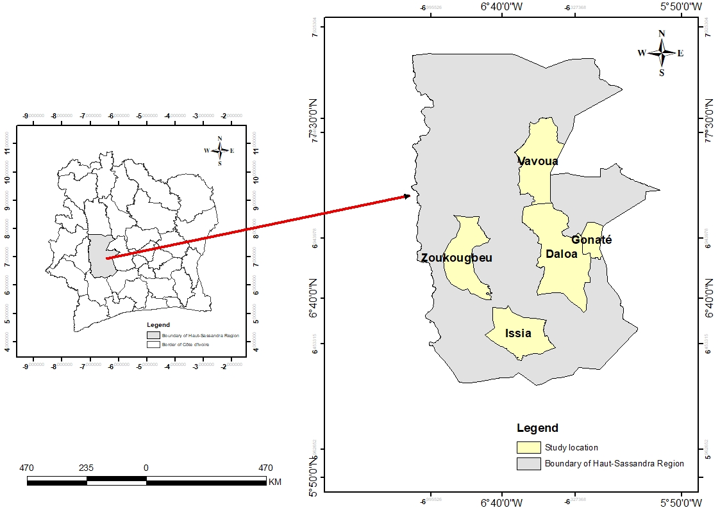
Fig. 1. Location of the study area
2.2 Data Collection and Statistical Analysis
Data were collected through surveys conducted from March to August 2022. A random sample of rice farmers was drawn from an existing database held by the National Agency for Rural Development Support (ANADER) and the Cooperative Society with a Board of Directors of Rice Farmers of Haut-Sassandra (COOP-CA-RI-HS). A total of sixty-nine rice farmers per locality, with lowland rice cultivation as their dominant system, were randomly selected. Information was obtained through field interviews. These interviews focused on two main areas: firstly, identifying parameters and sociodemographic characteristics such as age, education level, origin, and gender; and secondly, the characteristics of the different rice varieties cultivated, the methods and technological innovations related to rice production, labor usage, cultivated areas, inputs, and the quantity of paddy rice produced. To confirm the farmers' responses from the first interview, a second interview was conducted using the same questionnaire and the same farmers. The responses confirmed in the second interview were retained for data analysis.
The collected data were organized using Microsoft Excel (version 2021), and statistical analyses were performed with STATISTICA software (version 7.1). A Correspondence Analysis (CA) was conducted to identify the relationships between cultivation practices and the rice varieties grown. To assess the effect of cultivation practices on rice variety yields, data were subjected to a one-way Analysis of Variance (ANOVA). Fisher's LSD test at a significance level of 5% was used to identify homogeneous groups.
3. RESULTS
3.1 Typology of Rice Producers
A total of 345 rice farmers were interviewed during this study. Non-native farmers from other regions of Côte d'Ivoire represented 56.43%, while non-native farmers from Burkina Faso and Mali represented 23.28%, and indigenous farmers represented 20.29% (Fig. 2). Women were very underrepresented among the interviewed farmers, at 7.53%. The majority of these rice farmers were illiterate (87%), and their ages ranged from 18 to 75 years, with the majority in the 48-55 age bracket (Fig. 3).

Fig. 2. Representativeness of rice farmers according to their origins

Fig. 3. Distribution of rice producers by age groups
3.2 Characterization of Rice Varieties
Surveys conducted among rice producers identified 22 rice varieties, including nine (9) local varieties, three (3) introduced varieties, and 10 improved varieties (Table 1). The local varieties are all cultivated in both rainfed and lowland areas but remain the least widespread among farmers, unlike the introduced variety, Chinois. Chinois and Wita 9 varieties have usage frequencies between 25% and 30%. Bas-fond Rouge and KEAH varieties have usage frequencies between 5% and 10% (Fig. 4).

Table 1. Rice varieties recorded
Origins | Names | Types | Cropping systems
Côte d'Ivoire | Koukouo-gbapê | Local | Mixed
Côte d'Ivoire | Bas-fond rouge | Local | Mixed
Côte d'Ivoire | Maloba | Local | Mixed
Côte d'Ivoire | Motoba | Local | Mixed
Côte d'Ivoire | Tigba-seka | Local | Mixed
Côte d'Ivoire | Yamatoga | Local | Mixed
Côte d'Ivoire | 3 mois | Local | Mixed
Côte d'Ivoire | 5 mois | Local | Mixed
Côte d'Ivoire | Danané | Local | Mixed
Côte d'Ivoire | Bouaké 189; | Improved | Shallows
Côte d'Ivoire | Bouaké amélioré | Improved | Shallows
Côte d'Ivoire | C 15 | Improved | Shallows
Côte d'Ivoire | C 35 Blanc | Improved | Shallows
Côte d'Ivoire | C 35 Rouge | Improved | Shallows
Côte d'Ivoire | KEAH | Improved | Shallows
Côte d'Ivoire | V 10 | Improved | Shallows
Côte d'Ivoire | Tel-gold | Improved | Shallows
Côte d'Ivoire | Wita 4 | Improved | Shallows
Côte d'Ivoire | Wita 9 | Improved | Shallows
Burkina- Faso | Burkina | Introduced | Mixed
Chine | Chinois | Introduced | Pluvial
Thailande | Thailandais | Introduced | Pluvial

Fig. 4. Frequency of use of rice varieties
3.3 Description of local rice varieties of Ivorian origin
The local rice varieties (Table 2) were divided into three cycles: early, medium, and long. They are characterized by long to extra-long, thin grain strands. Overall, these varieties exhibited low field yields (1 to 3.13 t/ha).

Table 2. Characteristics of local rice varieties of Ivorian origin
Varietes | Collection locations | Cycle | grain characteristics | Yield (t/ha)
Koukouo-gbapê | Issia | 2 months (early) | L= 9.1 mm > 7.5 mm (extra-long); L/l = 4.3> 3 (thin) color: white | 1,8
Bas-fond rouge | Issia et Vavoua | 2 months (early) | L= 8.5 mm > 7.5 mm (extra-long); L/l = 4.2> 3 (thin) color: white | 2,34
Maloba | Issia et Vavoua | 2 mois (précoce) | L= 9 mm > 7.5 mm (extra-long); L/l = 2.9 < 3 (average) color: white | 2,51
Tigba-seka | Issia | 3 mois (moyen) | L= 8.1 mm > 7.5 mm (extra-long); L/l = 4.05 > 3 (thin) color: brown | 1
Yamatoga | Issia | 4 mois (moyen) | L= 8.9 mm > 7.5 mm (extra-long); L/l = 4.45 > 3 (thin) color: white | 3.13
3 mois | Issia, Gonaté et Vavoua | 3 mois (moyen) | L= 8 mm > 7.5 mm (extra-long); L/l = 4 > 3 (thin)  color: white | 1,61
5 mois | Gonaté, Zoukougbeu et Vavoua | 5 mois (long) | 6.1< L= 7.1 mm < 7.5 mm (long); L/l = 2.8 < 3 (average) color: white | 1.86

  - Typology of Technical Approaches
Based on tillage and sowing methods, the activities carried out for rice production allowed us to distinguish six cultivation practices:
- Technical approach including tillage and hill sowing (IT1);
- Technical approach including tillage followed by transplanting (IT2);
- Technical approach including tillage followed by broadcast sowing (IT3);
- Technical approach without tillage followed by hill sowing (IT4);
- Technical approach without tillage followed by transplanting (IT5);
- Technical approach without tillage followed by broadcast sowing (IT6).
These different technical approaches were adopted by the rice-growing population in varying proportions (Fig. 5). The IT4 cultivation practice was the most widely used (48.11%), followed by IT5 with 17.10% adoption and IT2 with 13.62% adoption among the rice-growing population.

Fig. 5. Adoption rate of technical itineraries by rice farmers
IT1: Technical itinerary including plowing and sowing in hills; IT2: Technical itinerary including plowing followed by transplanting; IT3: Technical itinerary including plowing followed by broadcast sowing; IT4: Technical itinerary without plowing followed by sowing in hills; IT5: Technical itinerary without plowing followed by transplanting; IT6: Technical itinerary without plowing followed by broadcast sowing.
3.5 Distribution of Rice Varieties According to Farming Techniques
The distribution of the recorded rice varieties according to the farming techniques used by rice farmers is shown in Figure 6. Correspondence Analysis (CA) indicated that axis 1 (74%) explained a greater variation compared to axis 2 (10.58%). The CA revealed four affinity groups. IT2, IT3, and IT5 formed a group to which the varieties w9, tg, K, b189, w4, and C35B were assigned. IT6 formed a group with the rice varieties V10, ba, and C15. IT4 also constituted a group with the rice varieties br, c, ma, mo, T, Ts, kg, d, and y. IT1 was identified as a group for which no rice varieties were found to be typical. But rice varieties such as 3m, 5m and b have been cultivated in all four (4) affinity groups.
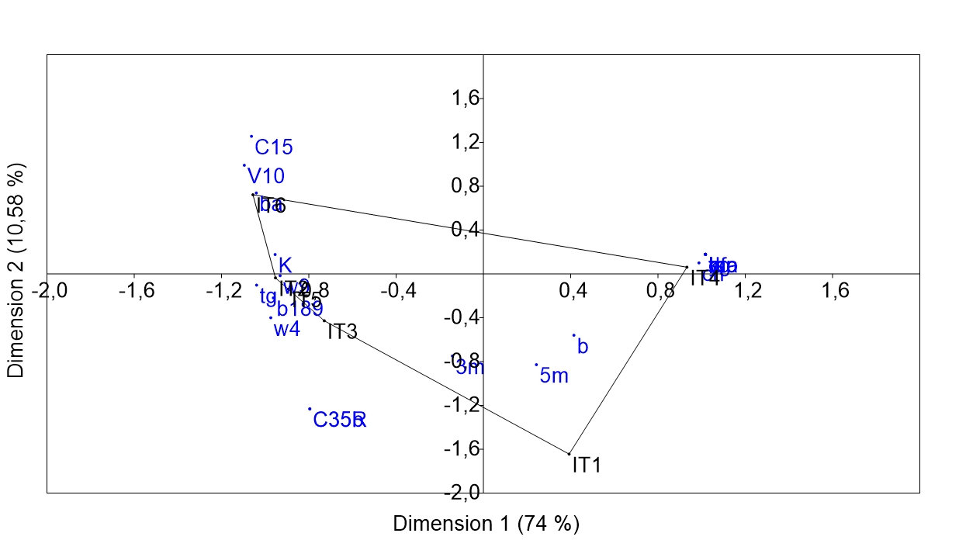
Fig. 6. Correspondence analysis of technical itineraries according to rice varieties
K: KEAH; W9: wita 9; W4: wita 4; tg: tel-gold; b189: bouaké 189; ba: bouaké amélioré; C35R: C35
rouge; C35B: C35 blanc; 3m: 3 mois; 5m: 5 mois; C: chinois; b: burkina; Ts: tigba-séka; ma: maloba;
mo: motoba; br: bas-fond rouge; kg: koukouo-gbapê; T: taïlandais; y: yamatoga; d: danané; IT1: Technical
itinerary including plowing and sowing in hills; IT2: Technical itinerary including plowing followed by
transplanting; IT3: Technical itinerary including plowing followed by broadcast sowing; IT4: Technical
itinerary without plowing followed by sowing in hills; IT5: Technical itinerary without plowing followed
by transplanting; IT6: Technical itinerary without plowing followed by broadcast sowing.
3.6 Effect of Technical Approaches on Rice Variety Yields
The varieties Chinois, Wita 9, and KEAH were the most widely used rice varieties among farmers. However, they were not all cultivated using the same technical approaches. Only the Wita 9 and KEAH varieties were cultivated using IT2, IT3, IT4, IT5, and IT6. The average yields of these two varieties were compared across these five technical approaches (Table 3). Analysis of variance showed that in IT2, there was no significant difference between the yields of the Wita 9 and KEAH varieties. In IT3, the analysis of variance revealed that the yields of the two varieties were statistically identical. In IT4, there was also no significant difference between the yields. Similarly, at IT5, yields were statistically identical. However, the yields of the KEAH and Wita 9 rice varieties obtained in IT6 were significantly different. The KEAH variety recorded the lowest yield (2.25 t/ha), while Wita 9 had the highest yield at 4.25 t/ha.
Table 3. Variation in average paddy rice yields according to technical itineraries
Varieties | Technical itineraries
Varieties | IT2 | IT3 | IT4 | IT5 | IT6
KEAK | 4.9 | 3.3 | 1 | 3.1 | 2.25
Wita 9 | 4.19 | 4.2 | 1.4 | 3.5 | 4.25
F | 181.77 | 73.25 | 16.1 | 102.14 | 151.90
P | 0.38 | 0.15 | 0.58 | 0.58 | 0.001
Mea | NS | NS | NS | NS | S
The averages followed by the same letter are statistically identical (Fisher's LSD test; α = 0,05). IT2: technical itinerary including plowing followed by transplanting; IT3: technical itinerary including plowing followed by broadcast sowing; IT4: technical itinerary without plowing followed by sowing in hills; IT5: technical itinerary without plowing followed by transplanting; IT6: technical itinerary without plowing followed by broadcast sowing; Mea: meaning; NS: not significant; S: significant.

4. DISCUSSION
The survey showed that of the 345 rice farmers, indigenous people represented 20.29%. Non-indigenous people, representing 56.43%, and non-indigenous people, representing 23.28%, are populations from Northern Côte d'Ivoire and neighbouring countries, respectively. These populations cultivate rice as a potential source of income. Indeed, rice farming constitutes their primary activity, generating their sole source of income. According to Koffi & N'Dri (2006), indigenous people produce rice only for their own consumption; this implies that, for them, rice farming is a secondary subsistence activity.
The rate of women's participation in rice farming in the study area was very low (7.53%). According to the FAO (2008), women's participation in rice farming in West Africa is 55%. This FAO figure contradicts our results obtained in the Haut-Sassandra region. However, our results are consistent with those obtained by Coulibaly (2019) in Korhogo, Northern Côte d'Ivoire. Indeed, according to this international organization, only 3% of Ivorian rural women hold land titles to agricultural land in Côte d'Ivoire.
This study identified 22 rice varieties in the Haut-Sassandra region, including 9 local varieties, whereas Mouton & Merny (1957) recorded 18 local varieties in the same area. This decrease in the number of local varieties can be explained by their abandonment in favor of improved varieties. Indeed, these local varieties are low-yielding and therefore not very competitive in a context of self-sufficiency and food security. However, the complete abandonment or even disappearance of these local varieties could pose a danger, such as the loss of disease resistance genes. According to Le Perchec et al. (2001), these varieties, selected since antiquity by farmers lacking means of protection, owe their survival solely to their intrinsic resistance to diseases and pests. They are often better adapted to local climatic and soil conditions. Furthermore, their production requires few resources and does not need massive inputs. These varieties often have an unbeatable taste quality, unlike improved varieties whose production requires maximum resources and is very demanding in terms of inputs.
Six technical itineraries were identified in the Haut-Sassandra region. The Association for the Development of Rice Farming in West Africa (1995) had identified 11 rice farming itineraries across the entire country. It is therefore not surprising that the Haut-Sassandra region alone presents 6 different itineraries. This considerable number of itineraries can also be explained by the diverse origins of the rice farmers and the varying levels of knowledge about rice cultivation in the Haut-Sassandra region. Among these itineraries, IT4 is the most widely used, employed by 166 rice farmers at a rate of 48%. This itinerary is characterized by the elimination of several costly agricultural activities such as plowing, nursery work, transplanting, and herbicide application before transplanting.
Based on the yield results, it was observed that yields are not dependent on either the technical approaches or the varieties. This suggests that it could be a matter of a variety adapting to a technical approach or vice versa. To this end, Correspondence Analysis (CA) performed on the approach-variety pair identified four groups that showed a significant influence on yield. These groups allowed for the identification of affinities between varieties and approaches for achieving the best yield.
The above observation corroborates the results of the analysis of variance performed for the two most productive varieties in each technical approach. Indeed, between IT2 and IT6, the average yields obtained by the KEAH and Wita 9 varieties are higher with IT2. In other words, these two varieties adapt better to IT2.
When considering the technical itineraries (IT2, IT3, IT4, and IT5) in isolation, no significant difference was observed between the yields of the varieties. However, regarding IT6, practiced without plowing, a significant difference was noted between the yields of the varieties. Wita 9 variety proved to be the most productive, with an average of 4.25 t/ha. According to Agreste (2014), no-till farming is a technique that helps protect soils from erosion and improves the organic matter content of the topsoil. Furthermore, the differences observed between varieties and yields are likely due to the variety itself and the chosen itinerary. However, selecting the right variety and itinerary can be challenging. Several parameters, such as seed quality and input use, can influence yield. Regarding seed quality, the choice of varieties unsuited to the growing environment or of defective seeds can have a strong impact on yield and household food security (FAO, 2014).
5. CONCLUSION
Investigations into the characterization of lowland rice farming systems in the Haut-Sassandra region show that producers are of diverse origins, with a strong presence of non-native farmers (56.43%). The study also reveals a low level of female participation in rice farming (7.53%) and a high rate of illiterate farmers (87%). A total of 22 rice varieties were identified, including nine (9) local varieties, (3) introduced varieties, and 10 improved varieties. They are cultivated using six (6) cultivation practices, the most common being no-till, followed by hill planting (IT4). The distribution of varieties according to cultivation practices allowed for the definition of 4 groups. Thus, each variety is suited to one or more cultivation practices. Furthermore, rice crop yield is related to the variety. Among all the varieties, Wita 9 is the most widely cultivated and proves to be the most profitable (4.25 t/ha). Following this work, it is necessary to conduct experimental studies on each rice variety in order to accurately determine the yield per hectare as well as the appropriate technical approach.
Consent
As per international standards or university standards, Participants’ written consent has been collected and preserved by the author(s).
DISCLAIMER (ARTIFICIAL INTELLIGENCE)
The authors hereby declare that no generative AI technology, such as large-scale language models (ChatGPT, COPILOT, etc.) and text-to-image generators have been used during the writing or edditing of this manuscript.
REFERNENCES
- Agency for the Development of the Rice Sector. (2022). National Strategy for the Development of the Rice Sector (NSDR 2.0) 2021-2030, 56 p.
- Food and Agriculture Organization of the United Nations (2024). Statistical directory. https://www.fao.org
- National Agency for Rural Development Support. (2014). Annual Activity Report, 33 p.
- AfricaRice. (2013). Technical guide to rice production in West Africa, 108 p.
- Mendez del Villar, P., & Bauer, J.-M. (2013). West African rice: dynamics, policies and prospects. Cahiers Agricultures, 22(5), 336-344.
- International Rice Research Institute. (2015). Rice Almanac (4th ed.). Los Baños, Philippines, 283 p.
- Food and Agriculture Organization of the United Nations. (2017). Rice Market. Monitor, Decembre 2017 (Vol. XX, No. 4). Rome, Italy https://openknowledge.fao.org/handle/20.500.14283/i8317en
- Airport, Aeronautical and Meteorological Operations and Development Company. (2020). Meteorological data from 2010 to 2020 collected at the Daloa meteorological station. https://sodexam.com/
- Koffi, C. & N’Dri, K. A. (2006). Market and marketing of local rice in the Centre-West region of Côte d'Ivoire. National Center for Agronomic Research. Abidjan, Côte d’Ivoire, 10 p.
- Food and Agriculture Organization of the United Nations. (2008). Overview of agricultural development in Côte d'Ivoire. Division of plant production and plant protection, 9 p.
- Coulibaly, R. (2019). Rice cultivation and women's access to land in the lowlands of the Poro region (Korhogo). African Journal of Social Sciences and Public Health, 5(1), 171-184.
- Mouton, J. & Merny, G. (1957). Rice cultivation in Bété country and rice smut. Rice, rice cultivation, and tropical food crops, 3(2), 51-59.
- Le Perchec, S., Guy, P. & Fracal, A. (2001). Agriculture and plant biodiversity. INRA Environment Files n°21, Paris, 170 p.
- Association Association for the Development of Rice Farming in West Africa. (1995). Rice Production Training. Trainer's Manual. Sayce publishing, United Kingdom, 305 p.
- Agreste. (2014). Structure and means of production. Ministry of Agriculture, Food and Forestry. https://agreste.agriculture.gouv.fr/agreste-web/disaron/ChdAgr237/detail/
- Food and Agriculture Organization of the United Nations. (2014). Suitable seed varieties for small-scale farmers. https://openknowledge.fao.org/handle/20.500.14283/i3768f

