Invisible Threats in Food Systems: Emerging Contaminants, Exposure Pathways and Safety Concerns

ABSTRACT
Emerging contaminants have become a major concern in global food systems due to their increasing detection in agricultural environments, food commodities, and human diets. These contaminants include pharmaceuticals, personal care products, endocrine disrupting chemicals, per- and polyfluoroalkyl substances (PFAS), microplastics, novel pesticides, and transformation products that are not routinely monitored or comprehensively regulated. Advances in high-resolution analytical techniques have revealed their widespread occurrence at trace levels, raising concerns regarding chronic dietary exposure, mixture toxicity, and long-term health effects. This review synthesizes current knowledge on sources, transport pathways, and fate of emerging contaminants in food systems, with particular emphasis on the soil–water–plant–animal–food continuum. Implications for food safety governance, research priorities, and preventive risk management are discussed.
KEYWORDS: Emerging contaminants; food systems; soil–water–plant–animal continuum; dietary exposure; One Health; food safety
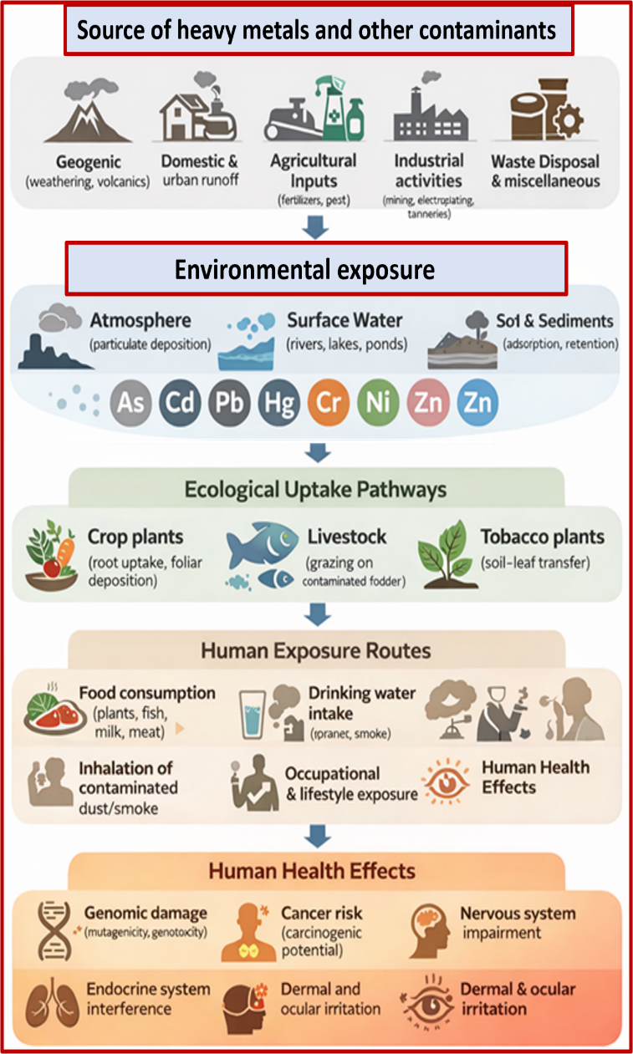
Graphical abstract

1. INTRODUCTION
Food systems are complicated networks that include environmental resources, farming, processing technology, distribution channels, and people eating. In the last few decades, changes in agriculture, industrialization, urbanization, and globalization have had a big effect on these systems. They have made the food supply better, but they have also made contamination risks worse (Käferstein et al., 1997; FAO, 2017).
Table 1. Classification of Major Emerging Contaminants in Food Systems
Contaminant class | Representative compounds | Primary sources | Main food matrices
Pharmaceuticals | Antibiotics, analgesics, antiepileptics | Wastewater, manure | Vegetables, milk, fish
Personal care products | Triclosan, UV filters | Wastewater, packaging | Fish, produce
Endocrine disrupting chemicals | Bisphenols, phthalates | Packaging, biosolids | Processed foods
PFAS | PFOA, PFOS | Industrial emissions, sludge | Milk, meat, crops
Microplastics/nanoplastics | PE, PP, PET particles | Packaging, environment | Seafood, salt
Novel pesticides | New active ingredients | Agriculture | Fruits, cereals
Transformation products | Metabolites, by-products | Soil, water, processing | Multiple foods

Emerging contaminants are defined as chemical, biological, or physical agents that have recently been identified, lack adequate regulation, or are increasingly detected due to advancements in analytical techniques and shifts in production or consumption patterns (Daughton, 2004; Richardson and Ternes, 2018). In food systems, these pollutants are different from other risks because they can be exposed to low doses over a long period of time and are found in complex mixes instead of as single compounds (Kortenkamp et al., 2007; EFSA, 2020). This page provides a synopsis of the principal categories of developing contaminants pertinent to food systems. It lists their main sources and the food matrices that are affected, including important studies and publications from Daughton (2004), Barceló and Gros(2008), and the European Food Safety Authority (EFSA, 2020). (Table 1)
2. DRIVERS OF EMERGING CONTAMINANTS IN FOOD SYSTEMS
Major pathways through which emerging contaminants enter food systems and the relative strength of available scientific evidence is mentioned in Table 2 (Qadir et al., 2010; Muncke et al., 2020; Stahl et al., 2014; Thompson and Darwish, 2019). Emerging contaminates with great concern can be understood by Figure 1.

Table 2. Dominant Pathways of Emerging Contaminants into Food Systems
Entry pathway | Key drivers | Typical contaminants | Evidence strength
Wastewater irrigation | Water scarcity | Pharmaceuticals, antibiotics | High
Biosolid application | Nutrient recycling | PFAS, flame retardants | High
Food packaging | Shelf-life extension | Plasticizers, bisphenols | High
Feed contamination | Intensive livestock systems | Veterinary drugs | Moderate–high
Environmental deposition | Industrial emissions | PFAS, microplastics | Moderate

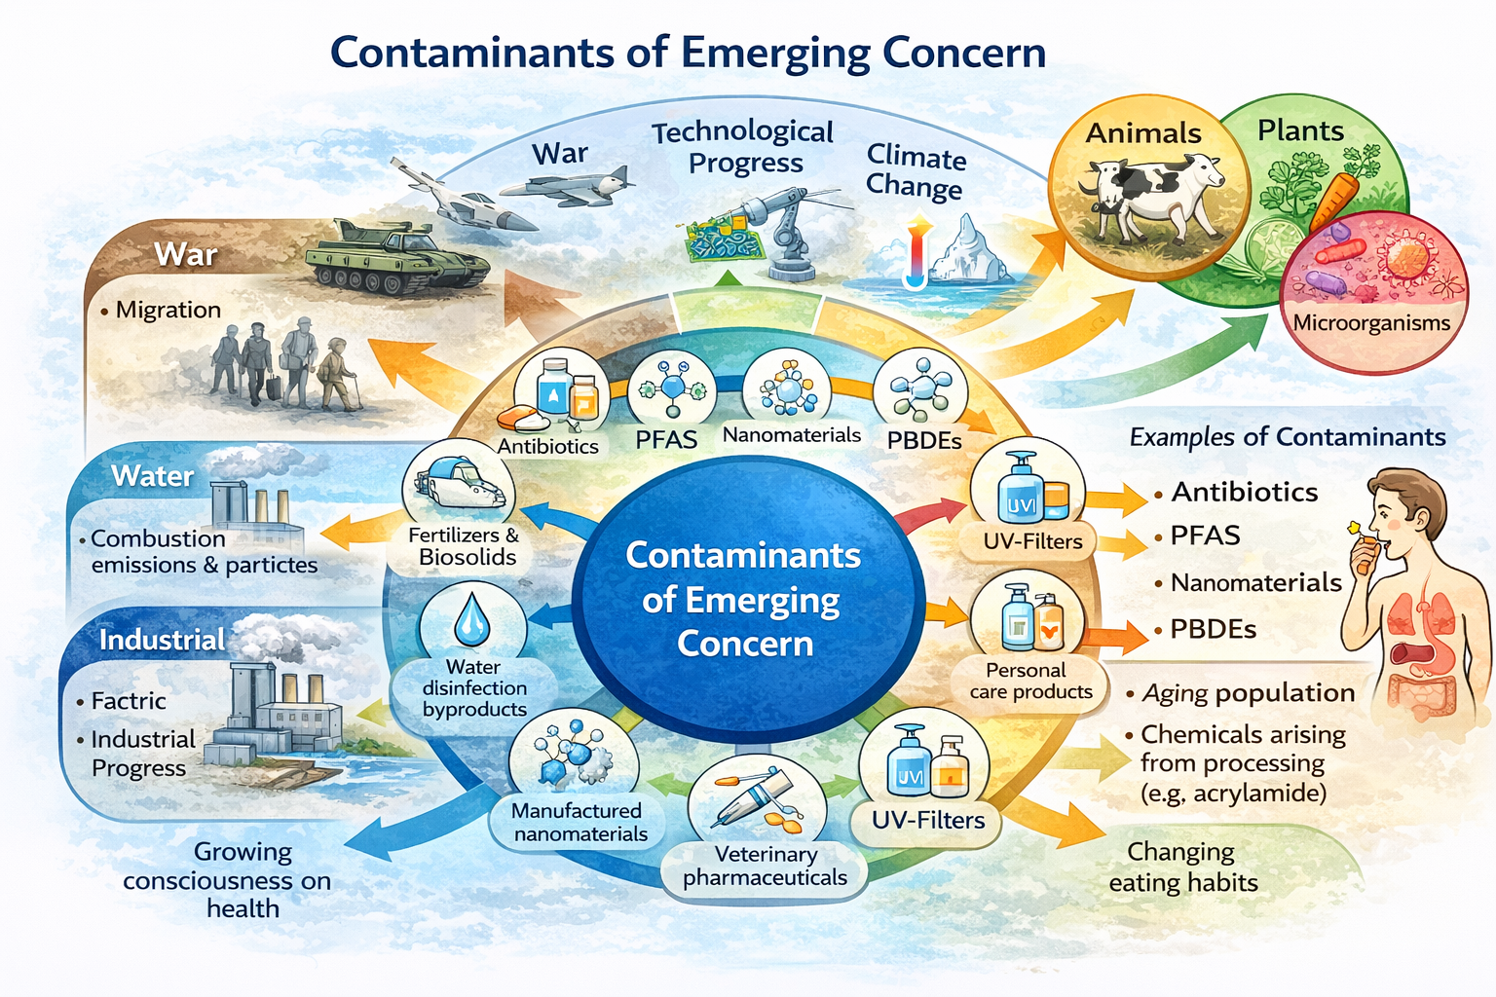
Figure 1: Emerging Contaminants with great Concern
2.1 AGRICULTURAL INTENSIFICATION
To sustain up high levels of output and fulfill the expanding demand for food throughout the world, modern farming uses a lot of chemicals, like pesticides, synthetic fertilizers, veterinary medications, and growth stimulants. They are very useful for enhancing animal health and food production, but they are used too much and often for no good reason, which has produced a lot of health and environmental problems (Kümmerer, 2009; Boxall et al., 2012). Hormones, antibiotics, parasiticides, pain relievers, and feed additives are all types of veterinary drugs. They are made to work in little doses in the body. A lot of the time, they are employed in devices that control more than one animal. Most of the time, animals don't break down these chemicals or get rid of them as waste. This makes the manure and slurry toxic, and they stay that way for a long period (Heberer, 2002; Boxall et al., 2012). (Figure 2)
The number of veterinary medications that are excreted intact varies widely, and these rates can be more than 50% of the dose given, depending on the type of drug and the animal being treated (Wang et al., 2021; Albarano et al., 2024). Manure and slurry, dirty water for irrigation, and the growing tendency of recycling biosolids are the main ways that these wastes get into farmlands and neighbouring waterways. This is because there isn't enough water and there are plans for a circular economy (Pérez-Lucas and Navarro, 2024; Christou et al., 2017). Leaching, surface runoff during rainstorms, and direct effluent from farming and aquaculture activities are other ways that pollutants can get into the water. These make it easier for veterinary drug residues to spread over land and aquatic habitats (Saeed et al., 2024; Ding et al., 2025; Boxall et al., 2003).
When veterinary drugs enter into the soil, they go through a lot of different environmental destiny processes. These include adsorption, disintegration, leaching, and photolysis. The medications' chemical makeup and the soil's qualities all have an effect on these. These actions affect the residues' ability to move, stay put, and have an effect on the environment (Amin et al., 2021; Luo et al., 2014). This has an effect on soil microorganisms, nutrient cycling, and the health of the ecosystem. Advanced reviews have indicated that residues that stay around can affect the diversity of plants and soil, which can put animals on land and in water in danger (Amin et al., 2025; Bacanlı , 2024).
A growing number of controlled and field studies demonstrate that various veterinary drug residues, particularly antibiotics such as tetracyclines, macrolides, and fluoroquinolones, can be absorbed by crop plants from treated soils and translocated to edible tissues, establishing a direct pathway for human exposure via food (van Dongen et al., 2025). Numerous plant species can absorb toxins such as trimethoprim and flumequine from soils enriched with digestate and fertilized with manure (van Dongen et al., 2021). Researchers have detected these compounds in the roots and shoots of vegetables including spinach and radishes. These residues can build up over time, depending on the type of soil and crop, which makes people worried about organic contaminants in food systems.
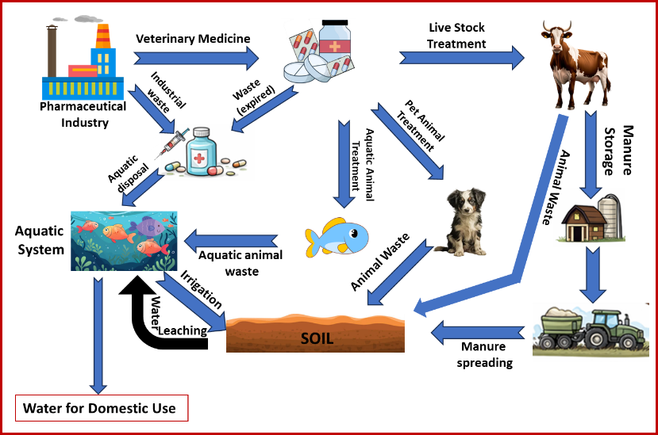
Figure 2: Various routes to Soil Contamination
Small amounts of veterinary medications are always being released into the environment, which imposes selective pressure on different types of bacteria. This happens in addition to direct exposure through food. This helps antibiotic-resistant bacteria (ARBs) and antibiotic resistance genes (ARGs) thrive and spread more easily. This is a big element of the global problem of antibiotic resistance that has to do with using manure and distributing it in the environment (Khmaissa et al., 2024). To keep food safe and the environment clean, we need to make risk assessment methods better, find better ways to handle manure so it doesn't hurt the environment, and make cleaning and remediation technologies more advanced (Ding et al., 2025). In agro-ecosystems, you can locate medicines that are no longer needed by animals.
2.2 WASTEWATER REUSE AND CIRCULAR ECONOMY PRACTICES
Because there isn't enough water, the weather changes, and nutrients need to be managed over time, there has been a growing drive around the world to reuse wastewater and restore resources based on a circular economy. Eventually, cleansed wastewater from towns and factories is utilized for things like watering crops, landscapes, and aquifers, as well as other industrial duties. But sewage sludge and biosolids are placed on land to recycle nutrients and organic matter (Pedrero et al., 2010; Christou et al., 2017). These technologies are helpful for the environment and the economy, but they also let new pollutants (ECs) into land and aquatic ecosystems.
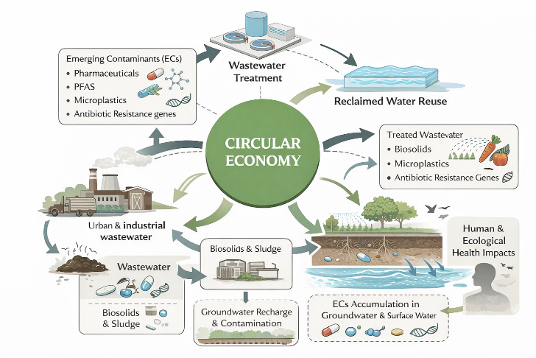
Figure 3: Soil Contamination Through circular economy practices
The major job of typical wastewater treatment facilities (WWTPs) is to get rid of pathogens, organic carbon, and suspended solids. However, they frequently do not eliminate low-concentration, biologically active pollutants such as medicines, personal care items, endocrine-disrupting compounds, microplastics, per- and polyfluoroalkyl substances (PFAS), and antibiotic resistance genes (Michael et al., 2013; Luo et al., 2014). So, biosolids and treated effluents may have a combination of parent compounds and transformation products that are subsequently disseminated again through reuse pathways. (Figure 3)
When reclaimed wastewater is applied for irrigation, ECs can directly enter agricultural soils and surface waters. Repeated irrigation cycles may result in the gradual accumulation of persistent contaminants, particularly those with high sorption affinity or resistance to biodegradation, such as carbamazepine, diclofenac, and PFAS (Malchi et al., 2014; aus der Beek et al., 2016). These compounds can undergo partial transformation in soil but may also leach into groundwater or be transported to adjacent surface waters via runoff, especially under intensive irrigation or heavy rainfall events (Christou et al., 2017).
Putting biosolids and sewage sludge on land is a huge step in the right direction. Microplastics, hydrophobic organic contaminants, and antibiotic resistance genes are often stored in biosolids when wastewater is being treated (Nizzetto et al., 2016; Chen et al., 2020). Putting these toxins on land can keep them there for a long time. They can modify the types of bacteria in the soil and interact with organic materials in the soil, which could influence how nutrients move through the soil and how fertile it is. Soils that have been changed by sludge can be secondary sources, releasing new pollutants into water systems through erosion and leaching decades after they were first utilized.
In terms of the food system, the reuse of wastewater and the flow of nutrients in cycles could be links between pollution in the environment and people being exposed to it. A lot of studies have demonstrated that plants that use recycled water can take in drugs and other new pollutants. Plants take in different amounts of water depending on the compounds' physical and chemical qualities, the types of plants that are watered, and the soil's features (Malchi et al., 2014; Christou et al., 2017). Even though the levels in food and water aren't particularly high, drinking and eating poisoned water over time makes people more worried about long-term health risks and consequences that operate together.
The circular economy concept says that recycling and reusing things again and over again can make pollutants build up, making land and water that gets them into permanent stores of new pollutants (Geissdoerfer et al., 2017; Kümmerer et al., 2020). This illustrates a fundamental paradox of sustainable transitions: efforts to save resources may inadvertently disseminate pollution from regions with abundant sources to those with diminished pollution levels. We need to apply modern treatment technologies including ozonation, activated carbon, and membrane filtering to fix this problem. We also need to maintain a close check on the most dangerous new pollutants (ECs) and make sure that people and the environment are safe when we reuse them (Michael et al., 2013; Chen et al., 2020).
2.3 FOOD PROCESSING AND PACKAGING
More and more people are realizing that food preparation and packaging are major sources of emerging contaminants (ECs) in soil, both directly and indirectly through waste streams and circular economy practices. It is possible for plastic additives, processing aids, lubricants, disinfectants, surfactants, per- and polyfluoroalkyl substances (PFAS), and microplastics/microfibers to get into wastewater and solid trash when food is processed (Bradley et al., 2017; Muncke et al., 2020). Chemicals used in packaging, like phthalates, bisphenols, and non-intentionally added substances (NIAS), are often found in food processing industries' wastewater. These chemicals are only partially removed by standard wastewater treatment plants, so they stay in treated water and biosolids (Chen et al., 2020). When treated wastewater is used for irrigation or sludge and biosolids are spread on farmland, they bring pollutants into the soil, where they may settle, change, or seep into groundwater (Christou et al., 2017; aus der Beek et al., 2016).
Packaging materials can not only cause soil contamination directly, but they can also distribute it. When you consume, throw away, or break down plastic boxes, multilayer composites, and coated papers, they can leak additives, oligomers, inks, and degradation byproducts into the environment (Muncke et al., 2020; Geueke et al., 2018). Microplastics are generated when trash isn't thrown away correctly, when landfills leak, and when packing materials break down. These microplastics can linger in the soil for a long time and contain additional harmful compounds, such as pesticides, heavy metals, and antimicrobial agents (Nizzetto et al., 2016). When organic waste from food preparation, like peels, leftovers, and biodegradable packaging, is used as soil supplements, there is a relationship between food systems and soil EC loading. This trash could have chemicals from packaging and tiny bits of plastic in it. The routes reveal that the techniques used to process and package food are not safe for food and are a big source of additional soil pollutants. This means that we need to improve the design of materials, how we handle waste, and how we enforce rules.
2.4 GLOBALIZED FOOD SUPPLY CHAINS
Global trade makes it harder to regulate pollution because it connects production systems that follow different rules and deal with different environmental situations. Concerns about contamination differ by location because of differences in pesticide rules, wastewater treatment plants, and the ability to enforce such rules (Unnevehr, 2000; Grace, 2015).
3. SOIL–WATER–PLANT–ANIMAL–FOOD CONTINUUM
The continuum of earth, water, flora, fauna, and sustenance elucidates the translocation of pollutants among various environmental compartments and biota (Heberer, 2002; Boxall et al., 2012). Soil operates as both a sink and a secondary source by taking in pollutants and slowly releasing them into pore water and groundwater (Helbling et al., 2010).
Plants usually absorb pollution through their roots. The way they do this relies on the size of the molecules, how lipophilic they are, their ionization state, and the characteristics of the soil (Trapp and Eggen, 2013; Miller et al., 2016). When animals eat food, drink water, or walk on dirty ground that has contaminants in it, the contaminants build up in their tissues, milk, and eggs (Stahl et al., 2014). Ultimately, individuals are exposed via their dietary intake, frequently over extended durations and in minimal quantities.
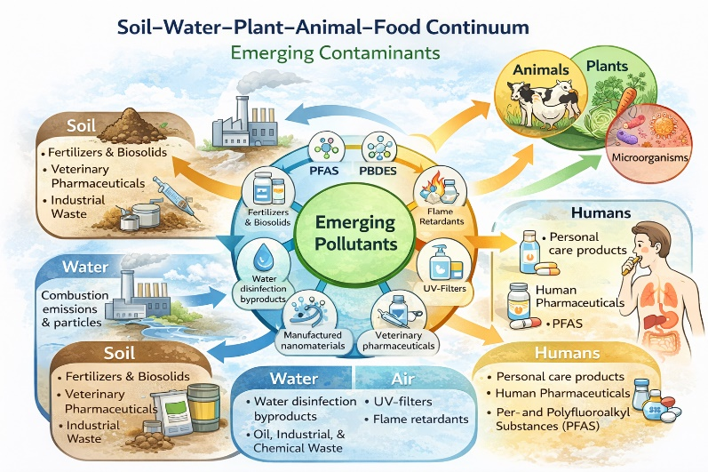
Figure 4. Conceptual diagram of the soil–water–plant–animal–food continuum
Conceptual representation of contaminant transfer across interconnected environmental and biological compartments. Emerging contaminants enter soil and water from anthropogenic sources, are taken up by plants and animals, and ultimately reach humans through food consumption (Heberer, 2002; Boxall et al., 2012). (Figure 4)
4. GLOBAL OCCURRENCE AND CASE EXAMPLES
Food sources all across the world have been proven to have new contaminants in them. In Europe and North America, PFAS, pharmaceuticals, and packaging contaminants are frequently detected in prepared foods, cheese, and beef (Blaine et al., 2013). In low- and middle-income nations, the main methods that pollution gets into the environment are through illegal rubbish dumping and wastewater irrigation (Qadir et al., 2010; wichelns et al., 2015).
Microplastics have been discovered in honey, fish, salt, and bottled water from various countries. This demonstrates that foodborne illness is a global issue (Van Cauwenberghe and Janssen, 2014; Karami et al., 2017; Cox et al., 2019).
5. MIXTURE TOXICITY AND CHRONIC EXPOSURE
Foods seldom contain isolated poisons. People are exposed to combinations of drugs that function in analogous or distinct manners (Kortenkamp et al., 2007; Carpenter, 2006). Hormone-disrupting chemicals are a major issue since they can have effects even at very low levels and during key times of development (WHO, 2013; Vandenberg et al., 2012).
Most modern risk assessment methods only look at the effects of one drug at a time. This makes it harder for them to look at effects that compound on top of each other (EFSA, 2019; Backhaus and Faust, 2012). (Figure 5)
Table 3. Comparative Risk Characteristics of Emerging Contaminant Groups (Kortenkamp et al., 2007; EFSA, 2019)
Contaminant group | Environmental persistence | Bioaccumulation potential | Regulatory coverage | Major concern
Pharmaceuticals | Moderate | Low–moderate | Limited | Chronic exposure
PFAS | Very high | High | Emerging | Long-term toxicity
Plasticizers | Moderate | Moderate | Partial | Endocrine disruption
Microplastics | Very high | Physical accumulation | Minimal | Health uncertainty
Novel pesticides | Variable | Low–moderate | Partial | Metabolite toxicity
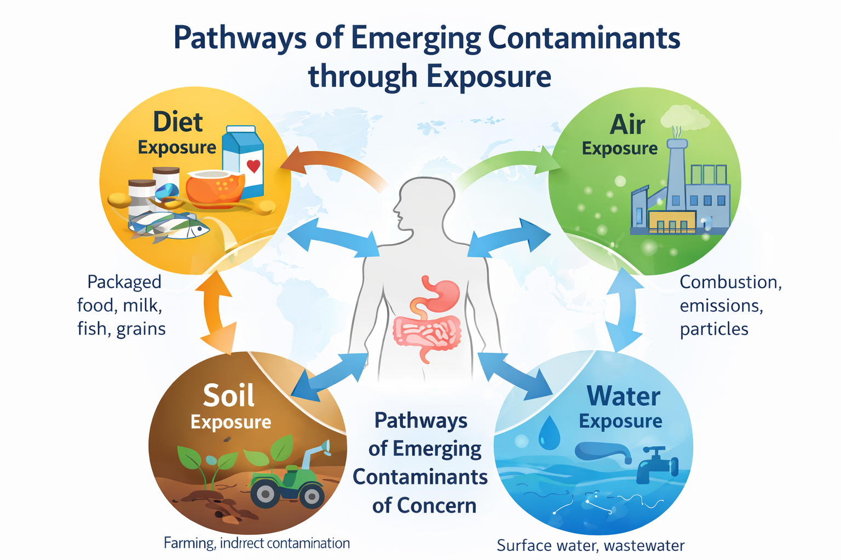
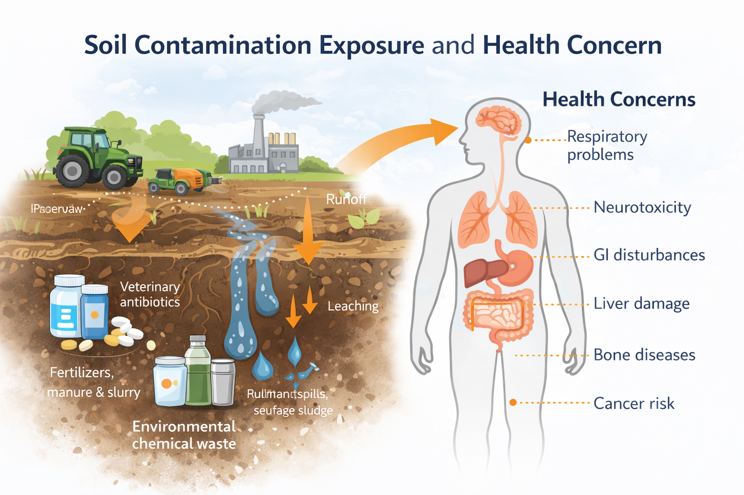

Source–Pathway–Receptor Framework for Emerging Contaminants
Environmental and Health Dimensions of Soil Contamination

Figure 5: Soil Contaminant Exposure and health Concern
6. ANALYTICAL ADVANCES AND MONITORING CHALLENGES
High-resolution mass spectrometry and non-target screening have transformed the detection of pollutants and facilitated the identification of numerous unknown substances in food (Hollender et al., 2019; Brack et al., 2017). But regular monitoring is problematic since there aren't any reference standards, it's hard to understand the data, and it's hard for regulators to work together (Richardson and Kimura, 2020).

7. IMPLICATIONS FOR FOOD SAFETY GOVERNANCE
New pollutants demonstrate that the present food safety approaches that focus on big dangers and checking the finished product aren't good enough. To make preventative governance effective, we need early warning systems, source control, and the ability to combine data from tracking food and the environment (FAO, 2017). The One Health paradigm is a comprehensive framework that elucidates the interconnections among environmental pollution, animal exposure, and human health outcomes (FAO et al., 2019, Mansour, 2011)
Schematic comparison of dominant exposure pathways contributing to dietary intake of emerging contaminants, illustrating the increasing importance of packaging, environmental sources, and upstream agricultural inputs (Vandenberg et al., 2012; Muncke et al., 2020). (Figure 6)
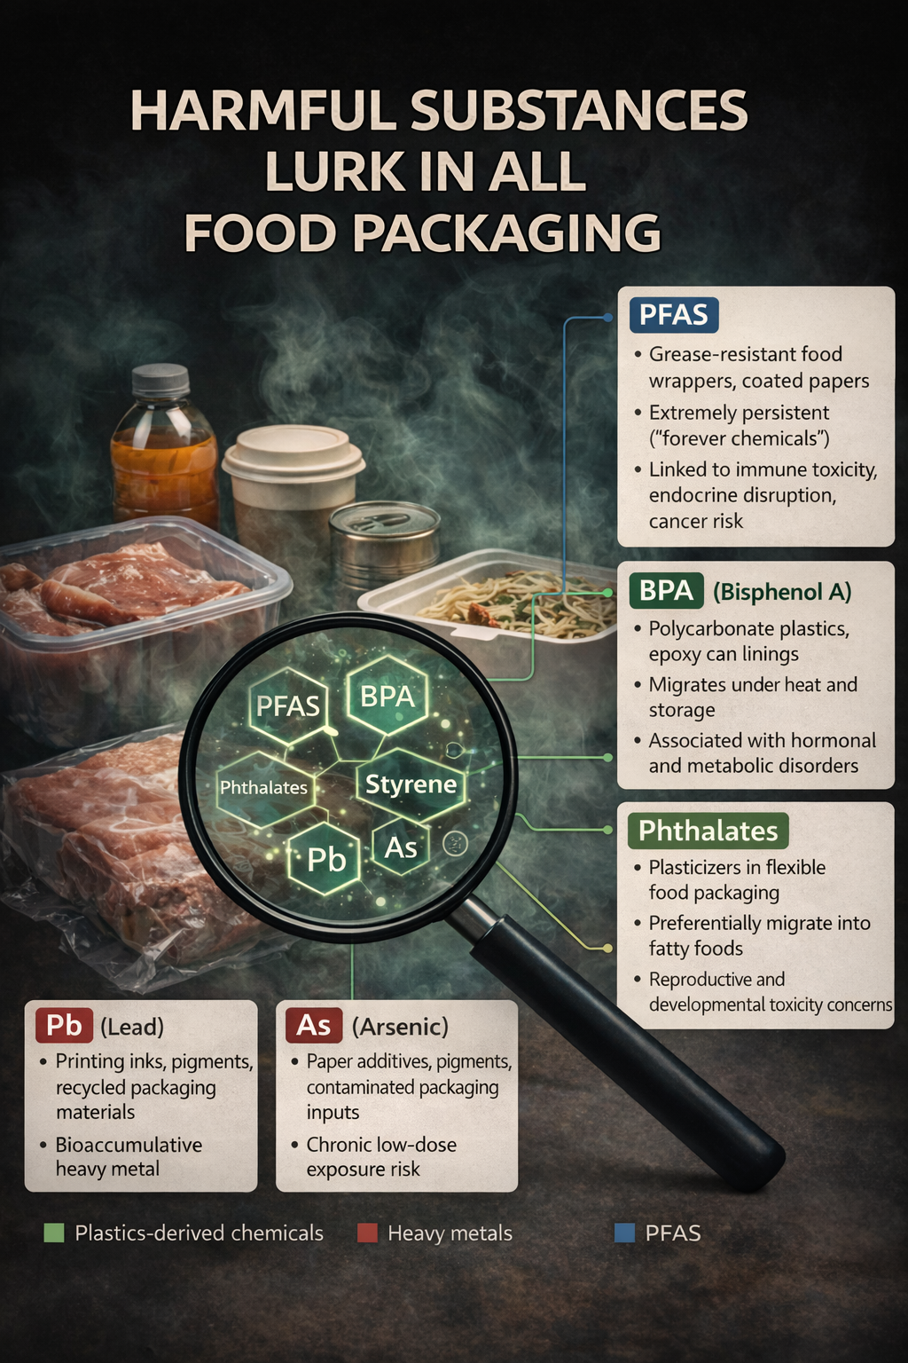
Figure 6. Relative contribution of exposure pathways to dietary intake
8. CONCLUSIONS
The modern food system is facing a systemic issue marked by increasing pollutants of concern. Food safety requires a governance plan that is proactive and system-oriented because there are many sources, complicated transmission paths, and health risks. To protect public health and encourage sustainable food production, it is important to have a deep understanding of how contaminants move through the soil, water, plants, animals, and food.
9. REFERENCES
Albarano, L., Suarez, E.G.P., Maggio, C., La Marca, A., Iovine, R., Lofrano, G., Guida, M., Vaiano, V., Carotenuto, M. and Libralato, G., 2024. Assessment of ecological risks posed by veterinary antibiotics in European aquatic environments: A comprehensive review and analysis. Science of the total environment, 954, p.176280.
Amin, J., Anjum, M.A., Sharif, M., Kadry, S. and Nam, Y. (2022) Fruits and vegetable diseases recognition using convolutional neural networks. Computers, Materials & Continua, 70(1)
Bacanlı, M.G., 2024. The two faces of antibiotics: an overview of the effects of antibiotic residues in foodstuffs. Archives of Toxicology, 98(6), pp.1717-1725.
Backhaus, T. and Faust, M. (2012) Predictive environmental risk assessment of chemical mixtures: a conceptual framework. Environmental Science & Technology, 46, pp. 2564–2573.
Bergman, Å., Heindel, J.J., Jobling, S., Kidd, K., Zoeller, T.R. and World Health Organization, 2013. State of the science of endocrine disrupting chemicals 2012. World Health Organization.
Blaine, A.C., Rich, C.D., Hundal, L.S., Lau, C., Mills, M.A., Harris, K.M. and Higgins, C.P., 2013. Uptake of perfluoroalkyl acids into edible crops via land applied biosolids: field and greenhouse studies. Environmental science & technology, 47(24), pp.14062-14069.
Boxall, A.B.A., Fogg, L.A., Blackwell, P.A., Blackwell, P., Kay, P., Pemberton, E.J. and Croxford, A., 2003. Veterinary medicines in the environment. Reviews of environmental contamination and toxicology, pp.1-91.
Brack, W., Dulio, V., Ågerstrand, M., Allan, I., Altenburger, R., Brinkmann, M., Bunke, D., Burgess, R.M., Cousins, I., Escher, B.I. and Hernández, F.J., 2017. Towards the review of the European Union Water Framework Directive: recommendations for more efficient assessment and management of chemical contamination in European surface water resources. Science of the Total Environment, 576, pp.720-737.
Carpenter, D.O., 2006. Polychlorinated biphenyls (PCBs): routes of exposure and effects on human health. Reviews on environmental health, 21(1), p.1.
Christou, A., Agüera, A., Bayona, J.M., Cytryn, E., Fotopoulos, V., Lambropoulou, D., Manaia, C.M., Michael, C., Revitt, M., Schröder, P. and Fatta-Kassinos, D., 2017. The potential implications of reclaimed wastewater reuse for irrigation on the agricultural environment: the knowns and unknowns of the fate of antibiotics and antibiotic resistant bacteria and resistance genes–a review. Water research, 123, pp.448-467.
Daughton, C.G. (2004) Non-regulated water contaminants: emerging research. Environmental Impact Assessment Review, 24, pp. 711–732.
Ding, C., Zhang, Y., Wang, L. and Li, J. (2025) Veterinary antibiotics in animal manure: environmental risks, fate, and mitigation technologies. Journal of Environmental Chemical Engineering, 13(1), 110231.
EFSA Scientific Committee, More, S.J., Bampidis, V., Benford, D., Bennekou, S.H., Bragard, C., Halldorsson, T.I., Hernández‐Jerez, A.F., Koutsoumanis, K., Naegeli, H. and Schlatter, J.R., 2019. Guidance on harmonised methodologies for human health, animal health and ecological risk assessment of combined exposure to multiple chemicals. EFSA journal, 17(3), p.e05634.
Geissdoerfer, M., Savaget, P., Bocken, N.M. and Hultink, E.J., 2017. The Circular Economy–A new sustainability paradigm?. Journal of cleaner production, 143, pp.757-768.
Geueke, B., Groh, K. and Muncke, J. (2018) Food packaging in the circular economy: overview of chemical safety issues. Journal of Cleaner Production, 193, pp. 491–505.
Grace, D., 2015. Food safety in developing countries: an overview.
Gros, M., Petrovic, M. and Barceló, D., 2008. Analysis of emerging contaminants of municipal and industrial origin. In Emerging Contaminants from Industrial and Municipal Waste: Occurrence, Analysis and Effects (pp. 37-104). Berlin, Heidelberg: Springer Berlin Heidelberg.
Heberer, T. (2002) Occurrence, fate, and removal of pharmaceutical residues in the aquatic environment: a review of recent research data. Toxicology Letters, 131(1–2), pp. 5–17.
Helbling, D.E., Hollender, J., Kohler, H.P.E., Singer, H. and Fenner, K., 2010. High-throughput identification of microbial transformation products of organic micropollutants. Environmental science & technology, 44(17), pp.6621-6627.
Hollender, J., Van Bavel, B., Dulio, V., Farmen, E., Furtmann, K., Koschorreck, J., Kunkel, U., Krauss, M., Munthe, J., Schlabach, M. and Slobodnik, J., 2019. High resolution mass spectrometry-based non-target screening can support regulatory environmental monitoring and chemicals management. Environmental Sciences Europe, 31(1), pp.1-11.
Kaferstein, F.K. and Motarjemi, Y., 1997. Foodborne disease control: a transnational challenge. Emerging infectious diseases, 3(4).
Karami, A., Golieskardi, A., Ho, Y.B., Larat, V. and Salamatinia, B., 2017. Microplastics in eviscerated flesh and excised organs of dried fish. Scientific reports, 7(1), p.5473.
Khmaissa, M., Zouari-Mechichi, H., Sciara, G., Record, E. and Mechichi, T. (2024) Pollution from livestock farming antibiotics: an emerging environmental and human health concern. Journal of Hazardous Materials Advances, 13, 100410.
Kortenkamp, A., Faust, M., Scholze, M. and Backhaus, T., 2007. Low-level exposure to multiple chemicals: reason for human health concerns?. Environmental health perspectives, 115(Suppl 1), p.106.
Kümmerer, K. (2009) Antibiotics in the aquatic environment – a review – part I. Chemosphere, 75(4), pp. 417–434.
Kümmerer, K., Clark, J.H. and Zuin, V.G., 2020. Rethinking chemistry for a circular economy. Science, 367(6476), pp.369-370.
Luo, Y., Guo, W., Ngo, H.H., Nghiem, L.D., Hai, F.I., Zhang, J., Liang, S. and Wang, X.C. (2014) A review on the occurrence of micropollutants in the aquatic environment. Environmental Pollution, 187, pp. 24–38.
Luo, Y., Guo, W., Ngo, H.H., Nghiem, L.D., Hai, F.I., Zhang, J., Liang, S. and Wang, X.C., 2014. A review on the occurrence of micropollutants in the aquatic environment and their fate and removal during wastewater treatment. Science of the total environment, 473, pp.619-641.
Malchi, T., Maor, Y., Tadmor, G., Shenker, M. and Chefetz, B. (2014) Irrigation of crops with treated wastewater: uptake of pharmaceuticals. Environmental Science & Technology, 48, pp. 9325–9333.
Mansour, S.A., 2011. Chemical pollutants threatening food safety and security: an overview. Advances in Food Protection: Focus on Food Safety and Defense, pp.73-117.
Mateo-Sagasta, J., Zadeh, S.M., Turral, H. and Burke, J., 2017. Water pollution from agriculture: a global review. Executive summary.FAO, WHO and OIE (2019) One Health: joint operational framework. Rome/Geneva/Paris.
Michael, I., Rizzo, L., McArdell, C.S., Manaia, C.M., Merlin, C., Schwartz, T., Dagot, C. and Fatta-Kassinos, D. (2013) Urban wastewater treatment plants as hotspots for the release of antibiotics. Water Research, 47, pp. 957–995.
Muncke, J., Backhaus, T., Geueke, B., Maffini, M.V., Martin, O.V., Myers, J.P., Soto, A.M. and Trasande, L. (2020) Impacts of food contact chemicals on human health. Environmental Health, 19, 25.
Nizzetto, L., Futter, M. and Langaas, S., 2016. Are agricultural soils dumps for microplastics of urban origin?.
Pedrero, F., Kalavrouziotis, I., Alarcón, J.J., Koukoulakis, P. and Asano, T., 2010. Use of treated municipal wastewater in irrigated agriculture—Review of some practices in Spain and Greece. Agricultural Water Management, 97(9), pp.1233-1241.
Pérez-Lucas, G. and Navarro, S. (2024) How pharmaceutical residues occur, behave, and affect the soil environment. Journal of Xenobiotics, 14(4), pp. 1343–1377.
Qadir, M., Wichelns, D., Raschid-Sally, L., McCornick, P.G., Drechsel, P., Bahri, A. and Minhas, P.S. (2010) The challenges of wastewater irrigation in developing countries. Agricultural Water Management, 97, pp. 561–568.
Richardson, S.D. and Kimura, S.Y. (2020) Emerging environmental contaminants: challenges facing our next generation. Analytical Chemistry, 92, pp. 473–505.
Richardson, S.D. and Ternes, T.A., 2018. Water analysis: emerging contaminants and current issues. Anal. Chem, 90(1), pp.398-428.
Saeed, H., Padmesh, S., Singh, A., Nandy, A., Singh, S.P. and Deshwal, R.K., 2024. Impact of veterinary pharmaceuticals on environment and their mitigation through microbial bioremediation. Frontiers in Microbiology, 15, p.1396116.
Stahl, C., Voss, A., Schmitz, F., Nuszbaum, M., Tüscher, O., Lieb, K. and Klauer, K.C. (2014) Behavioral components of impulsivity. Journal of Experimental Psychology: General, 143(2), p. 850.
Thompson, L.A. and Darwish, W.S., 2019. Environmental chemical contaminants in food: review of a global problem. Journal of toxicology, 2019(1), p.2345283.
Trapp, S. and Eggen, T., 2013. Simulation of the plant uptake of organophosphates and other emerging pollutants for greenhouse experiments and field conditions. Environmental Science and Pollution Research, 20(6), pp.4018-4029.
Unnevehr, L.J., 2000. Food safety issues and fresh food product exports from LDCs. Agricultural Economics, 23(3), pp.231-240.
Van Cauwenberghe, L. and Janssen, C.R. (2014) Microplastics in bivalves cultured for human consumption. Environmental Pollution, 193, pp. 65–70.
van Dongen, K.C.W., Huang, W., Jongedijk, E., van de Kooi, B., de Lange, E. and van der Fels-Klerx, H.J. (2025) Transfer of antibiotic residues from digestate-amended soil to edible crops in a circular food production system. Environmental Pollution, 384, 126915.
Vandenberg, L.N., Colborn, T., Hayes, T.B., Heindel, J.J., Jacobs, D.R., Lee, D.H., Shioda, T., Soto, A.M., vom Saal, F.S., Welshons, W.V., Zoeller, R.T. and Myers, J.P. (2012) Hormones and endocrine-disrupting chemicals. Endocrine Reviews, 33, pp. 378–455.
Wang, R., Sun, L., Xia, S., Wu, H., Ma, Y., Zhan, S., Zhang, G., Zhang, X., Shi, T. and Chen, W. (2021) B7-H3 suppresses doxorubicin-induced senescence-like growth arrest in colorectal cancer through the AKT/TM4SF1/SIRT1 pathway. Cell Death & Disease, 12(5), 453.
Wichelns, D., Drechsel, P. and Qadir, M., 2015. Wastewater: economic asset in an urbanizing world. In Wastewater: Economic asset in an urbanizing world (pp. 3-14). Dordrecht: Springer Netherlands..

