Original Research Article

Spatio-Temporal Dynamics of Groundwater Levels in Alluvial Aquifers of Anand District, Gujarat Using Geostatistical Approaches

Abstract
Groundwater plays a vital role in sustaining agriculture and water security in semi-arid regions of India, where increasing extraction pressures necessitate a clear understanding of its variability. This study examines the spatio-temporal dynamics of groundwater levels in the alluvial aquifers of Anand district, Gujarat, over a 20-year period (2000–2020) using pre and post-monsoon data from India-WRIS. Geostatistical analysis through Ordinary Kriging within a GIS framework was employed to map and analyze groundwater distribution. Results indicate significant spatial and temporal variability, with pre-monsoon groundwater declining from 4.4-22.0 m below ground level (bgl) in 2000 to 5.6-26.1 m bgl in 2020, reflecting progressive depletion. Spatially, northern and western regions consistently showed shallower water levels, while southeastern areas remained critically deeper. Post-monsoon analysis revealed an initial recovery phase (2000–2008) due to effective recharge, followed by a reversal after 2012, with expansion of deeper zones exceeding 26 m bgl by 2020. The study highlights a shift from recovery to depletion driven by combined natural and anthropogenic factors, emphasizing the need for sustainable groundwater management strategies, including regulated extraction and improved recharge interventions.
Keywords: Groundwater variability, Spatio-temporal analysis, Ordinary Kriging, Alluvial aquifers, Groundwater depletion
1.Introduction
Water is crucial for human survival and serves as a critical input for agricultural production. To ensure sustainable food production, efficient use of water for crop irrigation is essential (Mali & Singh 2016; Kambale et al., 2017; Tiwari et al., 2024). Among available water sources, groundwater has played an important role in supply for irrigation, industry, and household use especially where surface water supply is poor or seasonal. Globally, groundwater represents one of the largest freshwater reserves and provides drinking water to nearly half of the world’s population (Gleeson et al., 2012), while sustaining approximately 40% of irrigated agriculture (Siebert et al., 2010; Pandey et al., 2023). However, increasing pressures from population growth, climate variability, and intensified agricultural and industrial activities have led to unsustainable exploitation of groundwater resources. It has been estimated that between 20-30% of the world’s largest groundwater aquifers are being used unsustainably due to factors such as climate change, population growth, and increased industrial activity (Pagendam et al. 2023; Sahoo et al. 2021; Kaur et al. 2021). Groundwater extraction has become the backbone of India's agriculture and drinking water security, with the national average extraction rate at 63% (CGWB., 2019). However, groundwater extraction is not uniform across the country, with 16% of assessment units categorized as over-exploited and 4% as critical, indicating extraction exceeding annual recharge and between 90-100% of annual extractable resources, respectively. An additional 15% of assessment units are semi-critical, while 64% are categorized as safe. Finally, 1% of assessment units are saline, with brackish or saline groundwater in phreatic aquifers. These patterns clearly indicate that excessive & uncontrolled groundwater abstraction has caused considerable depletion in several regions, posing serious threats to long-term water security.
Understanding the spatio-temporal variability of groundwater levels is essential for assessing resource availability, identifying depletion trends, and supporting sustainable groundwater management (Patle et al. 2015; Ware et al. 2023). Various methods have been used to effectively analyze the spatio-temporal variability of groundwater levels. Geostatistical methods have been instrumental in effectively quantifying the correlation structures present in groundwater data (Roy et al. 2023; Varouchakis et al., 2022). One such geostatistical method is variogram modeling, which is used to define the degree of spatial dependence between two points of observation, which is critical for effective spatial prediction (Ahmadi & Sedghamiz 2007). Egidio et al., (2025) studied the spatiotemporal variability in groundwater level across the Piedmont Po Plain (NW Italy), with the objective to assess the climate change impacts and human drivers on regional groundwater systems. The period of 2010–2022, data was analyzed and results indicate a widespread decline in GWL, with an average of −4.32 cm/y and a maximum of −16.74 cm/y in the time period. Another geostatistical interpolation technique used to create continuous surfaces of groundwater levels is kriging. Kriging, a widely used geostatistical interpolation method, utilizes this spatial structure to generate continuous groundwater level surfaces from discrete well observations. In addition to this, other forms of interpolation methods such as Inverse Distance Weighting (IDW), spline interpolation methods can also be used to predict groundwater levels at unsampled locations (Narjary et al., 2017). Among these methods, Ordinary Kriging (OK) is used most frequently in groundwater studies. It is based on the assumption of a constant but unknown mean over the entire region of interest and takes into account the spatial autocorrelation between the values through the variogram model (Mini et al., 2014). This makes ordinary kriging a more reliable option than other deterministic methods such as IDW because not only is it unbiased but also minimizes the estimation of variance. Narjary et al., (2017) studied the spatio-temporal behavior of groundwater table and groundwater salinity was studied using ordinary kriging (OK) procedure in Arc GIS 9.3 software. The variograms and krigged spatial maps were generated for pre and post monsoon seasons of 2013 and 2015 and results indicate an increase in 36% area of shallow groundwater table. The advantage of OK is that it is capable of adapting to the spatial variability of groundwater systems and is therefore best suited for heterogeneous groundwater systems such as alluvial formations. It is capable of producing smooth and accurate maps of spatial distributions of groundwater levels, which is of critical importance for identifying groundwater depletion areas and recharge areas. Therefore, the aim of this study was to evaluate how the quantitative status of groundwater in the alluvial aquifers of the Anand district of Gujarat, India, has changed over the years under the influence of climate variability and increased groundwater extraction. Specifically, this study sought to examine the changes in groundwater levels (GWL) by analyzing long-term data from selected monitoring wells installed across the district.
2. Material and Methods
2.1 Study Area
The study area Anand, Gujarat, India (fig.1) has a geographic area of 2941 km² & has a semi-arid climate. It is situated between North latitudes 22°06' & 22°43' and East longitudes 72°20' & 73°12'. The area has scorching summers and comparatively cold winters, according to meteorological data from the closest India Meteorological Department (IMD) station in Ahmedabad. The mean maximum temperature ranges from 28.4°C in January to about 41.8°C in May, while mean minimum temperatures vary from 11.7°C in January to 27°C in June. Relative humidity fluctuates between 32% in March and 79% in August. Wind velocity varies from approximately 74 km/day in November to 174 km/day in June. The long-term average annual rainfall is about 799.6 mm, with the majority of precipitation occurring during the southwest monsoon season (June–September). Agriculture in the district is practiced across all three seasons, with paddy and jowar dominating the kharif season, wheat and pulses in the rabi season, and jowar and groundnut during summer. In this study, long-term pre- and post-monsoon groundwater level data from 2000 to 2020 were utilized to assess the spatial variability of groundwater levels.
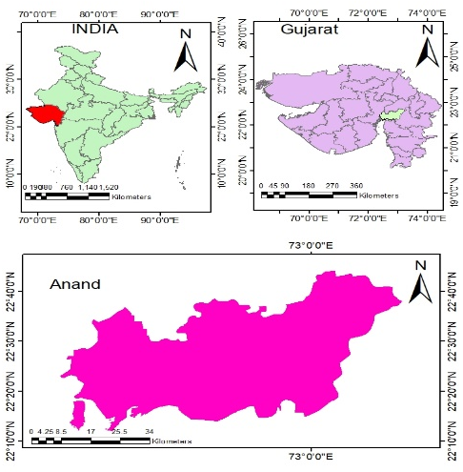
Fig. 1 The map showing location of the study area Anand district, Gujarat, India.
2.2 Data Collection
The study utilized long-term groundwater level data for the period 2000–2020 to assess spatial and temporal variability. Pre-monsoon (June) and post-monsoon (October) groundwater level data from observation wells located across Anand district were collected from the India-WRIS (Water Resources Information System) portal. The groundwater monitoring network is maintained by the Central Ground Water Board (CGWB). The groundwater level data was reported as depth to water level below ground level (m bgl). Only wells having consistent and continuous records for the study periods was considered for analysis to ensure data reliability. Ancillary data such as district boundary maps and administrative layers were collected from secondary sources for spatial analysis.
2.3 Spatial Analysis
Spatial analysis was conducted to quantify the spatial variability and distribution of groundwater levels in Anand district during the period 2000–2020. Groundwater level observations from selected monitoring wells were georeferenced using their geographic coordinates and analyzed within a Geographic Information System (GIS) framework. Separate datasets were prepared for pre-monsoon (June) and post-monsoon (October) seasons to capture seasonal variations in groundwater levels.
To transform discrete point observations into continuous groundwater level surfaces, geostatistical interpolation techniques were applied. Among various interpolation methods, ordinary kriging was adopted due to its capability to account for spatial autocorrelation and provide unbiased estimates with minimum estimation variance. Prior to interpolation, exploratory spatial data analysis was performed to examine data distribution and identify outliers.
The ordinary kriging estimator is expressed as:
$$\hat{Z}(X_{0})=\sum_{i=1}^{n}{λ_{i}}Z(X_{i})$$
where,
$\hat{Z}(X_{0})$= estimated groundwater level at the unsampled location x₀,
$Z(X_{i})$ = observed groundwater level at location xᵢ,
$λ_{i}$ = Kriging weight assigned to the iᵗʰ observation,
n = number of neighboring observation points used in estimation.
The unbiasedness condition is given by:
$\sum_{i=1}^{n}{λ_{i}}$ = 1
The Kriging system of equations is written as:
$$\sum_{j=1}^{n}{λ_{i}}γ\left(X_{i}-X_{j}\right)+µ=γ\left(X_{i}-X_{o}\right), i=1,2,…,n$$
where,
$γ\left(X_{i}-X_{j}\right)$ = semivariance between locations xᵢ and xⱼ,
$γ\left(X_{i}-X_{o}\right)$ = semivariance between the observation point xᵢ and estimation point x₀,
μ = Lagrange multiplier.
The estimation variance of Ordinary Kriging is given by:
$${σ^{2}}_{OK}=\sum_{i=1}^{n}{λ_{i}γ\left(X_{i}-X_{o}\right)+µ}$$
3. Results and Discussion
The geostatistical analysis using Ordinary Kriging (OK) revealed pronounced spatio-temporal variability in groundwater levels across Anand district during the period 2000–2020 for both pre- and post-monsoon seasons. The interpolated maps clearly illustrate that groundwater depth is highly heterogeneous, governed by a combination of hydrogeological conditions and anthropogenic influences.
3.1 Pre-Monsoon Spatial variability of groundwater level
Spatial distribution maps generated using Ordinary Kriging illustrate the pre-monsoon groundwater depth variability across Anand District, Gujarat, at four-year intervals from 2000 to 2020. Over the two-decade period, pronounced spatio-temporal fluctuations in groundwater levels were observed, reflecting the combined influence of natural processes and anthropogenic interventions (Todd and Mays, 2005; Kambale et al., 2017). In 2000, groundwater depths ranged between 4.4 and 22.0 m below ground level (bgl), with relatively shallow water tables observed in the northern and parts of the western and central regions, while deeper groundwater conditions prevailed in the southern region. By 2004, groundwater levels had further declined, with depths extending up to 26.1 m bgl, particularly in the southeastern part, although the spatial pattern of shallow zones remained largely unchanged. A temporary improvement was evident in 2008, when groundwater depths ranged from 2.1 to 20.7 m bgl, and shallow zones expanded, particularly in recharge-favorable areas, indicating the role of effective recharge processes (Gleeson et al., 2012). However, in 2012, groundwater levels again showed deterioration, with depths reaching up to 26.5 m bgl and a noticeable reduction in shallow zones, suggesting increased groundwater extraction and reduced recharge. In 2016, partial recovery was observed with depths ranging from 4.6 to 24.4 m bgl, especially in the western region, although deeper zones persisted. By 2020, groundwater depths ranged between 5.6 and 26.1 m bgl, with a clear contraction of shallow zones and continued dominance of deeper water tables. Throughout the study period, the northern and western regions consistently maintained relatively shallow groundwater levels, whereas the southeastern region remained critically affected, with depths often exceeding 22–28.6 m bgl. The progressive expansion of deeper groundwater zones highlights increasing stress on aquifer systems driven by both climatic variability and intensive groundwater abstraction, emphasizing the urgent need for sustainable groundwater management strategies (Rodell et al., 2009; Sahoo et al., 2021). The maximum and minimum variations of groundwater level (m bgl) for each year shown in fig. 4(a). The maximum value 28.6 & 22 m bgl was observed for year 2020 & 2000 respectively, while minimum groundwater level bgl value 4.4 m & 1.2 m bgl was observed for year 2020 & 2004 respectively.
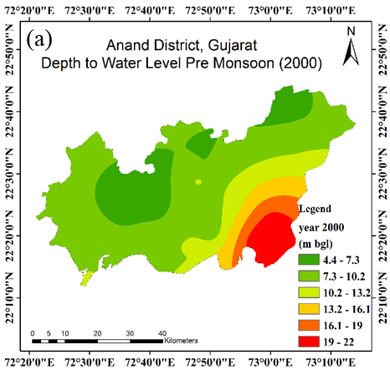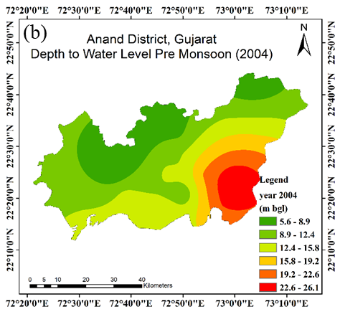
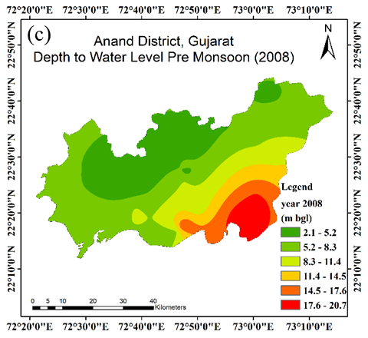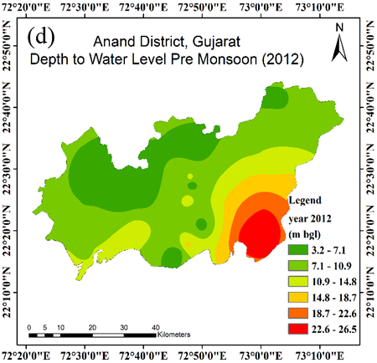
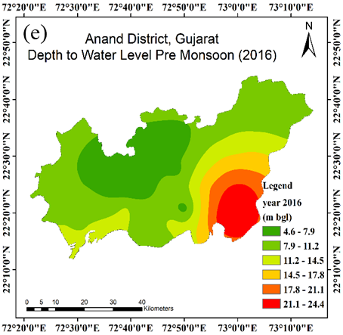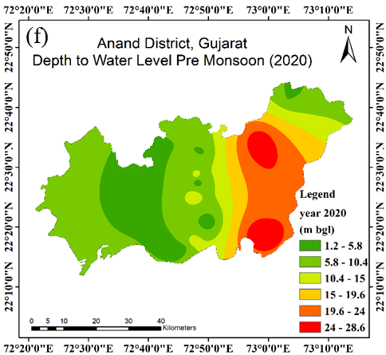
Fig. 2(a-f) Spatial variation of groundwater depth in Anand District, Gujarat, over the pre-monsoon seasons for year 2000 to 2020.
3.2 Post-Monsoon Spatial variability of groundwater level
GIS-based maps generated using Ordinary Kriging for the post-monsoon periods (2000–2020) at four-year intervals reveal substantial spatial and temporal variability in groundwater depth across Anand District, Gujarat. In 2000, groundwater conditions were predominantly stressed, with deeper water levels ranging from 15.8 to 20.7 m below ground level (bgl) dominating the southeastern region, while moderately deep levels (10.8–15.8 m bgl) prevailed in central areas and shallow zones (5.7–8.2 m bgl) were restricted to limited pockets in the northern and western parts. This distribution indicates significant groundwater stress, particularly in the southeastern region (Todd and Mays, 2005). By 2004, a marked improvement was observed, characterized by the expansion of shallow groundwater zones (0.3–4.4 m bgl) in the northern and western regions and a reduction in deeper zones in the southeast, suggesting enhanced recharge conditions. This recovery trend continued in 2008, with widespread shallow groundwater levels (0.2–8.0 m bgl) across much of the district and a contraction of deeper zones, representing the peak of groundwater recovery during the study period.
In 2012, groundwater conditions remained relatively favourable, with shallow to moderately shallow depths (1.1–9.6 m bgl) dominating large areas; however, isolated pockets of deep groundwater (22.4–26.1 m bgl) persisted in the southeastern region, indicating localized stress. A reversal of this recovery trend became evident by 2016, when deeper groundwater zones (15.3–20.1 m bgl) expanded significantly across central and southeastern regions, while shallow zones became confined to the northern and western parts, suggesting increasing groundwater abstraction and declining recharge efficiency (Rodell et al., 2009; Sahoo et al., 2021). By 2020, groundwater conditions further deteriorated, with extensive areas in the southeastern region exhibiting depths exceeding 26.2–31.1 m bgl, accompanied by the expansion of moderately deep zones (21.3–26.1 m bgl) in central areas. Shallow groundwater zones (1.2–6.2 m bgl) remained limited to the northern and western regions, indicating widespread depletion across the district.
The comparative analysis of groundwater maps from 2000 to 2020 highlights a distinct transition from an initial phase of recovery (2000–2008) to progressive and widespread depletion after 2012. While favourable monsoonal recharge contributed to short-term improvements, the long-term decline is primarily attributed to increased groundwater extraction and reduced recharge efficiency (Siebert et al., 2010; CGWB, 2019). The persistence of critically deep groundwater levels in the southeastern region underscores the influence of localized hydrogeological and anthropogenic factors (Patle et al., 2015). Overall, these findings emphasize the urgent need for targeted groundwater management and conservation strategies to ensure sustainable utilization of groundwater resources in semi-arid regions. The maximum and minimum variations of groundwater level (m bgl) post monsoon for each year shown in fig. 4(b). The maximum value 31.1 & 20.7 m bgl was observed for year 2020 & 2000 respectively, while minimum groundwater level bgl value 5.4 m & 5.7 m bgl was observed for year 2020 & 2004 respectively.

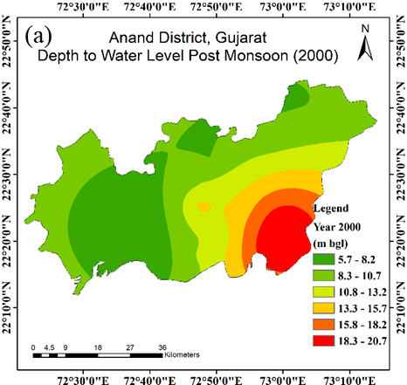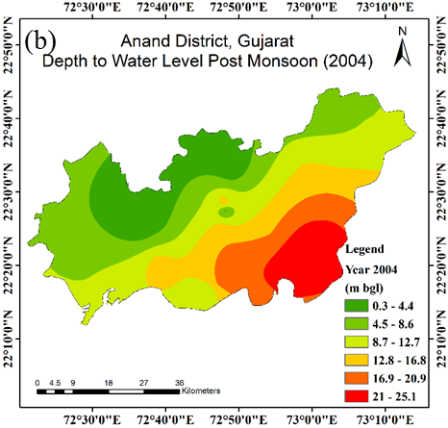
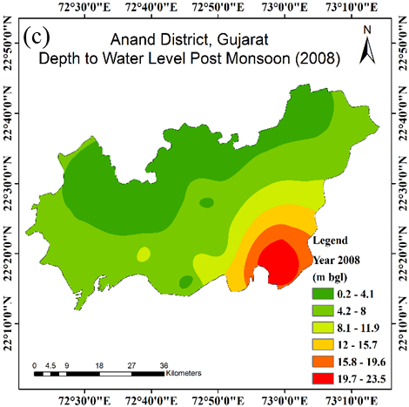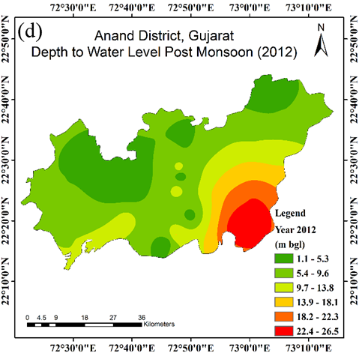
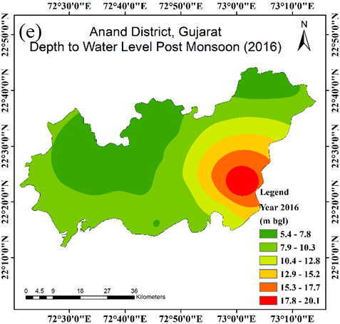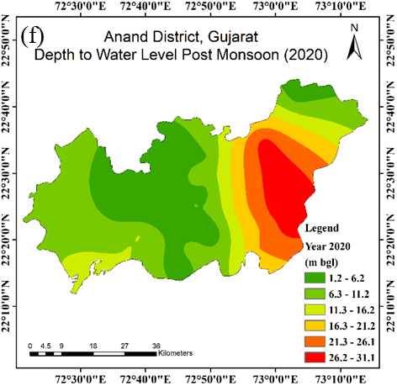
Fig. 3(a-f) Spatial variation of groundwater depth in Anand District, Gujarat, over the post-monsoon seasons for year 2000 to 2020.
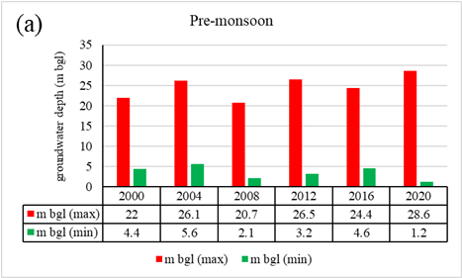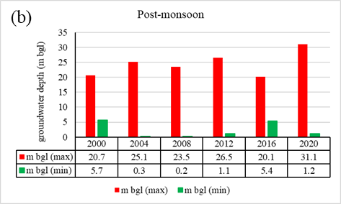
Fig. 4(a-b) Variation in maximum and minimum groundwater depth (mbgl) during pre- and post-monsoon periods (2000-2020) in Anand district, Gujarat.
4. Summary and Conclusion
The present study provides a comprehensive assessment of the spatio-temporal dynamics of groundwater levels in the alluvial aquifers of Anand district, Gujarat, over a 20-year period (2000–2020) using geostatistical techniques. The results reveal a clear transition from an initial phase of groundwater recovery (2000–2008) to a sustained period of depletion after 2012, with a pronounced expansion of deeper water table zones, particularly in the southeastern and central regions. Persistent spatial heterogeneity, characterized by relatively stable shallow groundwater in the northern and western parts and deepening in other areas, underscores the combined influence of hydrogeological settings and anthropogenic pressures, including intensive groundwater extraction and variability in recharge. The application of Ordinary Kriging effectively captured these spatial patterns and temporal shifts, demonstrating its robustness for groundwater assessment in data-sparse regions. Overall, the findings shows groundwater decline and emphasize the need for integrated and region-specific management strategies, including regulated abstraction, artificial recharge enhancement, to ensure long-term sustainability of groundwater resources in semi-arid alluvial aquifer systems. In addition to the above, future research should also be conducted to improve the spatial coverage and reliability of the groundwater monitoring network in the alluvial formations of the Anand district. This would improve the knowledge of the vertical groundwater flow and the aquifer interactions. Development of reliable and accessible datasets for groundwater abstraction, irrigation practices, and recharge patterns is also necessary. Integrating such datasets with advanced geospatial and groundwater modeling tools can significantly improve prediction accuracy. Ultimately, they will strengthen the scientific basis for sustainable water resource planning in the region. This manuscript is important for the scientific community, as it contributes significantly to the comprehension of groundwater in intensively exploited groundwater basins. This study offers a thorough comprehension of the spatio-temporal variability of groundwater dynamics under the influence of climatic variability and anthropogenic pressures. The integrated approach employed in this study increases the comprehension of the pattern of groundwater level fluctuations. The results offer scientific knowledge for the efficient management of groundwater and the utilization of this water resource.

Disclaimer (Artificial intelligence)

Author(s) hereby declare that NO generative AI technologies such as Large Language Models (ChatGPT, COPILOT, etc.) and text-to-image generators have been used during the writing or editing of this manuscript.
References:
- Ahmadi, S. H., & Sedghamiz, A. (2007). Geostatistical analysis of spatial and temporal variations of groundwater level. Environmental monitoring and assessment, 129(1), 277-294.
- CGWB. (2019). Ground water year book, Gujarat state Central Ground Water Board, Ministry of Jal Shakti, Government of India.
- Gleeson, T., Wada, Y., Bierkens, M. F., & Van Beek, L. P. (2012). Water balance of global aquifers revealed by groundwater footprint. Nature, 488(7410), 197-200.
- Kambale, J. B., Singh, D. K., & Sarangi, A. (2017). Impact of climate change on groundwater recharge in a semi-arid region of northern India. Applied Ecology and Environmental Research, 15(1), 335-362.
- Mali, S. S., & Singh, D. K. (2016). Groundwater modeling for assessing the recharge potential and water table behaviour under varying levels of pumping and recharge.
- Pagendam, D., Janardhanan, S., Dabrowski, J., & MacKinlay, D. (2023). A log-additive neural model for spatio-temporal prediction of groundwater levels. Spatial Statistics, 55, 100740.
- Pandey, A., Padhya, V., Chakra, S., Ganguly, A., & Deshpande, R. D. (2023). Groundwater recharge in Central India and its spatio-temporal variation: Insights and implications from oxygen and hydrogen isotopes. Journal of Hydrology, 617, 129040.
- Patle, G.T., Singh, D.K., Sarangi, A., Rai, A., Khanna, M. &Sahoo, R. N. (2015). Time series analysis of groundwater levels and projection of future trend. J. GeolSoc India; 85:232–242.
- Rodell, M., Velicogna, I., & Famiglietti, J. S. (2009). Satellite-based estimates of groundwater depletion in India. Nature, 460(7258), 999-1002.
- Roy, S., Taloor, A. K., & Bhattacharya, P. (2023). A geospatial approach for understanding the spatio-temporal variability and projection of future trend in groundwater availability in the Tawi basin, Jammu, India. Groundwater for Sustainable Development, 100912.
- Sahoo, S., Swain, S., Goswami, A., Sharma, R., & Pateriya, B. (2021). Assessment of trends and multi-decadal changes in groundwater level in parts of the Malwa region, Punjab, India. Groundwater for Sustainable Development, 14, 100644.
- Siebert, S., Burke, J., Faures, J. M., Frenken, K., Hoogeveen, J., Doll, P. &Portmann, F. T. (2010). Groundwater use for irrigation– a global inventory. Hydrol Earth SystSci; 14(10):1863–1880.
- Todd, D. K., & Mays, L. W. (2004). Groundwater hydrology. John Wiley & Sons.
- Mini, P. K., Singh, D. K., & Sarangi, A. (2014). Spatio-temporal variability analysis of groundwater level in coastal aquifers using geostatistics. International Journal of Environmental Research and Development, 4(4), 329-336.
- Egidio, E., De Luca, D. A., Cocca, D., & Lasagna, M. (2025). Spatio–Temporal Dynamics of Groundwater Levels in the Piedmont Po Plain (NW Italy): Impacts of Climate Change and Land Use. Water, 17(18), 2712.
- Narjary, B., Meena, M. D., Pathan, A. L., Kumar, N., Kumar, S., Kamra, S. K., & Sharma, D. K. (2017). Assessing spatio-temporal variations in groundwater table depth and salinity using geostatistics and its relation with groundwater balance in a salt affected soil. Indian Journal of Soil Conservation, 45(3), 235-243.
- Tiwari, V., Kumar, A., & Mukherjee, M. (2024). GIS and AHP-based groundwater recharge potential zones in urban region: A study of Ajmer City, Rajasthan, India. Urban Climate, 54, 101840.
- Varouchakis, E. A., Guardiola‐Albert, C., & Karatzas, G. P. (2022). Spatiotemporal geostatistical analysis of groundwater level in aquifer systems of complex hydrogeology. Water Resources Research, 58(3), e2021WR029988.
- Ware, H. H., Mengistu, T. D., Yifru, B. A., Chang, S. W., & Chung, I. M. (2023). Assessment of spatiotemporal groundwater recharge distribution using SWAT-MODFLOW model and transient water table fluctuation method. Water, 15(11), 2112.
- Kaur, N., Kaur, S., Kaur, P. and Aggarwal, R. (2021). Impact of climate change on groundwater levels in Sirhind Canal Tract of Punjab, India. Groundwater for Sustainable Development, 15, p.100670.

