
International Journal of Research and Reports in Dentistry

Volume XXX, Issue XX, Page XX-XX, 20YY; Article no.IJRRD.152351

Influence of Multirooted Teeth on Periodontitis and Treatment outcomes: A Case Series

Authors’ Name……………………………………………………

Affiliations……………………………………………………….………………

Authors’ contributions

This work was carried out in collaboration among all authors. All authors read and approved the final manuscript.

Article Information

DOI: 10.9734/IJRRD/2026/XXXXX

Open Peer Review History:
This journal follows the Advanced Open Peer Review policy. Identity of the Reviewers, Editor(s) and additional Reviewers, peer review comments, different versions of the manuscript, comments of the editors, etc are available here:

Received: DD/MM/20YY
………… Article
Published: DD/MM/20YY

Abstract

Aim: The Aim of the study is to evaluate the influence of root morphology, particularly root trunk length and crown–root ratio, on periodontal disease progression, diagnosis, and treatment outcomes.
Case Description: This case series presents three patients with furcation involvement affecting both premolar and molars. Each case highlights anatomical variations such as long and short root trunks and crown–root ratio differences, demonstrating their impact on periodontal management.
Outcome: All three cases showed uneventful healing, with reduction in probing depths and improved gingival architecture following regenerative therapy. Intraoperative findings confirmed that teeth with long root trunks exhibited delayed furcation involvement but posed challenges for complete debridement, while those with short root trunks demonstrated early furcation exposure, increased mobility, and compromised biomechanical support. Premolar furcation involvement further complicated diagnosis and limited therapeutic access.
Conclusion: Root morphology substantially influences disease severity and treatment complexity. Careful morphological assessment is essential for accurate diagnosis, effective treatment planning, and long-term periodontal stability. This case series emphasizes the clinical importance of anatomical variations in guiding periodontal therapy.

Keywords: Root morphology; long root trunk; short root trunk; premolar furcation involvement.

1. Introduction

The relationship between root morphology and periodontal disease progression is well recognized, as the anatomical features of a tooth play a central role in how periodontal disease begins, advances, and responds to treatment (Carranza et al., 2019). Root morphology including factors such as root length, crown–root ratio, root trunk height, root concavities, developmental grooves, and furcation architecture directly influences plaque accumulation, the pathway of inflammatory spread, and the clinician’s ability to provide effective instrumentation (Gher & Vernino, 1980).

These anatomical variations determine not only how easily plaque and calculus colonize the root surface but also how accessible these sites are for periodontal therapy. Consequently, root morphology becomes a guiding factor in both disease susceptibility and treatment complexity (Gher & Vernino, 1980; Goldman & Cohen, 1980).

This influence is especially evident in maxillary molars, which exhibit greater anatomical variability due to multiple roots, diverse root divergence patterns, and differences in the height of the root trunk (Svärdström & Wennström, 1988; Bowers et al., 1989). Such complexity makes these teeth more prone to undetected disease progression and more difficult to manage clinically. Furcation involvement in multirooted teeth further complicates diagnosis and treatment, as access limitations and anatomical irregularities make debridement challenging (Nabers, 1954; Bowers et al., 2003).

Among these features, root-trunk length plays a particularly important role. A short root trunk leads to early exposure of the furcation as periodontal destruction begins, making detection easier but increasing the risk of early involvement (Hou & Tsai, 1997). In contrast, a long root trunk masks early disease by delaying the clinical entry of furcation involvement, allowing significant subgingival bone loss to occur before detection (Ochsenbein & Ross, 1969).

Understanding these anatomical characteristics in an integrated manner enables clinicians to diagnose more accurately, anticipate disease progression, predict prognosis, and plan appropriate periodontal therapy tailored to the individual tooth anatomy (Waerhaug, 1978). Ultimately, root morphology is not an isolated concept but a continuous factor influencing every stage of periodontal health and management.

This case series presents three clinical scenarios highlighting the influence of different root morphological characteristics — long root trunk length, premolar furcation involvement, and short root trunk length on periodontal disease presentation and treatment outcomes.

2. Case Report

Case 1: A 59-year-old male reported to the Department of Periodontology with the chief complaint of food lodgment and receding gums. He was non-smoker and systemically healthy with no history of diabetes, and reported irregular dental check-ups.

Clinical examination: Generalized gingival recession with probing pocket depths ranging from 5-6 mm. With respect to 16 it was 5mm of probing pocket depths and 4mm of gingival recession. No mobility was detected. Moderate plaque accumulation with a Plaque Index score of 1.8 and mild gingival inflammation reflected by a Gingival Index score of 1.2.

Radiographic Findings: Orthopantomogram (OPG) revealed a vertical/angular defect on the mesial aspect of tooth 16, along with a long root trunk height.

Clinical and radiographic assessment confirmed that tooth 16 exhibited a long root trunk, characterized by an increased distance between the cemento-enamel junction (CEJ) and the furcation entrance. This anatomical variation contributed to delayed clinical detection of furcation involvement, as the extended root trunk masked the furcation area until significant attachment loss had already occurred.

The patient was diagnosed with generalized chronic periodontitis presenting with furcation involvement and a long root trunk morphology. As part of initial treatment plan scaling and root planing was performed. Subsequently, under local anaesthesia, a conventional flap surgery was carried out. Following flap reflection, thorough debridement of the root surfaces was achieved. A platelet-rich fibrin (PRF) membrane was carefully placed within the osseous defect, and a collagen membrane was adapted over the buccal aspect of teeth 16 and 17 to enhance regenerative outcomes. The surgical site was then secured with sutures and protected using a periodontal dressing.

Postoperative healing was uneventful. At follow-up visits, the surgical site demonstrated healthy gingival architecture, reduction in probing pocket depth to 3 mm and gain in clinical attachment. The Plaque Index improved to 0.8 and the Gingival Index to 0.5, reflecting good patient compliance with oral hygiene instructions.

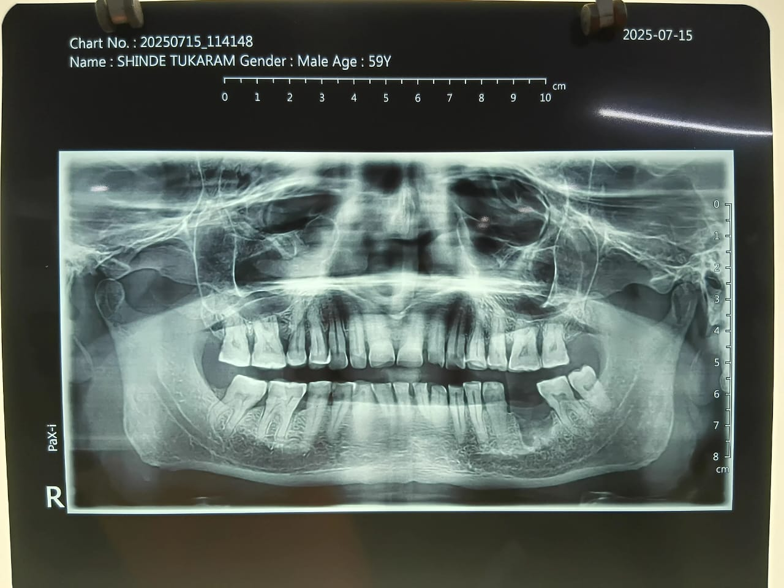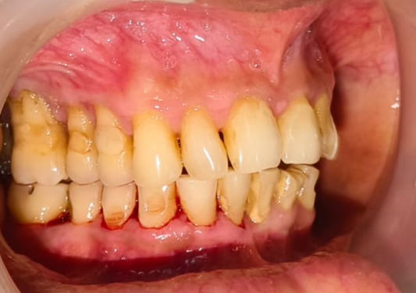

Fig. 1. OPG Fig. 2. Intra Oral

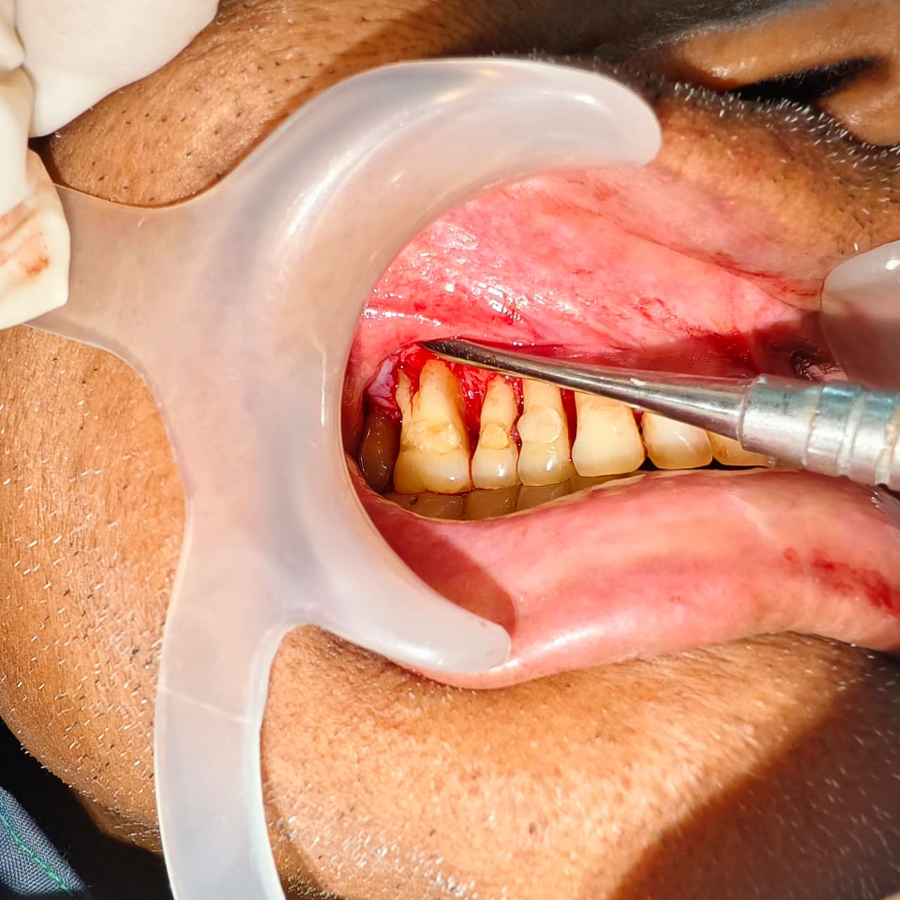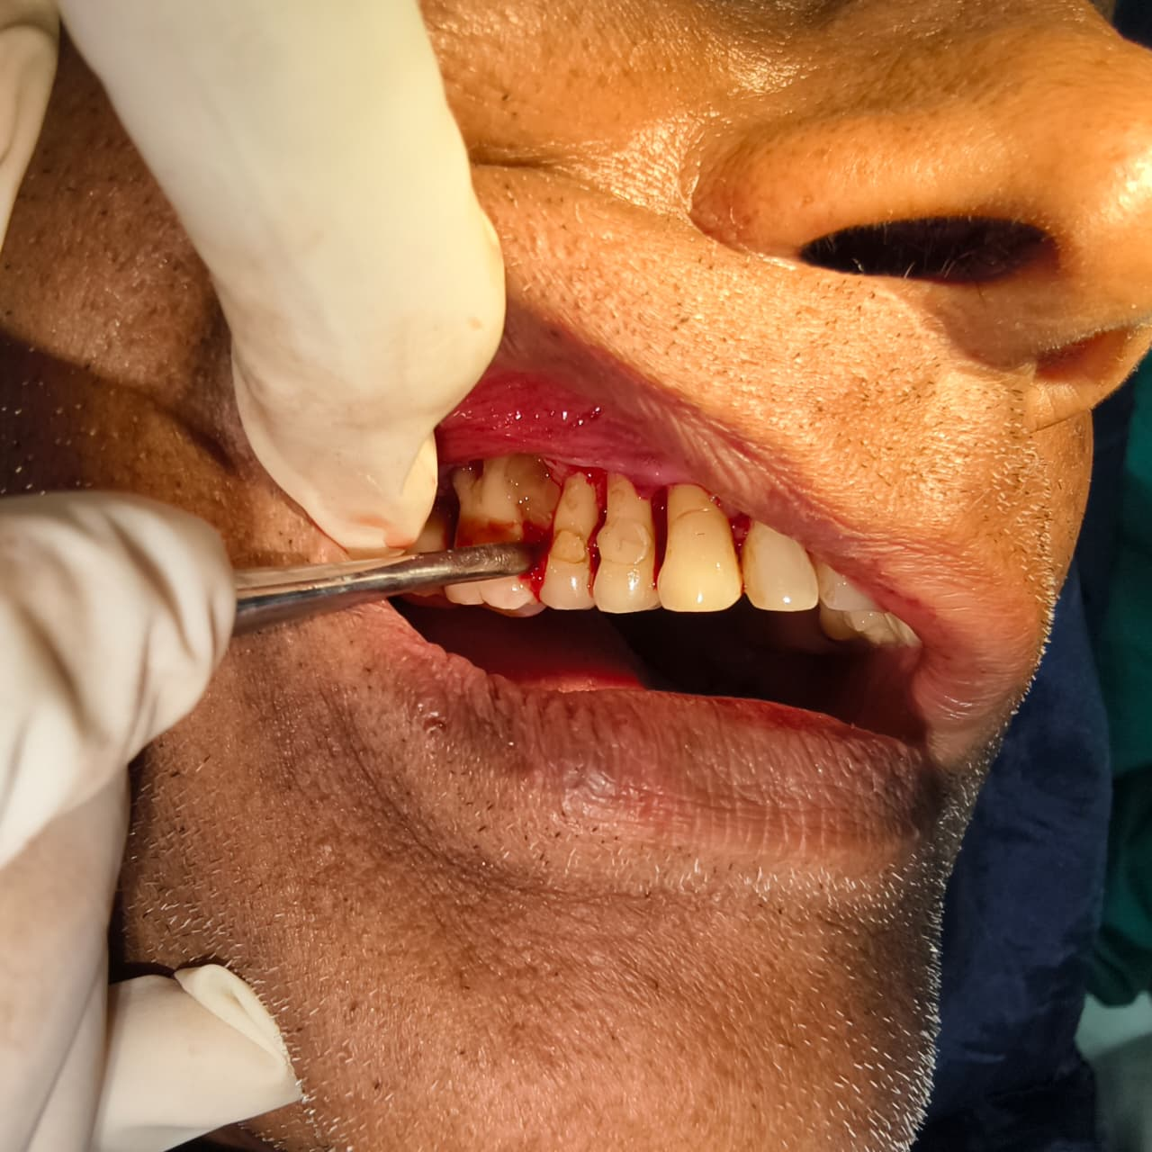

Fig. 3. Long root trunk seen with 16 Fig. 4. PRF placed in defect

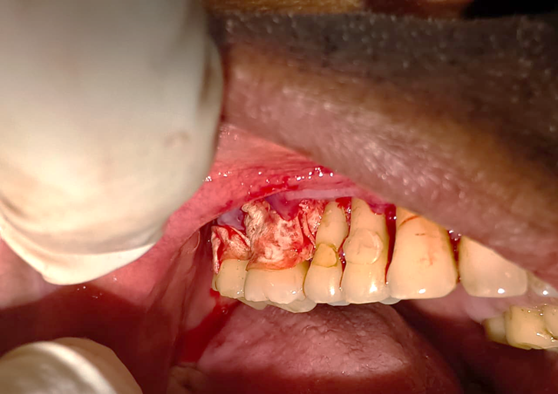

Fig. 5. Collagen membrane placed on buccal surface of 16,17
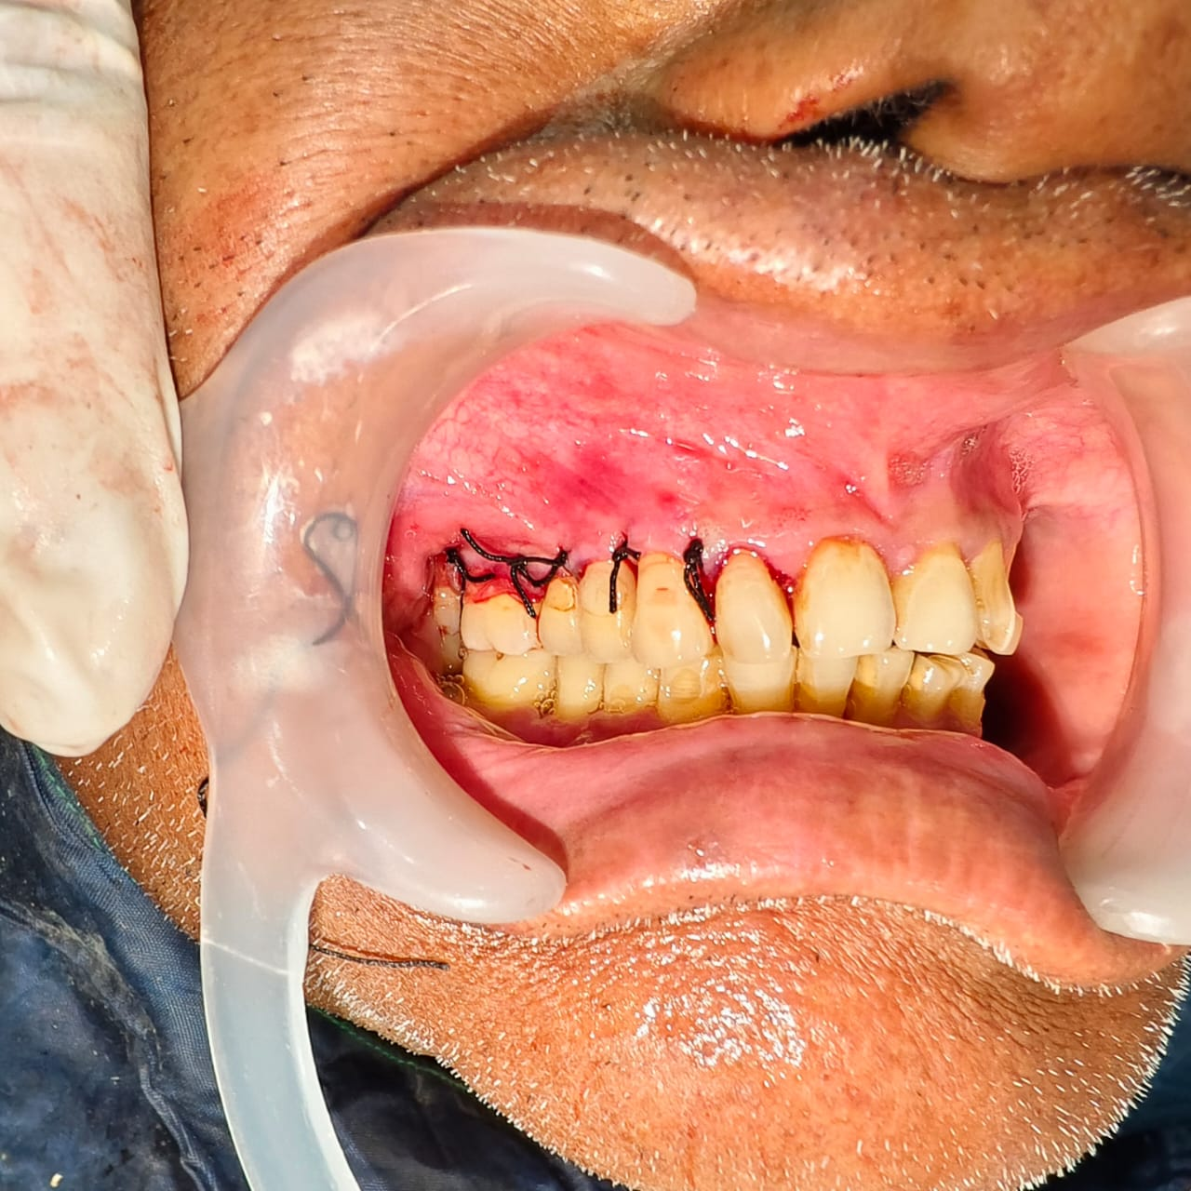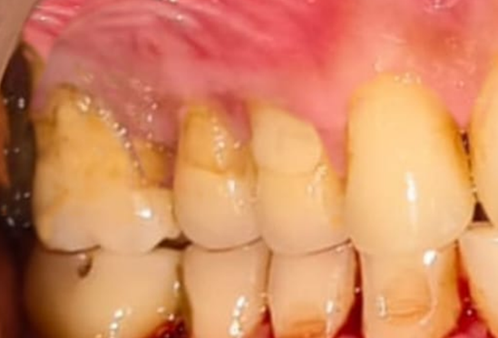

Fig. 6. Sutures placed Fig. 7. 4 months post operative

Intraoperative findings confirmed furcation involvement that was not easily detectable during initial probing. Although the long root trunk delayed furcation involvement, once exposed, the furcation region posed significant challenges for instrumentation and long-term plaque control. Thus, the patient was placed on a strict supportive periodontal therapy regimen.

Case 2: A 46-year-old male reported to the Department of Periodontology with the chief complaint of bleeding gums and overgrowth. He was non-smoker and systemically healthy with no history of diabetes, and reported irregular dental check-ups.

Clinical examination: Generalized gingival inflammation with probing pocket depths of 5-6 mm with respect to 24, moderate plaque accumulation with a Plaque Index score of 1.6 and Gingival Index score of 2.1. No mobility was detected with respect to tooth 24. On radiographic examination, OPG revealed moderate bone loss.

As part of initial treatment plan scaling and root planing was performed. Subsequently, under local anaesthesia, a conventional flap surgery was carried out. Following flap reflection, thorough debridement of the root surfaces was achieved. Intraoperative findings revealed Grade II furcation involvement with respect to tooth 24. A platelet-rich fibrin (PRF) membrane was then placed so as to enhance periodontal regeneration. The site was secured with sutures and covered with a periodontal dressing.

Postoperative healing was uneventful. At follow-up visits, the surgical site demonstrated healthy gingival architecture, reduction in probing pocket depth to 3 mm, and gain in clinical attachment. The Plaque Index improved to 0.7 and the Gingival Index reduced to 0.6, reflecting effective plaque control and patient compliance with oral hygiene instructions.

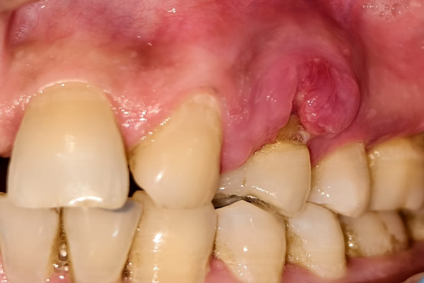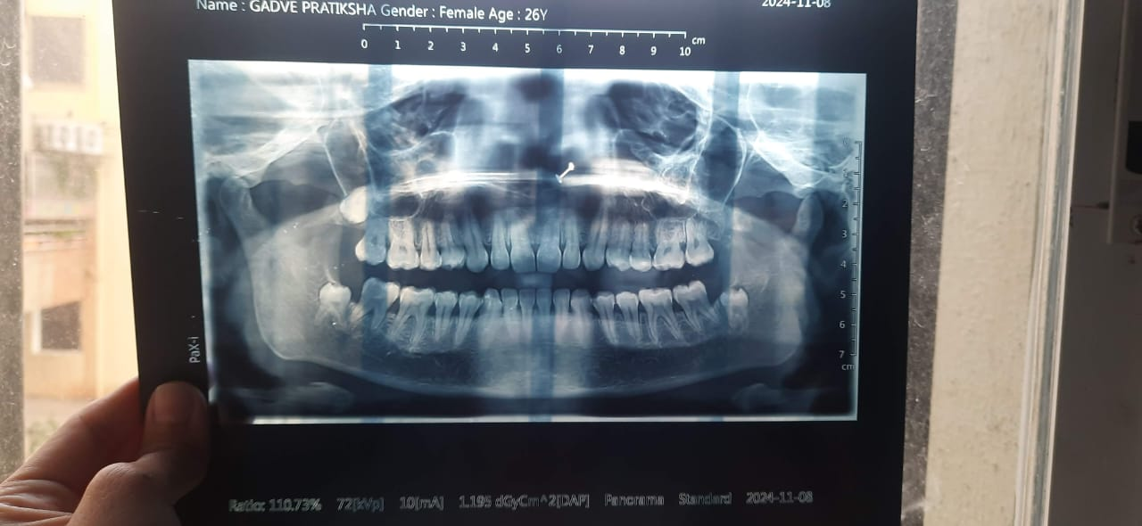

Fig. 8. Pre-operative Fig. 9. OPG

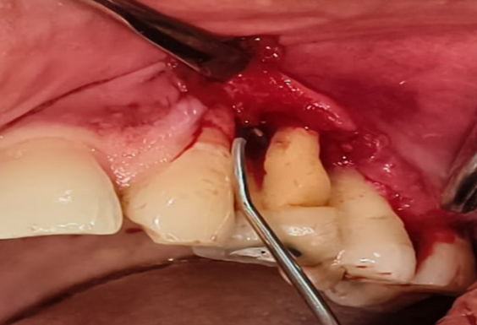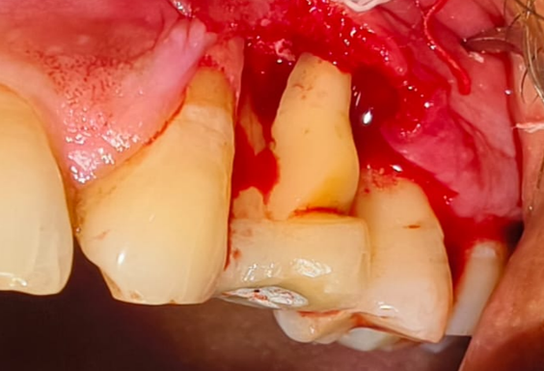

Fig. 10. Premolar Furcation involvement

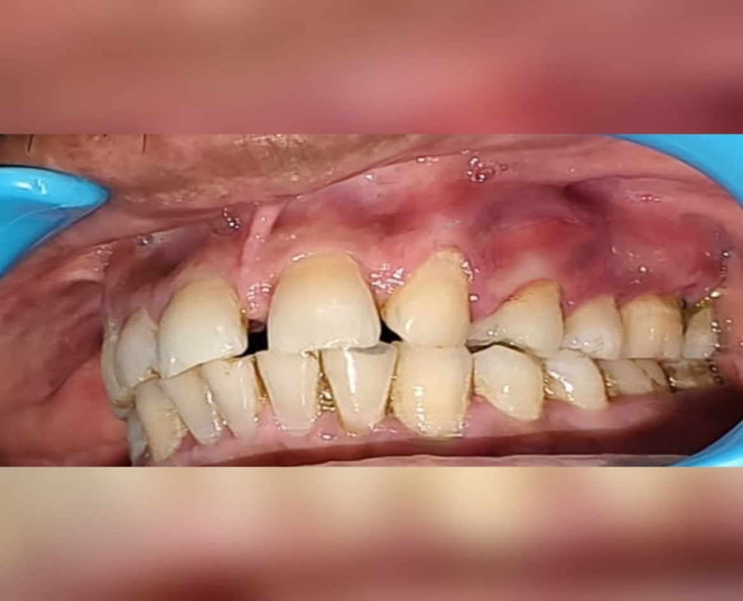

Fig. 11. 6 months post operative

Premolar furcation involvement is often overlooked due to its rarity. Maxillary first premolars with bifurcated roots can present early furcation involvement, complicating diagnosis and requiring careful radiographic and clinical evaluation.

Case 3: A 13-year-old patient reported to the Department of Periodontology with the chief complaint of localized swelling in the posterior region of the oral cavity. The swelling was associated with mild discomfort and intermittent discharge.

Clinical examination: Gingiva in the affected area appeared inflamed, with a sinus tract opening evident on the lingual aspect of tooth 46. The Plaque Index was recorded at 1.7, indicating moderate plaque accumulation, and the Gingival Index was 2.0, reflecting marked gingival inflammation. Probing revealed a lingual pocket depth of 4 mm with respect to tooth 46. The patient’s dental history revealed that root canal treatment (RCT) had been performed on 46 six months earlier at a private dental clinic. There was no history of trauma or systemic illness.
Intraoral periapical radiographic examination demonstrated: Radiolucency in the furcation region seen. These findings were suggestive of furcation involvement, despite the patient’s young age and relatively short duration since endodontic therapy.

Based on clinical and radiographic findings, a diagnosis of early furcation involvement associated with short root trunk length was made.

On surgical interventions under local anesthesia, conventional flap was reflected to gain access to the furcation area. Intraoperatively, Grade II furcation involvement was confirmed at an early level, consistent with short root trunk anatomy. Thorough debridement of granulation tissue was carried out, followed by bone graft was placed in the defect. The site was secured with sutures and covered with a periodontal dressing.

Postoperative healing was uneventful. At follow-up visits, the surgical site demonstrated healthy gingival architecture, reduction in probing pocket depth to 3–4 mm, and gain in clinical attachment. The Plaque Index improved to 0.8 and the Gingival Index reduced to 0.7, reflecting effective plaque control and patient compliance with oral hygiene instructions.

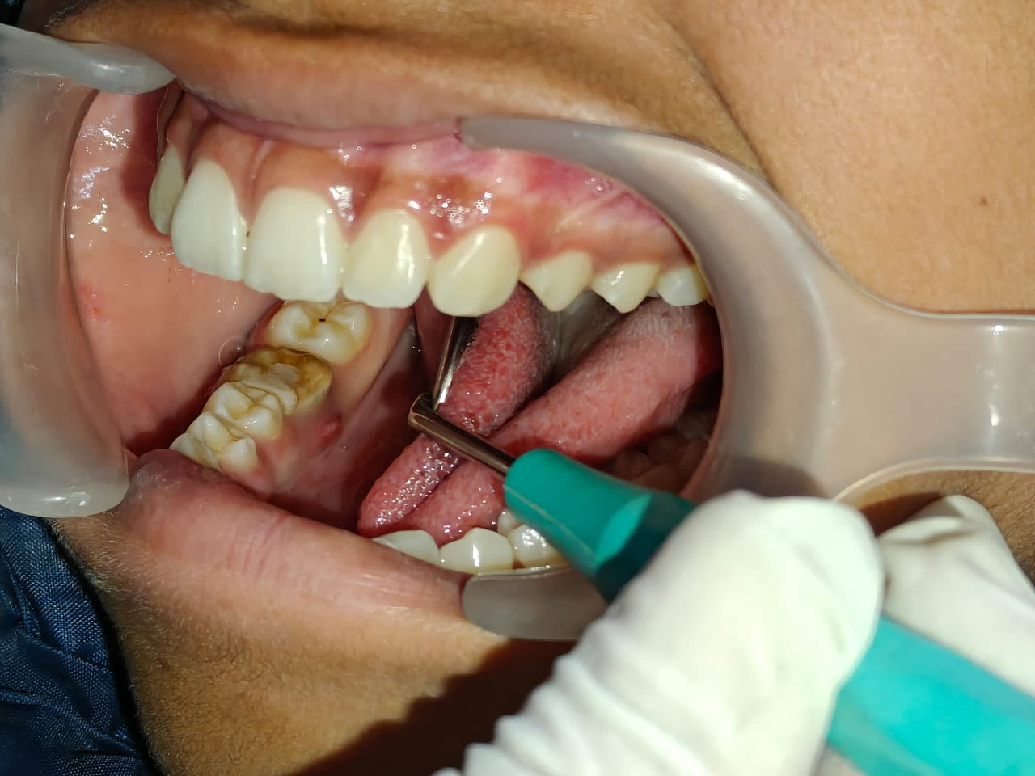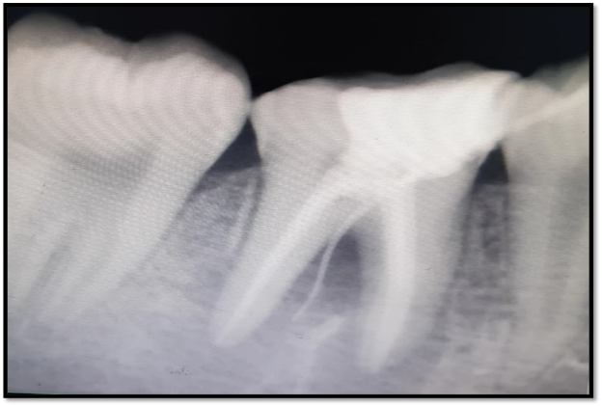

Fig. 12. Sinus Tract seen with 46 Fig. 13. RVG w.r.t 46

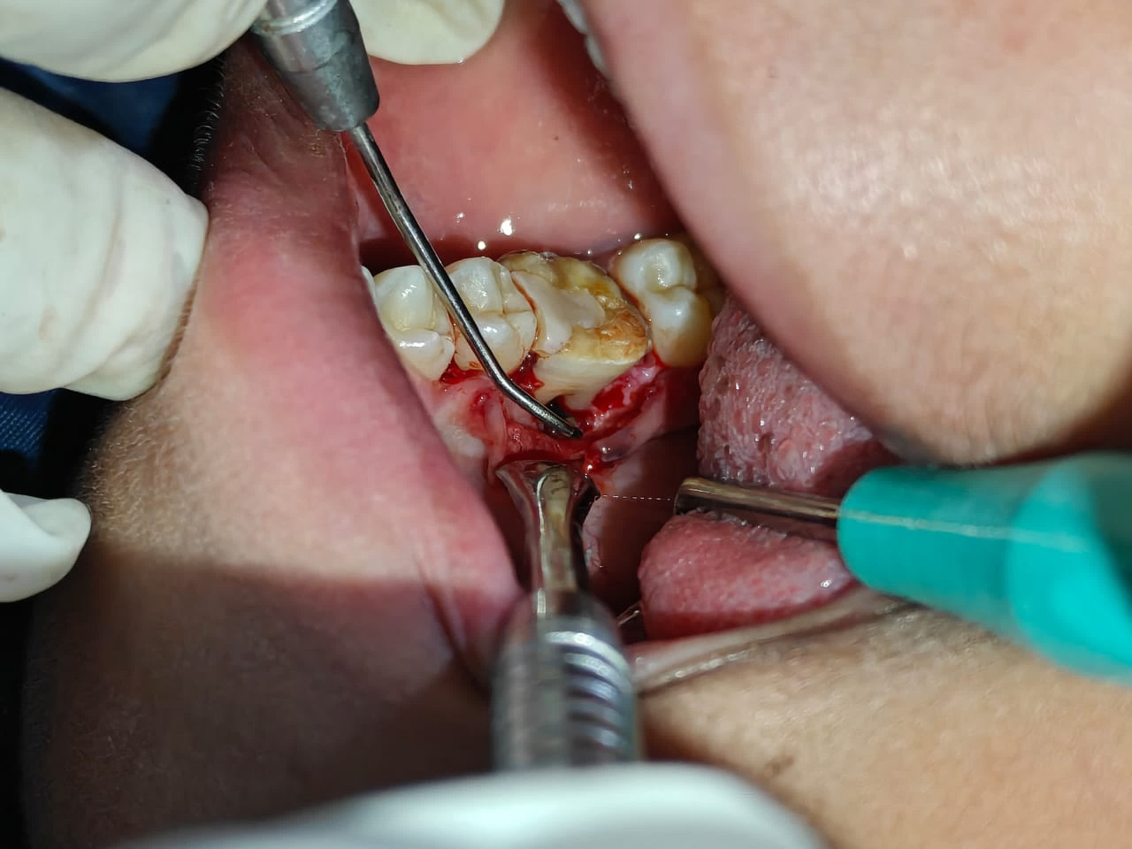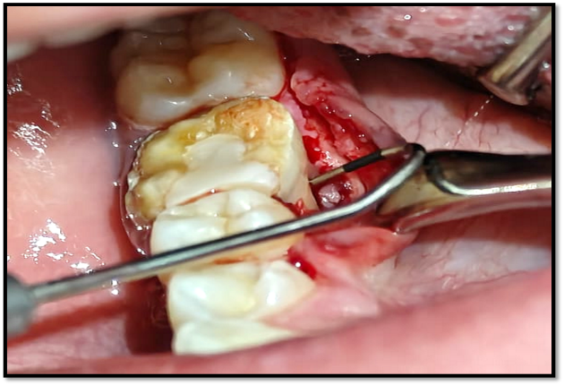

Fig. 14. Furcation involvement seen on lingual aspect of 46

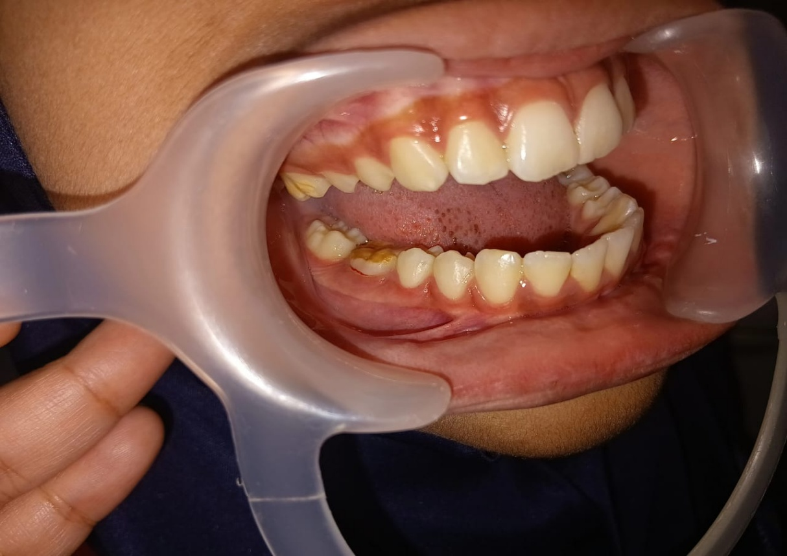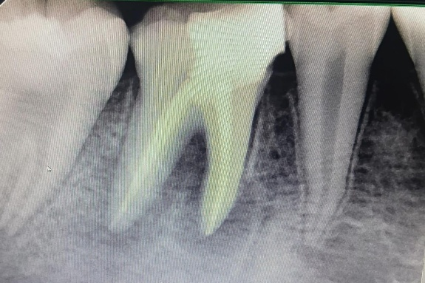

Fig. 15. Post-operative Fig. 16. Post-operative RVG

In teeth with a short root trunk, the furcation area become exposed early in the course of periodontal disease, even with limited attachment loss.

In the present case, the short root trunk allowed periodontal inflammation and plaque accumulation to rapidly extend into the furcation region. This resulted in:

- Early interradicular bone loss
- Difficulty in effective plaque control
- Rapid progression of periodontal destruction
- Formation of a sinus tract despite recent endodontic therapy

3. Discussion

Root morphology has a significant impact on the onset, progression, and treatment outcomes of periodontal disease, especially in molar teeth where root trunk length and root configuration determine the susceptibility to furcation involvement.

Al-Shammari et al. (2001) reported that, the average root lengths of maxillary and mandibular first molars have been reported as 12.6 mm and 13.7 mm, with maxillary mesiobuccal and palatal roots being longer than distobuccal roots, while root trunk heights may extend up to 7.8 mm in maxillary and 6.6 mm in mandibular molars. Teeth with long root trunks and short roots demonstrate delayed clinical detection of furcation involvement but experience greater periodontal destruction once furcal invasion occurs, making them poor candidates for root resection procedures (Dababneh et al., 2011).

Additionally, long root trunks combined with wide furcation entrances and high-positioned furcation fornix have been associated with reduced success of periodontal therapy due to challenges in achieving complete debridement in these areas (Horwitz et al., 2004). According to McClain & Schallhorn (McClain & Schallhorn, 2000), teeth with short root trunks become vulnerable to early furcation involvement; however, they tend to show better post-treatment prognosis since the extent of periodontal destruction required for furcation exposure is comparatively less.

Beyond trunk length alone, the presence of developmental grooves and root surface concavities significantly influences plaque retention and treatment predictability, particularly in regenerative procedures where anatomical irregularities can compromise outcomes even in teeth with short trunk morphology (Svärdström & Wennström, 1988). Lu (1992) Reported that 94% of the furcation possessed variant depth of developmental concavities on the root trunks. These superficial irregularities at the entrances of furcation may prevent complete adaptation of the coronal microstructure of the membrane along their root surfaces, so they suggested that subgingival application of guided tissue membranes 1-2 mm below CEJ cannot ensure complete adaptation of furcation defects with their coronal microstructures in the majority of molars.

Joseph et al. (1996) reported that furcation involvement in maxillary first premolars is uncommon but clinically significant because a substantial proportion of these teeth exhibit bifurcated roots. Due to this relative rarity, furcation involvement in premolars is often overlooked, resulting in delayed diagnosis and progression of periodontal destruction, as seen in the present case. Whereas Chen et al. (2024) demonstrated that mesial root concavities of maxillary first premolars are significantly associated with increased periodontal inflammation and alveolar bone loss. Such concavities act as plaque-retentive areas, accelerating periodontal destruction and contributing to furcation involvement, findings that correlate well with the clinical presentation in the present case.

Takei and Han et al. (1996) highlighted that root trunk length should be considered a key factor in treatment planning for furcation-involved teeth. Mandibular molars with short root trunks are often more amenable to open flap debridement and regenerative therapy, aligning with the treatment strategy employed in this case. Bowers et al. (1989) reported that Class II furcation defects, commonly encountered in mandibular molars with short root trunks, show better regenerative potential compared to advanced furcation defects. This supports the treatment approach and outcome achieved in the present case.

Newell et al. (1998) emphasized that early detection of furcation involvement in mandibular molars can result in a more favorable prognosis, provided appropriate periodontal therapy is instituted. The early identification in the present case contributed to timely management and improved treatment predictability.

Miron et al. (2024) Conducted a systematic review and meta-analysis showing that the use of platelet-rich fibrin (PRF) significantly improves clinical outcomes (PPD reduction, attachment gain) in Class II furcation defects when compared to open flap debridement, and that PRF combined with bone grafts or membranes may offer additional benefits.

Jepsen et al. (2020) Concluded that regenerative therapy provides superior clinical outcomes compared to open flap debridement alone in Class II furcation defects.

Georgiou et al. (2022) Provides a summary of clinical evidence showing mild to moderate clinical improvement with the use of regenerative materials (bone grafts, membranes, blood derivatives) in furcation treatment compared to OFD alone.

Sharma et al. (2011) Demonstrates enhanced periodontal healing and bone fill when PRF is used in Class II furcation defects as a grafting material or in combination with membranes. PRF acts as an autologous scaffold with growth factors that support wound healing and neovascularization.

Overall, these findings demonstrate that successful management of furcation-involved molars requires a comprehensive understanding of root trunk length, inter-root morphology, and surface characteristics to tailor periodontal treatment effectively.

4. Conclusion

Root morphology is a decisive determinant of periodontal disease progression, diagnostic accuracy, and therapeutic success. Anatomical variations such as root trunk length, furcation anatomy, and root surface characteristics profoundly influence plaque retention and accessibility for periodontal instrumentation. Comprehensive evaluation of root morphology should form an integral part of periodontal diagnosis and treatment planning. An individualized, morphology-based approach enhances treatment outcomes and contributes to long-term tooth presentation.

.
Consent

Written informed consent was obtained from all patients (and from the legal guardian in the case of the minor patient) prior to treatment and for the use of clinical data and photographs for publication purposes.

Ethical Approval

The study was conducted in accordance with the ethical principles outlined in the Declaration of Helsinki. This case series has been prepared in compliance with the CARE Guidelines for case reporting.

Competing Interests

Authors have declared that no competing interests exist.

Disclaimer (Artificial Intelligence)

Author(s) hereby declare that NO generative AI technologies such as Large Language Models (ChatGPT, COPILOT, etc) and text-to-image generators have been used during writing or editing of this manuscript.

References

Al-Shammari, K. F., Kazor, C. E., & Wang, H. L. (2001). Molar root anatomy and management of furcation defects. Journal of Clinical Periodontology, 28(8), 730– 740.
Bowers, G. M., Chadroff, B., Carnevale, R., et al. (1989). Histologic evaluation of new attachment apparatus formation in humans. Journal of Periodontology, 60(12), 683–693.
Bowers, G. M., Schallhorn, R. G., McClain, P. K., Morrison, G. M., & Morgan, R. (2003). Factors influencing the outcome of regenerative therapy in furcation defects. Journal of Periodontology, 74(9), 1257–1268.
Carranza, F. A., Newman, M. G., Takei, H. H., & Klokkevold, P. R. (2019). Carranza’s clinical periodontology (13th ed.). Elsevier.
Chen, F., Liu, Q., Liu, X., Fang, Q., Zhou, B., Li, R., et al. (2024). Periodontitis was associated with mesial concavity of the maxillary first premolar: A cross-sectional study. Scientific Reports.
Dababneh, R., et al. (2011). Root trunk: Types and dimension and their influence on the diagnosis and treatment of periodontally involved first molars. Journal of the Royal Medical Services.
Georgiou, O. A., et al. (2022). Regenerative materials in the treatment of Class II furcation defects: An overview. Dentistry Journal.
Gher, M. E., & Vernino, A. R. (1980). Root morphology—clinical significance in periodontal disease. Journal of the American Dental Association, 101(4), 627–633.
Goldman, H. M., & Cohen, D. W. (1980). Periodontal therapy (6th ed.). Mosby.
Horwitz, J., Machtei, E. E., Reitmeir, P., Holle, R., Kim, T. S., & Eickholz, P. (2004). Radiographic parameters as prognostic indicators for healing of class II furcation defects. Journal of Clinical Periodontology, 31, 105–111.
Hou, G. L., & Tsai, C. C. (1997). Relationship between periodontal furcation involvement and root trunk length. Journal of Periodontology, 68(4), 356–362.
Jepsen, S., et al. (2020). Regenerative surgical treatment of furcation defects: A systematic review and Bayesian network meta-analysis. Journal of Clinical Periodontology.
Joseph, I., et al. (1996). Clinical significance of furcation anatomy of the maxillary first premolar: A biometric study on extracted teeth. Journal of Periodontology.
Lu, H. K. J. (1992). Topographical characteristics of root trunk length related to guided tissue regeneration. Journal of Periodontology, 63, 215–219.
McClain, P. K., & Schallhorn, R. G. (2000). Focus on furcation defects – guided tissue regeneration in combination with bone grafting. Periodontology 2000, 22, 190–212.
Miron, R. J., et al. (2024). Use of platelet-rich fibrin in periodontal furcation defects: A systematic review and meta-analysis. Journal of Periodontology.
Nabers, C. L. (1954). The anatomy of the furcation area in maxillary and mandibular molars. Journal of Periodontology, 25(2), 123–128.
Newell, D. H., et al. (1998). The role of the furcation in periodontal disease. Periodontology 2000.
Ochsenbein, C., & Ross, S. (1969). A reevaluation of osseous surgery. Dental Clinics of North America, 13(1), 87– 102.
Sharma, A., et al. (2011). Treatment of mandibular Class II furcation defects using platelet-rich fibrin. Journal of Periodontology.
Svärdström, G., & Wennström, J. L. (1988). Furcation topography of the maxillary and mandibular first molars. Journal of Clinical Periodontology, 15(5), 271–275.
Svärdström, G., & Wennström, J. L. (1988). Furcation topography of the maxillary and mandibular first molars. Journal of Clinical Periodontology.
Takei, H. H., Han, T. J., Carranza, F. A., et al. (1996). The furcation problem: Etiology, diagnosis, and treatment considerations. Periodontology 2000.
Waerhaug, J. (1978). Healing of the dento-epithelial junction following subgingival plaque control. Journal of Periodontology, 49(3), 119–134.

Disclaimer/Publisher’s Note: The statements, opinions and data contained in all publications are solely those of the individual author(s) and contributor(s) and not of the publisher and/or the editor(s). This publisher and/or the editor(s) disclaim responsibility for any injury to people or property resulting from any ideas, methods, instructions or products referred to in the content.

© Copyright (2026): Author(s). The licensee is the journal publisher. This is an Open Access article distributed under the terms of the Creative Commons Attribution License (http://creativecommons.org/licenses/by/4.0), which permits unrestricted use, distribution, and reproduction in any medium, provided the original work is properly cited.

