Comparative Morphometrical Studies on the Head Region of Zovawk (Sus scrofa domesticus) and Wild Pig (Sus scrofa)

Abstract

Comparative morphometrical information on the cranial anatomy of indigenous pig breeds of Northeast India remains limited. The present study aimed to evaluate and compare the head morphometry of Zovawk (Sus scrofa), an indigenous semi-wild pig of Mizoram, and the Indian wild pig (Sus scrofa). Six adult skulls (three Zovawk and three wild pig), irrespective of sex, were collected, macerated, and examined following standard osteological procedures. A comprehensive set of cranial, neurocranial, viscerocranial, facial, palatine, orbital, and mandibular parameters was recorded using established reference points. Both Zovawk and wild pig skulls were classified as dolichocephalic; however, wild pigs consistently exhibited significantly larger dimensions across most parameters, including skull length, breadth, cranial capacity, facial measurements, orbital dimensions and palatine indices. Zovawk showed comparatively smaller but proportionate cranial and facial features, closely resembling those of domesticated pigs of Mizoram. The observed differences reflect breed-specific adaptations and varying degrees of domestication. This study provides baseline comparative morphometrical data that may be useful for anatomical reference, breed characterization, wildlife forensics, and clinical applications in veterinary practice.

Keywords: Head region, morphometrical, parameters, skull, wild pig, Zovawk

Introduction
Zovawk is an indigenous pig type of northeastern India, predominantly reared in various regions of Mizoram, which serves as its natural habitat (Mayengbam et al., 2014). They are characterized by a predominantly black body coat with a distinct white spot on the forehead, white patches on the ventral abdomen, and white markings on the lower limbs commonly referred to as white boots, along with erect ears, a concave snout, a pot-shaped abdomen, a concave topline, and long bristles distributed along the dorsal midline of the body. The average body weight is approximately 54 kg in male’s and in female’s was 59 kg (Vanlalrozami et al., 2018). These animals attain pubertal maturity at about 2.5 months of age, with a corresponding average body weight of 4.5 kg (Debroy et al., 2021).
The wild pig (Sus scrofa) in India is morphologically similar to the domestic pig. The Indian wild pig has a tall skull with a flat dorsal surface, small proportionate teeth, and short nasal bones. Adults wild pig display thick crests of stiff, coarse black and brindle-colored hair running from the nape along the dorsal midline. Male wild pigs possess well-developed upper and lower canines that curve upward and protrude from the long snout (Choudhary et al., 2017).
A review of the available literature indicates that comparative morphometrical data on the head region of Zovawk and wild pig are lacking. In view of this gap, the present study was undertaken to investigate the morphometry of the head region of Zovawk and wild pig.
Materials and Methods
The present study used six adult head specimens - three from Zovawk and three from wild pigs—irrespective of sex. The samples were sourced from the Livestock Farm Complex, local slaughterhouses, and Khawruhlian village. After collection, the heads were separated at the occipito-atlantal joint, the skin and muscles were carefully removed, and the samples were macerated using the method described by Savitri et al. (2023). After maceration, the skull bones were cleaned, treated with 3% hydrogen peroxide for three days, then washed with water, and dried for examination. The parameters mentioned below were measured using standard measuring instruments, including a digital vernier caliper, thread, and a measuring scale. Various measurements of the skull bones were taken as per the methodology described by Doley et al. (2018). The collected data was subjected to statistical analysis for calculating their mean, standard error and coefficient of variance as per the method described by Doley et al. (2018).
The comparative morphometrical investigations were conducted in the Department of Veterinary Anatomy and Histology, College of Veterinary Sciences and Animal Husbandry, Selesih, Aizawl, Mizoram.

Table 1-Statistical Analysis of the skull parameters of Zovawk and wild pig
Skull Parameters | Mean ± SE (cm) |  | Coefficient of Variance (%) |  | P Value
Skull Parameters | Zovawk | Wild pig |  |  | P Value
LSK: Opisthokranion (Op) to Prosthion (P) | 28.73 ± 0.58 | 31.87 ± 0.19 | 3.49 | 1.01 | 0.007**
BSK: Zygion (Zy) to Zygion (Zy) | 15.03 ± 0.78 | 21.60 ± 0.87 | 8.93 | 6.99 | 0.005**
SI: $\frac{ Skull breadth}{Skull length}×100$ | 52.25 ± 1.76 | 67.79 ± 2.85 | 5.85 | 7.28 | 0.010*
PRL: Akrokranion (A) to Prosthion (P) | 28.18 ± 0.51 | 30.93 ± 0.22 | 3.11 | 1.22 | 0.008**
SSL: Basion (B) to Premolare (Pm) | 19.07 ± 0.47 | 20.60 ± 0.70 | 4.27 | 5.91 | 0.144^{NS}
SBL: Basion (B) to Prosthion (P) | 27.67 ± 0.71 | 30.70 ± 0.55 | 4.46 | 3.11 | 0.028*
CBL: Post Occipital Condyle (POc) to Prosthion (P) | 29.43 ± 0.72 | 32.87 ± 0.52 | 4.22 | 2.76 | 0.018*
BCA: Basion (B) to Hormion (H) | 5.15 ± 0.14 | 6.73 ± 0.20 | 4.78 | 5.22 | 0.003**
BFA: Hormion (H) to Prosthion (P) | 22.52 ± 0.79 | 23.97 ± 0.37 | 6.05 | 2.68 | 0.171^{NS}
NST: The distance between the nasofrontal suture's median point (N) and the most caudal point of the horizontal section of the palate in the median plane (St). | 4.96 ± 0.20 | 6.60 ± 0.21 | 6.87 | 5.46 | 0.005**
GMB: Otion (Ot) to Otion (Ot) | 10.82 ± 0.13 | 18.03 ± 0.15 | 2.01 | 1.40 | <.001**
GBOC: The distance between the most lateral points of the occipital condyles (OcL). | 5.0 ± 0.12 | 7.90 ± 0.21 | 4.0 | 4.56 | <.001**
GBP: The distance between paracondyloid process bases (PcP). | 5.54 ± 0.09 | 9.03 ± 0.20 | 2.68 | 3.89 | <.001**
Neurocranial Parameters
NEL: Basion (B) to Nasion (N) | 10.50 ± 0.29 | 14.98 ± 0.32 | 4.76 | 3.67 | <.001**
NEB: Ectorbitale (Ect) to Ectorbitale (Ect) | 10.22 ± 0.33 | 15.53 ± 0.24 | 5.53 | 2.68 | <.001**
NI: $\frac{Greatest breadth of Frontal}{ Length of Frontal}×100$ | 97.60 ± 5.20 | 103.71 ± 0.58 | 9.23 | 0.98 | 0.308^{NS}
HNR: Basion (B) to Akrokranion (A) | 10.0 ± 0.50 | 17.17 ± 0.18 | 8.66 | 1.78 | <.001**
NC: Cotton was used to block all cranial foramina, and mustard seeds were inserted through the foramen magnum to fill the cavity and measure its capacity using measuring cylinder. | 89.33 ± 9.91 | 124.0 ± 1.16 | 19.21 | 1.61 | 0.025*
UNL: Akrokranion (A) to Supraorbitale (Sp) | 10.92 ± 0.70 | 13.84 ± 0.44 | 11.09 | 5.53 | 0.024*
MFL: Akrokranion (A) to Nasion (N) | 13.75 ± 0.20 | 14.87 ± 0.19 | 2.55 | 2.16 | 0.015*
FRL: Bregma (Br) to Nasion (N) | 9.79 ± 0.90 | 10.93 ± 0.15 | 15.95 | 2.30 | 0.279^{NS}
GFB: Ectorbitale (Ect) to Ectorbitale (Ect) | 10.22 ± 0.33 | 15.53 ± 0.24 | 5.53 | 2.68 | <.001**
FRI: $\frac{Greatest breadth of Frontal}{ Length of Frontal}×100$ | 105.79 ± 7.57 | 142.06 ± 0.45 | 12.93 | 0.55 | 0.009**
PL: Akrokranion (A) to Bregma (Br) | 3.96 ± 0.77 | 3.93 ± 0.24 | 33.76 | 10.58 | 0.975^{NS}
LBP: The least breadth between the parietal bone's temporal lines (TIP) | 3.91 ± 0.56 | 5.83 ± 0.15 | 24.75 | 4.31 | 0.029*
LBSO: The least breadth measured between the Linea Nuchalis Lateralis (LNuL). | 5.56 ± 0.17 | 7.84 ± 0.17 | 5.40 | 7.22 | 0.004**
HTF: The largest distance between the dorsal most point of the temporal line (TID) and the rostral edge of the temporal bone's root zygomatic process (RZyT). | 9.60 ± 0.23 | 14.43 ± 0.30 | 4.17 | 3.56 | <.001**
WTFO: Nuchal Crest Lateralis (NuCrL) to Ectorbitale (Ect) | 5.98 ± 0.47 | 12.33 ± 0.19 | 13.52 | 2.61 | <.001**
DTF: The largest distance between the medial wall of the temporal fossa (TIM) and the Caudo-dorsal process of the zygomatic arch (PZy). | 2.33 ± 0.09 | 4.03 ± 0.15 | 6.55 | 6.24 | <.001**
BFM: The maximum distance between the lateral margins of Foramen Magnum. | 2.47 ± 0.06 | 3.37 ± 0.12 | 4.23 | 6.18 | 0.003**
HFM: Basion (B) to Opisthion (O) | 2.58 ± 0.03 | 3.50 ± 0.12 | 2.27 | 5.71 | 0.002**
IFM: $\frac{Breadth of Foramen Magnum}{Height of foramen Magnum}×100$ | 95.70 ± 3.51 | 96.09 ± 1.04 | 6.36 | 1.88 | 0.920^{NS}
CMF: Measured along the foramen magnum's rim. | 6.30 ± 0.15 | 7.37 ± 0.07 | 4.2 | 1.57 | 0.003**
Viscerocranial and Facial Parameters
VIL: Nasion (N) to Prosthion (P) | 14.43 ± 0.33 | 16.07 ± 0.07 | 3.94 | 0.72 | 0.008**
GLN: Nasion (N) to Rhinion (R) | 13.68 ± 0.31 | 14.37 ± 0.09 | 3.91 | 1.06 | 0.100^{NS}
SNL: Nasion (N) to Post Nasomaxillary (PNMx) | 10.68 ± 0.36 | 12.14 ± 0.15 | 5.89 | 2.12 | 0.021*
BAN: The distance measured between the Naso-Fronto-Maxillary Sutures (NFMxS) | 4.36 ± 0.30 | 5.14 ± 0.25 | 12.01 | 8.38 | 0.117^{NS}
NI: $\frac{Breadth across Nasal bones}{ Greatest length of the Nasal bone}×100$ | 31.80 ± 1.68 | 35.75 ± 1.52 | 9.13 | 7.38 | 0.156^{NS}
ULA: Post Lacrimal (PoL) to Pre lacrimal (PrL) | 3.99 ± 0.26 | 5.88 ± 0.15 | 11.31 | 4.52 | 0.003**
HEL: The greatest distance between the lacrimal, zygomatic, and maxilla's most dorsal and rostral points of intersection. | 3.04 ± 0.19 | 3.30 ± 0.26 | 10.83 | 13.89 | 0.475^{NS}
LAM: The distance between the most caudal point of the zygomatico-maxillary suture and the most rostral point of the maxillo-incisive suture. | 11.19 ± 0.40 | 12.17 ± 0.40 | 6.14 | 2.51 | 0.087^{NS}
LAP: Nasointermaxillare (Ni) to Prosthion (P) | 11.14 ± 0.18 | 13.05 ± 0.13 | 2.83 | 1.79 | 0.001**
ENI: The nasomedial indentation of the orbit that runs from the medial angle of the eye in a living animal (Ent) to the caudodorsal point of the infraorbital foramen (If). | 6.10 ± 0.62 | 7.30 ± 0.12 | 17.65 | 2.74 | 0.132^{NS}
ICF: Infraorbitale (If) to Eminentia canina (EmC) | 6.00 ± 0.24 | 8.39 ± 0.31 | 6.84 | 6.44 | 0.004**
INP: The distance between the infraorbital foramen's caudo-dorsal point (If) and the median point of the line that connects the premaxilla's most rostral points. | 11.87 ± 0.37 | 15.53 ± 0.24 | 5.33 | 2.68 | 0.001**
FL: Supraorbitale (Sp) to Prosthion (P) | 17.07 ± 0.81 | 20.57 ± 0.79 | 8.21 | 6.62 | 0.036*
FAB: The distance between the most caudal points of the face crest. | 10.02 ± 0.72 | 13.83 ± 0.09 | 12.43 | 1.10 | 0.006*
FI: $\frac{ Facial breadth}{ Facial length}×100$ | 59.37 ± 7.31 | 67.42 ± 2.17 | 21.31 | 5.58 | 0.351^{NS}
ISF: The least distance between supraorbital foramina (SpF). | 3.89 ± 0.28 | 4.60 ± 0.28 | 12.44 | 10.71 | 0.151^{NS}
Palatine Parameters
MPL: Staphylion (St) to Prosthion (P) | 18.07 ± 0.22 | 20.53 ± 0.48 | 12.10 | 4.06 | 0.010*
GPB: Measured across the alveoli's external boundary. | 6.04 ± 0.09 | 8.38 ± 0.30 | 2.58 | 6.26 | 0.002**
PI: $\frac{Greatest Palatine breadth}{ Median Palarine length }×100$ | 33.51 ±0.39 | 40.79 ± 0.70 | 2.00 | 2.96 | <.001**
PRP: The distance between the median point of the line uniting the rostral point of the alveoli of the first cheek teeth (Pm) and the median point of the line connecting the most rostral points of the premaxilla (P). | 6.85 ± 0.09 | 10.17 ± 0.21 | 2.34 | 3.55 | <.001**
RPF: The distance between the median point of the line connecting the caudal borders of the anterior palatine foramina (RpF) and the most caudal point of the horizontal portion of the palate in the median plane (St). | 4.02 ± 0.17 | 4.52 ± 0.05 | 7.43 | 1.78 | 0.050*
POST: The distance between the palatine-maxillary suture's median point (Po) and the most caudal point of the horizontal section of the palate in the median plane (St). | 3.44 ± 0.29 | 3.88 ± 0.06 | 14.60 | 2.71 | 0.215^{NS}
POP: The distance between the palatine-maxillary suture's median point (Po) and the line connecting the premaxilla's most rostral point (P). | 14.1 ± 0.58 | 17.50 ± 0.41 | 7.09 | 4.05 | 0.009**
Orbital Parameters
MAXO: Ectorbitale (Ect) to Entorbital (Ent) | 3.69 ± 0.10 | 4.12 ± 0.14 | 4.89 | 6.02 | 0.069^{NS}
MAXIHO: The maximum distance between the zygomatic bone's frontal process (FZy) and the orbit's dorsal rim. | 4.38 ± 0.04 | 4.79 ± 0.41 | 1.58 | 14.90 | 0.378^{NS}
OI: $\frac{Maximum inner length of the orbit}{ Median inner height of the orbit}×100$ | 84.14 ± 1.73 | 87.56 ± 9.11 | 3.56 | 18.01 | 0.731^{NS}
ORC: Measured around the orbital rim's circumference. | 13.2 ± 0.17 | 15.07 ± 0.60 | 2.27 | 6.91 | 0.041*
ORA: ¼ π LH where L was the length of the orbit and H was the height of the orbit. | 12.68 ± 0.46 | 15.45 ± 1.08 | 6.32 | 12.08 | 0.077^{NS}
ORD: Distance from the optic foramen to the intersection of orbital length and height. | 5.21 ± 0.32 | 8.56 ± 1.17 | 10.52 | 23.69 | 0.051*
IND: The minimal distance across the orbit's dorsal rims | 7.42 ± 0.29 | 12.05 ± 0.35 | 6.82 | 5.10 | <.001**

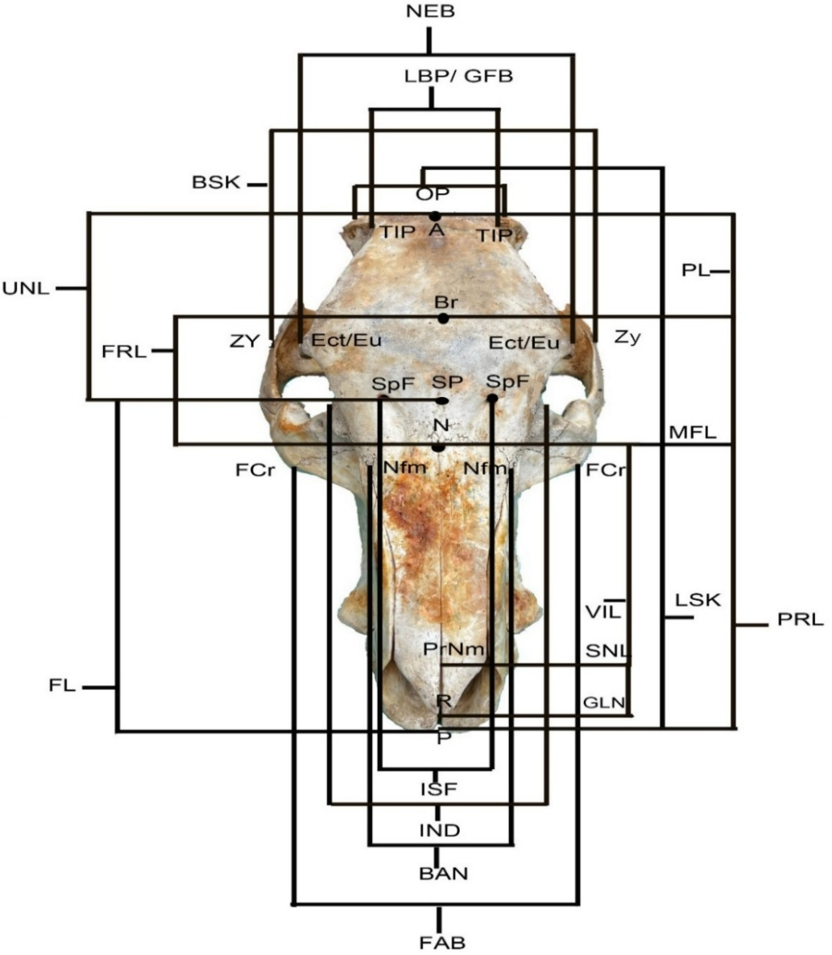

Fig. 1. Measurements of dorsal View of the skull of Zovawk. Skull length (LSK), Skull breadth (BSK), Profile length (PRL), Upper Neurocranial length (UNL), Neurocranial breadth (NEB), Median frontal length (MFL), Frontal length (FRL), Parietal length (PL), Least breadth of the parietals (LBP), Viscerocranial length (VIL), Greatest length of the nasal (GLN), Short nasal length (SNL), Breadth across the nasal (BAN), Facial length (FL), Facial breadth (FAB), Intra Supraorbital foramina distance (ISF), Prosthion (P), Rhinion (R), Bregma (Br), Nasion (N), Akrokranion (A), Opisthokranion (OP), Naso-Fronto-Maxillare suture (Nfm), Ectorbitale (Ect), Supraorbitale foramen (SpF), Euryon (EU), Facial Crest (FCr), Temporal line of the parietal (TIP), Zygion (Zy), Pre Nasomaxillary (PrNm), Supraorbitale (SP) and Inter Orbital distance (IND).
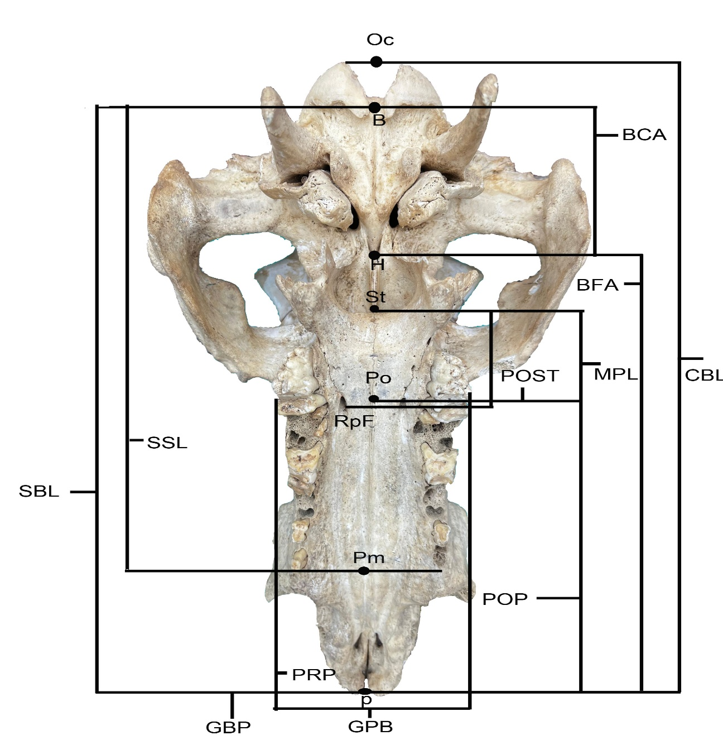

Fig. 2. Measurements of basal of the skull of wild pig. Short skull length (SSL), Skull base length (SBL), Condylobasal length (CBL), Basicranial axis (BCA), Basifacial axis (BFA), Median palatine length (MPL), Greatest palatine breadth (GPB), Premolar to Prosthion (PRP), Rostral palatine foramina to Staphylion (RPF), Palatino-oral to Staphylion (POST), Palatino-oral to Prosthion (POP), Basion (B), Hormion (H), Post Occipital condyle (Oc), Staphylion (St), Premolare (Pm), Rostral Palatine foramen (RpF) and Palatino-Oral (Po).
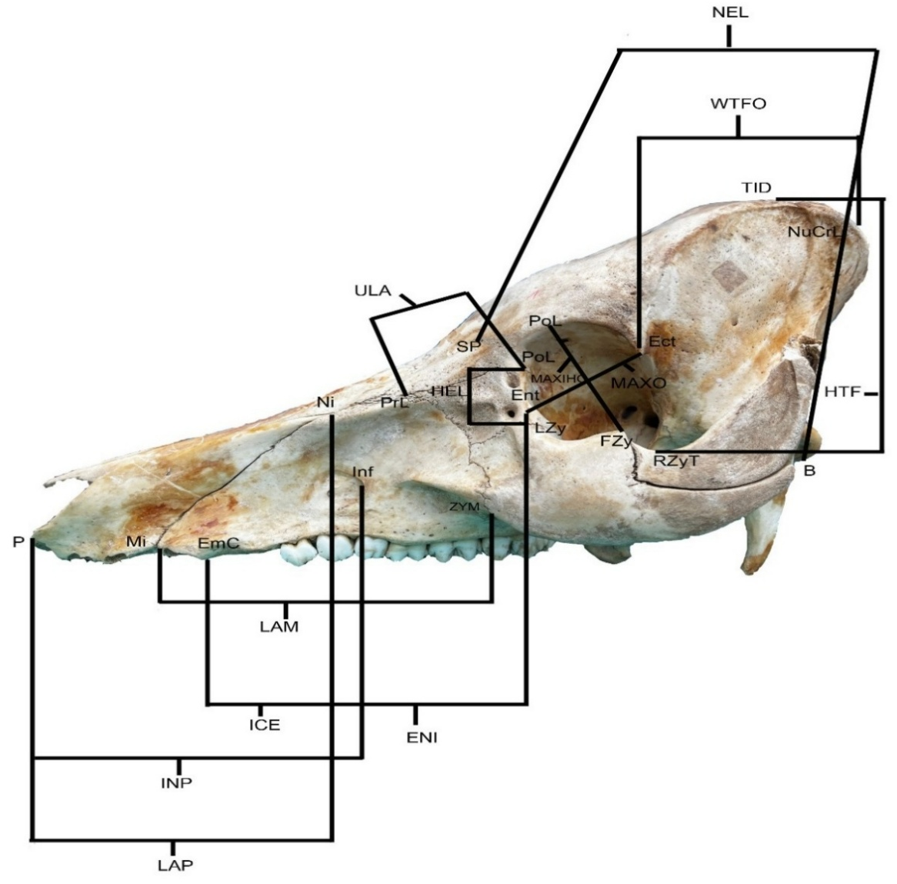

Fig. 3. Measurements of lateral surface of the skull of Zovawk. Neurocranial length (NEL), Height of temporal fossa (HTF), Width of temporal fossa (WTFO), Lateral length of the maxilla (LAM), Lateral length of the premaxilla (LAP), Upper length of the lacrimal (ULA), Entorbitale to infraorbitale (ENI), Infraorbitale to Eminentia canina (ICE), Prosthion (P), Maxilo- Incisive Suture (Mi), Eminentia canina (EmC), Infraorbitale (Inf), Zygomatico-Maxillary Suture (ZyM), Naso-Intermaxillare (Ni), Pre Lacrimal (PrL), Height of the lacrimal (HEL), Supraorbitale (SP), Post lacrimal (PoL), Entorbitale (Ent), Ectorbital (Ect), Lacrimo- Zygomatic (LZy), Frontal process of Zygomatic bone (FZy), Maximum inner length of the orbit (MAXO), Maximum inner height of the orbit (MAXIHO), Root of the zygomatic process of the temporal bone (RZyT), Basion(B), Nuchal Crest Lateralis (NuCrL) and Infraorbitale to prosthion (INP).

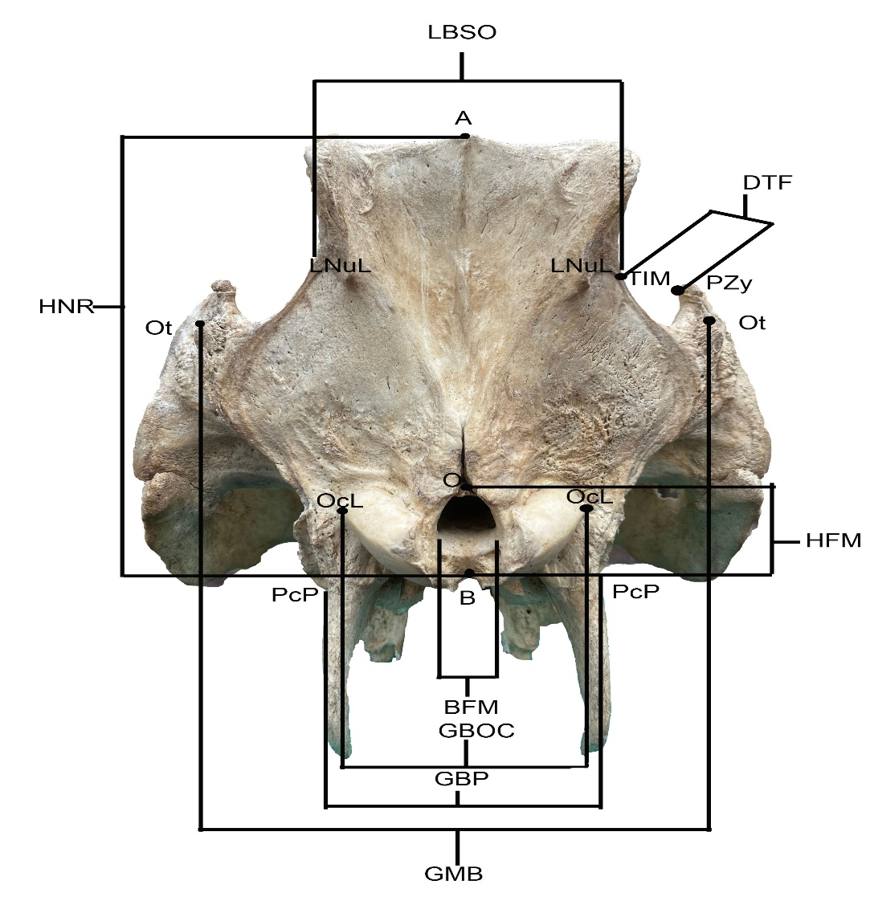

Fig. 4. Measurements of nuchal surface of wild pig. Greatest mastoid breadth (GMB), Breadth of occipital condyles (GBOC), Breadth at the base of paracondyloid process (GBP), Height of the Neurocranium (HNR), Least breadth of the squamous part of the occipital (LBSO), Depth of temporal fossa (DTF), Breadth of foramen magnum (BFM), Basion (B), Opisthion(O), Otion (Ot), Linea Nuchalis Lateralis (LNuL), Paracondyloid process (PcP), Occipital condyle (OcL), Akrokranion (A), Temporal fossa (TfM), Caudo-dorsal process of the Zygomatic arch (PZy) and Height of the foramen magnum (HFM).

Figure. 8: 3D reconstruction of the skull of wild pig in dorsal view. Parietal length (PL), Short nasal length (SNL) and Viscerocranial length (VIL).
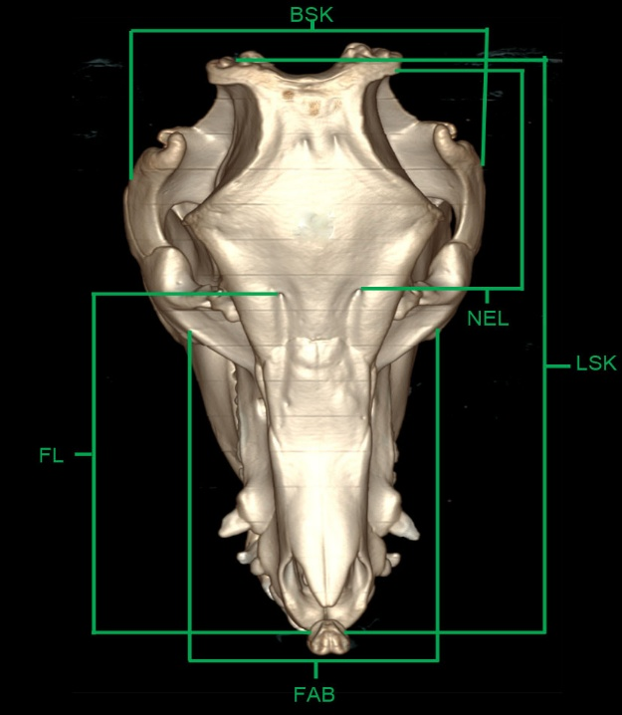
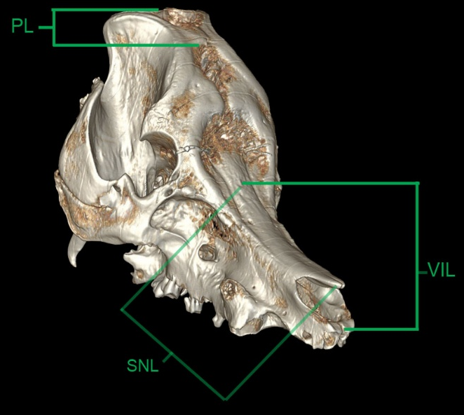
Fig. 6. 3D reconstruction of the skull of wild pig in dorsal view. Parietal length (PL), Short nasal length (SNL) and Viscerocranial length (VIL).
Figure. 5. 3D reconstruction of the skull of Zovawk in dorsal view. Skull length (LSK), Skull breadth (BSK), Neurocranial length (NEL), Facial length (FL) and Facial breadth (FAB).
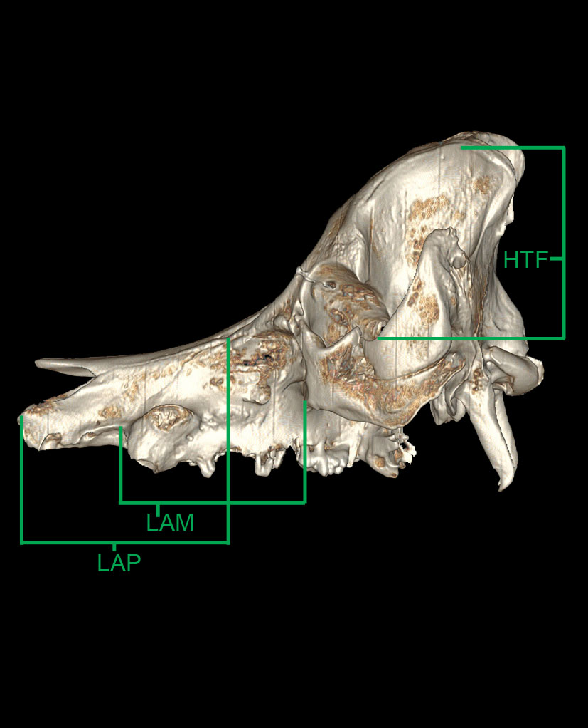
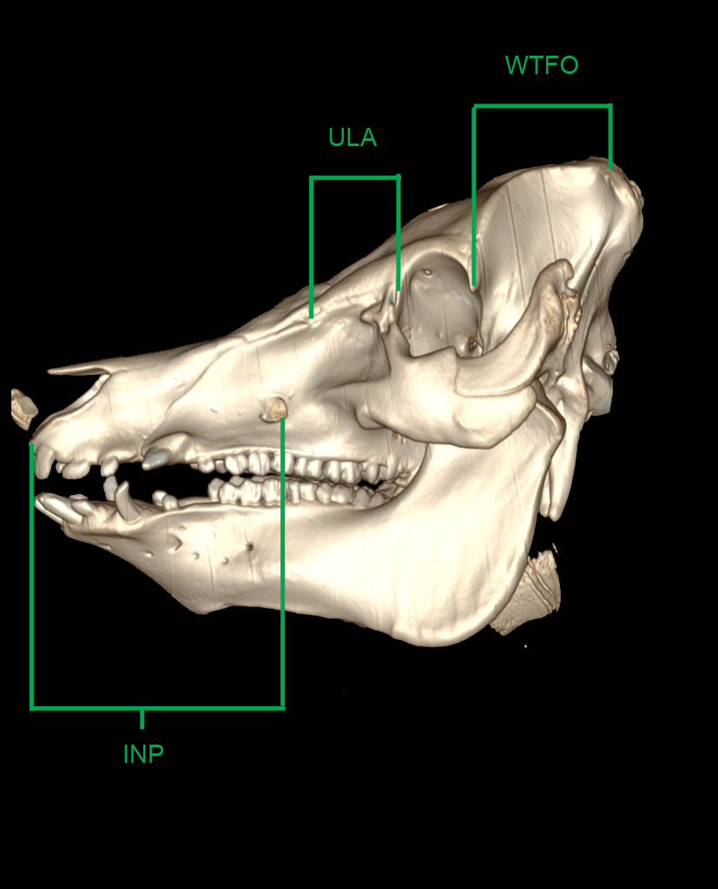
Fig. 8. 3D reconstruction of the skull of wild pig in lateral view. Lateral length of the maxilla (LAM), Lateral length of the premaxilla (LAP) and Height of temporal fossa (HTF).

Fig. 7. 3D reconstruction of the skull of Zovawk in lateral view. Infraorbitale to prosthion (INP), Upper length of the lacrimal (ULA) and Width of temporal fossa (WTFO).
Results and Discussion
The skulls of Zovawk and wild pig were classified as dolichocephalic type, indicating an elongated cranial form. This observation was consistent with reports in indigenous pigs of Northeast India (Sarma et al., 2002). In contrast, Kalita et al. (2019) classified Malayan Sun bear skull as mesocephalic type.
The mean skull length, breadth, and skull index in Zovawk were 28.73 ± 0.58 cm, 15.03 ± 0.78 cm, and 52.25 ± 1.76, respectively, whereas higher values were recorded in the wild pig (31.87 ± 0.19 cm, 21.60 ± 0.87 cm, and 67.79 ± 2.85, respectively). In contrast, Okandeji et al. (2023) observed relatively smaller skull measurements in Nigerian indigenous pigs of both sexes. The mean skull length was reported as 23.02 ± 0.35 cm in males and 22.02 ± 0.25 cm in females, while the skull width was identical in both sexes (11.01 ± 0.18 cm in males and 11.01 ± 0.17 cm in females). The corresponding skull index values were 63.26 ± 1.60 for males and 65.07 ± 0.48 for females. Overall, the skull length and width in Nigerian indigenous pigs were lower than those observed in Zovawk and wild pig.
The mean profile length, short skull length, condylobasal length in Zovawk were 28.18 ± 0.51 cm, 19.07 ± 0.47 cm, and 29.43 ± 0.72 cm and in wild pig were 30.93 ± 0.22 cm, 20.60 ± 0.70 cm, 32.87 ± 0.52 cm. Similar studies were carried out by Doley et al. (2018) on the skull of non-descript domesticated pigs of Mizoram where they found out the mean profile length, short skull length and condylobasal length were 27.84 ± 84 cm, 19.43 ± 0.86 cm and 30.04 ± 0.95 cm, respectively. The mean basicranial axis, basifacial axis, nasion to the staphylion and greatest mastoid breadth in Zovawk and wild pig were 5.15 ± 0.14 cm, 22.52 ± 0.79 cm, 4.96 ± 0.20 cm and 10.82 ± 0.13 cm, respectively.
In Zovawk, the neurocranial length, breadth, index, and height were 10.50 ± 0.29 cm, 10.22 ± 0.33 cm, 97.60 ± 5.20, and 10.0 ± 0.50 cm, respectively, while in wild pig, these values were 14.98 ± 0.32 cm, 15.53 ± 0.24 cm, 103.71 ± 0.58, and 17.17 ± 0.18 cm, respectively. Similar studies were carried out by Sarma et al. (2002) in indigenous pigs of northeast India where the cranial length, width, height, and cranial index were 14.14 ± 0.16 cm, 8.58 ± 0.11 cm, 17.72 ± 0.22 cm and 60.67%, respectively. A notable difference was observed in the neurocranial index among Zovawk, wild pig, and indigenous pigs. In contrast, Pachauri (2024) observed comparatively higher cranial width and index values in Mongrel dog, with cranial length, width, height, and cranial index measuring 10.9 ± 0.24 cm, 11.75 ± 0.18 cm, 5.08 ± 0.12 cm, and 107.89 ± 1.88%, respectively. Kalita et al. (2020) observed the cranial length, width, height, and index in binturong were 11.16 ± 0.09 cm, 6.56 ± 0.11 cm, 3.16 ± 0.08 cm, and 58.78, respectively.
The height, breadth, depth of temporal fossa in Zovawk were 9.60 ± 0.23 cm, 5.98 ± 0.47 cm and 2.33 ± 0.09 cm whereas in wild pig were 14.43 ± 0.30 cm, 12.33 ± 0.19 cm and 4.03 ± 0.15 cm. The mean height, width and depth of temporal fossa was measured to be 9.15 ± 0.15 cm, 5.62 ± 0.29 cm and 2.12 ± 0.13 cm respectively by Doley et al. (2018) in non-descript domesticated pigs of Mizoram. The mean facial morphometric parameters of Zovawk revealed a facial length of 17.07 ± 0.81 cm, facial breadth of 10.02 ± 0.72 cm, and a facial index of 59.37 ± 7.31, whereas comparatively higher values were observed in wild pig, with facial length, breadth, and index measuring 20.57 ± 0.79 cm, 13.83 ± 0.09 cm, and 67.42 ± 2.17, respectively.
In Zovawk, the mean orbital length, height, depth, and orbital index were 3.69 ± 0.10 cm, 4.38 ± 0.04 cm, 5.21 ± 0.32 cm, and 84.14 ± 1.73, respectively. Comparatively, wild pig exhibited slightly higher orbital dimensions, with mean values of 4.12 ± 0.14 cm for length, 4.79 ± 0.41 cm for height, 8.56 ± 1.17 cm for depth, and an orbital index of 87.56 ± 9.11. In local Mizo pig, Choudhary et al. (2019) described the orbital height was 4.16 ± 0.01 cm which was more in left than right orbit 4.08 ± 0.01 cm and orbital depth was 2.32 ± 0.01, respectively. The bony orbital rim exhibited an incomplete posterior wall in both pig breeds. In Zovawk, the mean orbital circumference, orbital area, and interorbital distance were 13.20 ± 0.17 cm, 12.68 ± 0.46 cm², and 7.42 ± 0.29 cm, respectively. In comparison, wild pig exhibited higher corresponding values of 15.07 ± 0.60 cm, 15.45 ± 1.08 cm², and 12.05 ± 0.35 cm, respectively. Comparable observations were reported in blackbuck by Choudhary and Singh (2015), who documented an orbital depth of 4.66 ± 0.004 cm and an orbital circumference of 13.49 ± 0.009 cm.
In Zovawk, the mean breadth, height, foramen magnum index, and circumference were 2.47 ± 0.06 cm, 2.58 ± 0.03 cm, 95.70 ± 3.51, and 6.30 ± 0.15 cm, respectively. In comparison, wild pig exhibited larger measurements, with a mean breadth of 3.37 ± 0.12 cm, height of 3.50 ± 0.12 cm, foramen magnum index of 96.09 ± 1.04, and circumference of 7.37 ± 0.07 cm. Yahaya et al. (2013) documented sexual dimorphism in one-humped camels, reporting that the mean foramen magnum height was 4.04 ± 0.15 cm in males and 3.70 ± 0.16 cm in females, while the corresponding widths were 3.65 ± 0.27 cm in males and 3.45 ± 0.21 cm in females, highlighting interspecies as well as sex-related variations in foramen magnum morphology.
The mean skull base length in Zovawk measured was 27.67 ± 0.71 cm, while a comparatively greater value of 30.70 ± 0.55 cm was observed in wild pig.
The mean neurocranial capacity, upper neurocranium length and median frontal length in Zovawk were 89.33 ± 9.91 cm³, 10.92 ± 0.70 cm and 13.75 ± 0.20 cm whereas a comparatively larger capacity of 124.00 ± 1.16 cm³, 13.84 ± 0.44 cm and 14.87 ± 0.19 cm, respectively were observed in wild pig. The non-descript domesticated pigs of Mizoram were measured 88.65 ± 2.74 cm ³, 10.39 ± 0.35 cm and 13.72 ± 0.67 cm by Doley et al. (2018). Saber and Gummow (2015) reported marked interspecies variation, with mean cranial capacities of 207.40 ± 24.49 cm³ in lions, 86.40 ± 11.87 cm³ in dogs, and 20.80 ± 1.95 cm³ in cats.
In Zovawk, the least breadth of the squamous part of the occipital bone measured was 5.56 ± 0.17 cm, whereas a considerably greater value of 7.84 ± 0.17 cm was recorded in wild pig. Similarly, the greatest breadth of the occipital condyles was 5.00 ± 0.12 cm in Zovawk compared to 7.90 ± 0.21 cm in wild pig. The greatest breadth at the base of the paracondyloid process also exhibited marked variation, measuring 5.54 ± 0.09 cm in Zovawk and 9.03 ± 0.20 cm in wild pig.
In Zovawk, the mean length, greatest breadth of the frontal bone and frontal index were measured 9.79 ± 0.90, 10.22 ± 0.33 cm and 105.79 ± 7.57, whereas comparatively higher values were observed in wild pig, with a frontal length of 10.93 ± 0.15 cm, breadth of 15.53 ± 0.24 cm and 142.06 ± 0.45, respectively. As per Doley et al. (2018) in the non-descript domesticated pigs of Mizoram, the mean length, greatest breadth of the frontal bone and frontal index were measured 9.15 ± 0.36 cm, 9.62 ± 0.38 cm and 105.23%.
The inter-supraorbital foraminal distance in Zovawk measured were 3.89 ± 0.28 cm, whereas a comparatively greater distance of 4.60 ± 0.28 cm was recorded in wild pig.
In Zovawk, the mean parietal length and least breadth measured were 3.96 ± 0.77 cm and 3.91 ± 0.56 cm, respectively, whereas in wild pig, the corresponding values were 3.93 ± 0.24 cm and 5.83 ± 0.15 cm, indicating a relatively broader parietal region. In contrast, Kumar (2017) reported considerably larger parietal dimensions in blue bull, with maximum parietal height and width measuring 6.64 ± 0.18 cm and 7.81 ± 0.16 cm, respectively.
The greatest nasal length, viscerocranial length, short nasal length, breadth across the nasal and nasal index recorded in Zovawk were 13.68 ± 0.31 cm, 14.43 ± 0.33 cm, 10.68 ± 0.36 cm, 4.36 ± 0.30 cm, 31.80 ± 1.68 and in wild pig were 14.37 ± 0.09 cm, 16.07 ± 0.07 cm, 12.14 ± 0.15 cm, 5.14 ± 0.25 cm and 35.75 ± 1.52, respectively, while the nasal breadth in Zovawk and wild pig measured were 4.36 ± 0.30 cm and 5.14 ± 0.25 cm, respectively. The length of nasal bone was 13.02 ± 0.22 cm and 13.02 ± 0.20 cm, respectively in male and female and breadth of nasal bone was 2.83 ± 0.07 cm and 2.93 ± 0.07 cm, respectively in male and female as per findings of Okandeji et al. (2023) in Nigerian indigenous pigs.
The lateral length of the maxilla was recorded as 11.19 ± 0.40 cm in Zovawk and 12.17 ± 0.40 cm in wild pig, whereas the distance between the infraorbitale and the eminentia canina measured 6.00 ± 0.24 cm and 8.39 ± 0.31 cm, respectively. In local Mizo pig, the maxillary length and breadth were reported as 10.16 ± 0.04 cm and 5.42 ± 0.01 cm, respectively. Additionally, Choudhary and Singh (2015) documented a maxillary length of 9.29 ± 0.005 cm and a breadth of 4.83 ± 0.08 cm in blackbuck.
The premaxilla showed a lateral length of 11.14 ± 0.18 cm in Zovawk and 13.05 ± 0.13 cm in wild pig. In comparison, Choudhary et al. (2019) reported the length and breadth of the premaxilla in local Mizo pigs as 0.68 ± 0.01 cm and 3.70 ± 0.05 cm, respectively.
The mean entorbitale to infraorbitale, infraorbitale to eminentia canina and infraorbitale to prosthion in Zovawk were 6.10 ± 0.62 cm, 6.00 ± 0.24 cm and 11.87 ± 0.37cm, whereas in wild pig were 7.30 ± 0.12 cm, 8.39 ± 0.31 cm and 15.53 ± 0.24 cm, respectively. Doley et al. (2018) measured, the mean entorbitale to infraorbitale, infraorbitale to eminentia canina and infraorbitale to prosthion were 6.65 ± 0.48 cm and 5.50 ± 0.10 cm, respectively in non-descript domesticated pigs of Mizoram.
In Zovawk, the median palatine length, greatest palatine breadth, and the distance from the rostral palatine foramina to the staphylion and palatine index were measured 18.07 ± 0.22 cm, 6.04 ± 0.09 cm, 4.02 ± 0.17 cm and 33.51 ± 0.39, while the corresponding values in wild pig were 20.53 ± 0.48 cm, 8.38 ± 0.30 cm, 4.52 ± 0.05 cm and 40.79 ± 0.70, respectively In chinkara, Din et al. (2020) reported palatine lengths of 10.58 ± 0.60 cm in males and 2.16 ± 0.24 cm in females, with corresponding palatine widths of 2.83 ± 0.22 cm and 2.67 ± 0.10 cm, respectively. In the Malayan sun bear, the total palatal length and palatal breadth between the canine and premolars were recorded as 9.50 cm and 3.00 cm, respectively (Kalita et al., 2019).
The mean premolare to prosthion, palatino-oral to prosthion and palatino- oral to prosthion in Zovawk were 6.85 ± 0.09 cm, 3.44 ± 0.29 cm and 14.1 ± 0.58 cm while in wild pig were 10.17 ± 0.21 cm, 3.88 ± 0.06 cm and 17.50 ± 0.41 cm, respectively. Whereas, in domesticated pigs of Mizoram the mean premolare to prosthion and palatino- oral to prosthion 6.56 ± 0.30 cm and 3.56 ± 0.27 cm, respectively (Doley et al., 2018).
In Zovawk, the upper length and height of the lacrimal bone were measured 3.99 ± 0.26 cm and 3.04 ± 0.19 cm, respectively, whereas in wild pig the corresponding measurements were 5.88 ± 0.15 cm and 3.30 ± 0.26 cm. Kumawat et al. (2014) recorded lacrimal bone measurements of 4.6 ± 0.2 cm in length and 3.1 ± 0.1 cm in width in the chital.
Conclusions
The skull of Zovawk and wild pig shows marked inter-breeds variation. Both the animals possess a dolichocephalic skull type, but the majority of morphometric parameters such as skull length, skull breadth, neurocranial dimensions, facial measurements, and orbital parameters were comparatively greater in wild pig than in Zovawk. These differences reflect breed-specific adaptations and provide useful baseline data for comparative anatomy, taxonomic studies, and for providing clinical landmarks in veterinary surgical and diagnostic procedures involving the head region of pigs.

Disclaimer (Artificial intelligence)
Author(s) hereby declare that NO generative AI technologies such as Large Language Models (ChatGPT, COPILOT, etc.) and text-to-image generators have been used during the writing or editing of this manuscript.
References
Choudhary, O. P., & Singh, I. (2015). Morphometrical Studies on the Skull of Indian Blackbuck (Antelope cervicapra). International Journal of Morphology, 33(3), 868-876.
Choudhary, O. P., Kalita, P. C., Doley, P. J., & Kalita, A. (2017). Applied anatomy of the head region of the Indian wild pig (Sus scrofa) and its clinical value during regional anesthesia. Journal of Animal Research, 7(2), 339-344.
Choudhary, O. P., Kalita, P. C., Konwar, B., Doley, P. J., Kalita, G., & Kalita, A. (2019). Morphological and applied anatomical studies on the head region of local Mizo pig (Zovawk) of Mizoram. International Journal of Morphology, 37(1), 196-204.
Debroy, S., Kalita, P. C., Kalita, A., Choudhary, O. P., Doley, P. J., Paul, A., & Sarkar, R. (2021). Anatomy of the Liver of Mizoram Local Pig (Zovawk). Indian Journal of Animal Research, 1:7.
Din, S., Masood, S., Zaneb, H., Rehman, H., Ashraf, S., Khan, I., Shah, M., & Hadi, S. A. (2020). Gross and clinical anatomy of the skull of adult chinkara (Gazella bennettii). Pakistan Journal of Zoology, 52(5), 1-11.
Doley, P. J., Tolenkhomba, T. C., Kalita, P. C., Kalita, A., Choudhary, O. P., & Das, H. (2018). Morphometrical studies on the skull of non-descript domesticated pigs of Mizoram. Journal of Experimental Zoology India, 21(2), 967-975.
Kalita, P. C., Debroy, S., Choudhary, O. P., Kalita, A., & Doley, P. J. (2020). Morphological and morphometrical studies on the skull of binturong (Arctictis binturong). Journal of Animal Research, 10(2), 309-314.
Kalita, P. C., Singh, T. S., Choudhary, O. P., Debroy, S., Kalita, A., & Doley, P. J. (2019). Morphological and applied anatomical studies on the head region of Malayan sun bear (Helarctos malayanus). Journal of Animal Research, 9(5), 753-758.
Kumar, V. (2017). Gross anatomical studies on the bones of skull in blue bull (Boselaphus tragocamelus). M.V.Sc. Thesis, Submitted to Rajasthan University of Veterinary and Animal Science, Bikaner, Rajasthan, India.
Kumawat, R., Joshi, S., Mathur, R., & Choudhary, O. P. (2014). Gross Anatomical Studies on the Cranial Bones of Skull in Chital (Axis axis). Indian Journal of Veterinary Anatomy, 26(1).
Mayengbam, P., Tolenkhomba, T. C., & Ali, M. A. (2014). Hematological profile of Zovawk-an indigenous pig of Mizoram. Veterinary World, 7(7), 505-508.
Okandeji, M. E., Olaniyi, Z. B., & Mustapha, O. A. (2023). Craniometric indices of the skull of adult Nigerian indigenous Pigs (Sus scrofa). Journal of Sustainable Veterinary and Allied Sciences, 4(2), 72-80.
Pachauri, P. (2024). Anatomical studies on the skull of dog (Canis lupus familiaris). M.V. Sc. Thesis, Submitted to U.P. Pandit Deen Dayal Upadhyaya Pashu Chikitsa Vigyan Vishwavidyalaya Evam Go Anusandhan Sansthan, Mathura (UP), India.
Saber, A.S.M., & Gummow, B. (2015). Skull morphometry of the lion (Panthera leo), dog (Canis lupus familiaris) and cat (Felis catus). Journal of Veterinary Anatomy, 8(1), 13-30.
Sarma, K., Sarma, M., Goswami, R.N., Devi, J., & Sarma, P. (2002). Craniometry of indigenous pigs (Sus scrofa) of north-east India. The Indian Journal of Animal Sciences, 72(1), 13-15.
Savitri, Yakkundi, R. C., Matapathi, N., & Talawar, V. (2023). A review of bone preparation techniques for anatomical studies. Journal of Ayurveda and Integrated Medical Sciences, 8(10), 112-117.
Vanlalrozami, Kalita, P. C., Doley, P. J., Kalita, A., Chaudhary, O. P., Das, H., & Singh, S. (2018). Gross morphological studies on the Harderian gland of Zovawk (Mizo local pig). International Journal of Agricultural Sciences, 10(15), 6815-6816.
Yahaya, A., Olopade, J. O., & Kwari, H. D. (2013). Morphological Analysis and Osteometry of the Foramen Magnum of the One‐Humped Camel (Camelus dromedarius). Anatomia, Histologia, Embryologia, 42(2), 155-159.

