Development and Physicochemical, Sensory, and Storage Evaluation of Blended Squash from Mangifera indica and Aloe barbadensis Gel
Abstract
Aloe vera is a nutritionally rich medicinal plant containing vitamins (A, B-complex, C, and E), minerals (calcium, potassium, sodium), amino acids, natural sugars, enzymes, and antioxidants. Blended beverages incorporating fruit pulp and aloe vera gel are gaining increasing demand in national and international markets due to their nutritional and therapeutic benefit. The present study aimed to standardize a blended squash formulation of ripe mango pulp and aloe vera gel and to evaluate its physicochemical and sensory changes during storage under ambient conditions. The experiment was conducted at the Department of Post Harvest Technology, Banda University of Agriculture and Technology, Banda, Uttar Pradesh. A Completely Randomized Design (CRD) with three replications was employed. Different formulations were prepared using varying proportions of mango pulp and aloe vera gel. Among the treatments, Recipe No. 5 consisting of 25% blend (70:30 mango pulp: aloe vera gel), 50% total soluble solids (TSS), 1.20% acidity, and 350 ppm SO₂ per 10 liters of squash was evaluated. The prepared squash was packed in sterilized glass bottles and stored at ambient temperature for five months. Physicochemical parameters and organoleptic quality were analyzed at monthly intervals. Statistical analysis indicated that Recipe No. 5 was significantly superior to other treatments in terms of overall acceptability. During storage, TSS, titratable acidity, reducing sugars, and total sugars showed a continuous increase. In contrast, non-reducing sugars, vitamin A, carotenoids, browning index, and organoleptic scores gradually decreased from the first month to the end of the five-month storage period. However, the product remained within acceptable sensory and quality limits throughout storage.The study demonstrated that a standardized blend of 70:30 mango pulp and aloe vera gel can be successfully developed into a shelf-stable squash with acceptable quality for up to five months under ambient conditions. The formulation offers potential for commercial production of functional beverages with enhanced nutritional value and extended shelf life.

Key Words: Mangifera indica L., Aloe vera, Vitamin-A, Squash, Health drink, Carotenoids.
Introduction
Mangifera indica L. (mango), belonging to the family Anacardiaceae, is one of the most important tropical fruit crops cultivated extensively in India and other subtropical regions. Mango is highly valued for its nutritional composition, being an excellent source of provitamin A carotenoids and a good source of ascorbic acid, sugars, organic acids, minerals, and dietary fiber. The antioxidant potential of mango is largely attributed to carotenoids, phenolic compounds, and vitamin C, which contribute to its health-promoting properties (Patel et al., 2023). Despite its nutritional richness, mango is highly perishable and prone to rapid postharvest deterioration due to physiological and biochemical changes. Considerable quantitative and qualitative losses occur during peak production seasons, creating a need for effective preservation and value-addition strategies. Recent studies have reported that Aloe vera-based coatings and formulations significantly enhance mango shelf life and maintain physicochemical quality during storage (Begum et al., 2023; Morsalpour and Rastegar, 2025; Oluba et al., 2025). These findings suggest the potential application of Aloe vera in improving the storage stability of mango-based products.
Processing mango into value-added beverages such as ready-to-serve (RTS) drinks, squash, nectar, syrup, jam, and other products is an effective approach to reduce postharvest losses and enhance economic returns. However, conventional mango beverages are often high in sugars and may lack additional functional attributes desired by health-conscious consumers. The incorporation of plant-derived bioactive ingredients into fruit beverages has therefore gained increasing research attention (Singh et al., 2021; Sharma et al., 2022). Aloe barbadensis Miller (Aloe vera), belonging to the family Liliaceae (Asphodelaceae), is a perennial succulent plant widely recognized for its medicinal and nutraceutical properties. The inner leaf gel contains biologically active polysaccharides such as acemannan and glucomannan, along with vitamins (ascorbic acid, tocopherol, thiamine, riboflavin, niacin, pyridoxine, and folic acid), minerals, enzymes, and phenolic compounds. Aloe vera exhibits antioxidant, antimicrobial, antiviral, anti-inflammatory, and immunomodulatory activities (Singh et al., 2021; Sharma et al., 2022). Due to these functional properties, Aloe vera has been increasingly utilized in the development of functional beverages and health drinks (Neharkar et al., 2025).
Recent investigations on Aloe vera-enriched fruit beverages have reported improved nutritional quality and acceptable storage stability under ambient conditions (Neharkar et al., 2025; Singh et al., 2021). However, most studies have evaluated mango beverages and Aloe vera-based drinks separately. Limited systematic research is available on optimizing blended mango–Aloe vera squash formulations with standardized total soluble solids (TSS), acidity, and preservative levels, along with comprehensive evaluation of physicochemical and sensory changes during extended ambient storage. Therefore, the present investigation was undertaken to standardize a blended squash formulation using mango pulp and Aloe vera gel and to evaluate its physicochemical characteristics, sensory attributes, and shelf stability during five months of ambient storage. The study aims to contribute to the development of nutritionally enriched, value-added functional beverages with improved shelf life and commercial potential.
Materials and Methods

Materials and Methods
Locale of the study: The present study was carried out at Post Harvest Technology laboratory of Department of Post Harvest Technology, College of Horticulture and Forestry, Banda University of Agriculture and Technology, Banda U. P.

Extraction of pulp from mango fruits and aloe vera leaves
The pulp extracted from ripe mango fruits Fig-1and picture-1 and mature aloe vera leaves as per flow diagram depicted in Fig-2.

Chemical characteristics of mango pulp and mature aloe vera leaves
The obtained data from analyzed fruits regarding on chemical characteristics of mango pulp and aloe vera gel, which used for the preparation of blended squash from mango and aloe vera gel was presented in Table- 1.0.

Preparation of squash
For formulation of recipes total soluble solids and total titratable acidity present in extracted mango pulp and aloe vera gel was first determined by hand refractometer and titration, respectively. Then find out for sugar and acid present in the pulp as well as for remaining amount of sugars, citric acid, potassium metabisulphite and water required to make the final squash in different proportions according to desired recipes.
Squash of each recipe were prepared in one liter by mixing the calculated amount of pulp, sugar, citric acid and water in different proportions (as per recipes) then organoleptically evaluated by a panel of seven semi trained judges on a 9.0 Point Hedonic Rating Scale to find out the best one recipe of blended squash. Finally best recipe viz. 25 per cent blend (70:30 mango pulp and aloe vera gel), 50 percent TSS, 1.20 percent acidity, totenliter squash was prepared. The methods used for
making blend squash is given in Fig 2.0. Prepared blend squash was filled in sterilized bottles (750mL capacity) by leaving 2 cm head space. Bottled squash was stored at room temperature for further study and biochemical composition were analyzed up to 5 months.

Determine the biochemical composition
Total soluble solids: The ERMA made hand refractometer was used to measure total soluble solids at ambient temperature (0-32 % ranges) and readings were corrected at 20⁰ C with the help of correction table (Ranganna, 2010).
Total titratable acidity : Quantity of sample was titrated against 0.1 N sodium hydroxide solution using phenolphthalein drops as an indicator to determine acidity and acid content was calculated and expressed in per cent anhydrous citric acid and browning was recorded as per Ranganna (2010),
Ascorbic acid (Vit C): To determine vitamin-C content sample was prepared in 3 per cent metaphosphoric acid solution and known volume of aliquot was titrated against 2, 6 dichlorophenol indophenols dye solution (Rangnna, 2010).
Reducing, Non-reducing and Total sugars: The solutions of Fehling’s ‘A’ and ‘B’ were used to determine the sugars content fallowing the procedure as suggested by (Ranganna, 2010).
Vitamin A: Vitamin-A was determined by the sample preparing in acetone then in petroleumether and thereafter in sodium sulphate upto the appearance of dark yellow-greenish colour.
Optical density: Optical density (OD) was measured at 440 nm by ELICO made spectrophotometer in the determination of non-enzymatic browning (Ranganna, 2010).
Carotenoids: The estimation of Carotenoids content in pulp and blended sugar during entire period of study was determined by AOAC (2012).

Organoleptic quality
Organoleptic evaluation of the blended squash was conducted to assess key sensory attributes, including colour, appearance, flavour, aroma, taste, and texture. The evaluation was carried out by a panel of seven semi-trained judges using a 9-point hedonic rating scale, as described by Amerine et al. (1965). Sensory evaluation provides a comprehensive assessment of product quality by integrating human perception, thereby enabling a holistic analysis of the various attributes of the squash as experienced through the senses.

Statistical analysis
The study of mango and aloe vera gel blended squash data were recorded at monthly interval on different parameters were subjected to statistical analysis using completely randomized design of analysis of variance and results were interpreted at significance level of 5 per cent.

Results and Discussion
Data presented in Table 1 indicate that the extracted mango pulp contained total soluble solids (TSS) of 22.64%, titratable acidity of 0.62%, ascorbic acid of 18.82 mg per 100 mL, reducing sugars of 6.84%, non-reducing sugars of 12.08%, and total sugars of 18.92%. Additionally, the carotenoid content was 11.60 mg per 100 g, and vitamin A content was 2632.65 IU. In contrast, aloe vera gel exhibited comparatively lower values, with TSS of 2.12%, titratable acidity of 0.18%, ascorbic acid of 2.16 mg per 100 mL, reducing sugars of 1.13%, non-reducing sugars of 1.08%, and total sugars of 2.21%. These compositional differences significantly influenced the palatability and overall quality of the blended squash. The formulations of squash prepared using varying proportions of mango pulp, aloe vera gel, sugar, and citric acid are presented in Table 2. The results reveal that Recipe No. 5, comprising 25% blended pulp, 50% TSS, and 1.20% acidity, received the highest sensory acceptability and was rated as “extremely liked” by the panelists. Accordingly, this formulation—consisting of 70% mango pulp and 30% aloe vera gel, with 50% TSS, 1.20% acidity, and 350 ppm SO₂—was selected for the preparation of blended squash for subsequent storage studies.

Total soluble solids
Observations presented in Table 3 indicate that the total soluble solids (TSS) content of the mango–aloe vera blended squash ranged from 50.00% to 52.73% and exhibited a gradual increase during the storage period. This rise in TSS may be attributed to the hydrolysis of complex polysaccharides into simpler sugars in the presence of organic acids over time. Similar trends of increasing TSS during storage have been reported in other beverage products, including mango–ginger ready-to-serve (RTS) beverages (Deen and Kumar, 2014), blended RTS beverages (Pali et al., 2023), blended RTS drinks (Masoumi, 2024), and RTS formulations derived from water apple fruit (Nagaraju et al., 2025), thereby supporting the findings of the present investigation.

Titratable acidity
Observations pertaining to the acidity content of the mango–aloe vera blended squash, as presented in Table 3, indicate a gradual increase in titratable acidity throughout the storage period. After one month of storage, the acidity was recorded at 1.26%, which increased to 1.84% after five months. This progressive rise in acidity may be attributed to the formation of organic acids resulting from the degradation of ascorbic acid, which tends to decline during storage. The findings of the present study are in close agreement with earlier reports by Tiwari and Deen (2015) in bael–aloe vera blended RTS beverages, Priyanka et al. (2015) in jamun blended squash, Pali et al. (2023) in blended RTS beverages, and Masoumi (2024) in blended RTS drinks, all of which documented similar increases in acidity during storage.

Ascorbic acid
Data presented in Table 3 indicate that the ascorbic acid content of the blended squash decreased progressively throughout the storage period. After five months of storage, the ascorbic acid content declined to 11.12 mg per 100 mL. This reduction may be attributed to oxidative degradation facilitated by the presence of entrapped oxygen within the glass bottles. Ascorbic acid is initially converted into dehydroascorbic acid, which is highly unstable and subsequently degrades into 2,3-diketogulonic acid and ultimately into furfural compounds.
These findings are in agreement with earlier studies, such as those reported by Priyanka et al. (2015) in jamun blended squash and Pali et al. (2023) in blended RTS beverages, which also documented a continuous decline in ascorbic acid content during storage.

Reducing and total sugars
Data with respect to per cent change in reducing and total sugars content in blended squash as illustrated in table -3 indicated clearly the reducing and total sugars of the squash were increased continuously throughout the entire period of study. The increase in reducing and total sugars content of squash could be due to inversion of non-reducing sugar into reducing sugars as decreases in non- reducing sugar corresponded to increase in reducing sugars content. Hydrolysis of polysaccharides like pectin and starch could also be one of the reasons for increase in the sugars content. The analogous findings observed by the several authors like Deen and Kumar (2014) in mango-ginger RTS, Tiwari and Deen (2015) in blended RTS
From bael and aloevera, Chaudhary et al.(2017)
mango and aloe vera syrup and Harendra and Deen (2021) in mango, citrus, aloe vera and ginger squash.

Non-reducing sugar
Data presented in Table 3 clearly indicate that the non-reducing sugar content of the mango–aloe vera blended squash decreased progressively with the advancement of the storage period. This trend is in contrast to the behaviour of reducing sugars, which generally tend to increase over time. The continuous decline in non-reducing sugars may be attributed to the process of inversion, whereby sucrose is hydrolysed into simpler reducing sugars such as glucose and fructose. These findings are in agreement with earlier studies, including those by Tiwari and Deen (2015) in bael–aloe vera blended RTS beverages, Kumari et al. (2020) in papaya–aloe vera squash, Harendra and Deen (2021) in mango, citrus, aloe vera, and ginger squash, and Patel et al. (2023) in bael squash, all of which reported similar trends of decreasing non-reducing sugar content during storage.

Browning
The data presented in Table 3 clearly indicate that browning in the blended squash increased progressively during the storage period, as also illustrated in Figure 2. This increase in browning may be primarily attributed to non-enzymatic reactions, such as interactions between organic acids and sugars, as well as the oxidation of phenolic compounds, leading to the formation of brown pigments. Furthermore, the observed increase in browning corresponds with the reduction in ascorbic acid content during storage, suggesting a possible relationship between oxidative degradation and pigment formation. These findings are in agreement with earlier reports by Deen and Kumar (2014) in mango–ginger RTS beverages and Chaudhary et al. (2017) in mango–aloe vera syrup, thereby supporting the results of the present investigation.

Carotenoids
Data with respect to carotenoids in mango and aloe vera squash as illustrated in table-3clearly reflected that carotenoids of blended squash was continuous decreased till termination of the research at ambient temperature. The decrease in carotenoids of storage might be due to oxidative breakdown, isomerization or enzymatic destruction of the pigments and/or auto oxidative degradation during processing and storage period. Reductions in carotenoids are also reported in mango aloe vera syrup (Chaudhary et al., 2017), in commercial fruit beverage (Sethy et al., 2018) and in blend RTS beverage (Pali et al. 2023). In present findings the carotenoids in blend squash remained acceptable organoleptically.

Vitamin-A
Data on Vitamin-content in mango and aloe vera squash showed that the Vitamin- A content was continually decreased during the entire period of study. The Vitamin- A content was continuously reduced from the storage time (715.36 IU) to termination of the investigation (713.65). The decrease in Vitamin-A of storage might be due to oxidative breakdown, isomerization or enzymatic destruction of the pigments. Similar decreasing trend in Vitamin-A was observed during period by Harendra and Deen (2021) in blend squash of mango, citrus, aloe vera and ginger.

Organoleptic quality
Data with respect to, organoleptic quality was decreased gradually with increase storage period in blended squash as illustrated in table-3. Loss in organoleptic quality of squash after certain period is obvious because of undesirable changes in the product. Temperature plays an important role in inducing certain undesirable biochemical changes in the beverage which leads to development of off flavour as well as discoloration and there by masking the original colour and flavors of the blend squash. Similarly, decrease organoleptic quality with increase storage period has also been reported Kumari et al., (2020) in papaya and aloe vera squash, and Patel et al., (2023) in bael squash and Nagaraju et al., 2025 in RTS blends from water apple fruit these reported observations support the present findings.
Conclusion
The present investigation demonstrated that the developed Mangifera indica–Aloe barbadensis blend beverage remained microbiologically safe and organoleptically acceptable for up to five months under ambient storage conditions. During storage, total soluble solids, titratable acidity, reducing sugars, and total sugars showed a gradual increase, primarily due to hydrolysis of polysaccharides into simpler sugars. In contrast, non-reducing sugars, vitamin A, carotenoids, and sensory attributes exhibited a moderate decline, which can be attributed to oxidative degradation, enzymatic reactions, and pigment isomerization. Although a measurable reduction in bioactive compounds occurred, the overall carotenoid retention remained satisfactory, and the sensory evaluation scores remained within the acceptable range (above 7.0 on a 9-point hedonic scale) throughout storage. The increase in browning index correlated with ascorbic acid degradation, indicating non-enzymatic browning reactions during prolonged storage. Importantly, this study addresses the limited scientific evidence on the development and storage stability of mango–aloe vera functional beverages. By combining a carotenoid-rich fruit with a bioactive medicinal plant, the formulation enhances nutritional density while maintaining acceptable sensory quality over extended storage. The findings highlight the technological feasibility of producing a value-added functional beverage with improved antioxidant potential and consumer acceptability. Future research may focus on optimizing preservation strategies to minimize nutrient losses, evaluating bioactive compound bioavailability, and assessing long-term microbial stability under different packaging and temperature conditions. The developed formulation presents promising potential for commercial-scale production of nutraceutical fruit beverages aligned with increasing consumer demand for health-promoting natural products.
Conflict of interest
The authors declare that there is no conflict of interest in the publication of this paper.

Disclaimer (Artificial intelligence)
Author(s) hereby declare that NO generative AI technologies such as Large Language Models (ChatGPT, COPILOT, etc.) and text-to-image generators have been used during the writing or editing of this manuscript.

References:
- Amerine M A, Pangborn R M, Roessler E B. (1965). Principles of Sensory Evaluation ofFood. Academic Press: London. 236-268.
- AOAC Official Methods of Analysis of AOAC (2012). International, 19th edition, AOAC International, Gaithersburg, MD, USA.
- Begum, L., Ahmed, M. and Rahman, A. (2023). Changes of postharvest nutritional quality and antioxidant enzymes in ‘Haribhanga’ mango by Aloe vera gel with chitosan/coconut oil coating during ambient storage. Journal of Horticultural Research, 31(2), 1–12.
- Chaudhary M. Deen, B.Gautam, D.K. and Mishra KK. (2017). Studies on development of squash from mango (Mangifera indica L.) and aloe vera (Aloe barbadensis Miller) gel blend. International Journal of Current Microbiology and Applied Science. 6(7): 1962-1969.
- Deen B, and Kumar A. (2014). Development and storage of mango ginger RTS beverage. International Journal of Food, Agriculture and Veterinary Sciences. 4(3): 15-20.
- Kumar A. and Deen B. (2017). Study on Preparation and Storage Stability of Wood Apple RTS Beverage. International Journal of Pure and Applied Bioscience. 5(6):879-886.
- Kumari P. Singh R, Kumar A. Kumar R. and Kumar A. (2020). Preparation of squash from papaya (Carica papaya L.) and aloe vera (Aloe barbadensis Miller) pulp. Indian Journal of agriculture and allied Sciences. 6(3)2:49-53.
- Masoumi, A. (2014). Development of blended RTS (Ready to Serve) drink from pomegranate and plum fruits. Journal of Natural Science Review. 2 (Special issue): 100-108.
- Morsalpour, R. and Rastegar, S. (2025). Innovative coatings of Aloe vera gel with salicylic acid and melatonin to preserve mango (Mangifera indica L.) fruit quality. BMC Plant Biology, 25, 733.
- Nagaraju D. Prasad MS, Lakshmi K.S. and Krishna M M. (2025). To standardize the process technique for preparation of RTS blends from water apple fruit and study their storage behavior. International Journal of Advanced Biochemistry Research. 9(3): 82-86.
- Neharkar, P. P., Bhosale, A. M., and Tamboli, A. R. (2025). Studies on physico-chemical properties and storage life of mulberry–Aloe vera blended squash. International Journal of Advanced Biochemistry Research, 9(9S), 1338–1342.
- Oluba, O. M., Muthusamy, S. and Subbiah, N. (2025). Sustainable packaging using Aloe vera infused mango starch–wool keratin biocomposite films to extend the shelf life of mango. Scientific Reports, 15, 29098.
- Pali O, Verma A. and Gond G. (2023). Quality assessment of ready-to-serve (RTS) beverage from blends of carrot, orange and ginger juice. The Pharma Innovation Journal.12(6): 4657-4663.
- Patel N.B. Mayani J M. Sangani S.L. and Raj D. (2023). Standardization of bael [Aegle marmelos (Linn) Corr] fruit squash. The Pharma Innovation Journal. 12(4): 1775-1778.
- Patel, D. K., Yadav, A. K., & Singh, R. P. (2023). Physicochemical and sensory evaluation of mango-based functional beverages during storage. Indian Food Packer, 77(3), 45–52.
- Priyanka N. Dorajeerao AVD. Sudhavani V. and Umakrishna K. (2015). Physico-chemical characters and sensory evaluation of jamun based blended squash beverages during storage, Plant Archives. 15(2): 939-946.
- Ranganna S. (2010). Handbook of Analysis and Quality Control for Fruit and Vegetable Products, (Tata McGraw–Hill Education Pvt. Ltd.), New Delhi.
- Sagar VR,Samuel DVK. (2008). Laboratory Manual on Analysis of Fruit and Vegetable Products. Discipline of Post Harvest Technology, IARI, New Delhi..
- Sethy, S., Sharma, K. and Dagar Amogra R. (2018). Effect of storage on physico-chemical and sensory qualities of commercial fruit beverages. International Journal of Current Microbiology and Applied Sciences. 7(10): 1138-1147.
- Sharma, R., Singh, V., & Kumar, S. (2022). Development and storage stability of Aloe vera blended fruit beverages. Indian Journal of Agricultural Sciences, 92(4), 512–517.
- Singh, R., Kaur, M., & Kaur, A. (2021). Effect of Aloe vera gel incorporation on quality and storage stability of fruit-based beverages. Journal of Food Science and Technology, 58(9), 3456–3464.
- Tiwari D K. and Deen B. (2015). Preparation and storage of blended ready-to-serve beverage from Bael and Aloe vera. The Bioscan. 10 (1): 113-116.

Table-1: Chemical characteristics of mango pup and aloe vera gel
SN. | Chemical characteristics | Mean Value
SN. | Chemical characteristics | Mango pulp | Aloe Vera gel
1. | Total Soluble Solids (%) | 22.64 | 2.12
2. | Titratable acidity (%) | 0.62 | 0.18
3. | Vitamin- C (mg/100g.) | 18.82 | 2.16
4. | Reducing sugars (%) | 6.84 | 1.13
5. | Non-reducing sugar (%) | 12.08 | 1.08
6. | Total sugars (%) | 18.92 | 2.21
7. | Vitamin-A (IU) | 2632.65 | -
8. | Carotenoids (mg/100g.) | 11.60 | -

Table-2: Organoleptic quality of squash prepared with different blended recipes from mango pup and aloe vera gel
Treatments | Different combination of pulp |  | Blended pulp | TSS (%) | Acidity (%) | Organoleptic Quality
Treatments | Mango pulp (%) | Aloe Vera gel (%) | Blended pulp | TSS (%) | Acidity (%) | Rating | Score
1 | 100 | NILL | 25 | 50 | 1.20 | 7.85 | Like Very Much
2 | NILL | 100 | 25 | 50 | 1.20 | 7.10 | Like Moderately
3 | 80 | 20 | 25 | 50 | 1.20 | 8.45 | Like Very Much
4 | 20 | 80 | 25 | 50 | 1.20 | 7.40 | Like Moderately
5 | 70 | 30 | 25 | 50 | 1.20 | 8.72 | Like Extremely
6 | 30 | 70 | 25 | 50 | 1.20 | 7.35 | Like Moderately
7 | 60 | 40 | 25 | 50 | 1.20 | 7.79 | Like Very Much
8 | 40 | 60 | 25 | 50 | 1.20 | 7.15 | Like Moderately
SEm ± |  |  |  |  |  | 0.089
CD at 5% |  |  |  |  |  | 0.029

Table-3: Changes in biochemical characteristics during storage of blended squash.
Storage period (months) | TSS (%) | Acidity (%) | Ascorbic acid (mg/100mL) | Reducing sugars (%) | Non-reducing sugar (%) | Total sugars (%) | Vitamin-A (IU) | Carotenoids (mg/100g.) | Browning (OD) | Organoleptic Quality
 |  |  |  |  |  |  |  |  |  | Score | Rating
0 | 50 | 1.20 | 12.65 | 1.75 | 46.52 | 48.27 | 715.38 | 3.40 | 0.47 | 8.72 | Like Extremely
1 | 50 | 1.30 | 12.40 | 2.45 | 46.45 | 48.90 | 715.10 | 3.37 | 0.49 | 8.55 | Like Extremely
2 | 51.60 | 1.42 | 12.13 | 2.90 | 46.26 | 49.16 | 714.75 | 3.33 | 0.52 | 7.90 | Like moderately
3 | 51.90 | 1.63 | 11.80 | 3.65 | 46.31 | 49.96 | 714.32 | 2.92 | 0.56 | 7.65 | Like moderately
4 | 52.10 | 1.77 | 11.45 | 4.12 | 45.98 | 50.10 | 714.15 | 2.83 | 0.58 | 7.40 | Like moderately
5 | 52.92 | 1.85 | 11.13 | 4.86 | 45.79 | 50.65 | 713.65 | 2.70 | 0.62 | 7.10 | Like moderately
SEm ± | 0.224 | 0.135 | 0.135 | 0.11 | 0.025 | 0.16 | 0.021 | 0.106 | 0.028 | 0.154
CD at 5 % | 0.072 | 0.043 | 0.043 | 0.036 | 0.008 | 0.051 | 0.007 | 0.034 | 0.009 | 0.049

Ripe mango fruits
Washing
Peeling and stone removal
Passing through pulper
Pulp/Juice

Fig.-1: Flow sheet for extraction of pulp from mango fruits
Mature aloe vera leaves
Left for 24 hours at
Room temperature
Washing
Cutting into halves
Removing peel by knife
Extracting gel by spoon
Passing through mixer
Aloe vera gel

Fig.-2: Flow sheet for extraction of gel from aloe vera leaves

Sugar + citric acid + water according to recipe
Mango pulp

Straining through muslin cloth
Mixing with syrup
Syrup
Addition of preservative
Homogenization

Bottling
Capping

Cooling
Labelling

Storage

Fig.-3: Flow sheet for preparation of mango and aloe verablend squash

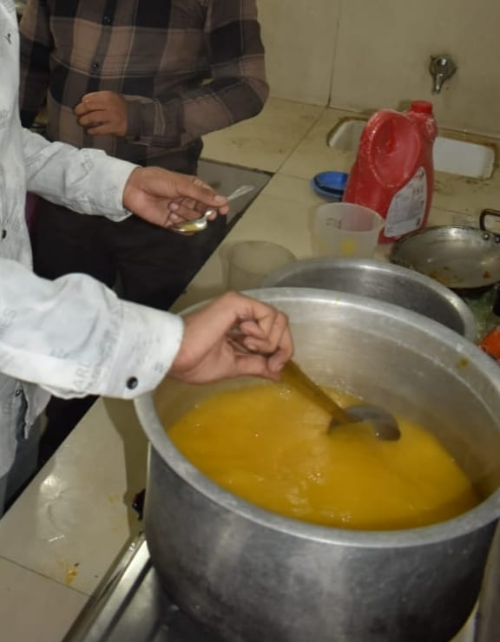
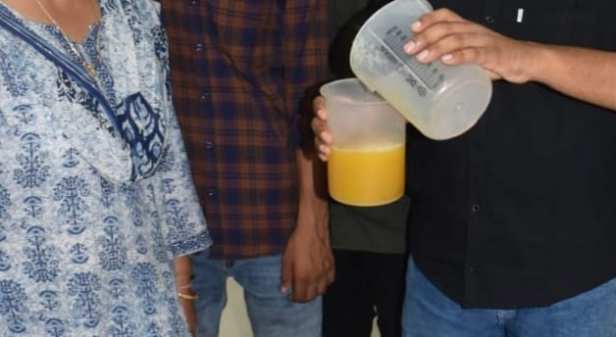
B
A

Picture- 1(A, B): Pulp extract from ripe mango fruits

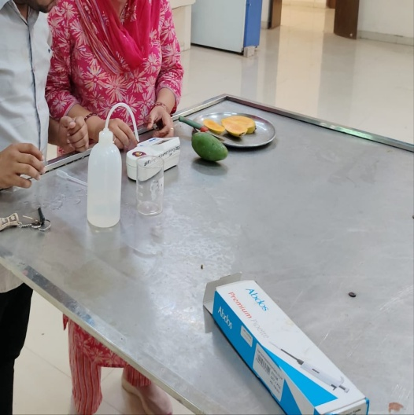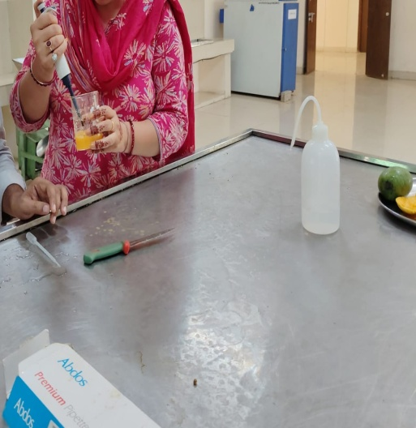
B
A
Picture-2 (A,B): Estimation of chemical composition of pulp as well as blended squash

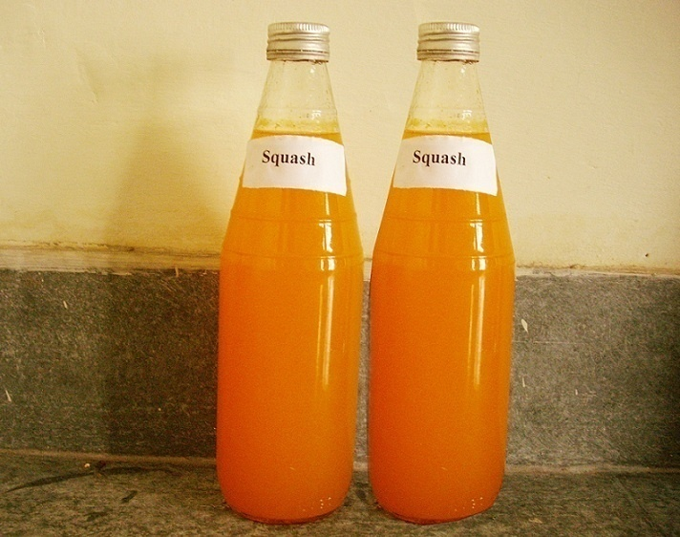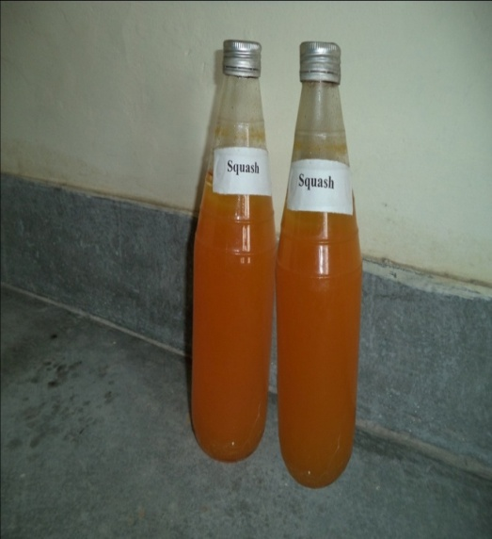
B
A

Picture-3: Browning in mango and aloe vera blend squash after storage.

- At the time of storage.
- After 4 months of storage.

Fig.4: Changes in total soluble solids (%) and acidity (%) of blend squash, during storage

Fig.5: Changes in ascorbic acid (mg/100mL) and carotenoids (mg/100g.) of blend squash,
during storage.

Fig.6: Changes in reducing sugars (%), Non reducing sugar(%) and total sugars (%) of
blend squash during storage

Fig.7: Changes in Vitamin A (IU) of blend squash during storage

Fig.8: Changes in Browning (OD) and organolepticrating of blend squash during storage

