Editor’s Comment:
The manuscript is good for acceptance as a book chapter and may be accepted. There are some corrections to be carried out. The authors are requested to carry out the corrections. These are given below:

- Visible revision marks/highlighting remain throughout the PDF. Many equations and words are green-highlighted, and stray “w” characters appear at the ends of several paragraphs. These must be removed.

2. Reference errors exist:
- “Panaja” should be Panjer.
- “Jonson” should be Johnson.
- “Escober” should be Escobar.
- One reference is numbered “[16]” while the rest use author-year style.
- Larsen and Marx is cited as 2006 in text but listed as 2018
3. Terminology problem: the paper repeatedly says “density,” but several examples are discrete distributions. Use “distribution/pmf/pdf” as appropriate.

4. The authors are required to verify this

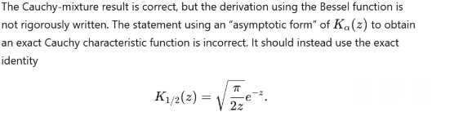

Editor’s Details:
Prof. G. Sudheer, GVP College of Engineering for Women, India

